Supplementary File
Sargassum-Synthesized ZnO Nanoparticles Induce Salt Tolerance in Maize Plants Through Enhanced Physiological and Biochemical Mechanisms
Hina Ashraf¹, Musarrat Ramzan², Muhammad Zaheer Ahmad³, Gul Naz⁴, Sheeraz Usman⁵, Anis Ali Shah^{5*}, Shifa Shaffique⁶, Abed Alataway⁷, Hosam O. Elansary⁸
¹ Department Botany The Government Sadiq College Women University, Bahawalpur, Pakistan
² Department of Botany, Faculty of Chemical and Biological Sciences, The Islamia University of Bahawalpur, Bahawalpur, Pakistan
³ Dr. M. Ajmal Khan Institute of Sustainable Halophytes Utilization (MAK-ISHU), University of Karachi, Karachi, Pakistan
⁴ Institute of Physics, Faculty of Physical & Mathematical Sciences, The Islamia University of Bahawalpur, Bahawalpur, Pakistan
⁵ Department of Botany, Division of Science and Technology, University of Education, Lahore, Pakistan
⁶ School of Applied Biosciences Kyungpook National University, Daegu, South Korea
⁷ Prince Sultan Institute for Environmental, Water and Desert Research, King Saud University, Riyadh 11451, Saudi Arabia
⁸ Plant Production Department, College of Food and Agriculture Sciences, King Saud University, Riyadh 11451, Saudi Arabia
*Corresponding author’s Email: anisalibot@gmail.com

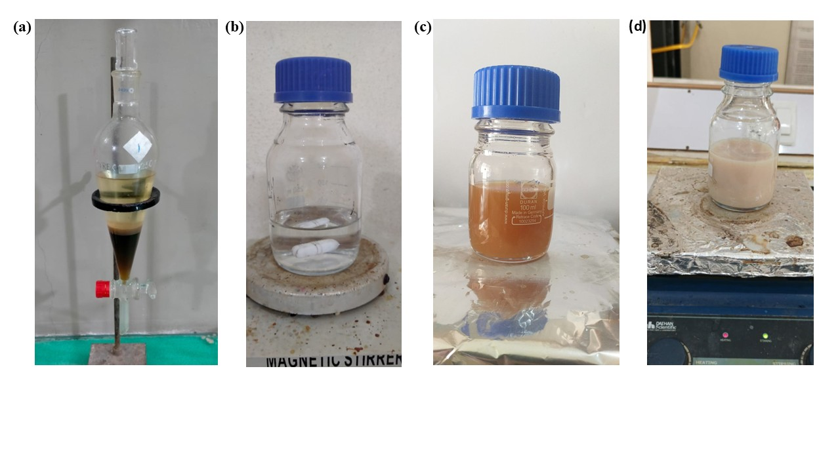
Figure S1. Synthesis of ZnO _{ST-}NPs. (a) Algal extract, (b) Zinc acetate solution (c) Solution of zinc acetate and algal extract and (d) Final change in color of the solution mixture.

