Identifying sets of phylogenetically informative markers for Anastrepha (Diptera: Tephritidae)

Running Title: Phylogenomic subsampling for species identification

Reinaldo A. de Brito^{1*}, Edyane Moraes dos Santos¹, Patricia Domingues de Freitas¹, Julian R. Dupuis², Carlos Congrains^{3,4}
¹Departamento de Genética e Evolução, Universidade Federal de São Carlos, São Carlos, SP, Brasil
²Department of Entomology, University of Kentucky, Lexington, KY 40546, USA.
³U.S. Department of Agriculture-Agricultural Research Service, Daniel K. Inouye U.S. Pacific Basin Agricultural Research Center, Tropical Pest Genetics and Molecular Biology Research Unit, Hilo, HI 96720, USA.
⁴Department of Plant and Environmental Protection Services, University of Hawaii at Manoa, Honolulu, HI 96822, USA.
* Corresponding Author. Email: brito@ufscar.br

Supplementary Files

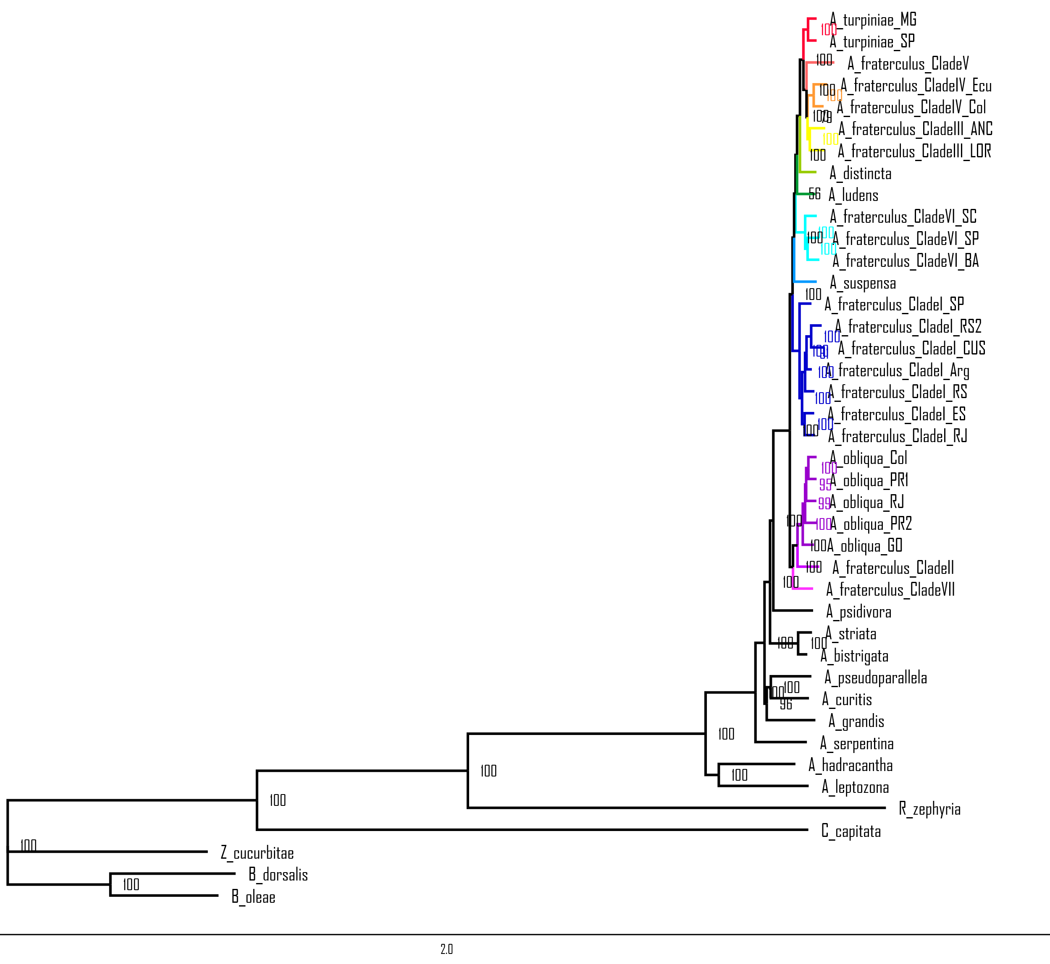 Supplementary Fig. S1. Maximum likelihood inference from concatenated 3,170 genes of Anastrepha species and five other Tephritidae species as outgroups inferred in IQ-TREE. Bootstrap supports are shown close to the nodes

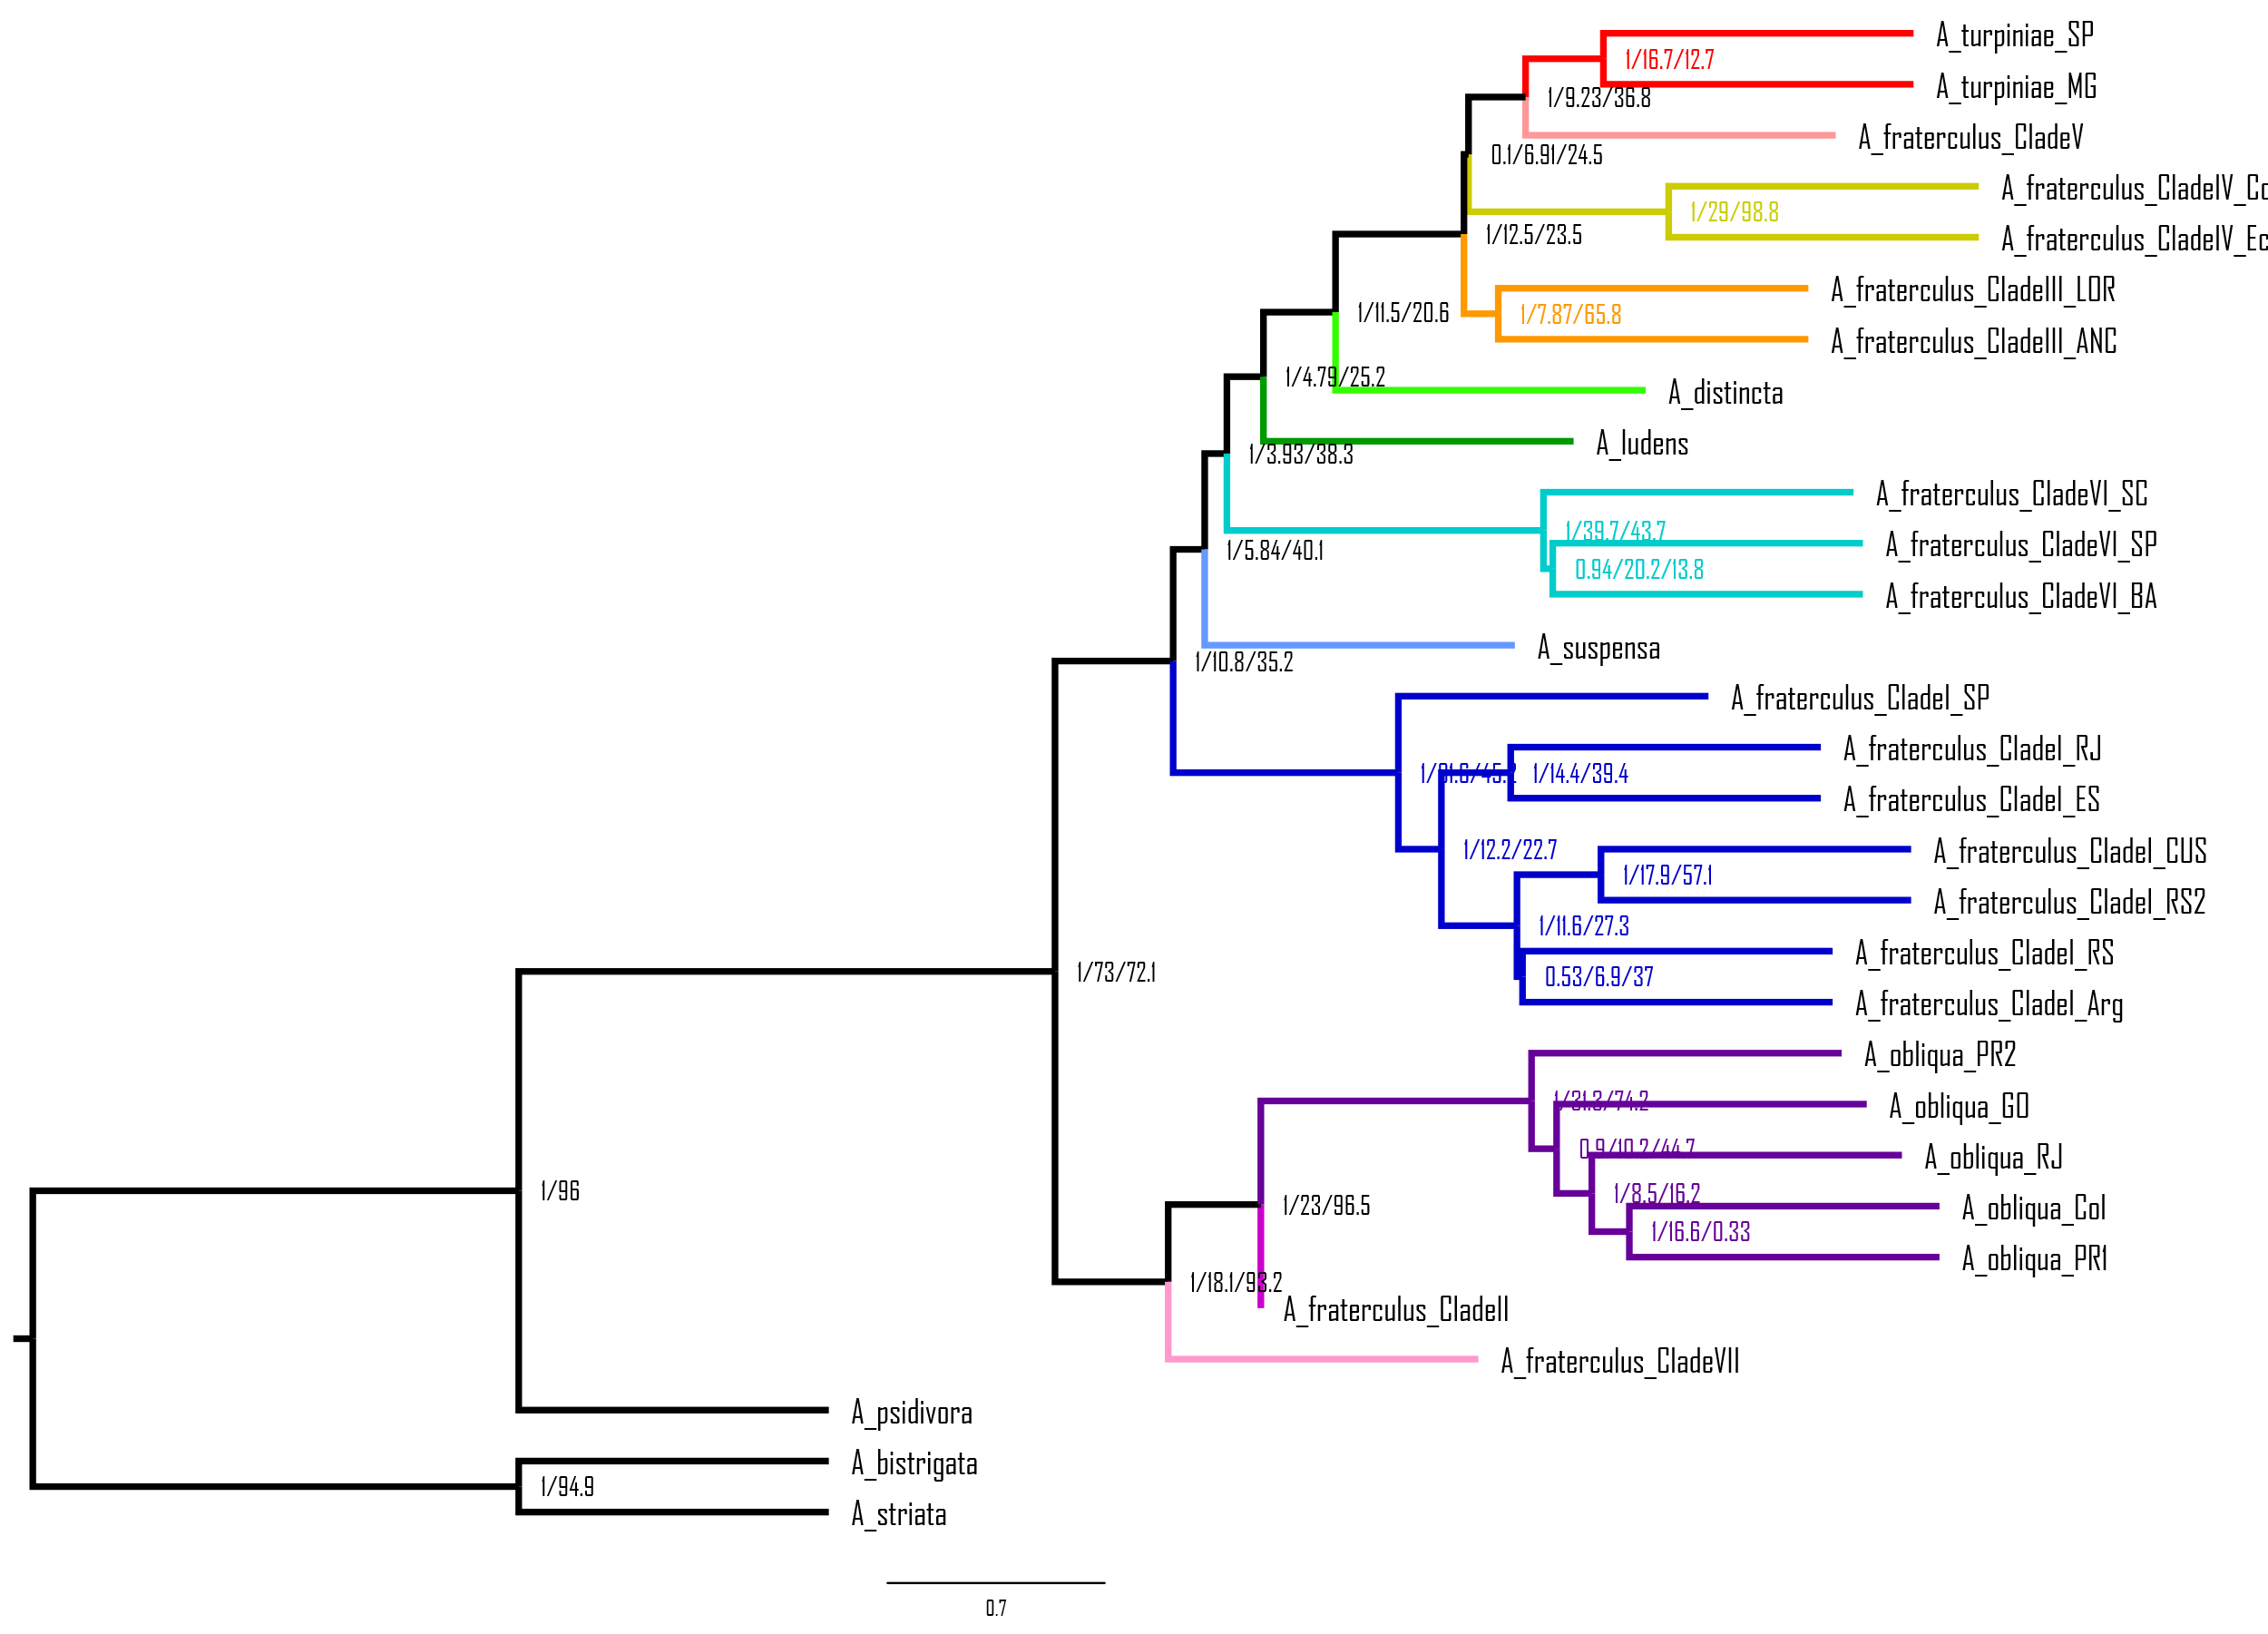

Supplementary Fig. S2. Multispecies coalescent species tree of Anastrepha species with focus on the fraterculus group using A. striata and A. bistrigata as outgroups based on 3,168 genes inferred in ASTRAL. Phylogenetic supports (bootstrap / gene concordance factor / quartet support) are shown on the nodes.

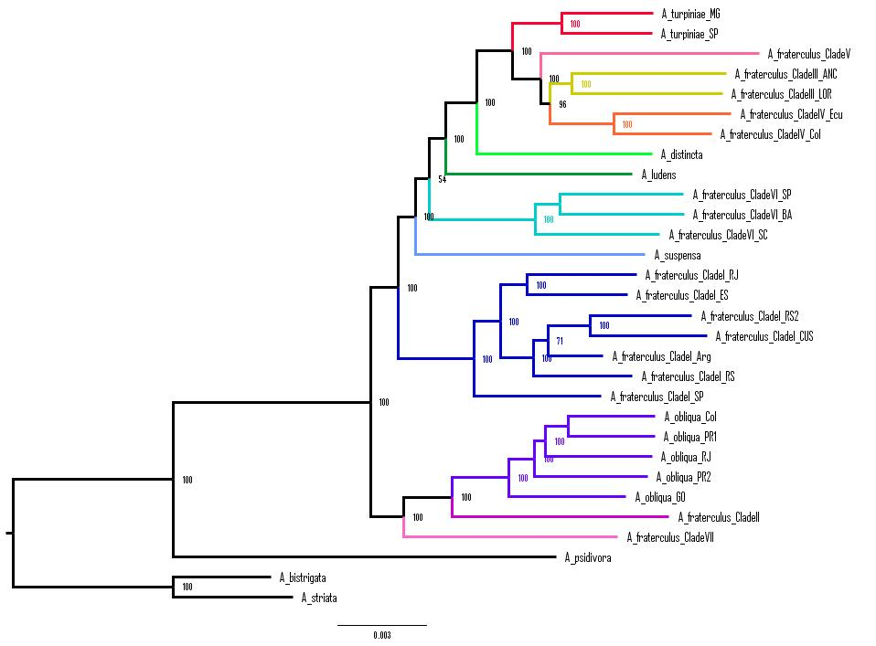

Supplementary Fig. S3. Maximum likelihood inference from concatenated 3,168 genes of Anastrepha species with focus on the fraterculus group using A. striata and A. bistrigata as outgroups inferred in IQ-TREE. Bootstrap supports are shown close to the nodes

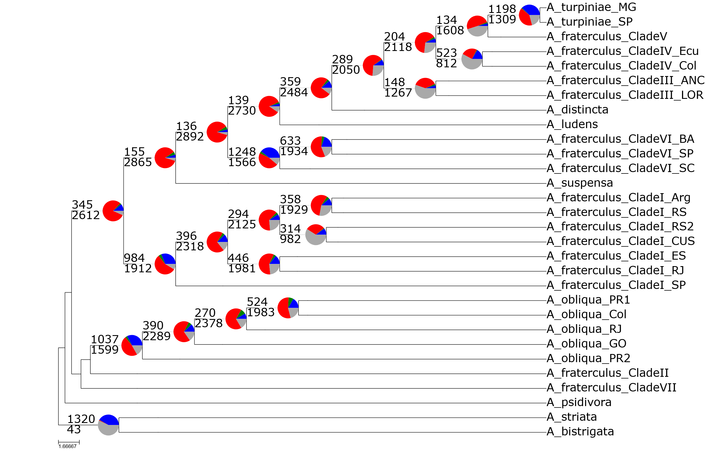

Supplementary Fig. S4. Summary of gene concordance and conflict based on PhyParts analysis against the species tree inferred on ASTRAL based on the fraterculus dataset. Pie charts show gene concordance (blue), conflict (green = one dominant alternative; red = other conflicting trees), and non-informative (gray) at each node.

Supplementary Fig. S5. Distribution of loci across the A. ludens genome. A) Full set of 3,170 genes, B) Distribution of Info_37 – 37 genes with more than 1,000 informative characters; C) Distribution of sgC60 – Set of 37 genes with highest sgC60; D) Distribution of Sortadate_37 – Set of 37 genes with longer and more robust internal branches inferred from Sortadate.

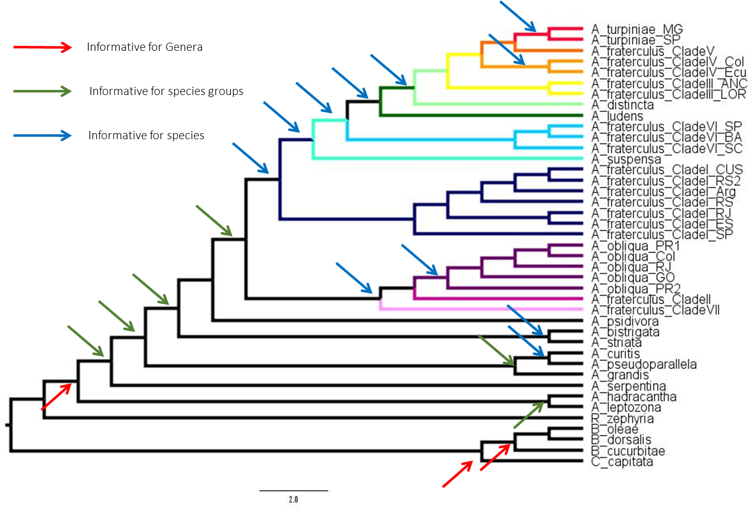
Supplementary Fig. S6. Species tree inferred from the Anastrepha dataset indicating which clades were considered as surrogate indicators of phylogenetic information at different hierarchical levels. Red arrows indicate nodes that separate genera, Green arrows indicate nodes that separate species groups, whereas blue arrows indicate nodes that separate species.

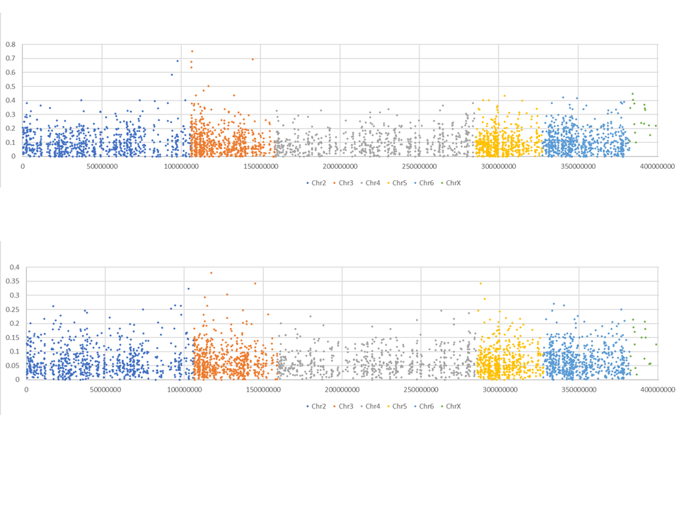

Supplementary Fig. S7. Distribution of omega (dN/dS) values inferred from the fraterculus (A) and Anastrepha (B) datasets across the genome, using A. ludens genome as reference.

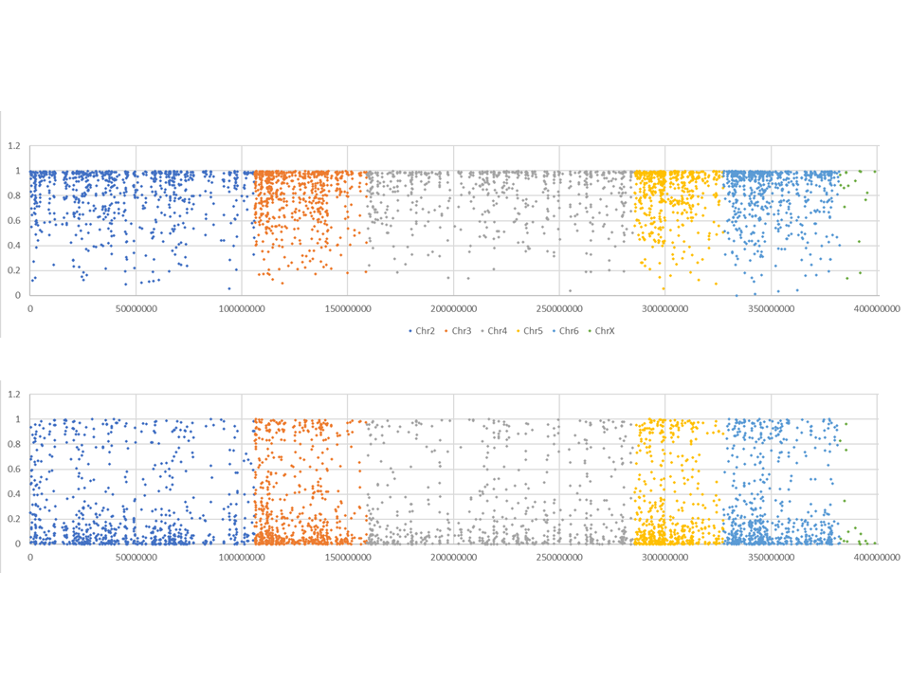

Supplementary Fig. S8: Distribution of phylogenetic saturation inferred from the fraterculus (A) and Anastrepha (B) datasets across the genome, using A. ludens genome as reference.

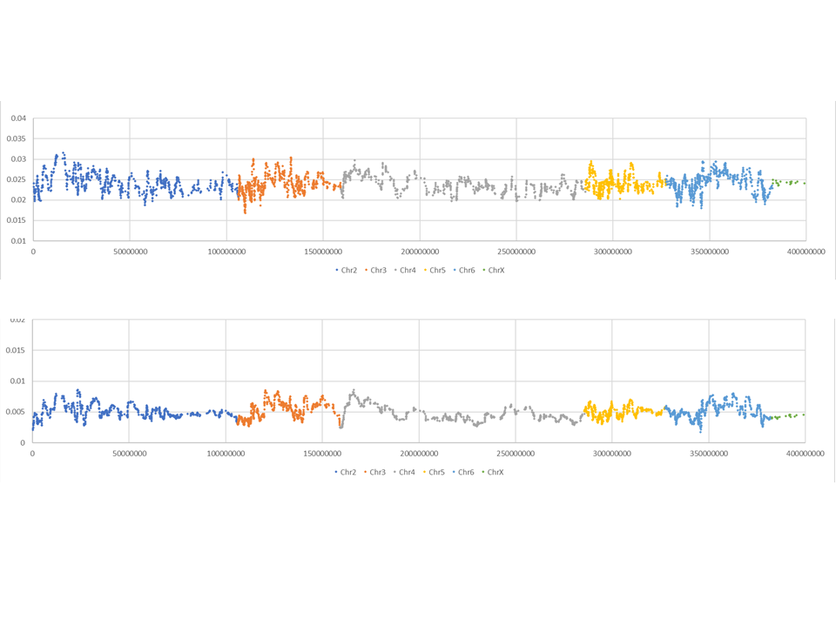

Supplementary Fig. S9: Distribution of evolutionary rates inferred from the fraterculus and Anastrepha datasets across the genome, using A. ludens genome as reference.

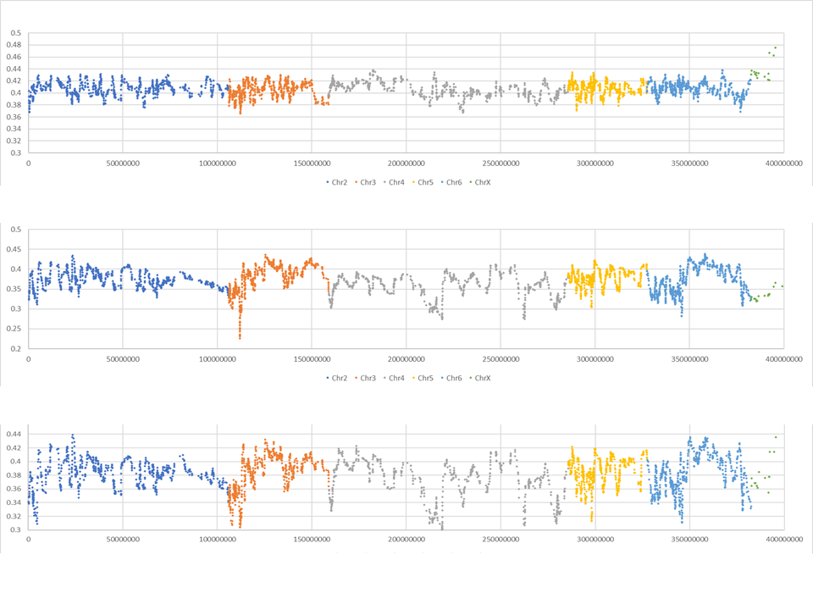

Supplementary Fig. S10: Distribution of Internode Certainty (IC) across the genome, using A. ludens genome as reference. A) Average IC among species group using the Anastrepha dataset (Green arrows on Suppl. Fig. S5); B) Average IC among different species using the Anastrepha dataset (Blue arrows on Suppl. Fig. S5); C) Average IC among species using the fraterculus datasets (Blue arrows on Suppl. Fig. S5).

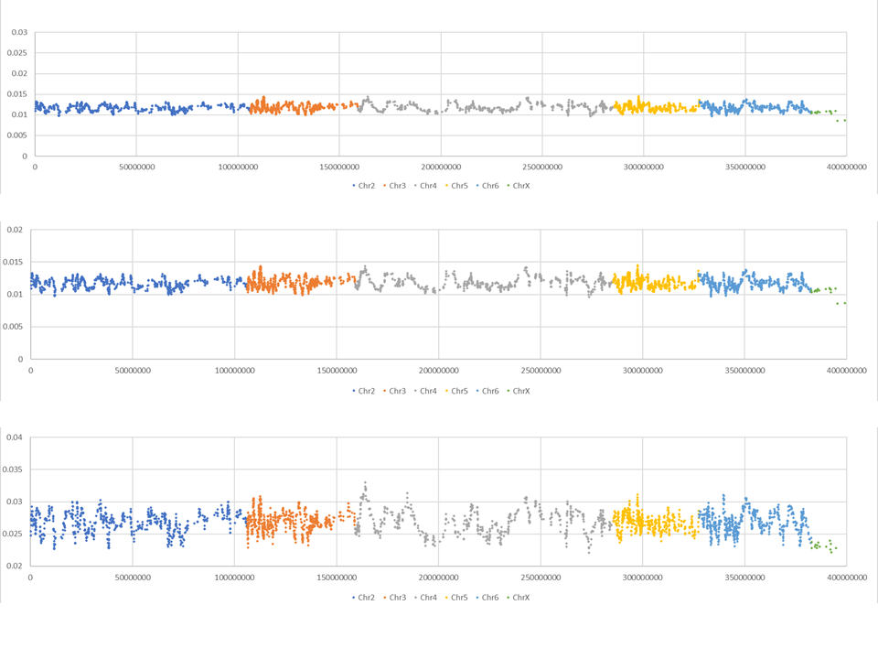
Supplementary Fig. S11. Distribution of f4-ratio across the genome, using A. ludens genome as reference. A) Average f4-ratio among genera, red arrows on Suppl. Fig. S5, using the Anastrepha dataset; B) Average f4-ratio among different species groups, green arrows on Suppl. Fig. S5, using the Anastrepha dataset; C) Average f4-ratio among species and A. fraterculus clades, blue arrows on Suppl. Fig. S5.

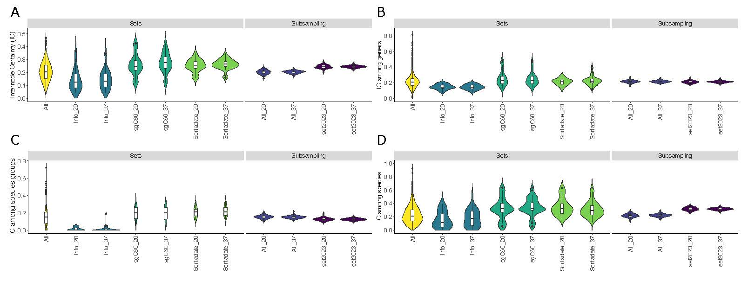

Supplementary Fig. S12. Violin charts of Internode Certainty (IC) estimated for different contrasts. A) Average IC among all Anastrepha dataset samples, estimated for the full dataset (All) and each subset, as well as from random subsamplings of 20 and 37 markers from the full dataset (All_20, All_37) and from a set of the 108 most informative loci of Congrains et al. (2023) (Set2023_20, Set2023_37); B) Same IC estimates only among genera in the Anastrepha dataset (Red arrows on Suppl. Fig. S5); C) Same IC estimates among species groups in the Anastrepha dataset (Green arrows on Suppl. Fig. S5); D) Same IC estimates among species in the Anastrepha dataset (Blue arrows on Suppl. Fig. S5).

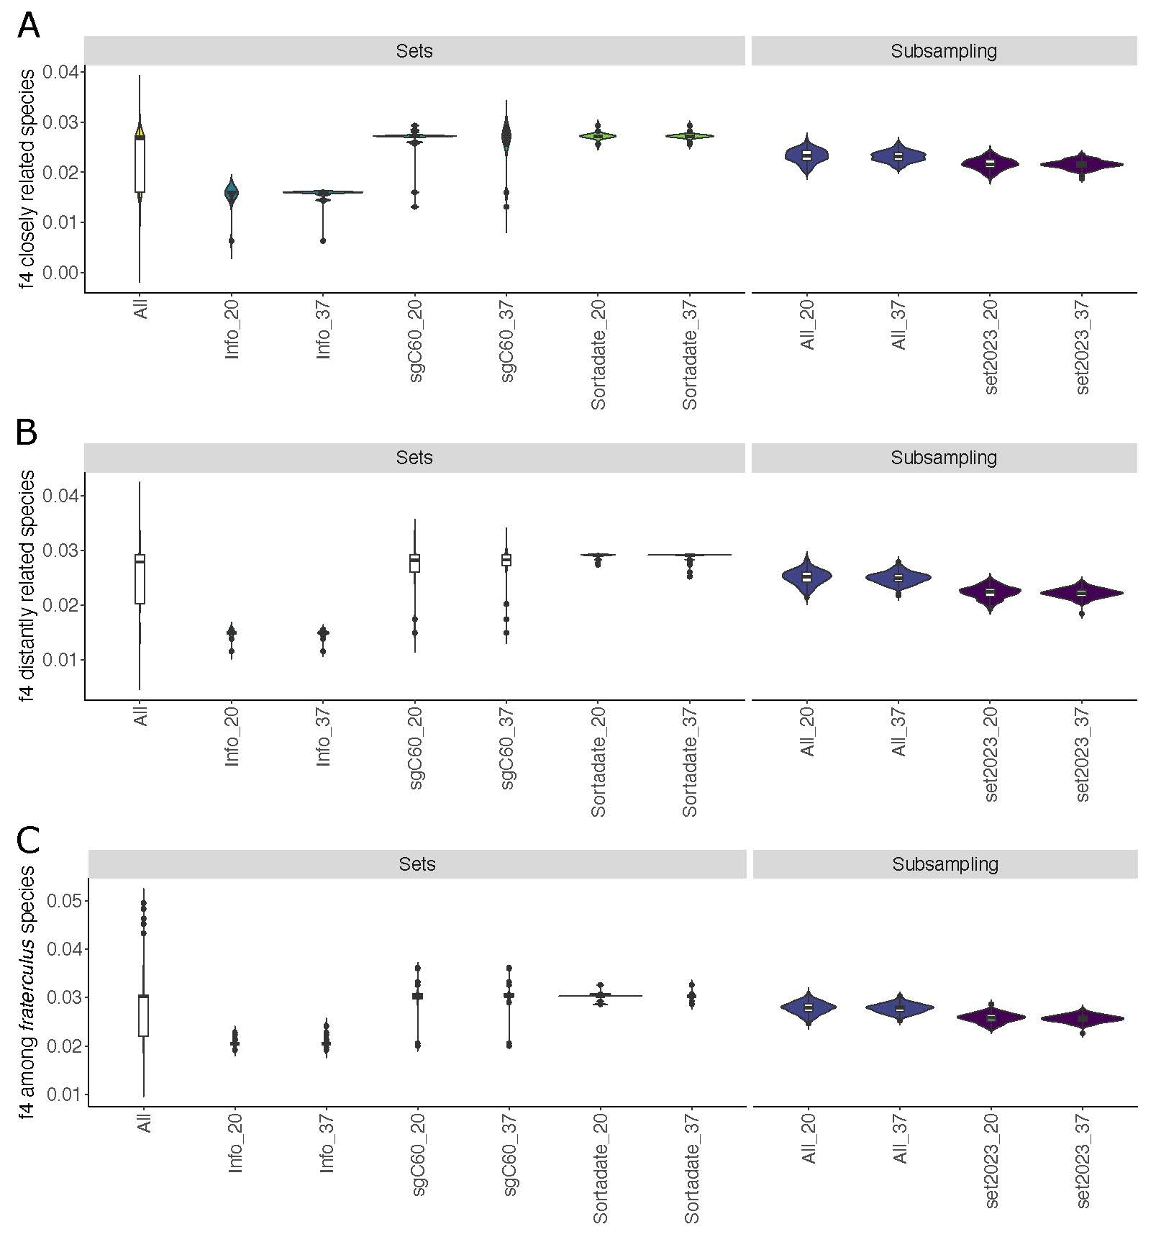

Supplementary Fig. S13. Violin charts of f4-ratio estimated at different evolutionary levels for the Anastrepha dataset (All) and each subset, as well as from random subsamplings of 20 and 37 markers from the full dataset (All_20, All_37) and from a set of the 108 most informative loci of Congrains et al. (2023) (Set2023_20, Set2023_37). A) Average f4-ratio values estimated among different species of Anastrepha in the same species group; B) Same f4-ratio contrasts, estimated among species on different species groups; C) Same f4-ratio contrasts, estimated only among species in the fraterculus species group, in which A. fraterculus clades are treated as different species.

Supplementary Table S1. Sampling information.
Sampleª | Species | Species group | City (State/Province) | Country | Coordinates lat/long^{b} | Host | Sample Identifier or NCBI Accession #
A. fraterculus ES | Anastrepha fraterculus | fraterculus | Muniz Freire (ES) | Brazil | 20°27'52.13"S / 41°24'54.88"W | Plinia cauliflora | SAMN17691821
A. fraterculus RJ | Anastrepha fraterculus | fraterculus | Conceição do Jacareí (RJ) | Brazil | 23° 1'54.32"S / 44° 9'54.14"W | Tropical- almond | SAMN17691822
A. fraterculus RS | Anastrepha fraterculus | fraterculus | Dois Irmãos (RS) | Brazil | 29°57'7"S / 51°11'33"W | Cattley guava | SAMN17691823
A. fraterculus RS2 | Anastrepha fraterculus | fraterculus | Vacaria (RS) | Brazil | 28°30'44"S / 50°56'02"W | Trap | AP20160307.44
A. fraterculus SP1 | Anastrepha fraterculus | fraterculus | São Carlos (SP) | Brazil | 22°1′49.84″ S / 20°27′52.13″ S | Savanna cherry | PRJNA934045
A. fraterculus AR | Anastrepha fraterculus | fraterculus | Tucumán (TUC) | Argentina | 27° 2'3.74"S/ 65°19'45.33"W | Trap | SAMN05554138
A. fraterculus SC | Anastrepha fraterculus | fraterculus | Itapema (SC) | Brazil | 27°05'36"S / 48°37'08"W | Barbados cherry | SAMN17691824
A. fraterculus SP2 | Anastrepha fraterculus | fraterculus | Porto Ferreira (SP) | Brazil | 21°50'59"S / 47°29'42"W | Rangpur | SAMN17691825
A. fraterculus BA | Anastrepha fraterculus | fraterculus | Ubaitaba (BA) | Brazil | 14°18'37.66"S / 39°19'18.08"W | Guava | SAMN17691826
A. fraterculus SP3 | Anastrepha fraterculus | fraterculus | Ilha Bela (SP) | Brazil | 23°47'19.52"S / 45°21'42.02"W | Guava | SAMN17691827
A. fraterculus CUS | Anastrepha fraterculus | fraterculus | Cusco | Peru | 13°19'18.18'' S / 71°57'24.9'' W | Prunus persica | SAMN31976350
A. fraterculus LOR | Anastrepha fraterculus | fraterculus | Loreto | Peru | 03°15' 5.27" S / 72°54'28.44" W | Trap | AP20160316.02
A. fraterculus ANC | Anastrepha fraterculus | fraterculus | Ancash | Peru | 09°29'07.4" S / 78°17'58.52" W | Trap | AP20160316.32
A. fraterculus MDD | Anastrepha fraterculus | fraterculus | Madre de Dios | Peru | 12°33'28.3" S / 70°06'31.36" W | Onychopetalum periquino | AP20160315.25
A. fraterculus Col | Anastrepha fraterculus | fraterculus | Rizaralda | Colombia | 05°11'18.8" N / 75°52'28.42" W | Trap | AP20160318.11
A. fraterculus Ecu | Anastrepha fraterculus | fraterculus | Pichincha | Ecuador | 00°12'02.7" S / 78°28'19.99" W | Chirimoya | AP20160307.04
A. fraterculus Mx^{c} | Anastrepha fraterculus | fraterculus | Ciudad de Mexico | Mexico | - | - | AP20160307.51
A. turpiniae MG | Anastrepha turpiniae | fraterculus | Três Marias (MG) | Brazil | 18°12'13.28"S / 45°14'23.34"W | Guava | SAMN17691828
A. turpiniae SP | Anastrepha turpiniae | fraterculus | Araraquara (SP) | Brazil | 21°48'55.81"S / 48°12'5.34"W | Guava | SAMN17691829
A. distincta SP | Anastrepha distincta | fraterculus | São Carlos (SP) | Brazil | 21°57'33"S / 47°53'54"W | Inga | SAMN17691830
A. obliqua RJ | Anastrepha obliqua | fraterculus | Conceição do Jacareí (RJ) | Brazil | 23° 1'54.32"S / 44° 9'54.14"W | Starfruit | SAMN17691831
A. obliqua GO | Anastrepha obliqua | fraterculus | Goiania (GO) | Brazil | 16°41′58″S / 49°16′35″W | Jacote | PRJNA934045
A. obliqua PR1 | Anastrepha obliqua | fraterculus | Capanema (PR) | Brazil | 25°39'45.54"S / 53°48'28.74"W | Eugenia uvalha | SAMN17691832
A. obliqua PR2 | Anastrepha obliqua | fraterculus | Marialva (PR) | Brazil | 23°30'56.68"N / 51°49'34.11"W | Jocote | SAMN17691833
A. obliqua Col | Anastrepha obliqua | fraterculus | - | Colombia | 4°54'8.49"S/ 74°41'20.46"W | Trap | GCA_027943255.1
A. suspensa | Anastrepha suspensa | fraterculus | - | United States^{c} | 41°33'57.11"N/ 77°54'8.54"W | Trap | PRJNA942850
A. ludens | Anastrepha ludens | fraterculus | - | United States^{c} | 41° 7'37.30"N/ 74°40'57.73"W | Trap | GCA_028408465.1
A. psidivora | Anastrepha psidivora | Unplaced | Cusco | Peru | 12°53'42" S / 71°24'10" W | Trap | SAMN31976356
A. bistrigata | Anastrepha bistrigata | striata | São Carlos (SP) | Brazil | 22°1'49.84"S / 47°54'27.90"W | Guava | SAMN17691834
A. striata | Anastrepha striata | striata | Cusco | Peru | 12°53'42.2" S / 71°24'09.98" W | Trap | SAMN31976357
A. pseudoparallela | Anastrepha pseudoparallela | pseudoparallela | Porto Ferreira (SP) | Brazil | 21°50'59"S / 47°29'42"W | Passion fruit | SAMN17691835
A. grandis | Anastrepha grandis | grandis | Porto Ferreira (SP) | Brazil | 21°50'59"S / 47°29'42"W | Pumpkin | SAMN17691836
A. serpentina | Anastrepha serpentina | serpentina | Araraquara (SP) | Brazil | 21°48'55.81"S / 48°12'5.34"W | Pouteria campechiana | SAMN17691837
A. hadracantha | Anastrepha hadracantha | mucronata | Madre de Dios | Peru | 12°33'11.2" S / 70°06'38.3" W | Trap | SAMN31976358
A. leptozona | Anastrepha leptozona | leptozona | Cusco | Peru | 12°53'42" S / 71°24'10" W | Trap | SAMN31976359
A. curitis | Anastrepha curitis | leptozona | Madre de Dios | Peru | 12°34'01" W / 70°06'05.72" S | Trap | SAMN31976360
ªCountry abbreviations are: Arg: Argentina; Col: Colombia: Ecu: Ecuador. State/Department/Province, City/Locality Abbreviations correspond to these full names: SP: São Paulo, ES: Espírito Santo, RJ: Rio de Janeiro, RS: Rio Grande do Sul, SC: Santa Catarina, BA: Bahia, GO: Goiás, PR: Paraná, MG: Minas Gerais, TUC: Tucumán, CDMX: Ciudad de México, CUS: Cusco, LOR: Loreto, ANC: Ancash, and MDD: Madre de Dios
^{b} These coordinates were obtained using Google Earth Pro v. 7.3.4.
^{c} Pooled sample from GenBank with some information not available

Supplementary Table S2. In a separate Excel Chart.

Supplementary Table S2. Populational, genomic, and phylogenetic parameters for list of contigs used to investigate sets of reduced markers.

Suppl. Table S3. Different significance tests of tree compatibility contrasting the likelihood of trees produced by each subset to explain the full Anastrepha dataset compared to the original tree produced (depicted on Fig. 1).

 | Subsets | logL All_loci | LogL Subset | deltaL | bp-RELL | p-KH | p-SH | p-WKH | p-WSH | c-ELW | p-AU
Info | Info_20 | -19521887.1 | -19547982.7 | 26096 | 0 | 0 | 0 | 0 | 0 | 0 | 0.0024
 | Info_37 | -20113714.1 | -20140403.2 | 26689 | 0 | 0 | 0 | 0 | 0 | 0 | 1.40E-64
sgC60 | sgC_20 | -20692846 | -20699571 | 6724.3 | 0 | 0 | 0 | 0 | 0 | 0 | 0.000218
 | sgC_37 | -20692846 | -20693046.8 | 200.76 | 0.3 | 0.29 | 0.29 | 0.29 | 0.29 | 0.3 | 0.28
Sortadate | Sortadate_20 | -20692846.8 | -20702176.9 | 9330.1 | 0 | 0 | 0 | 0 | 0 | 0 | 7.16E-39
 | Sortadate_37 | -20692845.8 | -20699036.4 | 6190.6 | 0 | 0 | 0 | 0 | 0 | 0 | 0.00506

logL: Log Maximum Likelihood of that Topology, considering their best inferred evolutionary models
deltaL: logL difference between logL of the full dataset and each subset logL
bp-RELL: bootstrap proportion using RELL method (Kishino et al. 1990)
p-KH: p-value of one-sided Kishino-Hasegawa (1989) test
p-SH: p-value of Shimodaira-Hasegawa (2000) test
p-WKH: p-value of weighted Kishino-Hasegawa test
p-WSH: p-value of weighted Shimodaira-Hasegawa test
c-ELW: Expected Likelihood Weight (Strimmer & Rambaut 2002).
p-AU: p-value of approximately unbiased (AU) test with 10000 replications (Shimodaira, 2002)

Suppl. Table S4. List of sets used to estimate introgression per loci. Species I and II are sister species, based on a species tree derived from Fig. 1 and Fig. 2, and test species are used to estimate deviations from ABBA-BABA expectations, considering different outgroups. Outgroups represent all the outgroup Tephritid species indicated in the text, or the Anastrepha species indicated below. Introgression f4-ratio estimates are averaged over all informative contrasts for each locus. A. fraterculus I-VI correspond to lineages A. fraterculus Clades I-VI indicated in the text and figures.
Set | outgroup | test | Species I | Species II
str_tur_fratIII | A_striata | A_distincta | A_turpiniae | A_fraterculus_III
 | A_striata | A_ludens | A_turpiniae | A_fraterculus_III
 | A_striata | A_fraterculus_VI | A_turpiniae | A_fraterculus_III
 | A_striata | A_suspensa | A_turpiniae | A_fraterculus_III
 | A_striata | A_fraterculus_I | A_turpiniae | A_fraterculus_III
 | A_striata | A_obliqua | A_turpiniae | A_fraterculus_III
 | A_striata | A_fraterculus_II | A_turpiniae | A_fraterculus_III
 | A_striata | A_psidivora | A_turpiniae | A_fraterculus_III
lep_tur_fratIII | A_leptozona | A_distincta | A_turpiniae | A_fraterculus_III
 | A_leptozona | A_ludens | A_turpiniae | A_fraterculus_III
 | A_leptozona | A_fraterculus_VI | A_turpiniae | A_fraterculus_III
 | A_leptozona | A_suspensa | A_turpiniae | A_fraterculus_III
 | A_leptozona | A_fraterculus_I | A_turpiniae | A_fraterculus_III
 | A_leptozona | A_obliqua | A_turpiniae | A_fraterculus_III
 | A_leptozona | A_fraterculus_II | A_turpiniae | A_fraterculus_III
 | A_leptozona | A_psidivora | A_turpiniae | A_fraterculus_III
 | A_leptozona | A_striata | A_turpiniae | A_fraterculus_III
 | A_leptozona | A_pseudoparallela | A_turpiniae | A_fraterculus_III
 | A_leptozona | A_grandis | A_turpiniae | A_fraterculus_III
 | A_leptozona | A_serpentina | A_turpiniae | A_fraterculus_III
out_tur_fratIII | outgroup | A_distincta | A_turpiniae | A_fraterculus_III
 | outgroup | A_ludens | A_turpiniae | A_fraterculus_III
 | outgroup | A_fraterculus_VI | A_turpiniae | A_fraterculus_III
 | outgroup | A_suspensa | A_turpiniae | A_fraterculus_III
 | outgroup | A_fraterculus_I | A_turpiniae | A_fraterculus_III
 | outgroup | A_obliqua | A_turpiniae | A_fraterculus_III
 | outgroup | A_fraterculus_II | A_turpiniae | A_fraterculus_III
 | outgroup | A_psidivora | A_turpiniae | A_fraterculus_III
 | outgroup | A_striata | A_turpiniae | A_fraterculus_III
 | outgroup | A_pseudoparallela | A_turpiniae | A_fraterculus_III
 | outgroup | A_grandis | A_turpiniae | A_fraterculus_III
 | outgroup | A_serpentina | A_turpiniae | A_fraterculus_III
 | outgroup | A_leptozona | A_turpiniae | A_fraterculus_III
 | outgroup | A_hadracantha | A_turpiniae | A_fraterculus_III

Suppl. Table S4 (cont.)
Set | outgroup | test | Species I | Species II
str_fratIV_fratIII | A_striata | A_distincta | A_fraterculus_IV | A_fraterculus_III
 | A_striata | A_ludens | A_fraterculus_IV | A_fraterculus_III
 | A_striata | A_fraterculus_VI | A_fraterculus_IV | A_fraterculus_III
 | A_striata | A_suspensa | A_fraterculus_IV | A_fraterculus_III
 | A_striata | A_fraterculus_I | A_fraterculus_IV | A_fraterculus_III
 | A_striata | A_obliqua | A_fraterculus_IV | A_fraterculus_III
 | A_striata | A_fraterculus_II | A_fraterculus_IV | A_fraterculus_III
 | A_striata | A_psidivora | A_fraterculus_IV | A_fraterculus_III
lep_fratIV_fratIII | A_leptozona | A_distincta | A_fraterculus_IV | A_fraterculus_III
 | A_leptozona | A_ludens | A_fraterculus_IV | A_fraterculus_III
 | A_leptozona | A_fraterculus_VI | A_fraterculus_IV | A_fraterculus_III
 | A_leptozona | A_suspensa | A_fraterculus_IV | A_fraterculus_III
 | A_leptozona | A_fraterculus_I | A_fraterculus_IV | A_fraterculus_III
 | A_leptozona | A_obliqua | A_fraterculus_IV | A_fraterculus_III
 | A_leptozona | A_fraterculus_II | A_fraterculus_IV | A_fraterculus_III
 | A_leptozona | A_psidivora | A_fraterculus_IV | A_fraterculus_III
 | A_leptozona | A_striata | A_fraterculus_IV | A_fraterculus_III
 | A_leptozona | A_pseudoparallela | A_fraterculus_IV | A_fraterculus_III
 | A_leptozona | A_grandis | A_fraterculus_IV | A_fraterculus_III
 | A_leptozona | A_serpentina | A_fraterculus_IV | A_fraterculus_III
out_fratIV_fratIII | outgroup | A_distincta | A_fraterculus_IV | A_fraterculus_III
 | outgroup | A_ludens | A_fraterculus_IV | A_fraterculus_III
 | outgroup | A_fraterculus_VI | A_fraterculus_IV | A_fraterculus_III
 | outgroup | A_suspensa | A_fraterculus_IV | A_fraterculus_III
 | outgroup | A_fraterculus_I | A_fraterculus_IV | A_fraterculus_III
 | outgroup | A_obliqua | A_fraterculus_IV | A_fraterculus_III
 | outgroup | A_fraterculus_II | A_fraterculus_IV | A_fraterculus_III
 | outgroup | A_psidivora | A_fraterculus_IV | A_fraterculus_III
 | outgroup | A_striata | A_fraterculus_IV | A_fraterculus_III
 | outgroup | A_pseudoparallela | A_fraterculus_IV | A_fraterculus_III
 | outgroup | A_grandis | A_fraterculus_IV | A_fraterculus_III
 | outgroup | A_serpentina | A_fraterculus_IV | A_fraterculus_III
 | outgroup | A_leptozona | A_fraterculus_IV | A_fraterculus_III
 | outgroup | A_hadracantha | A_fraterculus_IV | A_fraterculus_III
str_fratVI_fratIII | A_striata | A_suspensa | A_fraterculus_VI | A_fraterculus_III
 | A_striata | A_fraterculus_I | A_fraterculus_VI | A_fraterculus_III
 | A_striata | A_obliqua | A_fraterculus_VI | A_fraterculus_III
 | A_striata | A_fraterculus_II | A_fraterculus_VI | A_fraterculus_III
 | A_striata | A_psidivora | A_fraterculus_VI | A_fraterculus_III

Suppl. Table S4 (cont.)
Set | outgroup | test | Species I | Species II
lep_fratVI_fratIII | A_leptozona | A_suspensa | A_fraterculus_VI | A_fraterculus_III
 | A_leptozona | A_fraterculus_I | A_fraterculus_VI | A_fraterculus_III
 | A_leptozona | A_obliqua | A_fraterculus_VI | A_fraterculus_III
 | A_leptozona | A_fraterculus_II | A_fraterculus_VI | A_fraterculus_III
 | A_leptozona | A_psidivora | A_fraterculus_VI | A_fraterculus_III
 | A_leptozona | A_striata | A_fraterculus_VI | A_fraterculus_III
 | A_leptozona | A_pseudoparallela | A_fraterculus_VI | A_fraterculus_III
 | A_leptozona | A_grandis | A_fraterculus_VI | A_fraterculus_III
 | A_leptozona | A_serpentina | A_fraterculus_VI | A_fraterculus_III
out_fratVI_fratIII | outgroup | A_suspensa | A_fraterculus_VI | A_fraterculus_III
 | outgroup | A_fraterculus_I | A_fraterculus_VI | A_fraterculus_III
 | outgroup | A_obliqua | A_fraterculus_VI | A_fraterculus_III
 | outgroup | A_fraterculus_II | A_fraterculus_VI | A_fraterculus_III
 | outgroup | A_psidivora | A_fraterculus_VI | A_fraterculus_III
 | outgroup | A_striata | A_fraterculus_VI | A_fraterculus_III
 | outgroup | A_pseudoparallela | A_fraterculus_VI | A_fraterculus_III
 | outgroup | A_grandis | A_fraterculus_VI | A_fraterculus_III
 | outgroup | A_serpentina | A_fraterculus_VI | A_fraterculus_III
 | outgroup | A_leptozona | A_fraterculus_VI | A_fraterculus_III
 | outgroup | A_hadracantha | A_fraterculus_VI | A_fraterculus_III
out_fratIII_fratI | outgroup | A_obliqua | A_fraterculus_III | A_fraterculus_I
 | outgroup | A_fraterculus_II | A_fraterculus_III | A_fraterculus_I
 | outgroup | A_fraterculus_VII | A_fraterculus_III | A_fraterculus_I
 | outgroup | A_psidivora | A_fraterculus_III | A_fraterculus_I
 | outgroup | A_striata | A_fraterculus_III | A_fraterculus_I
 | outgroup | A_pseudoparallela | A_fraterculus_III | A_fraterculus_I
 | outgroup | A_grandis | A_fraterculus_III | A_fraterculus_I
 | outgroup | A_serpentina | A_fraterculus_III | A_fraterculus_I
 | outgroup | A_leptozona | A_fraterculus_III | A_fraterculus_I
 | outgroup | A_hadracantha | A_fraterculus_III | A_fraterculus_I
out_fratIV_fratI | outgroup | A_obliqua | A_fraterculus_IV | A_fraterculus_I
 | outgroup | A_fraterculus_II | A_fraterculus_IV | A_fraterculus_I
 | outgroup | A_fraterculus_VII | A_fraterculus_IV | A_fraterculus_I
 | outgroup | A_psidivora | A_fraterculus_IV | A_fraterculus_I
 | outgroup | A_striata | A_fraterculus_IV | A_fraterculus_I
 | outgroup | A_pseudoparallela | A_fraterculus_IV | A_fraterculus_I
 | outgroup | A_grandis | A_fraterculus_IV | A_fraterculus_I
 | outgroup | A_serpentina | A_fraterculus_IV | A_fraterculus_I
 | outgroup | A_leptozona | A_fraterculus_IV | A_fraterculus_I
 | outgroup | A_hadracantha | A_fraterculus_IV | A_fraterculus_I

Suppl. Table S4 (cont.)
Set | outgroup | test | Species I | Species II
out_tur_fratIIIa | outgroup | A_fraterculus_II | A_turpiniae | A_fraterculus_III
 | outgroup | A_fraterculus_VII | A_turpiniae | A_fraterculus_III
out_fratII_fratI | outgroup | A_psidivora | A_fraterculus_II | A_fraterculus_I
 | outgroup | A_striata | A_fraterculus_II | A_fraterculus_I
 | outgroup | A_pseudoparallela | A_fraterculus_II | A_fraterculus_I
 | outgroup | A_grandis | A_fraterculus_II | A_fraterculus_I
 | outgroup | A_serpentina | A_fraterculus_II | A_fraterculus_I
 | outgroup | A_leptozona | A_fraterculus_II | A_fraterculus_I
 | outgroup | A_hadracantha | A_fraterculus_II | A_fraterculus_I
out_fratII_obli | outgroup | A_turpiniae | A_fraterculus_II | A_obliqua
 | outgroup | A_fraterculus_III | A_fraterculus_II | A_obliqua
 | outgroup | A_fraterculus_IV | A_fraterculus_II | A_obliqua
 | outgroup | A_distincta | A_fraterculus_II | A_obliqua
 | outgroup | A_ludens | A_fraterculus_II | A_obliqua
 | outgroup | A_fraterculus_VI | A_fraterculus_II | A_obliqua
 | outgroup | A_psidivora | A_fraterculus_II | A_obliqua
 | outgroup | A_striata | A_fraterculus_II | A_obliqua
 | outgroup | A_pseudoparallela | A_fraterculus_II | A_obliqua
 | outgroup | A_grandis | A_fraterculus_II | A_obliqua
 | outgroup | A_serpentina | A_fraterculus_II | A_obliqua
 | outgroup | A_leptozona | A_fraterculus_II | A_obliqua
 | outgroup | A_hadracantha | A_fraterculus_II | A_obliqua
out_fratVII_obli | outgroup | A_psidivora | A_fraterculus_VII | A_obliqua
 | outgroup | A_striata | A_fraterculus_VII | A_obliqua
 | outgroup | A_pseudoparallela | A_fraterculus_VII | A_obliqua
 | outgroup | A_grandis | A_fraterculus_VII | A_obliqua
 | outgroup | A_serpentina | A_fraterculus_VII | A_obliqua
 | outgroup | A_leptozona | A_fraterculus_VII | A_obliqua
 | outgroup | A_hadracantha | A_fraterculus_VII | A_obliqua
out_fratVI_fratI | outgroup | A_fraterculus_II | A_fraterculus_VI | A_fraterculus_I
 | outgroup | A_fraterculus_VII | A_fraterculus_VI | A_fraterculus_I
 | outgroup | A_obliqua | A_fraterculus_VI | A_fraterculus_I
 | outgroup | A_psidivora | A_fraterculus_VI | A_fraterculus_I
 | outgroup | A_striata | A_fraterculus_VI | A_fraterculus_I
 | outgroup | A_pseudoparallela | A_fraterculus_VI | A_fraterculus_I
 | outgroup | A_grandis | A_fraterculus_VI | A_fraterculus_I
 | outgroup | A_serpentina | A_fraterculus_VI | A_fraterculus_I
 | outgroup | A_leptozona | A_fraterculus_VI | A_fraterculus_I
 | outgroup | A_hadracantha | A_fraterculus_VI | A_fraterculus_I

