Supplementary material
Targeting Acinetobacter baumannii lipase by coniferous species through metabolomics supported approach
Rania M. Kamal^{1*}, Ali M. El-Halawany¹, Mohamed S. Hifnawy¹, Asmaa M. Otify¹, Walaa G. Fahmy², Noha M. Elhosseiny², Ahmed S. Attia^{2,3}, Basma M. Eltanany⁴, Laura Pont^{5,6}, Fernando Benavente⁵, Inas Y. Younis^{1**}, Manal M. Sabry^{1**}
¹ Department of Pharmacognosy, Faculty of Pharmacy, Cairo University, Cairo 11562, Egypt.
² Department of Microbiology and Immunology, Faculty of Pharmacy, Cairo University, Cairo 11562, Egypt.
³ School of Pharmacy, Newgiza University, Giza 12588, Egypt.
⁴ Department of Pharmaceutical Analytical Chemistry, Faculty of Pharmacy, Cairo University, Cairo 11562, Egypt.
⁵ Department of Chemical Engineering and Analytical Chemistry, Institute for Research on Nutrition and Food Safety (INSA·UB), University of Barcelona, Barcelona 08028, Spain.
⁶ Serra Húnter Program, Generalitat de Catalunya, Barcelona 08007, Spain.
*Correspondence: rania.ahmed@pharma.cu.edu.eg (R.M.K.)
** Both authors contributed equally.

Figure S1: Diagram for extraction, fractionation and isolation of C1-C4 compounds

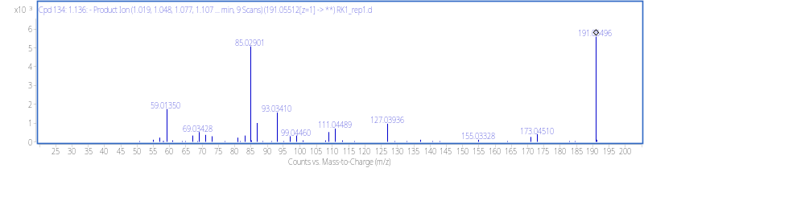
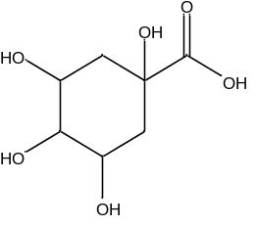
Quinic acid
m/z 191.0550 (C₇ H₁₂ O₆)
2
[M−H]⁻
[M−H−18]⁻
[M−H−18−18]⁻

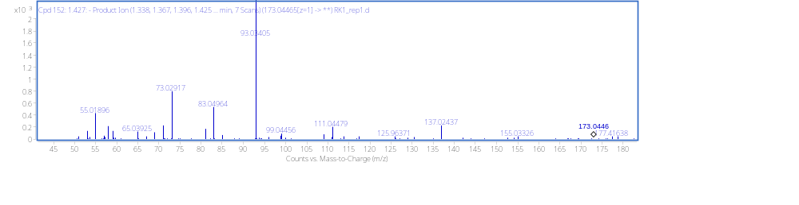
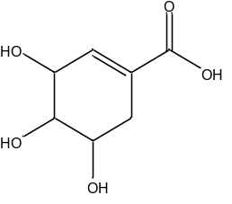
[M−H]⁻
[M−H−18]⁻
Shikimic acid
m/z 173.0434 (C₇ H₁₀ O₅)
4

Figure S2: MS/MS spectra of metabolites 2 and 4 (Table 3)

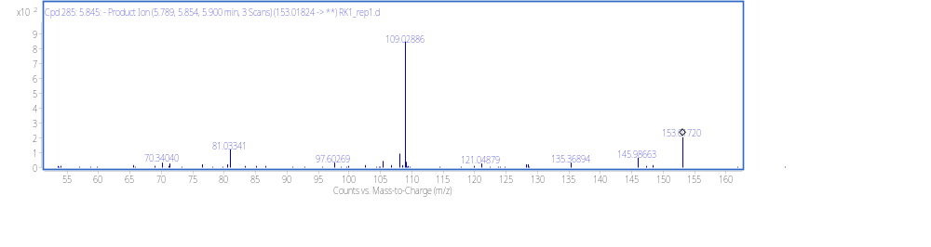
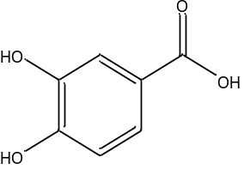
[M−H]⁻
[M-H-44]⁻
Protocatechuic acid
m/z 153.0182 (C₇ H₆ O₄)
7 (negative ESI mode)

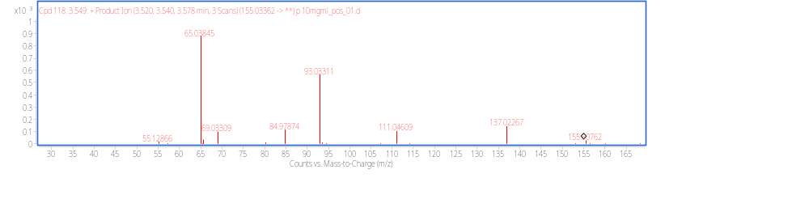
Protocatechuic acid
m/z 155.0336 (C₇ H₆ O₄)
[M+H]⁺
[M+H–44] ⁺

7 (positive ESI mode)

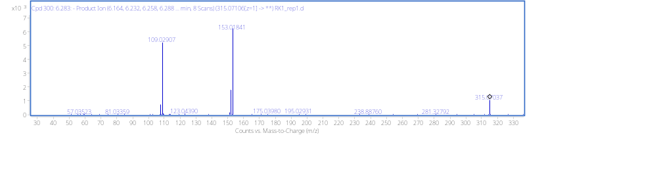
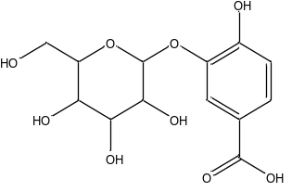
[M−H]⁻
[M−H−162]⁻
[M−H−162−44]⁻
Protocatechuic acid hexoside
m/z 315.0707 (C₁₃H₁₆O₉)
122

Figure S3: MS/MS spectra of metabolites 7 and 12 (Table 3)
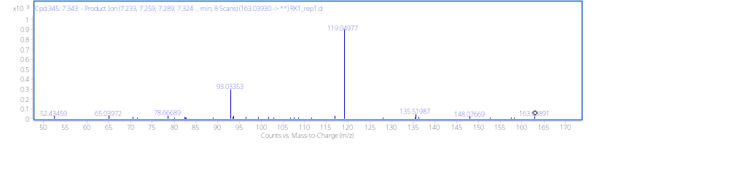
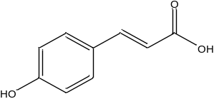
[M−H]⁻
[M−H−44]⁻
p-coumaric acid
m/z 163.0393 (C₉H₈O₃)
17 (negative ESI mode)

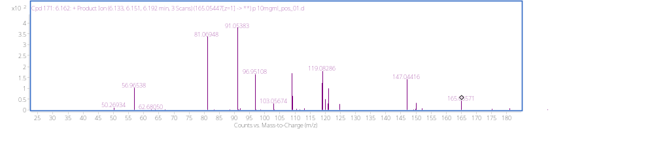
[M+H]⁺
[M+H-44]⁺
p-coumaric acid
m/z 165.0393 (C₉ H₈O₃)
17 (positive ESI mode)

Figure S4: MS/MS spectra of metabolite 17 (Table 3)

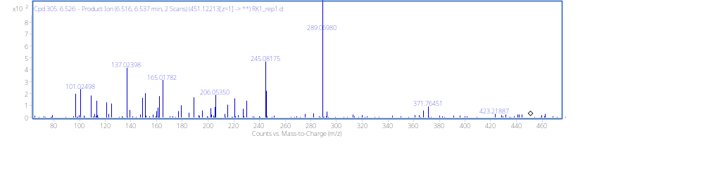
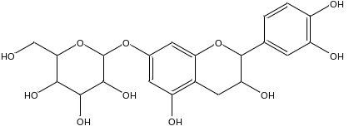
Catechin-7-O-β-D-glucopyranoside
m/z 451.1221 (C₂₁H₂₄O₁₁)
[M−H−162]⁻
[M−H]⁻
24

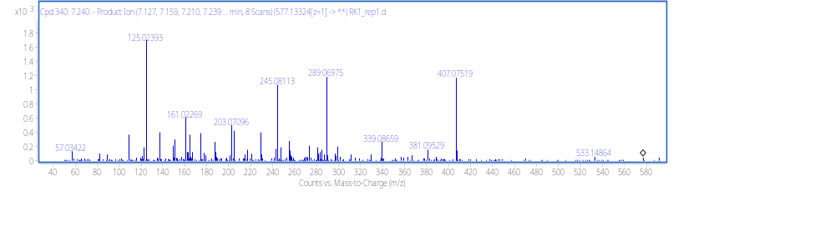
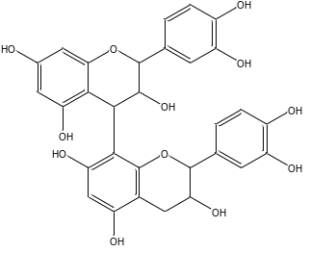
[M−H−288]⁻
[M−H−288−44]⁻
Procyanidin B
m/z 577.1332 (C₃₀H₂₆O₁₂)
25 (negative ESI mode)

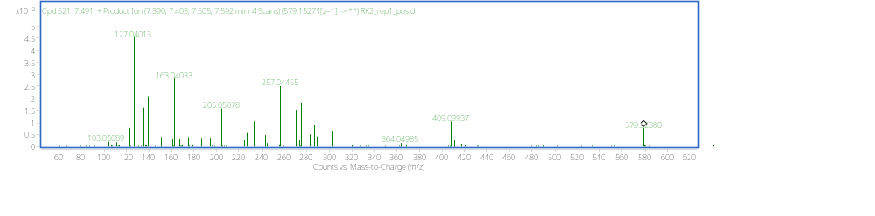
Procyanidin B
m/z 579.1527 (C₃₀H₂₆O₁₂)
[M+H-288]⁺
[M+H]⁺

25 (positive ESI mode)

Figure S5: MS/MS spectra of metabolites 24 and 25 (Table 3)

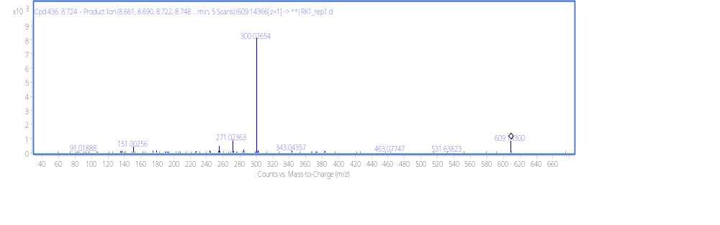
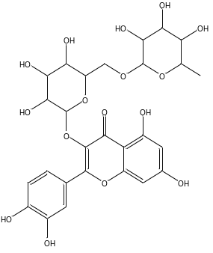
Rutin
m/z 609.1437 (C₂₇H₃₀O₁₆)
[M−H]⁻
[M−H−146]⁻
[M−H−146−162]⁻
32 (negative ESI mode)

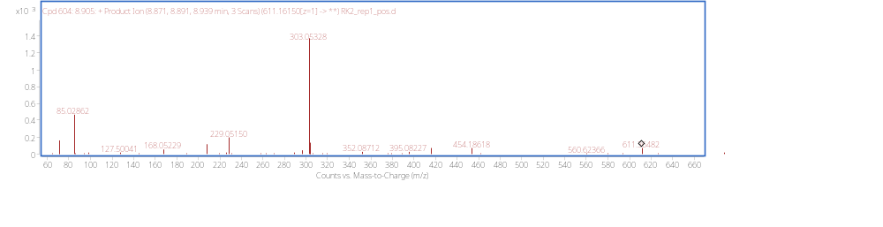
Rutin
m/z 611.1615 (C₂₇H₃₀O₁₆)

[M+H]⁺

32 (positive ESI mode)
[M+H−146−162]⁻

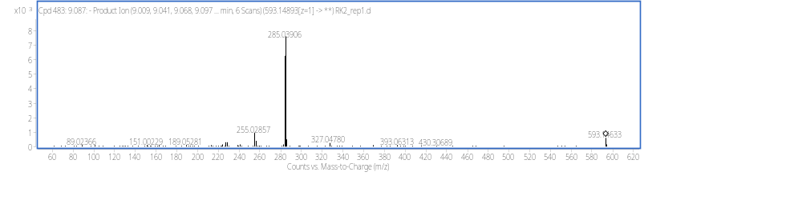
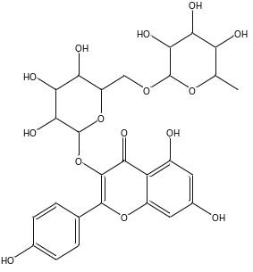
[M−H]⁻
[M−H−308]⁻
Kaempferol-3-O rutinoside
m/z 593.1489 (C₂₇H₃₀O₁₅)
36

Figure S6: MS/MS spectra of metabolites 32 and 36 (Table 3)

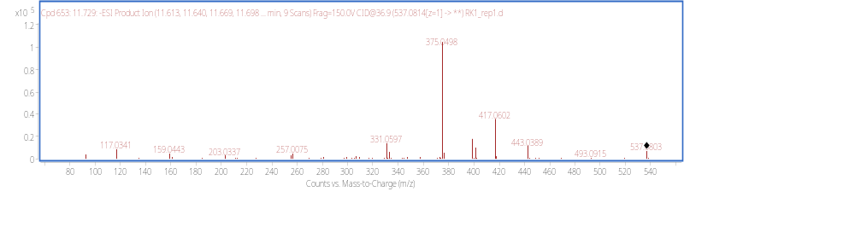
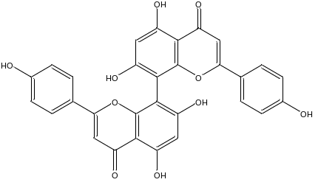
[M−H]⁻
[M−H−162]⁻
Cupressuflavone
m/z 537.0814 (C₃₀H₁₈O₁₀)
53 (negative ESI mode)

A

000000000000000000

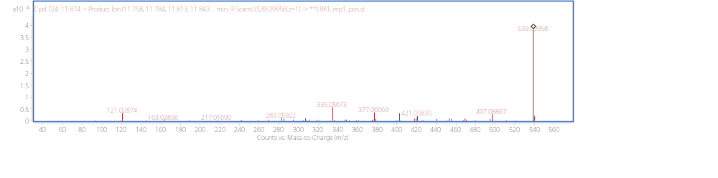
[M+H]⁺
[M+H–162]⁺
53 (positive ESI mode)
Cupressuflavone
m/z 539.0812 (C₃₀H₁₈O₁₀)
[M-H]⁻

Figure S7: MS/MS spectra of metabolite 53 (Table 3).

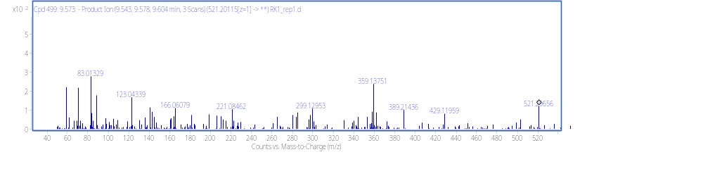
Lariciresinol hexoside
m/z 521.1995 (C₂₆H₃₄O₁₁)
60
[M−H]⁻
[M−H−162]⁻

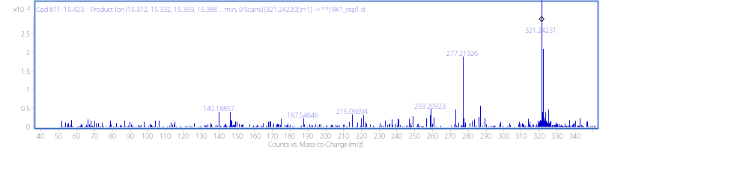
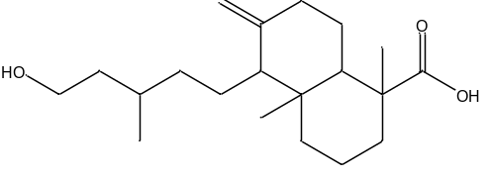
Figure S8: MS/MS spectrum of metabolite 60 (Table 3)
[M−H]⁻
[M−H−18−28]⁻
[M−H−18−28−18]⁻
Imbricatolic acid
m/z 321.2424 (C₂₀H₃₄O₃)
67

Figure S9: MS/MS spectra of metabolite 67 (Table 3)

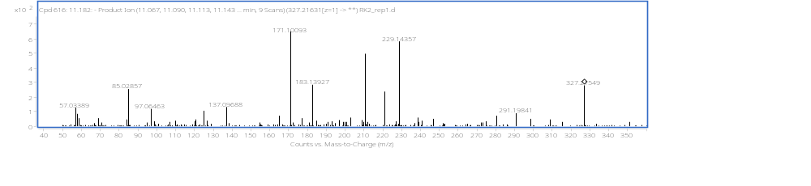
[M−H]⁻
[M−H−18]⁻
[M−H−18−18]⁻
Trihydroxy-octadecadienoic acid
m/z 327.2163(C₁₈H₃₂O₅)
72

Figure S10: MS/MS spectrum of metabolite 72 (Table 3)

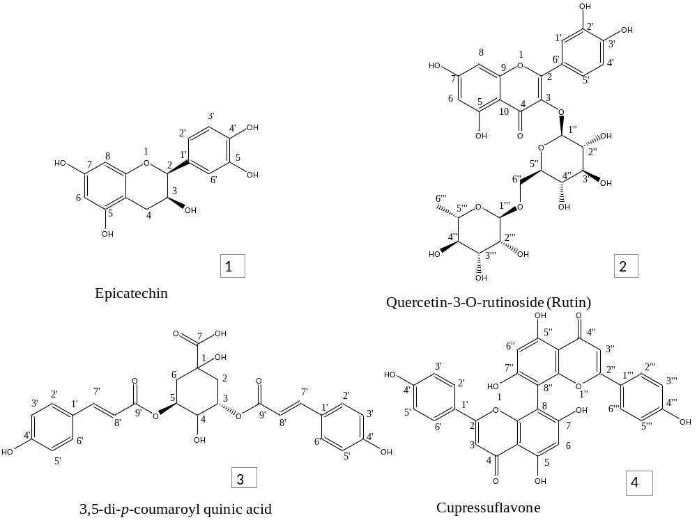

Figure S11: Chemical structures of the C1-C4 isolated compounds

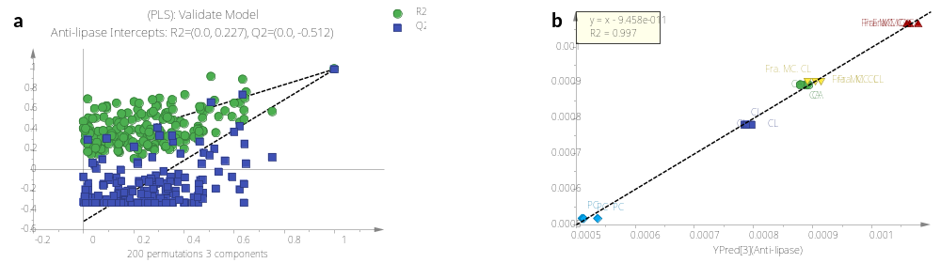
A
B

Figure S12: PLS validation parameters: a. the permutation tests of lipolytic activity inhibition and b. PLS derived relationship between observed vs predicted lipolytic inhibition activity

