Multidimensional Assessment of Sustainability and Competitiveness in the Ceramic Tile and Natural Stone Industries: A Cross-Country Comparative Study
Reza Yarahmadi^{1, *}, Ali Asghar Asadi²

¹ Department of Mining Engineering, Shiraz University, Abadeh High Education Center, Abadeh, Iran
² Department of Material Engineering, Shiraz University, Abadeh High Education Center, Abadeh, Iran
*Corresponding Author Email: reza.yarahmadi@saadi.shirazu.ac.ir

Abstract
Natural stone and ceramic tile industries are two of the leading competitors in the global building materials sector. This study employs a multidimensional and integrative framework to conduct a comprehensive comparative analysis of these strategic industries across seven selected countries. The assessment simultaneously examines their economic, environmental, organizational, and industrial performance.
To achieve this, the study integrates classical decision-making tools, namely Life Cycle Costing (LCC), SWOT analysis, and Porter’s Five Forces, with modern machine learning techniques, including Principal Component Analysis (PCA), K-Means clustering, and SHAP.
Five key indicators, production cost, energy consumption, CO₂ emission intensity, water usage, and non-recyclable waste generation, were sourced from authoritative international datasets, normalized, and comparatively analyzed. PCA results revealed that the first principal component reflects economic-energy intensity, while the second captures environmental burden. K-Means clustering classified countries into three structural categories: sustainable industrial economies, semi-sustainable states, and high-risk developing economies. SHAP analysis, applied to a multivariate regression model, identified CO₂ emissions as the most influential factor driving structural pressure, highlighting its significance in climate-focused policymaking. The LCC results further demonstrated that although natural stone entails higher initial installation costs, it proves more cost-effective over the long term compared to ceramic tile.
From an organizational standpoint, findings show that in advanced economies, the ceramic tile sector benefits from skilled labor, high levels of technological integration, and institutional maturity. In contrast, the natural stone industry, particularly in developing nations, faces challenges such as low-skilled workforces, regulatory complexity, and cultural resistance to innovation.
Key Words: Sustainability Assessment; Ceramic Industry; Natural Stone; Life Cycle Cost, Machine Learning; CO₂ Emissions

- Introduction
Natural stone has long served as a foundational material in building construction. Extracted from mountains in the form of large blocks, it is transported to processing facilities and transformed into market-ready products, primarily tiles and slabs. From an environmental perspective, stone extraction and processing not only disrupt the visual integrity of natural landscapes but also generate significant waste and contribute to ecological degradation ^{1–4}
However, the application of resin-based coatings in recent years has significantly enhanced the durability of natural stone, reducing its overall environmental impact ^{5,6}. Meanwhile, the rise of urban construction has accelerated the growth of the ceramic industry, which offers lower costs and greater design flexibility, key advantages over stone. Nevertheless, ceramic tile manufacturing imposes a heavier environmental burden due to its energy-intensive production processes ^{7–9}.
Natural stone and ceramic tiles have long competed in architectural applications. Recently, their rivalry has expanded across multiple dimensions. Both sectors represent major components of the global construction industry and account for a significant share of global resource and energy consumption. While they serve similar functional roles, primarily in surface coverings, they differ markedly in production chains, energy profiles, raw material usage, national policy environments, and life cycle cost structures.
As of 2022, the global ceramic tile market was valued at over USD 104 billion and is projected to exceed USD 150 billion by 2030, with a compound annual growth rate (CAGR) of 5% ¹⁰
The global natural stone industry, which includes ornamental stones like marble, granite, and travertine, generated over USD 50 billion in revenue in 2021. This sector is expected to grow steadily throughout the decade, driven by infrastructure expansion and rising demand for luxury construction ¹¹
From an environmental standpoint, both industries significantly contribute to greenhouse gas emissions, energy consumption, and natural resource depletion. The ceramic industry, due to its high-temperature kilns and thermal processes, is particularly energy- and carbon-intensive ^{12,13}. In contrast, while the environmental impact of natural stone extraction is not negligible, its downstream processing typically consumes less energy ¹⁴
Numerous studies have examined technological advancements and process optimization in both sectors ^{15,21}. In ceramics, research has emphasized innovations in drying techniques, energy-efficient firing, and low-energy glazes ³. For natural stone, advancements have included cutting and polishing technologies, low-impact quarrying methods, and stone waste recycling strategies ^{22,25}
Despite these efforts, economic evaluations of both sectors remain fragmented, often limited to direct production cost comparisons. Few studies offer comprehensive assessments that include energy costs, capital investment, economic returns, or sensitivity analysis, and most are restricted to national or regional scopes. While Life Cycle Assessment (LCA) has been broadly adopted in sustainability research, its rigorous and comparative application to the stone and ceramic industries at a global level remains rare. Existing literature typically isolates individual variables, such as CO₂ emissions in ceramics or water usage in stone processing, and lacks a cohesive cross-sectoral LCA framework^{26,28}
Previous research has primarily focused on engineering attributes such as mechanical strength, aesthetic appeal, and material durability. However, comprehensive economic and environmental comparisons, especially those with a global perspective, remain significantly underexplored.
The selection of countries for comparative analysis was based on a combination of contextual access and global representativeness. Iran was included as the authors’ home country, which enabled direct access to sector-specific knowledge from experienced professionals and industry experts. These insights supported the development of locally grounded models aligned with international dynamics. China was selected as a strategic trade partner of Iran, being the leading importer of its ceramic and natural stone products. In addition, Germany, China, Italy, Spain, Brazil, and the United States were chosen due to their global leadership in these industries and the accessibility of reliable and well-documented datasets. Together, these countries provide a robust and diverse basis for cross-national benchmarking in sustainability and competitiveness. This gap is particularly notable given the increasing global emphasis on sustainable production and resource efficiency.
Accordingly, there is a growing need for an integrated scientific framework capable of evaluating both the economic and environmental performance of these two critical industries. This study addresses that need through a comparative assessment of the natural stone and ceramic tile sectors, analyzing key economic indicators (e.g., production cost, energy consumption, transport, and labor) alongside environmental indicators (e.g., CO₂ emissions, resource consumption, and recyclability).
By leveraging numerical modeling and advanced machine learning algorithms, the research also forecasts future trends in cost and pollution, offering strategic insights for policymakers, investors, and industrial stakeholders. To the best of our knowledge, this is the first international, data-driven study to compare these two industries using real-world data, statistical modeling, artificial intelligence, and a rigorous Life Cycle Assessment (LCA) framework.
Conceptual Framework and Analytical Design:
This study adopts a multidimensional analytical framework that integrates classical strategic tools with modern machine learning techniques to comprehensively assess the sustainability and competitiveness of the natural stone and ceramic tile industries. Each methodological layer operates at a distinct level of analysis and serves a specific function:
Product-Level Analysis:
Life Cycle Costing (LCC) is used to assess the long-term economic viability of natural stone versus ceramic tiles from a consumer-centered perspective. This includes installation, maintenance, energy use, and replacement costs over a 30-year horizon.
Industry and Market-Level Analysis:
SWOT analysis and Porter’s Five Forces are applied to evaluate structural competitiveness, market entry barriers, supply chain dynamics, and strategic positioning of both industries. These frameworks capture qualitative factors such as technological maturity, export capacity, and vulnerability to substitutes.
Cross-Country Quantitative Assessment:
Principal Component Analysis (PCA) and K-Means clustering are used to uncover latent patterns in environmental and economic indicators across seven selected countries. These tools reduce data dimensionality and categorize countries into performance-based clusters.
Variable Importance Interpretation:
SHAP (SHapley Additive exPlanations) is applied to interpret the output of multivariate regression models. It quantifies the contribution of individual variables, such as CO₂ emissions or energy use, to the overall structural pressure. This facilitates data-driven policymaking by identifying high-impact levers for sustainability.
Methodological Boundaries:
While SWOT analysis and Porter’s Five Forces are applied at the industry level to assess global structural competitiveness, they are not extended to country-level analysis due to the absence of consistent and detailed national data. This constitutes a recognized methodological limitation, and future studies could incorporate localized SWOT/Porter frameworks to generate more granular, country-specific insights.
Additionally, although PCA and K-Means clustering operate at the country level, the aforementioned strategic tools are intentionally confined to the global industry scale. This distinction is clearly acknowledged in the methodology. Table 1 presents overview of analytical methods and their application levels.
Table 1: Overview of analytical methods and their application levels
Method | Level of Analysis | Purpose | Data Source
LCC | Product | Long-term cost analysis | Consumer perspective, ISO 15686
SWOT / Porter | Industry (Global) | Structural competitiveness | Deloitte, World Bank
PCA / K-Means | Country | Environmental-economic clustering | UNEP, IEA, Eurostat
SHAP | Variable-level | Feature importance | AI explainability

- Materials and Methods
To perform a robust and multidimensional comparison between the natural stone and ceramic tile industries, this study relied on a curated set of performance and statistical indicators sourced from internationally recognized databases. These datasets served a dual function: they supported conventional environmental and economic evaluations, while simultaneously feeding into human-centered analytical models and machine learning algorithms. This integration enabled both a clear snapshot of current performance and predictive modeling of future trends. Seven countries were selected as focal points: Spain, China, Italy, Germany, the United States, Iran, and Brazil. Each was chosen based on a distinct combination of factors, ranging from diversity in energy sources and maturity of environmental policies to production capacity, export performance, and industrial development level. Spain, for example, as a leading global exporter of ceramic tiles, provides detailed and structured data through EU statistical systems. China, dominating both industries at the global scale, offers abundant data, especially in relation to energy use and production costs. Germany and the U.S. exemplify highly industrialized nations with strict environmental regulations, whereas Brazil presents a contrasting case with a low-carbon electricity grid heavily reliant on hydro power. Iran was included to represent the context of a developing economy, where domestic data remains publicly accessible and adds valuable depth to international comparisons. Italy also plays a strategic role in this sample, not only as a design leader in ceramics but also due to its widespread adoption of advanced kiln and glazing technologies, well documented in life cycle assessments (LCA).Finally, Brazil’s energy-intensive sectors have been extensively reviewed in United Nations Environment Programme (UNEP) reports, with particular attention to its hydro-based energy infrastructure and comparatively low CO₂ emissions intensity^{29,30}

To enable robust cross-national and cross-sector analysis, five essential indicators were selected: total production cost (USD/m²), final energy consumption (kWh/m²), CO₂ emissions (kg/m²), process water use (L/m²), and non-recyclable industrial waste (kg/m²). Because source data often appeared in formats like kg/ton or MJ/ton, all values were normalized to a per-square-meter basis using surface area conversion coefficients. For example, according to Eurostat, the average material coverage per ton is approximately 25 m² for ceramic tiles and 32 m² for natural stone. A standard energy conversion factor (1 MJ = 0.2778 kWh) was applied to ensure consistency across national datasets. Energy normalization followed methodological standards from the IEA and UNEP, while CO₂ emission intensities were adjusted to reflect each country's unique energy mix. Spain, for instance, with its substantial share of renewable electricity, demonstrates much lower carbon intensity than nations like China or Iran, where coal and natural gas still dominate. Additional environmental indicators, such as water use and non-recyclable waste, were obtained from specialized UNEP construction sector reports and recalibrated to surface area outputs. Meanwhile, production cost data, including inputs such as raw materials, energy, labor, processing, and logistics, were sourced from World Bank industry evaluations and converted into final per-unit costs.
These harmonized datasets were critical not only for conventional assessment frameworks like Porter’s Five Forces, SWOT, and Life Cycle Costing (LCC), but also for training machine learning models aimed at forecasting future trends in cost, energy intensity, and emissions. To this end, the study applied Principal Component Analysis (PCA) to reduce the dimensionality of the dataset and isolate the dominant economic-environmental axes. The first component, PC1, captured the combined variance of cost and energy intensity, termed economic-energy pressure, while the second component reflected environmental burden, primarily driven by emissions and waste indicators.
In tandem with PCA, K-Means clustering was employed to classify the selected countries into three structurally distinct groups: sustainable industrial economies, semi-sustainable transitional states, and high-risk developing economies. To interpret the internal logic of the predictive model, the study utilized SHAP, a powerful explainability method grounded in game theory. SHAP enabled the attribution of importance scores to each input feature, such as CO₂ emissions or energy consumption, revealing their proportional influence on the output metric (structural pressure as measured by PC1). This interpretability aspect is especially vital for policymakers seeking to prioritize sustainability interventions based on transparent, data-driven insights.
Table 2 presents the normalized values of the five core indicators across countries. As seen in the data, there is significant cross-national variation in environmental and economic performance. China and Iran exhibit the highest CO₂ emissions and energy usage, whereas Germany ranks lowest across nearly all environmental metrics, reflecting its advanced infrastructure and strong regulatory compliance.
Table 2. Normalized quantitative values of five core environmental and economic indicators for the natural stone and ceramic tile industries in selected countries ^{12,13,29,31}
Country | Production Cost ($/m²) | Energy Consumption (kWh/m²) | Water Usage (Liters/m²) | Non-Recyclable Waste (kg/m²) |  |  | CO₂ Emissions (kg/m²)
Spain | 13.5 | 24.0 | 2.3 | 1.0 |  |  | 3.8
China | 9.2 | 39.5 | 3.8 | 1.9 |  |  | 7.5
Iran | 8.8 | 36.0 | 3.2 | 1.5 |  |  | 6.9
Germany | 18.0 | 20.5 | 1.7 | 0.7 |  |  | 2.9
USA | 16.5 | 21.0 | 1.9 | 0.9 |  |  | 3.1
Italy | 14.7 | 26.0 | 2.6 | 1.2 |  |  | 4.2
Brazil | 11.3 | 28.3 | 2.1 | 1.1 |  |  | 4.8
- Methodology
To assess the competitive dynamics of the natural stone and ceramic tile sectors, this study utilizes Porter’s Five Forces framework, a foundational model in strategic analysis developed by Michael Porter in 1980. Despite the passage of decades, this framework remains one of the most influential and widely applied tools for evaluating industry attractiveness and structural competitiveness across diverse global markets ³². The framework assesses five fundamental forces that define industry competitiveness: the threat of new entrants, the bargaining power of suppliers, the bargaining power of buyers, the threat posed by substitute products, and the intensity of rivalry among existing firms. For both the natural stone and ceramic tile industries, each force was rated on a standardized five-point scale, where 1 denotes very low intensity and 5 indicates very high intensity. These evaluations were grounded in structural data drawn from globally recognized sources such as Deloitte and the World Bank. Additionally, the analysis was supplemented by qualitative insights into sector-specific characteristics, including technological complexity, entry barriers, cost structures, product diversity, and the degree of value chain integration ^{14,33}. Figure 1 illustrates the results of this analysis using a polar matrix visualization, offering an intuitive and immediate overview of the competitive dynamics within each industry. The radial distance from the center reflects the intensity level of each competitive force, measured on a scale from 1 (very low) to 5 (very high). In the diagram, green markers denote the natural stone industry, while blue markers represent the ceramic tile sector.
As further detailed in Table 3, the ceramic tile industry exhibits notably higher levels of competitive intensity, particularly in areas such as the threat of new entrants, buyer bargaining power, and internal rivalry. These findings can be largely attributed to the sector’s high degree of globalization, the relative ease of accessing production technologies, and the widespread prevalence of aggressive price competition. By contrast, the natural stone industry is more resource-dependent, characterized by significant entry barriers and generally more stable competitive conditions. Nevertheless, both sectors face substantial pressure from substitute materials, including engineered stone and advanced composites.
Table 3. Comparative assessment of the five competitive forces in the natural stone and ceramic tile industries. The ceramic tile sector demonstrates stronger market rivalry, a heightened threat of substitution, and greater supply chain flexibility. In contrast, the natural stone industry remains more reliant on location-bound extraction processes and contends with higher supplier power
Table 3. Structured comparison of the five competitive forces in the natural stone and ceramic tile industries
Ceramic Tile | Natural Stone | Competitive Force
High-Technology is accessible, many new producers. | Moderate - Requires specific quarrying equipment and permits | Threat of New Entrants
Moderate - Global supply chains provide flexibility. | High - Few local suppliers, location-dependent materials. | Bargaining Power of Suppliers
High - Highly competitive and commoditized market. | High-Price-sensitive market with many alternatives. | Bargaining Power of Buyers
High - Alternatives like vinyl, laminate flooring. | High-Composite materials and engineered stones. | Threat of Substitutes
Very High - Intense global competition and price wars. | Moderate - Traditional market with moderate competition. | Industry Rivalry

Figure
1. Enhanced polar matrix visualization of Porter’s five forces analysis comparing the competitive structure of the natural stone and ceramic tile industries. The visual reveals the high rivalry and threat of substitutes faced by ceramic tiles, in contrast with the moderate competitive pressures in the natural stone sector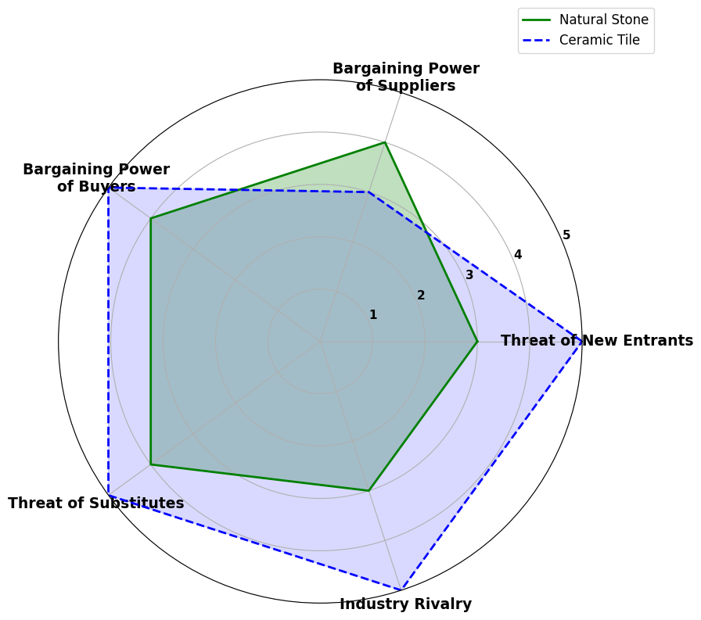
Fig. 1. Enhanced polar matrix visualization of Porter’s five forces analysis comparing the competitive structure of the natural stone and ceramic tile industries.
  - Strategic SWOT Analysis
In this section, the strategic positioning of the natural stone and ceramic tile industries is analyzed using the SWOT framework, one of the most established tools in strategic management. This approach systematically organizes internal factors (strengths and weaknesses) alongside external factors (opportunities and threats), offering a comprehensive perspective on the competitive landscape of each industry³⁴. The natural stone industry boasts several core strengths, including exceptional durability, resistance to weathering, and long-established credibility, particularly in traditional and heritage-oriented markets. Its minimal maintenance requirements make it a preferred choice for landmark architecture and long-term infrastructure projects. In contrast, the ceramic tile industry excels in scalability, design versatility, and export-driven growth, enabling ceramic products to dominate large segments of the global building materials market.
However, each industry faces unique structural challenges. For natural stone, drawbacks include its high density, resulting in elevated transportation costs, alongside energy-intensive extraction and processing methods, and dependence on non-renewable resources. The ceramic sector, while more industrially agile, contends with high consumption of water and energy during production, vulnerability to breakage, and generally shorter product life cycles.
Opportunities exist for both industries in expanding construction markets, especially in developing regions where durable and cost-effective materials are in demand. Rising global interest in sustainable architecture and eco-conscious design has revitalized the appeal of natural materials like stone. Meanwhile, innovations such as digital printing and lightweight ceramics are expanding the technological frontier of the ceramic tile industry.
Yet, both sectors face strategic threats. Natural stone is increasingly challenged by engineered alternatives like synthetic composites and artificial stone, as well as tightening regulations around quarrying. The ceramic industry, in turn, must navigate global pricing pressures, the rise of substitute products such as vinyl and laminate flooring, and potential supply chain disruptions tied to raw material dependency.
Table 4 presents a structured comparison of these SWOT elements, distilling the contrasting strategic dynamics that influence the development paths of both sectors.
Table 4. SWOT matrix comparing natural stone and ceramic tile industries.
Industry | Threats | Opportunities | Weaknesses | Strengths
Natural Stone | Synthetic rivals, quarry regulation, market cycles | Green construction demand, exports, restoration markets | Heavy, energy-intensive, limited design | Durable, low maintenance, heritage value
Ceramic Tile | Global price wars, substitutes, raw material risks | Smart tech, lightweight trends, digital printing | High water/energy use, fragile, shorter lifespan | Mass production, flexible design, export-oriented
Based on the preceding analysis, natural stone maintains a strategic advantage in high-end and heritage construction markets, largely due to its unmatched durability, timeless aesthetic, and association with long-lasting architectural value. Conversely, the ceramic tile industry, driven by mass manufacturing efficiency, design adaptability, and rapid technological adoption, exhibits greater flexibility and competitiveness in global commercial markets. As such, strategic investment in either sector should be guided by a clear understanding of market-specific demands, environmental regulatory contexts, and the comparative long-term value each material can deliver within its respective niche.
  - Life Cycle Cost Analysis (LCC)

Life Cycle Costing (LCC) is an established economic evaluation methodology that accounts for the total cost of ownership over a product’s entire functional lifespan. Unlike traditional cost analyses, which often emphasize only the initial capital expenditure, LCC provides a more comprehensive perspective by including maintenance costs, energy consumption, and eventual replacement or disposal expenses over time [35]. This approach is standardized in international frameworks for building and infrastructure design, notably through ISO 15686 and ASTM E917 guidelines ^{36,37}.
In the present study, an LCC comparison was carried out between natural stone and ceramic tile flooring systems over a 30-year horizon. Cost components were standardized in USD per square meter, drawing on industry benchmarks, contractor estimates, and global case studies. Importantly, the analysis adopts a consumer-centric lens, focusing not on industrial profitability but on the total economic burden borne by end-users over time. This framing aligns with ISO and ASTM conventions and enables a realistic evaluation of long-term cost efficiency from the standpoint of individual building occupants or project owners.
The LCC was calculated using Equation 1.
Equation 1.

In the cost modeling assumptions, natural stone is assigned a service life of 40 years, which exceeds the 30-year analysis window, meaning no replacement is required during the evaluated period. In contrast, ceramic tile is assumed to have a service life of 25 years, necessitating a complete replacement within the same timeframe. Maintenance costs for both materials are standardized using average service contract rates from developed economies, ensuring comparability across contexts.
Although ceramic tile incurs a lower upfront installation cost (USD 35.00/m²) compared to natural stone (USD 60.00/m²), the total life cycle cost tells a different story. When recurring maintenance, replacement, and energy consumption are factored in, ceramic tile reaches a cumulative cost of USD 138.00/m², whereas natural stone totals only USD 92.50/m². This contrast highlights the long-term economic advantage of natural stone, its higher initial cost is offset by greater material longevity, reduced maintenance needs, and the absence of replacement during the evaluation period.
These findings provide strong support for selecting natural stone in long-duration construction projects, particularly in public infrastructure, civic buildings, and sustainability-driven urban developments. Its extended durability not only minimizes economic costs but also aligns with environmental goals by reducing material turnover. A detailed breakdown of the calculated cost parameters for both materials is presented in Table 5.
Table 5. Life cycle cost comparison of natural stone and ceramic tile flooring systems over a 30-year evaluation period. ^{38,39}
Ceramic Tile (USD/m²) | Natural Stone (USD/m²) | Cost Component
35.00 $ | 60.00 $ | Initial Installation Cost (C_{a})
2.00 $/year | 1.00 $/year | Annual Maintenance Cost (C_{m})
25 years | 40 years | Estimated Service Life (n)
40.00 $ | 70.00 $ | Replacement Cost (C_{r})
3.00 $ | 2.50 $ | Energy Consumption over Lifecycle (C_{e})
138.00$ | 92.50 $ | Total Life Cycle Cost (LCC)
Ultimately, the Life Cycle Cost (LCC) analysis reinforces a critical insight: material selection decisions should not be driven solely by initial installation costs. Instead, a comprehensive evaluation that accounts for long-term performance, including maintenance requirements, energy consumption, and replacement frequency, offers a more accurate measure of economic and environmental sustainability. This broader perspective is especially vital for long-term infrastructure investments, such as public buildings and commercial developments, where durability, operational efficiency, and lifecycle value far outweigh short-term savings.

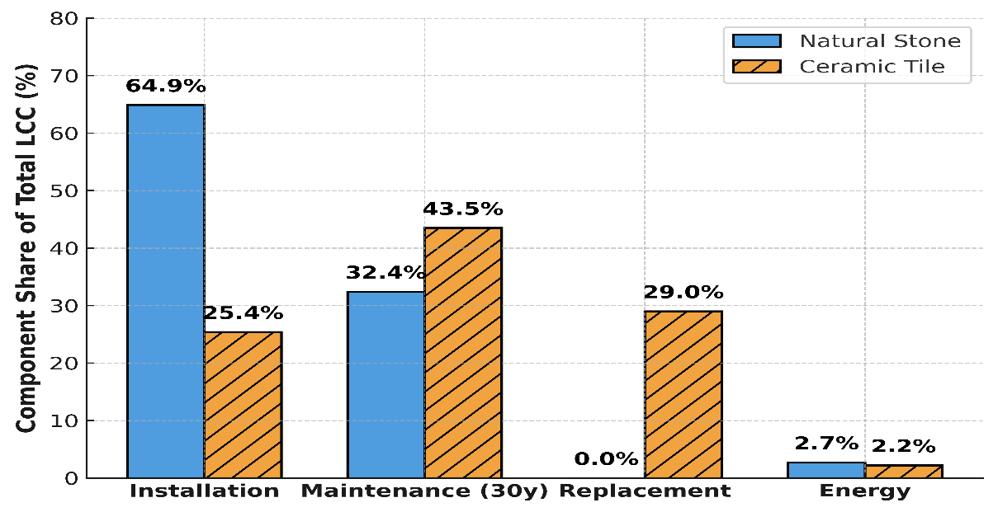
Fig.2. Proportional cost distribution in LCC natural stone vs ceramic tile^{38,39}
Figure 2 illustrates a clear contrast in the cost composition of the Life Cycle Cost (LCC) for natural stone and ceramic tile systems. For natural stone, the initial installation accounts for approximately 65% of the total LCC, underscoring its high upfront investment. In contrast, ceramic tiles exhibit a different profile: maintenance and replacement costs collectively make up over 70% of their total LCC. This distribution reveals a key economic insight, while natural stone requires greater initial capital, its long-term financial demands are comparatively minimal. Conversely, ceramic tile systems, despite lower entry costs, accumulate substantial ongoing expenses over time, highlighting the importance of considering hidden operational costs in material selection.
Table 6. Discounted and Nominal Life Cycle Cost Comparison (30-Year Period)
Natural Stone (USD/m²) | Ceramic Tile (USD/m²) | Metric
92.50 $ | 138.00 $ | Nominal LCC(Undiscounted)
82.10 $ | 96.31 $ | Discounted LCC (3% over 30 years)
Table 6 demonstrates that when costs are discounted at a 3% rate to reflect net present value (NPV), natural stone remains significantly more cost-effective than ceramic tile. This distinction is particularly critical for projects financed by public infrastructure budgets or long-term investments, where economic evaluations are based on discounted cash flow analysis. While ceramic tiles may initially appear more affordable due to lower upfront installation costs, their shorter service life, higher maintenance needs, and greater energy consumption ultimately lead to Table 6 highlights that, even when applying a 3% discount rate to account for Net Present Value (NPV), natural stone remains substantially more cost-effective than ceramic tile over the long term. This distinction is particularly important in contexts such as public infrastructure and long-horizon investment projects, where economic assessments are based on discounted cash flow principles. Although ceramic tiles may appear more affordable at first glance, due to their lower initial installation costs, their shorter service life, higher maintenance requirements, and increased energy consumption contribute to significantly greater cumulative costs throughout their lifecycle.
As such, in public sector construction, institutional facilities, and urban infrastructure development, material selection should be guided by Life Cycle Cost (LCC) principles rather than short-term budget constraints. LCC-based evaluations enable engineers, planners, and investors to avoid cost-driven misjudgments and to identify materials offering superior long-term economic value. When integrated with Life Cycle Assessment (LCA) and analyses of durability and technical risk, LCC forms a comprehensive framework for sustainable design and strategic infrastructure planning^{38,39}
To compare countries across multiple sustainability dimensions, a Principal Component Analysis (PCA) was conducted using five standardized indicators: production cost, energy consumption, CO₂ emissions, water usage, and non-recyclable waste. PCA reduced the complexity of the dataset while preserving its interpretive value. Two principal components were retained: PC1, representing the economic-energy axis, and PC2, capturing environmental burden. The results of the variance analysis confirmed the model's robustness, PC1 explained 94.81% of the total variance and PC2 explained 5.19%, together accounting for the full structure of the data. This validated the focus on these two axes as sufficient for interpreting the dominant sustainability patterns among countries.
  - Organizational Structure and Human Capital
Beyond technical, economic, and environmental considerations, a comprehensive understanding of the organizational and social structures governing the natural stone and ceramic tile industries is vital for identifying obstacles to sustainable development. Elements such as workforce quality, ownership and governance models, levels of technological adoption, and the strength of institutional frameworks exert a substantial influence on the performance and adaptability of each industry. Without addressing these structural and human dimensions, any technical evaluation remains fundamentally incomplete.
Table 7 offers a comparative assessment of the organizational characteristics of the two sectors, shedding light on key differences in governance systems, labor force dynamics, and strategic institutional capacity. These insights are crucial for contextualizing the industries’ varying abilities to transition toward more sustainable and resilient models of growth
Table 7. Comparative organizational structure of the two industries.
Feature | Natural Stone Industry | Ceramic Tile Industry
Dominant Ownership Type | Fragmented ownership across private quarries and traditional workshops | Large-scale industrial corporations, often publicly traded or export-oriented
Supply Chain Integration | Disconnected-extraction, processing, and sales often operate separately | Highly integrated - from raw materials to final product distribution
Productivity Level | Generally low, due to outdated equipment and lack of standardization | Relatively high, driven by automation and quality control systems
Organizational Formality | Informal and tradition-driven, often lacking strategic governance | Formalized structures with professional quality and R&D departments
Technology Adaptability | Low-resistance to innovation due to cultural and infrastructural barriers | High-proactive in adopting smart manufacturing and digitalization
Human capital structure and quality are fundamental determinants of industrial competitiveness, innovation capacity, and long-term scalability. In the natural stone sector, the labor force is predominantly composed of workers with informal, experience-based skills and minimal access to structured training. This dependence on traditional craftsmanship, while valuable in certain artisanal contexts, often results in low technological adaptability, frequent occupational safety risks, and limited compliance with modern professional standards. These structural limitations constrain the sector’s ability to modernize and scale sustainably.
By contrast, the ceramic tile industry, particularly in advanced economies, benefits from a formally trained workforce that includes technical specialists, university-educated professionals, and personnel with established ties to vocational training institutes and industry-academia partnerships. This institutionalized human capital structure fosters higher innovation throughput, greater process standardization, and stronger adherence to health, safety, and environmental (HSE) regulations.
Table 8 presents a comparative overview of the human capital ecosystems in the natural stone and ceramic tile industries, highlighting the strategic strengths and constraints that shape their capacity for adaptation, modernization, and sustainable growth.
Table 8. Human capital and skills landscape.
Aspect | Natural Stone Industry | Ceramic Tile Industry
Workforce Qualification | Mostly low-skilled; manual labor | Skilled technicians and engineers
Training Systems | Rare; limited to on-the-job learning | Institutionalized; academic collaborations
Health & Safety Standards | Weak; high risk in quarries | Strong enforcement of safety norms
Innovation Culture | Resistant to change | Proactive and research-driven
Institutional governance, regulatory frameworks, and government support mechanisms are critical determinants of industrial growth, competitiveness, and modernization. In the natural stone sector, persistent structural challenges such as institutional fragmentation, opaque and inconsistent licensing procedures, limited supply chain transparency, and the widespread presence of informal economic practices have hindered sectoral development and integration into modern global markets.
In contrast, the ceramic tile industry, particularly in economies with stronger regulatory coherence, benefits from a more centralized industrial structure, enhanced global integration, and greater exposure to standardized environmental regulations, export compliance protocols, and public incentive mechanisms. These characteristics have allowed it to align more closely with international market norms and technological trends.
However, it is important to note that in developing economies, both industries continue to experience bureaucratic inefficiencies, regulatory misalignments, and institutional inertia, all of which limit their operational efficiency and ability to respond to shifting global demands.
Organizational culture further shapes how each industry navigates change, innovation, and risk. In the natural stone industry, cultural traits such as traditionalism, overreliance on tacit, experiential knowledge, and skepticism toward digital or automated technologies have created resistance to transformation. Meanwhile, the ceramic tile industry, driven by intensifying international competition, has incrementally adopted a culture of continuous improvement, digital transition, and proactive innovation uptake.
These divergent institutional and cultural dynamics critically shape each sector’s adaptive capacity and long-term strategic positioning. Table 9 summarizes the key institutional, regulatory, and organizational contrasts between the natural stone and ceramic tile industries, highlighting both constraints and leverage points for sustainable development.
Table 9. Challenges and opportunities for organizational modernization.
Key Domain | Challenges | Opportunities
Labor Market | Shortage of skilled labor in stone sector, brain drain | Workforce development programs; upskilling initiatives
Technology Adoption | Low digital readiness in stone; high CapEx in ceramic sector | Industry 4.0 pilot projects; public-private tech accelerators
Policy Support | Weak coordination across agencies; complex licensing | Regulatory simplification; green certification incentives
Export Readiness | Branding issues for natural stone; logistical inefficiencies | Market diversification; e-commerce platforms for B2B export
In summary, the social, cultural, and institutional foundations of the natural stone and ceramic tile industries represent critical, yet frequently underestimated, determinants of long-term sustainability. An industry's ability to adopt emerging technologies, mobilize a skilled and dynamic workforce, and align with coherent national policy frameworks plays a decisive role in shaping its developmental trajectory. Accordingly, beyond physical infrastructure and capital investment, strategic emphasis must be placed on human capital development, organizational modernization, and institutional transparency as core prerequisites for meaningful industrial transformation.

Due to the scarcity of comprehensive cross-country data on organizational systems and labor structures, this study employed AI-based estimations and trend-driven modeling techniques to fill data gaps. These surrogate approaches enhance the realism of scenario analysis and improve the comparability of national profiles, particularly in multidimensional assessments.
Although socio-organizational indicators were not directly integrated into the Principal Component Analysis (PCA) due to data limitations, their structural influence emerges clearly through the clustering patterns. For example, countries such as Germany and the United States, which are characterized by formal governance systems, highly skilled labor forces, and advanced innovation cultures (see Tables 7–9), consistently appear in the sustainable cluster (Cluster 1) within the PCA-derived typology. In contrast, nations like Iran and China, where institutions are more fragmented, informal labor is widespread, and digital readiness remains low, fall into Cluster 3, marked by higher environmental and economic risks.
This alignment between qualitative institutional characteristics and quantitative clustering outputs reinforces the hypothesis that socio-organizational capacity co-evolves with environmental and economic performance. It also suggests that targeted reforms in human capital systems and governance structures may help reposition countries within more resilient and sustainable industrial archetypes. While these structural variables were not explicitly modeled within the PCA, their interpretive value is evident and offers important context for understanding the underlying drivers of sustainable industrial development.

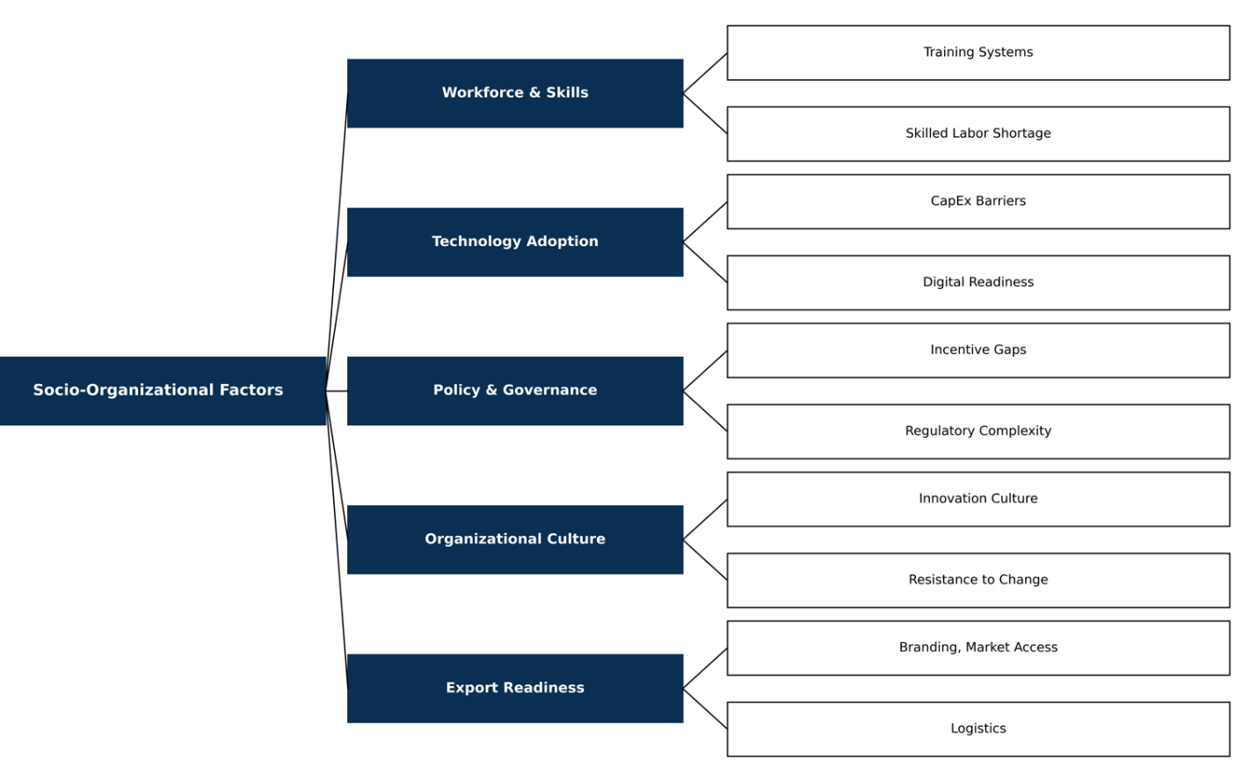
Fig. 3. Conceptual map -Socio- organizational dynamics in stone vs ceramic industries
Figure 3 presents a conceptual map that outlines the hierarchical and network-based analytical framework of socio-organizational factors influencing the performance and sustainability of the natural stone and ceramic tile industries. At the core of this map lies the central construct of socio-organizational dimensions, viewed as the foundational substrate for strategic decision-making in sustainable industrial development. This framework is structured into five key domains: Human Capital and Skills, this axis includes two critical sub-components shortage of skilled labor and weak institutional training systems. The natural stone sector, heavily reliant on traditional labor, suffers from structural deficits in this area, while the ceramic industry benefits from formal training programs and close collaboration with technical and academic institutions. Technology Adoption, this domain captures two elements digital readiness and CapEx-related barriers. It reflects the gap between traditional industries and innovation-driven sectors in embracing advanced technologies such as AI, digital production lines, and energy efficiency improvements. Governance and Policy, this axis covers challenges such as fragmented regulatory systems and lack of effective incentives. In many countries, decentralized licensing and institutional misalignment hinder innovation and competitiveness. Organizational Culture, this includes resistance to change and weak innovation culture. The natural stone sector, in particular, exhibits high internal resistance to technological transition, whereas the ceramic industry, spurred by global competition, has gradually embraced continuous improvement and digitalization. Export Readiness, this domain includes logistics infrastructure and branding limitations. The ceramic sector shows greater maturity, leveraging international B2B channels and diversified exports, while the stone industry still faces branding deficiencies and logistical inefficiencies in several regions. The conceptual map illustrates that socio-organizational structure is not merely a supporting factor, but a direct influencer of foresight capacity, competitiveness, and long-term sustainability. Achieving structural transformation demands that these factors be addressed as an interconnected system, rather than in isolation.
The conceptual map illustrates that socio-organizational structure is not merely a supporting factor, but a direct influencer of foresight capacity, competitiveness, and long-term sustainability. Achieving structural transformation demands that these factors be addressed as an interconnected system, rather than in isolation.
Although socio-organizational data were not directly included in PCA due to data limitations, the structural characteristics discussed in Section 3.3 are strongly aligned with the industrial pressures reflected in PC1 and PC3. Improvements in workforce qualification and organizational modernization would likely shift countries toward more sustainable clusters in the PCA space.
Note on Methodology:
Due to the scarcity of publicly available cross-national data on organizational and human capital structures, particularly in emerging economies, the study utilized a hybrid approach combining international datasets (e.g., UNEP, ILO, World Bank) with AI-based inferential modeling. Patterns identified via PCA and K-Means clustering were used to estimate likely organizational characteristics, as these structures often co-evolve with macro-level industrial pressures such as energy intensity and environmental burden. This methodological strategy allowed for a more holistic and comparative treatment of socio-organizational factors across countries, despite data constraints.
These organizational dynamics offer a structural lens through which to interpret the cross-country performance clusters identified in the PCA and K-Means analysis in Section 4.
- Cross-Country Comparison of the Stone and Ceramic Industries
To evaluate the operational profiles of the natural stone and ceramic tile industries across selected countries, unsupervised machine learning algorithms were employed. Five normalized indicators were used for comparison: final production cost (USD/m²), final energy consumption (kWh/m²), CO₂ emissions intensity (kg/m²), water consumption (Liters/m²), and non-recyclable waste generation (kg/m²). The dataset includes Spain, China, Iran, the United States, Germany, Brazil, and Italy, selected based on diversity in energy structures, industrial maturity, and global market share. All metrics were standardized to per square meter (m²) based on data from reputable sources including Eurostat, World Bank, IEA, and UNEP ^{11,29-31}. Following standard scaling to neutralize unit discrepancies, a Principal component analysis (PCA) was conducted to reduce dimensionality.
Principal Component Analysis (PCA) was applied to reduce the dimensionality of the five standardized indicators. The first principal component (PC1), representing economic-energy pressure, explains 94.80% of the total variance, while the second component (PC2), reflecting environmental burden, accounts for 5.20%. Together, these two components capture 100% of the dataset’s variability, ensuring that no information was lost in the dimensionality reduction process. This high explanatory power confirms the robustness and interpretability of the PCA structure used for country comparison. The first component (PC1) represents economic-energy pressure (i.e., cost and energy intensity), while the second component (PC2) reflects environmental burden (i.e., CO₂ emissions, water use, and waste). A K-Means clustering algorithm was then applied, categorizing the countries into three distinct clusters, The choice of k=3 for the number of clusters was determined using two established unsupervised validation techniques: the Elbow Method and the Silhouette Score.
As shown in Figure 4, the Elbow curve reveals a clear inflection point at k=3, indicating the optimal balance between model simplicity and intra-cluster variance. Additionally, the silhouette score peaks at k=3, confirming that the clustering quality is highest when the data are divided into three clusters. These results statistically validate the selection of k=3 as the most representative segmentation of the dataset. ⁴⁰
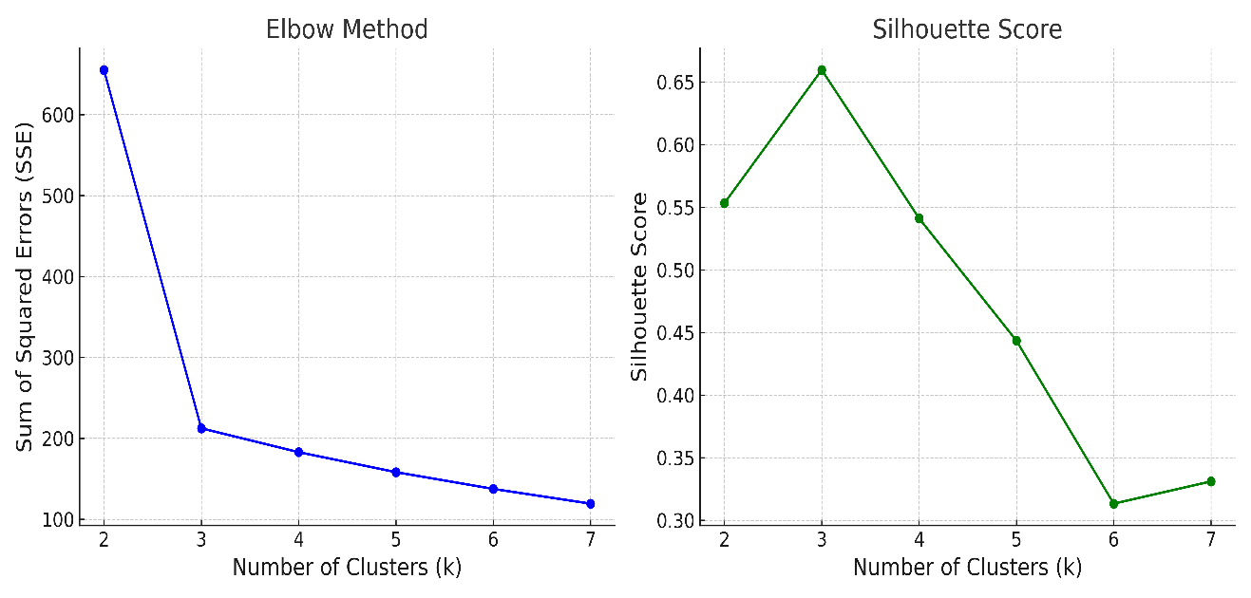
Figure 4. Cluster validation using Elbow Method and Silhouette Score demonstrating optimal cluster count (k = 3). ⁴⁰
Cluster 1 (High Sustainability), Germany and the USA characterized by technological efficiency, stringent environmental regulations, and strong sustainability performance. Cluster 2 (Moderate Balance), Brazil, Italy, and Spain exhibiting moderate production costs and relatively balanced environmental profiles. Cluster 3 (High Risk), China and Iran marked by high energy consumption, lower production costs, and elevated CO₂ emissions. Iran’s presence in the high-risk cluster reflects structural inefficiencies in energy productivity and environmental governance compared to industrialized nations. The AI-driven model reveals that cost metrics alone are insufficient for policy formulation. A robust multi-indicator framework that combines environmental and economic dimensions is necessary to guide sustainable industrial strategies, particularly in emerging economies like Iran.

Figure 5. PCA-based distribution of countries by economic and environmental indicators. Countries with higher environmental burdens (e.g., China, Iran) are separated from more efficient economies (e.g., Germany, Italy), highlighting strategic clustering patterns in sector performance.
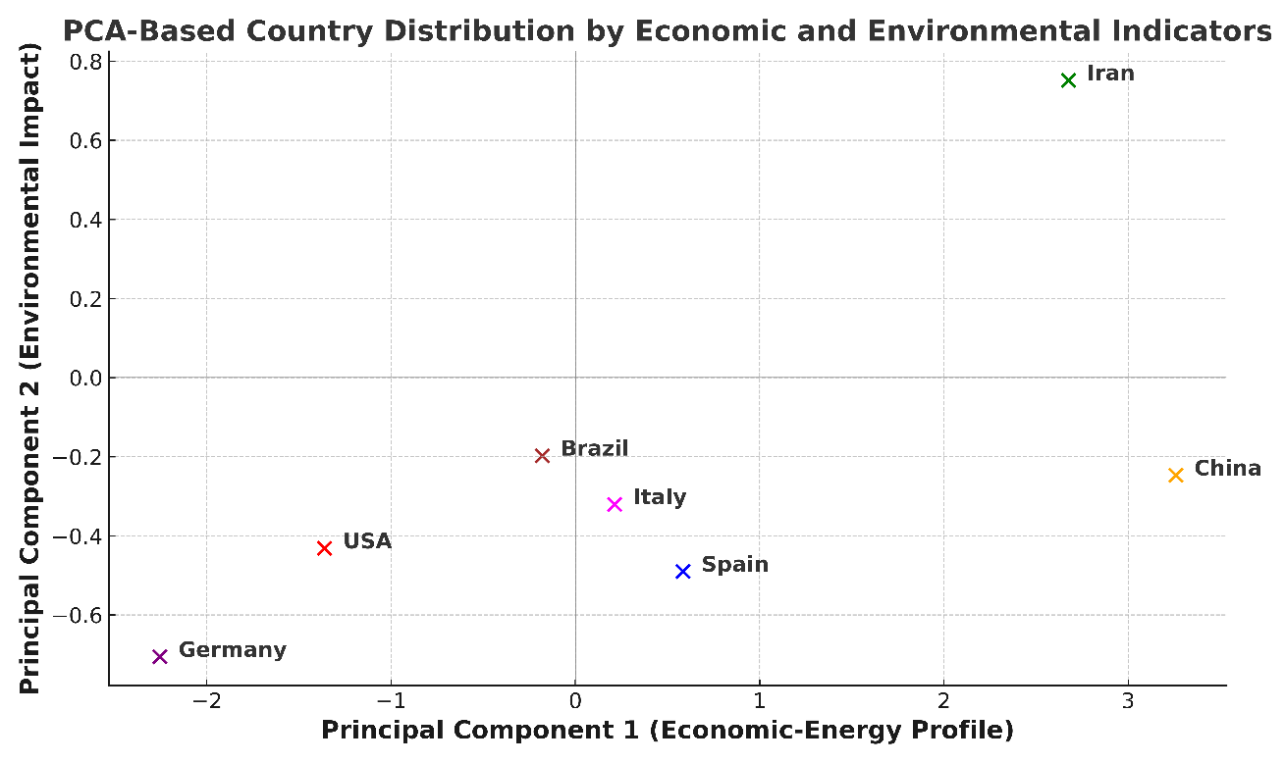
Fig.5. PCA-Based country distribution by economic and environmental indicators⁴¹
Table 10. PCA Component Summary, country-Level positioning.
Country | Economic-Energy Axis (PC 1) | Environmental Axis (PC 2) | Performance Analysis
China | 3.258 | -0.247 | High energy consumption and emissions – industrially strong but environmentally weak
Iran | 2.676 | 0.752 | Energy-intensive with considerable environmental burden, though slightly better positioned than China
Spain | 0.584 | -0.490 | Moderate production profile, yet with relatively high environmental stress
USA | -1.361 | -0.432 | Technologically advanced and energy-efficient with balanced environmental performance
Germany | -2.254 | -0.706 | Best performer in terms of sustainability, low emissions, and high energy efficiency
Italy | 0.213 | -0.320 | Moderate emissions, strong in production efficiency, but not leading in sustainability
Brazil | -0.179 | -0.197 | Balanced in energy use and emissions, positioned between developing and developed profiles
Table 10, the bivariate PCA analysis effectively distinguishes countries based on their economic and environmental structural characteristics within a multidimensional space. Performance analysis interprets countries' positions based on aggregated indicators. China ranks highest along the economic-energy axis (PC1), indicating strong industrial capability but also high environmental strain and energy intensity. Iran similarly demonstrates substantial energy consumption and environmental burden. Its higher position on the environmental axis (PC2 = 0.752) compared to China (PC2 = -0.247) indicates even greater ecological stress, making Iran more vulnerable from an environmental standpoint. This elevated PC2 score aligns with the country’s high CO₂ emissions, inefficient resource use, and institutional challenges. Spain occupies a middle-ground position, reflecting moderate production efficiency but noticeable environmental stress. The United States benefits from balanced indicators, with efficient energy use and manageable ecological pressure, signaling a more harmonized industrial structure. Germany stands out as the benchmark for sustainable industrial development exhibiting the lowest energy consumption and minimal emission intensity among all countries evaluated. The joint analysis reveals that China and Iran experience the highest combined structural pressure (economic + environmental) and rank lowest in sustainability. In contrast, Germany and the U.S. are consistently positioned as the most sustainable and resilient industrial systems, while Spain sits in an intermediate zone with room for targeted improvement.

To assess the sensitivity of country performance to potential changes in key environmental indicators, a multivariate linear regression model was applied. The objective was to predict the effect of a simultaneous 10% increase in final energy consumption and CO₂ emissions on a country’s position along the economic-energy axis (PCA Component 1). The independent variables in the model were standardized values of energy use and emissions, and the dependent variable was PC1, interpreted as a composite indicator of economic and energy efficiency. Model results indicate that countries like China and Iran are highly sensitive to changes in these two variables. A 10% rise in both CO₂ emissions and energy consumption would significantly elevate their position on PC1, signaling greater structural and environmental stress. In contrast, developed nations such as Germany and the United States maintained relatively stable positions even under simulated stress conditions highlighting their structural resilience and industrial efficiency. Table 11 presents a summary of the regression model's results, including predicted PC1 values under stress conditions and a structural risk ranking generated through the AI-based model output.
Table 11. AI-Powered Risk Projection and Structural Stress Ranking
Country | Current PC1 (Econ-Energy) | Predicted PC1 (+10% CO₂ & Energy) | AI Risk Ranking
China | 3.258 | 3.862 | 1
Iran | 2.676 | 3.055 | 2
Spain | 0.584 | 1.937 | 3
USA | -1.361 | -1.160 | 4
Germany  Italy  Brazil | -2.254  0.213  -0.179 | .1.771  1.247  0.811 | 5  6  7
This analysis reveals that developing countries, particularly Iran and China, are highly vulnerable to future environmental changes. To achieve sustainable development, these nations must implement policies focused on reducing energy intensity, improving resource efficiency, and restructuring industrial frameworks. By contrast, industrialized countries have successfully maintained structural resilience through the adoption of sustainable policies, enabling them to better withstand environmental pressures. ⁴¹

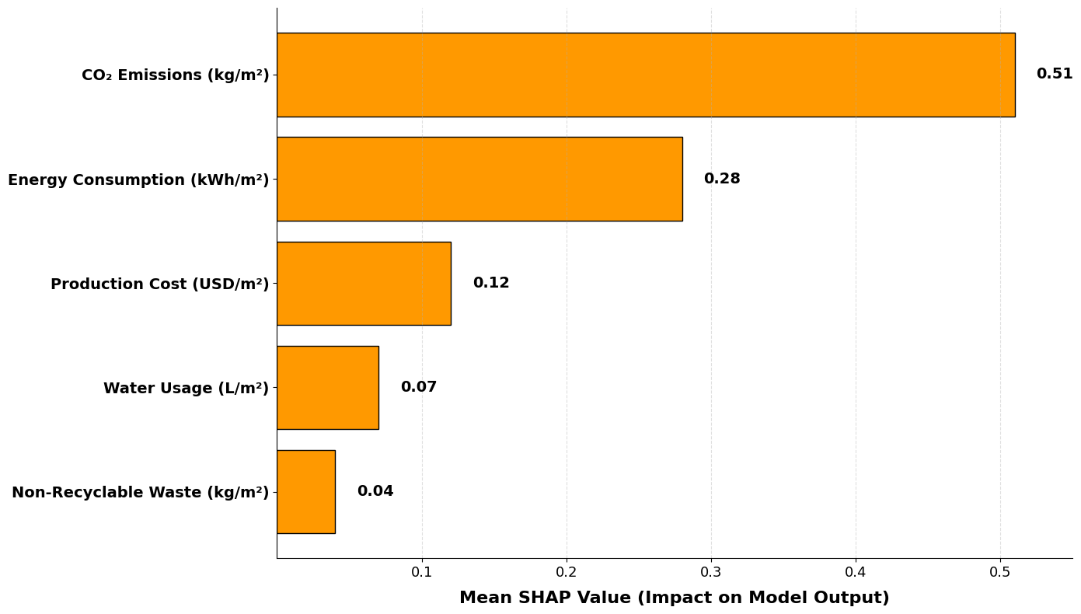
Fig. 6 Feature importance based on SHAP values⁴²
To enhance the transparency of the regression model predicting the economic-energy pressure component (PC1), tools from explainable artificial intelligence were used. The SHAP algorithm, one of the most reliable methods for interpreting machine learning decisions, was employed to quantitatively and visually display the contribution of each input variable (energy consumption and CO₂ emissions) to the model’s output. The SHAP analysis shows that CO₂ emissions are the most influential variable in increasing the structural pressure of countries on the PC1 axis, followed by energy consumption. This finding aligns with the regression model results and reinforces that policy measures to reduce carbon intensity should be prioritized over those focusing solely on energy savings. The presented analysis directly relates to three key United Nations Sustainable Development Goals (SDGs), SDG 9 (Industry, Innovation, and Infrastructure), the use of machine learning algorithms to evaluate countries’ industrial structures paves the way for innovation in industrial performance modeling and supports sustainable infrastructure development. SDG 12 (Responsible Consumption and Production), by focusing on indicators such as energy use, waste, and water consumption, this analysis enables comparative assessment of industries in terms of resource efficiency, replacing traditional decision-making with data-driven approaches. SDG 13 (Climate Action), the results emphasize the urgency of climate policy, especially for countries with high environmental stress like China and Iran, and provide a predictive tool for assessing future climate scenarios. Thus, the AI-based analytical framework developed in this study offers a robust tool not only for cross-industry and cross-country comparisons, but also as an actionable method for global sustainable development goals. It can be adopted by policymakers, international organizations, and infrastructure planners at the macro level. ⁴²
Figure 6 illustrates the relative importance of each key environmental and economic indicator in the regression model predicting structural pressure (PC1) for the natural stone and ceramic tile industries. The values are based on the mean absolute SHAP values (Mean SHAP) for each feature and indicate their relative impact in the multivariate regression model using real global data. CO₂ emissions (kg/m²), with a SHAP value of 0.51, had the highest impact, highlighting it as the primary contributor to the structural economic-environmental pressure. Energy consumption (kWh/m²) ranked second, emphasizing its strong role in the composite industrial pressure indicator. Production cost (USD/m²), despite being economically important, had less influence compared to environmental factors, reaffirming the centrality of sustainability in the analysis. Water usage and waste generation, while environmentally significant, showed lower influence in the model. This may be due to lower data variance or weaker correlations with PC1. This scientific analysis not only confirms that climate action and decarbonization must be at the core of industrial policy, but also demonstrates the capacity of machine learning models to explain complex interrelationships between variables. The statistical performance of the model was also validated the coefficient of determination was R² = 0.89, indicating that the model explains 89% of the variance in the data. The mean squared error (MSE) was calculated to be 0.012, reflecting minimal differences between actual and predicted values. These results confirm that the regression model is both accurate and reliable for use in policymaking and industrial analysis. ³⁸⁻⁵²
- Conclusion
The integration of machine learning algorithms with normalized environmental and economic indicators has created an innovative and data-driven framework for globally comparing the performance of the natural stone and ceramic tile industries. This model is not only capable of interpreting current industry conditions but also enables strategic forecasting and informed decision-making for policymakers, investors, and engineers. Based on the findings, it is recommended that countries such as Iran and China, which exhibit energy-intensive structures and high environmental stress, be prioritized for policy reforms. These should include, investment in low-carbon technologies and energy efficiency, environmental standardization across the building materials supply chain, economic incentives for sustainable, low-impact materials, improved data transparency, and the deployment of intelligent industrial monitoring systems.
This study presents a multi-dimensional, data-driven, and cross-sectoral framework for analyzing the competitiveness, sustainability, and future outlook of construction material industries. By combining classical decision-making models (LCC, SWOT, Porter’s Five Forces) with advanced machine learning algorithms (PCA, KMeans, SHAP), the research introduces a hybrid analytical model that enhances forecasting, policy formulation, and strategic decision-making at the macro level. This model can be applied by government agencies, policymakers, industry practitioners, and investors, and aligns directly with UN Sustainable Development Goals (SDGs 9 – Industry, Innovation, and Infrastructure; 12 – Responsible Consumption and Production; and 13 – Climate Action). Thus, the model not only facilitates a clearer understanding of the current industrial landscape but also serves as a practical tool for simulating policy scenarios and guiding the transition toward sustainable development. Life Cycle Cost (LCC) analysis confirms that material selection should not be based solely on initial installation cost. Natural stone proves more cost-effective over longer time horizons. SHAP and PCA analyses identified CO₂ emissions as the most influential factor in structural stress. Countries with high carbon intensity are at greater environmental and economic risk. PCA and clustering algorithms revealed that countries like Germany and the United States are in the most sustainable positions, whereas Iran and China experience the highest levels of structural pressure. In the natural stone sector, transformation is hindered by lack of skilled labor, traditionalist culture, and limited innovation incentives. In contrast, the ceramic tile industry in developed countries benefits from a more competitive and modern organizational structure.
This research acknowledges a methodological limitation in not applying SWOT and Porter's Five Forces analysis across countries, due to data availability constraints. The results thus primarily reflect cross-sectoral rather than cross-national structural competitiveness.
Future research can explore country-level application of SWOT and Porter frameworks by building new datasets or collaborating with national industry associations to capture competitive dynamics more granularly.
5.1 Integrated Discussion and Cross-Analytical Conclusions
The findings of this research highlight the importance of a multi-level analytical approach in evaluating the sustainability and competitiveness of the natural stone and ceramic tile industries. Each methodological component, LCC, PCA, SHAP, SWOT, Porter’s Five Forces, and socio-organizational analysis, offers a distinct yet interrelated perspective. By integrating these elements, a comprehensive picture of industrial performance emerges, enabling more informed strategic decisions.
At the macro-structural level, PCA and K-Means clustering identified countries like Germany and the United States as resilient, low-risk industrial ecosystems due to their combination of low energy intensity, advanced environmental compliance, and efficient organizational structures. Conversely, Iran and China consistently appear in high-stress clusters, not only due to elevated CO₂ emissions and energy use, but also because of structural deficiencies such as weak governance, labor informality, and cultural resistance to innovation, as revealed in the socio-organizational analysis.
From a policy prioritization perspective, the SHAP analysis confirms that CO₂ emissions are the most critical determinant of structural stress across both industries. This reinforces the need to align decarbonization policies with broader industrial modernization strategies, especially in developing countries.
The Life Cycle Cost (LCC) results complement these structural findings by demonstrating that natural stone, despite its higher initial cost, offers greater long-term economic efficiency. This aligns with PCA results showing lower environmental burdens in countries that prioritize durability and material lifespan. In this sense, environmental sustainability and economic rationality are not contradictory, but mutually reinforcing in high-performing industrial systems.
The SWOT and Porter analyses, while conducted at the global industry level, help explain the sector-specific vulnerabilities that shape country-level positions in the PCA space. For example, the ceramic tile industry’s high exposure to global price competition correlates with cost pressures observed in PC1, while the natural stone sector’s institutional fragmentation and traditionalist resistance to change mirror the organizational challenges found in high-risk countries like Iran.
Finally, the organizational dimension serves as a unifying axis across all analytical layers. Countries with stronger human capital systems, digital readiness, and governance formalization tend to perform better economically and environmentally. This suggests that industrial transformation and environmental resilience are co-dependent on socio-organizational modernization, an insight not immediately obvious from classical LCA or economic models alone.
In summary, this integrative framework reveals that addressing sustainability in construction materials requires not only technology upgrades and emissions control, but also deep structural reforms in human capital, industrial organization, and institutional support systems. The mutual reinforcement of economic, environmental, and organizational factors, as demonstrated through the layered analytical approach, provides a more robust basis for future policymaking, industrial reform, and academic investigation.
The integration of multi-method analyses, spanning techno-economic assessments, unsupervised machine learning (PCA + K-Means), organizational diagnostics, and structural competitiveness (SWOT/Porter), reveals a coherent picture of the industrial sustainability landscape in the natural stone and ceramic tile sectors. While each methodology independently uncovers critical performance dimensions, their synthesis yields deeper strategic insights.
From the life-cycle cost (LCC) perspective, hidden economic liabilities, such as energy inefficiencies and waste management costs, significantly erode long-term industrial viability, particularly in countries with outdated production systems. These economic patterns are strongly mirrored in the PCA results, where nations such as China and Iran cluster together in a high-risk zone characterized by elevated energy and emissions intensity, and weak resource efficiency.
Organizational and human capital diagnostics reinforce these findings. Countries positioned in the high-risk PCA cluster also exhibit fragmented governance, informal labor practices, and resistance to innovation, factors that the conceptual map in Section 3.3 identifies as core socio-organizational bottlenecks. Conversely, countries like Germany and the United States not only demonstrate robust environmental and economic performance, but also benefit from highly structured human capital pipelines and integrated policy frameworks. This alignment suggests that socio-organizational capacity is not merely a contextual factor but a structural determinant of industrial sustainability.
Furthermore, the structural competitiveness analysis (SWOT/Porter) highlights the importance of industry-level strategic positioning. For instance, the ceramic tile industry, due to its export orientation and formalized innovation culture, shows greater adaptability and resilience across most countries. These competitive attributes overlap with PCA-based performance clusters and explain the relative strength of certain nations in navigating global pressures.
Taken together, these interlocking perspectives provide a comprehensive diagnosis: sustainable industrial transformation requires simultaneous progress along four axes (1) cost and energy efficiency, (2) environmental burden mitigation, (3) institutional modernization, and (4) strategic governance of human capital. Isolated technical improvements, without accompanying socio-organizational reform, will likely yield limited systemic impact.
Policy Implication:
For emerging economies, particularly those in the high-risk cluster, a strategic roadmap should prioritize (i) the institutionalization of vocational training, (ii) regulatory simplification and digital governance, (iii) incentives for cleaner production, and (iv) industrial integration across the supply chain. Without addressing these structural foundations, economic growth will remain environmentally and socially fragile.
This integrated synthesis underscores that machine learning models, when complemented by socio-institutional diagnostics, can not only classify industrial systems but also guide policy-makers toward resilient, future-ready industrial strategies.
5.2 Study Limitations
This study is subject to several important limitations. First, due to the unavailability of consistent and granular international-level data, strategic frameworks such as SWOT and Porter’s Five Forces were applied only at the global industry level rather than at the country level. Second, data on organizational structure and human capital, particularly in developing countries, were either incomplete or unavailable. To address this, the study employed AI-based inferential modeling tools (e.g., PCA and K-Means) to estimate structural characteristics. While methodologically sound, such models do not replace empirical field data.
Third, the Life Cycle Cost (LCC) analysis was based on global averages and generalized benchmarks, which may limit its applicability to site-specific investment or policy decisions. Fourth, while machine learning tools like PCA and SHAP enhanced the analytical depth, they cannot fully account for latent socio-political, cultural, or institutional variables that may influence sustainability outcomes across regions.
Fifth, due to partial reliance on web-based AI tools for data collection, especially in countries with limited data transparency, some country-level indicators were extracted from secondary online platforms that aggregate open-source and institutional databases. While these platforms often leverage reliable sources, they introduce uncertainty related to completeness, contextual interpretation, and real-time accuracy.
Sixth, to the best of the authors’ knowledge, this study represents one of the first attempts to design a multilayered, AI-integrated framework to compare the natural stone and ceramic tile industries across countries. Although innovative, such novelty also introduces conceptual risk in terms of generalizability, cross-domain validation, and interpretive consistency, especially when bridging engineering, economic, and environmental domains.
Finally, the selection and weighting of indicators were shaped by the authors’ background in materials and mining engineering. While this facilitated a scientifically grounded framework and ensured up-to-date coverage of materials science literature, the authors also included complementary sources from environmental policy and industrial economics to broaden the scope. Notably, the AI modeling components were trained to interpret which industry characteristics are most relevant to sustainability and market competitiveness, including variables indirectly tied to user satisfaction and product adoption. Though these insights stem from empirical datasets, they are partially reflective of human-centered factors such as public perception, end-user experience, and material aesthetics, which are not directly measurable in traditional engineering literature.
Despite these limitations, the study offers a transparent, extensible, and data-driven methodology that can serve as a foundation for future cross-sectoral research, particularly when supported by fieldwork and interdisciplinary collaboration.
Funding Declaration: The authors received no financial support for the research, authorship, and/or publication of this article.
Data availability: The datasets generated and/or analysed during the current study are collected from the reports by international related organizations, and are available in the reports of the following websites.
- https://www.freedoniagroup.com/industry-study/global-decorative-tile-4341.htm
- https://www.statista.com
- https://www.unep.org/resources/publication/2022-global-status-report-buildings-and-construction
- https://www.iea.org/data-and-statistics/data-product/emissions-factors-2023
- https://www.worldbank.org
- https://www2.deloitte.com/us/en/insights/industry/engineering-and-construction/engineering-and-construction-industry-outlook.html
- https://ec.europa.eu/eurostat
- https://www.iso.org/
- https://www.climate-transparency.org
- https://www.ft.com
- https://www.cleanenergywire.org

References
- Siegesmund, S., & Snethlage, R. Stone in architecture: Properties, durability (4th ed.). Springer (2011). https://doi.org/10.1007/978-3-642-14475-2
- Sivrikaya, O., Kıyıldı, K. R., & Karaca, Z. Recycling waste from natural stone processing plants to stabilise clayey soil. Environmental Earth Sciences, 71(10), 4397–4407, (2014). https://doi.org/10.1007/s12665-013-2833-x
- Török, Á., & Přikryl, R. Current methods and future trends in testing, durability analyses and provenance studies of natural stones used in historical monuments. Engineering Geology, 115(3–4), 139–142, (2010). https://doi.org/10.1016/j.enggeo.2010.07.003
- Yurdakul, M. Natural stone waste generation from the perspective of natural stone processing plants: An industrial-scale case study in the province of Bilecik, Turkey. Journal of Cleaner Production, 276, 123339, (2020). https://doi.org/10.1016/j.jclepro.2020.123339
- Zhou, Y., Liu, H., Wang, X., Zhang, Y., & Fang, Z. Brazilian splitting testing of the restorative properties of eco-friendly epoxy resin on cracked granite samples with various widths. Construction and Building Materials, 401, 132907, (2023). https://doi.org/10.1016/j.conbuildmat.2023.132907
- Shishegaran, A., Saeedi, M., Mirvalad, S., & Habibnejad Korayem, A. Mechanical and environmental performances of an epoxy-resin-based recycled artificial stone containing hazardous sediment. Journal of Building Engineering, 82, 108162, (2024). https://doi.org/10.1016/j.jobe.2023.108162
- Atılgan Türkmen, B., Budak Duhbacı, T., & Karahan Özbilen, Ş. Environmental impact assessment of ceramic tile manufacturing: A case study in Turkey. Clean Technologies and Environmental Policy, 23, 1295–1310, (2021). https://doi.org/10.1007/s10098-021-02035-w
- Huang, Y., Luo, J., & Xia, B. Application of cleaner production as an important sustainable strategy in the ceramic tile plant: A case study in Guangzhou, China. Journal of Cleaner Production, 43, 113–121, (2013). https://doi.org/10.1016/j.jclepro.2012.12.013
- Monteiro, H., Cruz, P. L., & Moura, B. Integrated environmental and economic life cycle assessment of improvement strategies for a ceramic industry. Journal of Cleaner Production, 345, 131173, (2022). https://doi.org/10.1016/j.jclepro.2022.131173
- Freedonia Group. Global ceramic tile market report. The Freedonia Group, (2022). Retrieved from https://www.freedoniagroup.com/

- Statista.. Natural stone market value worldwide. Statista Inc. (2021), Retrieved from https://www.statista.com
- United Nations Environment Programme (UNEP). Global status report for buildings and construction. Nairobi: UNEP, (2022). Retrieved from https://globalabc.org
- International Energy Agency (IEA). Emissions factors. IEA Publications, (2023).Retrieved from https://www.iea.org
- World Bank. Sustainable building materials and industrial performance. Washington, D.C.: World Bank Group, (2022). Retrieved from https://www.worldbank.org/
- Yarahmadi, R., Bagherpour, R., Taherian, S.-G., & Sousa, L. M. O. Discontinuity modelling and rock block geometry identification to optimize production in dimension stone quarries. Engineering Geology, 232, 22–33, (2018). https://doi.org/10.1016/j.enggeo.2017.11.006
- Şirin, E., Bonduà, S., & Elkarmoty, M. Environmental and economic optimization for block cutting of dimension stones in a limestone quarry. Resources Policy, 74, 102396, (2021). https://doi.org/10.1016/j.resourpol.2021.102396
- Wang, Q., Zhang, Z., Liu, X., Li, H., & Yang, Y. Optimization and progress of interface construction of ceramic oxide solid-state electrolytes in Li-metal batteries. Energy Storage Materials, 71, 103589, (2024). https://doi.org/10.1016/j.ensm.2024.103589
- Raza, M., Ahmed, W., Qazi, S., Azam, S., & Sajid, M. Characterization of Buner marble from Pakistan for construction purposes. International Journal of Mining and Geo-Engineering, 58(1), 135–143, (2024). https://doi.org/10.22059/ijmge.2024.364177.595094
- Mandal, A., & Rajput, S. P. S. Computational optimization of ceramic waste-based concrete mixtures: A comprehensive analysis of machine learning techniques. Archives of Computational Methods in Engineering, (2025). https://doi.org/10.1007/s11831-025-10233-8
- Liu, B., Zhang, H., Chen, Y., Zhao, T., & Yang, F. Materials design of silicon-based ceramic coatings for high temperature oxidation protection. Materials Science and Engineering: R: Reports, 163, 100936, (2025). https://doi.org/10.1016/j.mser.2025.100936
- Mageswari, D. U., Raj, S. N., Vijayakumar, R., Senthil, R., & Ramesh, M. Experimental investigation of mechanical properties and multi-objective optimization of electronic, glass, and ceramic waste–mixed concrete. Environmental Science and Pollution Research, 31, 57158–57176, (2024). https://doi.org/10.1007/s11356-024-33751-7
- Xi, F., & Zhou, D. Modeling surface roughness in the stone polishing process. International Journal of Machine Tools and Manufacture, 45, 365–372, (2005). https://doi.org/10.1016/j.ijmachtools.2004.09.016
- Yavuz, H., Ozkahraman, T., & Demirdag, S. Polishing experiments on surface quality of building stone tiles. Construction and Building Materials, 25, 1707–1711, (2011). https://doi.org/10.1016/j.conbuildmat.2010.10.016
- Çetintaş, S. Polishing performance of Muğla white marble with different abrasives. Geoheritage, 17(1), 23. (2025). https://doi.org/10.1007/s12371-025-01064-x
- Kandji, M., Fournier, B., Duchesne, J., & Doucet, F. Effect of polishing time, mechanisms and mineralogy on the microtexture evolution and polishing resistance of pavement surface aggregates. Construction and Building Materials, 476, 141105, (2025). https://doi.org/10.1016/j.conbuildmat.2025.141105
- Sodha, D. S., Mali, H. S., & Singh, A. K. Sustainable life cycle assessment of the marble processing industry: A gate-to-gate analysis in Rajasthan. Journal of Sustainable Metallurgy. (2025). https://doi.org/10.1007/s40831-024-00970-8
- Caetano, N., Ferraz, E. D., & Rodrigues, R. C. In Proceedings of the ICEER 2024 – 11th International Conference on Energy and Environment Research: Renewable Energy Towards Decarbonization (pp. 173–180). Springer Nature. (2024).
- Toombs, G. D., & Horowitz, R. A. An experimental analysis of water content on stone raw material quality. Lithic Technology, 1–9, (2025). https://doi.org/10.1080/01977261.2025.2451542
- Eurostat. Material coverage ratio in tile and stone production. European Commission. (2021), Retrieved from https://ec.europa.eu/eurostat
- United Nations Environment Programme (UNEP). Global status report for buildings and construction: Water & waste module. Nairobi: UNEP. (2022). Retrieved from https://globalabc.org
- World Bank. Global trends in sustainable construction materials. Washington, D.C.: World Bank Group. (2022). Retrieved from https://www.worldbank.org/
- Porter, M. E. The five competitive forces that shape strategy. Harvard Business Review, 86(1), 78–93. (2008).
- Deloitte Insights. Construction and building materials – Sector outlook. Deloitte Development LLC. (2021). Retrieved from https://www2.deloitte.com
- Leigh, D. SWOT analysis. In H. D. Stolovitch & E. J. Keeps (Eds.), Handbook of improving performance in the workplace: Volumes 1–3 (pp. 115–140), (2009). International Society for Performance Improvement / Pfeiffer.
- Desole, M. P., Fedele, L., Gisario, A., & Barletta, M. Life cycle assessment (LCA) of ceramic sanitaryware: Focus on the production process and analysis of scenario. International Journal of Environmental Science and Technology, 21, 1649–1670, (2024). https://doi.org/10.1007/s13762-023-05074-6
- Harris, D., & Fitzgerald, L. Life-cycle cost analysis (LCCA): A comparison of commercial flooring. Facilities, 35(5/6), 303–318, (2017). https://doi.org/10.1108/F-12-2015-0092
- Bochare, R., Dagliya, M., & Kadam, M. Assessment of economic performance of an industrial building using life cycle cost & refined benefit-cost analysis – A case study. Journal of Building Engineering, 83, 108397. (2024). https://doi.org/10.1016/j.jobe.2023.108397
38. ISO 15686-5:2017. Buildings and constructed assets – Service life planning – Part 5: Life-cycle costing. International Organization for Standardization. (2017). Retrieved from https://www.iso.org/standard/61147.html
39. ASTM E917-17. Standard Practice for Measuring Life-Cycle Costs of Buildings and Building Systems. ASTM International. (2023). Retrieved from https://www.astm.org/e0917-17.html
40. Lloyd, S. P. Least squares quantization in PCM. IEEE Transactions on Information Theory, 28(2), 129–137, (1982). https://doi.org/10.1109/TIT.1982.1056489
41. Jolliffe, I. T., & Cadima, J. Principal component analysis: a review and recent developments. Philosophical Transactions of the Royal Society A: Mathematical, Physical and Engineering Sciences, 374(2065), 20150202, (2016). https://doi.org/10.1098/rsta.2015.0202
42. Lundberg, S. M., & Lee, S.-I. A unified approach to interpreting model predictions. In Advances in Neural Information Processing Systems (NeurIPS 2017), 4765–4774. (2017). https://proceedings.neurips.cc/paper_files/paper/2017/file/8a20a8621978632d76c43dfd28b67767-Paper.pdf
43. Wikipedia, List of countries by energy intensity. (accessed July 2025). Retrieved from https://en.wikipedia.org/wiki/List_of_countries_by_energy_intensity
44.Global Energy Review: CO₂ Emissions in 2021 – IEA. (accessed July 2025). Retrieved from https://iea.blob.core.windows.net/assets/c3086240-732b-4f6a-89d7-db01be018f5e/GlobalEnergyReviewCO2Emissionsin2021.pdf
45. Climate Transparency, Climate Transparency Report. BRAZIL (accessed July 2025). Retrieved from https://www.climate-transparency.org/wp-content/uploads/2022/10/CT2022-Brazil-Web.pdf
46.German Watch, Climate Transparency Report 2021: Country Profile – Germany. (accessed July 2025). Retrieved from https://www.germanwatch.org/sites/default/files/ct_report_2021_-_country_profile_germany.pdf
47. Climate Transparency, Climate Transparency Report, GERMANY. (accessed July 2025). Retrieved from https://www.climate-transparency.org/wp-content/uploads/2022/10/CT2022-Germany-Web.pdf
48. Financial Times, How Germany's steelmakers plan to go green. (accessed July 2025). Retrieved from https://www.ft.com/content/8bf86419-e749-46d1-9cd9-5a72bc306fdc
49. IEA, Brazil – Countries & Regions. (accessed July 2025). Retrieved from https://www.iea.org/countries/brazil
50.Reuters, Brazil diversifies clean power sources away from hydro (accessed July 2025). Retrieved from https://www.reuters.com/markets/commodities/brazil-diversifies-clean-power-sources-away-hydro-2024-03-14
51.Europa, Greenhouse gas emissions from energy use in buildings in Europe – EEA. (accessed July 2025). Retrieved from https://www.eea.europa.eu/en/analysis/indicators/greenhouse-gas-emissions-from-energy
52. Clean Energy Wire, Germany's greenhouse gas emissions and energy transition targets (accessed July 2025). Retrieved from https://www.cleanenergywire.org/factsheets/germanys-greenhouse-gas-emissions-and-climate-targets

