Supplementary File
Comparative Study of the Chemical Profile, Cytotoxic Activity, and Molecular Docking of Serenoa repens Extract and a Pharmaceutical Product

- Figure S1. Photograph of Serenoa repens (Bartram) J.K.Small (Saw palmetto)
- Figure S2. The chromatograms of LCHR-ESI-MS of Serenoa repens seeds extract (S1) vs. a particular pharmaceutical product (S2) containing Serenoa repens
- Figure S3. Histogram representing cytotoxic activity of Saw palmetto extract (S1) Product (S2) against Pc3 and DU-145 cell lines
- Figure S4. Docking analysis of the co-crystalized ligand (sunitinib).

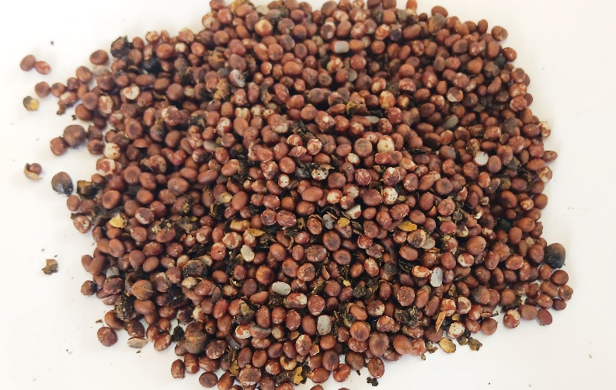

Figure S1. Photograph of Serenoa repens (Bartram) J.K.Small (Saw palmetto).
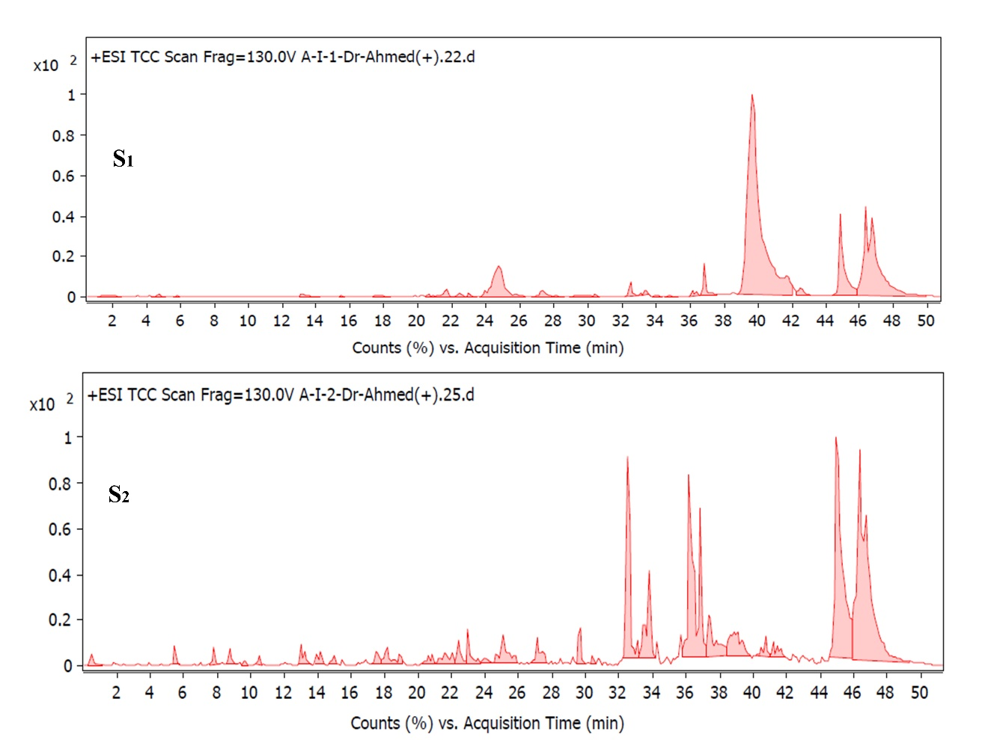
Figure S2: The chromatograms of LCHR-ESI-MS of Serenoa repens seeds extract (S1) vs. a particular pharmaceutical product (S2) containing Serenoa repens

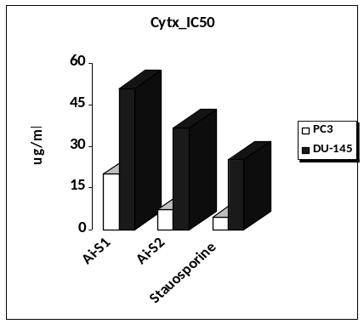

Figure S3. Histogram representing cytotoxic activity of Saw palmetto extract (S1) Product (S2) against Pc3 and DU-145 cell lines

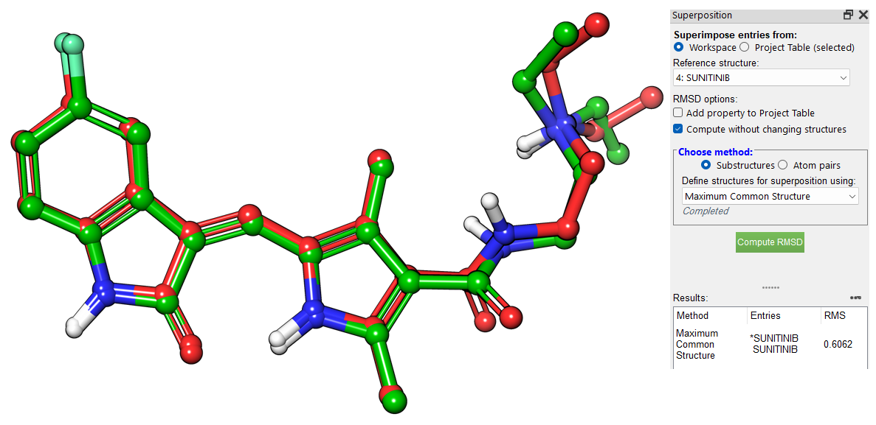
Figure S4. Docking analysis of the co-crystalized ligand (sunitinib).

