AMP21
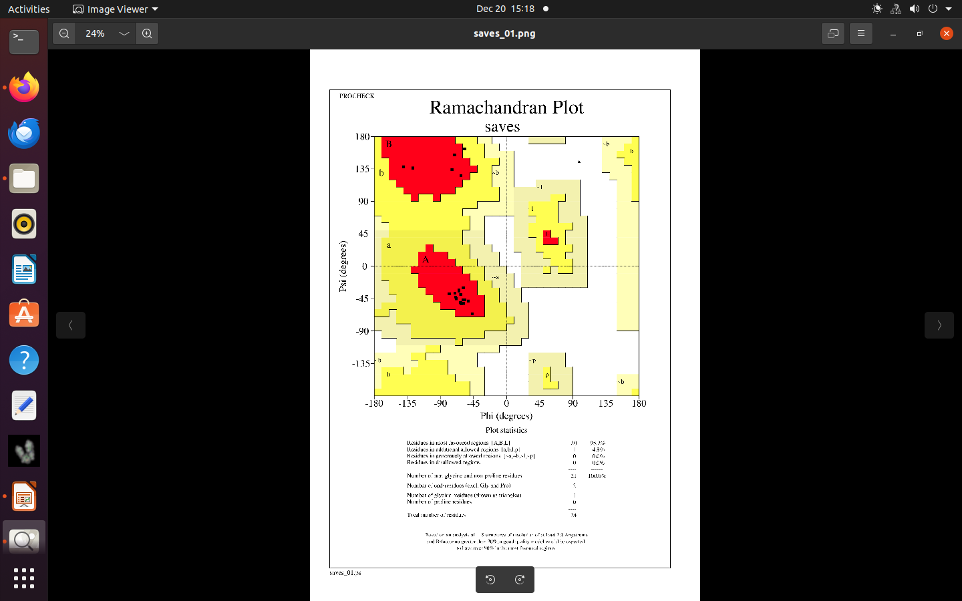
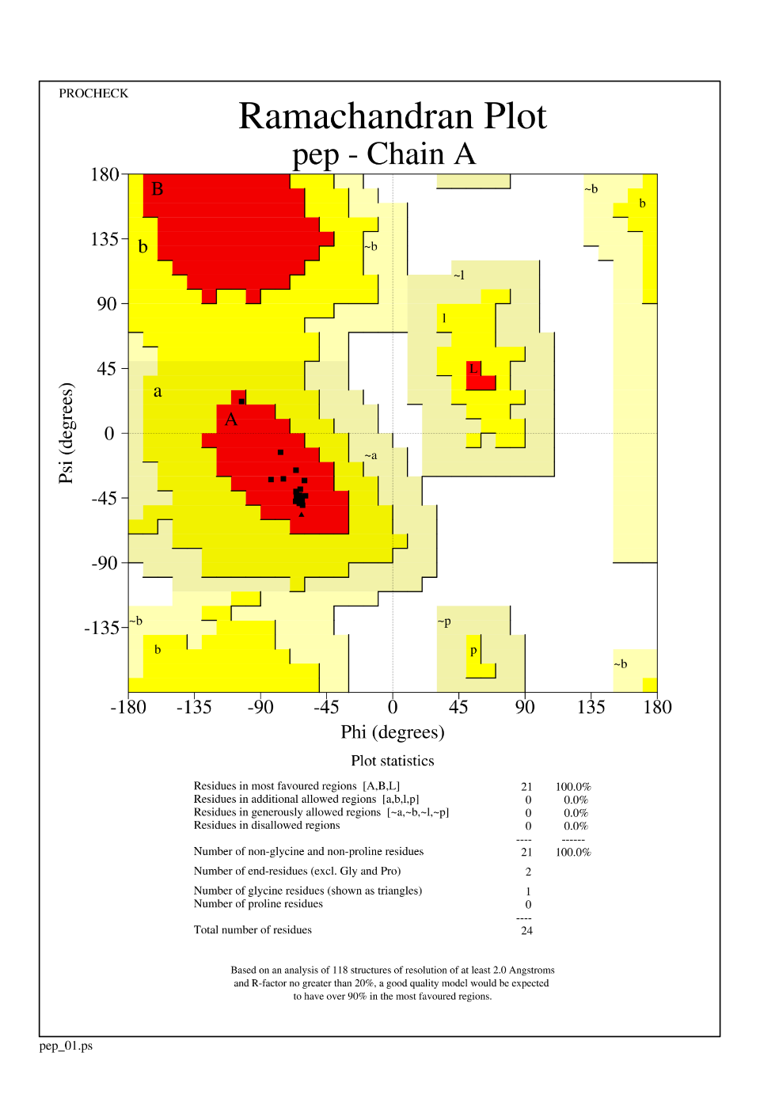
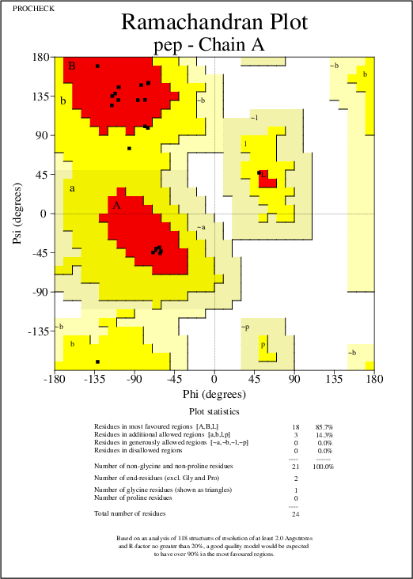
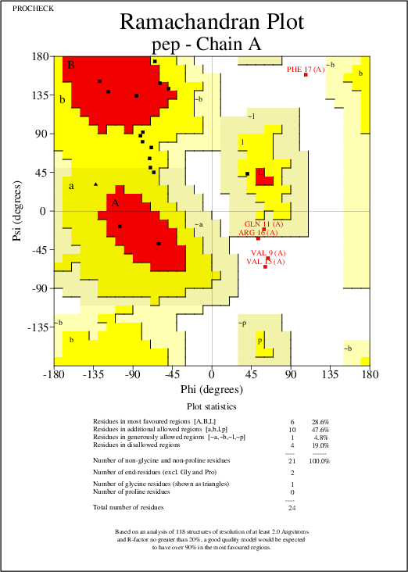

Homology Modeling
AlphaFold

Threading
PEP-FOLD

Figure S1. Ramachandran plots for peptide structures obtained using different peptide modeling algorithms for AMP21. The plots were generated using PROCHECK v.3.5.4.

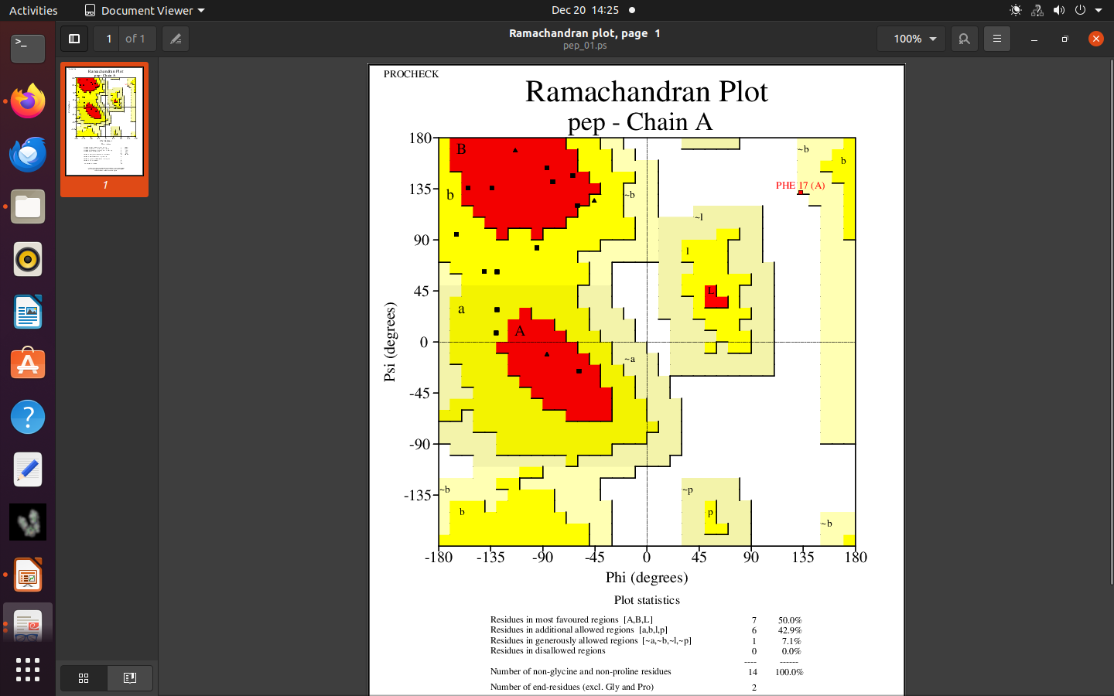
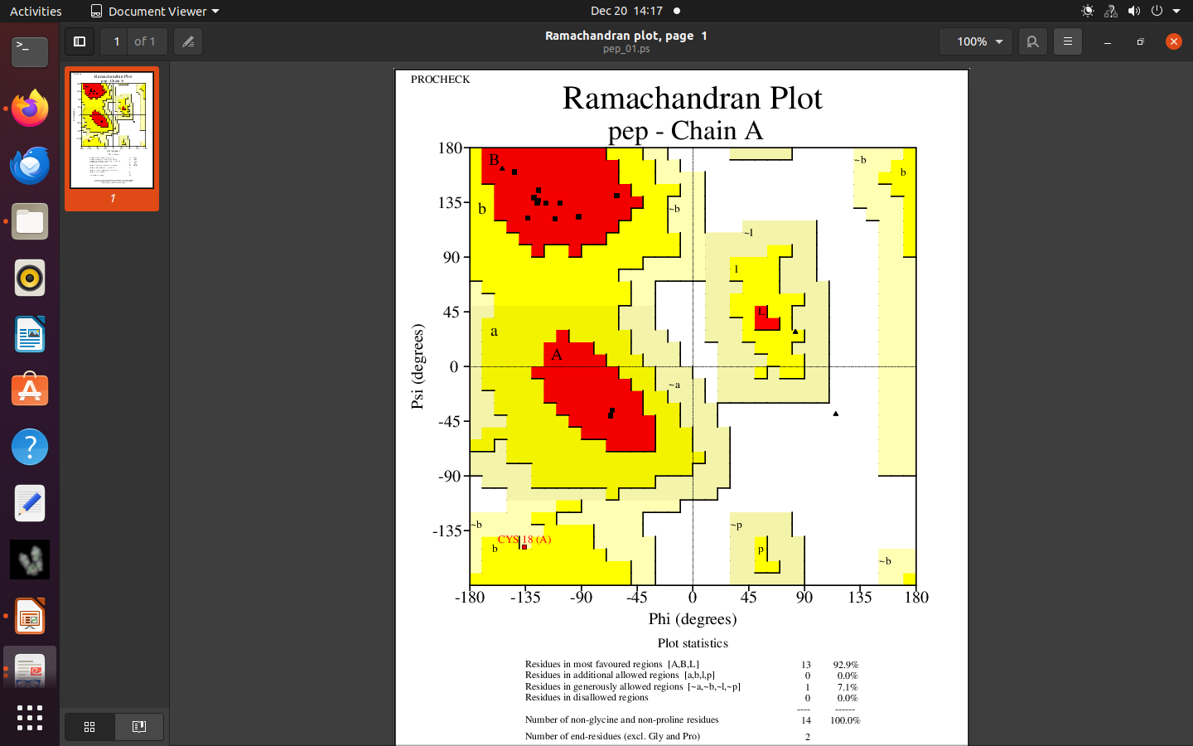
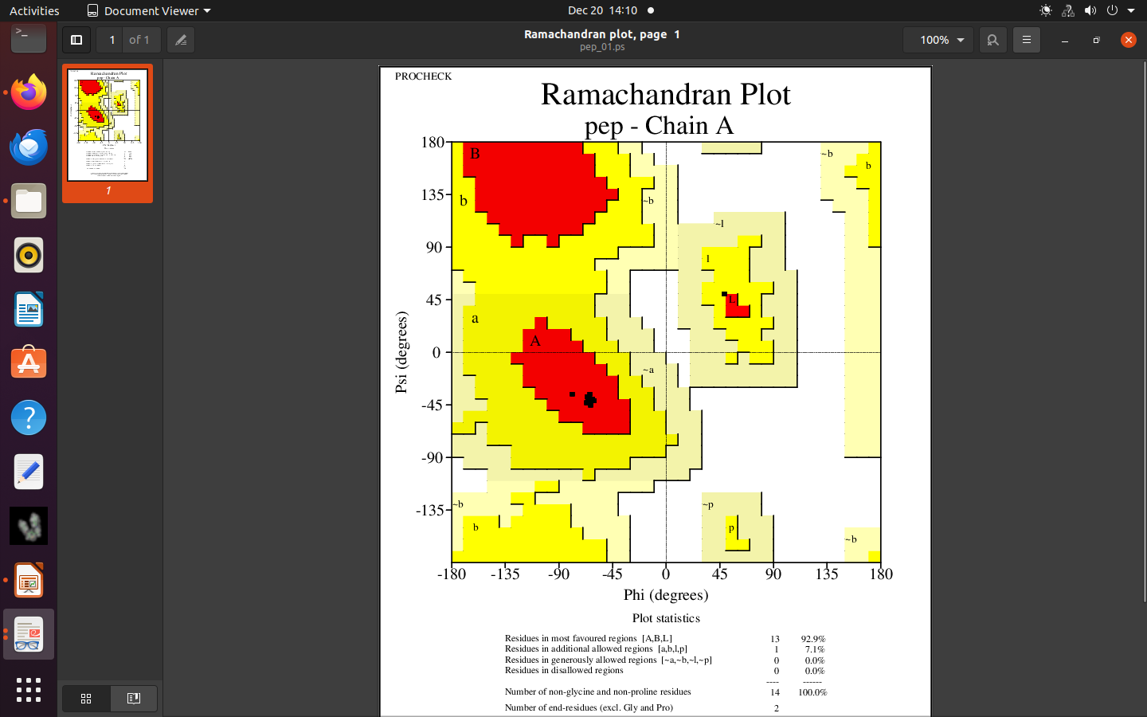
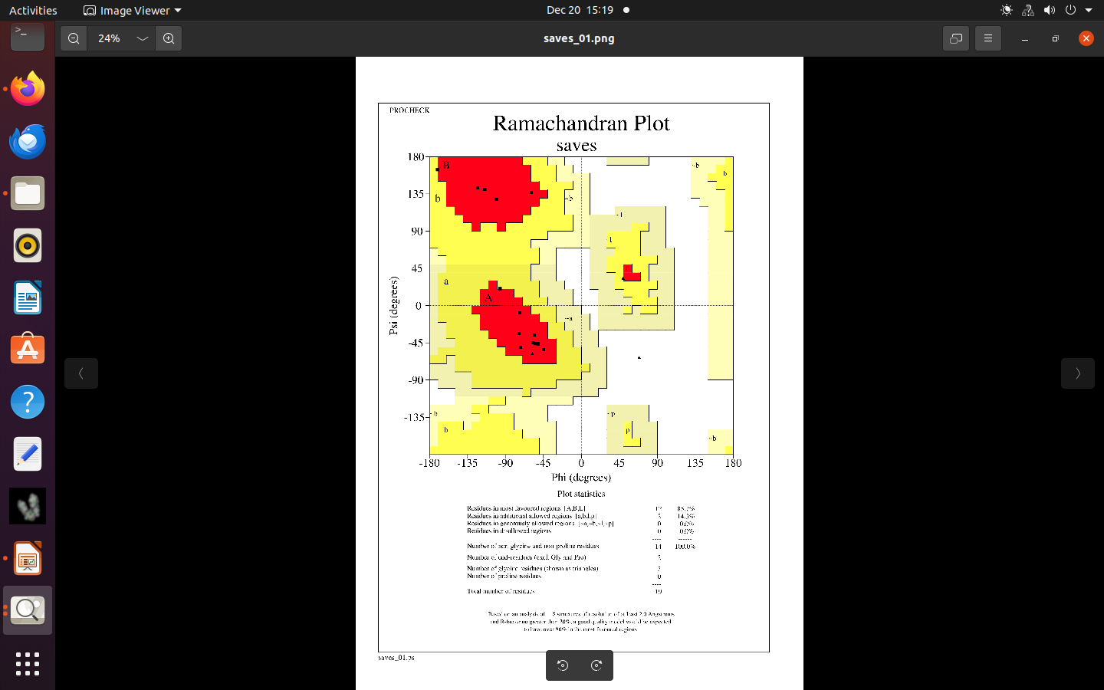
Figure S2. Ramachandran plots for peptide structures obtained using different peptide modeling algorithms for AMP32. The plots were generated using PROCHECK v.3.5.4.

Homology Modeling
AlphaFold
Threading
PEP-FOLD
AMP32
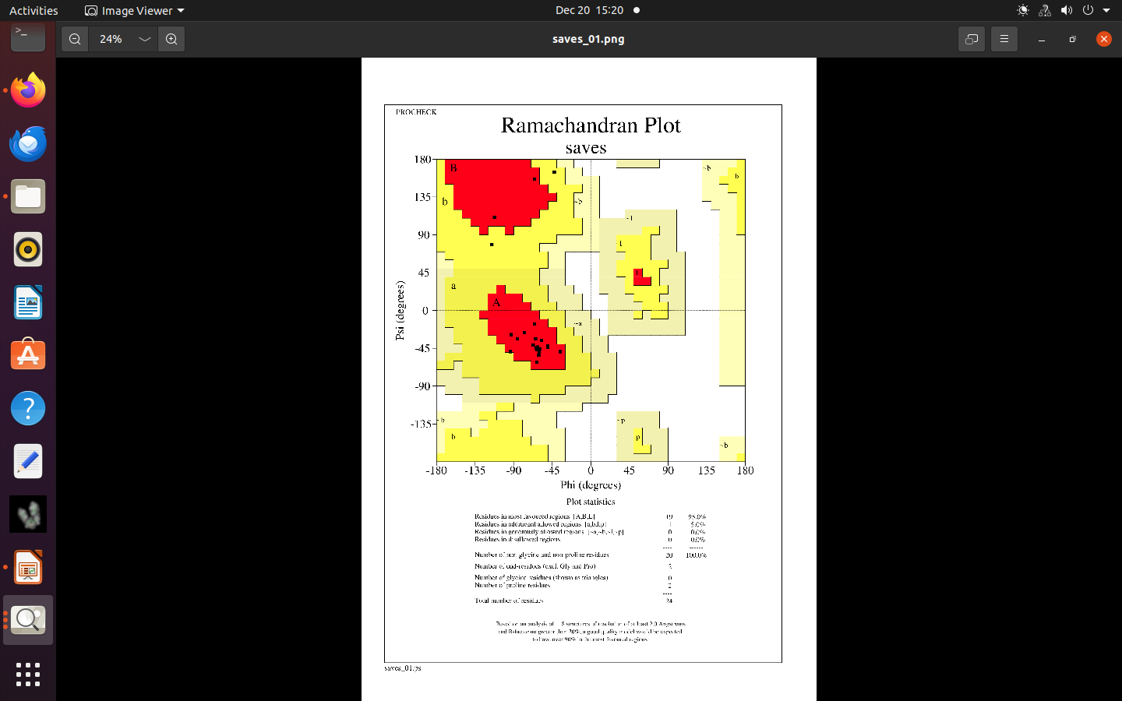
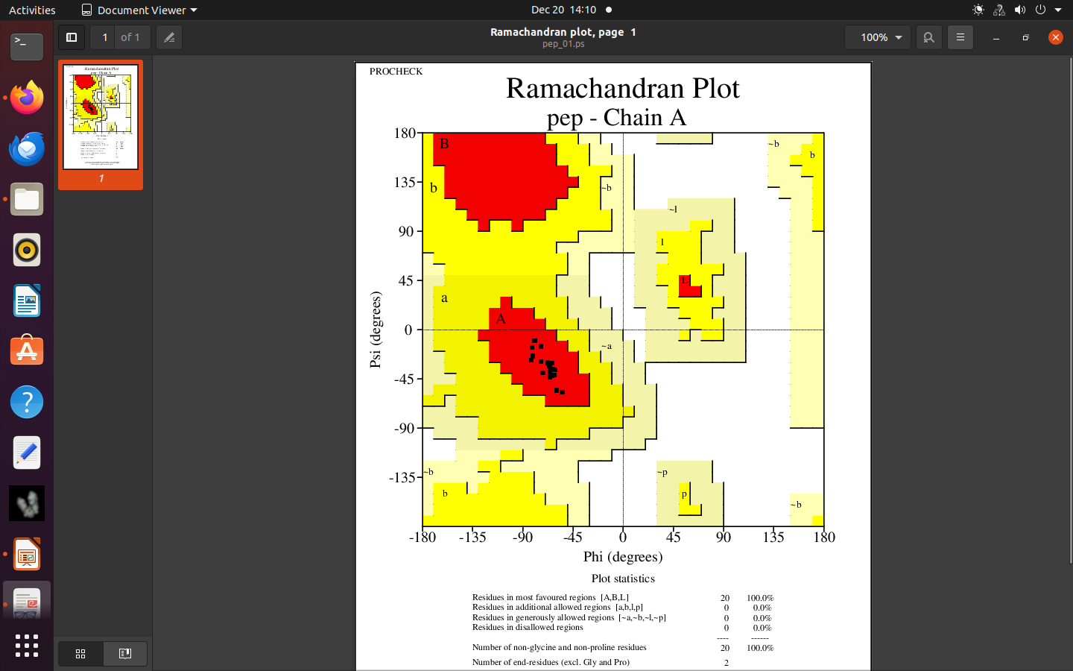
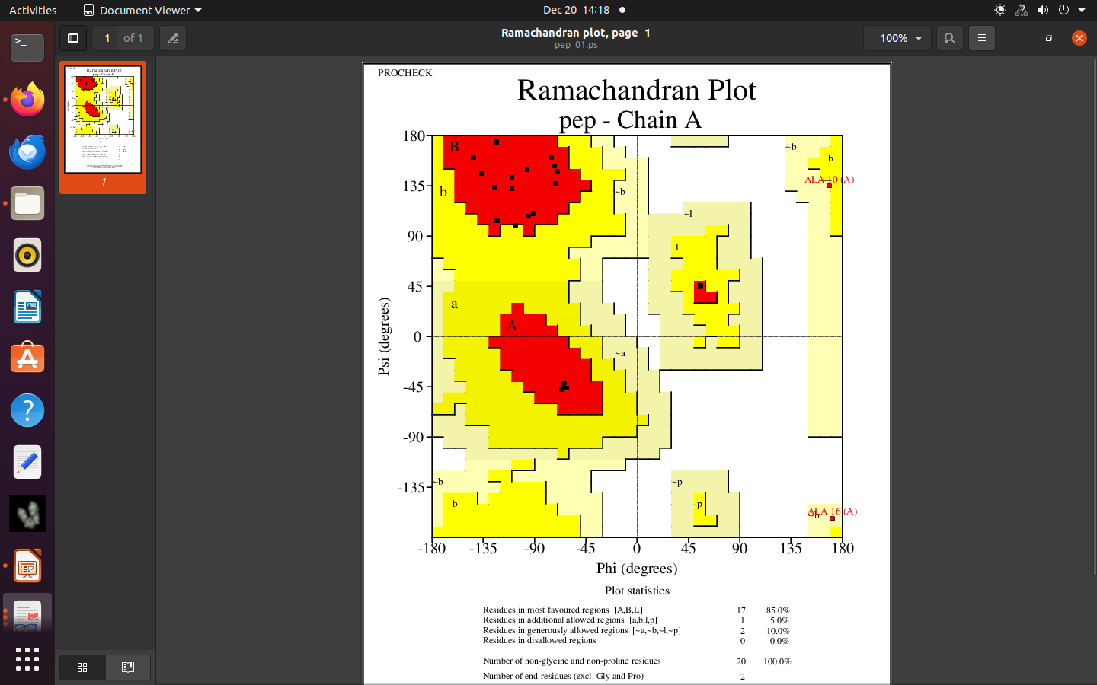
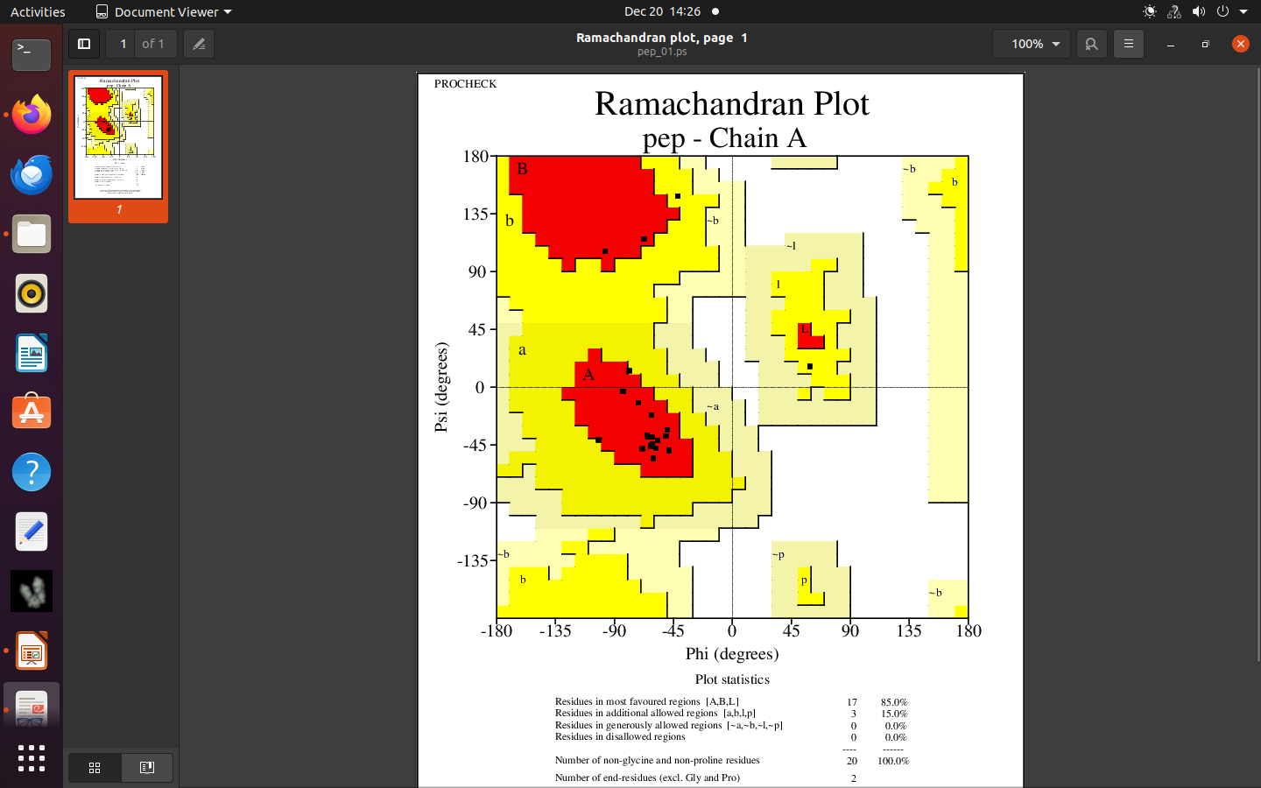
AMP43
Threading
AlphaFold
Homology Modeling
PEP-FOLD
Figure S3. Ramachandran plots for peptide structures obtained using different peptide modeling algorithms for AMP43. The plots were generated using PROCHECK v.3.5.4.

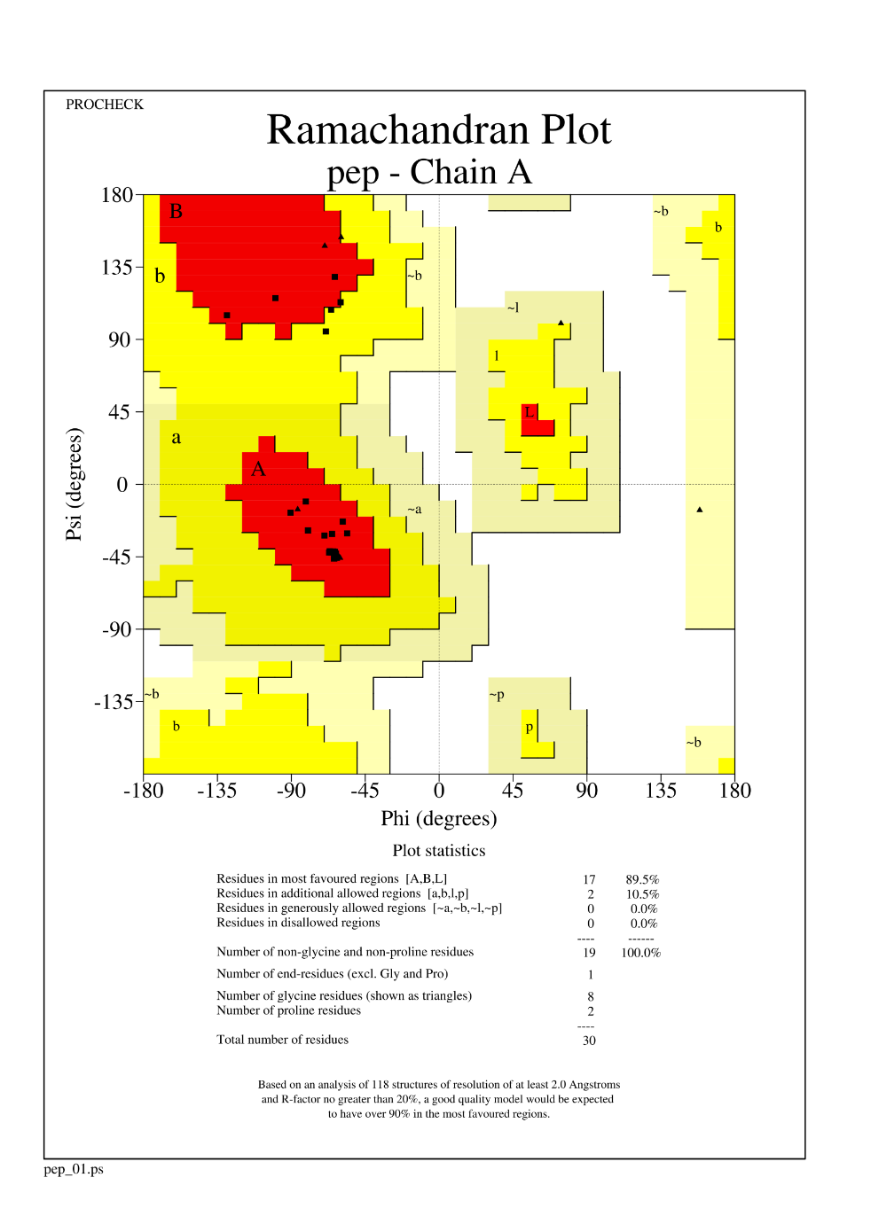
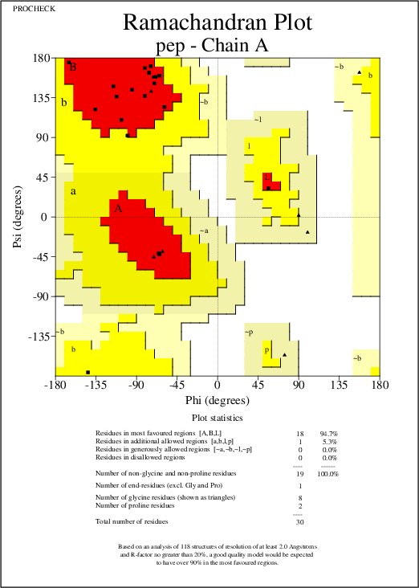
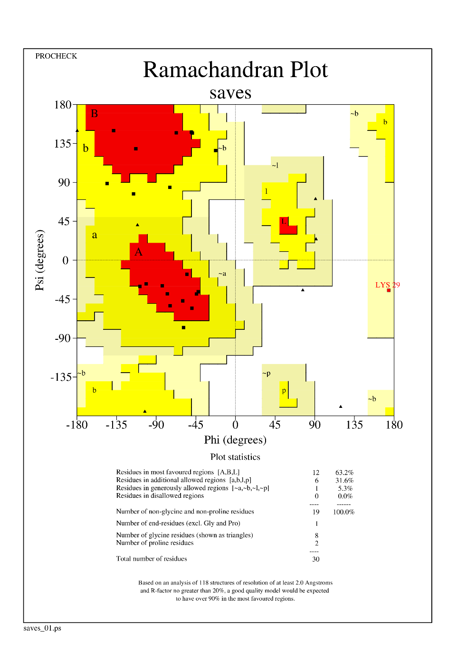
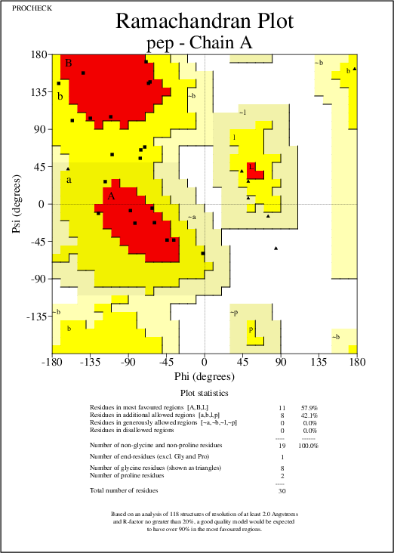
Figure S4. Ramachandran plots for peptide structures obtained using different peptide modeling algorithms for AMP164. The plots were generated using PROCHECK v.3.5.4.

PEP-FOLD
Threading
Homology Modeling
AlphaFold
AMP164
AMP175
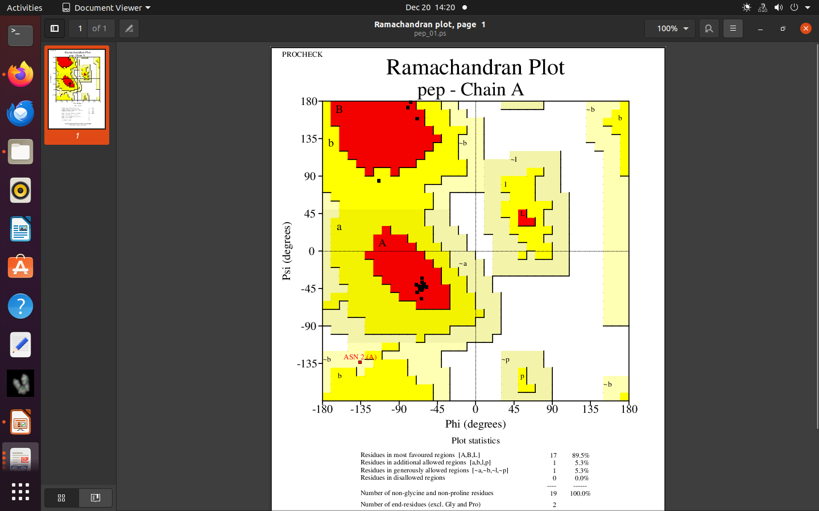
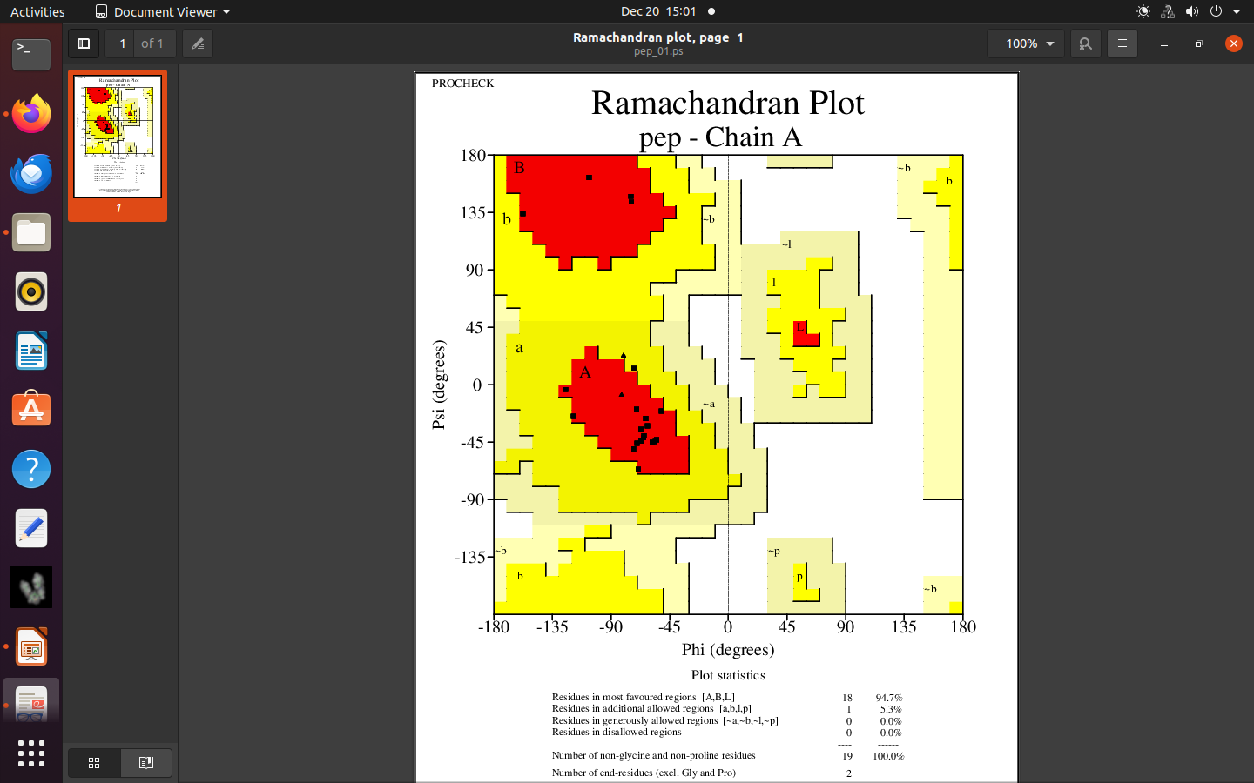
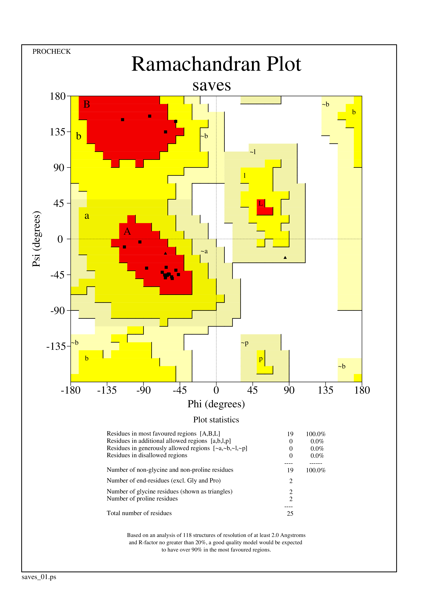
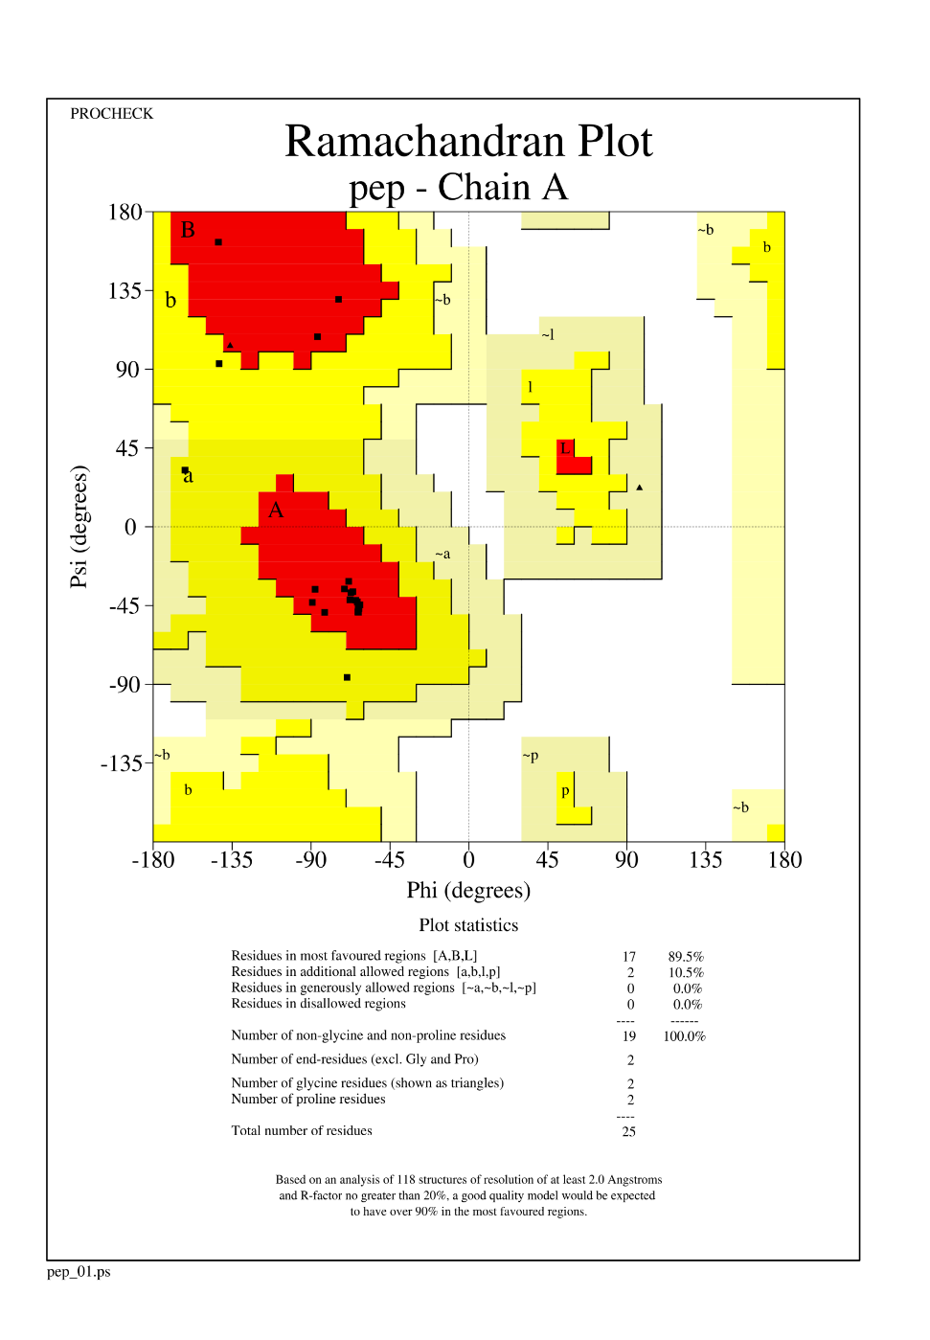
Figure S5. Ramachandran plots for peptide structures obtained using different peptide modeling algorithms for AMP175. The plots were generated using PROCHECK v.3.5.4.

AlphaFold
Threading
PEP-FOLD
Homology Modeling
AMP186
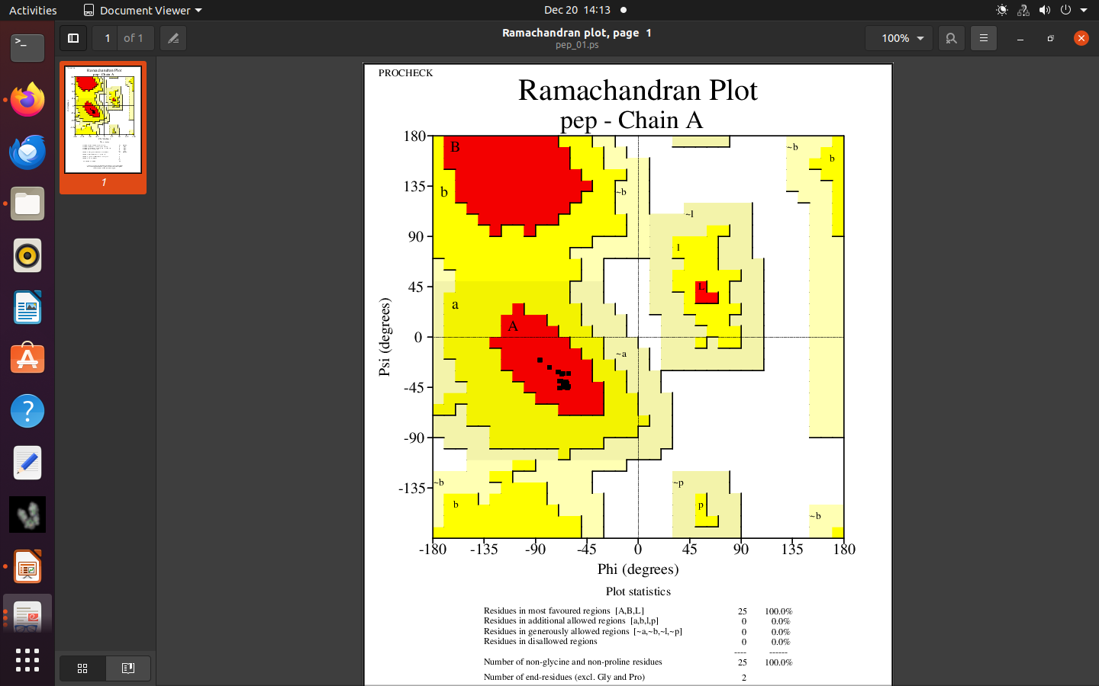
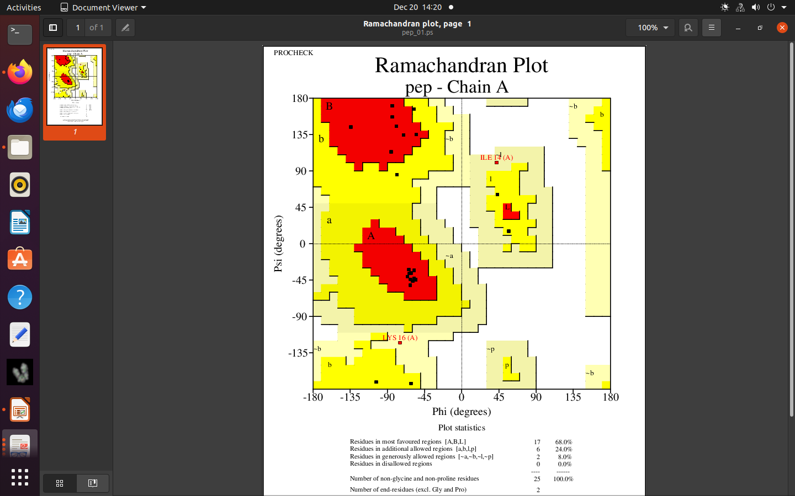
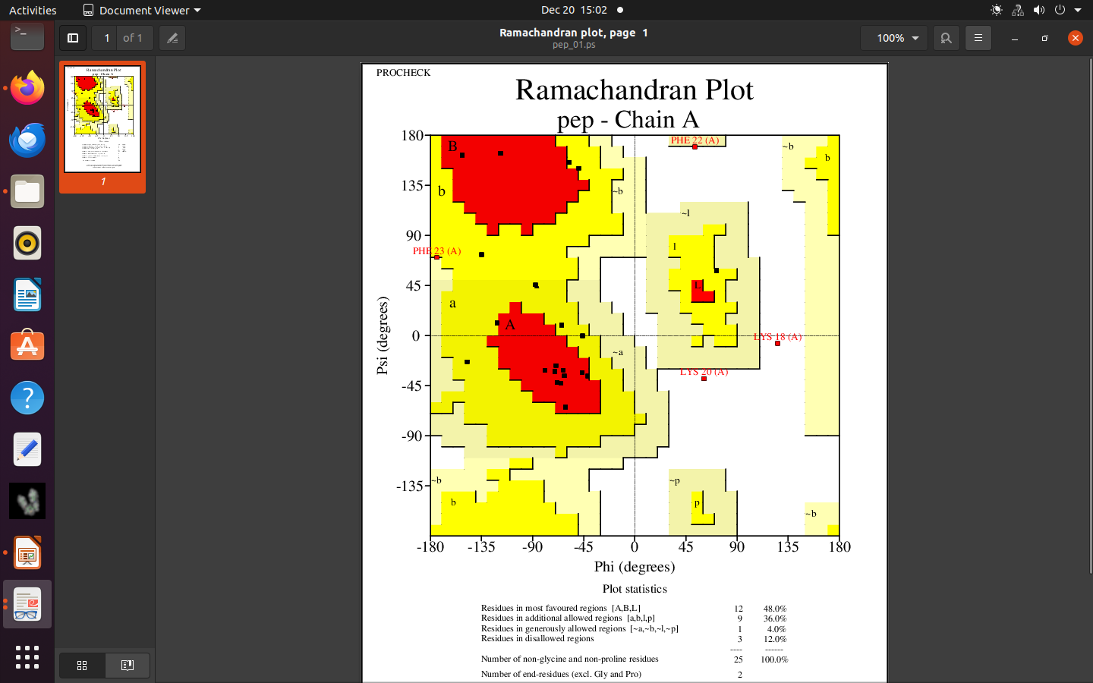
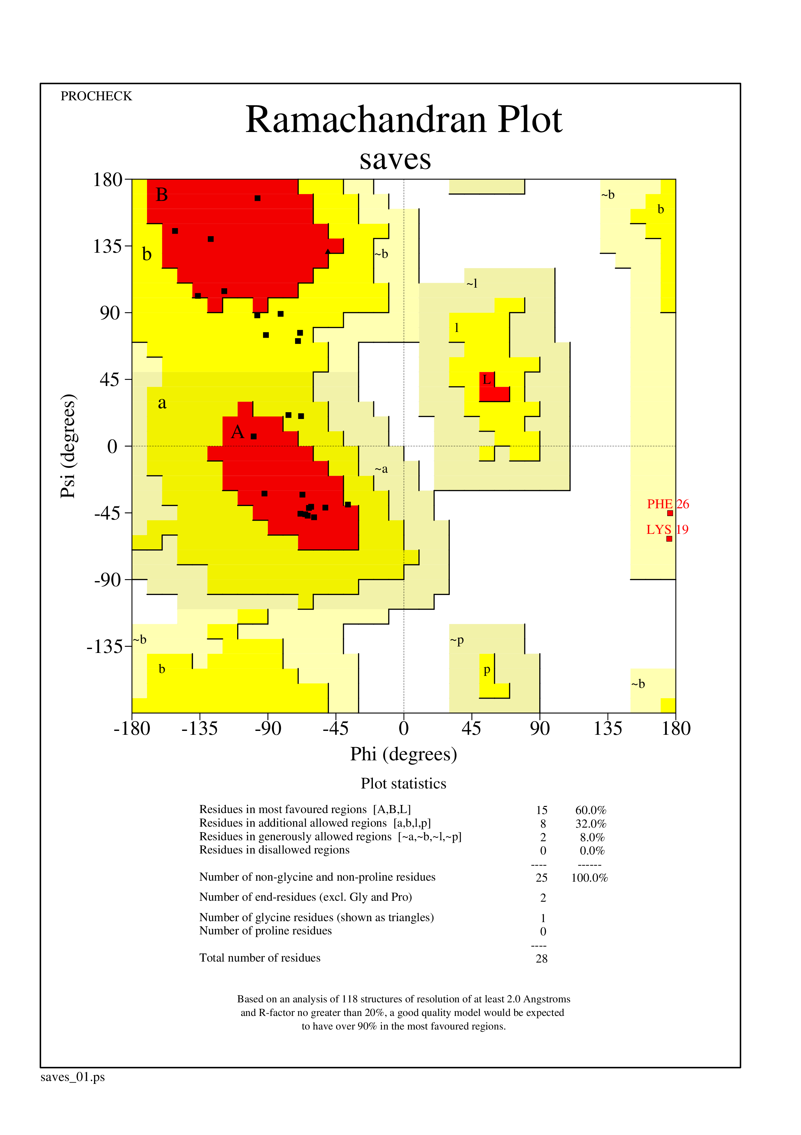
AlphaFold
Homology Modeling
Threading
Figure S6. Ramachandran plots for peptide structures obtained using different peptide modeling algorithms for AMP186. The plots were generated using PROCHECK v.3.5.4.

PEP-FOLD
AMP175
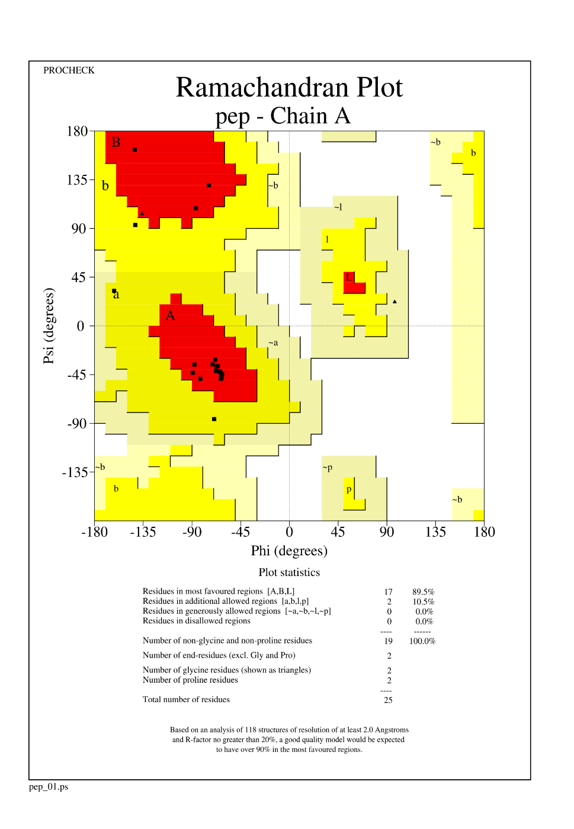
AlphaFold
Homology Modeling
Threading
PEP-FOLD
Figure S7. Ramachandran plots for peptide structures obtained using different peptide modeling algorithms for AMP175. The plots were generated using PROCHECK v.3.5.4.

AMP218
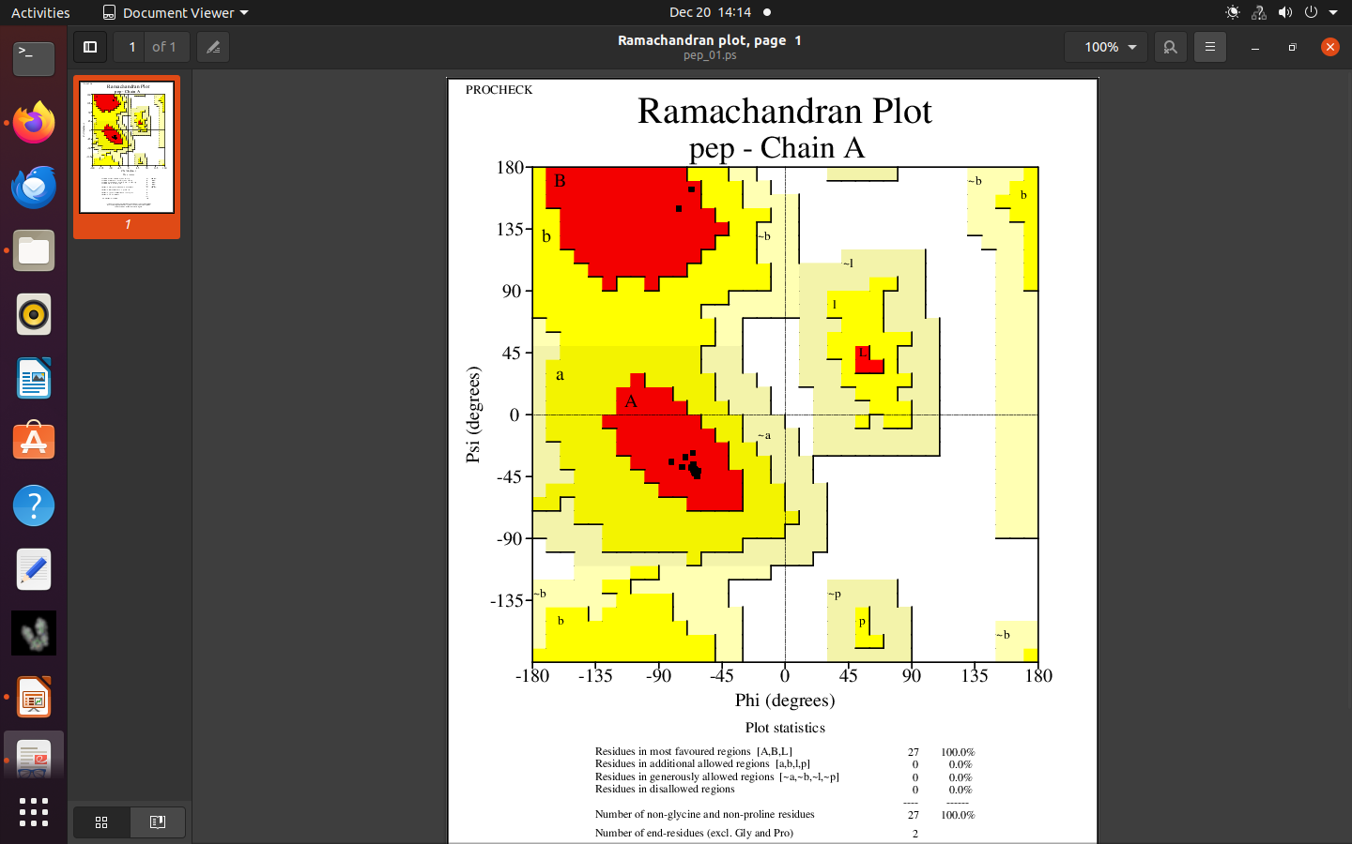
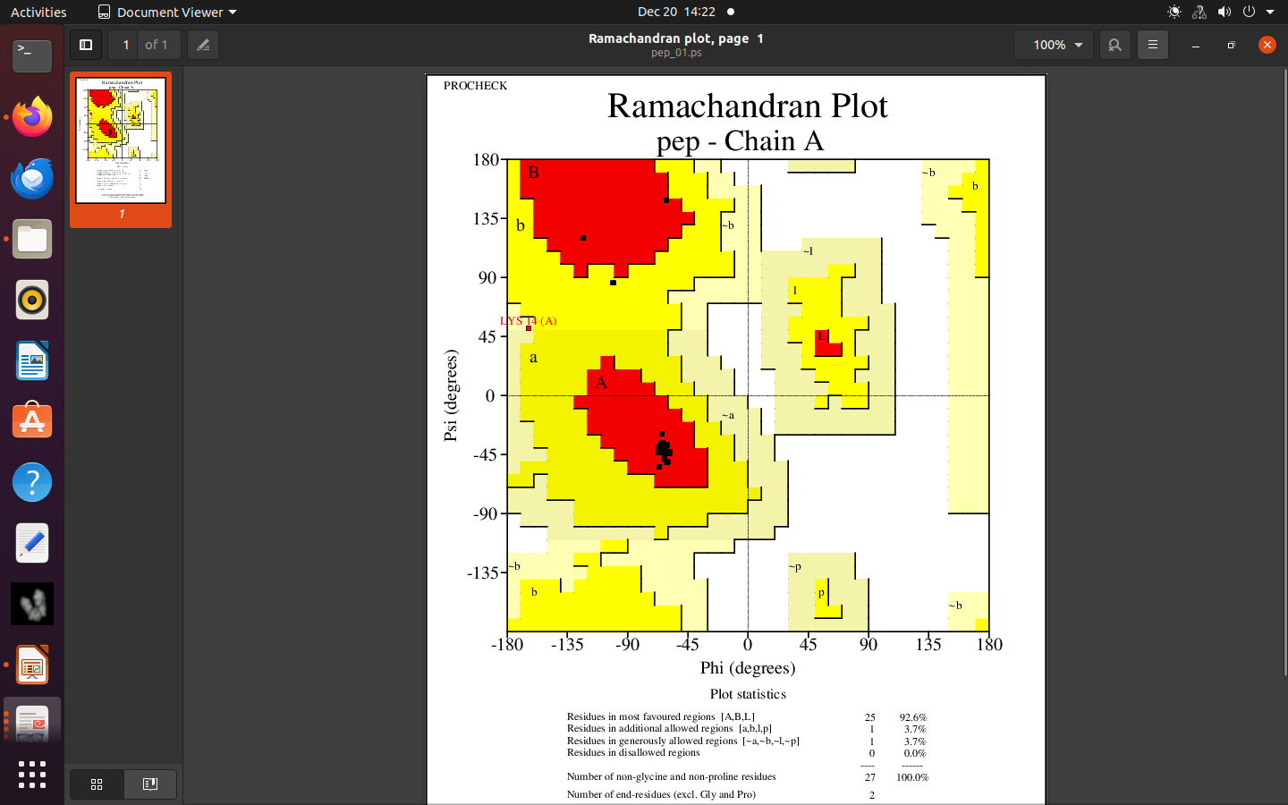
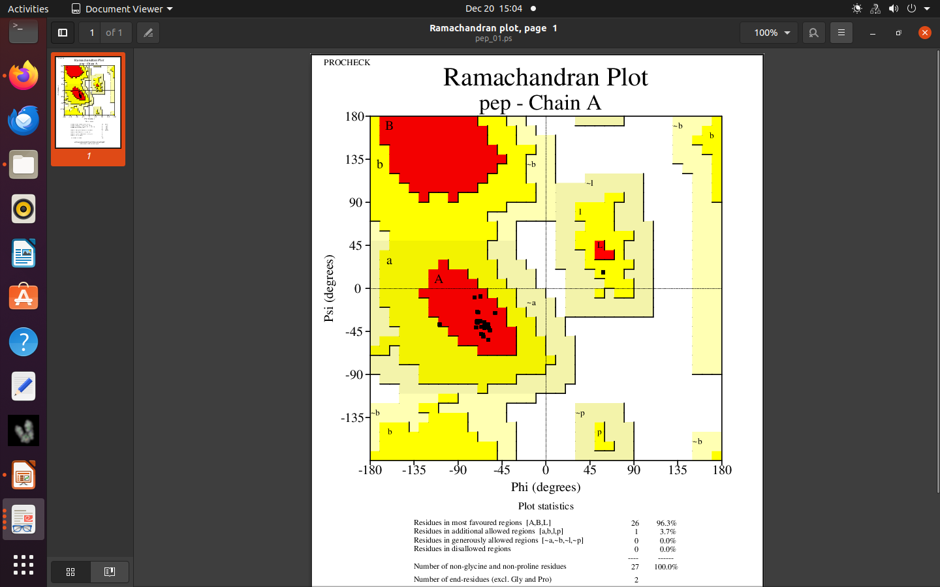
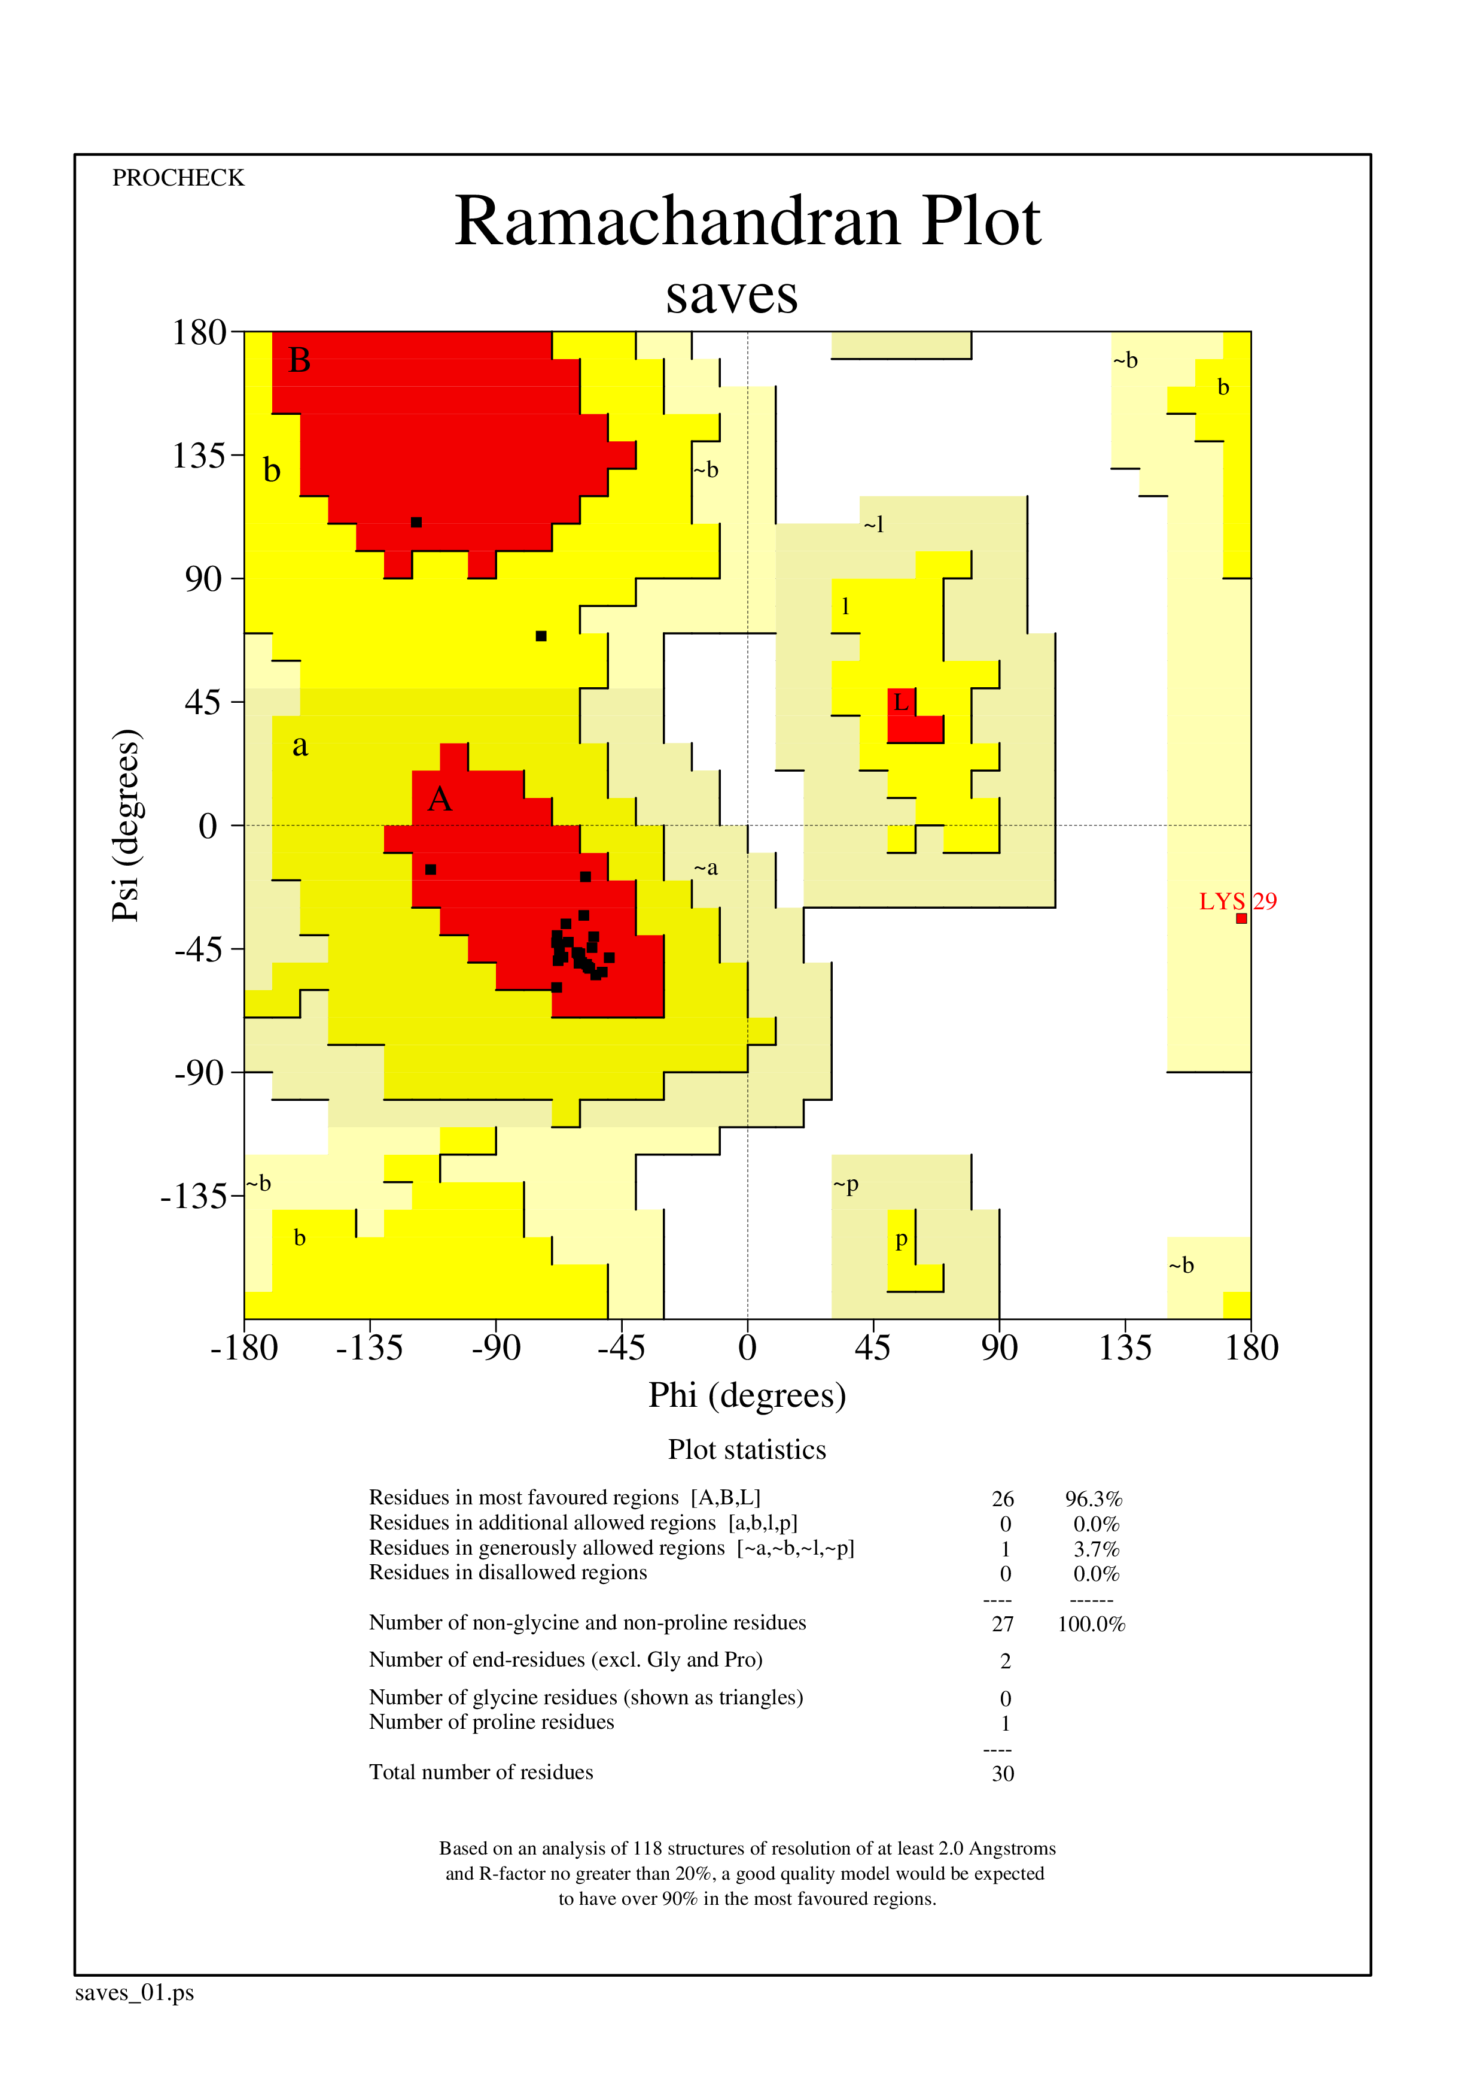
Figure S8. Ramachandran plots for peptide structures obtained using different peptide modeling algorithms for AMP218. The plots were generated using PROCHECK v.3.5.4.

Homology modeling
AlphaFold
Pep-Fold
Threading
AMP239
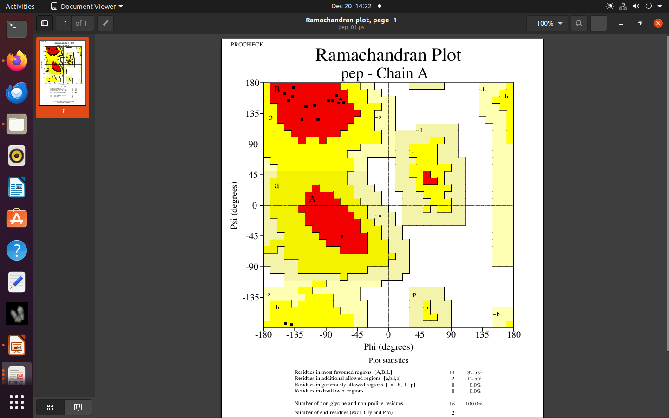
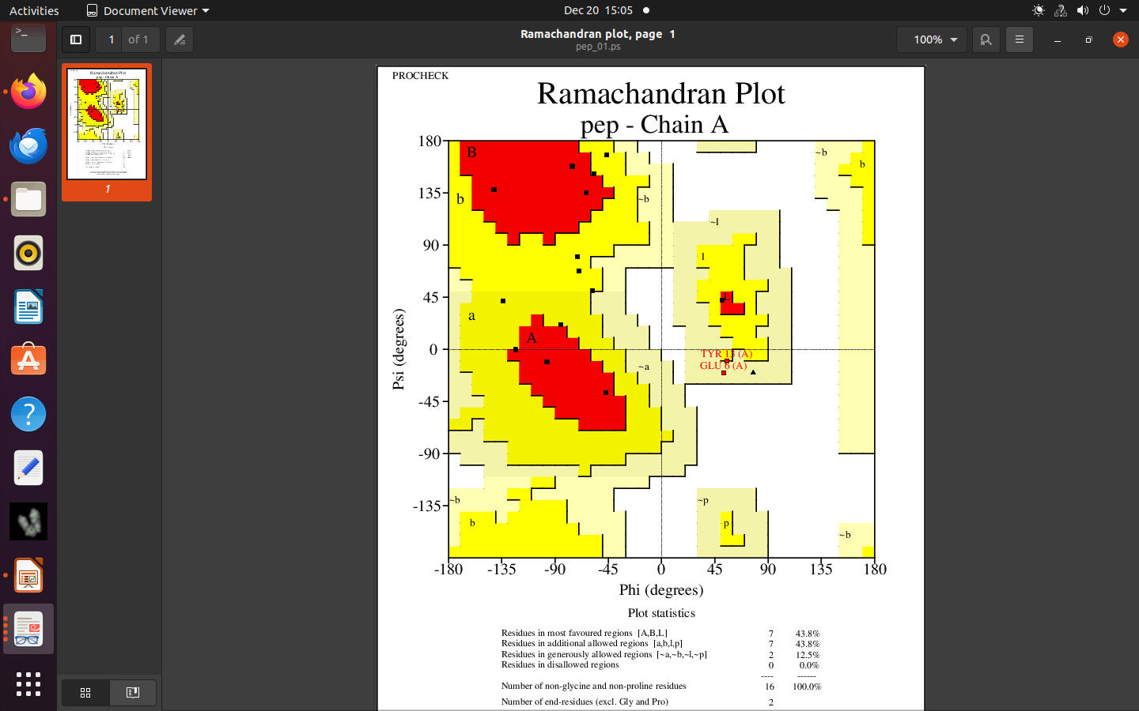
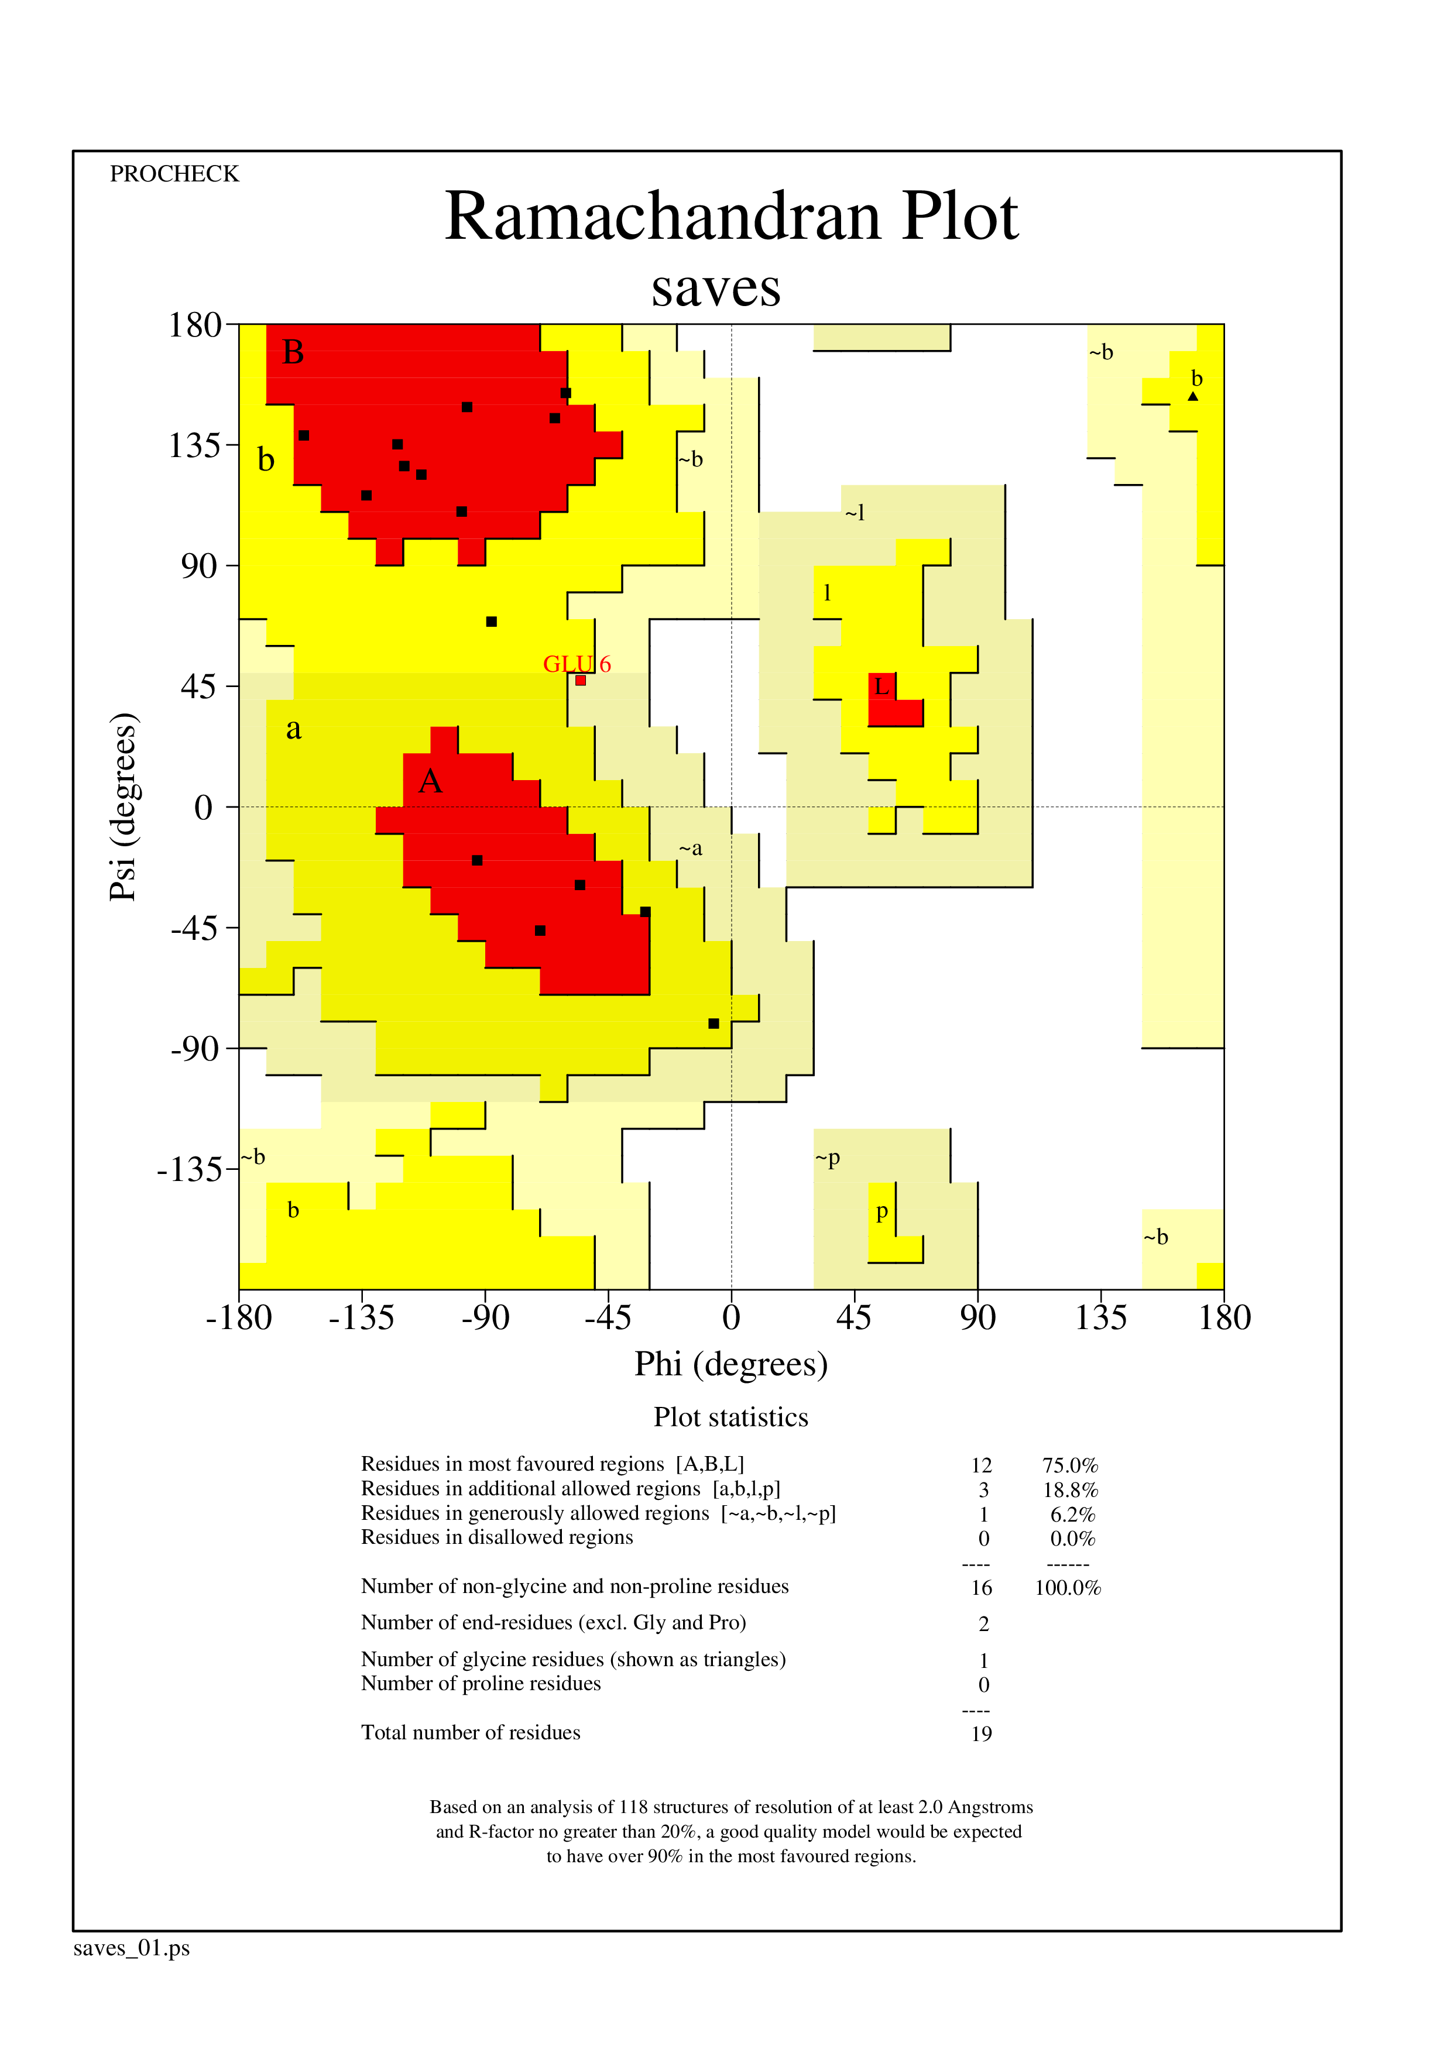
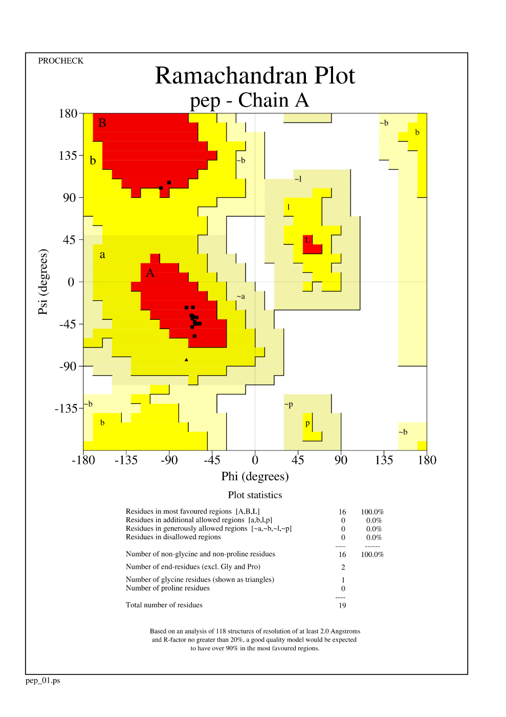
Figure S9. Ramachandran plots for peptide structures obtained using different peptide modeling algorithms for AMP239. The plots were generated using PROCHECK v.3.5.4.

Threading
PEP-FOLD
AlphaFold
Homology Modeling
AMP2410
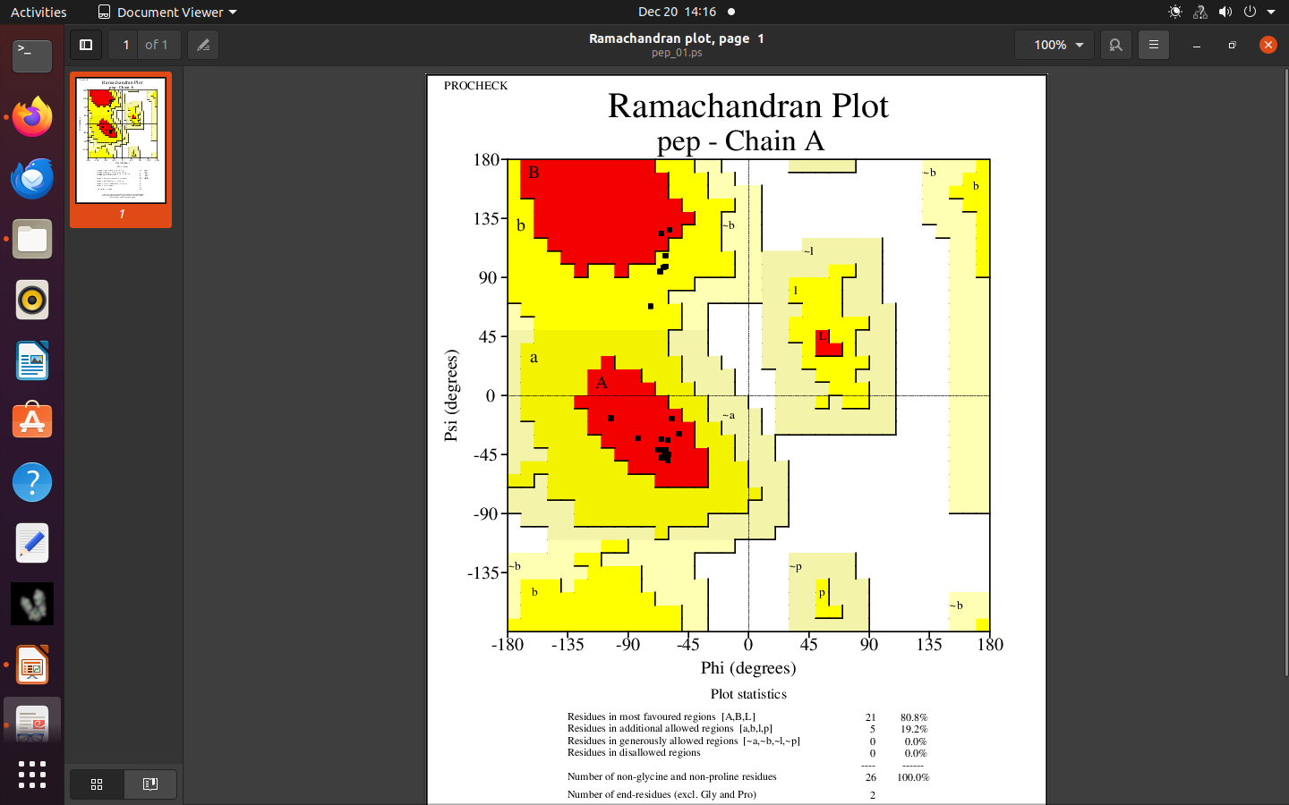
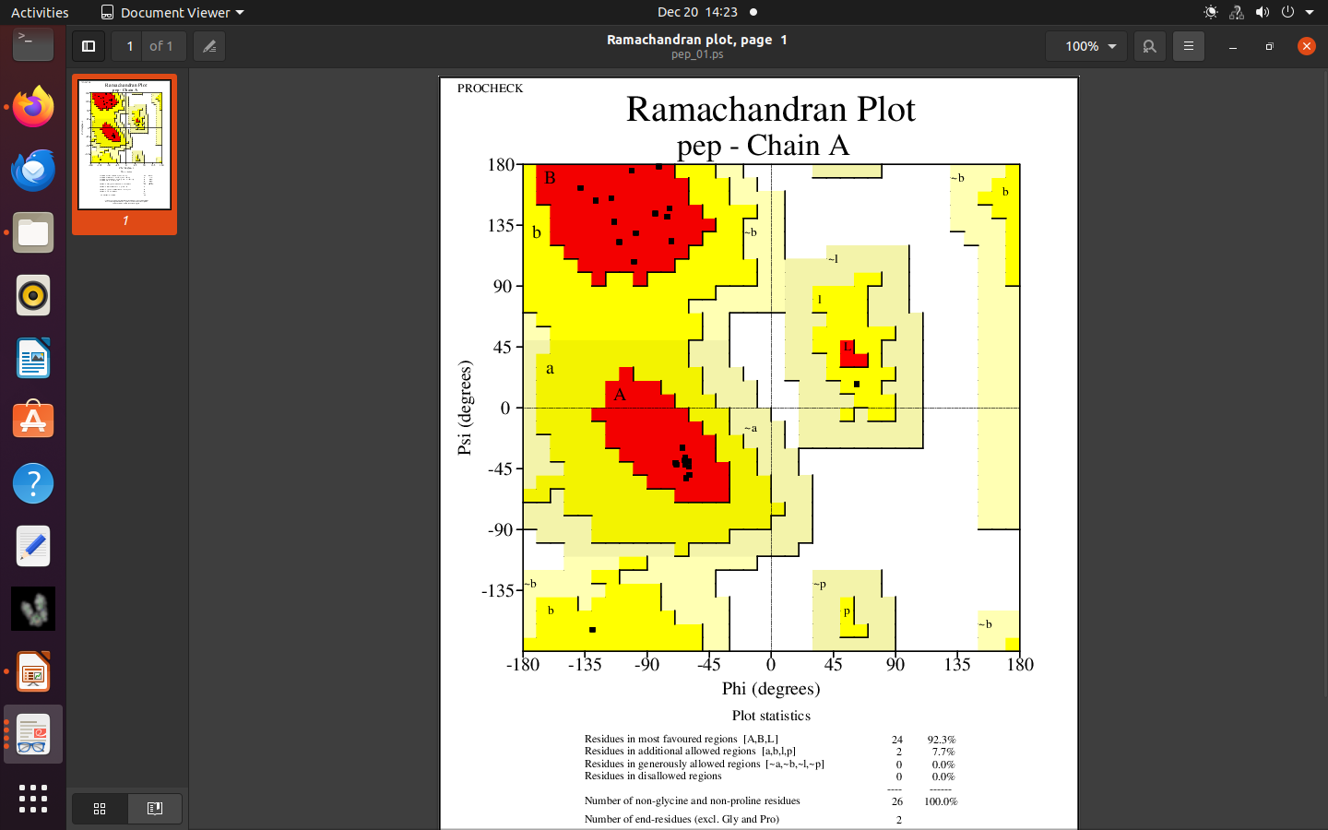
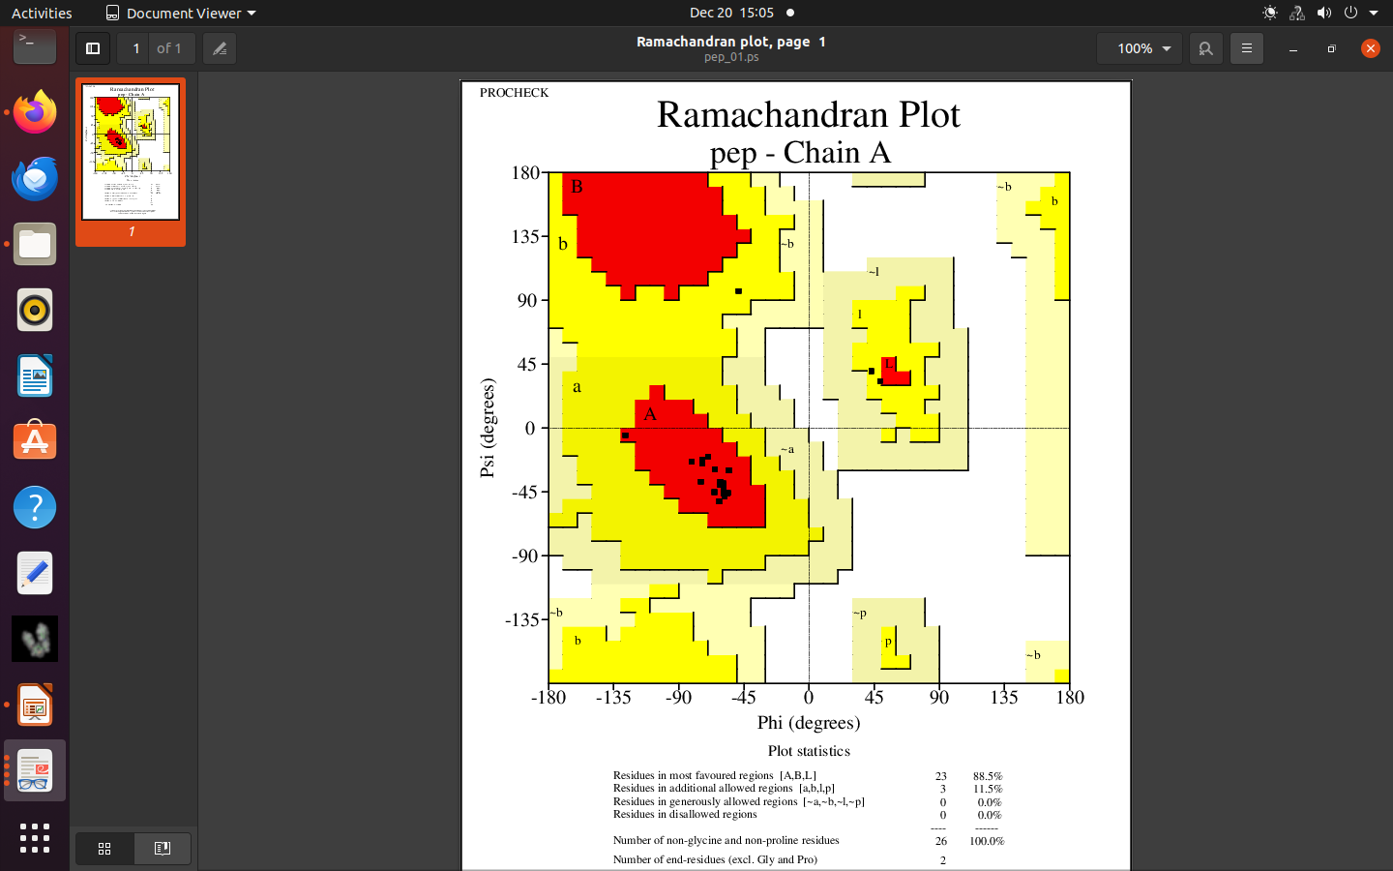
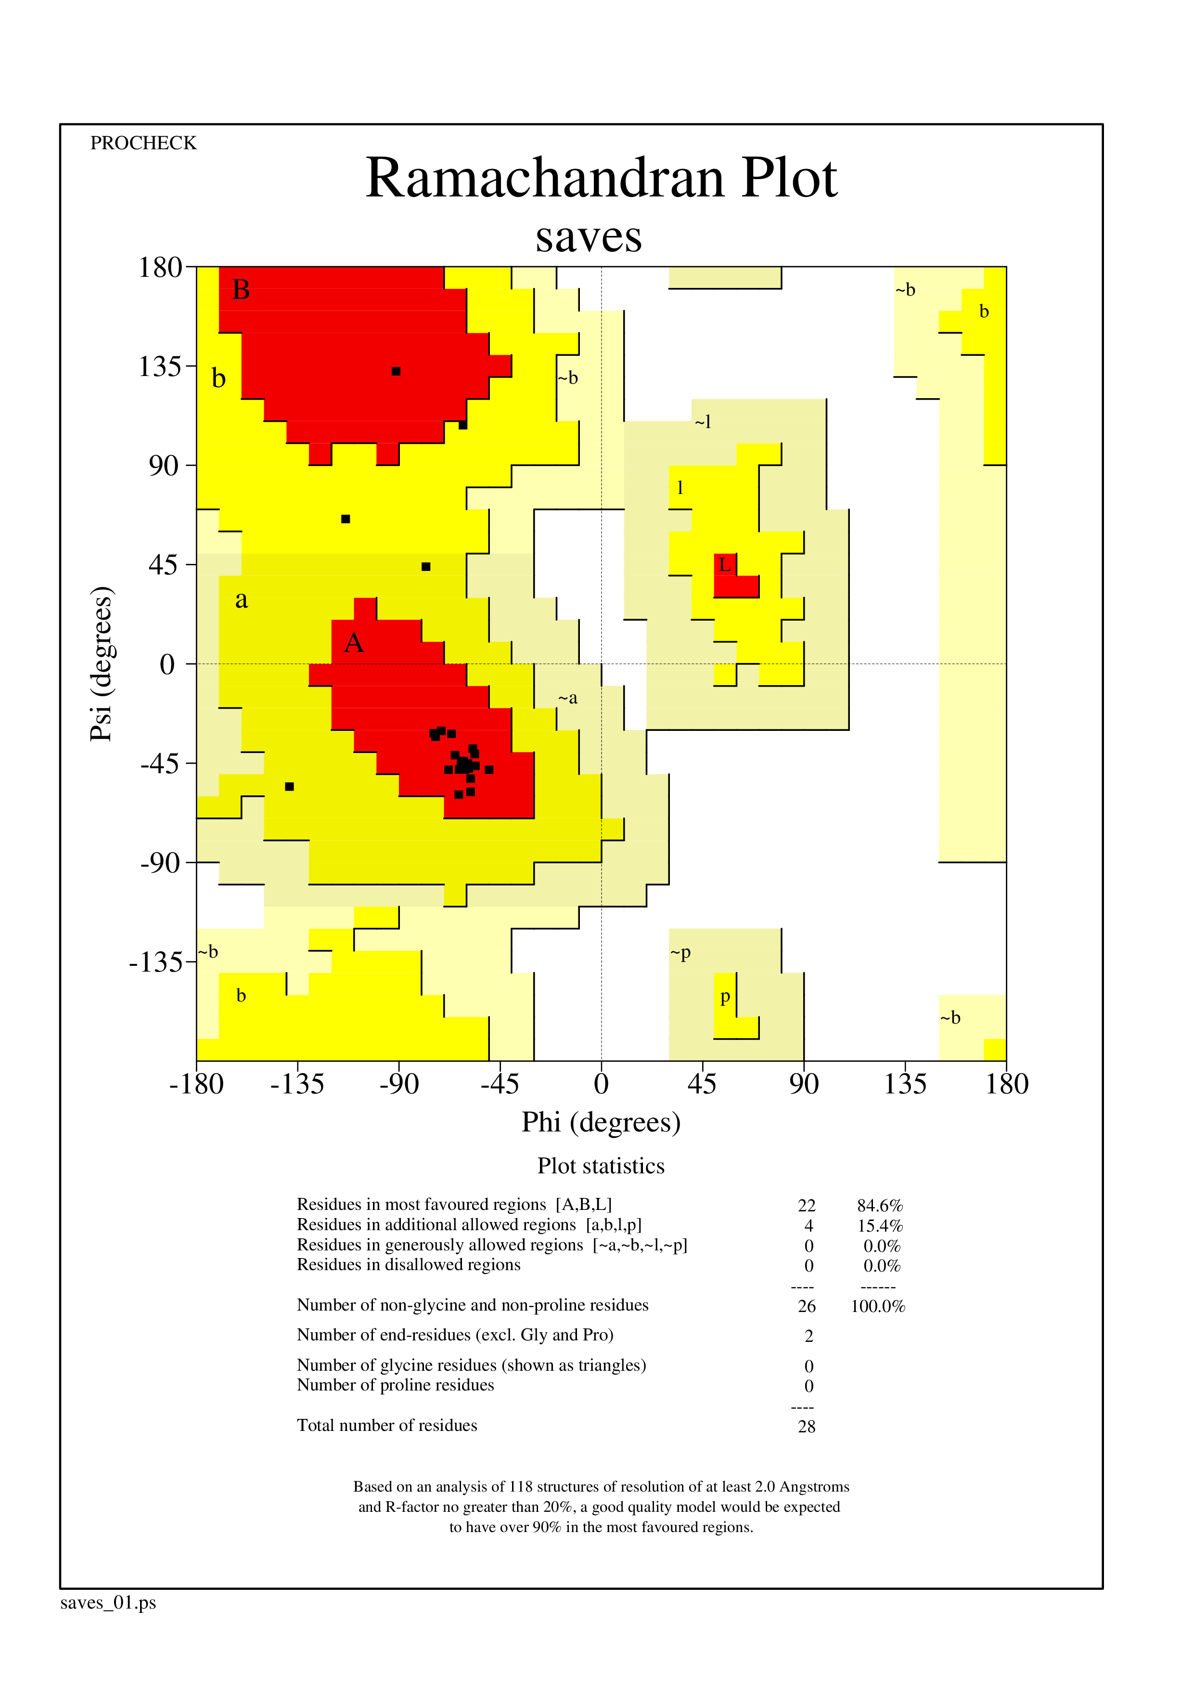
Threading
PEP-FOLD
AlphaFold
Homology Modeling
Figure S10. Ramachandran plots for peptide structures obtained using different peptide modeling algorithms for AMP2410. The plots were generated using PROCHECK v.3.5.4.

