Development and Internal Validation of an AI-Based Emergency Triage Model for Predicting Critical Outcomes in Emergency Department
Authors:
Patipan Sitthiprawiat¹, Borwon Wittayachamnankul¹, Wachiranun Sirikul², Korsin Laohavisudhi¹*
Affiliations:
¹ Department of Emergency Medicine, Faculty of Medicine, Chiang Mai University, Chiang Mai, Thailand
² Department of Community Medicine, Faculty of Medicine, Chiang Mai University, Chiang Mai, Thailand
Corresponding Author:
Korsin Laohavisudhi, MD
Department of Emergency Medicine, Faculty of Medicine,
Chiang Mai University, Chiang Mai, Thailand
Email: korsin.laohavisudhi@cmu.ac.th

TRIPOD+AI Checklist
Section/Topic | Item | Checklist item | Reported on page
TITLE
Title | 1 | Identify the study as developing/evaluating a prediction model, the target population, and the outcome. | 1
ABSTRACT
Abstract | 2 | Provide a structured summary of objectives, methods, results, and conclusions. | 1
INTRODUCTION
Background | 3a | Explain the context and rationale for the model. | 2
 | 3b | Describe the target population and intended use of the model. | 2
Objectives | 4 | Specify the study objectives (development/validation). | 2
METHODS
Data | 5a | Describe the source of data and its representativeness. | 3
 | 5b | Specify the dates of data collection. | 3
Participants | 6a | Specify key elements of the study setting. | 3
 | 6b | Describe eligibility criteria for participants. | 3
Outcome | 8a | Clearly define the outcome, time horizon, and how it was assessed. | 3
Predictors | 9b | Clearly define all predictors and how they were measured. | 3
Sample size | 10 | Explain how the study size was arrived at. | 4
Missing data | 11 | Describe how missing data were handled. | 4
Analytical methods | 12a | Describe how data were used (training/testing partitions). | 4
 | 12b | Describe how predictors were handled in the analyses. | 4
 | 12c | Specify the type of model, all model-building steps, and internal validation method. | 4
 | 12e | Specify all measures used to evaluate model performance. | 5
Model output | 15 | Specify the output of the prediction model. | 3
Ethical approval | 17 | Name the ethics committee and describe consent. | 3
RESULTS
Participants | 20a | Describe the flow of participants through the study. | 5 (Fig 1)
 | 20b | Report the characteristics of the participants. | 13 (Table 1)
Model development | 21 | Specify the number of participants and outcome events in each analysis. | 5, 13 (Table 1)
Model specification | 22 | Provide details of the full prediction model. | 4, Supp. Table S2
Model performance | 23a | Report model performance estimates with confidence intervals. | 5, 13 (Table 2), 15 (Fig 2)
DISCUSSION
Interpretation | 25 | Give an overall interpretation of the main results. | 6-7
Limitations | 26 | Discuss any limitations of the study. | 7-8
Usability/Next Steps | 27c | Discuss next steps for future research and generalizability. | 7-8

Supplementary Table S1. Distribution of Patient Chief Complaints Categorized by a Modified CEDIS Presenting Complaint List.
Rank | Group | Chief complaint | Frequency (%)
1 | Trauma | Fall | 25,845 (10.30%)
2 | Trauma | Minor Trauma | 23,290 (9.29%)
3 | Orthopedic | Limb pain (upper/lower) | 20,967 (8.36%)
4 | Trauma | Motor vehicle related accident | 20,157 (8.04%)
5 | Gastrointestinal | Abdominal pain | 17,851 (7.12%)
6 | Respiratory | Shortness of breath | 17,204 (6.86%)
8 | Cardiovascular | Chest pain | 10,197 (4.07%)
9 | Neurologic | Altered level of consciousness | 8,536 (3.40%)
10 | General & Minor | Fever | 8,108 (3.23%)
11 | Gastrointestinal | Vomiting and/or nausea | 8,070 (3.22%)
12 | Skin | Abscess / Localized swelling | 6,746 (2.69%)
13 | Neurologic | Weakness / loss of strength / Paresthesia | 6,593 (2.63%)
14 | Neurologic | Dizziness / Vertigo | 6,037 (2.41%)
15 | Cardiovascular | Palpitations | 5,411 (2.16%)
16 | Cardiovascular | Syncope / pre-syncope | 4,953 (1.97%)

Note: To provide a structured overview of the study population's presenting problems, free-text chief complaints were retrospectively mapped to a classification scheme adapted from the Canadian Emergency Department Information System (CEDIS) list. This modified CEDIS framework was developed to better capture local terminology and complaint patterns. The mapping was performed via a keyword-matching algorithm where a single complaint could be assigned to multiple categories. Therefore, the total count of categorized complaints may exceed the number of unique patient visits.
Supplementary Table S2. Final Hyperparameters for Tuned Models
Model | Hyperparameter | Value
Logistic Regression | C (Inverse regularization) | 0.1
 | Penalty | L1 (Lasso)
 | Solver | Saga
Random Forest | n_estimators | 500
 | max_depth | 10
 | min_samples_leaf | 2
 | Min_samples_split | 2
XGBoost | n_estimators | 1000
 | max_depth | 6
 | learning_rate | 0.01
 | subsample | 0.5
 | colsample_bytree | None
 | gamma | None

Supplementary Figure S1. Comparison of Data Distributions Before and After KNN Imputation
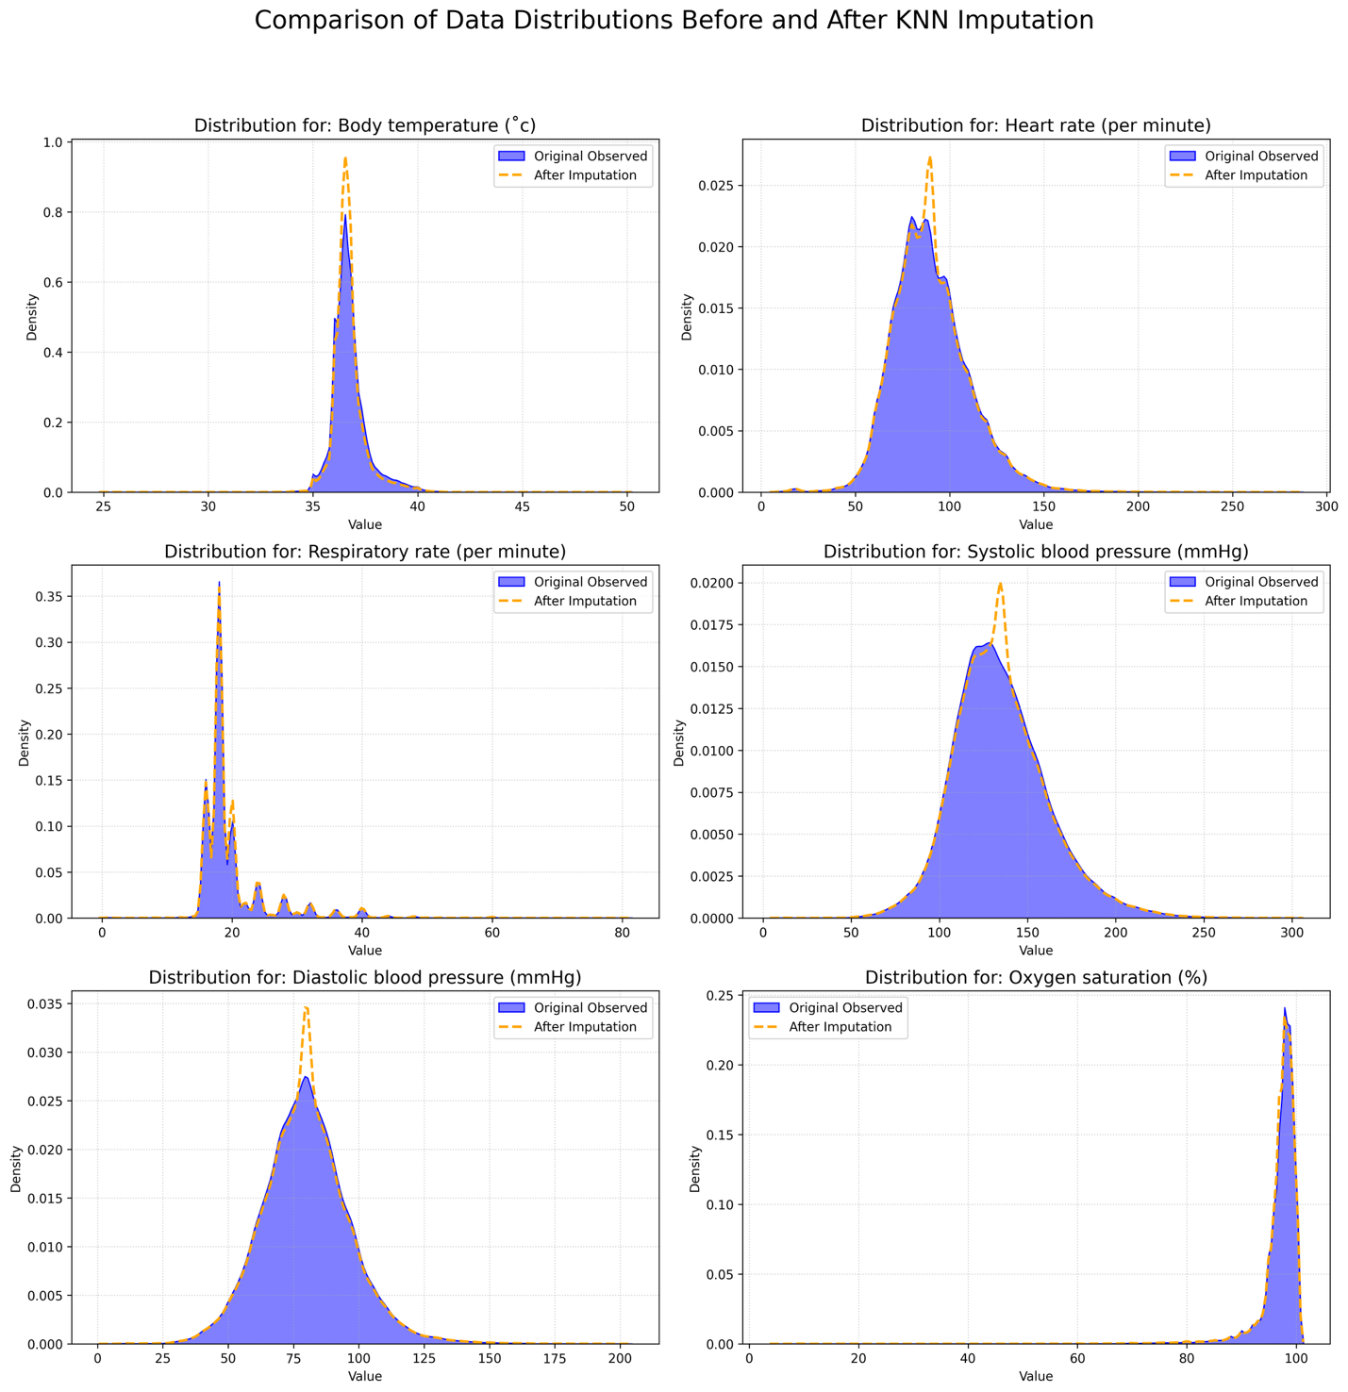
Figure legend: Kernel density plots illustrating the distributions of six continuous variables; body temperature (°C), heart rate (beats per minute), respiratory rate (breaths per minute), systolic blood pressure (mmHg), diastolic blood pressure (mmHg), and oxygen saturation (%). before and after imputation using the k-nearest neighbors (KNN) algorithm (k = 5). The original observed values are shown as solid purple lines, and the imputed distributions as dashed orange lines. The substantial overlap between the curves indicates minimal distortion introduced by imputation, affirming the robustness of the approach.”

