SUPPLEMENTARY MATERIALS
Supplementary Table 1. Part list of the loading apparatus and the control unit. N/A=Not Available.
 | Major material | Acquisition method | Model number | Company
Main frame | Delrin | Machined | N/A | ProtoLabs®, Maple Plain, MN
Linear guide rail | Carbon fiber | Purchased | CWM-12, CWM-20, WSPC-06-30, | igus®, Cologne, Germany
Linear carriage | Plastic | Purchased | RJMP-01-12, RJUMP-05-20, WWPL-06-30-06 | igus®, Cologne, Germany
Pneumatic cylinder | Plastic, Copper, Carbon fiber, Delrin | Purchased | AC 17438-1 | Airpot®, Norwalk, CT
Cylinder connector | Delrin | Machined | N/A | ProtoLabs®, Maple Plain, MN
Foot cast | Polypropylene | Purchased | SP walking boot brace | Aircast®, Vista, CA
Foot cast frame | Delrin | Machined | N/A | ProtoLabs®, Maple Plain, MN
Fasteners | Nylon, Brass | Purchased | N/A | McMaster-Carr®, Elmhurst, Il
Hard stop | PLA | 3D printing | PolyLiteTM PLA | PolyMaker, Changshu, China
Air pump | N/A | Purchased | D55410 | DEWALT®, Towson, MD
Air regulator | N/A | Purchased | QB3TANEEZP100PSG | Proportion-Air, Inc. McCordsville, IN
Power source | N/A | Purchased | DC Power Supply 1710A | B&K Precision Corp., Yorba Linda, CA
DAQ system | N/A | Purchased | NI USB-6251 | National Instruments Corp., Austin, TX
Control circuit²⁰ | N/A | N/A | N/A | Customized
Air hoses | Rubber, Superthane ether | Purchased | N/A | McMaster-Carr®, Elmhurst, Il
Air-tight connectors | Nylon, Brass | Purchased | N/A | McMaster-Carr®, Elmhurst, Il

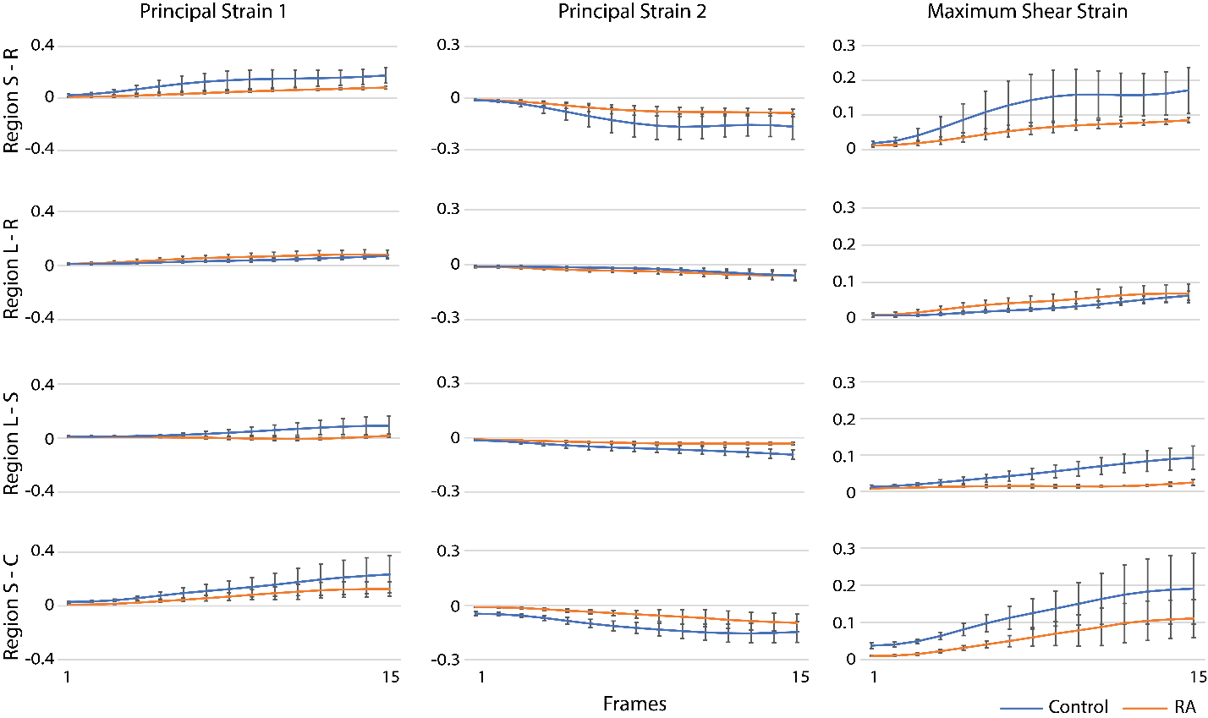
Supplementary Figure 1. Averaged principal strain 1, principal strain 2, and maximum shear strain values within each region from frame 1 to frame 15. Overall, the control group tended to have a larger increase of the strain values when compared to the RA group over time.

