Examining the impact of warnings on eyewitness memory
McKinzey G. Torrance, Jessica M. Karanian, Elizabeth Race, Ayanna K. Thomas
Supplemental Materials
Signal Detection
We calculated signal detection for eyewitness memory accuracy. Accurate responses were scored as hits while misinformation selection was scored as False Alarms. Discriminability (d’) was calculated as the z-score of the proportion hits minus the z-score of the proportion of false alarms by participant. These analyses were conducted to examine if warning impacted a criterion shift in eyewitnesses.
Experiment 1
We conducted a 3 (trial type: misleading, consistent, neutral) x 3 (warning group: no warning, pre-warning, post-warning) ANOVA on accuracy on discriminability on the final memory test. Discriminability depended on trial type, F [2,264] = 135.50, p < .001, $η_{p}^{2}$ = .51. Discriminability on misleading trials (M = -1.47) was significantly lower than consistent trials (M = 1.24), t [268] = -15.37, p < .001*, d = -1.60 and neutral trials (M = 0.23), t [268] = -9.66, p < .001*, d = -0.97. Discriminability on consistent trials was also significantly greater than neutral trials (t [268] = 5.70, p < .001*, d = 0.84). Discriminability did not significantly differ according to warning group (F [2,132] = 1.49, p = .230,${ η}_{p}^{2}$ = .02). Importantly, there was a significant interaction (F [4, 264] = 9.23, p < .001; $η_{p}^{2}$ = .12). Warnings significantly impacted discriminability on misleading trials (F [2,132] = 9.04, p < .001; $η_{p}^{2}$ = .12), but not on consistent trials (F [2,132] = 1.64, p = .200,${ η}_{p}^{2}$ = .02), or on neutral trials (F [2,132] = 0.58, p = .561,${ η}_{p}^{2}$ = .01; Figure 1). Discriminability for misleading trials was greater in both the pre-warning group (M = -1.02; t [132] = -3.51, p = .002*, d = -0.73) and post-warning group (M = -0.90; t [132] = -3.84, p = .001*, d = -0.80) compared the no warning group (M = -2.51). There was no difference between the two warning groups (t [132] = -0.29, p < .955*, d = -0.01).
Figure 1
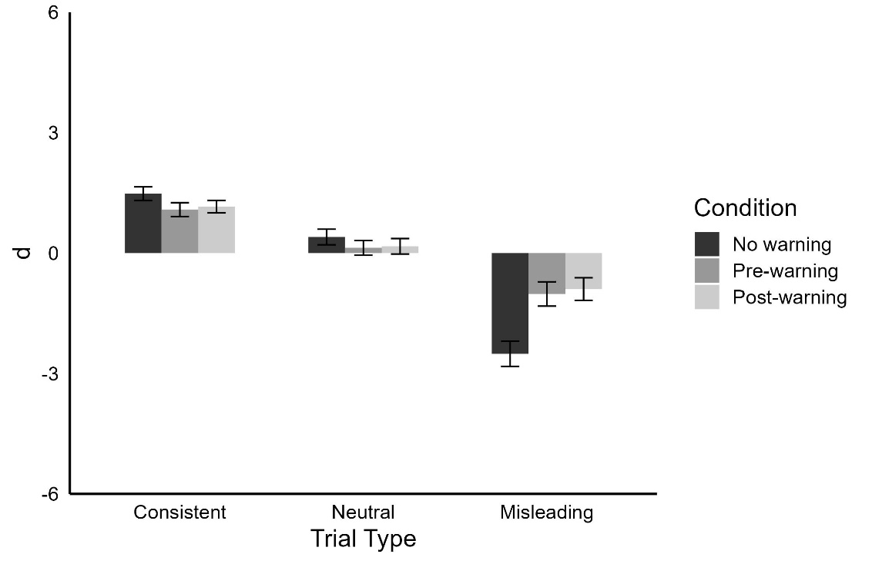
Experiment 2
We conducted a 3 (trial type: misleading, consistent, neutral) x 4 (warning group: no warning, pre-warning, post-warning, repeated warning) ANOVA on discriminability on the final memory test (See Figure 2). Discriminability depended on trial type, F [2,376] = 157.08, p < .001, $η_{p}^{2}$ = .46. Discriminability on misleading trials (M = -1.42) was significantly lower than consistent trials (M = 1.08), t [382] = -16.65, p < .001*, d = 1.47 and neutral trials (M = 0.33), t [382] = -11.66, p < .001*, d = 0.96. Discriminability on consistent trials was also significantly greater than neutral trials (t [382] = 4.99, p < .001*, d = 0.59). Discriminability did not significantly differ according to warning group (F [3,188] = 0.61, p = .613, $η_{p}^{2}$ = .01). Importantly, there was a significant interaction between trial type and warning group (F [6,376] = 4.82, p = .003, $η_{p}^{2}$ = .07). There was no impact of warning on neutral trial discriminability (F [3,188] = 0.39, p = .763, $η_{p}^{2}$= .01). Warnings impacted discriminability on misleading trials (F [3,188] = 3.77, p = .011, $η_{p}^{2}$ = .06). Discriminability on misleading trials was greater in the pre-warning group (M = -1.09; t [188] = 3.00, p = .016*, d = 0.62) and repeated warning group (M = -0.88; t [188] = 3.50, p = .003*, d = 0.73) compared to those in the no warning group (M = -2.37). There was no statistically significant difference in discriminability for misleading trials between the no warning and post-warning groups (M = -1.32; t [188] = 2.45, p = .071*, d = 0.49). There was no statistically significant difference between the post-warning and pre-warning group (t [188] = 0.53, p = .952*, d = 0.11), the pre-warning group and repeated warning group (t [188] = 0.49, p = .961*, d = 0.10), and post-warning group and repeated warning group (t [188] = 1.02, p = .738*, d = 0.21).
Warning also impacted consistent trial discriminability (F [3,188] = 3.19, p = .025, $η_{p}^{2}$ = .05). Discriminability on consistent trials was lower in the repeated warning group (M = 0.73; t [188] = 3.06, p = .013*, d = 0.59) compared to those in the no warning group (M = 1.38). There was no statistically significant difference in discriminability for consistent trials between the post-warning group (M = 1.13; t [188] = 1.15, p = .660*, d = 0.26) or the pre-warning group (M = 1.09; t [188] = 1.33, p = .542*, d = 0.30) compared to the no warning group. There was no statistically significant difference between the post-warning and pre-warning group (t [188] = 0.18, p = .998*, d = 0.04), the pre-warning group and repeated warning group (t [188] = 1.72, p = .316*, d = 0.32), and post-warning group and repeated warning group (t [188] = 1.89, p = .236*, d = 0.36).
Figure 2
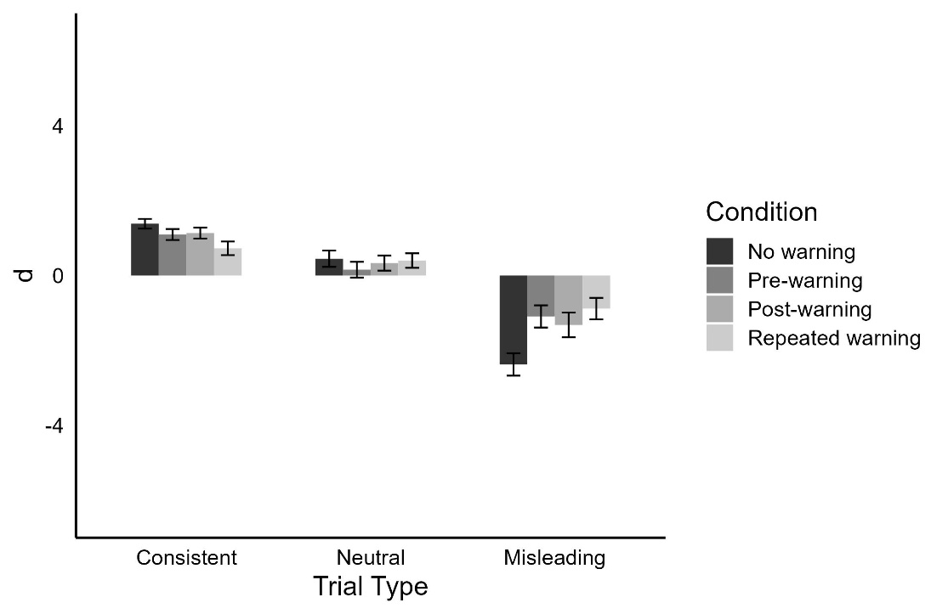
Mega-Analysis
In Experiment 2, we did not find that post-warning resulted in statistically significantly different memory accuracy or misinformation selection on the final memory test in comparison to the no warning condition. This is inconsistent with what we found in Experiment 1 and in prior eyewitness memory research on post-warnings. To further evaluate the effect of post-warnings within our two experiments we conducted a mega-analysis. Mega-analysis, also known as a meta-analysis of individual participant data, pools the raw data from multiple studies that were conducted under comparable conditions [16]. We were able to analyze the raw data for each of these conditions given that they had received identical procedure across experiments. Given that there was no double warning condition in Experiment 1, the data from the condition was not included in the mega-analysis. Analysis of Variance (ANOVAs) were estimated to explore the impact of warning group (post-warning, pre-warning, no warning) and trial type (misleading, neutral, consistent) on eyewitness memory accuracy and misinformation selection across Experiment 1 and Experiment 2. Consistent with Experiment 1, we found that post-warning and pre-warning resulted in significantly higher memory accuracy and significantly lower misinformation selection on misleading questions compared to the no warning condition.
All mega-analyses are reported below.
Accuracy
We conducted a 3 (trial type: misleading, consistent, neutral) x 3 (warning group: no warning, pre-warning, post-warning) ANOVA on accuracy on the final memory test. Correct recognition of witnessed event details depended on trial type, F [2,550] = 244.05, p < .001, $η_{p}^{2}$= .47. Accuracy on misleading trials (M = 0.49) was significantly lower than consistent trials (M = 0.82), t [554] = -21.14, p < .001*, d = -1.48 and neutral trials (M = 0.68), t [554] = -12.19, p <.001*, d = -0.80. Accuracy on consistent trials was also significantly greater than neutral trials (t [554] = 8.96, p < .001*, d = 0.78). Memory accuracy did not significantly differ according to warning group (F [2,275] = 0.77, p = 0.463,${ η}_{p}^{2}$ = .01). Importantly, there was a significant interaction (F [4, 550] = 12.56, p < .001; $η_{p}^{2}$ = .08). Warnings significantly impacted memory accuracy on misleading trials (F [2,275] = 11.12; p < .001; $η_{p}^{2}$ = .07), but not on consistent trials (F [2,275] = 2.52, p = .082,${ η}_{p}^{2}$ = .02), or on neutral trials (F [2,275] = 1.10, p = .334,${ η}_{p}^{2}$ = .01; Figure 3). Memory accuracy for misleading trials was greater in both the pre-warning group (M = 0.54; t [275] = 4.10, p = .002*, d = 0.61) and post-warning group (M = 0.54; t [275] = 4.01, p = .002*, d = 0.59) compared the no warning group (M = 0.39). There was no difference between the two warning groups (t [275] = 0.05, p < .999*, d = 0.01).
Figure 3
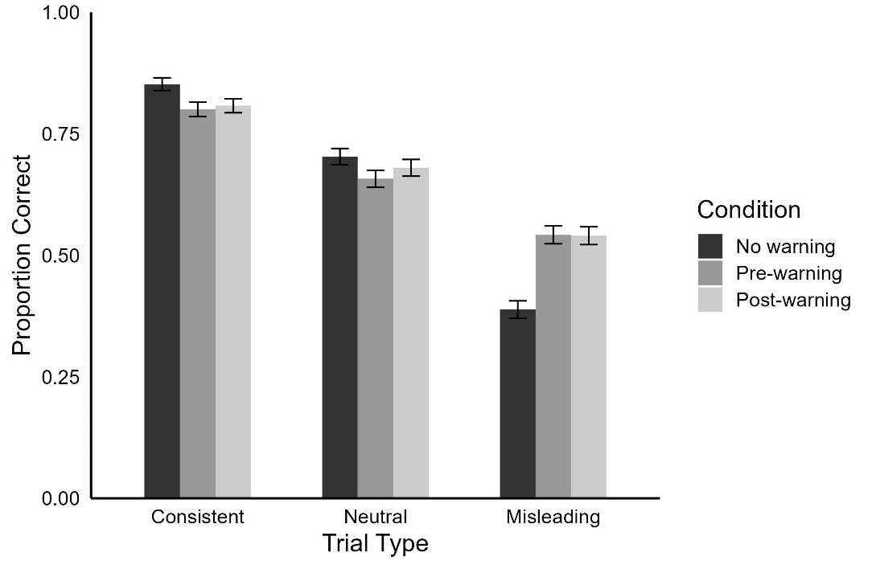

Misinformation Selection
We conducted a 3 (trial type: misleading, consistent, neutral) x 3 (warning group: no warning, pre-warning, post-warning) ANOVA on misinformation selection on the final memory test. Misinformation selection was also dependent upon trial type (F [2, 550] = 264.24, p < .001, $η_{p}^{2}$ = .49). As expected, misinformation selection was significantly higher on misleading trials (M = 0.43) compared to consistent trials (M = 0.09; t [554] = 21.33, p < .001*, d = 0.83) and neutral trials (M = 0.18; t [268] = 15.48, p < .001*, d = 0.54). Further, misinformation selection was significantly less for consistent trials compared to neutral trials (t [268] = -5.85, p < .001*, d = -0.27). Warning group significantly affected misinformation selection (F [2,275] = 4.51, p = .001; $η_{p}^{2}$= .04). Misinformation selection was significantly higher for the no warning condition (M = 0.26) compared to the per-warning (M = 0.22; t [275] = 2.59, p = .027*, d = 0.10) and post-warning conditions (M = 0.22; t [275] = 2.61, p < .026*, d = 0.10). Further, misinformation selection was significantly less for consistent trials compared to neutral trials (t [275] = -4.32, p = .001*, d = -0.0003).
There was a significant interaction between trial type and warning group (F [4, 550] = 13.18, p < .001, $η_{p}^{2}$ = .09; Figure 4). Warning group significantly impacted the misinformation selection on questions relating to misinformation (F [2, 275] = 14.64, p < .001, $η_{p}^{2}$ = .10). Specifically, misinformation selection on misleading trials was significantly lower in both the pre-warning group (M = .36; t [275] = -4.80, p < .001*, d = 0.70) and post-warning group (M = .37; t [275] = -4.56, p < .001*, d = -0.04) compared to the no warning group (M = .54). The difference in misinformation selection on misleading trials between the post-warning and pre-warning conditions was not significant (t [275] = 0.291, p = .954*, d = 0.06). Warning group did not significantly impact misinformation selection on questions relating to neutral (F [2, 275] = 0.69, p = .504, $η_{p}^{2}$= .01) or consistent information (F [2, 275] = 2.24, p = .108, $η_{p}^{2}$= .02).
Figure 4
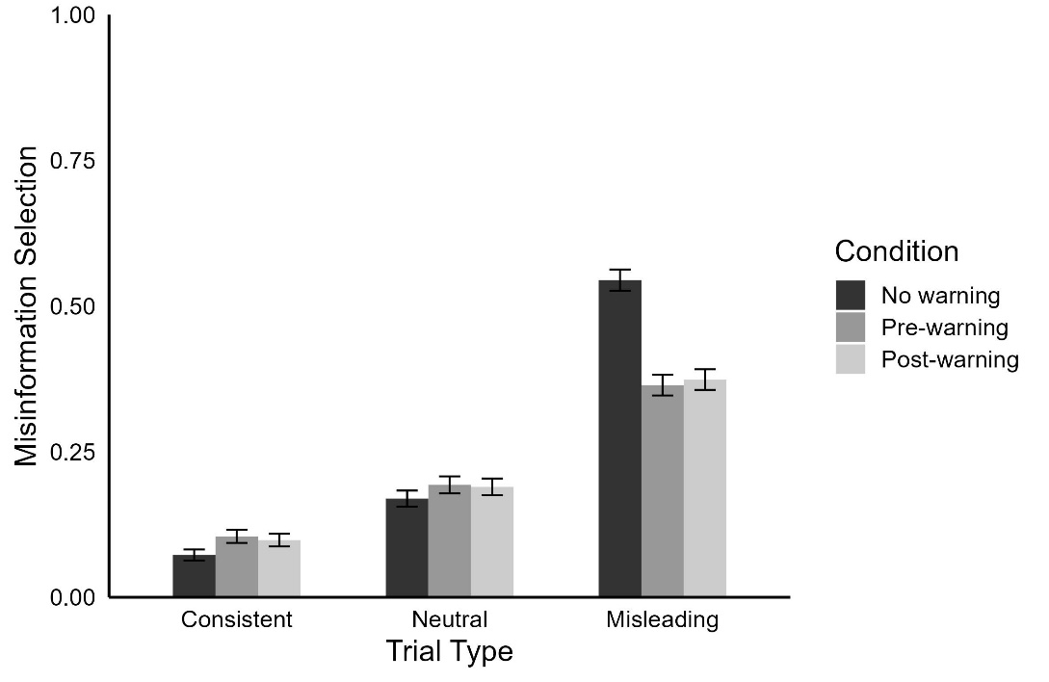

Comparisons of In-Person and Online Samples in Experiment 2
We compared the memory accuracy and misinformation selection results in our in-person sample and our online sample. These comparisons were made to evaluate if there were glaring differences in the behavior of these two groups and to assess the quality of our online data. It is important to note that our Experiment 1, Experiment 2, and mega-analysis results are overall consistent will prior in-person eyewitness memory and warning literature discussed in the main text. Furthermore, participants in our online sample were screened for paying attention through the amount of time they spent on webpages and their initial memory test accuracy. Importantly, we insured that participants had paid attention to experimental stimuli through the amount of time they spent on the crime video webpage and the post-event information webpage. As outlined in the main text, we removed particiants that spent too little time or too much time on these web pages. We further removed all participants that had an initial memory test accuracy that was less than chance, and our average initial test accuracy in Experiment 1 and Experiment 2 was comparable to initial test accuracy conducted in our prior in-person research [6]. The comparisons made below further support our position that our online sample is of comparable quality to samples obtained in prior in-person studies.
In the final sample there were 49 participants that completed the study in-person and 143 participants that completed the study online. In the in-person sample, there were an uneven number of participants in the no warning (n = 15), pre-warning (n = 9), post-warning (n = 11), and repeated warning (n = 14) conditions. In the online sample, there were an uneven number of participants in the no warning (n = 33), pre-warning (n = 39), post-warning (n = 36), and repeated warning (n = 35) conditions. We conducted Welches t-tests to assess overall differences in memory accuracy and misinformation selection between the two groups. Participants in the online sample had higher memory accuracy for the crime (M = 0.69, SD = 0.46) compared to the in-person condition (M = 0.61, SD = 0.49; t (73.37) = -2.74, p = .008, d = 0.47). There was no observed difference in misinformation selection between the online sample (M = 0.22, SD = 0.41) and in-person sample (M = 0.25, SD = 0.43; t (80.97) = 1.58, p = .119, d = -0.26). The in-person sample had insufficient sample size to do further statistical comparisons between conditions and trial type between samples. I report the average accuracy (Table 1) and misinformation selection (Table 2) by condition, trial type, and sample type below. Overall, statistical analysis and observations of the data do not suggest that the online sample was performing worse than the in-person sample. Thus, we maintain that the online samples collected in Experiment 1 and Experiment 2 are suitable for data analysis and provide further insight into the effectiveness of warnings on eyewitness memory that can be generalized outside of an online setting.

Table 1
Warning Condition | Online Sample |  |  | In-Person Sample
Warning Condition | Consistent | Neutral | Misleading | Consistent | Neutral | Misleading
No Warning | 0.86 (0.35) | 0.73 (0.39) | 0.39 (0.49) | 0.81 (0.40) | 0.63 (0.47) | 0.44 (0.50)
Pre-Warning | 0.81 (0.39) | 0.67 (0.47) | 0.55 (0.50) | 0.75 (0.44) | 0.61 (0.49) | 0.51 (0.50)
Post-Warning | 0.83 (0.38) | 0.69 (0.46) | 0.51 (0.50) | 0.73 (0.44) | 0.69 (0.46) | 0.58 (0.50)
Repeated Warning | 0.81 (0.39) | 0.75 (0.43) | 0.62 (0.49) | 0.62 (0.49) | 0.54 (0.50) | 0.40 (0.49)

Table 2
Warning Condition | Online Sample |  |  | In-Person Sample
Warning Condition | Consistent | Neutral | Misleading | Consistent | Neutral | Misleading
No Warning | 0.06 (0.25) | 0.16 (0.37) | 0.55 (0.50) | 0.11 (0.31) | 0.20 (0.40) | 0.43 (0.50)
Pre-Warning | 0.10 (0.30) | 0.16 (0.37) | 0.37 (0.48) | 0.14 (0.35) | 0.29 (0.46) | 0.32 (0.47)
Post-Warning | 0.09 (0.29) | 0.19 (0.39) | 0.40 (0.49) | 0.14 (0.34) | 0.13 (0.33) | 0.35 (0.48)
Repeated Warning | 0.13 (0.33) | 0.13 (0.34) | 0.29 (0.45) | 0.21 (0.41) | 0.23 (0.42) | 0.41 (0.49)

Figure 1. Discriminability on the final memory test in Experiment 1. “d” refers to d’ which was calculated as the z-score of proportion hits minus the z-score of the proportion of false alarms. Hits were accurate responses to questions on the final memory test while false alarms were selecting misinformation on the final memory test. Error bars indicate standard error.
Figure 2. Discriminability on the final memory test in Experiment 2. “d” refers to d’ which was calculated as the z-score of proportion hits minus the z-score of the proportion of false alarms. Hits were accurate responses to questions on the final memory test while false alarms were selecting misinformation on the final memory test. Error bars indicate standard error.
Figure 3. Accuracy results from the final memory tests from Experiment 1 and Experiment 2. “Proportion Correct” refers to the proportion of trials (consistent, neutral, misleading) that were answered correctly (i.e., the number of trials in which participants selected the correct details from the witnessed event divided by the total number of trials of each associated with each trial type). Error bars indicate standard error.
Figure 4. Misinformation selection results from the final memory test from Experiment 1 and Experiment 2. Misinformation Selection refers to the proportion of trials (consistent, neutral, misleading) that were answered with misinformation from the post-event information (i.e., the number of trials in which participants selected the misinformation from the post-event information on the final memory test divided by the total number of trials of each associated with each trial type). Error bars indicate standard error.
Table 1. Memory accuracy results from the final memory test from Experiment 2 broken down by sample source, trial type, and warning condition. Means are reported as a proportion and standard deviation is reported in parentheses.

Table 2. Misinformation Selection results from the final memory test from Experiment 2 broken down by sample source, trial type, and warning condition. Means are reported as a proportion and standard deviation is reported in parentheses.

