Supplementary Table 1. The information of measurement systems about virious biomakers
Biomarkers | Instruments | Measurement principal | Reagents | Calibrators | Quality Control | Linear Range | Current RIs
HDL | Hitachi 7600 | Direct Measurement. | Sekisui | Sekisui | Bio-Rad | 0.05 - 3.89 mmol/L | > 1.04 mmol/L
LDL | Hitachi 7600 | Direct Measurement. | Sekisui | Sekisui | Bio-Rad | 0.026 - 11.66 mmol/L | ≤ 3.4 mmol/L
AST | Hitachi LABOSPECT 008 AS | Enzyme Kinetic | Wako | Wako | Bio-Rad | 3 - 1200 U/L | M: 15 - 40 U/L  F: 13 - 35 U/L
ALT | Hitachi LABOSPECT 008 AS | Enzyme Kinetic | Wako | Wako | Bio-Rad | 2.4 - 1200 U/L | M: 9.0 – 50 U/L  F: 7.0 - 40 U/L
Glu | Hitachi LABOSPECT 008 AS | Hexokinase Method | Wako | Wako | Bio-Rad | 0.08 - 55.51 mmol/L | 3.9 - 5.8 mmol/L
UA | Hitachi LABOSPECT 008 AS | Uricase Method | Wako | Wako | Bio-Rad | 0.0117 - 4.679 mmol/L | Age < 20: 0.12 - 0.33  Age ≥ 20: 0.1 - 0.42 mmol/L
Crea | Hitachi LABOSPECT 008 AS | Creatininase Method | Hitachi | Wako | Bio-Rad | 7 - 8840 μmol/L | Age < 60 M: 57 - 97, F: 41 - 73, Age > 60 M: 57 - 111, F: 41 - 81μmol/L
Urea | Hitachi LABOSPECT 008 AS | Urease-Glutamate Dehydrogenase Method | Hitachi | Wako | Bio-Rad | 0.43 - 64.3 mmol/L | Age < 60 M: 3.1 - 8.0, F: 2.6 - 7.5. Age > 60 M: 3.6 - 9.5, F: 3.1 - 6.8 mmol/L
Cys C | Hitachi LABOSPECT 008 AS | Latex-Enhanced Immunoturbidimetric | Maccura | Maccura | Maccura | 0.25 - 7.80 mg/L | 0.51 - 1.09 mg/L
HbA1c | MEDCONN Q8000 | HPLC | MEDCONN | MEDCONN | Bio-Rad | 3 - 20% | 4.0 - 6.0%
Note F, Female, M, Male, HPLC, High performance liquid chromatography, Wako, Wako Pure Chemical Industries, Bio-Rad, Bio-Rad Laboratories, Sekisui, Sekisui Medical, Hitachi, Hitachi High-Tech Corporation, Tokyo, Japan, Sekisui: Sekisui Chemical Co., Ltd, Tokyo, Japan, Maccura, Sichuan Maccura Technology Co., Ltd., Chengdu, China.

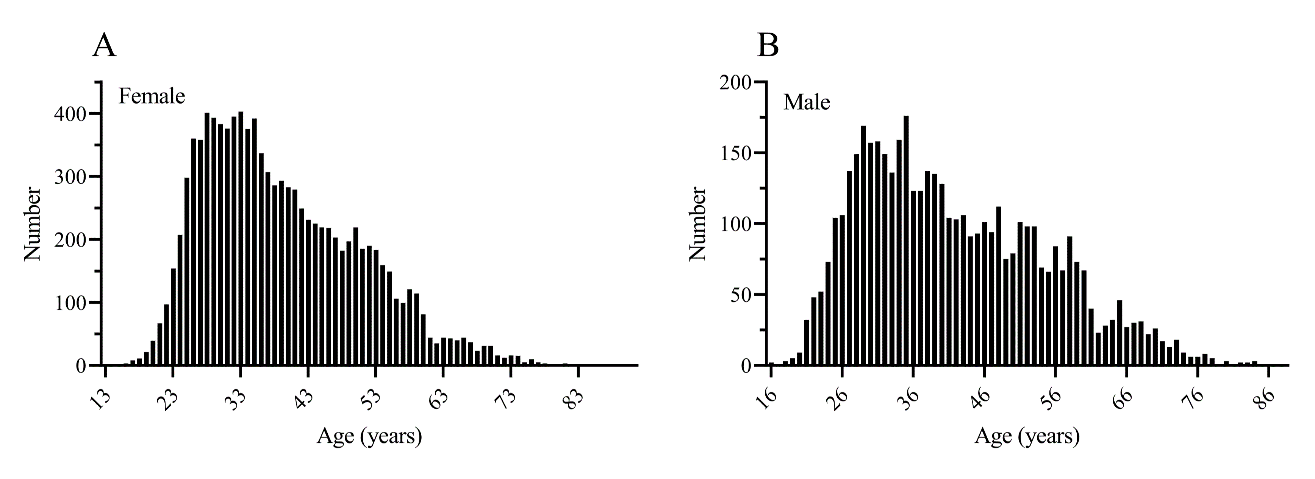
Supplementary Fig. 1. The age distribution of included female and male cases.

