Structure based drug design and machine learning approaches for identifying natural inhibitors against the human αβIII tubulin isotype
Pruthanka Anant Patil and Bajarang Vasant Kumbhar*
Department of Biological Sciences, Sunandan Divatia School of Science, SVKM’s NMIMS (Deemed to be) University, Mumbai-400056, Maharashtra, India.

*Corresponding Author
Dr. Bajarang Vasant Kumbhar
Assistant Professor
Sunandan Divatia School of Science
Department of Biological Science
NMIMS (Deemed to be) University, Mumbai
Maharashtra-400056, India
Contact: (91-22) 4235 5963
Email: bajarang.kumbhar@nmims.edu

Figure
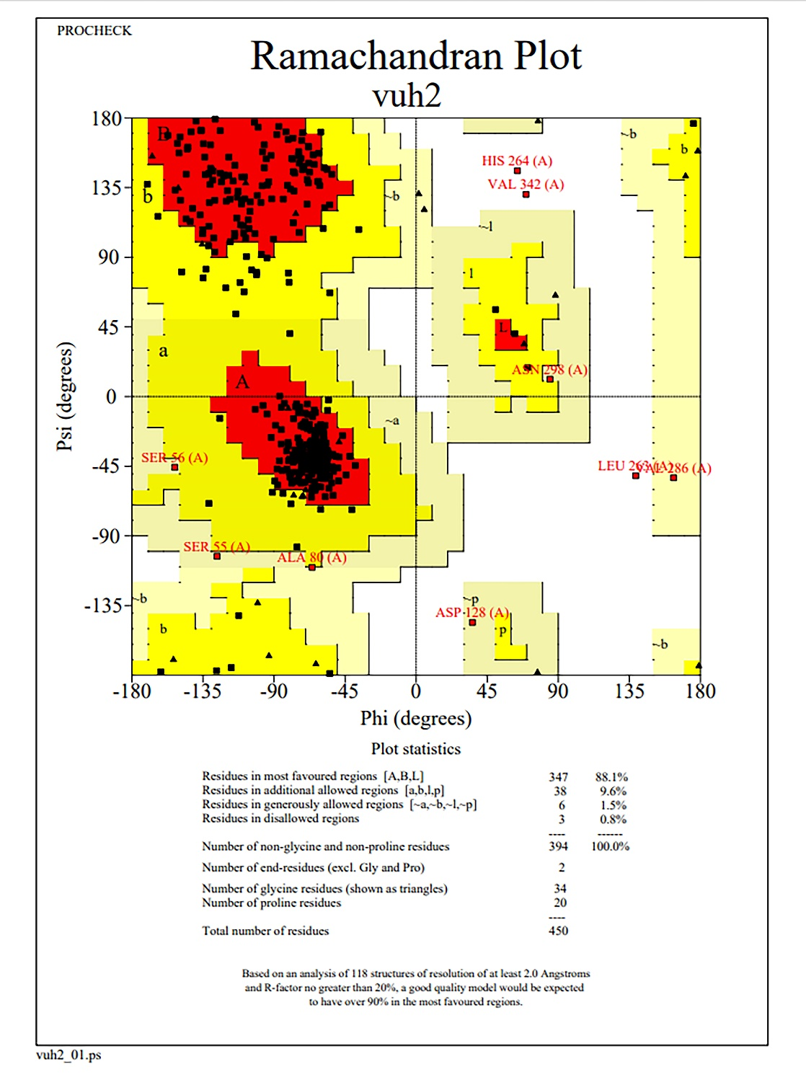
Supplementary Figure 1: Ramachandran plot for βIII tubulin isotype. Here 88.1 % residues are in most favoured region, 9.6 % residues in the additional allowed region, 1.5% residues in generously allowed region and 0.8% residues in the disallowed region. The red region in Ramachandran plot is ‘most favoured’, bright yellow is ‘additional allowed’, dull yellow is the ‘generously allowed’ and white is the ‘disallowed’ region. There is total 97.7 % residues are in the most favoured and additional allowed region. This shows that the model quality is good for further modelling study.

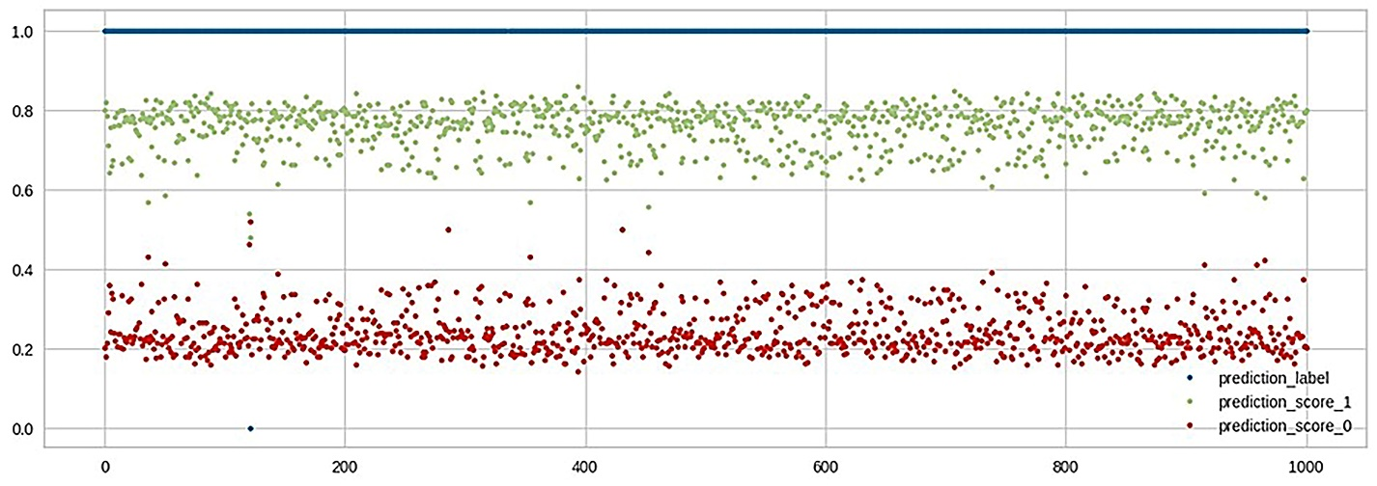
Supplementary Figure 2: Scatter plot of a test dataset from ML. Here prediction_label: indicated in blue line represents the true labels of the data. It appears to be a horizontal line at the top of the plot, indicating that most predictions are correct. prediction_score_1: indicated in green shows the predicted probability or score for the positive class (class 1). The dots are scattered around the 0.8 level, suggesting that the model is confident in its positive predictions. prediction_score_0: indicated in red shows the predicted probability or score for the negative class (class 0). The dots are scattered around the 0.2 level, indicating that the model is also confident in its negative predictions. Based on the predicted probability scores for the positive class, we selected 20 compounds exhibiting the highest activity.

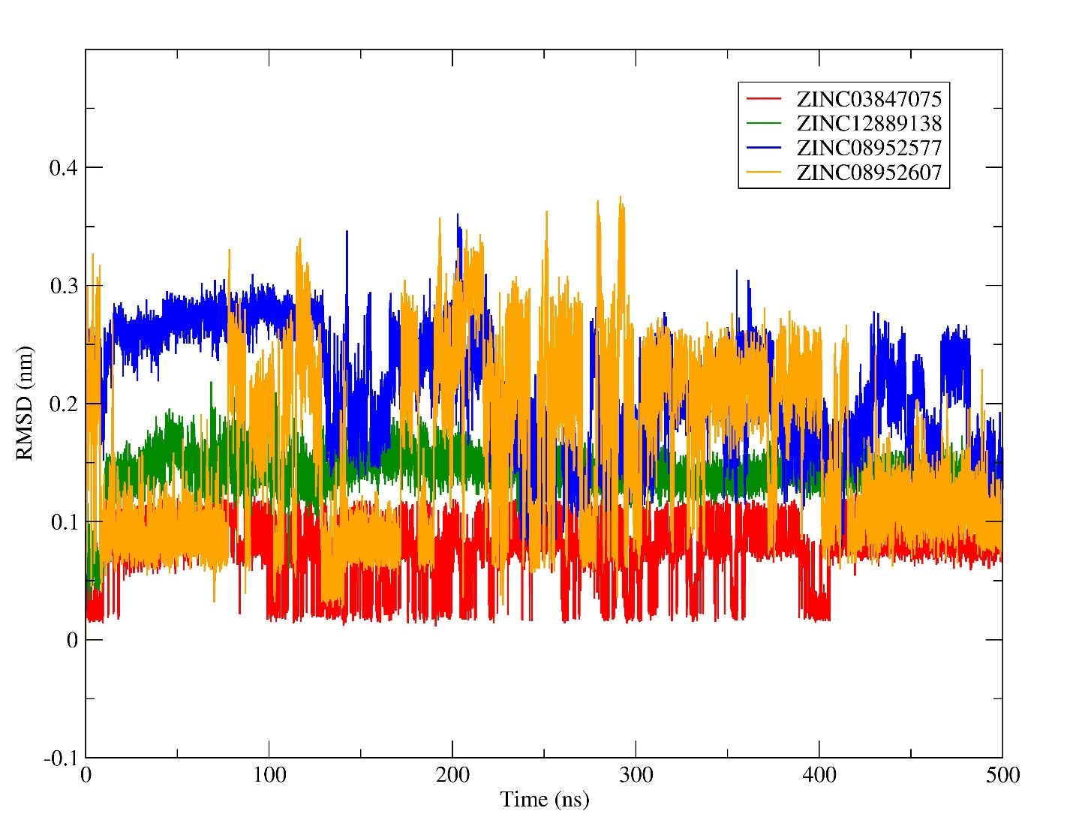
Supplementary Figure 3: RMSD plot analysis of the drug compounds. Here, ZINC03847075 is depicted in red, ZINC12889138 in green, ZINC08952577 in blue and ZINC08952607 in orange. The RMSD plot was generated of backbone C_{α} atoms for 500ns, all the systems reached their equilibrium after 100ns time steps.

Table
Supplementary Table 1. List of Drugs for active training Dataset
Sr.No. | Active Drugs Targeting Taxol Site | References
 | Paclitaxel, Taxol, Oraxol | Alqahtani FY, Aleanizy FS, El Tahir E, Alkahtani HM, AlQuadeib BT. Paclitaxel. Profiles Drug Subst Excip Relat Methodol. 2019;44:205-238. doi: 10.1016/bs.podrm.2018.11.001. Epub 2019 Apr 22. PMID: 31029218.
 | Docetaxel ,taxotere | Ma Z, Zhang W, Dong B, Xin Z, Ji Y, Su R, Shen K, Pan J, Wang Q, Xue W. Docetaxel remodels prostate cancer immune microenvironment and enhances checkpoint inhibitor-based immunotherapy. Theranostics. 2022 Jun 27;12(11):4965-4979. doi: 10.7150/thno.73152. PMID: 35836810; PMCID: PMC9274752.
 | Ixabepilone (BMS-247550), AzaepothiloneB | LiverTox: Clinical and Research Information on Drug-Induced Liver Injury [Internet]. Bethesda (MD): National Institute of Diabetes and Digestive and Kidney Diseases; 2012–. Ixabepilone. 2017 Jan 5. PMID: 31643317.
 | EpothiloneD (EPO D) (KOS-862, NSC-703147, desoxyepothiloneB BMS-241027) | Kolman A. Epothilone D (Kosan/Roche). Curr Opin Investig Drugs. 2004 Jun;5(6):657-67. PMID: 15242255.
 | EpothiloneD (EPO D) (KOS-862, | Cheng H, Huang G. Synthesis and Activity of Epothilone D. Curr Drug Targets. 2018;19(15):1866-1870. doi: 10.2174/1389450119666180803122118. PMID: 30073925.
 | Albendazol | Dharnidharka, V. R., Agrawal, M., & Dandge, V. P. (1993). Albendazole. Indian pediatrics, 30(9), 1115–1118.
 | Mebendazol | Keystone, J. S., & Murdoch, J. K. (1979). Mebendazole. Annals of internal medicine, 91(4), 582–586. https://doi.org/10.7326/0003-4819-91-4-582
 | sagopilone (ZK-EPO, ZK-219477) | Klar, U., Hoffmann, J., & Giurescu, M. (2008). Sagopilone (ZK-EPO): from a natural product to a fully synthetic clinical development candidate. Expert opinion on investigational drugs, 17(11), 1735–1748. https://doi.org/10.1517/13543784.17.11.1735
 | IDN-5109 (BAY 59-8862, Ortataxel) | Rong, D., Wang, C., Zhang, X., Wei, Y., Zhang, M., Liu, D., Farhan, H., Momen Ali, S. A., Liu, Y., Taouil, A., Guo, W., Wang, Y., Ojima, I., Yang, S., & Wang, H. (2020). A novel taxane, difluorovinyl-ortataxel, effectively overcomes paclitaxel-resistance in breast cancer cells. Cancer letters, 491, 36–49. https://doi.org/10.1016/j.canlet.2020.06.025
 | Cabazitaxel( Jevtana, XRP-6258) | Hofman, M. S., Emmett, L., Sandhu, S., Iravani, A., Joshua, A. M., Goh, J. C., Pattison, D. A., Tan, T. H., Kirkwood, I. D., Ng, S., Francis, R. J., Gedye, C., Rutherford, N. K., Weickhardt, A., Scott, A. M., Lee, S. T., Kwan, E. M., Azad, A. A., Ramdave, S., Redfern, A. D., … TheraP Trial Investigators and the Australian and New Zealand Urogenital and Prostate Cancer Trials Group (2021). [177Lu]Lu-PSMA-617 versus cabazitaxel in patients with metastatic castration-resistant prostate cancer (TheraP): a randomised, open-label, phase 2 trial. Lancet (London, England), 397(10276), 797–804. https://doi.org/10.1016/S0140-6736(21)00237-3
 | Tesetaxel (DJ-927, Genta, Inc) Novel oral taxane derivative | Saif, M. W., Sarantopoulos, J., Patnaik, A., Tolcher, A. W., Takimoto, C., & Beeram, M. (2011). Tesetaxel, a new oral taxane, in combination with capecitabine: a phase I, dose-escalation study in patients with advanced solid tumors. Cancer chemotherapy and pharmacology, 68(6), 1565–1573. https://doi.org/10.1007/s00280-011-1639-3
 | Larotaxel (XRP9881, Sanofi) A semi-synthetic taxane derived from 10-deacylbaccatin III | Metzger-Filho, O., Moulin, C., de Azambuja, E., & Ahmad, A. (2009). Larotaxel: broadening the road with new taxanes. Expert opinion on investigational drugs, 18(8), 1183–1189. https://doi.org/10.1517/13543780903119167
 | BMS-184476 (Bristol Myers Squib) A 7 methylthiomethyl ether of paclitaxel | Ojima, I., & Geney, R. (2003). BMS-184476 Bristol-Myers Squibb. Current opinion in investigational drugs (London, England: 2000), 4(6), 732–736.
 | TPI-287 (Archer Biosciences) Paclitaxel derivative with a 5-membered baccatin ring crosses blood brain barrier | Fitzgerald, D. P., Emerson, D. L., Qian, Y., Anwar, T., Liewehr, D. J., Steinberg, S. M., Silberman, S., Palmieri, D., & Steeg, P. S. (2012). TPI-287, a new taxane family member, reduces the brain metastatic colonization of breast cancer cells. Molecular cancer therapeutics, 11(9), 1959–1967. https://doi.org/10.1158/1535-7163.MCT-12-0061
 | Nab-paclitaxel (Abraxane, Celgene) serum albumin conjugated paclitaxel | Yardley D. A. (2013). nab-Paclitaxel mechanisms of action and delivery. Journal of controlled release: official journal of the Controlled Release Society, 170(3), 365–372. https://doi.org/10.1016/j.jconrel.2013.05.041
 | Xyotax (Opaxio, paclitaxel polyglumex (PPX) Cell Therapeutics, Inc.) paclitaxel conjugated to α-poly-L- glutamic acid | Singer J. W. (2005). Paclitaxel poliglumex (XYOTAX, CT-2103): a macromolecular taxane. Journal of controlled release: official journal of the Controlled Release Society, 109(1-3), 120–126. https://doi.org/10.1016/j.jconrel.2005.09.033
 | EndoTag-1 (Medigene AG) Cationic liposomal paclitaxel, Genexol-PM (Samyang Gene, South Korea) Polymeric micellar paclitaxel formulation | Schuch G. (2005). EndoTAG-1. MediGene. Current opinion in investigational drugs (London, England: 2000), 6(12), 1259–1265.  Nam, S. H., Lee, S. W., Lee, Y. J., & Kim, Y. M. (2023). Safety and Tolerability of Weekly Genexol-PM, a Cremophor-Free Polymeric Micelle Formulation of Paclitaxel, with Carboplatin in Gynecologic Cancer: A Phase I Study. Cancer research and treatment, 55(4), 1346–1354. https://doi.org/10.4143/crt.2022.1436
 | DHA-paclitaxel (Taxoprexin, Protarga, Inc.) DHA-conjugated paclitaxel | Payne, M., Ellis, P., Dunlop, D., Ranson, M., Danson, S., Schacter, L., & Talbot, D. (2006). DHA-paclitaxel (Taxoprexin) as first-line treatment in patients with stage IIIB or IV non-small cell lung cancer: report of a phase II open-label multicenter trial. Journal of thoracic oncology: official publication of the International Association for the Study of Lung Cancer, 1(9), 984–990.
 | Milataxel | Ramanathan, R. K., Picus, J., Raftopoulos, H., Bernard, S., Lockhart, A. C., Frenette, G., Macdonald, J., Melin, S., Berg, D., Brescia, F., Hochster, H., & Cohn, A. (2008). A phase II study of milataxel: a novel taxane analogue in previously treated patients with advanced colorectal cancer. Cancer chemotherapy and pharmacology, 61(3), 453–458. https://doi.org/10.1007/s00280-007-0489-5
 | EPO906 | Rothermel, J., Wartmann, M., Chen, T., & Hohneker, J. (2003). EPO906 (epothilone B): a promising novel microtubule stabilizer. Seminars in oncology, 30(3 Suppl 6), 51–55. https://doi.org/10.1016/s0093-7754(03)00125-8
 | Ixabepilone (Ixempra, Bristol Myers Squib), BMS-247550 An epothilone B lactam | Ixabepilone. (2017). In LiverTox: Clinical and Research Information on Drug-Induced Liver Injury. National Institute of Diabetes and Digestive and Kidney Diseases.  Lin, N., Brakora, K., & Seiden, M. (2003). BMS-247550 Bristol-Myers Squibb/GBF. Current opinion in investigational drugs (London, England: 2000), 4(6), 746–756.
 | Sagopilone (ZK-EPO, Bayer Schering AG), ZK 219477 Fully synthetic allyl derivative of epothilone B | Galmarini C. M. (2009). Sagopilone, a microtubule stabilizer for the potential treatment of cancer. Current opinion in investigational drugs (London, England: 2000), 10(12), 1359–1371.
 | KOS 862 (Kosan Biosciences; BMS-241027 Bristol Myers Squib) Natural epothilone D, ZK-EPO | Monk, J. P., Villalona-Calero, M., Larkin, J., Otterson, G., Spriggs, D. S., Hannah, A. L., Cropp, G. F., Johnson, R. G., & Hensley, M. L. (2012). A phase 1 study of KOS-862 (Epothilone D) co-administered with carboplatin (Paraplatin®) in patients with advanced solid tumors. Investigational new drugs, 30(4), 1676–1683. https://doi.org/10.1007/s10637-011-9731-4
 | KOS 1584 (Kosan Biosciences) Epothilone D derivative | Lam, E. T., Goel, S., Schaaf, L. J., Cropp, G. F., Hannah, A. L., Zhou, Y., McCracken, B., Haley, B. I., Johnson, R. G., Mani, S., & Villalona-Calero, M. A. (2012). Phase I dose escalation study of KOS-1584, a novel epothilone, in patients with advanced solid tumors. Cancer chemotherapy and pharmacology, 69(2), 523–531. https://doi.org/10.1007/s00280-011-1724-7
 | Discodermolide (Novartis) | De Souza M. V. (2004). (+)-discodermolide: a marine natural product against cancer. TheScientificWorldJournal, 4, 415–436. https://doi.org/10.1100/tsw.2004.96
 | Rhazinilam | Sirindil, F., Weibel, J. M., Pale, P., & Blanc, A. (2022). Rhazinilam-leuconolam family of natural products: a half century of total synthesis. Natural product reports, 39(8), 1574–1590. https://doi.org/10.1039/d2np00026a
 | Cephalomannine | An, S., Xu, X., Bao, Y., Su, F., & Jiang, Y. (2024). Cephalomannine reduces radiotherapy resistance in non-small cell lung cancer cells by blocking the β-catenin-BMP2 signaling pathway. Tissue & cell, 91, 102577. Advance online publication. https://doi.org/10.1016/j.tice.2024.102577
 | deacetyltaxol | Helson L. (1993). Cephalomannine and 10-deacetyltaxol cytotoxicity in human glial and neuroblastoma cell-lines. International journal of oncology, 2(2), 297–299.
 | 4,12-diacetyloxy-10,14,16,16-tetramethyl-1,9,15-tris(oxidanyl)-11-oxidanylidene-6-oxatetracyclo [11.3.1.0%5E%7B3,10%7D.0%5E%7B4,7%7D] heptadec-13-en-2-yl] %20benzoate | Jiang, B., Gao, L., Wang, H., Sun, Y., Zhang, X., Ke, H., Liu, S., Ma, P., Liao, Q., Wang, Y., Wang, H., Liu, Y., Du, R., Rogge, T., Li, W., Shang, Y., Houk, K. N., Xiong, X., Xie, D., Huang, S., … Yan, J. (2024). Characterization and heterologous reconstitution of Taxus biosynthetic enzymes leading to baccatin III. Science (New York, N.Y.), 383(6683), 622–629. https://doi.org/10.1126/science.adj3484
 | 3-(2-bromanylethanoylamino)-2-oxidanyl-3-phenyl-propanoyl] oxy-10,14,16,16-tetramethyl-1,9,12-tris(oxidanyl)-11-oxidanylidene-6-oxatetracyclo [11.3.1.0%5E%7B3,10%7D.0%5E%7B4,7%7D]heptadec-13-en-2-yl]%20benzoate | Prota, A. E., Lucena-Agell, D., Ma, Y., Estevez-Gallego, J., Li, S., Bargsten, K., Josa-Prado, F., Altmann, K. H., Gaillard, N., Kamimura, S., Mühlethaler, T., Gago, F., Oliva, M. A., Steinmetz, M. O., Fang, W. S., & Díaz, J. F. (2023). Structural insight into the stabilization of microtubules by taxanes. eLife, 12, e84791. https://doi.org/10.7554/eLife.84791
 | 3-[(4-methoxy-2-methylidene-4-oxidanylidene-butanoyl)amino]-2-oxidanyl-3-phenyl-propanoyl]oxy-10,14,16,16-tetramethyl-1,9,12-tris(oxidanyl)-11-oxidanylidene-6-oxatetracyclo[11.3.1.0^{3,10}.0^{4,7}]heptadec-13-en-2-yl] benzoate | Prota, A. E., Lucena-Agell, D., Ma, Y., Estevez-Gallego, J., Li, S., Bargsten, K., Josa-Prado, F., Altmann, K. H., Gaillard, N., Kamimura, S., Mühlethaler, T., Gago, F., Oliva, M. A., Steinmetz, M. O., Fang, W. S., & Díaz, J. F. (2023). Structural insight into the stabilization of microtubules by taxanes. eLife, 12, e84791. https://doi.org/10.7554/eLife.84791
 | sphinxolide b | Zhang, X., Minale, L., Zampella, A., & Smith, C. D. (1997). Microfilament depletion and circumvention of multiple drug resistance by sphinxolides. Cancer research, 57(17), 3751–3758.

Supplementary Table 2. List of Drugs for inactive training Dataset
Sr.No. | Inactive Drugs Targeting Non-Taxol Site: | References
 | Vinblastine | Wang, Y. N., Wang, Y. Y., Wang, J., Bai, W. J., Miao, N. J., & Wang, J. (2023). Vinblastine resets tumor-associated macrophages toward M1 phenotype and promotes antitumor immune response. Journal for immunotherapy of cancer, 11(8), e007253. https://doi.org/10.1136/jitc-2023-007253
 | Vincristine | Finkel H. E. (1967). Vincristine therapy. New York state journal of medicine, 67(18), 2474–2478.
 | Vinorelbine | Capasso A. (2012). Vinorelbine in cancer therapy. Current drug targets, 13(8), 1065–1071. https://doi.org/10.2174/138945012802009017
 | Estramustine | Sangrajrang, S., Calvo, F., & Fellous, A. (1999). Estramustine resistance. General pharmacology, 33(2), 107–113. https://doi.org/10.1016/s0306-3623(98)00272-9
 | Vindesine | Gökbuget, N., & Hoelzer, D. (1997). Vindesine in the treatment of leukaemia. Leukemia & lymphoma, 26(5-6), 497–506. https://doi.org/10.3109/10428199709050886
 | Triazolopyrimidine | Felicetti, T., Pismataro, M. C., Cecchetti, V., Tabarrini, O., & Massari, S. (2022). Triazolopyrimidine Nuclei: Privileged Scaffolds for Developing Antiviral Agents with a Proper Pharmacokinetic Profile. Current medicinal chemistry, 29(8), 1379–1407. https://doi.org/10.2174/0929867328666210526120534
 | Cevipabulin | Nasrin, S. R., Rashedul Kabir, A. M., Konagaya, A., Ishihara, T., Sada, K., & Kakugo, A. (2019). Stabilization of microtubules by cevipabulin. Biochemical and biophysical research communications, 516(3), 760–764. https://doi.org/10.1016/j.bbrc.2019.06.095
 | Cryptophycin 52 | Eren, E., Watts, N. R., Sackett, D. L., & Wingfield, P. T. (2021). Conformational changes in tubulin upon binding cryptophycin-52 reveal its mechanism of action. The Journal of biological chemistry, 297(4), 101138. https://doi.org/10.1016/j.jbc.2021.101138
 | Cemadotin | Jordan, M. A., Walker, D., de Arruda, M., Barlozzari, T., & Panda, D. (1998). Suppression of microtubule dynamics by binding of cemadotin to tubulin: possible mechanism for its antitumor action. Biochemistry, 37(50), 17571–17578. https://doi.org/10.1021/bi9817414
 | Dolastatins (TZT-1027, Tasidotin) | Pettit G. R. (1997). The dolastatins. Fortschritte der Chemie organischer Naturstoffe = Progress in the chemistry of organic natural products. Progres dans la chimie des substances organiques naturelles, 70, 1–79. https://doi.org/10.1007/978-3-7091-6551-5_1
 | Hemiasterlins (HTI-286) | Gamble, W. R., Durso, N. A., Fuller, R. W., Westergaard, C. K., Johnson, T. R., Sackett, D. L., Hamel, E., Cardellina, J. H., 2nd, & Boyd, M. R. (1999). Cytotoxic and tubulin-interactive hemiasterlins from Auletta sp. and Siphonochalina spp. sponges. Bioorganic & medicinal chemistry, 7(8), 1611–1615. https://doi.org/10.1016/s0968-0896(99)00089-9
 | Vinflunine | Vinflunine. (2011). Prescrire international, 20(112), 11–13.
 | Eribulin | Schöffski, P., Chawla, S., Maki, R. G., Italiano, A., Gelderblom, H., Choy, E., Grignani, G., Camargo, V., Bauer, S., Rha, S. Y., Blay, J. Y., Hohenberger, P., D'Adamo, D., Guo, M., Chmielowski, B., Le Cesne, A., Demetri, G. D., & Patel, S. R. (2016). Eribulin versus dacarbazine in previously treated patients with advanced liposarcoma or leiomyosarcoma: a randomised, open-label, multicentre, phase 3 trial. Lancet (London, England), 387(10028), 1629–1637. https://doi.org/10.1016/S0140-6736(15)01283-0
 | Mertansine | von Minckwitz, G., Huang, C. S., Mano, M. S., Loibl, S., Mamounas, E. P., Untch, M., Wolmark, N., Rastogi, P., Schneeweiss, A., Redondo, A., Fischer, H. H., Jacot, W., Conlin, A. K., Arce-Salinas, C., Wapnir, I. L., Jackisch, C., DiGiovanna, M. P., Fasching, P. A., Crown, J. P., Wülfing, P., … KATHERINE Investigators (2019). Trastuzumab Emtansine for Residual Invasive HER2-Positive Breast Cancer. The New England journal of medicine, 380(7), 617–628. https://doi.org/10.1056/NEJMoa1814017
 | Colchicine | Buckley, L. F., & Libby, P. (2024). Colchicine's Role in Cardiovascular Disease Management. Arteriosclerosis, thrombosis, and vascular biology, 44(5), 1031–1041. https://doi.org/10.1161/ATVBAHA.124.319851
 | Combretastatins (AVE8062. CA-1-P, CA-4-P | Karatoprak, G. Ş., Küpeli Akkol, E., Genç, Y., Bardakci, H., Yücel, Ç., & Sobarzo-Sánchez, E. (2020). Combretastatins: An Overview of Structure, Probable Mechanisms of Action and Potential Applications. Molecules (Basel, Switzerland), 25(11), 2560. https://doi.org/10.3390/molecules25112560
 | Fosbretabulin | Granata, R., Locati, L. D., & Licitra, L. (2014). Fosbretabulin for the treatment of anaplastic thyroid cancer. Future oncology (London, England), 10(13), 2015–2021. https://doi.org/10.2217/fon.14.154
 | Verubulin | Lindberg, A., Mossine, A. V., Aliaga, A., Hopewell, R., Massarweh, G., Rosa-Neto, P., Shao, X., Bernard-Gauthier, V., Scott, P. J. H., & Vasdev, N. (2021). Preliminary Evaluations of [11C]Verubulin: Implications for Microtubule Imaging With PET. Frontiers in neuroscience, 15, 725873. https://doi.org/10.3389/fnins.2021.725873
 | Crolibulin | Zhang Z, Wang C, Ma L, Jiang X, Wu C, Wang Y, Jiang Y, Zheng W, Yang Y, Ma Y, Yang J. Molecular mechanism of crolibulin in complex with tubulin provides a rationale for drug design. Biochem Biophys Res Commun. 2019 Apr 2;511(2):381-386. doi: 10.1016/j.bbrc.2019.02.064. Epub 2019 Feb 22. PMID: 30803758.
 | Ombrabulin | Blay, J. Y., Pápai, Z., Tolcher, A. W., Italiano, A., Cupissol, D., López-Pousa, A., Chawla, S. P., Bompas, E., Babovic, N., Penel, N., Isambert, N., Staddon, A. P., Saâda-Bouzid, E., Santoro, A., Franke, F. A., Cohen, P., Le-Guennec, S., & Demetri, G. D. (2015). Ombrabulin plus cisplatin versus placebo plus cisplatin in patients with advanced soft-tissue sarcomas after failure of anthracycline and ifosfamide chemotherapy: a randomised, double-blind, placebo-controlled, phase 3 trial. The Lancet. Oncology, 16(5), 531–540. https://doi.org/10.1016/S1470-2045(15)70102-6
 | 2-Methoxyestradiol | Kim, J. H., Nam, J. K., Kim, A. R., Park, M. S., Lee, H. J., Park, J., Kim, J., & Lee, Y. J. (2022). 2-Methoxyestradiol Inhibits Radiation-Induced Skin Injuries. International journal of molecular sciences, 23(8), 4171. https://doi.org/10.3390/ijms23084171
 | Methoxybenzene-sulfonamide (ABT-751, E7010) | Kasawar, G. B., & Farooqui, M. N. (2009). Stability Indicating HPLC Method for the Determination of Chiral Purity of R-(-)-5-[2-aminopropyl]-2-methoxybenzene Sulfonamide. Indian journal of pharmaceutical sciences, 71(5), 533–537. https://doi.org/10.4103/0250-474X.58187
 | BNC105 | Wang, T., Wu, C., Wang, C., Zhang, G., Arnst, K. E., Yao, Y., Zhang, Z., Wang, Y., Pu, D., & Li, W. (2020). Unraveling the molecular mechanism of BNC105, a phase II clinical trial vascular disrupting agent, provides insights into drug design. Biochemical and biophysical research communications, S0006-291X(20)30008-5. Advance online publication. https://doi.org/10.1016/j.bbrc.2019.12.083
 | Nocodazole | Surani, A. A., Colombo, S. L., Barlow, G., Foulds, G. A., & Montiel-Duarte, C. (2021). Optimizing Cell Synchronization Using Nocodazole or Double Thymidine Block. Methods in molecular biology (Clifton, N.J.), 2329, 111–121. https://doi.org/10.1007/978-1-0716-1538-6_9
 | (NPI-2358)-Plinabulin | Al-Shakliah, N. S., Kadi, A. A., Al-Salahi, R., & Rahman, A. F. M. M. (2022). In Vitro Identification of Potential Metabolites of Plinabulin (NPI 2358) in Hepatic Preparations Using Liquid Chromatography-Ion Trap Mass Spectrometry. ACS omega, 7(25), 21465–21472. https://doi.org/10.1021/acsomega.2c00929
 | Indanocine | Khwaja, S., Fatima, K., Mishra, D., Babu, V., Kumar, Y., Malik, S. B., Tabassum, M., Luqman, S., Bawankule, D. U., Chanda, D., Khan, F., Mondhe, D. M., & Negi, A. S. (2021). An improved synthesis of indanocine and antiproliferative activity of 2-benzylindanocine via microtubule destabilization. Chemical biology & drug design, 98(1), 127–143. https://doi.org/10.1111/cbdd.13857

Supplementary Table 3. List of selected 20 Active compounds for machine learning
Sr. No. | 20 Active Compounds
 | ZINC02944617
 | ZINC08764924
 | ZINC03847075
 | ZINC08952577
 | ZINC04258871
 | ZINC03841969
 | ZINC12661777
 | ZINC02147998
 | ZINC02092587
 | ZINC02104549
 | ZINC12864260
 | ZINC08918490
 | ZINC04073313
 | ZINC04073314
 | ZINC08952607
 | ZINC08789098
 | ZINC08918146
 | ZINC08964756
 | ZINC12889138
 | ZINC12296715

Supplementary Movie 1. MD simulation movie of αβ_{III} tubulin heterodimer without drug compound in Taxol site. The visual molecular dynamics (VMD) software was used create a simulation movie.
Supplementary Movie 2. MD simulation movie of αβ_{III} tubulin heterodimer with ZINC03847075 compound in Taxol site. The visual molecular dynamics (VMD) software was used create a simulation movie.
Supplementary Movie 3. MD simulation movie of αβ_{III} tubulin heterodimer with ZINC12889138 compound in Taxol site. The visual molecular dynamics (VMD) software was used create a simulation movie.
Supplementary Movie 4. MD simulation movie of αβ_{III} tubulin heterodimer with ZINC08952577 compound in Taxol site. The visual molecular dynamics (VMD) software was used create a simulation movie.
Supplementary Movie 5. MD simulation movie of αβ_{III} tubulin heterodimer with ZINC08952607 compound in Taxol site. The visual molecular dynamics (VMD) software was used create a simulation movie.

