Supplementary Data as Per Reviewer’s Comment

Table S1: Showing IUPAC Name and Structures of 1,2-disubstituted Benzimidazole derivatives used as ligands
Ligand Code | IUPAC/Ligand Name | Structures
P1 | 4-(((2-ethyl-1H-benzo[d]imidazol-1-yl)methyl)amino)-2-hydroxybenzoic acid
P2 | 4-(((2-butyl-1H-benzo[d]imidazol-1-yl)methyl)amino)-2-hydroxybenzoic acid
P3 | 2-hydroxy-4-(((2-propyl-1H-benzo[d]imidazol-1-yl)methyl)amino)benzoic acid
P4 | 4-(((2-(carboxymethyl)-1H-benzo[d]imidazol-1-yl)methyl)amino)-2-hydroxybenzoic acid
P5 | 2-hydroxy-4-(((2-(2-hydroxyphenyl)-1H-benzo[d]imidazol-1-yl)methyl)amino)benzoic acid
P6 | 4-(((2-(2-carboxyethyl)-1H-benzo[d]imidazol-1-yl)methyl)amino)-2-hydroxybenzoic acid
P7 | 2-hydroxy-4-(((2-(3-hydroxyphenyl)-1H-benzo[d]imidazol-1-yl)methyl)amino)benzoic acid
P8 | 2-hydroxy-4-(((2-(4-hydroxyphenyl)-1H-benzo[d]imidazol-1-yl)methyl)amino)benzoic acid
P9 | 4-(((2-(2,3-dihydroxyphenyl)-1H-benzo[d]imidazol-1-yl)methyl)amino)-2-hydroxybenzoic acid
P10 | 4-(((2-(2,4-dihydroxyphenyl)-1H-benzo[d]imidazol-1-yl)methyl)amino)-2-hydroxybenzoic acid
P11 | 4-(((2-(2,5-dihydroxyphenyl)-1H-benzo[d]imidazol-1-yl)methyl)amino)-2-hydroxybenzoic acid
P12 | 4-(((2-(2,6-dihydroxyphenyl)-1H-benzo[d]imidazol-1-yl)methyl)amino)-2-hydroxybenzoic acid
P13 | 4-(((2-(3,4-dihydroxyphenyl)-1H-benzo[d]imidazol-1-yl)methyl)amino)-2-hydroxybenzoic acid
P14 | 4-(((2-(3,5-dihydroxyphenyl)-1H-benzo[d]imidazol-1-yl)methyl)amino)-2-hydroxybenzoic acid
P15 | 4-(((2-(3-chlorophenyl)-1H-benzo[d]imidazol-1-yl)methyl)amino)-2-hydroxybenzoic acid
P16 | 2-hydroxy-4-(((2-(o-tolyl)-1H-benzo[d]imidazol-1-yl)methyl)amino)benzoic acid
P17 | 4-(((2-(2-carboxyphenyl)-1H-benzo[d]imidazol-1-yl)methyl)amino)-2-hydroxybenzoic acid
P18 | 4-(((2-(2-aminophenyl)-1H-benzo[d]imidazol-1-yl)methyl)amino)-2-hydroxybenzoic acid
P19 | 2-hydroxy-4-(((2-(3-nitrophenyl)-1H-benzo[d]imidazol-1-yl)methyl)amino)benzoic acid
P20 | 4-(((2-(4-carboxyphenyl)-1H-benzo[d]imidazol-1-yl)methyl)amino)-2-hydroxybenzoic acid
P21 | 4-(((2-(3-bromophenyl)-1H-benzo[d]imidazol-1-yl)methyl)amino)-2-hydroxybenzoic acid
P22 | 4-(((2-(4-bromophenyl)-1H-benzo[d]imidazol-1-yl)methyl)amino)-2-hydroxybenzoic acid
P23 | 4-(((2-(4-(bromomethyl)phenyl)-1H-benzo[d]imidazol-1-yl)methyl)amino)-2-hydroxybenzoic acid
P24 | 2-hydroxy-4-(((2-(4-nitrophenyl)-1H-benzo[d]imidazol-1-yl)methyl)amino)benzoic acid
P25 | 2-hydroxy-4-(((2-(3,4,5-trihydroxyphenyl)-1H-benzo[d]imidazol-1-yl)methyl)amino)benzoic acid
P26 | 2-hydroxy-4-(((2-styryl-1H-benzo[d]imidazol-1-yl)methyl)amino)benzoic acid
P27 | 2-hydroxy-4-(((2-(2-nitrophenyl)-1H-benzo[d]imidazol-1-yl)methyl)amino)benzoic acid
P28 | 2-hydroxy-4-(((2-(p-tolyl)-1H-benzo[d]imidazol-1-yl)methyl)amino)benzoic acid
P29 | 4-(((2-(2-amino-3-hydroxyphenyl)-1H-benzo[d]imidazol-1-yl)methyl)amino)-2-hydroxybenzoic acid
P30 | 2-hydroxy-4-(((2-(3,4,5-trihydroxystyryl)-1H-benzo[d]imidazol-1-yl)methyl)amino)benzoic acid
P31 | 2-hydroxy-4-(((2-(4-hydroxystyryl)-1H-benzo[d]imidazol-1-yl)methyl)amino)benzoic acid
P32 | 4-(((2-(2-acetoxyphenyl)-1H-benzo[d]imidazol-1-yl)methyl)amino)-2-hydroxybenzoic acid
P33 | 2-hydroxy-4-(((2-(2-hydroxy-3-methylphenyl)-1H-benzo[d]imidazol-1-yl)methyl)amino)benzoic acid
P34 | 2-hydroxy-4-(((2-(2-hydroxy-5-sulfophenyl)-1H-benzo[d]imidazol-1-yl)methyl)amino)benzoic acid
P35 | 2-hydroxy-4-(((2-(3-methyl-4-nitrophenyl)-1H-benzo[d]imidazol-1-yl)methyl)amino)benzoic acid
P36 | 2-hydroxy-4-(((2-(4-methyl-2-nitrophenyl)-1H-benzo[d]imidazol-1-yl)methyl)amino)benzoic acid
P37 | 2-hydroxy-4-(((2-(1-hydroxyethyl)-1H-benzo[d]imidazol-1-yl)methyl)amino)benzoic acid
P38 | 4-(((2-(2,5-dihydroxyphenyl)-1H-benzo[d]imidazol-1-yl)methyl)amino)-2-hydroxybenzoic acid
P39 | 2-hydroxy-4-(((2-(4-hydroxy-3-methoxyphenyl)-1H-benzo[d]imidazol-1-yl)methyl)amino)benzoic acid
P40 | 2-hydroxy-4-(((2-(4-methoxyphenyl)-1H-benzo[d]imidazol-1-yl)methyl)amino)benzoic acid
P41 | 4-(((2-acetyl-1H-benzo[d]imidazol-1-yl)methyl)amino)-2-hydroxybenzoic acid
P42 | 4-(((2-(2-carboxy-2-hydroxyethyl)-1H-benzo[d]imidazol-1-yl)methyl)amino)-2-hydroxybenzoic acid
P43 | 2-hydroxy-4-(((2-(pyridin-3-yl)-1H-benzo[d]imidazol-1-yl)methyl)amino)benzoic acid
P44 | 4-(((2-(2-carboxyvinyl)-1H-benzo[d]imidazol-1-yl)methyl)amino)-2-hydroxybenzoic acid
P45 | 2-hydroxy-4-(((2-vinyl-1H-benzo[d]imidazol-1-yl)methyl)amino)benzoic acid
P46 | 2-hydroxy-4-(((2-(1,2,3,4,5-pentahydroxypentyl)-1H-benzo[d]imidazol-1-yl)methyl)amino)benzoic acid
P47 | 1-(((4-carboxy-3-hydroxyphenyl)amino)methyl)-1H-benzo[d]imidazole-2-carboxylic acid
P48 | 4-(((2-(3-carboxypropyl)-1H-benzo[d]imidazol-1-yl)methyl)amino)-2-hydroxybenzoic acid
P49 | 4-(((2-(2-carboxy-1,2-dihydroxyethyl)-1H-benzo[d]imidazol-1-yl)methyl)amino)-2-hydroxybenzoic acid
P50 | 4-(((2-(benzamidomethyl)-1H-benzo[d]imidazol-1-yl)methyl)amino)-2-hydroxybenzoic acid

2D and 3D Structure for Research Article
- 3D Image of interaction (compound P32)
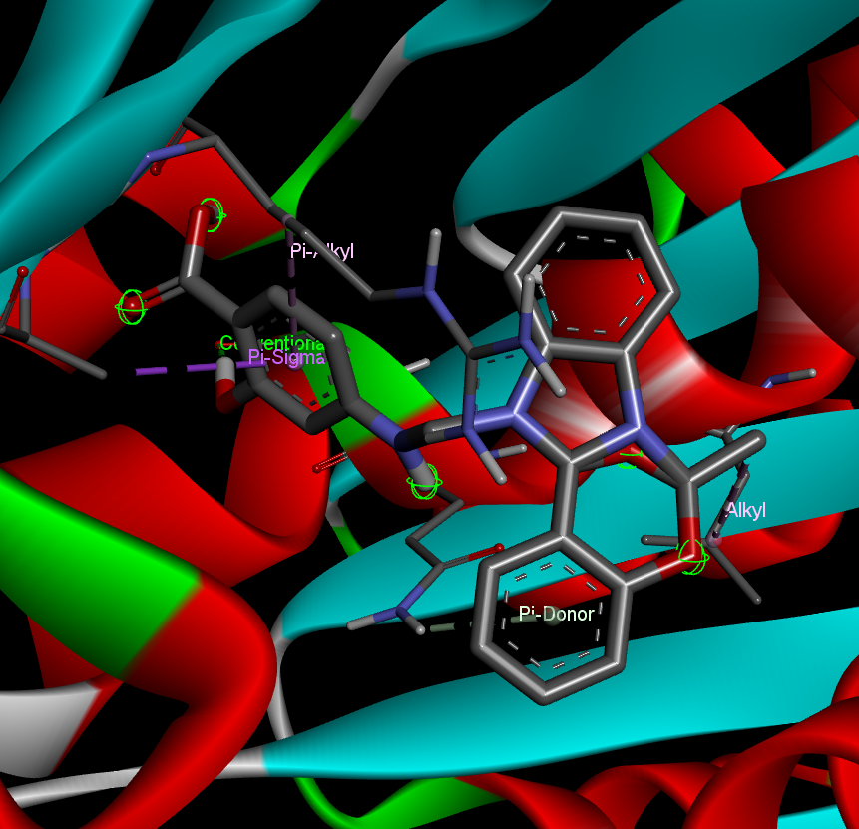

2D Image of Interaction (Compound P32)
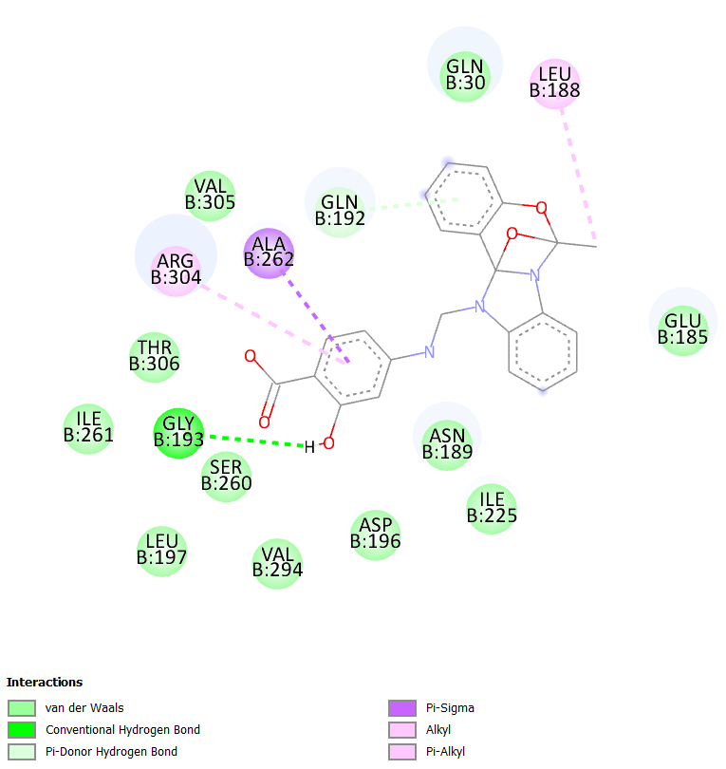
Fig. 4: Binding interaction of compound P32 with 2Q1Y protein

- 3D Image of interaction (Para-amino salicylic acid) Standard
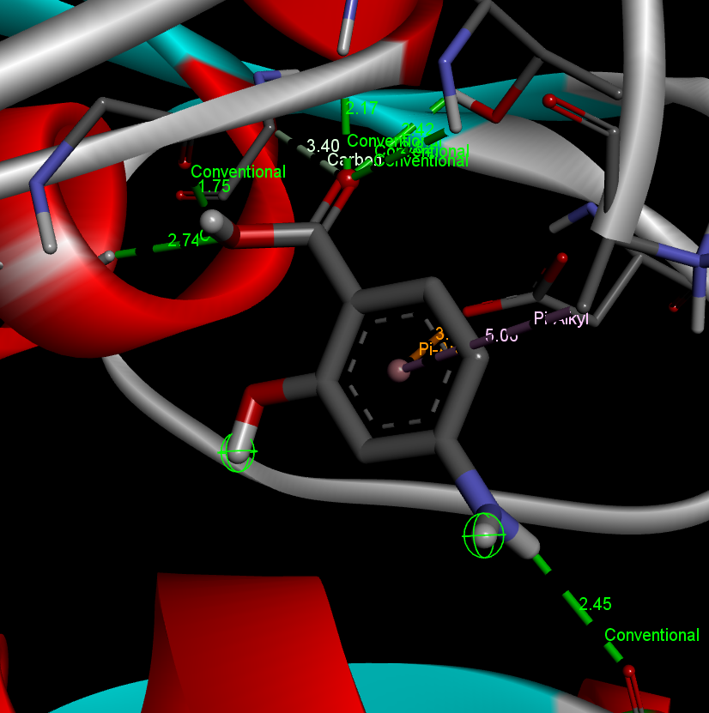

2D Image of interaction (Para-amino salicylic acid) Standard
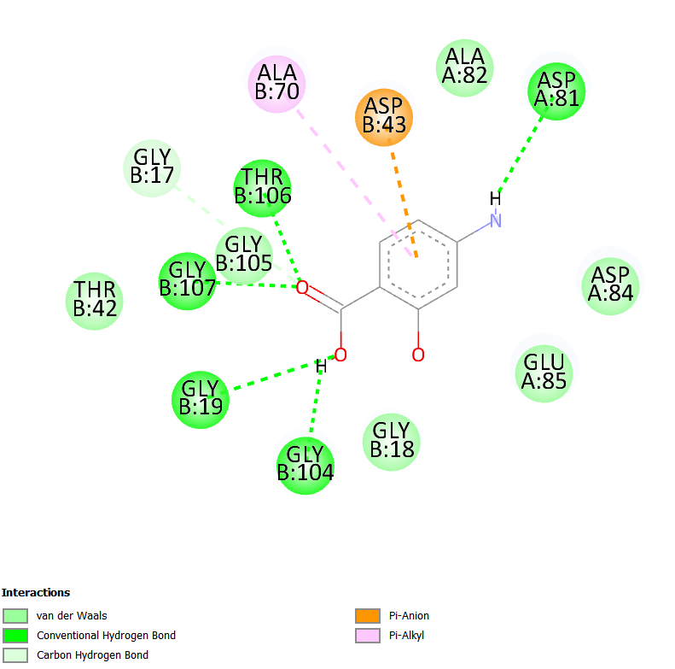
Fig. 5: Binding interaction of Para-amino salicylic acid (Standard) with 2Q1Y protein
- 3D Image of interaction (Isoniazid) Standard
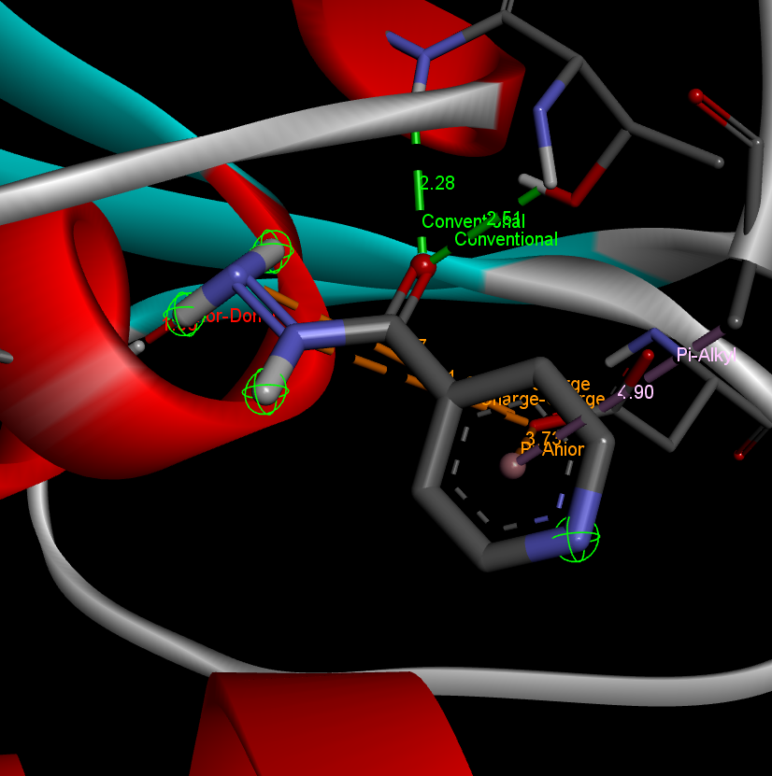
2D Image of interaction (Isoniazid) Standard
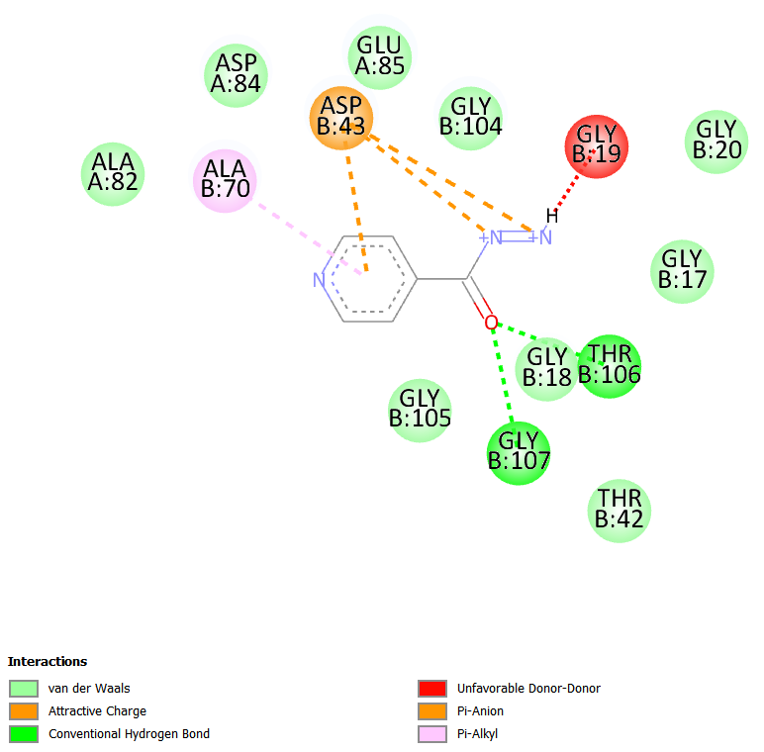
Fig. 6: Binding interaction of Isoniazid (Standard) with 2Q1Y protein

