Supplementary materials
Supplementary Figure 1 – The visualisation of the Boruta feature selection analysis. Feature selection analysis to identify variables most closely related to D2T RA definition at baseline (A) and two (B) and one (C) years in advance. Green columns indicate features confirmed as 'important' features for D2T RA. In contrast, red columns represent rejected or 'tentative' features as essential variables for D2T RA. Blue columns represent 'shadow attributes'. The Y axis shows the value of importance.

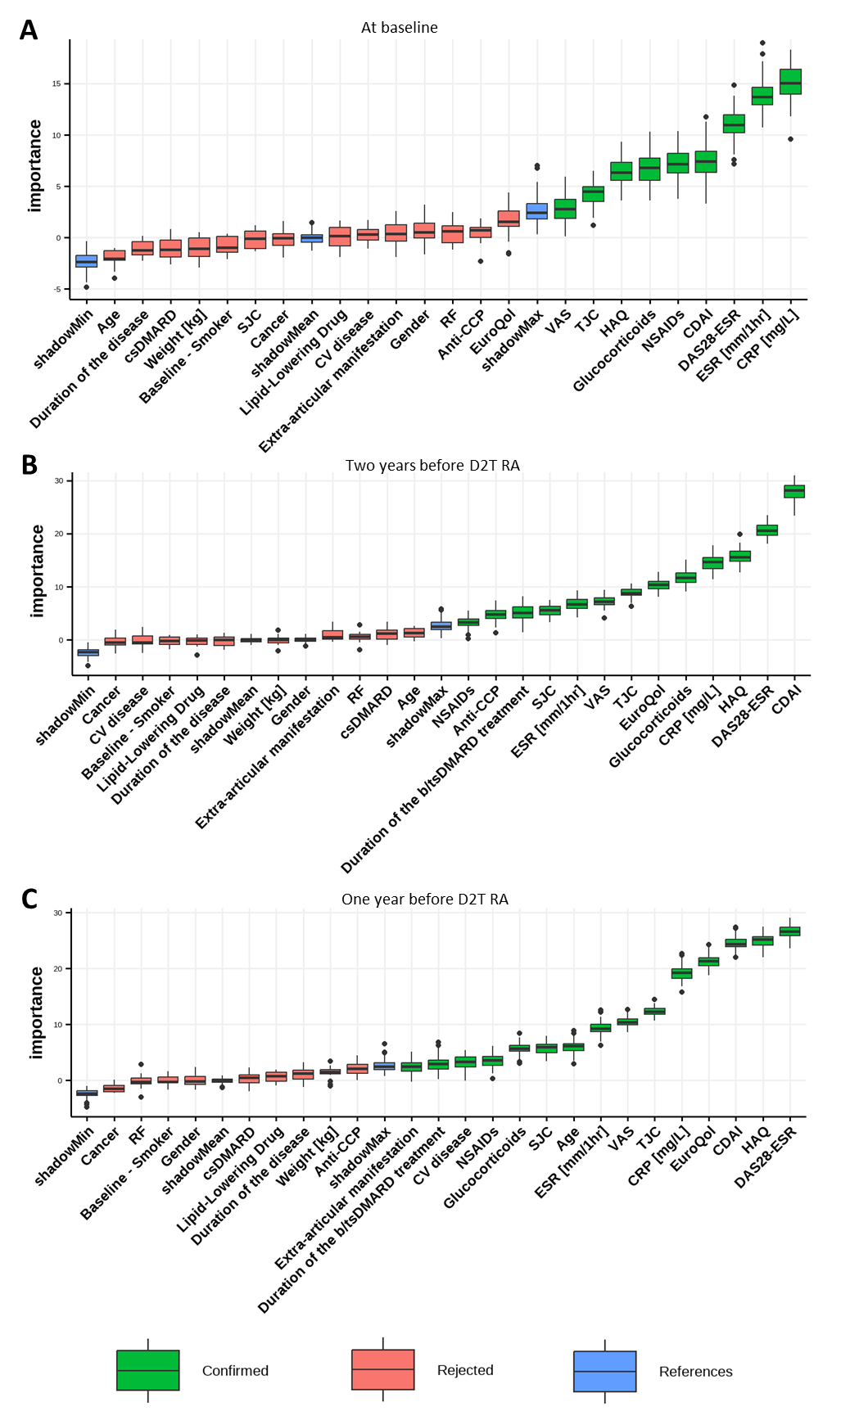
Supplementary Figure 2 - The visualisation of the Decision tree analysis. A decision tree was derived using recursive partitioning, and pruning was performed to remove trivial features. The figures illustrate the features most strongly associated with the transition to D2T RA at three key time points: baseline (A), two years prior (B) and one year prior (C) to meeting the definition of D2T RA.

