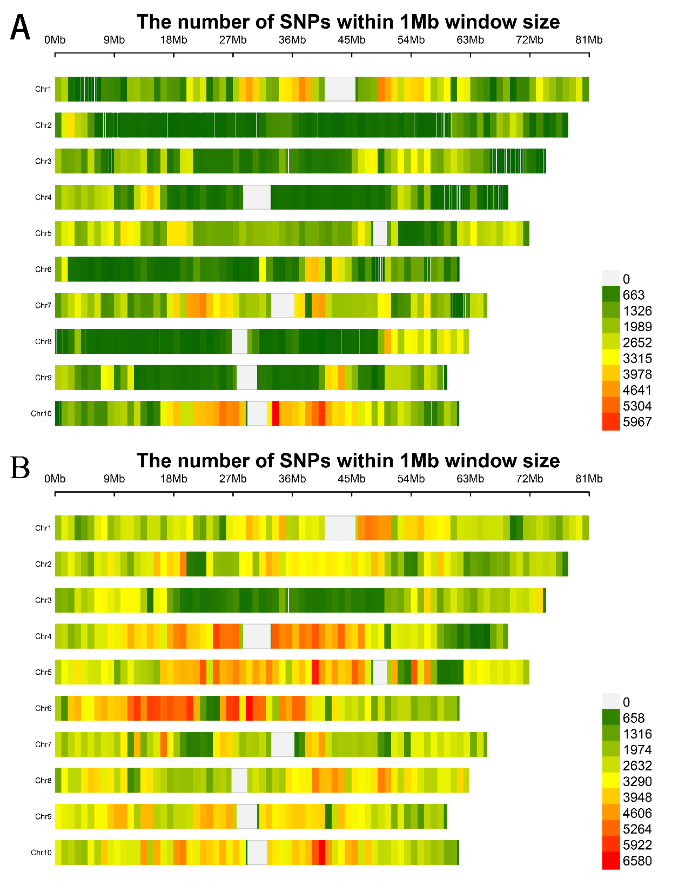
Fig S1. SNP marker density distribution
A and B, The distribution of SNP variations in 2 sorghum varieties on 10 chromosomes. A represents AJ2055, and B represents RN133.

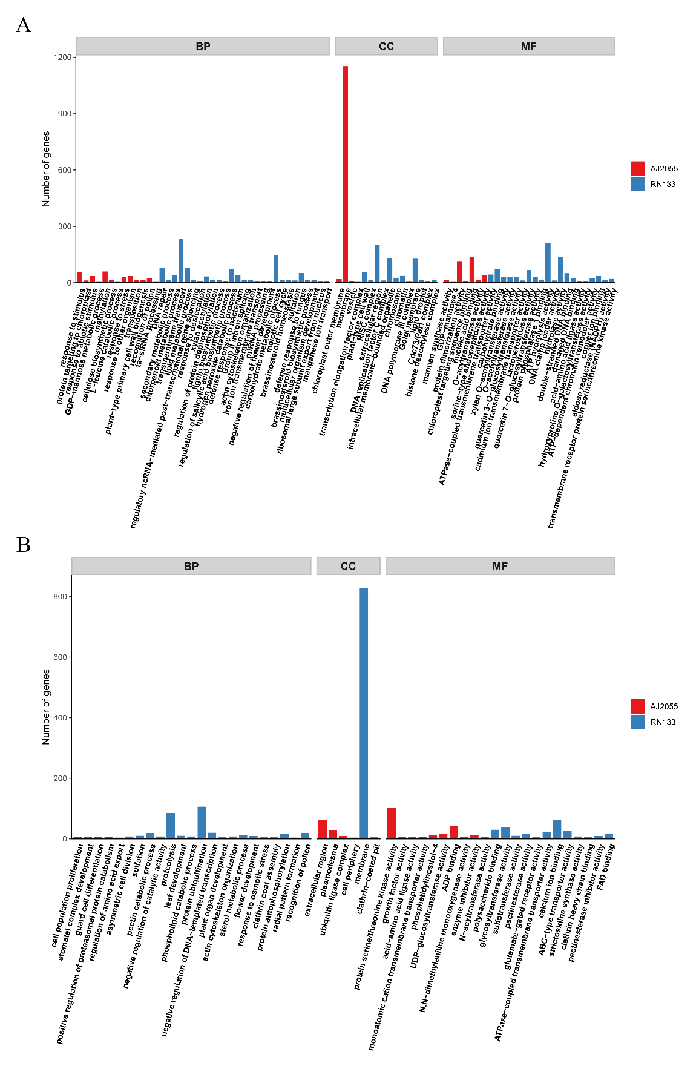
Fig S2. Go enrichment analysis.
A and B, Functional enrichment analysis of unique SNPs and InDels variants in two sorghum varieties (P<0.05). Red represents AJ2055, and blue represents RN133. The analysis includes three categories: Biological Process (BP), Cellular Component (CC), and Molecular Function (MF).
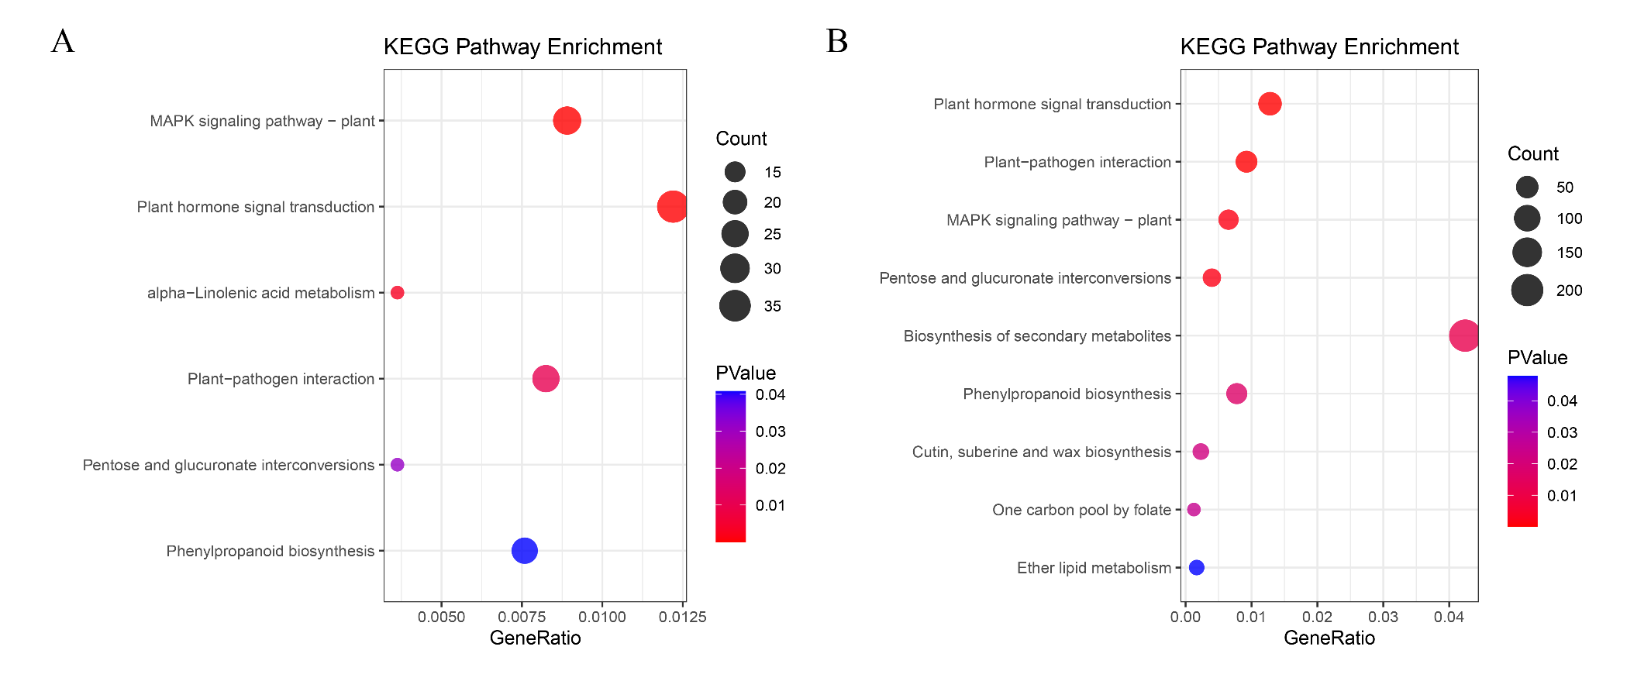

Fig S3. Significant enrichment pathway of InDels variants.
A and B, KEGG enrichment analysis of InDels variants in two sorghum varieties (P<0.05). A represents AJ2055, and B represents RN133.

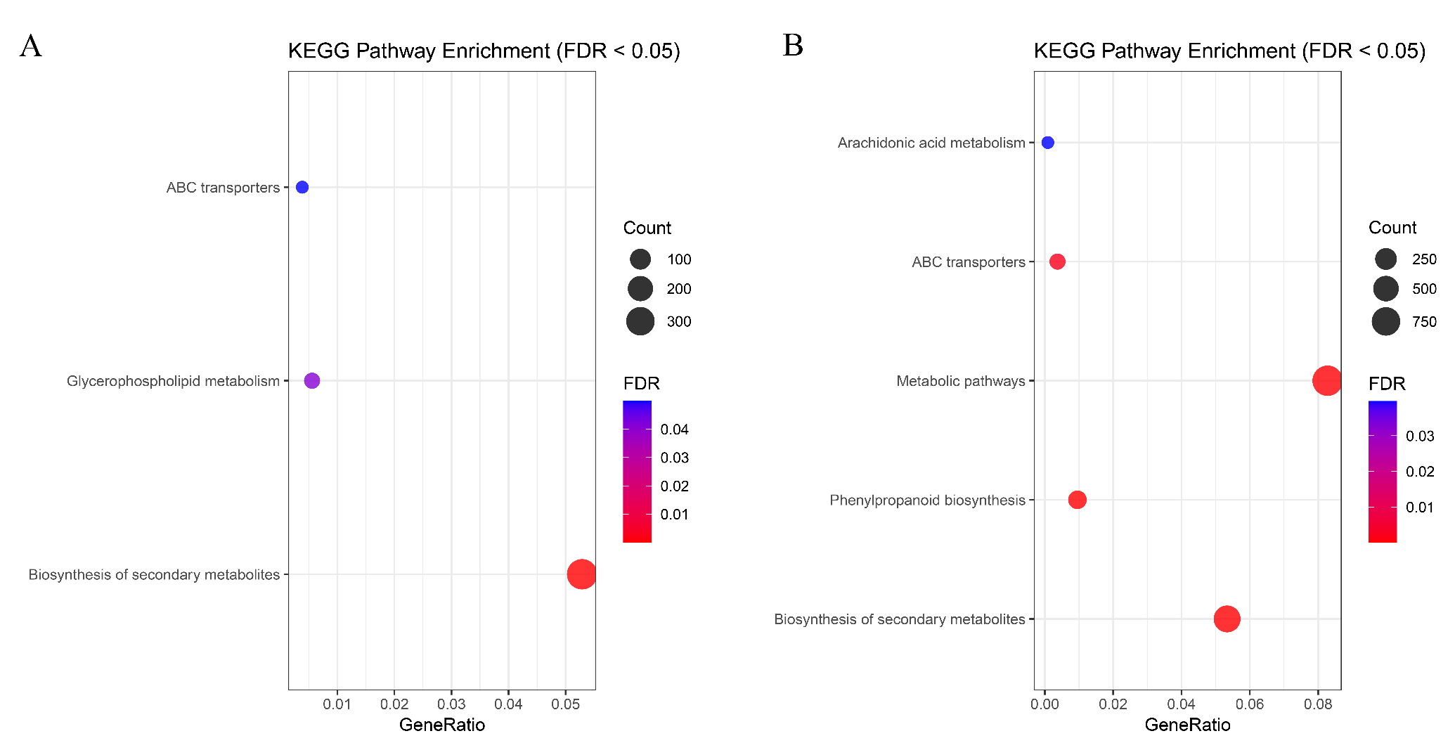
Fig S4. Significant enrichment pathway of SNPs variants.
A and B, KEGG enrichment analysis of SNPs variants in two sorghum varieties (FDR<0.05). A represents AJ2055, and B represents RN133.

Fig S5. Significant enrichment pathway of InDels variants.
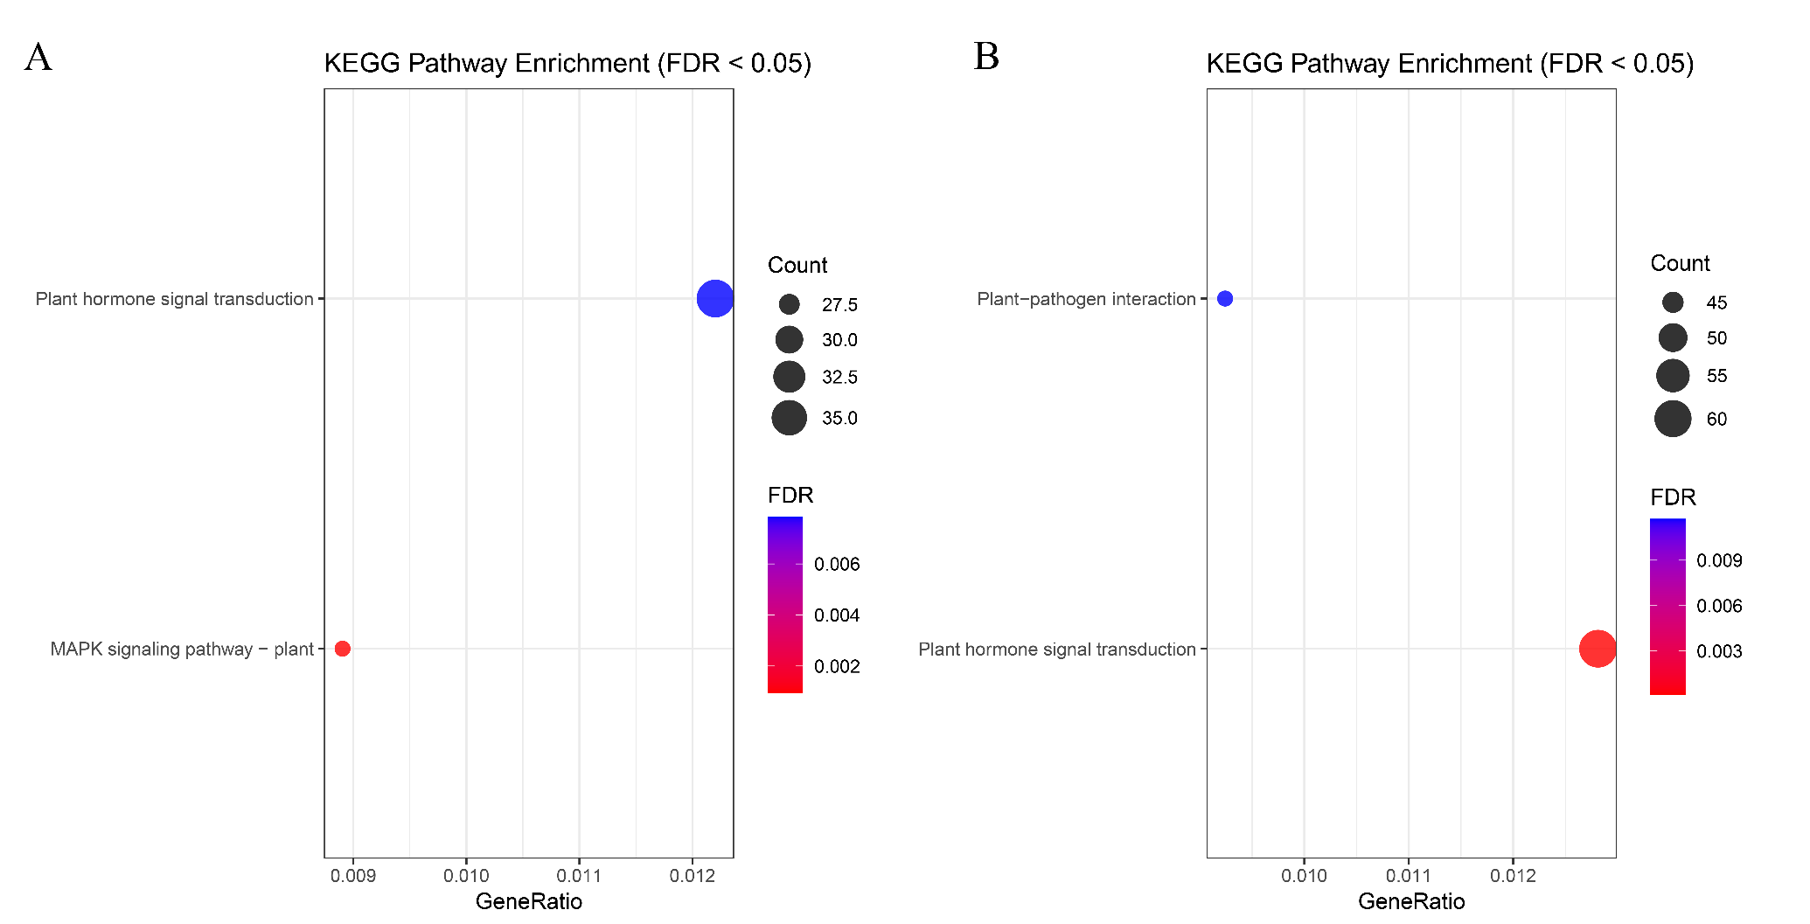
A and B, KEGG enrichment analysis of InDels variants in two sorghum varieties (FDR<0.05). A represents AJ2055, and B represents RN133.

Table S1. Statistics of InDels variant gene regions and mutation types
Name | Upstream | Stop gain | Stop loss | Frameshift deletion | Frameshift insertion | Non-frameshift deletion | Non-frameshift insertion | Intronic | Downstream | Heterogenous rate | Total
B2055 | 17964 | 30 | 0 | 540 | 435 | 1689 | 1597 | 22879 | 13124 | 0.03 | 177391
N133 | 28884 | 55 | 4 | 808 | 723 | 2616 | 2612 | 37343 | 21435 | 0.041 | 296856

