Genetic Relationship Among Grape (Vitis vinifera L.) Genotypes Grown in Inner Anatolia Region Turkey Analyzed by ISSR and RAPD Markers

SUPPLEMENTARY MATERIALS
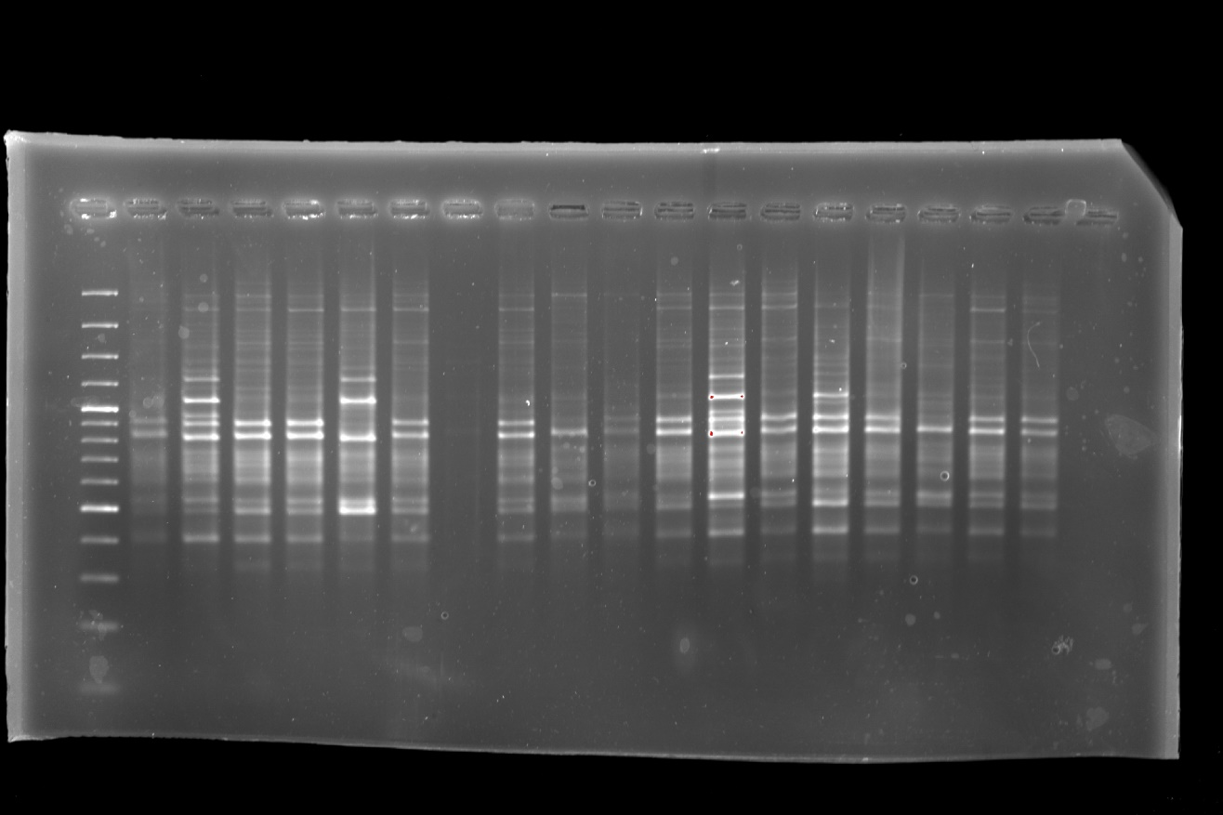
Figure S1. Uncropped agarose gel image of PCR products amplified with RAPD primer UBC-810

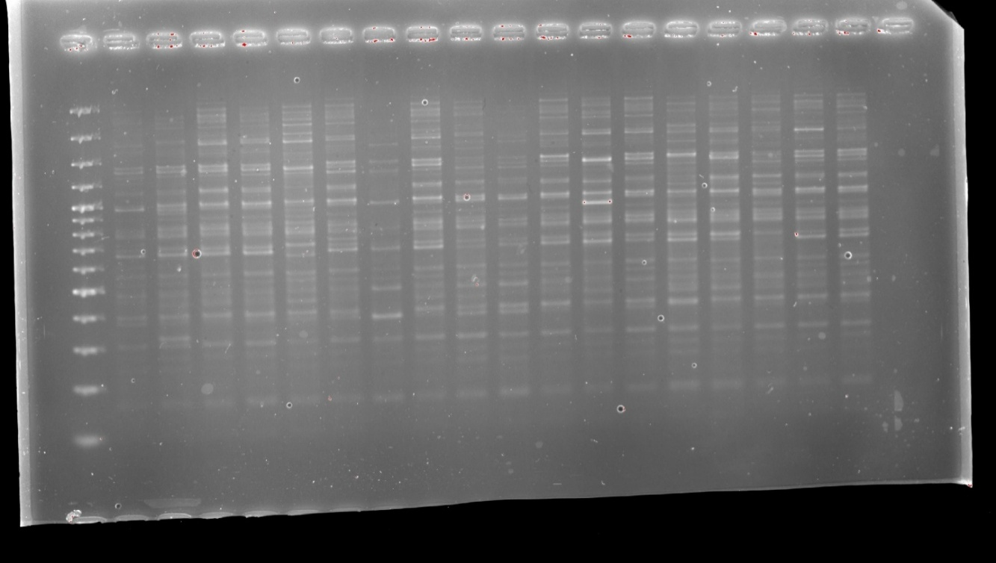
Figure S2. Uncropped agarose gel image of PCR products amplified with RAPD primer OPA-18.

