Supplementary material
Analysis | Variable | ANOVA
 | SDNN | F_{23,86}= 2.61, p<0.001
 | RMSSD | F_{23,86}= 3.73, p<0.001
 | pNN50 | F_{23,86}= 4.95, p<0.001
Frequency domain(4) | HF | F_{23,86}= 4.88, p<0.001
Frequency domain(4) | LF | F_{23,86}= 4.84, p<0.001
Frequency domain(4) | VLF | F_{23,86}= 1.65, p=0.02
Frequency domain(4) | LF/HF | F_{23,86}= 19.07, p<0.001
Non-linear(9) | SD1 | F_{23,86}= 3.73, p<0.001
Non-linear(9) | SD2 | F_{23,86}= 1.97, p=0.03
Non-linear(9) | SD2/SD1 | F_{23,86}= 3.68, p<0.001
Non-linear(9) | SamPEN | F_{23,86}= 3.11, p<0.001
Non-linear(9) | AmpEN | F_{23,86}= 1.68, p=0.02
Non-linear(9) | Alf1 | F_{23,86}= 3.79, p<0.001
Non-linear(9) | Alf2 | F_{23,86}= 3.75, p<0.001
Non-linear(9) | CorrDim | F_{23,86}= 1.76, p=0.01
Non-linear(9) | REC | F_{23,86}= 1.10, p=0.32
Non-linear(9) | DET | F_{23,86}= 2.12, p=0.001
Non-linear(9) | ShannE | F_{23,50}= 1.21, p=0.223
Autonomic indexes(3) | SNS | F_{23,86}= 7.14, p<0.0001
Autonomic indexes(3) | PNS | F_{23,86}= 11.72, p<0.0001

Table 1. Repeated measures ANOVA- rhythmicity test

Figure 1. Histograms of age distribution by sex
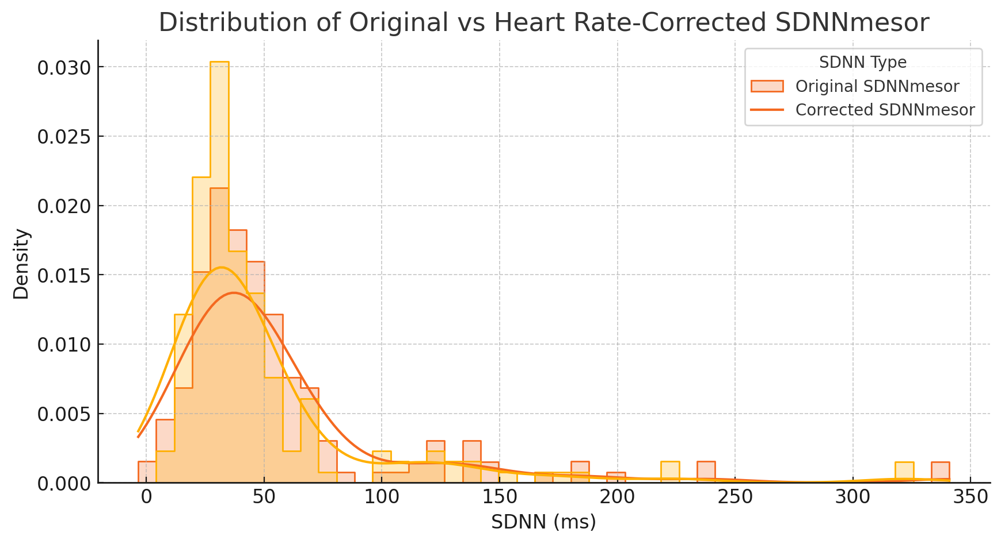
Figure 2. Distribution of original vs HR-corrected SDNN MESOR

Figure 3. Analysis procedures

