Supplymentary figures
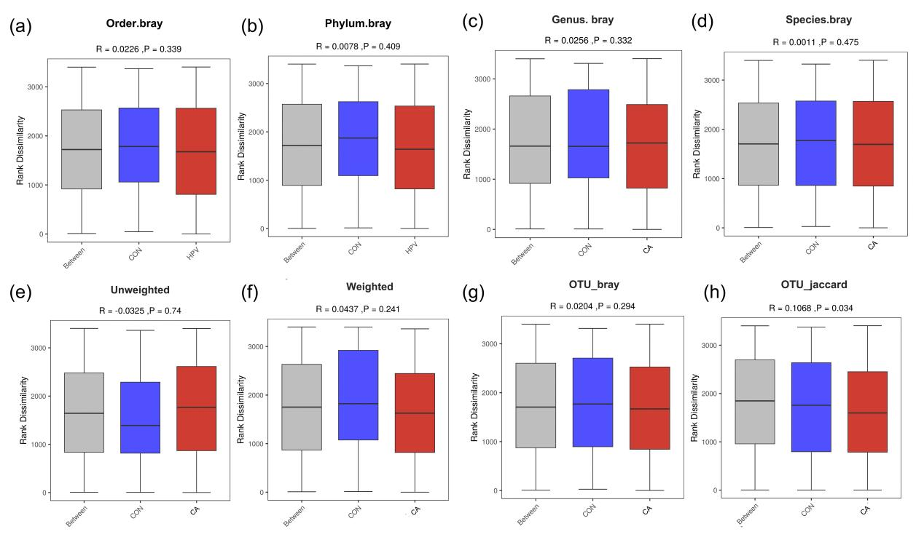
Supplymentary figure 1. Beta diversity of vaginal microbiota between healthy control samples (CON) and condyloma acuminatum group (CA) using ANOSIM。
Beta-diversity was calculated based on Bray-Curtis dissimilarity at different taxonomic ranks: (a) Order level, (b) Phylum level, (c) Genus level, and (d) Species level. Additional beta-diversity metrics were also assessed: (e) Unweighted UniFrac, (f) Weighted UniFrac, (g) Bray-Curtis dissimilarity of OTUs (Operational Taxonomic Units), and (h) Jaccard dissimilarity (Jaccard) of OTUs. The statistical significance of the separation between the CON and CA groups for each metric is indicated by the ANOSIM R-value and P value.

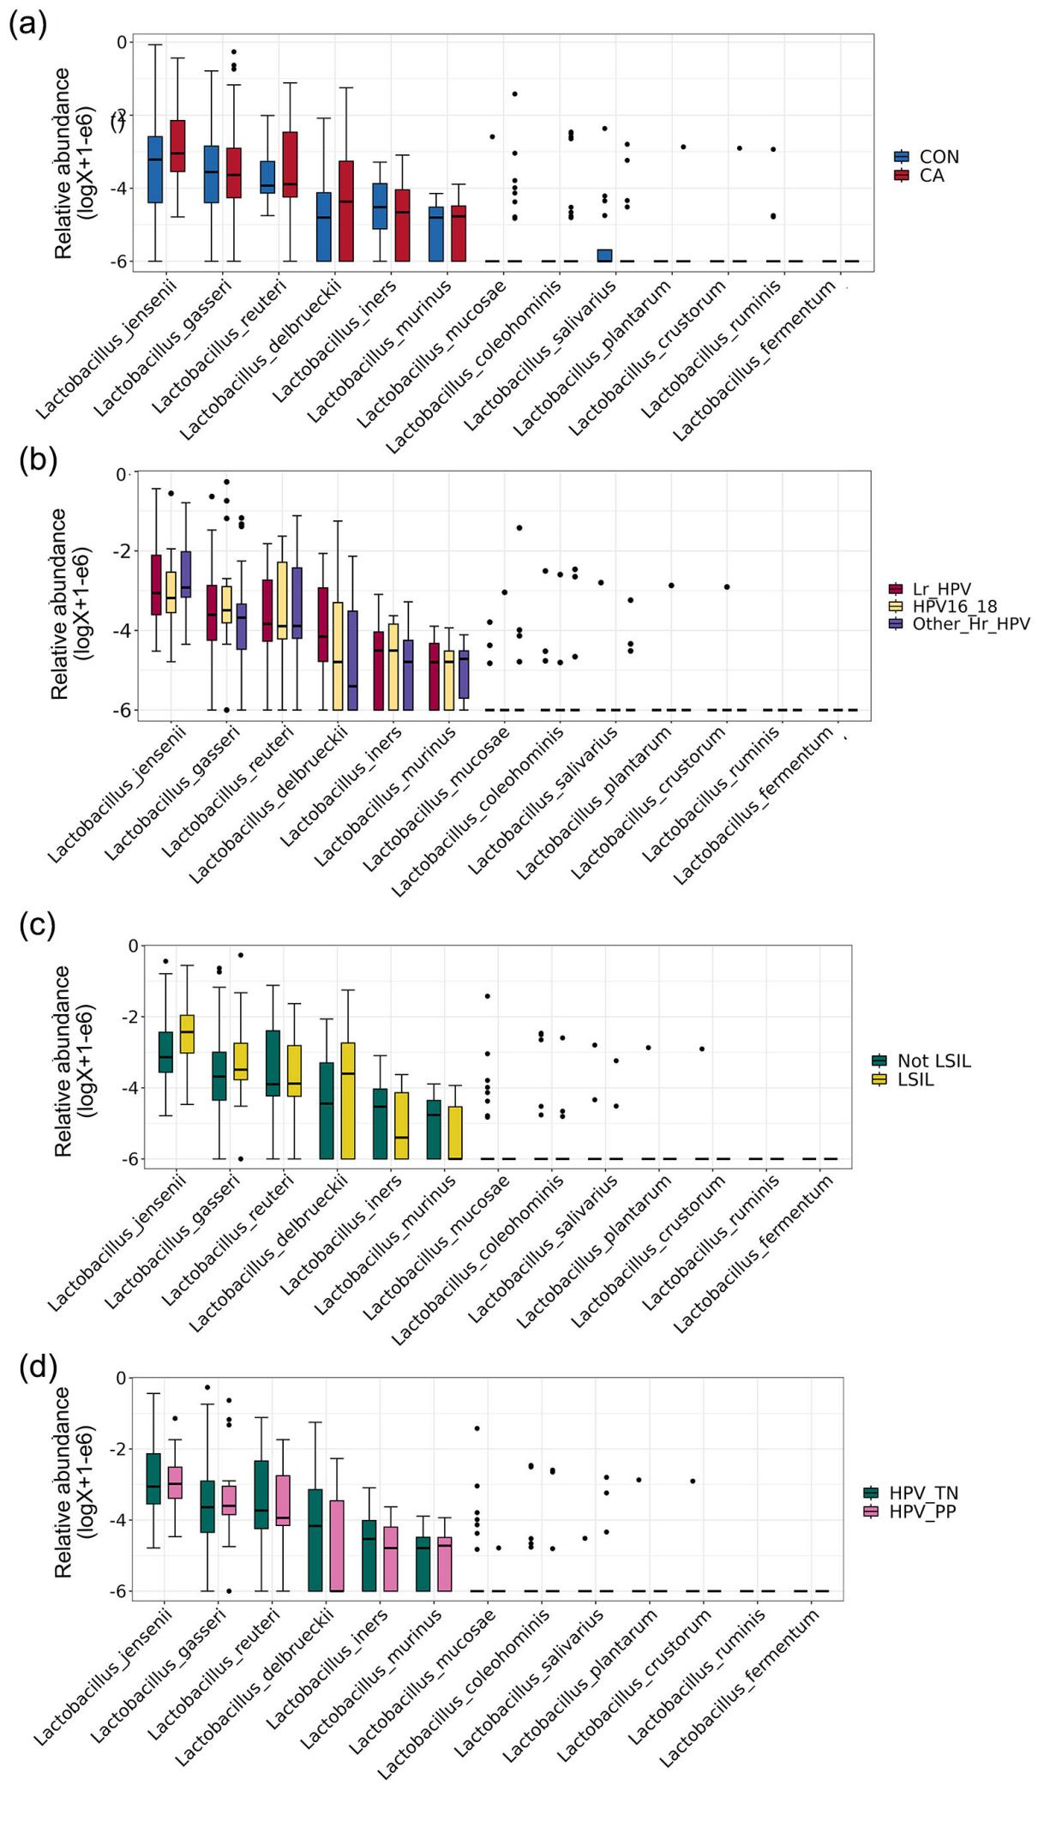
Supplymentary figure 2. Relative abundance of various Lactobacillus species in the condyloma acuminatum group (CA) and the healthy control group (CON), as well as across each subgroup. (a) Relative abundance of various Lactobacillus species in the CA and CON groups. (b) Relative abundance of various Lactobacillus species in the groups with different HPV genotypes of low-risk HPVs (Lr_HPV), co-infected with HPV16/18 (HPV16_18) and co-infected with other high-risk HPVs (Other_Hr_HPV). (c) Relative abundance of various Lactobacillus species in the groups with or without histological LSIL (LSIL or Not LSIL), based on the status of intracervical neoplasia. (d) Relative abundance of various Lactobacillus species in the group with HPV persistent positive (HPV_PP) and the group with HPV turn negative (HPV_TN).

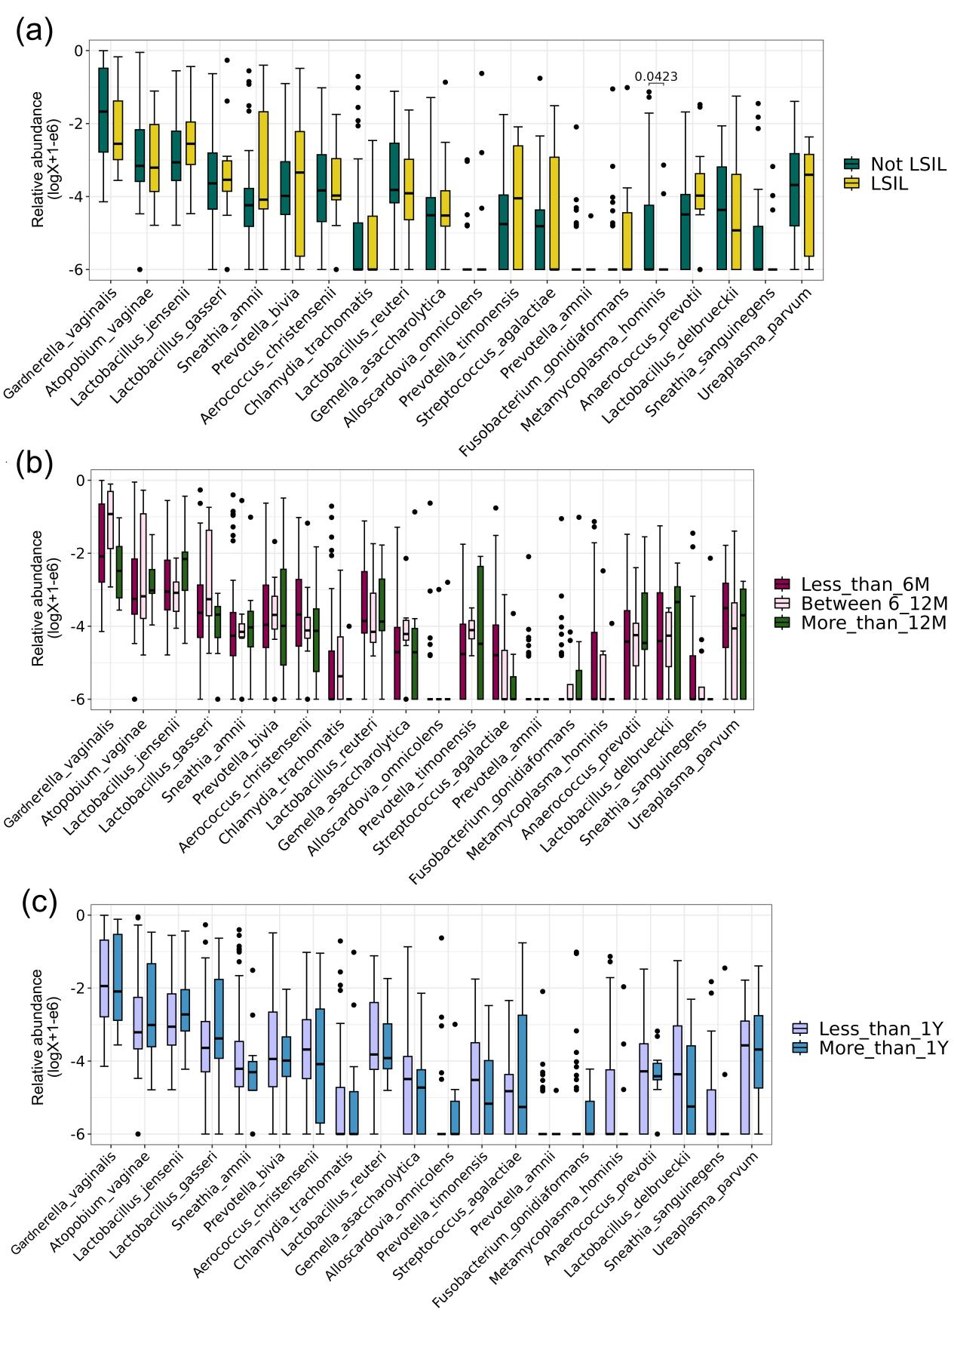
Supplymentary figure 3. Relative abundance of top 20 species in different groups based on the status of LSIL, disease duration at the first visit and the treatment duration. (a) Relative abundance of top 20 species in the groups with or without histological LSIL (LSIL or Not LSIL), based on the status of intracervical neoplasia. (b)Relative abundance of top 20 species among groups with different disease courses of less than 6 months, 6-12 months and more than 12 months, base on the disease duration at the first visit. (c) Relative abundance of top 20 species in the groups with different treatment duration of less than 1 year (Less_than_1Y) and more than 1 year (More_than_1Y), based on the treatment duration.

