Supplementary Figures (Wang et al.)

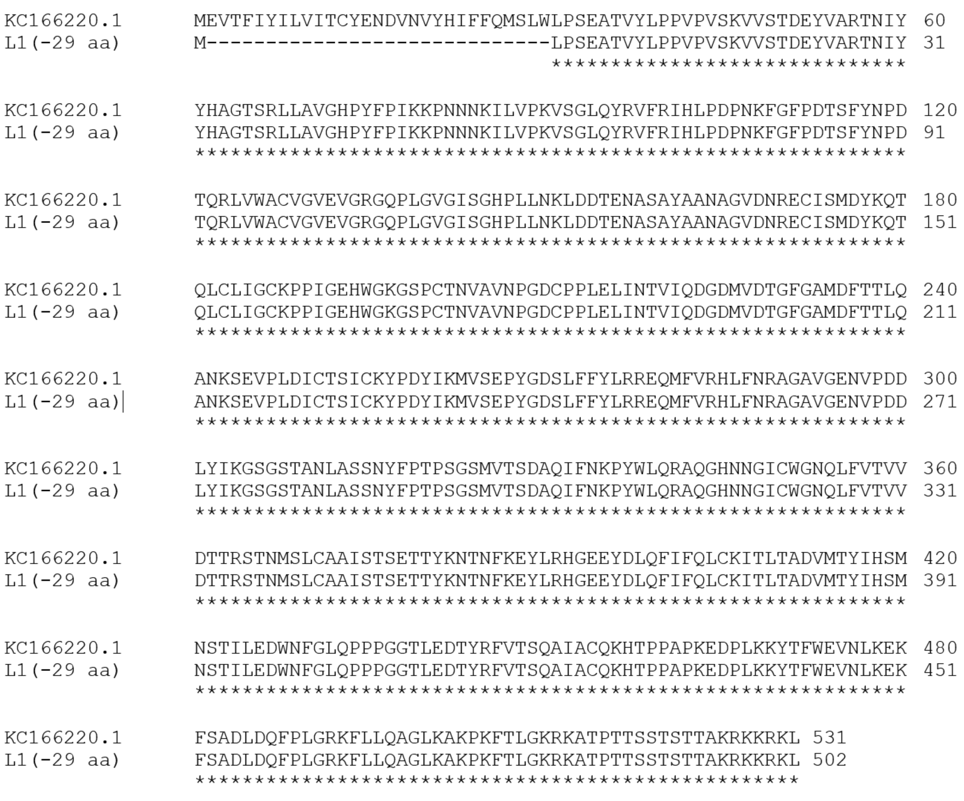
Figure S1. Amino acid sequence alignment of recombinant L1.
The amino acid sequence of the truncated L1 protein, that was used in this study, lacking twenty-nine N-terminal amino acids was aligned to the full-length reference sequence (GenBank accession number KC166220.1) via the Clustal Omega online tool (www.ebi.ac.uk).

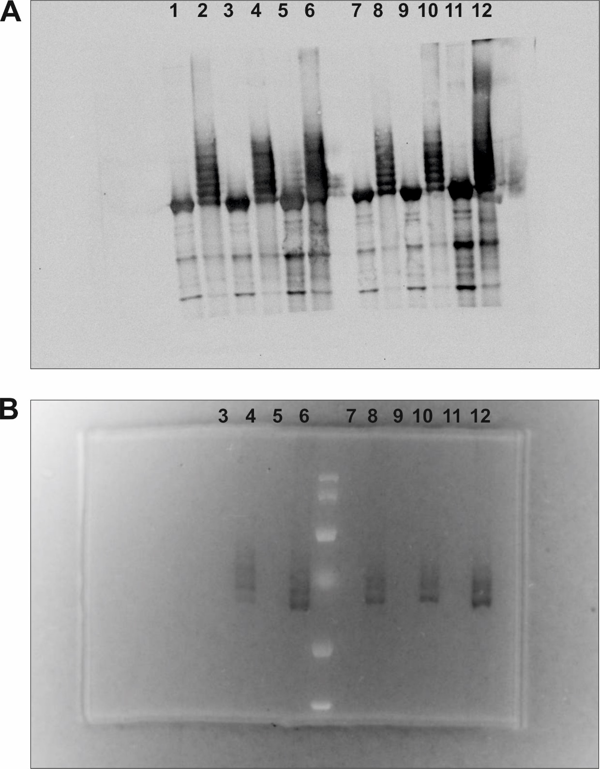
Figure S2. Analysis of peptide binding to L1-DBCO.
Western blot (A) and fluorescence gel (B) analysis of L1 proteins before and after DBCO activation. After Western Blot, the membrane was stained with anti-HPV-16 L1 antibody CAMVIR-1 and HRP-coupled secondary antibody. Lanes 1-6 correspond to one production batch, and lanes 7-12 to another. Within the same batch, samples were loaded onto SDS-PAGE (10 % bisacrylamide gels) at different amounts: 0.5 µg (lanes 1, 2, 7, 8), 1.25 µg (lanes 3, 4, 9, 10), and 2.5 µg (lanes 5, 6, 11, 12). Lanes 1, 3, 5, 7, 9, and 11: untreated L1 proteins; lanes 2, 4, 6, 8, 10, and 12: DBCO-activated L1 proteins. Following incubation with an N₃- and FITC-labeled peptide, DBCO-activated L1 proteins exhibited detectable gel shifts compared to untreated controls. Lanes 9 and 10 were cropped and presented in Figure 3B.

