MdHSFA2 enhances heat stress tolerance through promoting the MdGolS4 transcription in apple
Mohan Li¹†, Xiaoshuang Zhang¹†, Dongliang Zuo¹†, Junkai Wu¹, Libin Zhang¹, Xiao Xiao¹, Libo Xing², Chenguang Zhang¹*
¹Hebei Key Laboratory of Horticultural Germplasm Excavation and Innovative Utilization, Hebei Higher Institute Application Technology Research and Development Center of Horticultural Plant Biological Breeding, College of Horticulture Technology, Hebei Normal University Of Science & Technology, 066600, Changli, Hebei, P. R. China
²College of Horticulture, Northwest A&F University, 712100 Yangling, Shaanxi, P. R. China
†Equal contributors
*Correspondence:
Chenguang Zhang: Zchenguang0105@163.com;

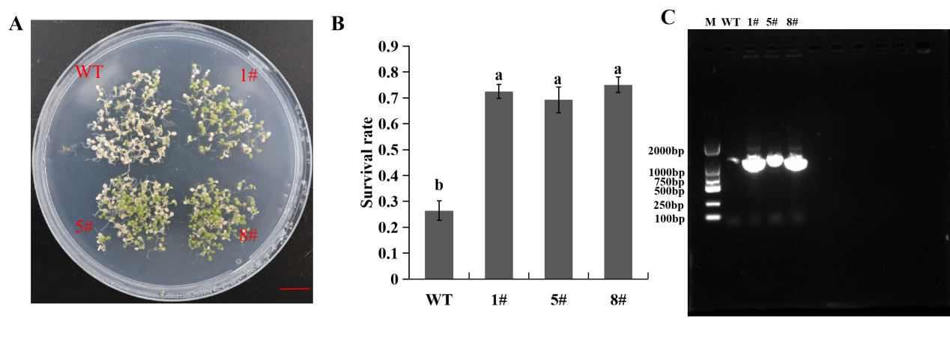

Figure S1. MdHSFA2 enhanced heat-stress tolerance in Arabidopsis.
(A) Phenotype of the MdHSFA2-OE Arabidopsis lines for heat-stress tolerance. Bar = 1cm. (B) Statistical analysis of survival rate of WT and MdHSFA2-OE Arabidopsis lines after the heat treatment. (C) Genomic PCR analyses of MdHSFA2 in transgenic Arabidopsis lines.

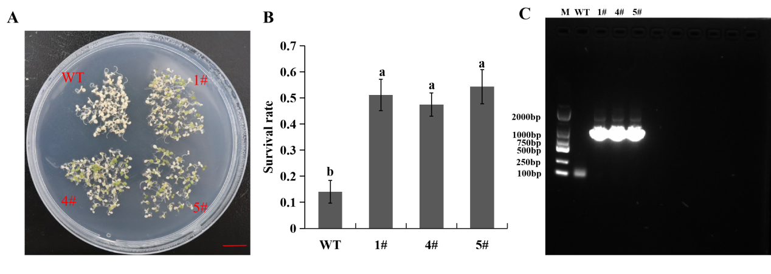

Figure S2. MdGolS4 enhanced heat-stress tolerance in Arabidopsis.
(A) Phenotype of the MdGolS4-OE Arabidopsis lines for heat-stress tolerance. Bar = 1cm. (B) Statistical analysis of survival rate of WT and MdGolS4-OE Arabidopsis lines after the heat treatment. (C) Genomic PCR analyses of MdGolS4 in transgenic Arabidopsis lines.

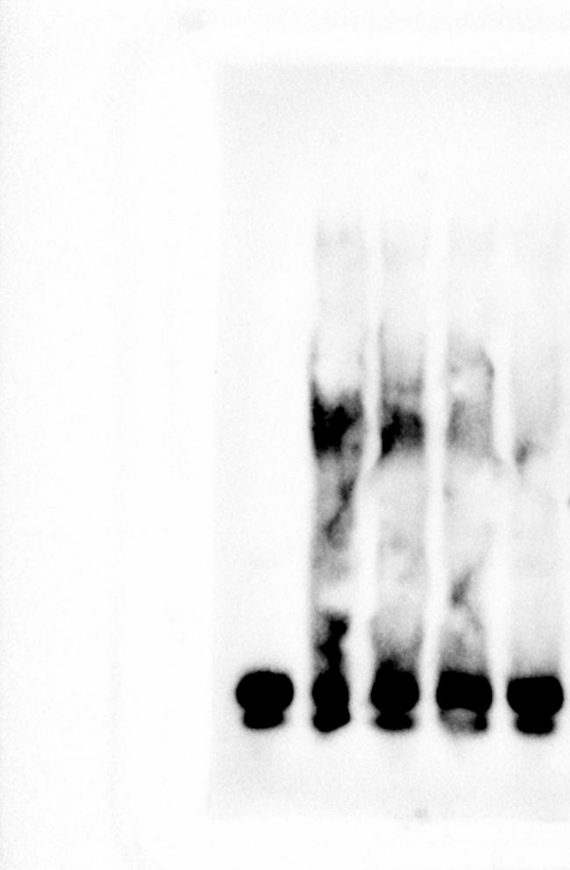
Figure S3. Image of EMSA full-length membrane

Table S1. Primers used for qRT-PCR
Gene name | Gene ID | Primer sequences
MdACTIN-F | MD04G1127400 | CAACTCATCCGAACCTCAAACC
MdACTIN-R | MD04G1127400 | CGCTGTCCGCCATCTTCTACT
AtActin-F | AT2G37620 | GCGATTCCGTTGTCCTGAGGTTC
AtActin-R | AT2G37620 | TTCCACCACTGAGCACAATGTTACC
MdHSFA2-F | MD04G1127400 | GAGGCAGCAGCAACATAA
MdHSFA2-R | MD04G1127400 | AGCATTCTTCTCAACAAGGT
MdGolS4-F | MD17G1280400 | GAGGGAGGACATTAAGATGCT
MdGolS4-R | MD17G1280400 | CAGCTGCTTCCGACAGAGC
AtGolS1-F | AT2G47180 | CAAACACAAACACACGACTA
AtGolS1-R | AT2G47180 | CGGTGGACATAGCATCAG
AtGolS2-F | AT1G56600 | TTGCTGGAACTGGAGACT
AtGolS2-R | AT1G56600 | CCTTGATCCACCAACTGTT
AtHSP70-F | AT3G12580 | TGAGGAGGCTTAGGACAG
AtHSP70-R | AT3G12580 | CGAGTGATGGTAGTGTAGAA
AtHSP70T-F | AT1G56410 | ACGACTGTTGAGGTTGAC
AtHSP70T-R | AT1G56410 | CAGGCTCCATACACTTCC

Table S2. Primers used for plasmid construction
Gene name | Gene ID |  | Primer sequences
MdHSFA2-GST-F | MD08G1064100 | CTGGTTCCGCGTGGATCCATGGATGGAGTGGTGGTG
MdHSFA2-GST-R | MD08G1064100 | CGATGCGGCCGCTCGAGAAGGAATGTGGTCATCTG
MdHSFA2-35S-F | MD08G1064100 | ACGAGCTCGGTACCATGGATGGAGTGGTGGTG
MdHSFA2-35S-R | MD08G1064100 | CATGGTGTCGACTCTAGACGGCTTGGGTTGGGTCTG
MdGolS4-LUC-F | MD17G1280400 | GGCGAATTGGGTACCCTTTTATTTTCCCACAAG
MdGolS4-LUC-R | MD17G1280400 | AGAACTAGTGGATCCGAGAAATTACGTGTCCAA
MdGolS4-35S-F | MD17G1280400 | ACGAGCTCGGTACCATGGCTCCCGAACTCGTC
MdGolS4-35S-R | MD17G1280400 | CATGGTGTCGACTCTAGAAGCCGCTGACGGTGCTGT

