Higher-Order Factorization Machine for Accurate Surrogate Modeling in Material Design

Sanghyo Hwang¹⁺, Seongmin Kim²⁺, Zhihao Xu³, Tengfei Luo^{3*}, Eungkyu Lee^{1*}

¹Department of Electronic Engineering, Kyung Hee University; Yongin-Si, Gyeonggi-do 17104, Republic of Korea

²National Center for Computational Sciences, Oak Ridge National Laboratory, Oak Ridge, Tennessee 37830, United States

³Departement of Aerospace and Mechanical Engineering, University of Notre Dame, Notre Dame, Indiana 46556, United States

*Corresponding author. Email: tluo@nd.edu, and eleest@khu.ac.kr,

⁺These authors contributed equally to this work

Supplemental Information

Methods

Performance Evaluation Metrics
Root Mean Squared Error
To analytically evaluate the performance of surrogate models from 2nd and 3rd-order FM, we calculate the root mean squared error (RMSE) between actual and predicted values. By definition, low RMSE value indicates superior surrogate model performance and more reliable representations. This metric provides quantitative evidence for determining which surrogate model more accurately approximates the actual optimization space.

Figure-of-Merit
For material design, we implement active learning algorithms based on 2nd and 3rd-order FM. Active learning returns the optimal structure after completing optimization where the optimized structure should have the lowest FOM value since this is a minimization optimization problem by FOM definition. We compare FOMs obtained after finishing 2nd and 3rd-order FM-based active learning to determine their relative effectiveness in identifying optimal structures in global design spaces. This analysis provides insights of the performance of each FM model-based active learning for materials design applications.

Hyperparameter
The FM class is initialized with the input feature n and latent space k_{2nd} = k_{3rd} = 8. Training is performed using Adam optimizer in PyTorch library (learning rate = 0.01, 0.02, and 0.05 when dataset size < 200, 500, and 1,000, respectively. Learning rate is 0.1 when dataset size is over 1,000), and the loss function used is mean squared error (MSELoss). Training is set to run for a maximum of 10,000 epochs, but early stopping is applied if the validation loss (measured by mean squared error) falls below 2.5 and does not improve for 2,000 consecutive epochs. This dual condition helps avoid unnecessary training when the model has sufficiently converged, while also preventing premature termination in cases where the loss remains high but stable. And we use Adam for optimizer with a learning rate of 0.05 and no weight decay. Adam is well-suited as the optimizer due to its ability to adapt learning rates and incorporate momentum, enabling fast and stable convergence for experiments that require efficient initial exploration and training stability. The training follows an active learning strategy in which one data point is incrementally added at each optimization cycle of active learning. The dataset is split into 80% for the training set and 20% for the validation set. During training the model, batches of 1,024 samples are used for training, and 256 samples for validation, because validation set is a quarter of training set. All computations without TMM are performed using the CUDA cores of a GPU.

Active Learning
First step. Create a dataset in the form of {x, FOM} that calculates 25 random input binary vectors and the FOM matching them. At this time, FOM can be obtained by calculating it as the objective function to be optimized, and in our study, TMM corresponds to this. Second step. A surrogate model is created by training the dataset in the method described above. The surrogate model created here is to predict what the value of the objective function according to the input will be based on the dataset. In our work, the FM model is retrained from scratch at every optimization cycle, meaning that all model parameters are reinitialized and updated in every cycle. Even though retraining surrogate model takes more time than warm-starting, it can help mitigate overfitting.
Third step. The minimum value obtained from the surrogate model and the input binary vector corresponding to that value are obtained. Since the goal of active learning is to find the ground state of the FOM, it is to obtain the minimum value and the corresponding input value among the predicted values. If the corresponding input binary vector already exists in the dataset, a new random input binary vector that is not in the dataset is obtained to make a better model in the next optimization cycle.
Fourth step. Obtain the actual value (FOM) by putting the input binary vector obtained in the previous step into the objective function. It is a step to verify whether the input binary vector expected to have a minimum value actually has a minimum value.
Last step, the new input binary vector and FOM obtained in the previous step are added to the dataset. After that, return to the first step and repeat the above cycle. In our works, we fix the number of optimization cycles as 3000.

Transfer Matrix Method
TMM is a mathematical technique that models wave propagation through multilayer structures using matrix multiplication to compute transmission and reflection properties. ³¹ In optical systems, it is widely employed to model the transmission and reflection of electromagnetic waves in stratified media. Each layer is characterized by its thickness and refractive index, and the boundary conditions at interfaces are enforced using matrix formalism. The electromagnetic field in each layer is expressed as a superposition of forward and backward propagating waves, and a transfer matrix is constructed to relate the fields across the entire multilayer structure. By computing the product of individual transfer matrices, one can efficiently determine the overall optical response, including reflectance and transmittance.

Computational Efficiency
Computational efficiency is also an important performance metric in model evaluation. We measure the computational times required for training each FM model. Our studies use four workstations: (1) AMD Ryzen Threadripper PRO 3975WX @ 3.5 GHz processor with 32 cores and 32GB of RAM. (2) AMD Ryzen Threadripper PRO 5955WX @ 4.0GHz processor with 16 cores and 512GB of RAM. (3) Intel (R) Xeon (R) Silver 4216 CPU @ 2.10GHz processor with 32cores and 735GB of RAM. (4) 12th Gen Intel (R) Core (TM) i5-12400F @ 2.5GHz processor with 6cores and 32GB of RAM. Workstations (1 – 3) are used for active learning, and (4) is used for generating surrogate models with FMs.

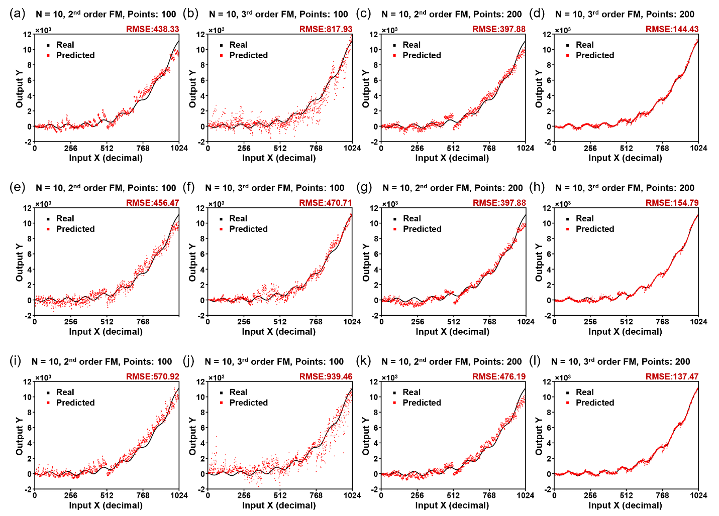
Fig. S1. The surrogate modeling performance of the 2nd and 3rd-order FMs for an analytical function. The output of surrogate functions as a function of input ($d_{x}$) after training (a, c, e, g, i, k) the 2nd-order FM and (b, d, f, h, j, l) the 3rd-order FM. Black solid lines are the output directly evaluated from the analytical function. (a, b, e, f, i, j) Dataset size = 100, binary vector length = 10. (c, d, g, h, k, l) Dataset size = 200, binary vector length = 10.

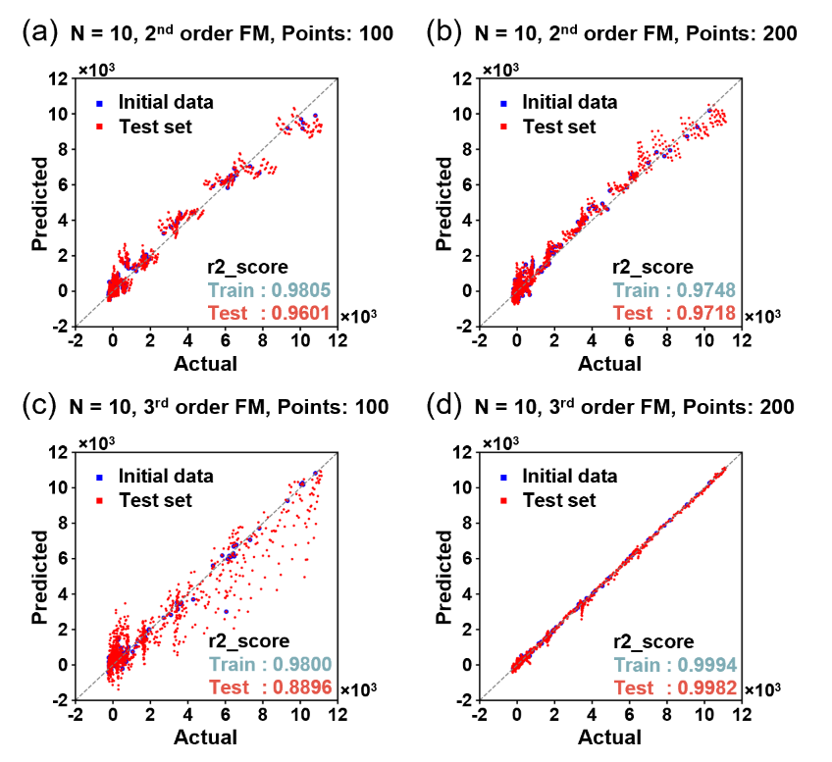
Fig S2. Parity plot of the 2nd and 3rd-order FMs for an analytical function. The output of surrogate functions corresponding to the actual function output after training (a, b) 2nd-order FM and (c, d) 3rd-order FM. Blue dots are predicted values of dataset and red dots are the other predicted values of the entire landscape. Dataset size=100, binary vector length = 10. R2_score measures the proportion of variance in the target variable explained by the model, indicating its fitness (values close to 1 indicate good fitting, while values near 0 indicate poor fitting).

