Supplementary materials

Atractylodes macrocephala compounds attenuate pediatric epilepsy neuroinflammation through multitarget regulation of the NF-κB pathway

Aiyuan Cai¹, Ran Liu¹, Zilong Li¹, Hailong Huang¹, Jing Xiao¹, Yuanhong Lin², Haixia Wu¹, Ping Liu¹, Jing Ying¹, Qingpeng Hu^{1*},

¹Department of Pediatrics, Longhua District People's Hospital, Shenzhen, Guangdong, 518109, China
²Second Clinical Medical College, Guangzhou University of Chinese Medicine, Guangzhou 510410

*corresponding author:
Qingpeng Hu
18718234370
huqingpeng163@126.com
Department of Pediatrics, Longhua District People's Hospital, Shenzhen, Guangdong, 518109, China

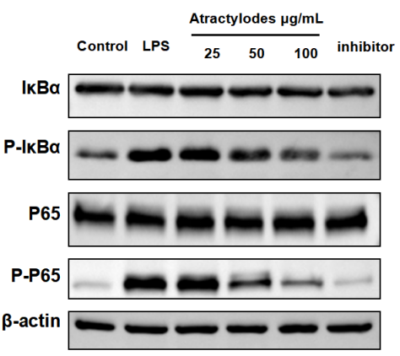
Supplementary Figure 1. Original Image for Fig4E
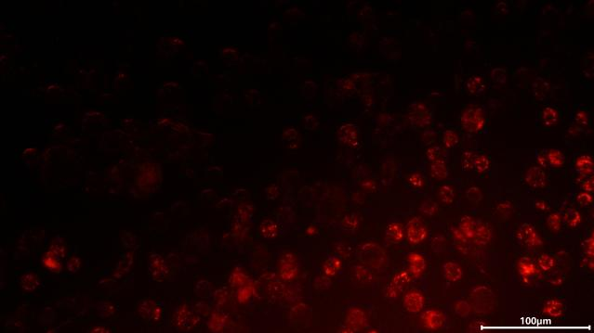
Supplementary Figure 2. Original Image for Fig5A

