Supplementary Material to: A High-Pressure Bioreactor System for the Cultivation of Methanothermobacter marburgensis on Advanced Growth Media for Sustainable Energy Applications

Marco Orthofer^{1,+}, Walter Hofmann^{2,+}, Simon K.-M. R. Rittmann², Christian Paulik^{1*}
¹ Institute for Chemical Technology of Organic Materials, Johannes Kepler University Linz, Altenberger Strasse 69, 4040 Linz, Austria.
² Archaea Physiology & Biotechnology Group, Department of Functional and Evolutionary Ecology, University of Vienna, Djerassiplatz 1, 1030 Wien, Austria.
*christian.paulik@jku.at
⁺ these authors contributed equally to this work

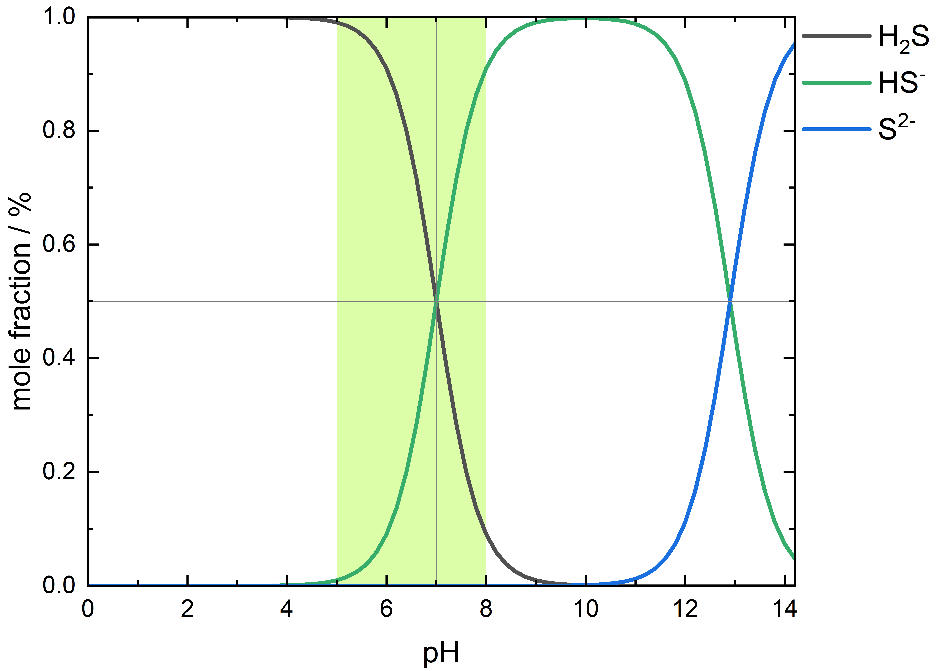
Supplementary Figure 1. Distribution of ion species of sulfide. Mole fractions are calculated as a function of the pH from the specific pK_{a} values (H₂S: pK_{a1} = 7.0, pK_{a2} = 12.9). The highlighted area represents the habitable pH range of M. marburgensis, from pH 5 to 8.

Supplementary Figure 2. P&ID flowchart of the SBRS-II. The reactors R-001 to R-004 are equipped with pressure sensors (PI1 - PI4) connected to the pressure control system (PICR1 - PICR4), thermocouples (TI1 - TI4), electric mantle heating (TIC10 - TIC40) and have the opportunity to hold a pH electrode (QI-pH). In standard automatic operation mode gas is fed in and out via the gas line and BV-011, BV-021, BV-031, and/or BV-041 are opened. Gas samples (in standard automatic operation) can be taken via the gas sampling port by opening valve BV-015, BV-025. BV-035 or BV-045. Liquid transfer to or from the reactor is done via the liquid line by opening valves BV-012/-014, BV-022/-024, BV-032/-034 or BV-042/-044. For manually sparging gas though the liquid valves BV-012/-013, BV-022/-023, BV-032/-033 and/or BV-042/-043 are opened instead. For feeding gas, releasing offgas, or applying vacuum the respective solenoid valves (indicated as *-CV-*) are opened eighter manually or in automatic operation by the pressure control system.

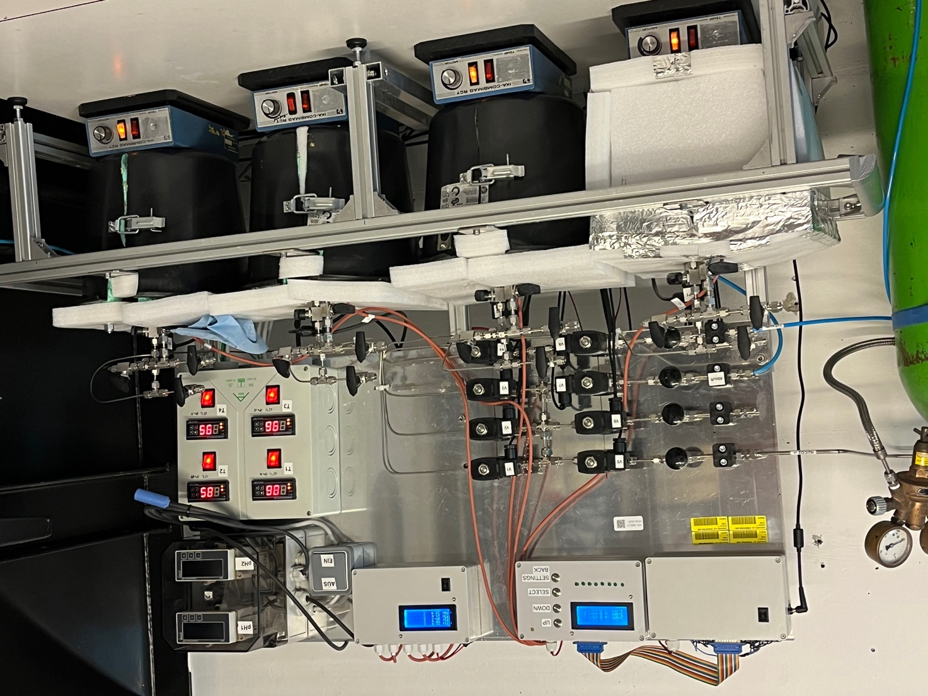
Supplementary Figure 3. SBRS-II system located at the high-pressure lab at the Johannes Kepler University Linz, Austria. Reactors R1 – R4 are situated on the frame structure from left to right. Three gray boxes on the top left are the control unit. The control valves sit on the back panel above R1 and R2. The pH electrode signal converter and displays are located in the right top corner. Temperature control units for the four heating bands are located on the right side of the back panel above R4.

Laboratory Safety Measures

NOTE: The measures described in the following comply with Austria’s current legal framework and specific university regulations. In other countries, the relevant regulations must always be strictly adhered to.

The operation of pressurized reactors, particularly when utilizing flammable gases, necessitates the implementation of comprehensive safety measures to ensure maximum protection for operators. The laboratory housing the SBRS-II system is governed by a combination of general and specific regulatory protocols. Personnel operating within this facility are subject to periodic training to ensure adherence to these regulations. Individuals are only permitted to work on the premises once these conditions have been met. In addition to overarching conduct guidelines, these regulations include detailed instructions on emergency response procedures and the safe handling of chemicals and gases.
Furthermore, a specialized gas warning system has been installed within the laboratory to detect the presence of explosive atmospheres generated by hydrocarbons and hydrogen. This system is designed to trigger a preliminary pre-alarm once predetermined concentration thresholds are exceeded. Concurrently, the laboratory's ventilation system is automatically ramped up to maximum capacity to facilitate optimal air exchange. Should gas concentrations continue to rise beyond a secondary threshold, a comprehensive alarm is activated, the laboratory's electrical supply is disconnected, and a rescue team is alerted. All four reactors are integrated into the laboratory's grounding system to mitigate static buildup and prevent sparking. Sensors and valves compatible with hydrogen and methane are installed on each reactor.
Prior to commencing experiments, thorough system integrity assessments must be performed using inert gases such as nitrogen to verify leak tightness. Introduction of hydrogen-containing gases is permissible only after successful leak testing and complete inerting of the reactors. It is imperative to regulate the gas pressure according to the maximum allowable working pressure, considering the reactor's temperature.
In the event of a malfunction, immediate disconnection of the gas supply is required. Subsequently, the reactors should be vented via the designated offgas line, and heating needs to be switched off. To eliminate any residual flammable gases, reactors must be flushed with inert gases like nitrogen, preventing the formation of explosive atmospheres.
Prior to initiating any experiment, operators must comprehensively review all safety mechanisms, assess potential hazards, identify possible malfunctions, and familiarize themselves with appropriate remedial actions in case of emergencies.

Operational constraints of SBRS-II

The accurate quantification of CH₄ production kinetics, derived from pressure changes observed during the methanation reaction as described by Taubner and Rittmann (2016)¹, critically depends on maintaining the gas-tight integrity throughout the reactor system. To ensure the reliability and reproducibility of measurements, it is essential to perform regular leak tests and verify the complete sealing of all components.
Due to the elevated cultivation temperatures and the high re-gassing rates employed in specific experiments, significant condensation and subsequent accumulation of condensate may occur within the system’s piping. To mitigate measurement artifacts and operational inconsistencies, the reactor system must be thoroughly dried after each experimental run. Additionally, all solenoid valves should be subjected to routine cleaning protocols to ensure optimal performance and to prevent cross-contamination between experiments.
The maximum operating pressure of the system is restricted by the pressure tolerance of the installed sensor components, particularly the pH probe and the immersion sleeve of the PT100 temperature sensor. Currently, the configuration allows for a maximum operating overpressure of 17 bar. Similarly, the operational temperature of the SBRS-II is limited to 135°C, as determined by the power specifications of the electrical heating bands, the thermal insulation materials used, and the temperature resilience of the pH probe.
The pH probe requires regular calibration and maintenance following the manufacturer's guidelines (Endress+Hauser). Cleaning should be conducted using a mixture of a 3% aqueous HCl solution and 7.5% thiourea. The probe must then be thoroughly rinsed with diH₂O and recalibrated prior to subsequent use.
Finally, it is essential to recognize that the performance of the magnetic stir bar influences gas-liquid mass transfer efficiency. This factor should be carefully considered when evaluating the overall process dynamics and reactor performance.

Lit:
1. Taubner, R.-S. & Rittmann, S. K.-M. R. Method for Indirect Quantification of CH₄ Production via H₂O Production Using Hydrogenotrophic Methanogens. Front Microbiol 7, 532 (2016).

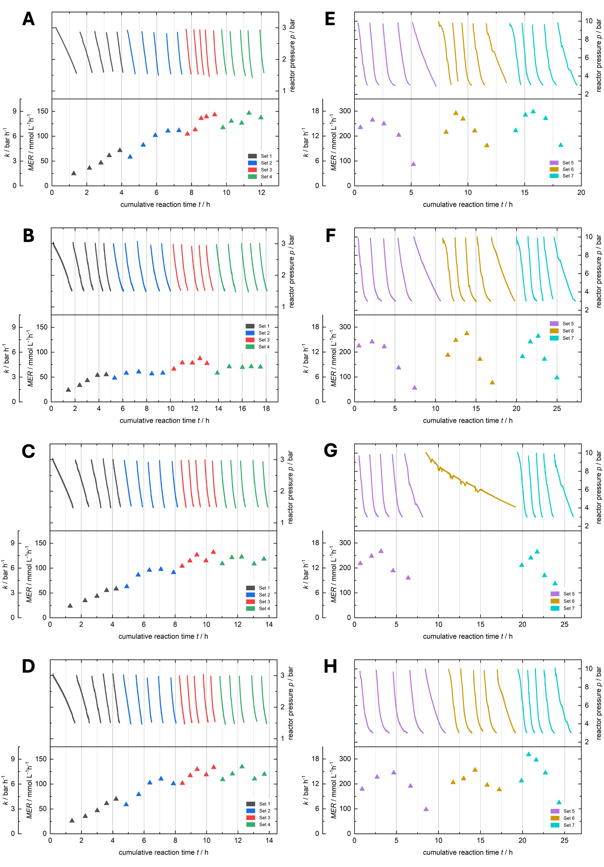
Supplementary Figure 4. Overview of pressure data (in bar absolute pressure) and calculated MER_{max} over time of cultivation experiments using MM-CF-S medium. A – D representing 3 bar experiments. E – H representing 10 bar experiments. A, E = R1, B, F = R2, C, G = R3, D, H = R4. Colored lines indicate the recorded pressure data after applying a smoothing factor for subsequent calculations, and the colored triangles represent the calculated MER_{max} during each reaction cycle. Changing of the reactors atmosphere in between the reaction cycles is excluded in the pressure curves. The individual colors represent one reaction set consisting of 5 cycles each. During 10 bar experiments R3 (G) experienced a malfunction, therefore R3-Set6 data is not used for calculations. Spikes are considered to be systemic artifacts and therefore have no further effect on the calculations.
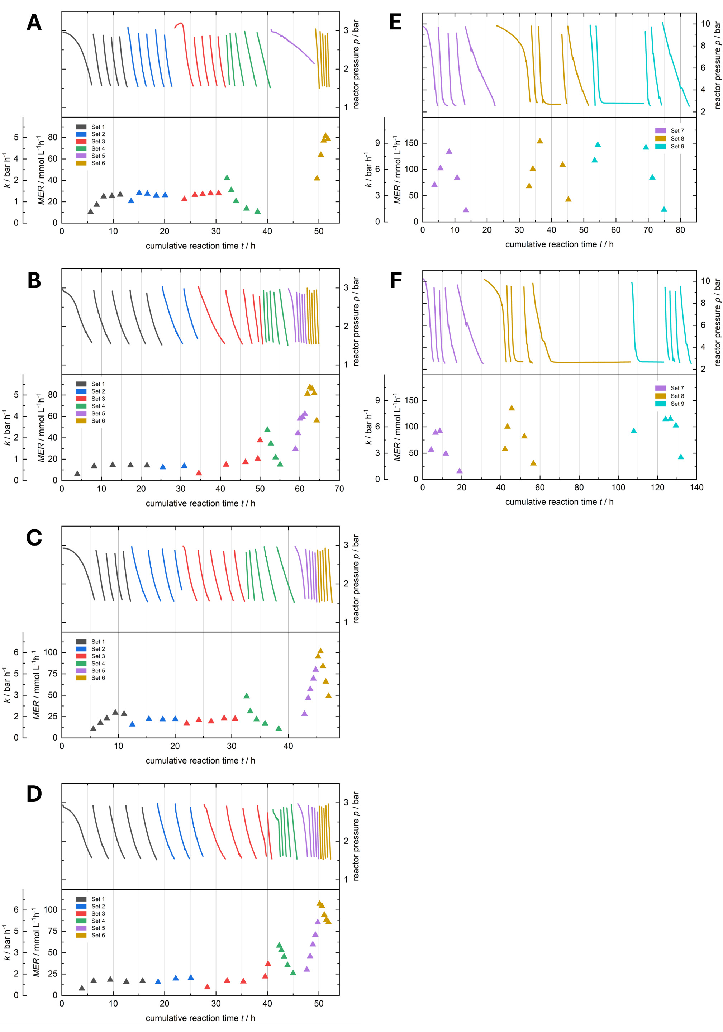
Supplementary Figure 5. Overview of pressure data (in bar absolute pressure) and calculated MER_{max} over time of cultivation experiments using MM-CF medium. A – D representing 3 bar experiments. E – F representing 10 bar experiments. A, E = R1, B, F = R2, C = R3, D = R4. Colored lines indicate the recorded pressure data after applying a smoothing factor for subsequent calculations, and the colored triangles represent the calculated MER_{max} during each reaction cycle. Changing of the reactors atmosphere in between the reaction cycles is excluded in the pressure curves. The individual colors represent one reaction set consisting of 5 cycles each. During 10 bar experiments, R1 and R2 (E and F) required manual action to initiate the atmosphere exchange cycle, indicated by prolonged flat regions. The accuracy of the MER data is not affected by those issues. Spikes are considered to be systemic artifacts and therefore have no further effect on the calculations.
Supplementary Figure 6. Microscopic images of M. marburgensis after reaction sets 2 (A) – 7 (F). Reaction sets 2 (A), 3 (B), and 4 (C) were performed at 3 bar. Reaction sets 5 (D), 6 (E), and 7 (F) were performed at 10 bar. After competition of reaction set 3 (C) the formation of cell clusters was observable. Size and appearance however are inconsistent as the number of reaction cycles (and sets) increases.

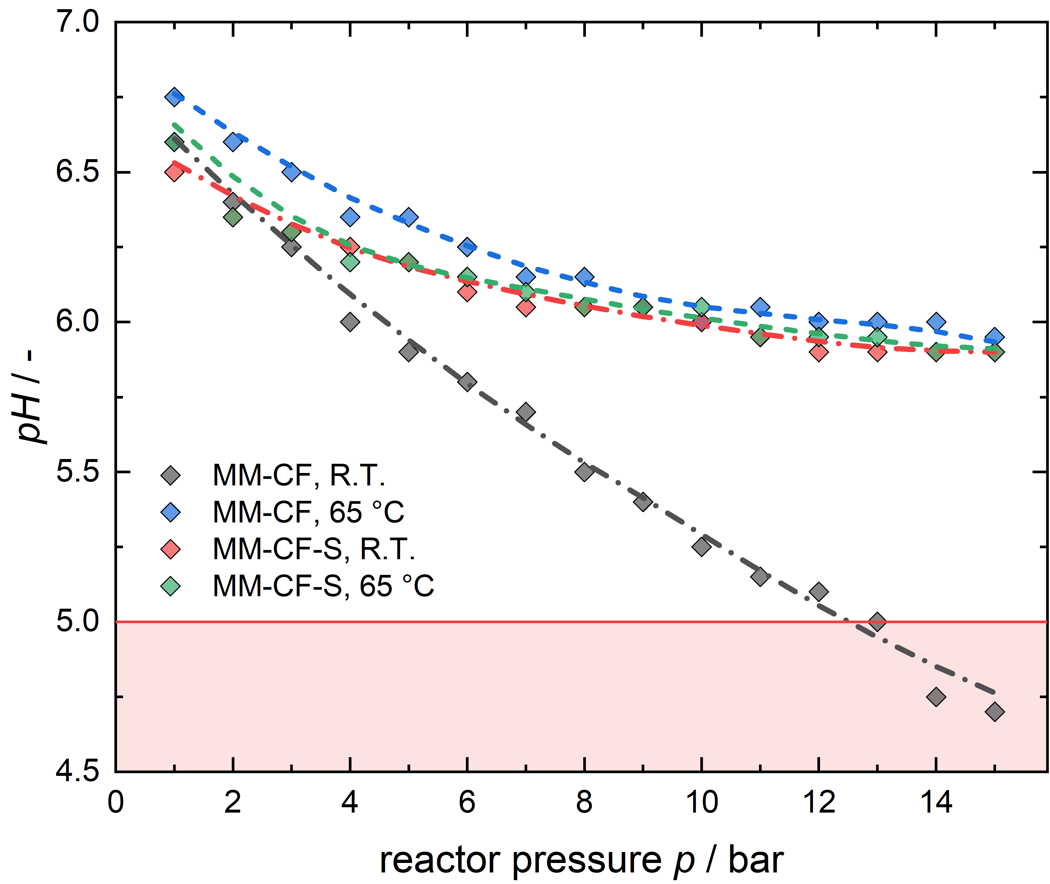
Supplementary Figure 7. Growth media pH characteristics at varying pressures. pH values were determined at room temperature (R.T.) and 65°C (cultivation temperature of M. marburgensis) for both growth media. Gray and blue diamonds for MM-CF, red and green diamonds for MM-CF-S medium.

Supplementary Table 1. Composition of the culture broth used in all cultivation experiments (here for a final volume of 500 mL and 175 mL).
Component | Amount / mL
Culture Target Volume | 500 | 175
Inoculum | 10 | 5
MM-CF(-S) Base medium | 50 | 17.5
TE(-S) 100x | 5 | 1.75
Na₂S-Solution | 2.5 | 0.875
18 MΩ H₂O | 433 | 149.875

Note: Addition of Na₂S solution and inoculation are performed subsequent to anaerobization.

Supplementary Table 2. Composition of a 10-fold concentrated MM-CF base medium for 1 L final volume.
Component | CAS No. | Concentration / g L⁻¹ | Amount / g
NH₄Cl | 12125-02-9 | 21.00 | 21.00
KH₂PO₄ | 7778-77-0 | 68.00 | 68.00
NaCl | 7647-14-5 | 10.00 | 10.00
fill to 1 L with UV sterilized 18 MΩ H₂O

Supplementary Table 3. Composition of the TE 100× solution for 1 L final volume.
Component | CAS No. | Concentration / mg L⁻¹ | Amount / g
Nitrilotriacetic acid | 139-13-9 | 9 000 | 9.00
MgCl₂ · 6 H₂O | 7791-18-6 | 4 000 | 4.00
FeCl₂ · 4 H₂O | 13478-10-9 | 1 000 | 1.00
CoCl₂ · 6 H₂O | 7791-13-1 | 20 | 0.02
NiCl₂ · 6 H₂O | 7791-20-0 | 120 | 0.12
Na₂MoO₄ · 2 H₂O | 10102-40-6 | 17 | 0.017
fill to 1 L with UV sterilized 18 MΩ H₂O

Supplementary Table 4. Composition of a 10-fold concentrated MM-CF-S base medium for 1 L final volume.
Component | CAS No. | Concentration / g L⁻¹ | Amount / g
(NH₄)₂SO₄ | 7783-20-2 | 25.94 | 25.94
KH₂PO₄ | 7778-77-0 | 68.00 | 68.00
NaCl | 7647-14-5 | 10.00 | 10.00
fill to 1 L with UV sterilized 18 MΩ H₂O

Supplementary Table 5. Composition of the TE-S 100× solution for 1 L final volume.
Component | CAS No. | Concentration / mg L⁻¹ | Amount / g
Nitrilotriacetic acid | 139-13-9 | 9 000 | 9.000
MgSO₄ · 7 H₂O | 10034-99-8 | 4 850 | 4.850
FeSO₄ · 7 H₂O | 7782-63-0 | 1 398 | 1.398
CoSO₄ · 7 H₂O | 10026-24-1 | 23.6 | 0.0236
NiSO₄ · 6 H₂O | 10101-97-0 | 132.7 | 0.1327
Na₂MoO₄ · 2 H₂O | 10102-40-6 | 17 | 0.0170
fill to 1 L with UV sterilized 18 MΩ H₂O

Standard Operating Procedure (SOP) for the SBRS-II

- Preparation of the reactor system.
  - Cleaning the reactor with biocide.
Prior to the experiment, the reactor is cleaned with a biocide mixture (38.6 wt.-% 2-Propanol and
18.2 wt.-% 1-Propanol in water) in accordance with standard procedure. The reactor is filled via the liquid in/out line (see Suppl. Fig. 1) with 300 mL of the mixture at room temperature. The biocide is agitated at maximum stirring speed for approximately 15 minutes and subsequently emptied with Biogon® C20 gas. Subsequently, the reactor is filled with 300 mL of deionized water, stirred at maximum speed, and then emptied with Biogon® C20. The relevant valves are opened via the SBRS-II control unit to facilitate gas manipulation.

  - Autoclaving.
The reactor is filled with approx. 150 mL diH2O and heated. The actual autoclaving process is conducted at 120°C for 20 minutes. Once the reactor has cooled to below 100°C, it is emptied and flushed with Biogon® C20 in order to establish an anoxic environment. Once the desired cultivation temperature is reached or the reactor temperature is below the desired level, the reactor is ready for use.

- Running a repetitive closed batch cultivation experiment.
  - Filling of the reactor
Once the reactor is ready to use the culture broth can be filled into the reactor. Therefore, a piece of tubing with a canula is connected to the liquid line of the reactor. The tubing is then flushed with Biogon® C20 (max. pressure 1.5 bar) by opening the respective control ball valves (i.e., N2-CV-6, R1-CV-1, BV-011, BV-012, BV-014) and subsequently connected to the Schott bottle with the culture. Another gas line is, after flushing, also connected to the Schott bottle (max. pressure 1.5 bar).
To transfer the culture to the reactor, the Offgas valve and the corresponding reactor control and ball valves (i.e., BV-014, BV-012, BV-011, R1-CV-1, Offgas-CV-7) are opened. During liquid transfer, the stirrer is engaged at a slow stirring speed to ensure heat transfer to the liquid. The actual liquid temperature is shown on the control unit’s temperature display. Once the liquid is transferred completely all valves are closed.

  - Control unit setup
Prior to initiating the experiment, the desired program must be uploaded to the control unit. The program is presented in Supplementary Tables 6 and 7. For each reactor, a *.csv program file is stored on the control unit's SD card. Once the SD card is reinserted into the control unit, the unit is restarted, and the program files are loaded automatically, showing “Setup complete.” if successfully uploaded. The data sampling rate is set by default to 1 second. At this point, the controller is operational.

  - Running the experiment
Once the desired cultivation temperature is reached and stabilized the program is started. It will follow the steps of the respective cultivation program. The stirring speed is increased to the desired rpm and the reactors gas line valve is opened (i.e., BV-011). The control unit is showing the status “ON”, the respective step and the actual pressure for each reactor.

  - Post processing
Upon completion of the program, the control unit will indicate the status "DONE." Subsequently, the SD card can be removed from the controller for further data processing. The stirring speed is decreased, all valves are closed, and the heating is deactivated. It is possible to maintain the heating on in the event that a follow-up experiment is conducted without cleaning. To remove the culture from the reactor once more, a piece of tubing with a cannula is connected to the liquid line of the reactor and flushed with gas. The cannula side and a venting line are then connected to the Schott bottle. Once all requisite lines are connected and flushed, the respective valves to empty the reactor are opened (i.e., N2-CV-6, R1-CV-1, BV-011, BV-012, BV-014). It is important to ensure that the pressure within the reactor does not exceed 2 bar. The process is manually controlled through the opening and closing of the gas line ball valve (i.e., BV-011). Once the reactor has been emptied and no subsequent experiment is to be conducted, it is cleaned in accordance with the procedure described in A.1.

Supplementary Table 6. Representation of the used SBRS-II cultivation program in 3 bar experiments.
Step | Valve | status  Value | ValveOn  Time | PressureHigher | Pressure Lower | Jump | Number of jumps
1 | 7 | 1 | 0 | 0 | 0 | 0 | 0
2 | 7 | 0 | 0 | 0 | 1100 | 0 | 0
3 | 5 | 1 | 0 | 0 | 0 | 0 | 0
4 | 5 | 0 | 0 | 2500 | 0 | 0 | 0
5 | 7 | 1 | 0 | 0 | 0 | 0 | 0
6 | 7 | 0 | 0 | 0 | 1500 | 3 | 2
7 | 5 | 1 | 0 | 0 | 0 | 0 | 0
8 | 5 | 0 | 0 | 3000 | 0 | 0 | 0
9 | 7 | 1 | 0 | 0 | 1500 | 0 | 0
10 | 7 | 0 | 0 | 0 | 1100 | 0 | 0
11 | 5 | 1 | 0 | 0 | 0 | 0 | 0
12 | 5 | 0 | 0 | 2500 | 0 | 0 | 0
13 | 7 | 1 | 0 | 0 | 0 | 0 | 0
14 | 7 | 0 | 0 | 0 | 1500 | 11 | 5
15 | 5 | 1 | 0 | 0 | 0 | 0 | 0
16 | 5 | 0 | 0 | 3000 | 0 | 9 | 3
17 | 7 | 1 | 0 | 0 | 1500 | 0 | 0
18 | 7 | 0 | 0 | 0 | 1100 | 0 | 0

Steps 1 – 7 represent the initial exchange of the reactor’s atmosphere (Figure 2, A).
Steps 8 – 9 represent the pressure decrease due to the methanation reaction (Figure 2, B).
Steps 10 – 14 represent the exchange of the reactor’s atmosphere between two reaction cycles and steps 15 – 16 represent the re-pressurization of the reactor (Figure 2, C).
Steps 17 - 18 represent the end of the test pattern (Figure 2, D).

Column “statusValue” indicate if a certain valve is closed (0) or opened (1).
Column "ValveOnTime” indicate the time a valve action is executed (not active if value is 0).
Column "PressureHigher” indicates that a valve action is executed if the pressure is higher than the defined value (in mbar).
Column "PressureLower” indicates that a valve action is executed if the pressure is lower than the defined value (in mbar).
Column “Jump” indicates if at a certain step a jump to another step is executed, i.e., after execution of step 6 the program jumps back to step 3.
Column “Number of jumps” indicates how often the jump is executed.

Supplementary Table 7. Representation of the used SBRS-II cultivation program in 10 bar experiments.
Step | Valve | status  Value | ValveOnTime | PressureHigher | PressureLower | Jump | Number of jumps
1 | 7 | 1 | 0 | 0 | 0 | 0 | 0
2 | 7 | 0 | 0 | 0 | 1100 | 0 | 0
3 | 5 | 1 | 0 | 0 | 0 | 0 | 0
4 | 5 | 0 | 0 | 2500 | 0 | 0 | 0
5 | 7 | 1 | 0 | 0 | 0 | 0 | 0
6 | 7 | 0 | 0 | 0 | 1500 | 3 | 2
7 | 5 | 1 | 0 | 0 | 0 | 0 | 0
8 | 5 | 0 | 0 | 10000 | 0 | 0 | 0
9 | 7 | 1 | 0 | 0 | 2500 | 0 | 0
10 | 7 | 0 | 0 | 0 | 2000 | 0 | 0
11 | 5 | 1 | 0 | 0 | 0 | 0 | 0
12 | 5 | 0 | 0 | 2500 | 0 | 0 | 0
13 | 7 | 1 | 0 | 0 | 0 | 0 | 0
14 | 7 | 0 | 0 | 0 | 1500 | 11 | 3
15 | 5 | 1 | 0 | 0 | 0 | 0 | 0
16 | 5 | 0 | 0 | 10000 | 0 | 9 | 3
17 | 7 | 1 | 0 | 0 | 2500 | 0 | 0
18 | 7 | 0 | 0 | 0 | 2000 | 0 | 0

