Supplementary Materials for

A Novel D-peptide modulates DCLK1 Gelsolin interactions, reducing PDAC tumor growth

Landon L. Moore^{1,2}, Dongfeng Qu¹, Parthasarathy Chandrekesan†^{1,3}, Kamille Pitts^{1,2}, Randal May¹, Byron E. Anderson⁴, Milton Brown⁵, and Courtney W. Houchen*^{1,2,3}

*Corresponding author, courtney-houchen@ouhsc.edu (C.W.H.). Tel.: +(405)-271-5428; Fax: +(405)-271-5803

Fig. S1.
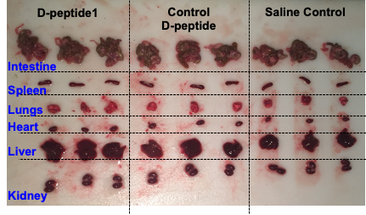
Supplemental Figure 1. Assessment of DCLK1 D-peptide Toxicity in Mice. Mice received escalating doses of D-peptide 1 every three days, starting with 750 µg (equivalent to 210 nM in blood and extravascular fluid) and increasing by 500 µg per dose, reaching a maximum of 4000 µg/mouse. Monitored toxicity indicators included soft feces, urine stains, depression, rough coat, nasal/ocular discharge, hunching, and body weight changes. Mice exhibited no adverse effects compared to saline-treated controls. Major organs were collected, and serum was stored for further biochemical analysis.

Fig. S2.
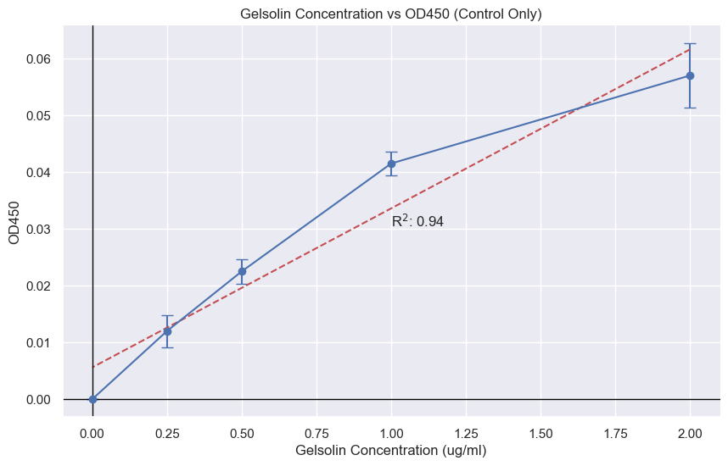
Supplemental Figure 2. Plasma Gelsolin (pGSN) ELISA Binding Optimization Curve
ELISA assays were performed where plates were coated with DCLK1 with increasing concentrations of plasma gelsolin were added and a dose curve based on Gelsolin protein was constructed. Peak concentration for pGSN was identified as 2 μg/ml with a R² of 0.94.

Supplemental Table 1.
Supplemental Table 1. SPR Analysis of DCLK1 isoform 4 with Gelsolin and FGF19
Protein | MW (Da) | Kinetic 1:1  Ave K_{a} (M⁻¹s¹) | Kinetic 1:1  Ave K_{d} (s¹) | Kinetic 1:1  Ave K_{D} (μM) | Steady-state Affinity Ave K_{D} (μM)
FGF19 | 21430 | 5.09E+03 | 9.13E-03 | 1.794 | 0.970
Gelsolin | 85710 | 5.48E+03 | 5.47E-04 | 0.099 | 1.760

