Supplementary documents 1
1. Joint Model 1
1.1 Mixed-effects modeling 1
1.2 Survival model 3
1.3 Joint model selection 4
Table S1: Selection criteria for the best longitudinal structure 7
Table S2: model fitness parameter among five different association structures of joint modeling models 7

Supplementary documents

Joint Model
A joint model (JM) is a statistical method that combines two or more connected processes, such as longitudinal and survival data, to examine their interrelationships and joint distribution. This modeling framework enables the concurrent examination of the progression of a time-varying outcome (e.g., a biomarker or clinical measurement) and the duration until an event of interest (e.g., disease onset or death). The primary benefit of joint models lies in their capacity to manage the correlation between longitudinal data and event timings, allowing for more precise estimations of the impact of time-varying covariates on survival results. Moreover, joint models can handle both the intra-subject variability in longitudinal data and the censoring present in survival data, a concern that traditional methods may not adequately tackle. This results in a stronger grasp of intricate relationships, enhancing the accuracy and dependability of conclusions derived from the data, especially in research involving repeated measurements and event durations(1, 2).

Mixed-effects modeling

A linear mixed model (LMM) is a statistical method utilized to assess data that display both fixed and random influences. It expands conventional linear regression models by including random effects, which address correlations in clustered or grouped data, like repeated observations from the same individual or data from subjects in various treatment groups. In an LMM, the fixed effects denote estimates at the population level, including the impact of particular covariates or treatments on the outcome, whereas random effects account for variations at the individual level or deviations specific to groups from the fixed effects. This modeling technique is especially beneficial for hierarchical or longitudinal data since it enables a more adaptable representation of the connection between the predictors and the outcome while appropriately addressing the correlation structure within the data. Incorporating random effects aids in minimizing bias and enhancing the accuracy of estimates, rendering LMMs a crucial resource across various domains, such as medicine, psychology, and social sciences.
In a straightforward model, we concentrate on a variable measured over time, yi(t), which is presumed to adhere to a normal distribution. To define the connection between the longitudinal variable and its related covariates, we propose a linear mixed-effects model(3).
$$Y_{i}=X_{i }(t)β+Z_{i}{\left(t\right)b}_{i}+ε_{i}(t)$$
$$b_{i}\sim N(0.D)$$
$$ε_{i}(t)\sim N(0.σ_{ε}^{2})$$
In this context, xi(t) denotes the covariate vector associated with the fixed-effects coefficient vector β, whereas Zi(t) signifies the covariate vector linked to the random-effects vector bi, for subject i (where i: 1,…,n). The random effects, bi, are presumed to be independent of each other and to be multivariate normally distributed, having a mean of zero and a variance-covariance matrix, D. The term εi(t) denotes the within-subject error, which is assumed to conform to a normal distribution with a mean of zero and a constant variance of σ²(4).
In our research, the dependent variables of thyroid stimulating hormone (TSH) and free thyroxine (FT4) levels were evaluated at various time points along with differing individual traits. To represent the longitudinal measurements of TSH and FT4 levels over time for an individual, a linear mixed-effects model was applied, which can be expressed by the subsequent equation:
$$m_{i}\left(t\right)={Log TSH}_{i}(t)={(β}_{0}+b_{0i})+{(β}_{1}+b_{1i})×{Time}_{i}+β_{2}×gender+β_{3}×follow-up current smoker+β_{4}×follow-up Log TPOAb+ε_{i}\left(t\right)$$
$$m_{i}(t))={FT4}_{i}(t)={(β}_{0}+b_{0i})+{(β}_{1}+b_{1i})×{Time}_{i}+β_{2}×gender+β_{3}×current smoker+β_{4}×follow-up Log TPOAb+ε_{i}\left(t\right)$$

To establish the ideal time structure in the mixed-effects model, we evaluated both linear and non-linear arrangements of second and third-order time elements, choosing the most suitable structure according to the minimum Bayesian Information Criterion (BIC) (Supplementary Table 1).

Survival model

The Cox proportional hazards model is a commonly employed statistical method for evaluating survival data, particularly to evaluate the impact of explanatory variables on the risk or hazard of an event happening over time. It is a semiparametric model, which means it does not presuppose a particular baseline hazard function, providing greater flexibility in modeling time-to-event data. The Cox model posits that an individual's hazard rate is a combination of a baseline hazard and an exponential function of the covariates, assuming that the impact of each covariate remains constant over time (i.e., the proportional hazards assumption). A major benefit of the Cox model is its capacity to manage censored data, which happens when the event of interest has not been recorded for every subject by the conclusion of the study period. Although the Cox model is flexible, it necessitates thorough verification of the proportional hazards assumption and attention to possible interactions among covariates(5).
The Cox proportional hazards (PH) model operates under the premise that covariates exert a multiplicative influence on the hazard of an event occurring at time t for every subject i, where i ranges from 1 to n. This may be articulated as
$$hi\left(t\right)=h_{0}\left(t\right)exp⁡\{βX_{i}\}$$
In the equation provided, h₀(t) signifies the basic hazard function, X_{i} is a 1×p vector of covariates that do not change over time for individual i, and $β$ denotes the related p×1 vector of regression coefficients, where p indicates the number of parameters.
These baseline factors include age, gender, education, BMI, physical activity, and HOMA-IR. The model is structured as follows:
$$incidence MetS=h_{0}(t) exp({β_{1} baseline Age+β_{2} Gender \left(Female\right)+β_{3} baseline Education+β_{4} baseline BMI+β}_{5} baseline physical activity+β_{6}basline HOMA-IR)+α_{1}m_{i}\left(t\right))$$
The parameter α quantifies the association between chosen characteristics of the longitudinal process (TSH/FT4) and the risk of developing incident MetS.

Joint model selection
In joint modeling, there are estimation approaches that connect the longitudinal data to the survival outcome based on slope and area. These techniques are especially valuable in clinical and biomedical studies where the behavior of a longitudinal covariate (such as a biomarker) can influence the timing of an event (like disease progression or death).
Slope affect: This method uses the slope to signify how a longitudinal variable changes over time (for example, the variation in a biological marker or clinical measurement). The slope is subsequently utilized as an indicator in the survival model to evaluate its impact on the event's hazard of interest. This technique reflects the time-related pattern of the longitudinal variable, offering essential insights into the advancement of a disease or the efficacy of a treatment. For instance, regarding thyroid hormone levels, the variation in the slope of thyroid-stimulating hormone (TSH) over time may be associated with the likelihood of developing Mets.
This aspect accounts for the rate of change in measurements at time t, which is estimated as the derivative of m_{i}(t)(1, 2).
$$hi\left(t\right)=h_{0}\left(t\right)exp⁡\{γ^{T}X_{i}+α_{2} m_{i}^{'} (t) \}$$
where $m_{i}^{'} \left(t\right)=\frac{d}{dt}m_{i}(t)$.
The model in our study is as follows:
$$incidence MetS=h_{0}(t) exp({β_{1} baseline Age+β_{2} Gender \left(Female\right)+β_{3} baseline Education+β_{4} baseline BMI+β}_{5} baseline physical activity+β_{6}basline HOMA-IR)+α_{i}\acute{m_{i}(t)})$$
The parameter α_{i} quantifies the association between the velocity of the true longitudinal trajectory at time t and the concurrent event risk, under the condition that mi(t) remains constant.

Cumulative affect area: This technique pertains to estimating the area beneath the curve (AUC) of the longitudinal variable across time. The area reflects the overall impact of the longitudinal variable, offering a summary measure of its complete change throughout the study duration. In joint modeling, this region may serve as a predictor in the survival model to assess its effect on the event's hazard. This method is especially beneficial in cases of non-linear shifts or when the cumulative exposure to a variable over time matters more than the specific rate of change at any moment. For example, the AUC of a biomarker across multiple years may reflect the overall risk of a disease, like cardiovascular events(1, 2, 6).
The integral represents the cumulative effect of the longitudinal outcome up to time point t. This is expressed as:

$$hi\left(t\right)=h_{0}\left(t\right)exp⁡\{γ^{T}X_{i}+α_{i}\int_{t_{0}}^{t}{m_{i}\left(s\right)ds} \}$$
Here, α represents the degree of association between the risk for an event at time point t and the area under the longitudinal trajectory up to the same time t. The model in our study is as follows:
$$incidence MetS=h_{0}(t) exp({β_{1} baseline Age+β_{2} Gender \left(Female\right)+β_{3} baseline Education+β_{4} baseline BMI+β}_{5} baseline physical activity+β_{6}basline HOMA-IR)+α_{i}\int_{t_{0}}^{t}{m_{i}\left(s\right)ds})$$
The coefficient $α_{i}$represents the association between the area under the longitudinal trajectory and the risk of MetS.
Slope-based and area-based approaches enable a more precise assessment of the connection between longitudinal changes and survival outcomes, incorporating both temporal trends and the cumulative impacts of longitudinal variables on the risk of events. These methods are particularly useful in situations where the longitudinal data are anticipated to affect the event's hazard over time, and they aid in enhancing the accuracy of survival forecasts.

Table S1: Selection criteria for the best longitudinal structure
longitudinal structure | Log TSH |  | FT4
 | AIC | BIC | AIC | BIC
Time | 15684.25 | 16125.38 | -5565.45 | -5643.74
Time+ I(time^2) | 15619.78 | 16272.35 | -5639.33 | 5737.87
Time+ I(time^2)+I(time^3) | 15692.15 | 16105.43 | -5536.99 | -5857.36
AIC, Akaike information criteria; BIC, Bayesian information criteria

Table S2: model fitness parameter among five different association structures of joint modeling models
 | Log TSH | FT4
 | DIC | DIC
Current value | 16383.43 | -6652.56
Slope value | 16440.09 | -6584.32
Current value plus slope | 16355.65 | -6587.39
Cumulative effects (area) | 16446.30 | -6479.79
DIC, deviance information criterion

Table S3: Joint analysis parameter estimated (95% confidence intervals) of longitudinal TSH and FT4 hormone and time to incident MetS based gender: Tehran Thyroid Study 1999-2012
Variable | gender | Model 1 |  | Model 2 |  | Model 3 |  | Model 4
Variable | gender | HR(95%CI) | p-value | HR(95%CI) | p-value | HR(95%CI) | p-value | HR(95%CI) | p-value
Log TSH | Male | 1.001(0.75-1.13) | 0.58 | 1.01(0.85-1.14) | 0.60 | 1.02(0.85-1.16) | 0.62 | 0.99(0.78-1.125) | 0.71
Log TSH | Female | 1.18(1.02-1.41) | 0.03 | 1.08(1.01-1.20) | 0.009 | 1.11(1.01-1.23) | 0.008 | 1.12(1.02-1.31) | 0.01
FT4 | Male | 0.67(0.38-0.81) | 0.02 | 0.84(0.68-1.00) | 0.05 | 0.82(0.65-0.98) | 0.04 | 0.88(0.68-1.01) | 0.09
FT4 | Female | 0.28(0.18-0.60) | 0.002 | 0.37(0.24-0.83) | 0.03 | 0.38(0.22-0.81) | 0.02 | 0.46(0.29-0.87) | 0.01

Table S4: Joint model estimates after multiple imputation for association between longitudinal logarithm TSH hormone and time to incident MetS and its components :Tehran Thyroid Study 1999–2012
 | Model 1 |  | Model 2 |  | Model 3 |  | Model 4
 | HR(95%CI) | p-value | HR(95%CI) | p-value | HR(95%CI) | p-value | HR(95%CI) | p-value
Log TSH | 1.30(1.12-1.54) | 0.005 | 1.16(1.03-1.28) | 0.008 | 1.19(1.04-1.27) | 0.01 | 1.23 (1.03-1.31) | 0.01
Abdominal obesity | 1.07(0.97-1.10) | 0.35 | 1.09(0.95-1.11) | 0.51 | 1.08(0.94-1.11) | 0.52 | 1.06(0.97-1.07) | 0.25
Hyperglycemia | 0.85(0.79-0.93) | 0.008 | 0.88(0.80-0.94) | 0.01 | 0.88(0.80-0.93) | 0.01 | 0.90(0.81-0.96) | 0.03
Hypertension | 1.06(1.02-1.17) | 0.04 | 1.10(1.04-1.20) | 0.01 | 1.10(1.04-1.19) | 0.01 | 1.15(1.04-1.23) | 0.02
hypertriglyceridemia | 1.35(0.89-1.87) | 0.45 | 1.38(0.87-1.94) | 0.39 | 1.38(0.85-2.00) | 0.39 | 1.43(0.86-1.98) | 0.31
Low HDL | 1.12(0.99-1.20) | 0.43 | 1.12(0.95-1.22) | 0.48 | 1.08(0.97-1.21) | 0.45 | 1.10(0.97-1.18) | 0.40
HR, hazard ratio; CI, confidence intervals; TSH, thyroid stimulating hormone; MetS, Metabolic Syndrome; HDL, High Density Lipoprotein;
Model 1, adjusted for Gender, age, Education, physical activity; Model 2, adjusted for Gender, age, Education, physical activity, BMI; Model 3:Model 2+HOMA-IR ; Mode14: Model 2+FPG, SBP,DBP,TG/HDL, anti-hyperglycemic drug, lipid-lowering drugs, anti-hypertensive drugs

Table S5: Joint model estimates after multiple imputation for association between longitudinal FT4 hormone and time to incident MetS and its components :Tehran Thyroid Study 1999–2012
 | Model 1 |  | Model 2 |  | Model 3 |  | Model 4
Variable | HR(95%CI) | p-value | HR(95%CI) | p-value | HR(95%CI) | p-value | HR(95%CI) | p-value
FT4 | 0.44 (0.25–0.80) | 0.006 | 0.55 (0.31–0.99) | 0.006 | 0.56 (0.30–0.98) | 0.04 | 0.53 (0.29–0.97) | 0.04
Abdominal obesity | 0.38 (0.23–0.66) | <0.001 | 0.59 (0.35–1.01) | 0.04 | 0.60 (0.34–1.02) | 0.04 | 0.63 (0.36–1.09) | 0.08
Hyperglycemia | 1.05 (0.86–1.52) | 0.14 | 1.10 (0.66–1.68) | 0.31 | 1.11 (0.68–1.66) | 0.33 | 1.14 (0.72–1.72) | 0.27
Hypertension | 0.56 (0.37–1.23) | 0.09 | 0.60 (0.31–1.10) | 0.12 | 0.61 (0.32–1.10) | 0.13 | 0.63 (0.35–1.16) | 0.14
Hypertriglyceridemia | 0.89 (0.78–1.01) | 0.03 | 0.87 (0.76–0.98) | 0.01 | 0.88 (0.76–1.00) | 0.01 | 0.89 (0.80–1.01) | 0.04
Low HDL | 0.96 (0.53–1.75) | 0.41 | 0.98 (0.52–1.83) | 0.40 | 0.99 (0.51–1.86) | 0.41 | 0.90 (0.47–1.68) | 0.44
HR, hazard ratio; CI, confidence intervals; TSH, thyroid stimulating hormone; MetS, Metabolic Syndrome; HDL, High Density Lipoprotein;
Model 1, adjusted for Gender, age, Education, physical activity; Model 2, adjusted for Gender, age, Education, physical activity, BMI; Model 3:Model 2+HOMA-IR ; Mode14: Model 2+FPG, SBP,DBP,TG/HDL, anti-hyperglycemic drug, lipid-lowering drugs, anti-hypertensive drugs

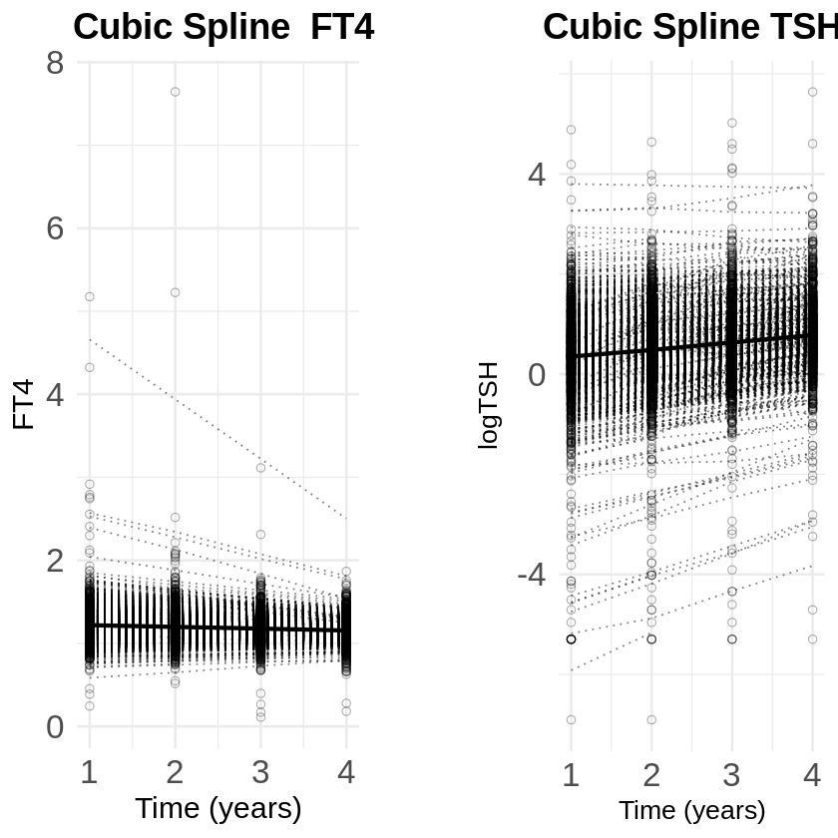
Fig S1. Longitudinal trajectories of FT4 and logTSH modeled using cubic splines

1. Mchunu NN, Mwambi HG, Rizopoulos D, Reddy T, Yende-Zuma N. Using joint models to study the association between CD4 count and the risk of death in TB/HIV data. BMC Medical Research Methodology. 2022;22(1):1-9.
2. Illipse M, Czene K, Hall P, Humphreys K. Studying the association between longitudinal mammographic density measurements and breast cancer risk: a joint modelling approach. Breast Cancer Research. 2023;25(1):1-11.
3. Rizopoulos D. Joint models for longitudinal and time-to-event data: With applications in R: CRC press; 2012.
4. Fitzmaurice GM, Laird NM, Ware JH. Applied longitudinal analysis: John Wiley & Sons; 2012.
5. Lin H, Zelterman D. Modeling survival data: extending the Cox model. Taylor & Francis; 2002.
6. Mauff K, Steyerberg EW, Nijpels G, van der Heijden AA, Rizopoulos D. Extension of the association structure in joint models to include weighted cumulative effects. Statistics in medicine. 2017;36(23):3746-59.

