Supplemental Material

Vinclozolin and MEHP disrupt piRNA and miRNA expression and increase apoptosis in Embryonic Mouse Ovaries
Odei Barreñada¹; Justin Bochter¹; Miguel Ángel Brieño‑Enríquez^{1*}; Jesús del Mazo^{2*}

Table of Contents

Figures
Figure S1: Representative images of alkaline phosphatase staining after PGC enrichment assay using anti-SSEA1 antibody beads.
Figure S2: PCA plot of sncRNAs expression patterns of each group
Figure S3: Venn Diagram showing the piRNA and miRNA sequences shared among different cell type – Endocrine disruptor couple.
Tables
Table S1: Detailed information of TaqMan probes acquired in Thermofisher.
Table S2: Detailed Summary of Table 1.
Excel document

Figure S1: Examples of Alkaline phosphatase staining after PGC enrichment assay using anti-SSEA1 antibody beads. Scale bar represents 100 μm.
PGC fraction | SC fraction
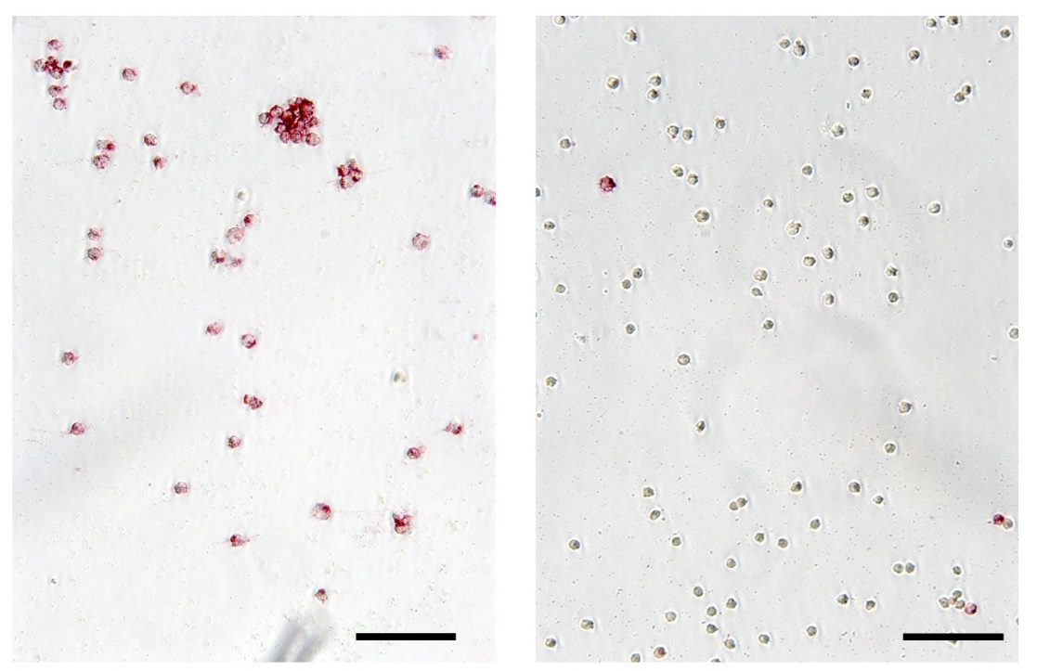

Figure S2: PCA plot of sncRNAs expression patterns of each group. The sample names can be made meaningful using the following code: C=control; M=exposure to MEHP; V=exposure to vinclozolin; P=PGCs; S=somatic cells; 1, 2, 3= successive generations respectively; Sy=Parental Synergic effect. 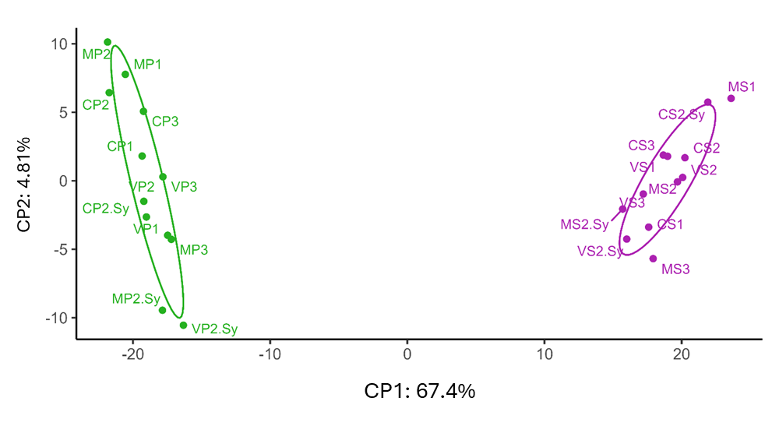

Figure S3: Venn Diagram showing the piRNA and miRNA sequences shared among different cell type – Endocrine disruptor couple.
piRNAs | miRNAs
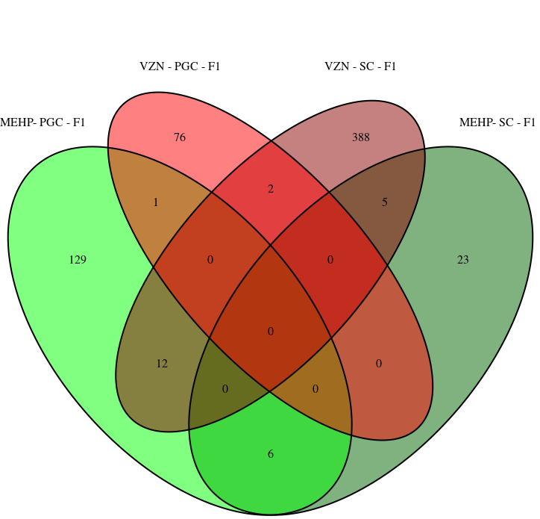 | 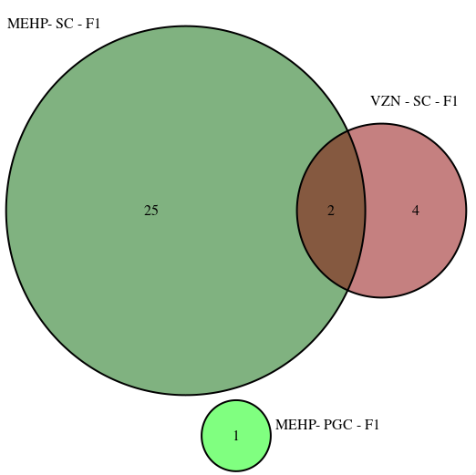

Table S1: Detailed information of TaqMan probes acquired in Thermofisher for mature microRNA expression validation. All probes are certified for use to detect mouse microRNA by the manufacturer.
Assay ID | Assay Name | Catalog number | Mature RNA sequence
001141 | mmu-miR-451 | 4427975 | AAACCGUUACCAUUACUGAGUU
001821 | hsa-miR-484 | 4427975 | UCAGGCUCAGUCCCCUCCCGAU
464322 | mmu-miR-871-3p | 4440886 | UGACUGGCACCAUUCUGGAUAAU
000443 | hsa-miR-107 | 4427975 | AGCAGCAUUGUACAGGGCUAUCA
000379 | hsa-let-7c | 4427975 | UGAGGUAGUAGGUUGUAUGGUU
001516 | hsa-miR-425-5p | 4427975 | AAUGACACGAUCACUCCCGUUGA

Table S2: Detailed Summary of Table 1. Shows sequences and reads in each of the samples analyzed. Columns represent the mean between replicates of “>10CPM” (the sequences exceeding 10 counts per million), piRNAs (those identified as piRNAs) and miRNAs (those identified as miRNAs). The sample names can be made meaningful using the following code: C=control; M=exposure to MEHP; V=exposure to vinclozolin; P=PGCs; S=somatic cells; 1, 2, 3= successive generations respectively; Sy=Parental Synergic effect. *Note that the values and percentages of piRNAs and miRNAs presented here have been independently identified. Consequently, it is possible for the same sequence to be identified both as a piRNA and a miRNA, and thus it will be included in both categories.
 | Different sequences* |  |  |  |  | Total reads*
Sample | >10 CPM | piRNA | % piRNA | miRNA | % miRNA | >10 CPM | piRNA | % piRNA | miRNA | % miRNA
CP1 | 4,414 | 4,147 | 94.0% | 1,546 | 35.0% | 9,767,389 | 9,586,379 | 98.2% | 5,958,797 | 61.0%
CP2 | 4,195 | 3,972 | 94.7% | 1,615 | 38.5% | 10,632,947 | 10,492,690 | 98.7% | 6,456,415 | 60.7%
CP2.Sy | 4,151 | 3,794 | 91.4% | 1,507 | 36.3% | 9,792,156 | 9,578,283 | 97.8% | 5,765,401 | 58.9%
CP3 | 4,341 | 4,092 | 94.3% | 1,558 | 35.9% | 10,650,492 | 10,471,937 | 98.3% | 6,114,518 | 57.4%
CS1 | 3,568 | 3,448 | 96.6% | 2,056 | 57.6% | 10,928,868 | 10,859,605 | 99.4% | 9,189,833 | 84.1%
CS2 | 3,388 | 3,277 | 96.7% | 2,076 | 61.3% | 12,644,142 | 12,560,256 | 99.3% | 10,856,423 | 85.9%
CS2.Sy | 3,460 | 3,339 | 96.5% | 2,145 | 62.0% | 12,264,329 | 12,198,810 | 99.5% | 10,770,241 | 87.8%
CS3 | 3,554 | 3,438 | 96.8% | 2,088 | 58.7% | 11,640,391 | 11,506,028 | 98.9% | 9,394,308 | 80.7%
MP1 | 4,547 | 4,295 | 94.5% | 1,577 | 34.7% | 10,207,138 | 10,032,952 | 98.3% | 6,071,586 | 59.5%
MP2 | 4,187 | 3,902 | 93.2% | 1,562 | 37.3% | 12,343,944 | 12,123,023 | 98.2% | 7,155,919 | 58.0%
MP2.Sy | 4,305 | 4,112 | 95.5% | 1,568 | 36.4% | 8,941,144 | 8,842,865 | 98.9% | 5,908,462 | 66.1%
MP3 | 4,121 | 3,901 | 94.7% | 1,523 | 36.9% | 9,126,880 | 8,989,120 | 98.5% | 5,487,817 | 60.1%
MS1 | 3,394 | 3,285 | 96.8% | 2,103 | 62.0% | 12,250,922 | 12,171,044 | 99.4% | 10,570,724 | 86.3%
MS2 | 3,407 | 3,272 | 96.1% | 2,034 | 59.7% | 12,517,569 | 12,325,921 | 98.5% | 10,475,588 | 83.7%
MS2.Sy | 3,499 | 3,396 | 97.1% | 2,105 | 60.2% | 10,846,851 | 10,779,488 | 99.4% | 9,414,036 | 86.8%
MS3 | 3,535 | 3,418 | 96.7% | 2,026 | 57.3% | 12,434,863 | 12,325,185 | 99.1% | 9,662,093 | 77.7%
VP1 | 4,412 | 4,200 | 95.2% | 1,485 | 33.6% | 9,301,195 | 9,186,636 | 98.8% | 5,278,739 | 56.8%
VP2 | 4,173 | 3,961 | 94.9% | 1,518 | 36.4% | 10,663,069 | 10,511,607 | 98.6% | 6,156,870 | 57.7%
VP2.Sy | 4,100 | 3,766 | 91.9% | 1,409 | 34.4% | 8,322,585 | 8,083,041 | 97.1% | 5,110,319 | 61.4%
VP3 | 4,171 | 3,943 | 94.5% | 1,638 | 39.3% | 9,722,748 | 9,560,033 | 98.3% | 6,148,031 | 63.2%
VS1 | 3,769 | 3,611 | 95.8% | 2,000 | 53.1% | 12,547,897 | 12,447,721 | 99.2% | 10,491,147 | 83.6%
VS2 | 3,355 | 3,239 | 96.6% | 2,055 | 61.2% | 12,323,989 | 12,216,250 | 99.1% | 10,610,400 | 86.1%
VS2.Sy | 3,613 | 3,415 | 94.5% | 2,064 | 57.1% | 10,295,262 | 10,181,244 | 98.9% | 8,437,553 | 82.0%
VS3 | 3,608 | 3,484 | 96.6% | 2,134 | 59.20% | 11,340,105 | 11,261,970 | 99.3% | 9,339,081 | 82.4%

Additional Excel Document:
Excel Table S1: Birth rate collection records per pregnant mice collected. The table includes the total number of mice collected, number of embryos, number of female gonads, number of reabsorptions including the date of collection and the group of collection.
Excel Table S2: Differentially expressed piRNA sequences for each cell type and assessed ED as DESeq2 result file. Meaning of each column is based on software user manual: baseMean, mean of normalized counts for all samples; log2FoldChange, log2 fold change (LFC); lfcSE, standard error of the log2Foldchange value; stat, Wald test statistic; pvalue, Wald test p-value; padj, multiple test correction using Benjamini-Hochberg adjusted p-value.
Excel Table S3: piRNAs with conserved expression alteration in consecutive generations. Each row represents a cell type-ED combination and the comparison of: A) three consecutive generations and B) first two generations.
Excel Table S4: Differentially expressed miRNA sequences for each cell type and assessed EDs as DESeq2 result file. Meaning of each column is detailed in software’s user manual: baseMean, mean of normalized counts for all samples; log2FoldChange, log2 fold change; lfcSE, standard error of the log2Foldchange value; stat, Wald test statistic; pvalue, Wald test p-value; padj, multiple test correction using Benjamini-Hochberg adjusted p-value.
Excel Table S5: Shared piRNA and miRNA sequences comparing maternal exposure and both parental exposures.
Excel Table S6: Analysis of detected mitochondrial sncRNAs. In total, 203 sequences, all of them annotated as piRNAs, and 3 of them also as miRNAs. The mapping region, mismatches, mean expression by cell type and p-value, and LFC of different comparisons are included.
Excel Table S7: piRNA targets calculated by miRanda software as described in Materials and Methods.
Excel Table S8: Result of DESeq2 differential expression analysis comparing F2 with F2.Sy for each cell type-ED combination of sequences identified as piRNA.
Excel Table S9: Result of DESeq2 differential expression analysis comparing F2 with F2.Sy for each cell type-ED combination of sequences identified as miRNA.
Excel Table S10: The annotations of sequences made by SPORTS1.1 software.

