Supplementary materials

Supplementary table
Supplementary Table 1. Metadata and Karyotype of all Sequenced Samples. This table includes sample ID, collection details (country, location, and year), sex, coordinates, mitochondrial ID, and corresponding karyotype.
Supplementary Figures

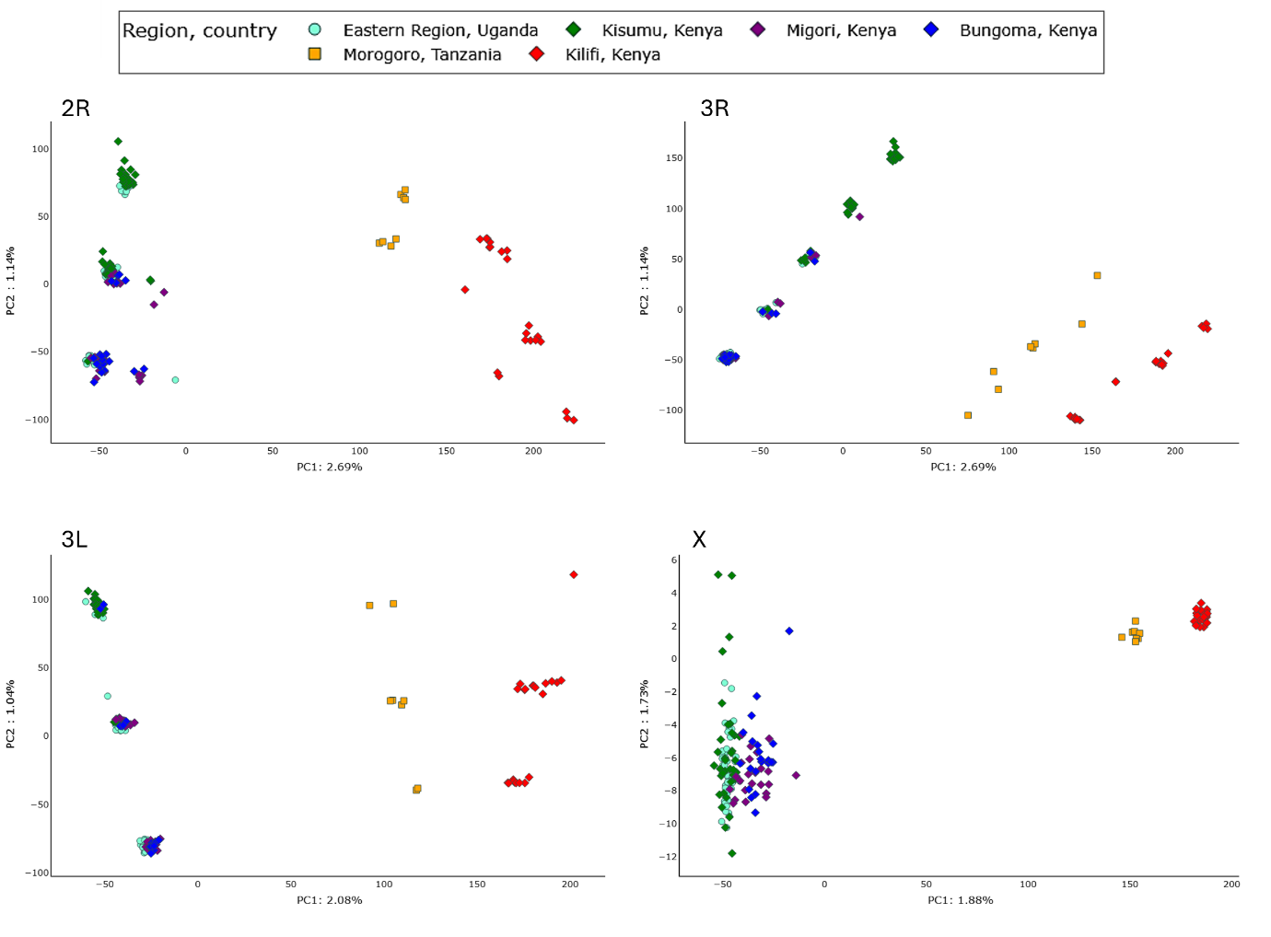
Supplementary figure 1: Projection of individual samples coloured by cohort along PCA1 and PCA2 on chromosome arms 2R, 3R, 3L and X. Percentage of explained variance is shown in the axe’s labels.
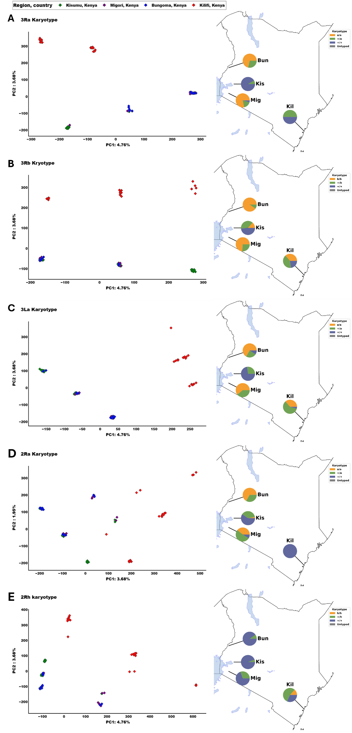
Supplementary figure 2: On the left side is the projection of individual samples coloured by cohort along PCA1 and PCA2 on chromosomal inversion 3Ra, 3Rb, 3La, 2Ra and 2Rh inversion regions. The percentage of explained variance is shown in the axe’s labels. On the right is the map of Kenya indicating the proportion of different karyotypes at the chromosomal inversion regions.

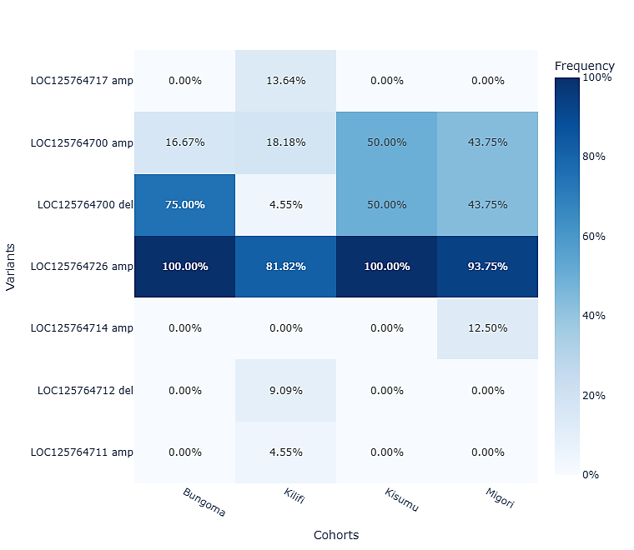
Supplementary figure 3: Heat map showing the frequency of copy number variance (CNV) frequencies (max freq >5%) in the Cyp6(rp1) gene cluster of An. funestus population from Kenya. The lighter the blue colour the lower the CNV frequency and the darker the blue colour the higher the SNP frequency.

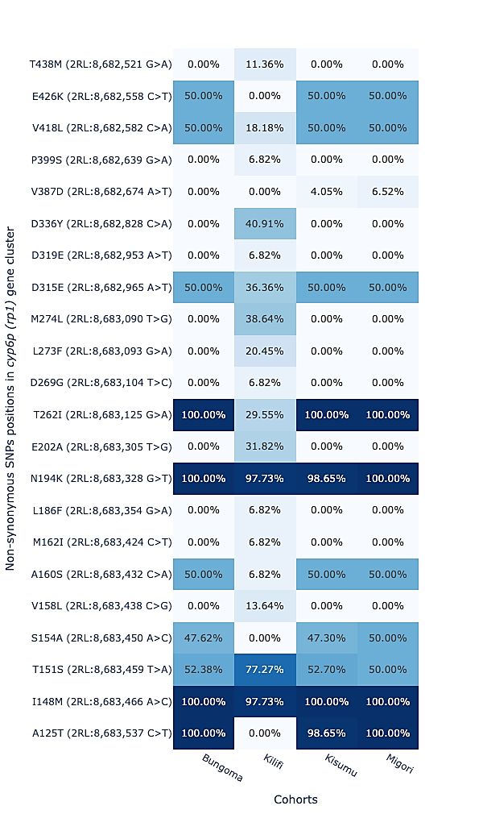
Supplementary figure 4: Heat map showing the frequency of non-synonymous SNPs frequencies (max freq >5%) in the Cyp6(rp1) gene region of An. funestus population from Kenya. The lighter the blue colour the lower the SNP frequency and the darker the blue colour the higher the SNP frequency.

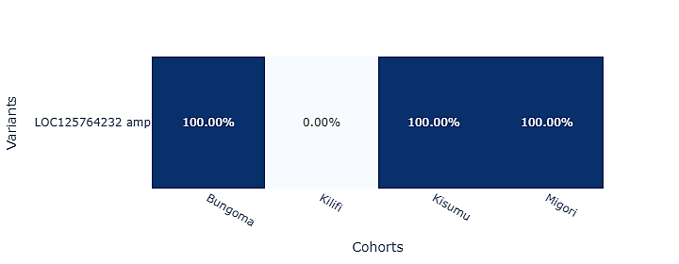
Supplementary figure 5: Heat map showing the frequency of copy number variance (CNV) frequencies (max freq >5%) in the Cyp9k1 gene region of An. funestus population from Kenya. The lighter the blue colour the lower the CNV frequency and the darker the blue colour the higher the SNP frequency.

