Supplementary Table 1 Features with ICC > 0.8
Features | ICC
wavelet-LHH_glrlm_ShortRunEmphasis | 0.817642621
original_shape_Elongation | 0.933991545
original_shape_Maximum2DDiameterColumn | 0.827364334
wavelet-LLH_glrlm_ShortRunEmphasis | 0.874822749
wavelet-HHL_glcm_Idn | 0.901436586
wavelet-HLL_firstorder_Energy | 0.805842639
wavelet-HLL_glszm_GrayLevelNonUniformityNormalized | 0.810730263
wavelet-LLL_glcm_InverseVariance | 0.881776834
wavelet-HHL_glrlm_ShortRunLowGrayLevelEmphasis | 0.825782736
original_glszm_ZoneEntropy | 0.845578278
wavelet-HHL_firstorder_TotalEnergy | 0.853958923
wavelet-HHL_firstorder_Energy | 0.853958923
wavelet-LHL_glszm_SizeZoneNonUniformity | 0.842602778
diagnostics_Image-original_Mean | 0.868911937
The intraclass correlation coefficient (ICC) was used to assess feature reliability, ranging from 0 to 1. Thresholds are commonly defined as: ICC < 0.5, poor; 0.5–0.75, moderate; 0.75–0.90, good; and >0.90, excellent. Based on the study design, the ICC(3,1) model (Two-way Mixed, Single Rater, Absolute Agreement) was applied, and features with ICC > 0.8 were retained for further analysis.

Supplementary Table 2 Comparative analysis of clinical and ultrasound features from three centers
Variable | Center 1 | Center 2 | Center 3 | χ²/H | p-value
Age | 47.0(35.0,57.0) | 50.0(35.0,57.0) | 45.8±12.0 | 1.664 | 0.435
Diameter (mm) | 9.20(6.70,14.20) | 8.00(6.00,12.00) | 9.70(6.20,12.95) | 5.899 | 0.052
Sex |  |  |  | 2.953 | 0.228
Male | 141 | 30 | 37
Female | 342 | 96 | 72
Composition |  |  |  | 0.644 | 0.725
Mixed cystic-solid | 8 | 2 | 3
Solid | 475 | 124 | 106
Echogenicity |  |  |  | - | 0.100
Markedly hypoechoic | 36 | 3 | 3
Hypoechoic | 438 | 121 | 103
Iso- or hyperechoic | 9 | 2 | 3
Shape |  |  |  | 4.367 | 0.113
Wider-than-tall | 191 | 52 | 55
Taller-than-wide | 292 | 74 | 54
Margin |  |  |  | - | <0.001
Smooth | 30 | 14 | 20
ill-defined | 167 | 60 | 10
Lobulated/irregular | 279 | 52 | 77
Extrathyroidal extension | 7 | 0 | 2
Calcification |  |  |  | - | <0.001
Absent or macro-comet tail | 129 | 41 | 33
Microcalcification | 316 | 84 | 60
Coarse calcification | 27 | 1 | 16
Rim calcification | 11 | 0 | 0
“-” indicates Fisher’s exact test

Supplementary Table 3 Comparative analysis of clinical and ultrasound features from three datasets
Variable | Training Set | Test Set | External Validation | χ²/H | p-value
Age | 47.0 (36.0, 57.0) | 48.0 (34.0, 57.3) | 45.8±12.0 | 0.693 | 0.707
Diameter (mm) | 8.8 (6.30, 13.60) | 10.00 (7.45, 14.05) | 9.70 (6.20, 12.95) | 3.355 | 0.187
Sex |  |  |  | 1.921 | 0.383
Male | 134 | 37 | 37
Female | 353 | 85 | 72
Composition |  |  |  | - | 0.517
Mixed cystic-solid | 9 | 1 | 3
Solid | 478 | 121 | 106
Echogenicity |  |  |  | - | 0.237
Markedly hypoechoic | 28 | 11 | 3
Hypoechoic | 451 | 108 | 103
Iso- or hyperechoic | 8 | 3 | 3
Shape |  |  |  | 7.425 | 0.024
Wider-than-tall | 203 | 40 | 55
Taller-than-wide | 284 | 82 | 54
Margin |  |  |  | - | <0.01
Smooth | 42 | 2 | 20
ill-defined | 181 | 46 | 10
Lobulated/irregular | 257 | 74 | 77
Extrathyroidal extension | 7 | 0 | 2
Calcification |  |  |  | - | 0.005
Absent or macro-comet tail | 141 | 29 | 33
Microcalcification | 315 | 85 | 60
Coarse calcification | 23 | 5 | 16
Rim calcification | 8 | 3 | 0
“-” indicates Fisher’s exact test
Supplementary Table 4 Principal Component Loading Matrix (PC1–PC10)
Feature Name | PC1 | PC2 | PC3 | PC4 | PC5 | PC6 | PC7 | PC8 | PC9 | PC10
ShortRunEmphasis.1 | 0.307 | 0.382 | 0.501 | 0.053 | 0.028 | 0.061 | 0.014 | 0.037 | 0.006 | 0.707
Elongation | 0.132 | 0.187 | 0.280 | 0.874 | 0.290 | 0.092 | 0.050 | 0.101 | 0.005 | 0.000
Maximum2DDiameterColumn | 0.293 | 0.346 | 0.461 | 0.193 | 0.002 | 0.145 | 0.123 | 0.707 | 0.093 | 0.000
ShortRunEmphasis | 0.307 | 0.382 | 0.501 | 0.053 | 0.028 | 0.061 | 0.014 | 0.037 | 0.006 | 0.707
ldn | 0.379 | 0.331 | 0.068 | 0.104 | 0.426 | 0.036 | 0.292 | 0.127 | 0.669 | 0.000
Energy | 0.376 | 0.028 | 0.323 | 0.111 | 0.001 | 0.819 | 0.102 | 0.207 | 0.135 | 0.000
GrayLevelNonUniformityNormalized | 0.313 | 0.393 | 0.108 | 0.083 | 0.110 | 0.094 | 0.795 | 0.262 | 0.092 | 0.000
InverseVariance | 0.231 | 0.298 | 0.008 | 0.312 | 0.766 | 0.025 | 0.402 | 0.055 | 0.095 | 0.000
ShortRunLowGrayLevelEmphasis | 0.366 | 0.384 | 0.089 | 0.040 | 0.296 | 0.186 | 0.270 | 0.091 | 0.711 | 0.000
ZoneEntropy | 0.371 | 0.231 | 0.282 | 0.252 | 0.217 | 0.498 | 0.144 | 0.590 | 0.045 | 0.000
Bold values indicate |loading| ≥ 0.30 (threshold for significant contribution). Bold feature names: the six features retained in the final model. Plain feature names: Features that were excluded.

Supplementary Table 5 Feature Retention Criteria

Feature | Key Loading Positions | Retention Rationale
ShortRunEmphasis.1 | PC3(0.501), PC10(0.707) | Maintained consistently high variance contribution across the multidimensional space
Elongation | PC4(0.874) | Dominant contribution from a single principal component (core representative of morphological features)
ldn | PC1(0.379), PC5(0.426), PC9(0.669) | Stable contribution across three principal components, reflecting textural complexity
Energy | PC6(0.819) | Possesses the strongest explanatory power for the critical variation dimension (PC6).
GrayLevelNonUniformityNormalized | PC2(0.393), PC7(0.795) | Significant loadings on both the discrete dimension (PC2) and the heterogeneity dimension (PC7).
InverseVariance | PC6(0.766) | Primary carrier of spatial correlation

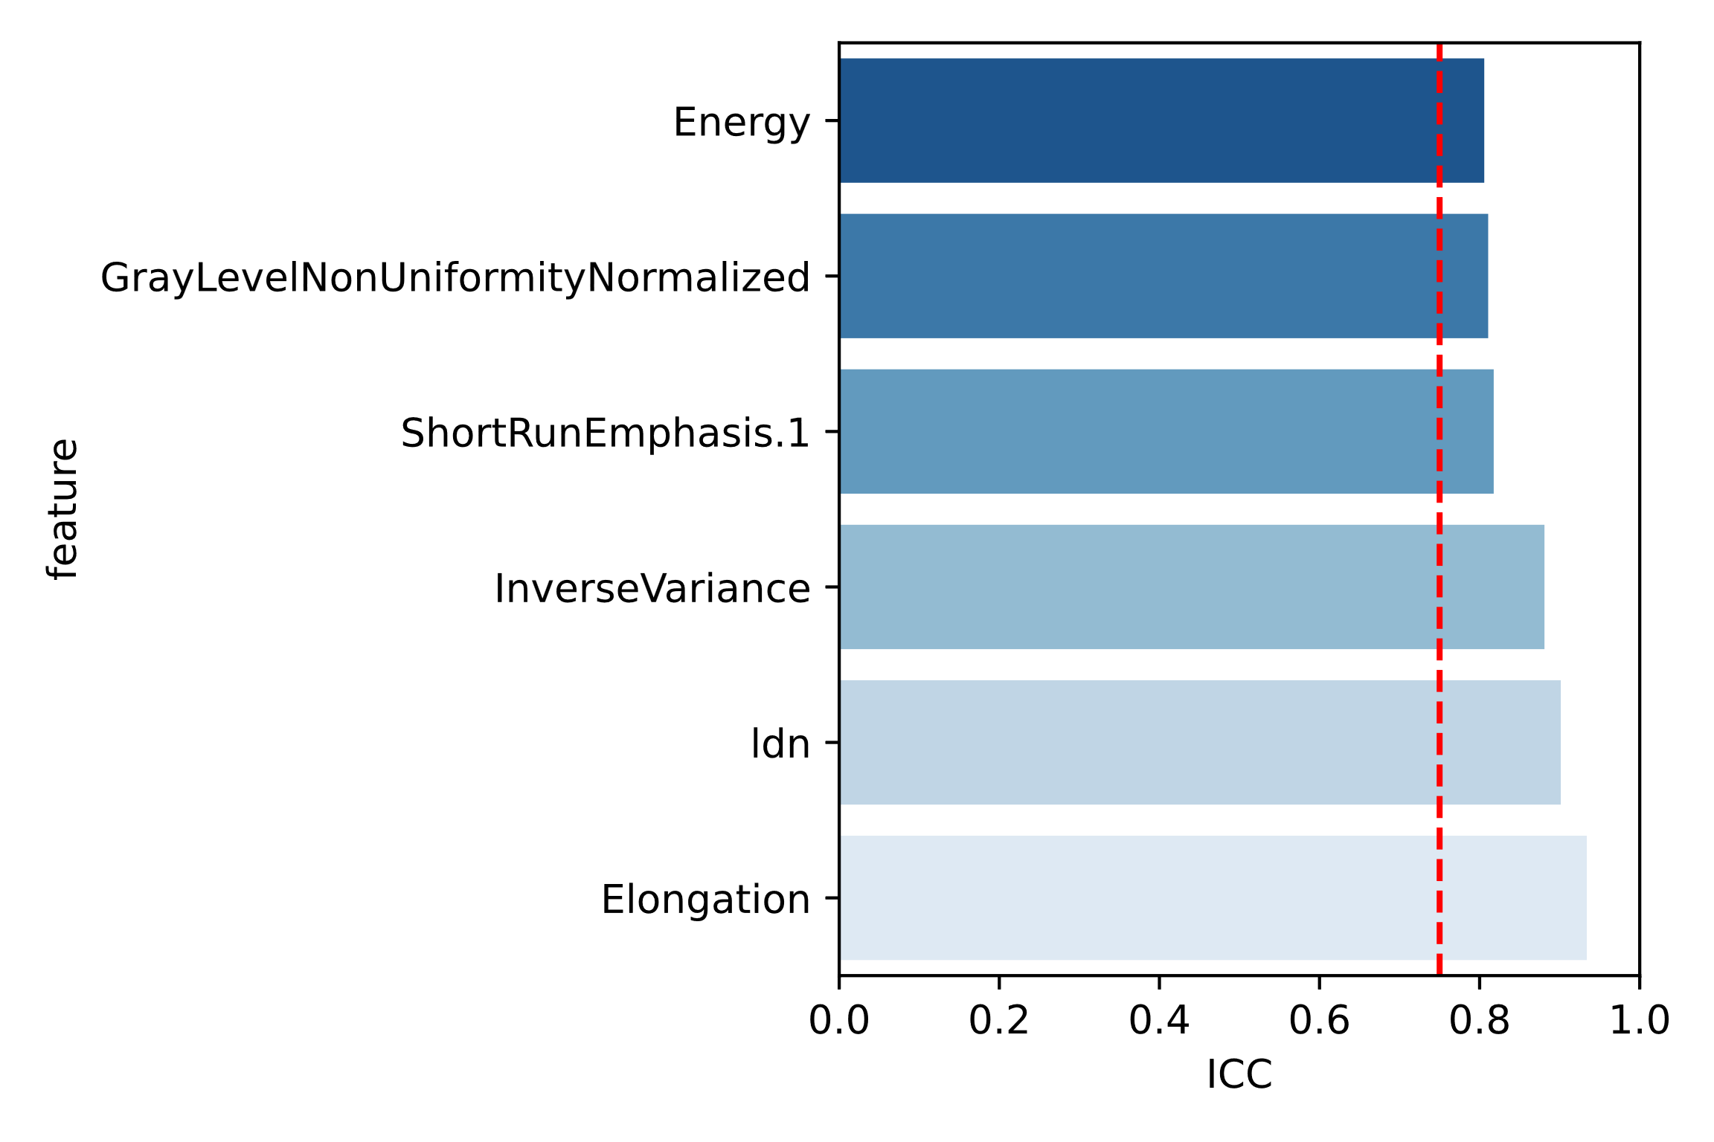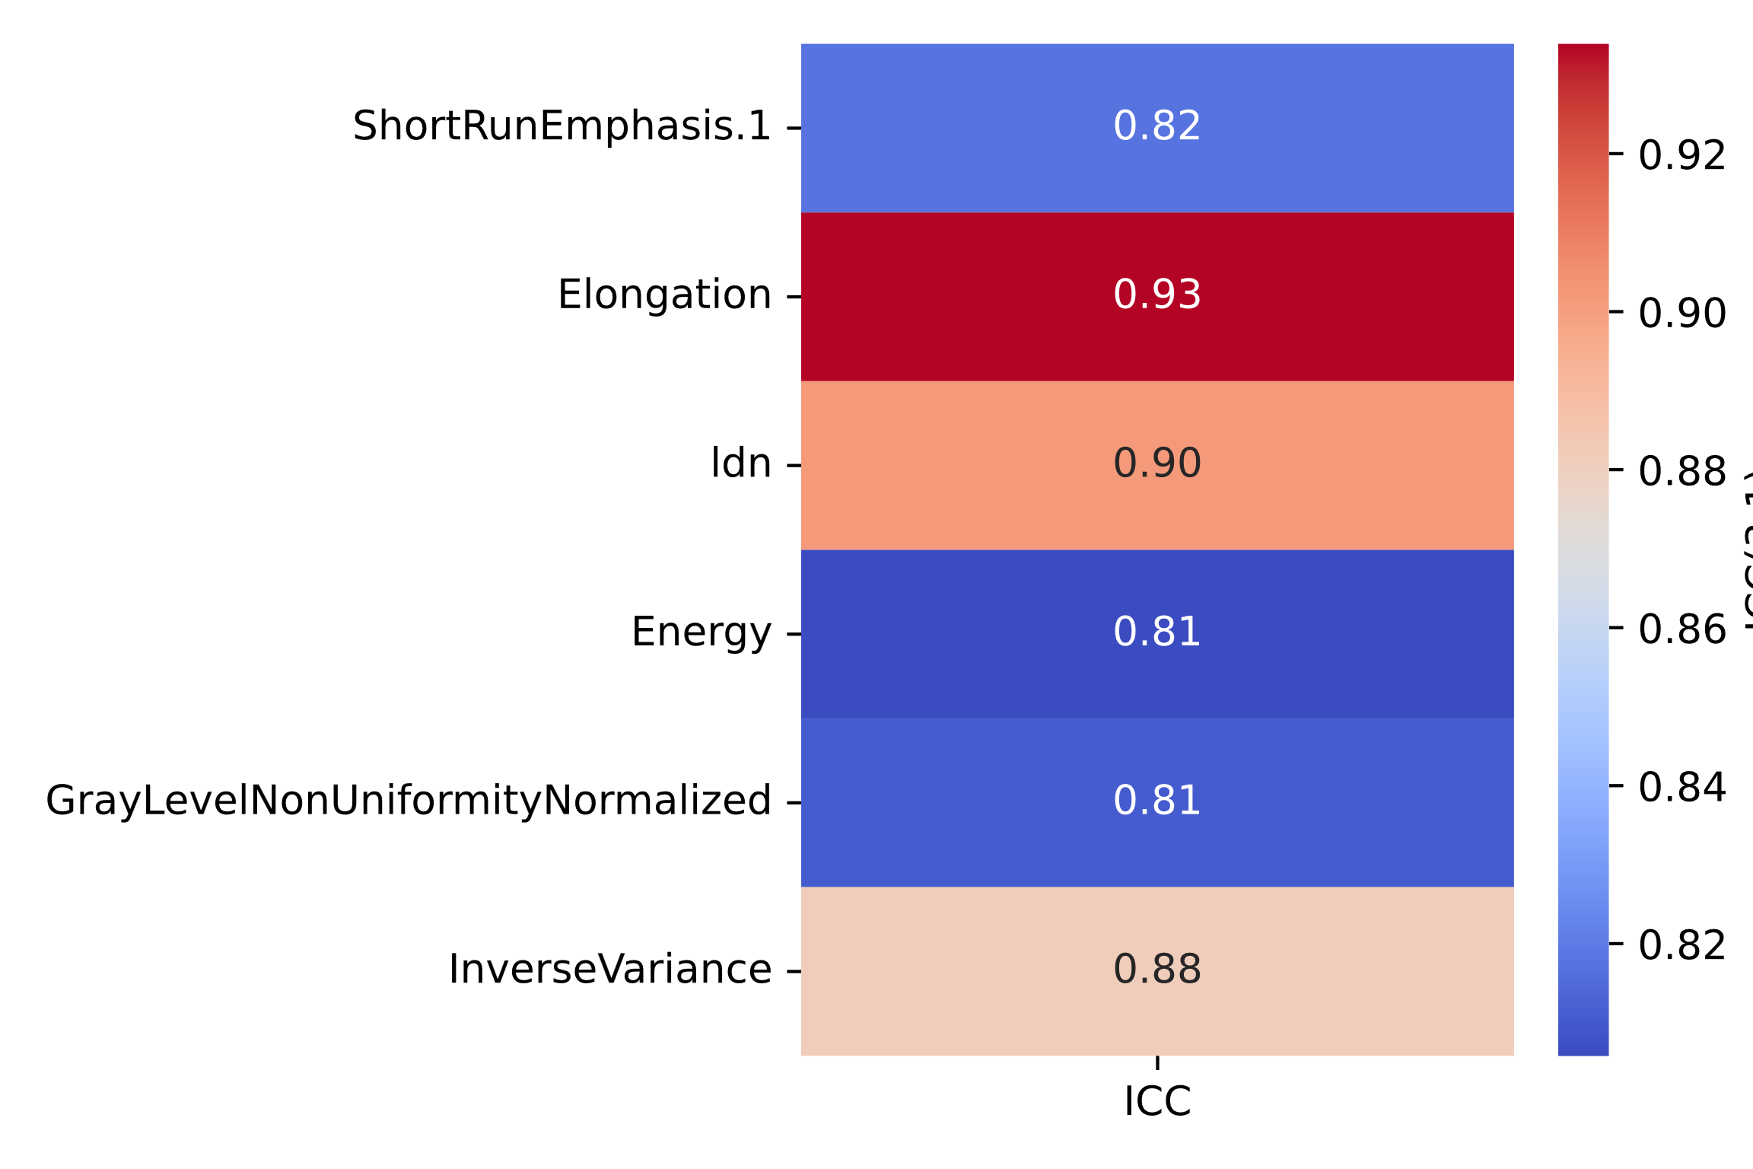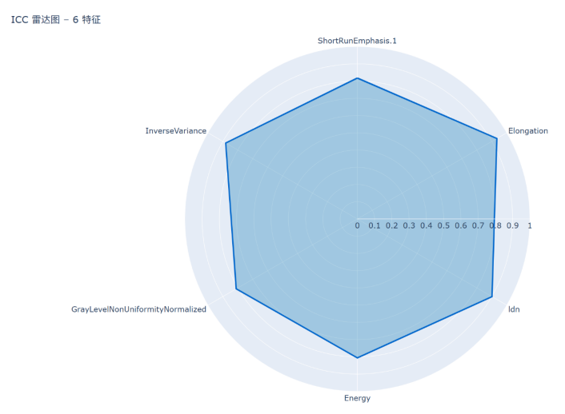
a
b
c
Supplementary Figure 1 Visual ICC analysis of the final six selected features. 1a The Y-axis shows six radiomics features — Energy, GrayLevelNonUniformityNormalized, ShortRunEmphasis.1, InverseVariance, Idn, and Elongation — representing classical texture- and shape-related descriptors. The X-axis denotes the intraclass correlation coefficient (ICC, range 0–1), with ICC > 0.75 indicating good agreement and ICC ≥ 0.80 considered a stricter benchmark.
(1b, 1c) Exact ICC values are displayed, enabling a detailed assessment of feature reproducibility. Elongation and Idn demonstrated excellent stability (ICC ≥ 0.90); InverseVariance and ShortRunEmphasis.1 showed good agreement (ICC ≈ 0.85); while Energy and GrayLevelNonUniformityNormalized were threshold-compliant (ICC ≈ 0.81).

