Supplementary Figures
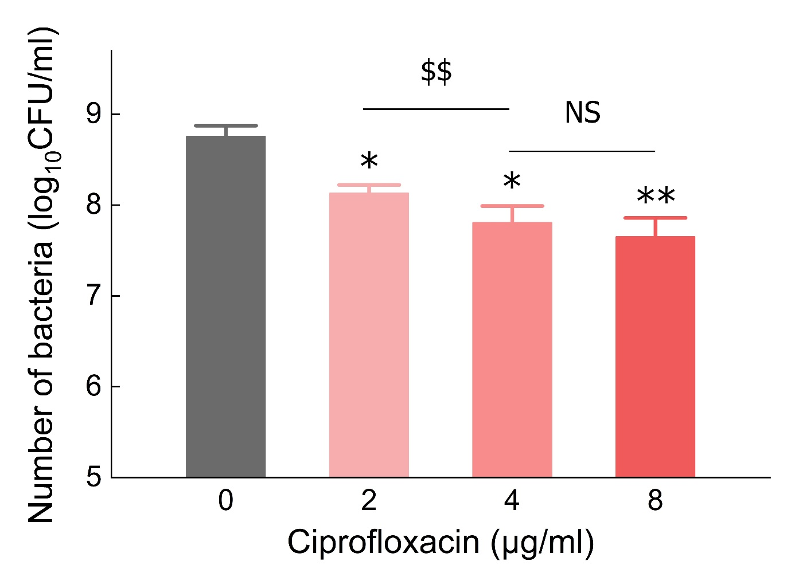

Fig. S1. Colony-forming unit (CFU) counts of P. aeruginosa biofilms treated with varying concentrations of ciprofloxacin for 6 h to assess bacterial survival. (NS = no significant difference; *P < 0.05 vs. CTRL; **P < 0.01 vs. CTRL; $$P < 0.01; N = 5 per group).

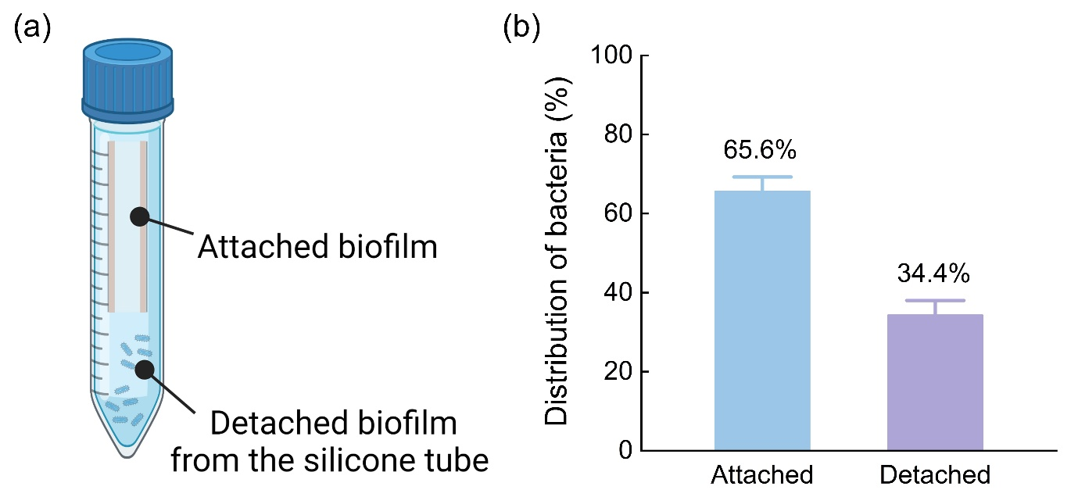

Fig. S2. Distribution of bacteria in biofilms after catheter insertion: (a) illustrations of attached biofilm on the silicone tube and detached biofilm and (b) percentage of both attached and detached bacteria quantified by CFU.’

