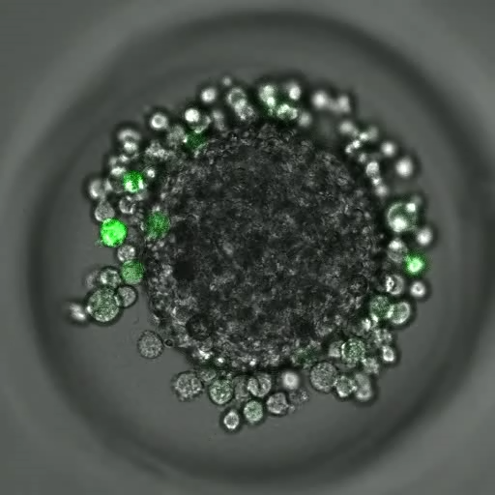
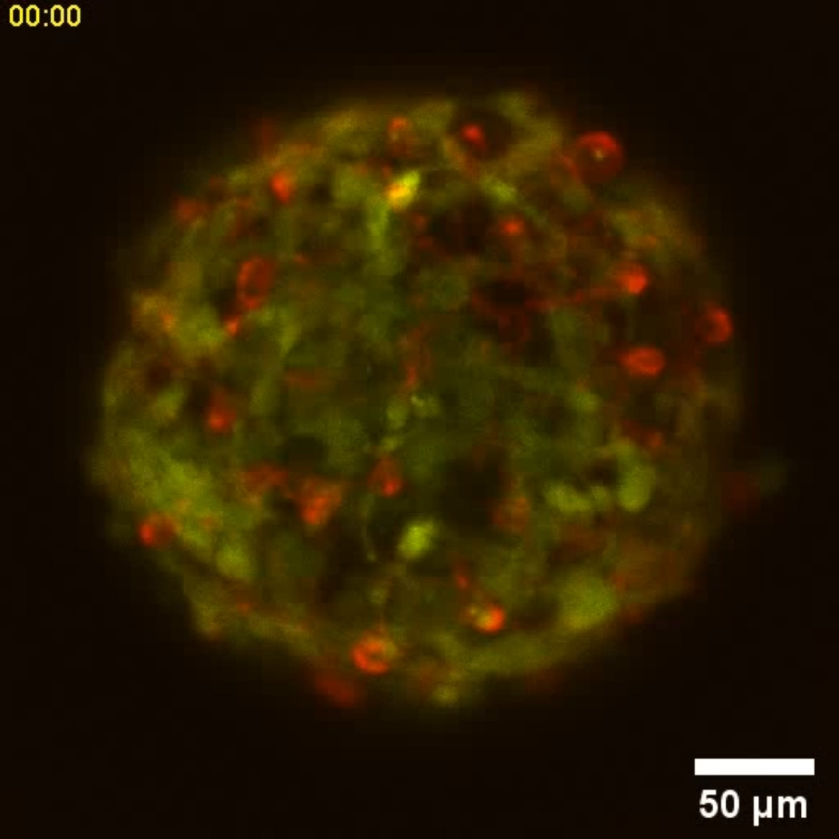
Supplemental Information:

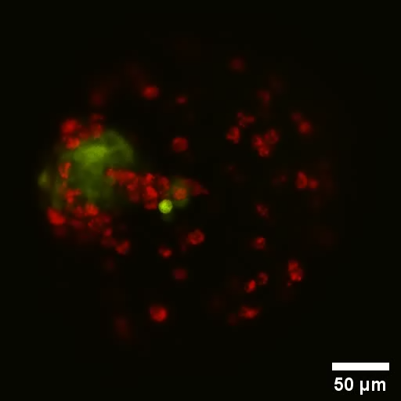
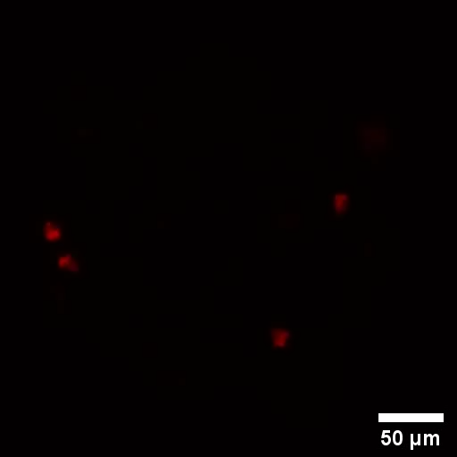
Supplemental Figure S.1: Timelapse confocal micrograph z-projection of DIV2 cortical microtissue seeded with CNS200 (green). Z-stacks were collected every 5 minutes for 72 hours. CNS1 cells infiltrated and incorporated into the microtissue in the first 24 hours. CNS1 cells infiltrated more deeply into the center of the microtissue over the following 2 days
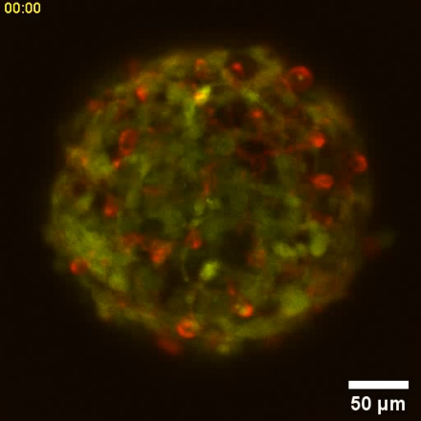

Supplemental Figure S.2: Timelapse confocal micrograph z-projections of DIV14 cortical microtissues stained for microglia with IB4 (red). Control (left) microtissues exhibited few microglia. 9L100 BCMs (center) exhibited many microglia that clustered together and moved towards the 9L (green) microtumor. CNS100 BCMs (right) exhibited many microglia spread throughout the microtissue, as were the CNS1 cells (green). Z-stacks were collected every 2 minutes for 30 minutes.

