SUPPLEMENTARY FILE
This document consists of 3 parts. Part 1 details the release kinetics, Part 2 details the DSC analyses and Part 3 details the FTIR analyses.

PART 1:
The graphs given below in the main text of the publication are single versions of the graphs as A, B, C, D, E, F in the form of 'DDSolver program graphs for kinetic modeling of TMZ release from nanoparticles'.

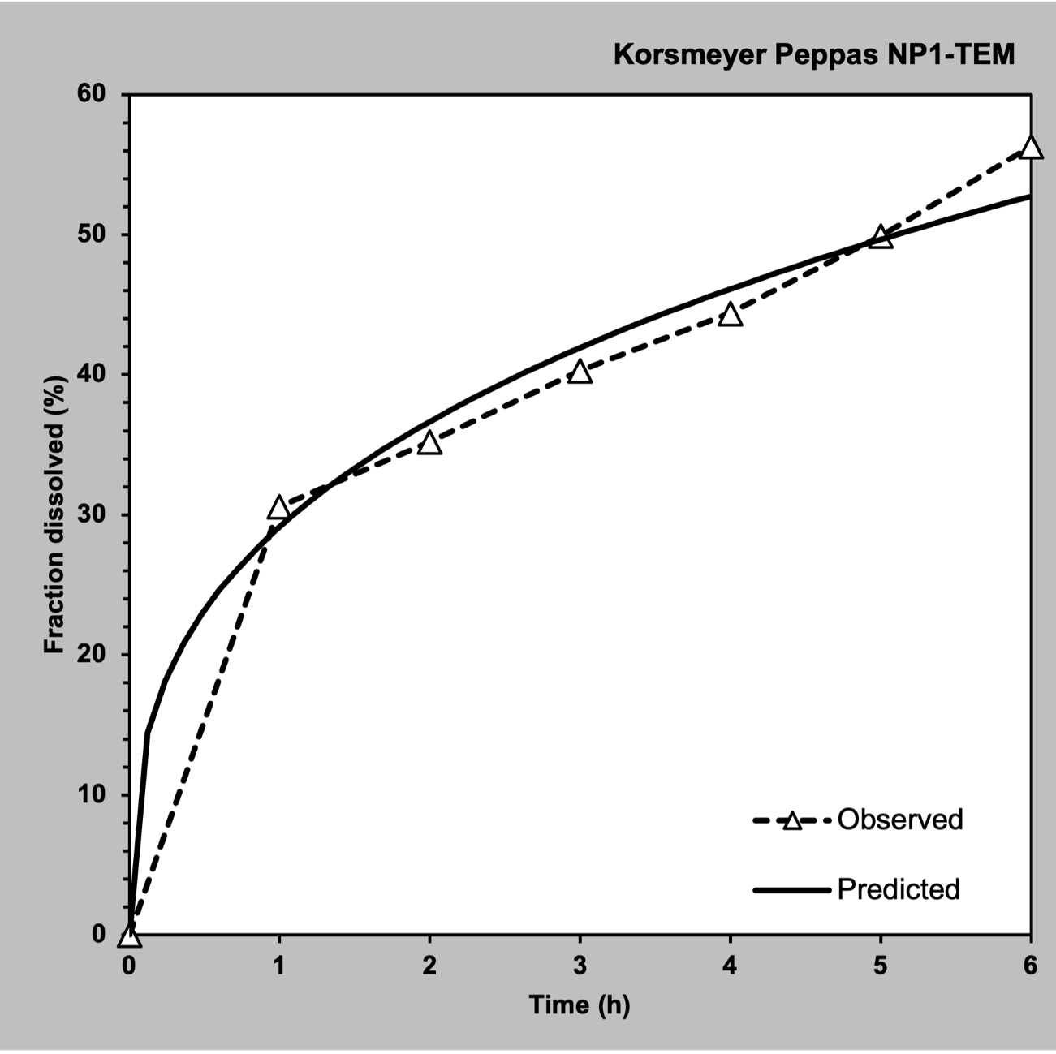
Korsmeyer–Peppas model for NP1-TEM
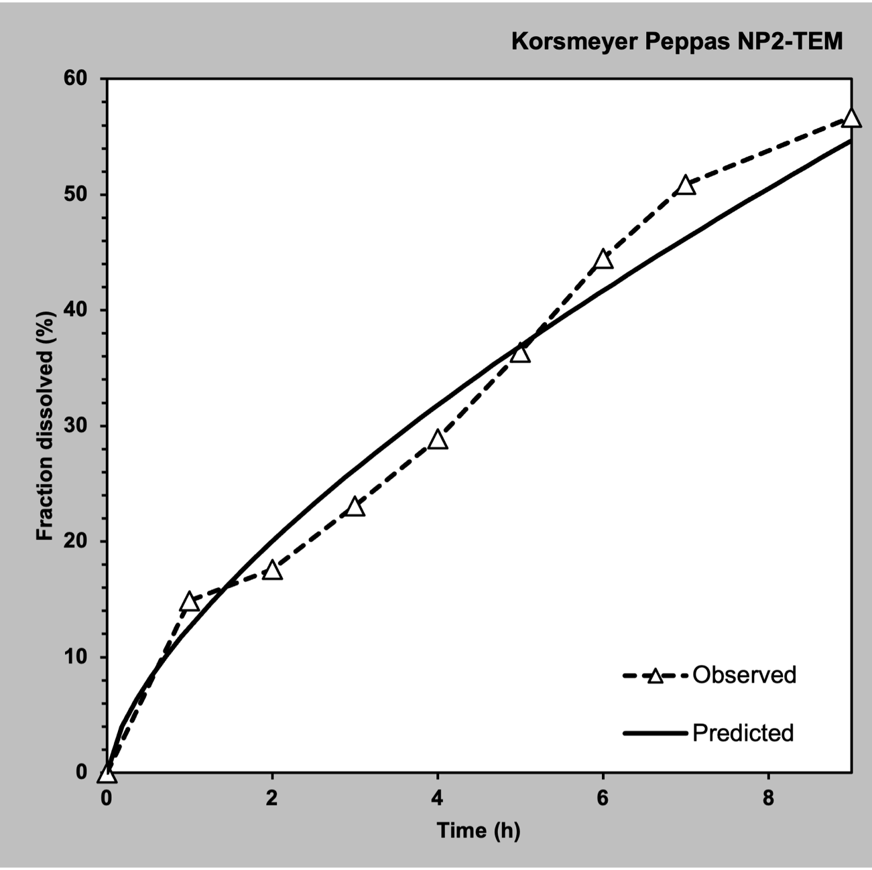
Korsmeyer–Peppas model for NP2-TEM
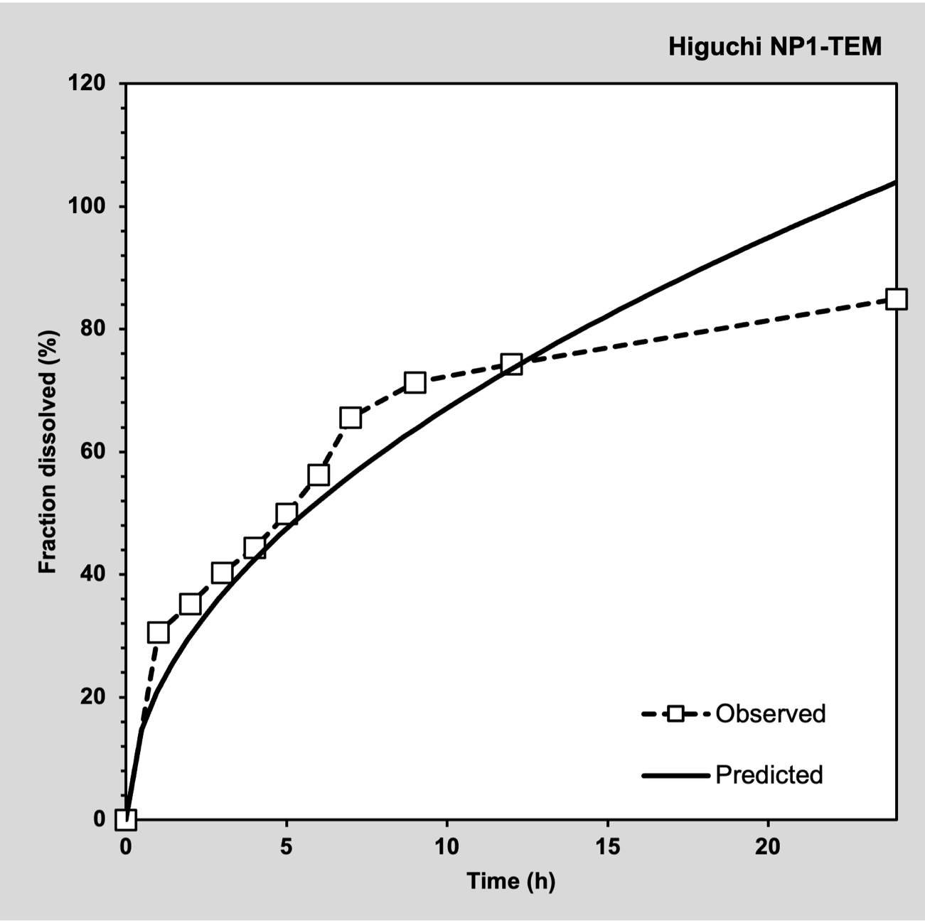
Higuchi model for NP1-TEM
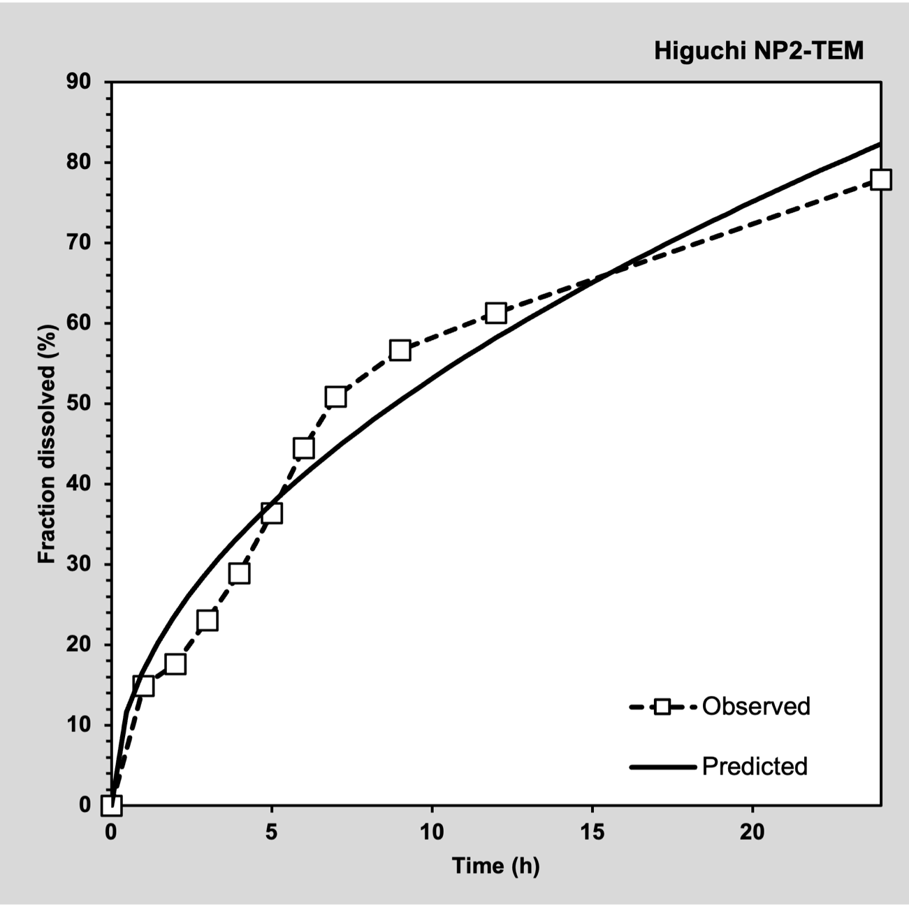
Higuchi model for NP2-TEM

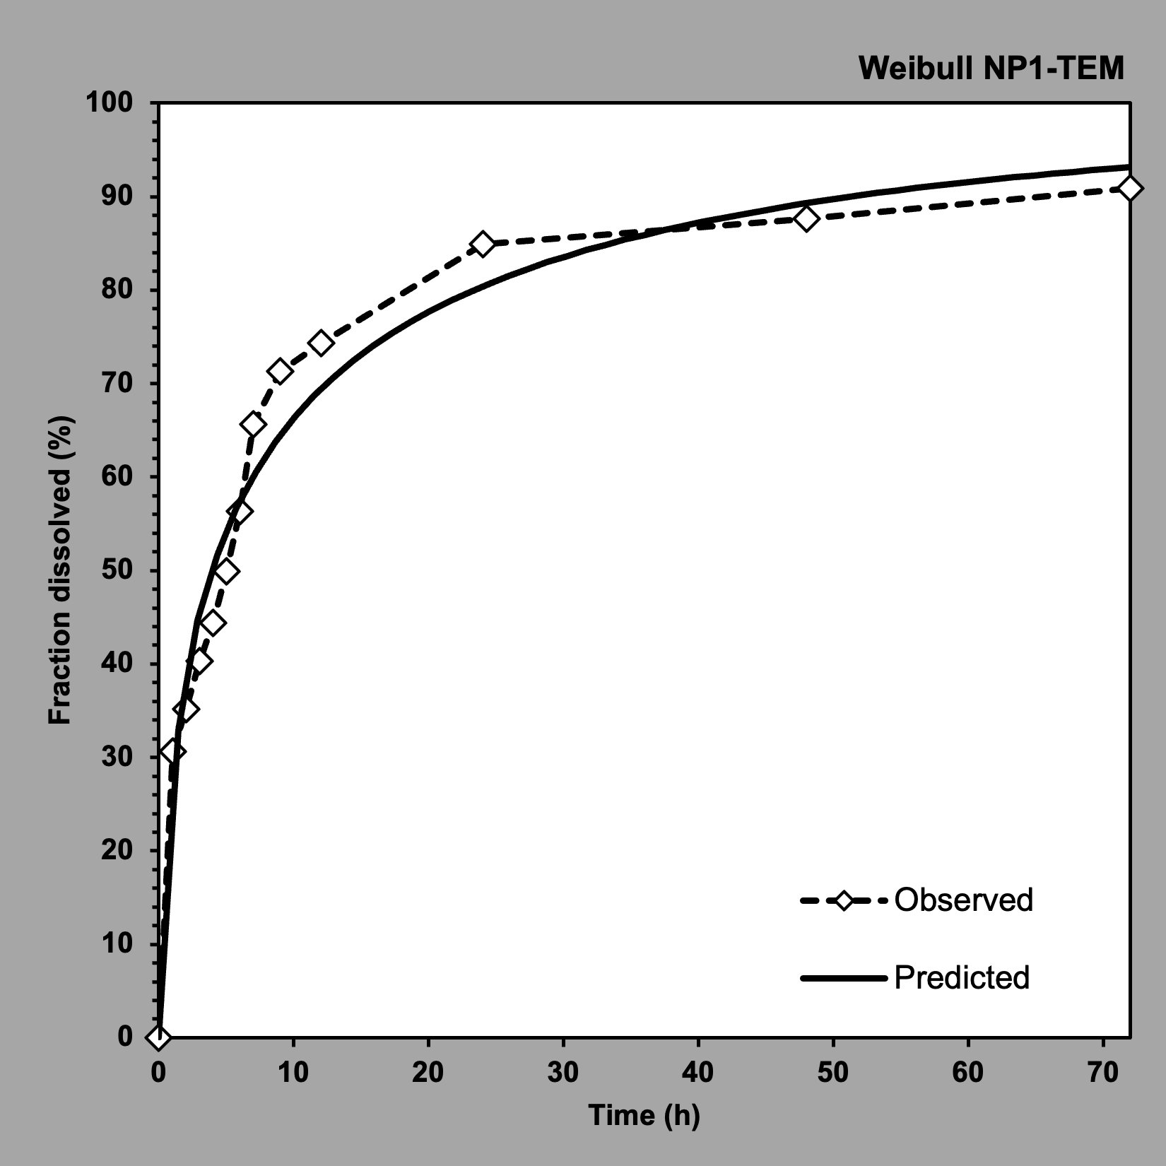
Weibull model for NP2-TEM
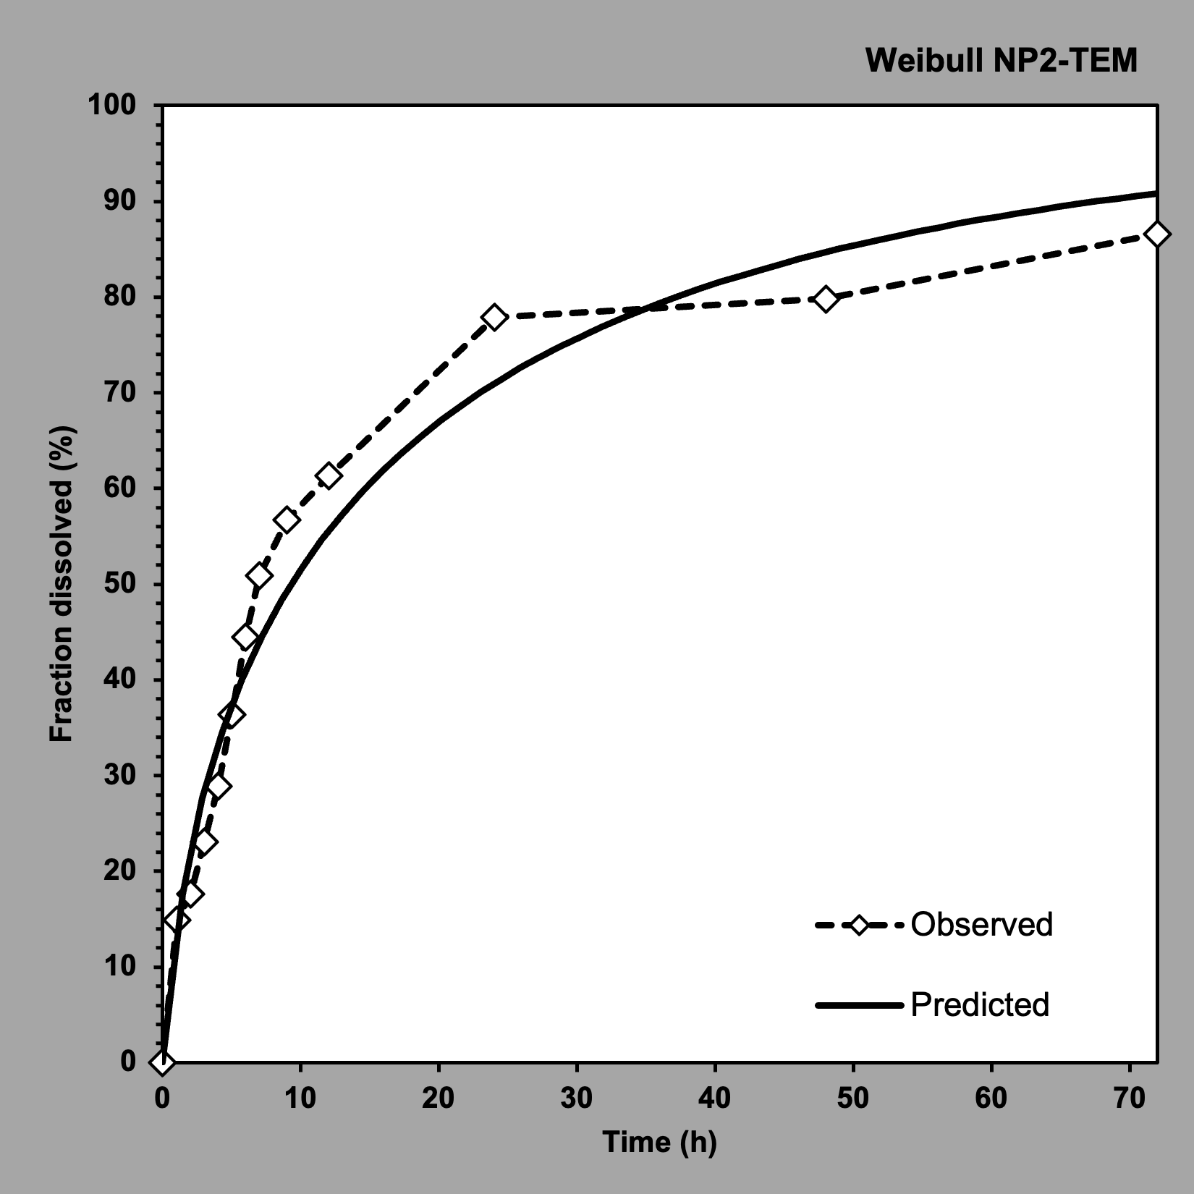
Weibull model for NP1-TEM.

PART 2:

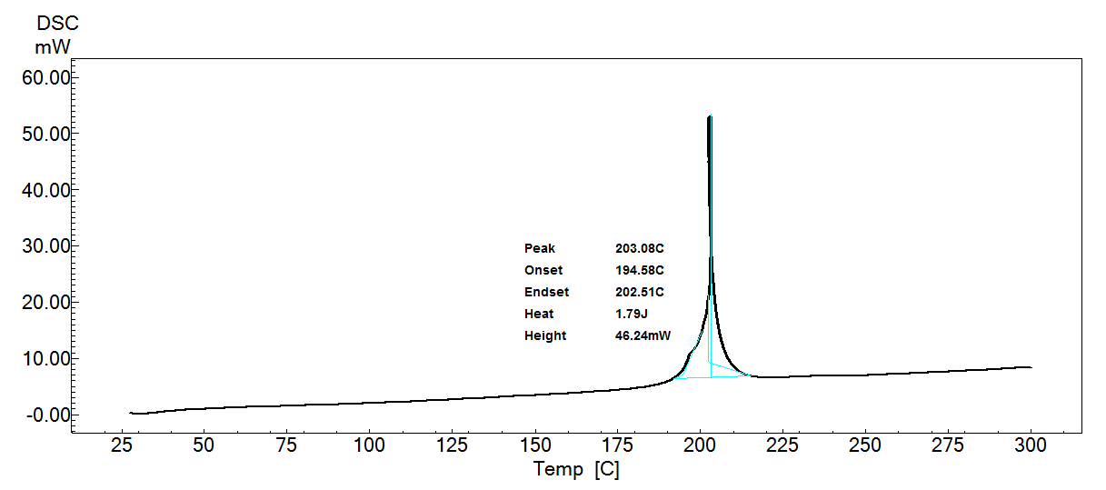
DSC thermogram of TMZ
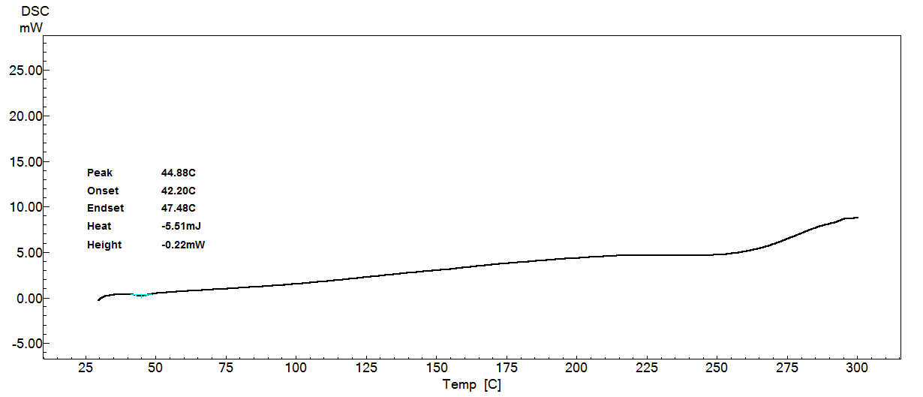
DSC thermogram of PLGA

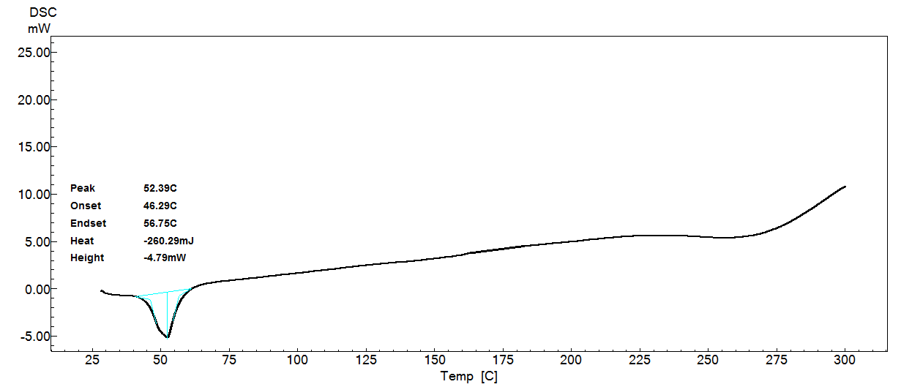
DSC thermogram of NP1-Blank

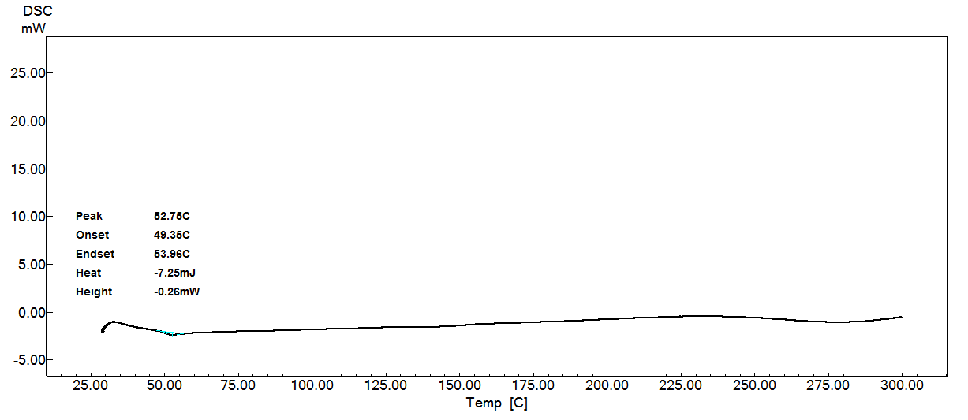
DSC thermogram of NP1-TEM

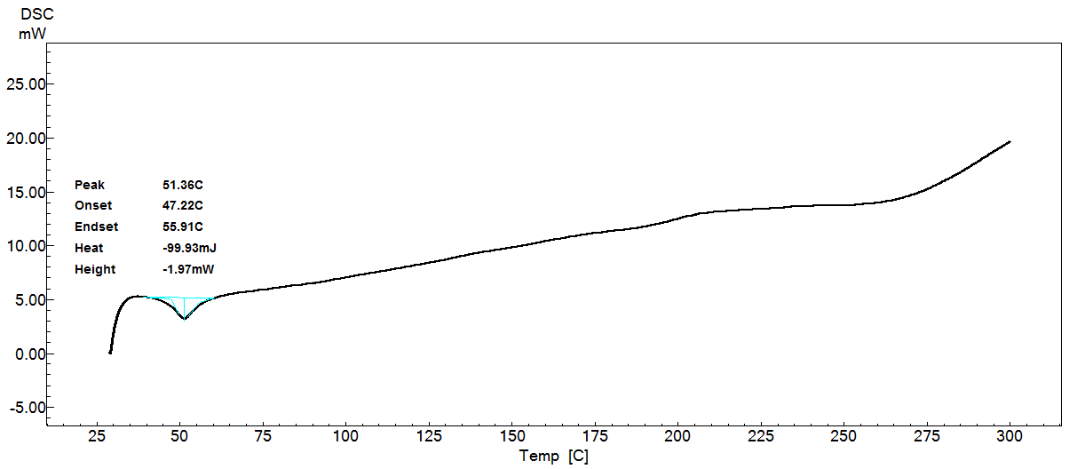
DSC thermogram of NP2-Blank

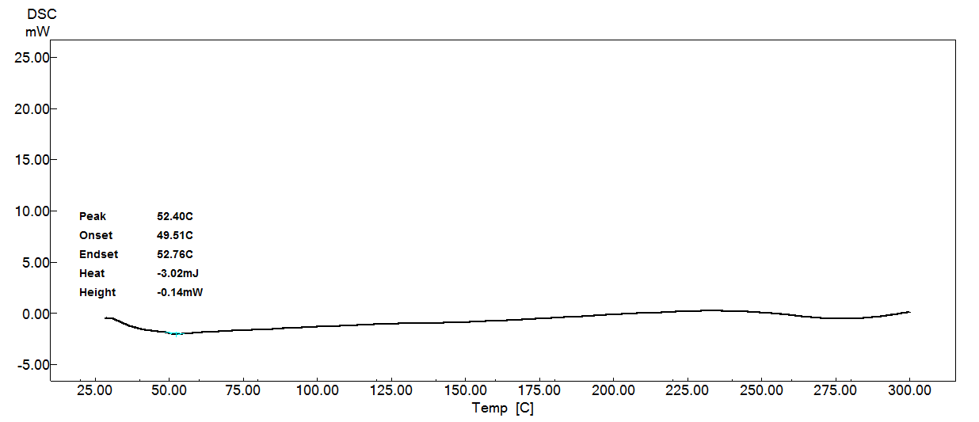
DSC thermogram of NP2-TEM

PART 3:

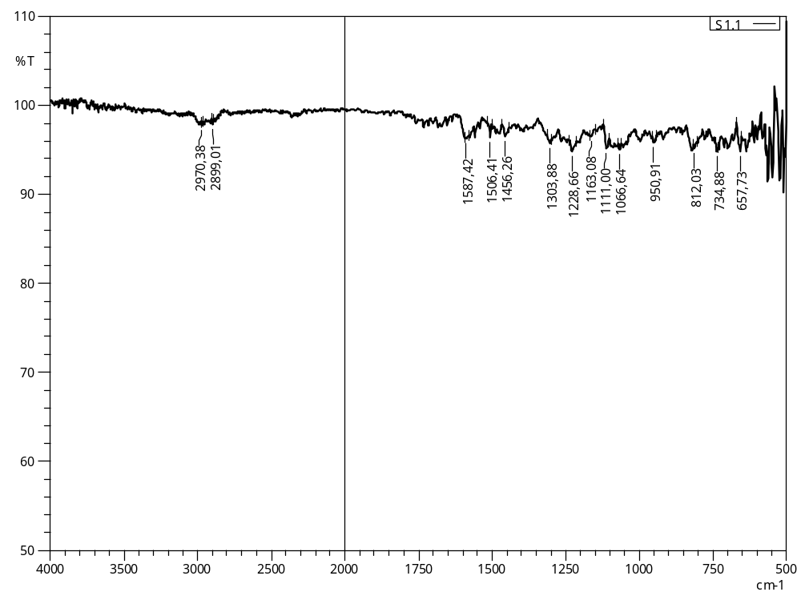
FTIR spectrum for TMZ
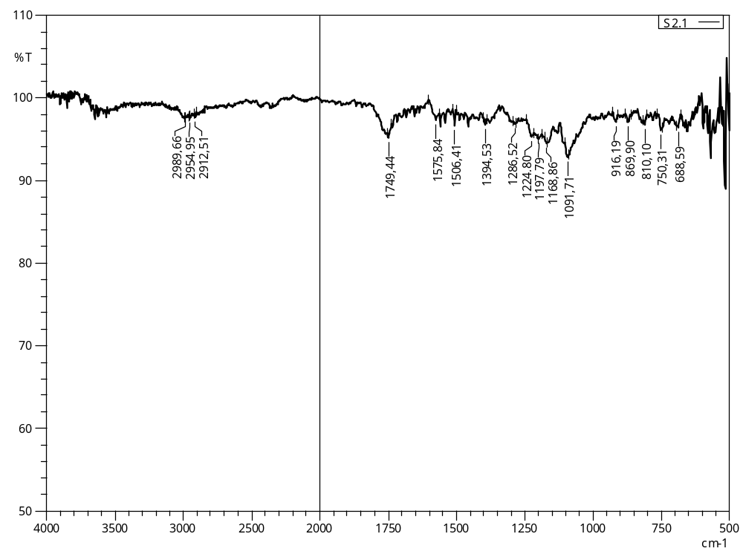
FTIR spectrum for PLGA

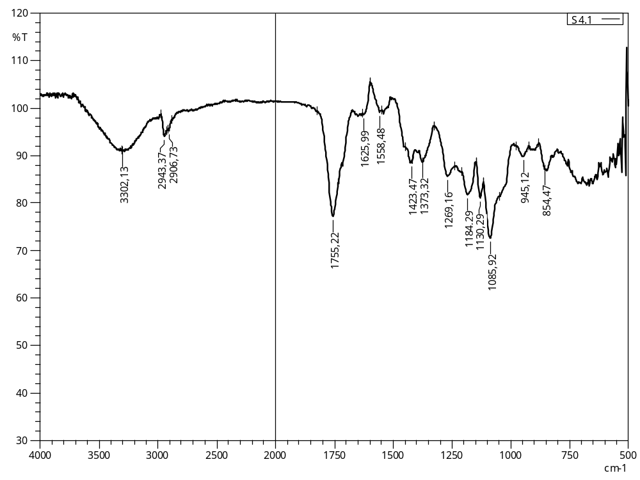
FTIR spectrum for NP1-Blank
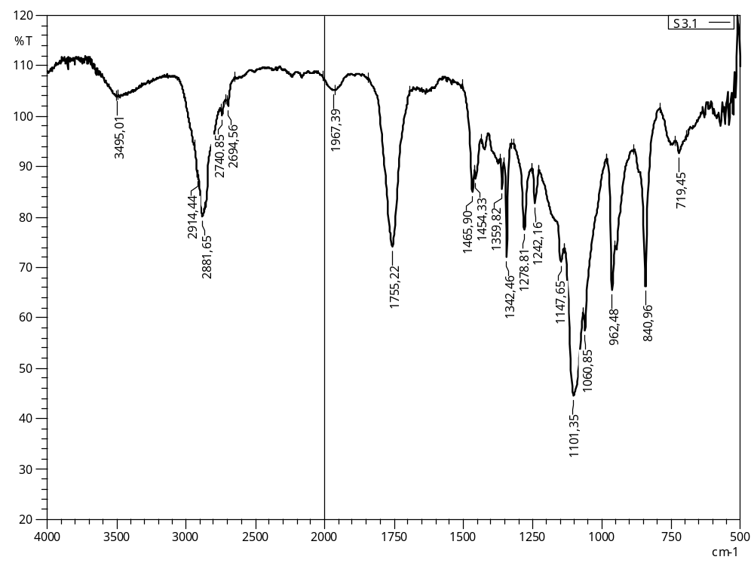
FTIR spectrum for NP1-TEM

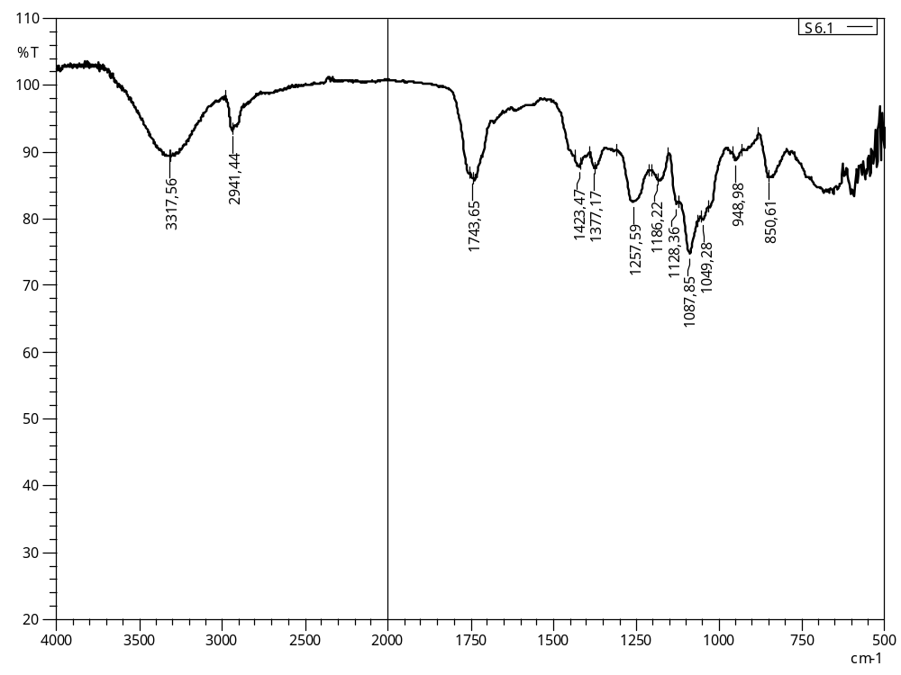
FTIR spectrum for NP2-Blank
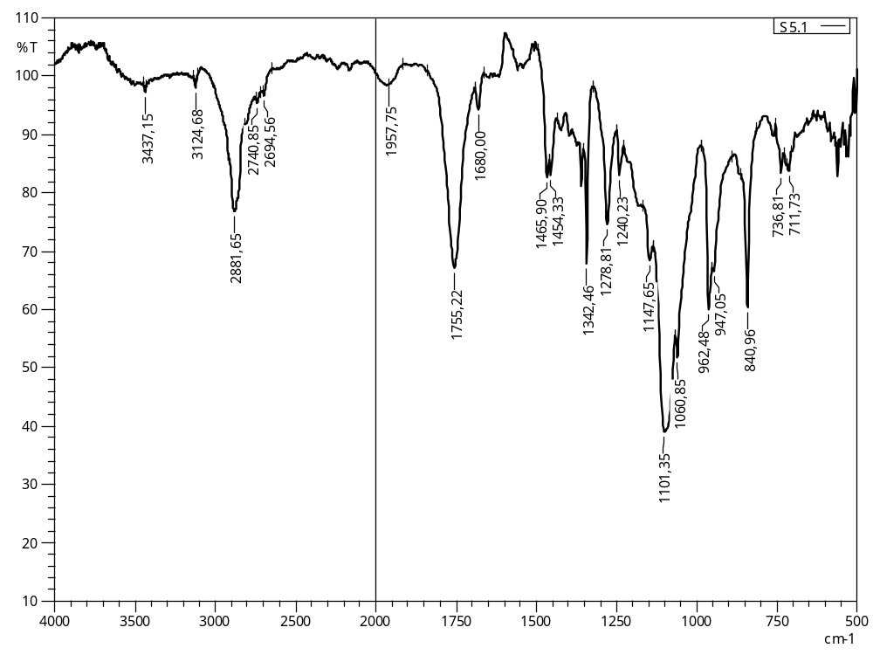
FTIR spectrum for NP2-TEM

