Figure S 1 : Original western blot details
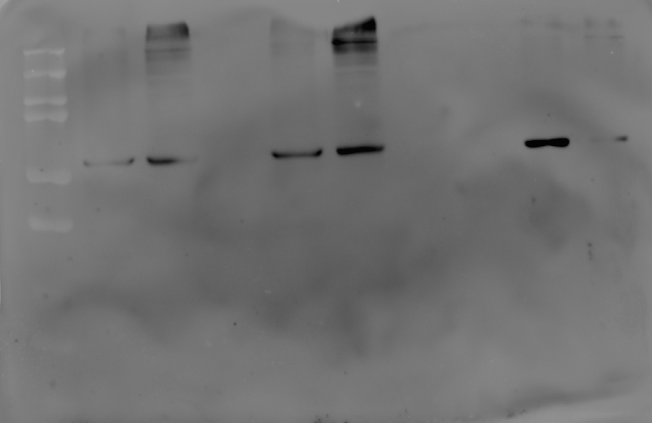
55 kDa
Figure S1.1. : The uncropped, untouched, full original image of western blot presenting Calsequestrin (55 kDa).
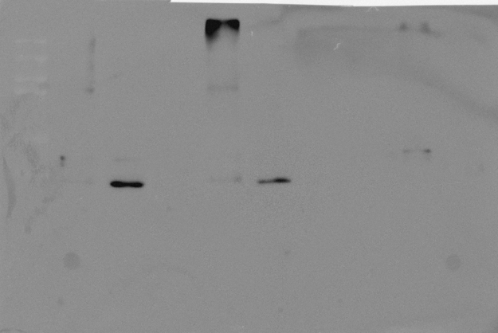
26 kDa
Figure S1.2. : The uncropped, untouched, full original image of western blot presenting Troponin I (26 kDa).
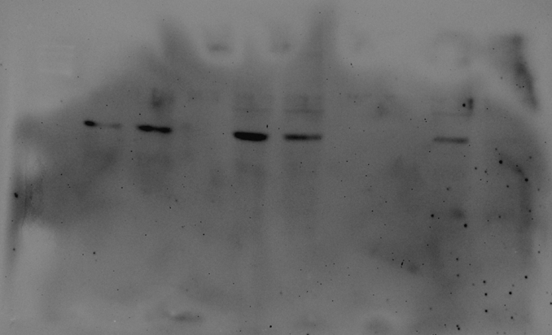
43 kDa
Figure S1.3. : The uncropped, untouched, full original image of western blot presenting Beta actin (43 kDa).

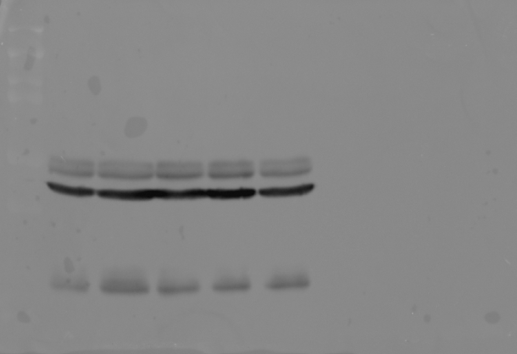
43 kDa
Figure S1.4. : The uncropped, untouched, full original image of western blot presenting B-actin (43 kDa).
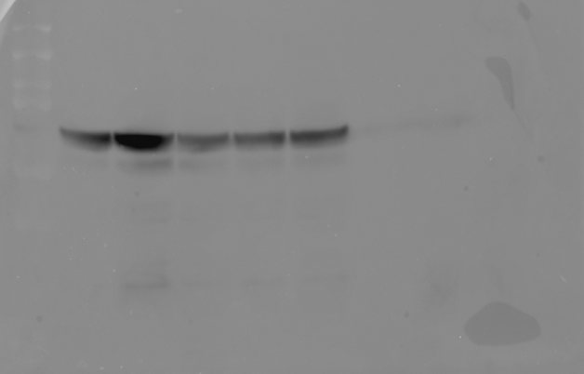
78 kDa
Figure S1.5. : The uncropped, untouched, full original image of western blot presenting Bip (78 kDa).
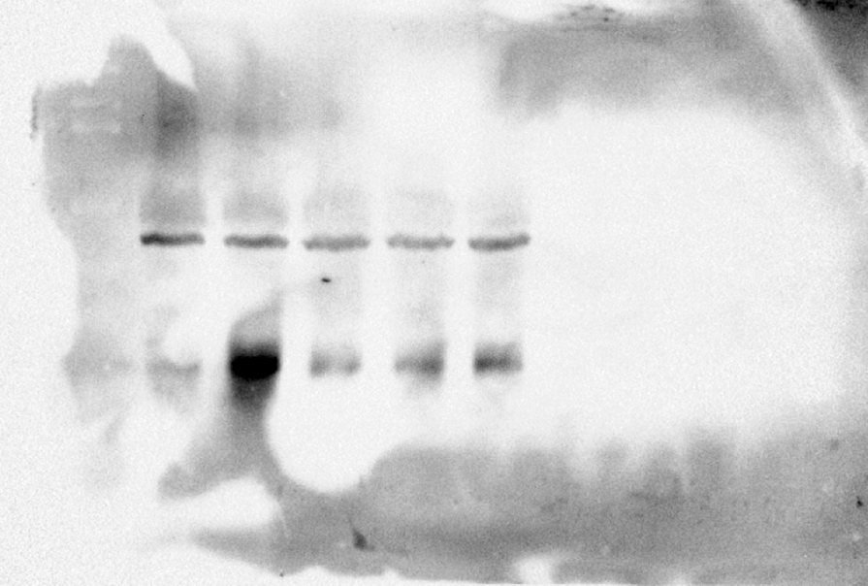
19 kDa
Figure S1.6. : The uncropped, untouched, full original image of western blot presenting CHOP (19 kDa).

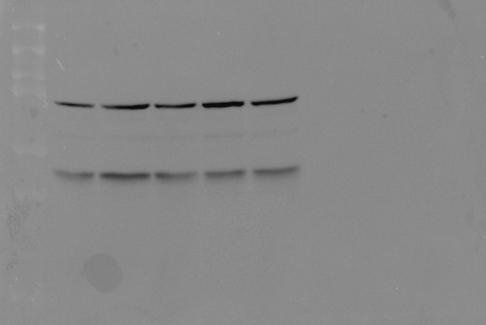
57 kDa
Figure S1.7. : The uncropped, untouched, full original image of western blot presenting PDI (57 kDa).

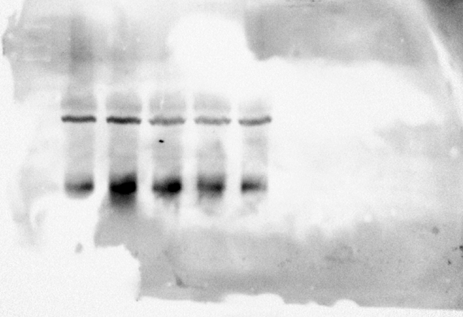
35 kDa
Figure S1.8. : The uncropped, untouched, full original image of western blot presenting Cas 3 (35 kDa).

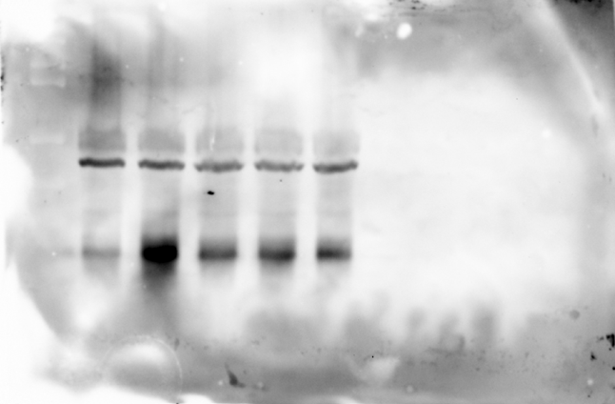
37 kDa
Figure S1.9. : The uncropped, untouched, full original image of western blot presenting Cas 9 (37 kDa).

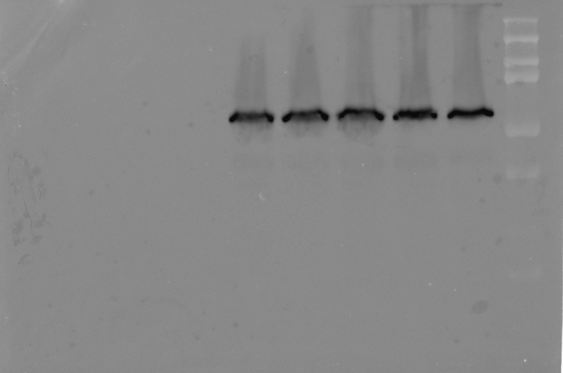
60 kDa
Figure S1.10. : The uncropped, untouched, full original image of western blot presenting AKT (60 kDa).
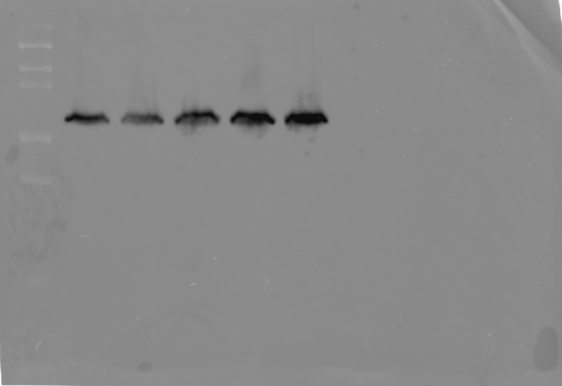
60 kDa
Figure S1.11. : The uncropped, untouched, full original image of western blot presenting pAKT (60 kDa).
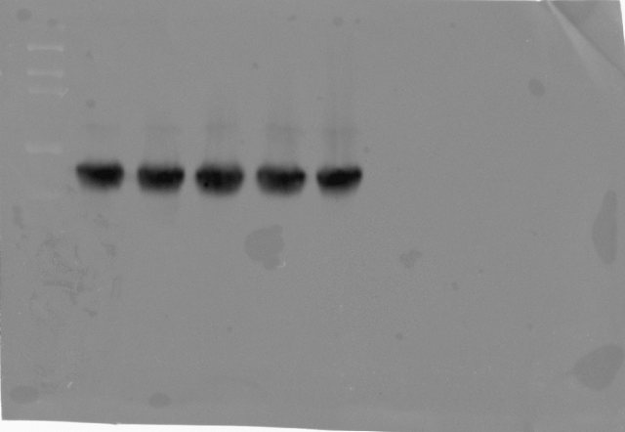
46 kDa
Figure S1.12. : The uncropped, untouched, full original image of western blot presenting GSK3 β (46 kDa).
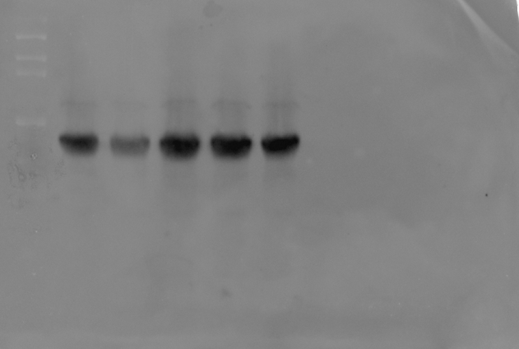
46 kDa
Figure S1.13. : The uncropped, untouched, full original image of western blot presenting pGSK3-β (46 kDa).
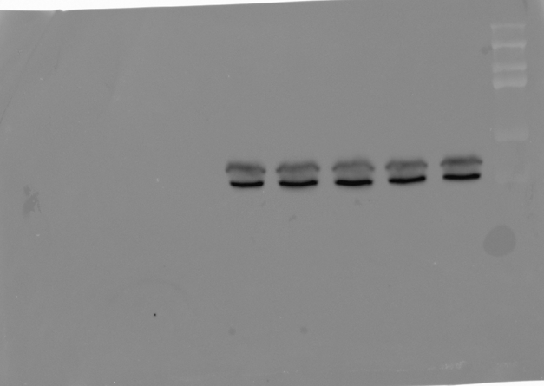
44/42 kDa
Figure S1.14. : The uncropped, untouched, full original image of western blot presenting ERK1/2 (44/42 kDa).

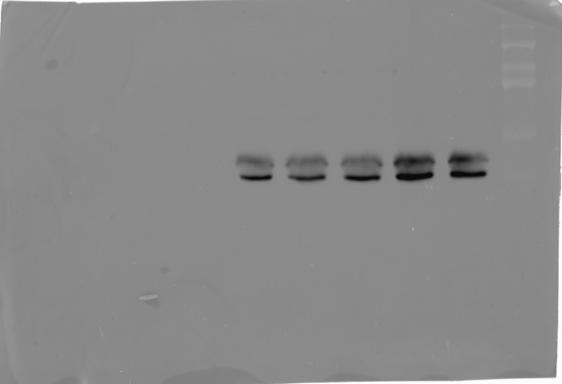
44/42 kDa
Figure S1.15. : The uncropped, untouched, full original image of western blot presenting pERK1/2 (44/42 kDa).

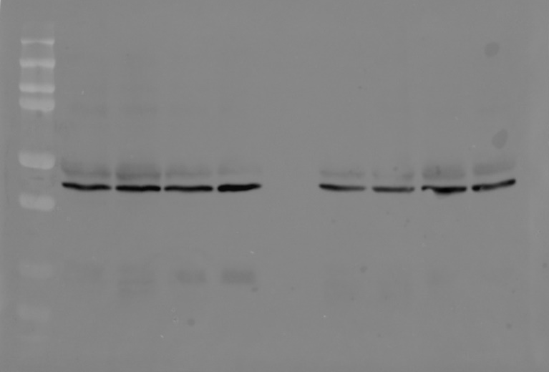
43 kDa
Figure S1.16. : The uncropped, untouched, full original image of western blot presenting β -actin (43 kDa).
78 kDa
Figure S1.17. : The uncropped, untouched, full original image of western blot presenting Bip (78 kDa).
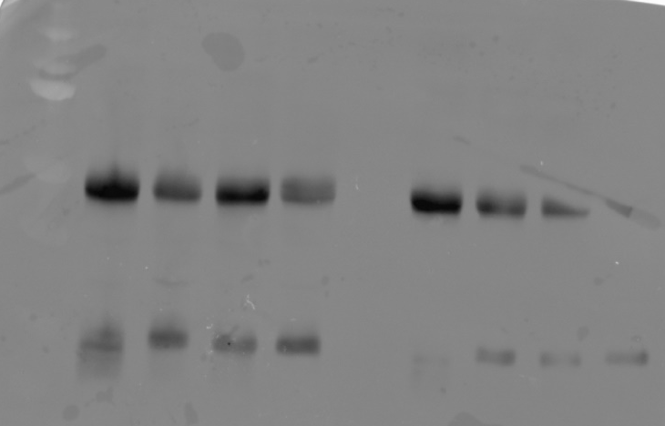
19 kDa
Figure S1.18. : The uncropped, untouched, full original image of western blot presenting CHOP (19 kDa)
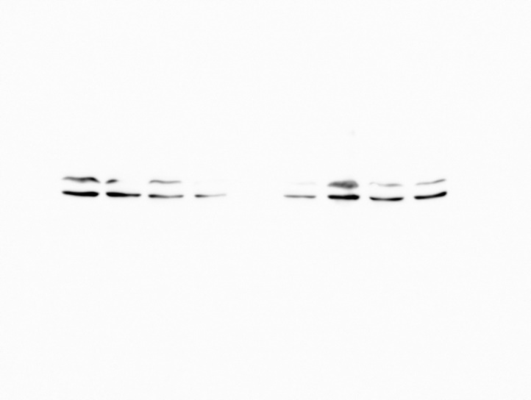
32 kDa
Figure S1.19. : The uncropped, untouched, full original image of western blot presenting Cas-3 (32 kDa)
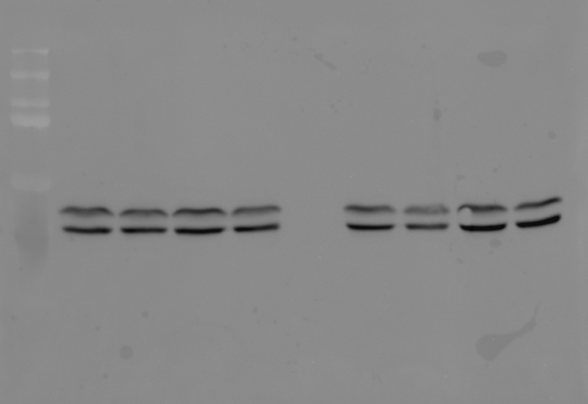
44/42 kDa
Figure S1.20. : The uncropped, untouched, full original image of western blot presenting ERK1/2 (44/42 kDa)
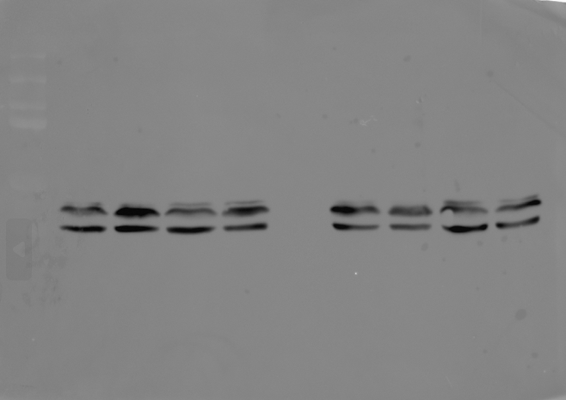
44/42 kDa
Figure S1.21. : The uncropped, untouched, full original image of western blot presenting pERK1/2 (44/42 kDa)
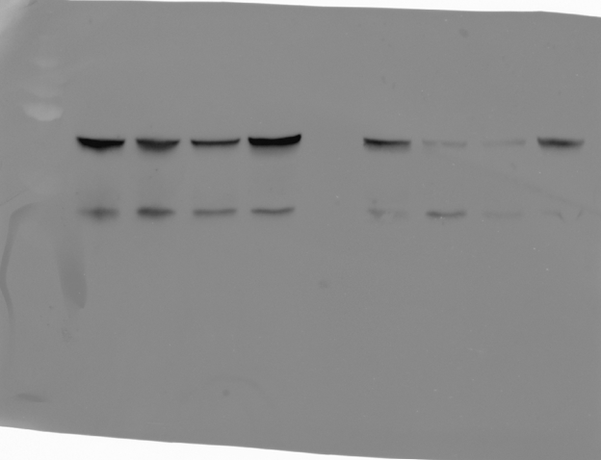
60 kDa

Figure S1.22. : The uncropped, untouched, full original image of western blot presenting AKT (60 kDa)
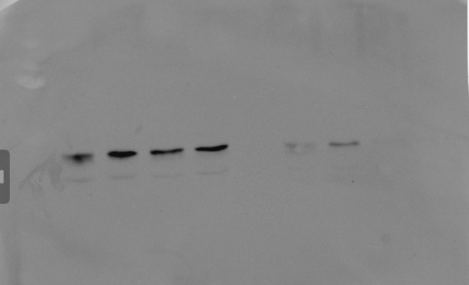
37 kDa
Figure S1.23. : The uncropped, untouched, full original image of western blot presenting cas 9 (37 kDa)

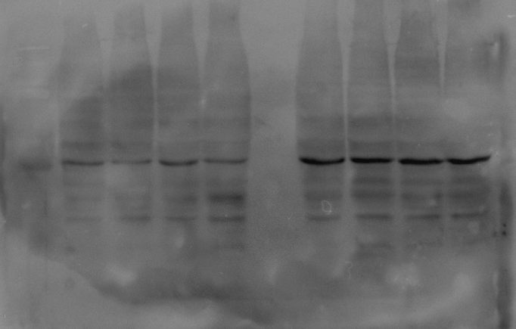
43 kDa
Figure S1.24. : The uncropped, untouched, full original image of western blot presenting B actin (43 kDa)

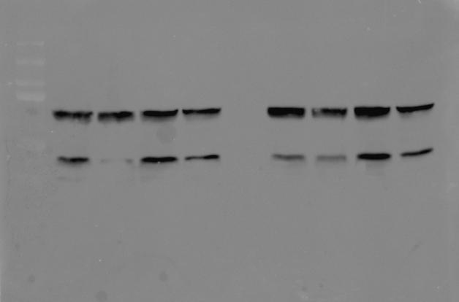
60 kDa
Figure S1.25. : The uncropped, untouched, full original image of western blot presenting PAKT (43 kDa)
43 kDa
Figure S1.26. : The uncropped, untouched, full original image of western blot presenting p-ERK1/2 (43 kDa)
57 kDa
Figure S1.27. : The uncropped, untouched, full original image of western blot presenting PDI (57 kDa)
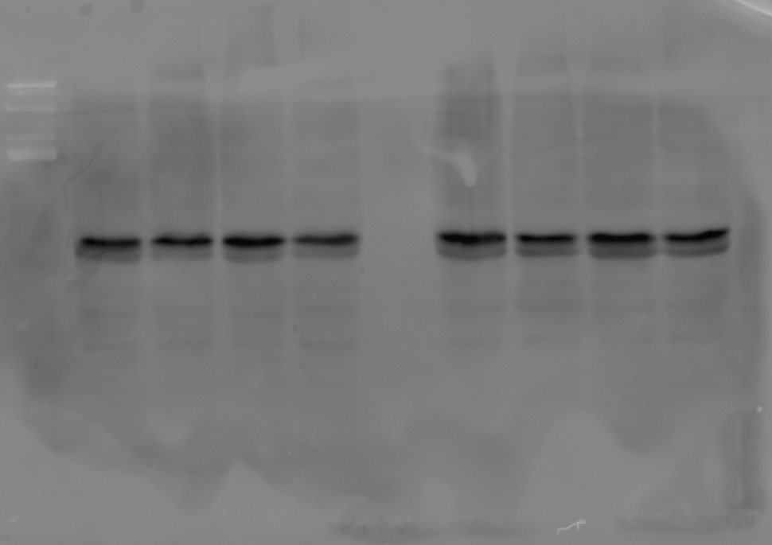
Figure S1.28. : The uncropped, untouched, full original image of western blot presenting GSK-3beta

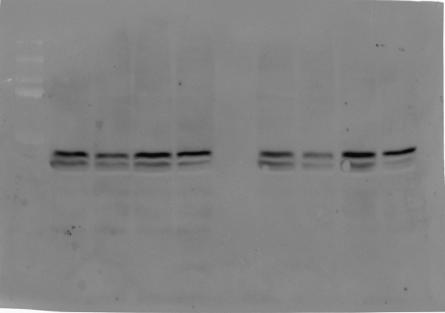
Figure S1.29. : The uncropped, untouched, full original image of western blot presenting pGSK-3beta
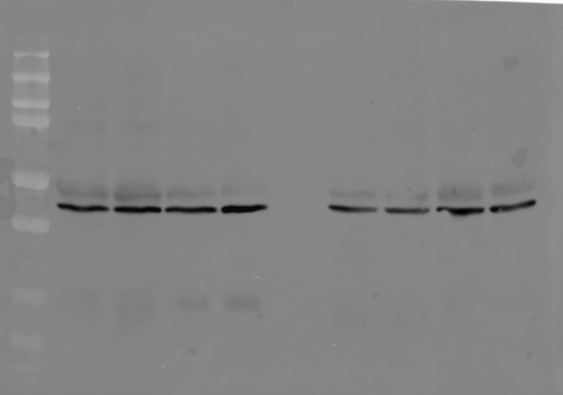
Figure S1.30. : The uncropped, untouched, full original image of western blot presenting beta actin

Figure S 2: Original image of ROS scavenging activity by DCFH-DA staining
Rob + ISO
Rob
Met + ISO
ISO
Control

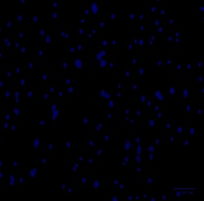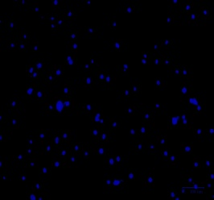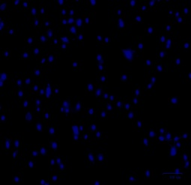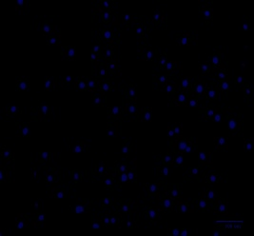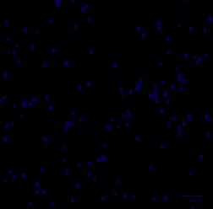
DAPI
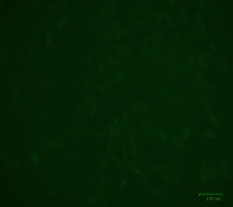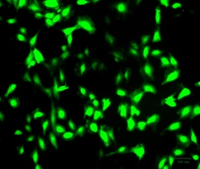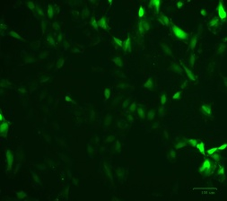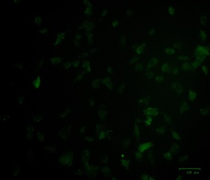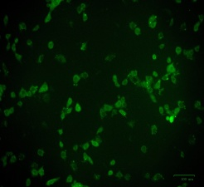
DCF-DA
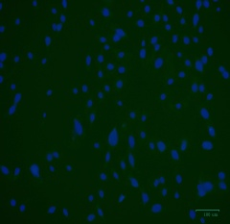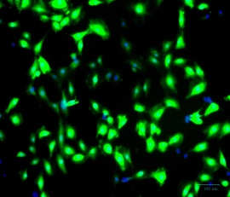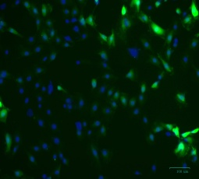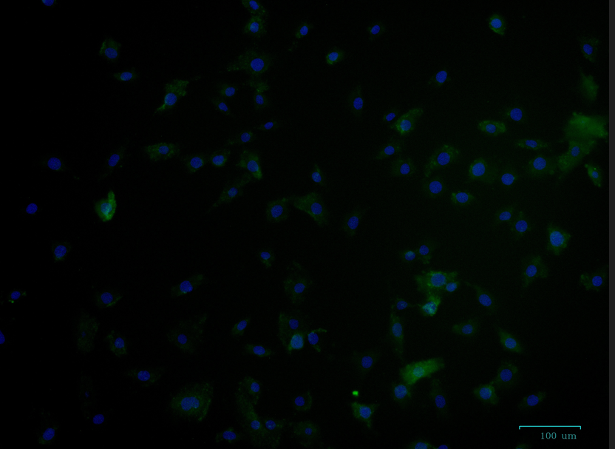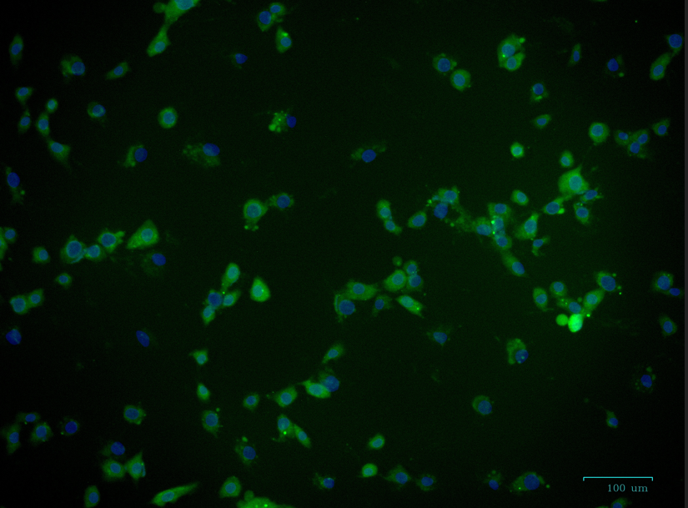
Merged
Figure S 3: Original image of Anti apoptotic activity by AO EtBr staining
ISO
Rob + ISO
Rob
Met + ISO
Control
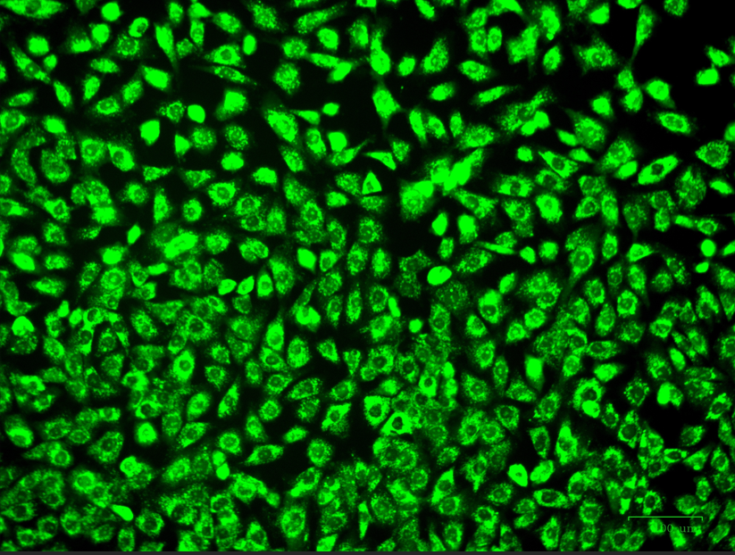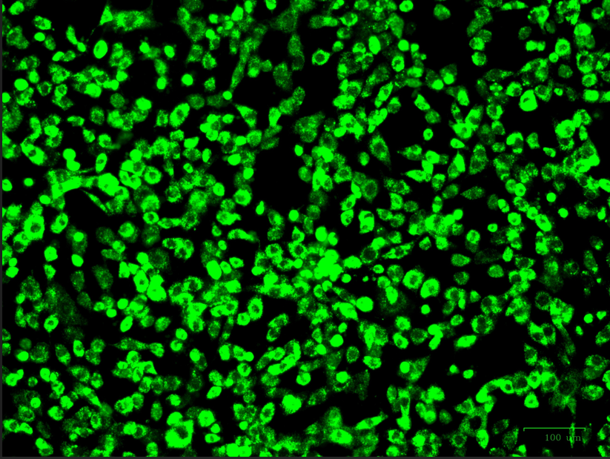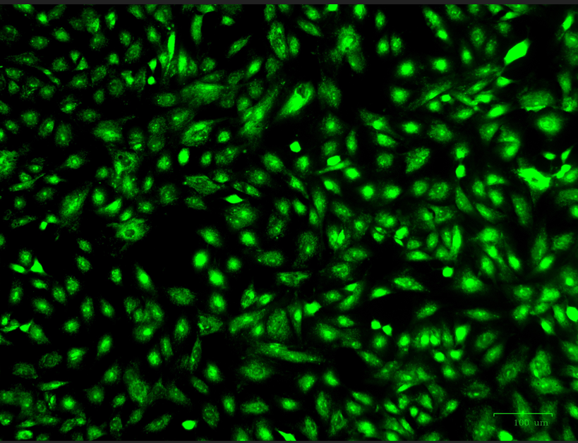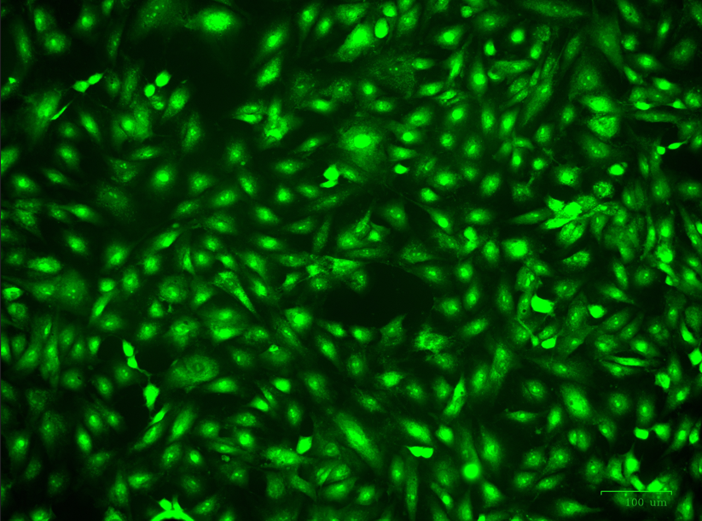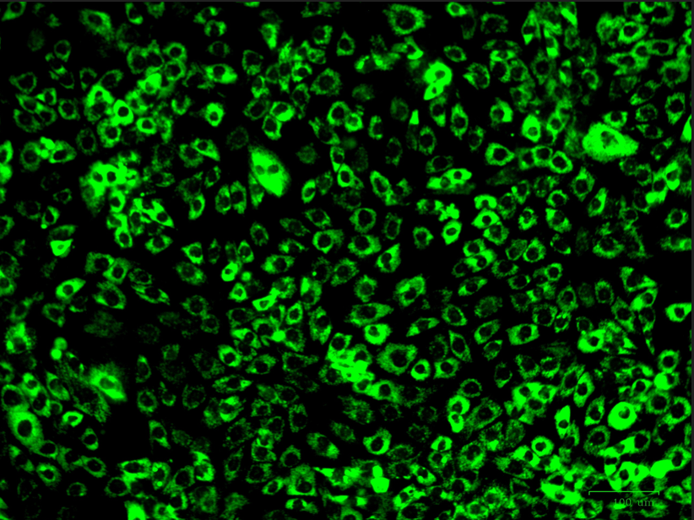
AO
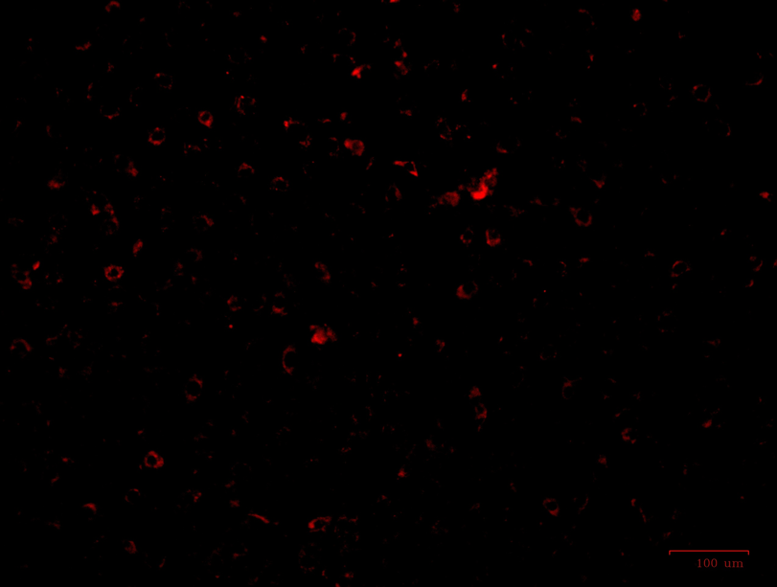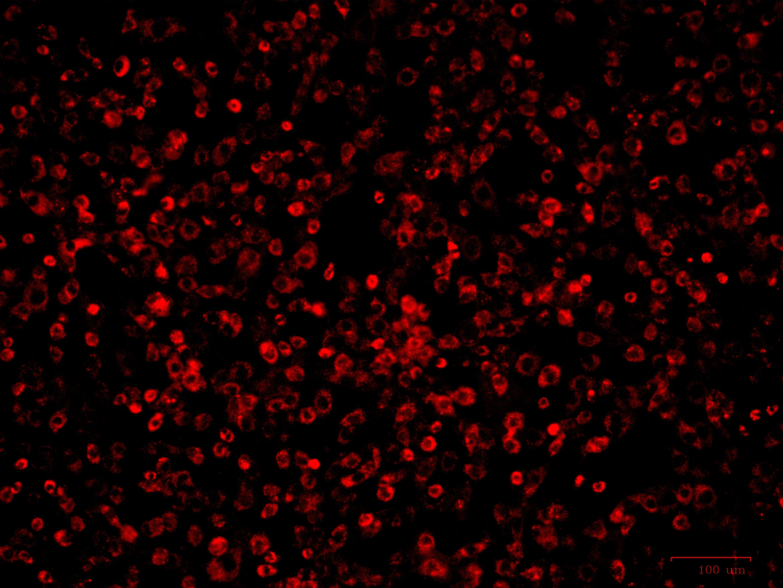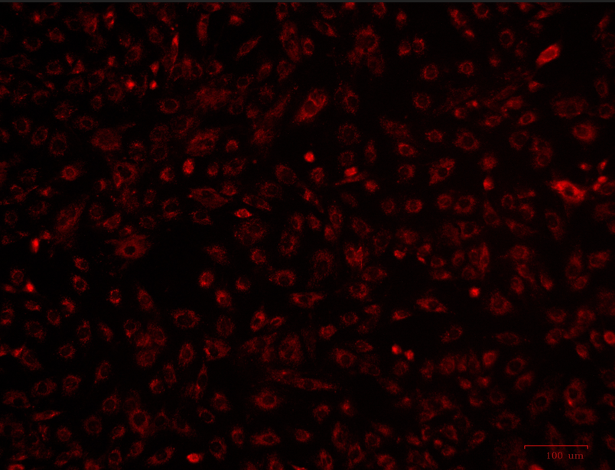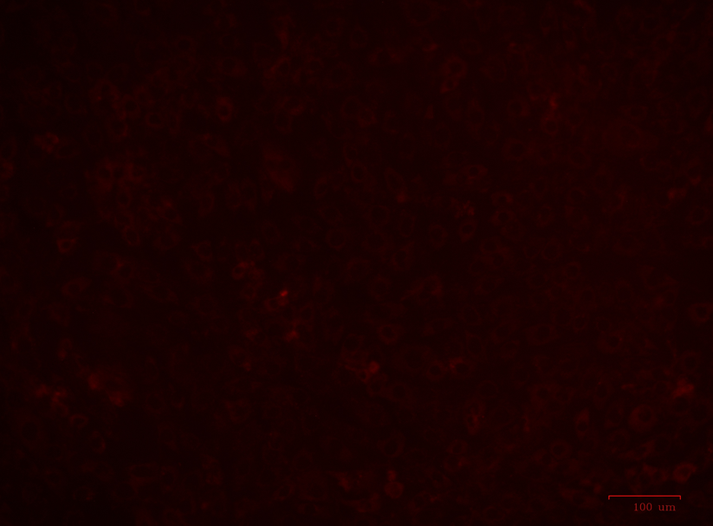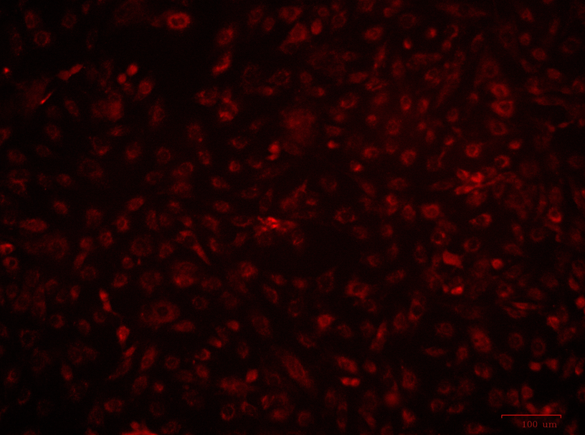
EtBr
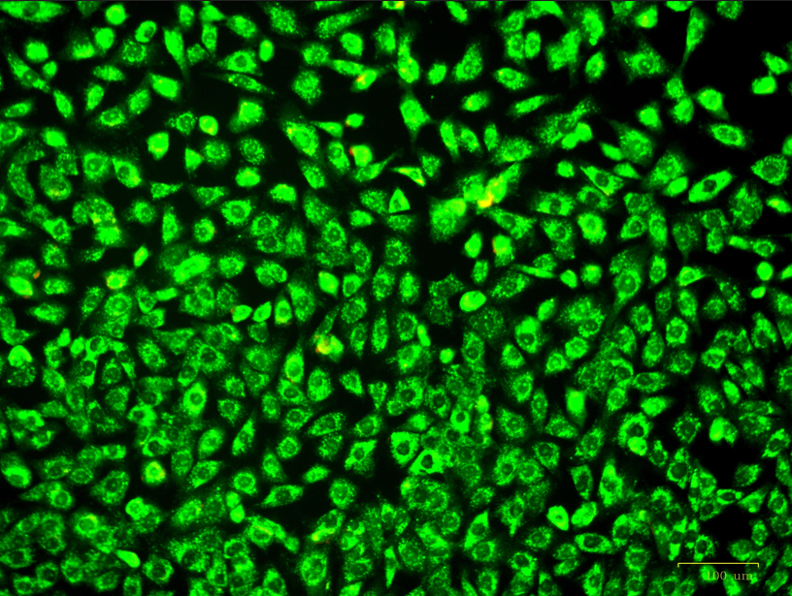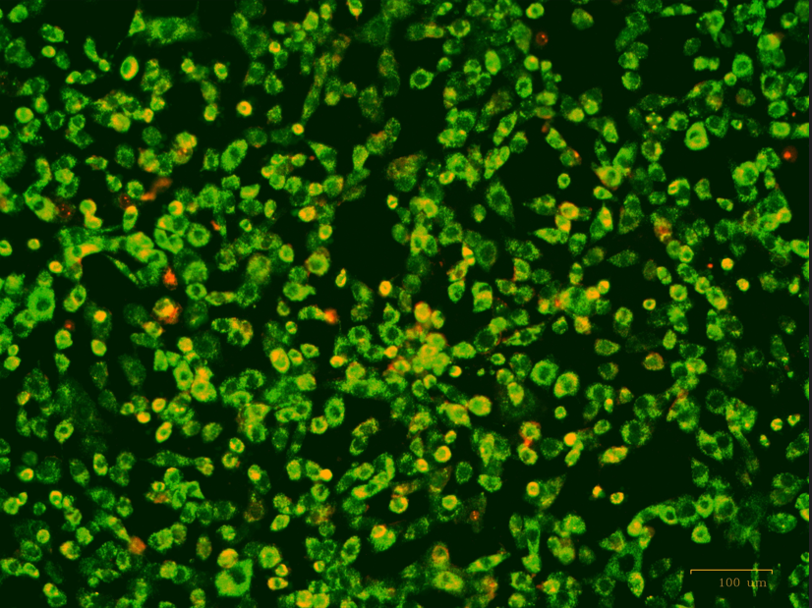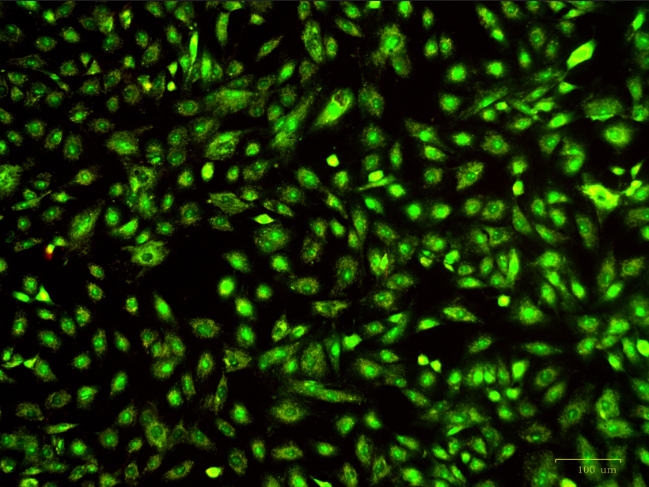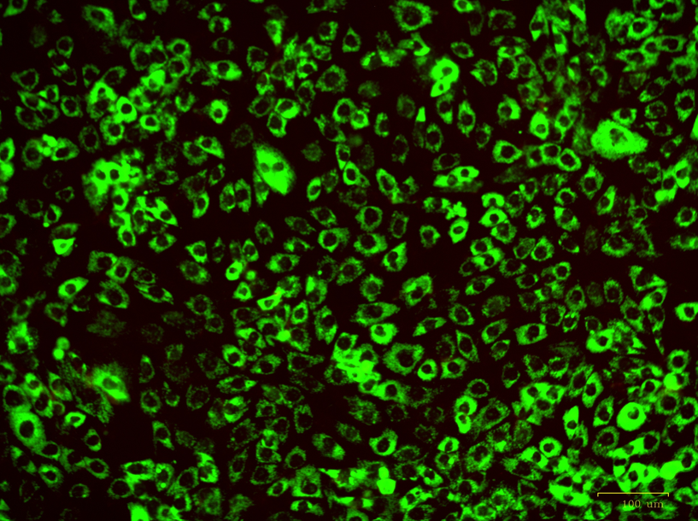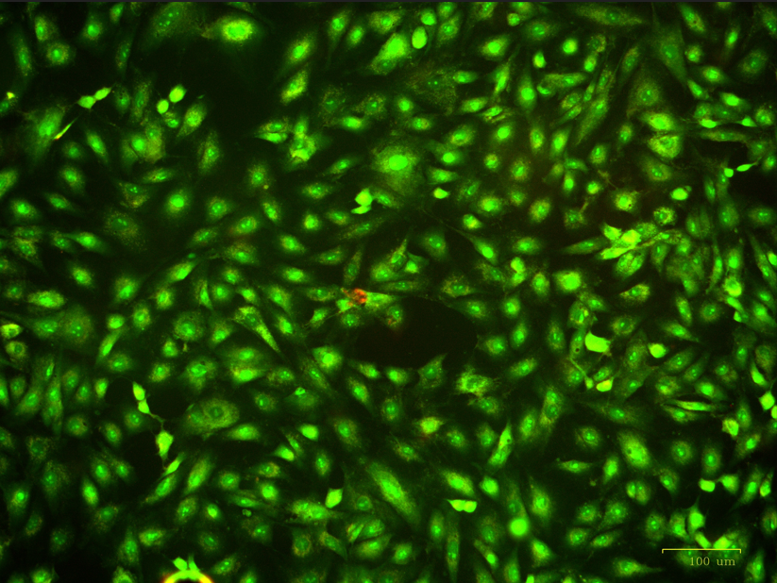
Merged
Figure S 4: Original image of Anti apoptotic activity FLOW CYTOMETRY (ANNEXIN V PI Staining)
