Supplementary 1

Supplementary 1 table 1. Published radiocarbon dates for pearl millet before 1500 BCE
Site | Country | Lab code | Date | Deviation | Material dated | References
Karkarichinkat Nord (KN05) Context 31 | Mali | OxA16919 | 4011 | 33 | Pennisetum sp. | Manning, K., Pelling, R., Higman, T., Schwenniger, J.-L. & Fuller, D. Q. 4500-year-old domesticated pearl millet (Pennisetum glaucum) from the Tilemsi Valley, Mali: new insights into an alternative domestication pathway. Journal of Archaeological Science 38, 312-322 (2011).
Bhando Qubo | Pakistan | CIRAM-8334 | 3982 | 30 | Pennisetum glaucum | This study
Bhando Qubo | Pakistan | CIRAM-8335 | 3977 | 28 | Pennisetum glaucum | This study
Kanmer | India | PLD-16352 | 3880 | 20 | Hordeum vulgare | Goyal, P. et al. Subsistence system, paleoecology, and 14C chronology at Kanmer, a Harappan site in Gujarat, India. Radiocarbon 55(1), 144 (2013).  Pokharia, A. K. et al. Archaeobotany and archaeology at Kanmer, a Harappan site in Kachchh, Gujarat: evidence for adaptation in response to climatic variability. Current Science 100(12), 1833-1846 (2011).  Kharakwal, J. S. et al. Kanmer: a multicultural site in Kachchh, Gujarat, India. In T. Uno (Ed.). Changing Perceptions of Japan in South Asia in the New Asian Era: The State of Japanese Studies in India and other SAARC Countries, 355-376. International Research Center for Japanese Studies, Kyoto (2011).
Kanmer | India | PLD-17147 | 3835 | 20 | Hordeum vulgare | Goyal et al. (2013: 144); Pokharia et al. (2011); Kharakwal et al. (2011)
Khirsara | India | B1 | 3760 | 30 | Triticum sp. | Nath, J., Kumaran, R. N. & Kulkarni, A. Excavations at Khirsara: a Harappan outpost in Kachchh. Purātattva 42, 122-132 (2012).  Nath, J., Kumaran, R. N., Chandra, B. & Meena, R. Fortified factory at Harappan metropolis Khirsara, Gujarat. Heritage: Journal of Multidisciplinary Studies in Archaeology 1, 424-437 (2013).  Nath, J. & Kumaran, R. N. Khirsara - a Harappan metropolis in western Kachchh, Gujarat, India. Heritage: Journal of Multidisciplinary Studies in Archaeology 5, 541-555 (2017).
Khirsara | India | B2 | 3750 | 30 | Hordeum vulgare | Nath et al. (2012, 2013, 2017)
Winde Koroji | Mali | GX-19990 | 3635 | 90 | Charcoal (unspecified) associated with Pearl millet | MacDonald, K. C. The Windé Koroji Complex: evidence for the peopling of the eastern Niger Delta (2100-500 BC). Préhistoire Anthropologie Méditerranéenes 5, 147-165 (1996).
Birimi | Ghana | TO-8172 | 3460 | 200 | Pennisetum glaucum | D'Andrea, A. C., Klee, M. & Casey, J. Archaeobotanical evidence for pearl millet (Pennisetum glaucum) in sub-Saharan West Africa. Antiquity 75(288), 341-348 (2001).
Ounjougou/ Varves E2 | Mali | Erl-9196 | 3416 | 109 | Pennisetum glaucum | Ozainne, S. Un néolithique Ouest-Africain: cadre chrono-culturel, économique et environnemental de l'Holocène récent en Pays dogon (Mali). Journal of African Archaeology Monograph Series 8 (Africa Magna Verlag, Frankfurt, 2013).
Kachama | Nigeria | MAMS 13667 | 3282 | 22 | Pennisetum glaucum | Franke, G. A. Chronology of the Central Nigerian Nok Culture - 1500 BC to the beginning of the Common Era. Journal of African Archaeology 14, 257-289 (2016). Table 1
Ounjougou Varves/ E2 | Mali | Erl-9197 | 3078 | 131 | Pennisetum glaucum | Ozainne (2013)

Supplementary 1 table 2. Unmodelled and modelled radiocarbon dates for pearl millet
 | Unmodelled (BCE/CE) |  |  | Modelled (BCE/CE) |  |  | Indices= Aoverall 125.5 / Amodel 126.3
 | median | from 95.4 / 2σ | to 95.4 / 2σ | median | from 95.4 / 2σ | to 95.4 / 2σ | A | L | P | C
 |  |  |  | 1 | -294 | 462 |  |  |  | 99.9
General |  | -2.65 | 2.65 | 0.035 |  |  |  |  |  | 98.7
 | 2.0495E-12 | 3.99E-17 | 4 | 1.724 | 5.38E-17 | 3.872 | 100 |  |  | 99.8
 | 2 |  |  | -16 | -395 | 3 |  |  |  | 100
Charcoal |  | -3.19 | -0.05 | -0.67 |  |  |  |  |  | 99.6
 | -0.74 | 2.21E-17 | 3 | 1.392 | 3.60E-17 | 2.763 | 100 |  |  | 99.7
Sequence. Earlier dates of Pennisetum glaucum | 1.515
Boundary Dates Pearl millet before 1500 BCE |  |  |  | -2603 | -2859 | -2483 |  |  |  | 98.2
Karkarichinkat Nord (KN05) (Pennisetum sp.) / OxA16919 | -2529 | -2621 | -2464 | -2519 | -2617 | -2461 | 104.6 |  | 96.5 | 99.9
Bhando Qubo (Pennisetum glaucum) / CIRAM-8334 | -2520 | -2578 | -2358 | -2501 | -2576 | -2356 | 100.5 |  | 96.6 | 99.8
Bhando Qubo (Pennisetum glaucum) / CIRAM-8335 | -2515 | -2576 | -2356 | -2495 | -2575 | -2354 | 100.4 |  | 96.6 | 99.8
Kanmer (Hordeum vulgare) / PLD-16352 | -2377 | -2461 | -2291 | -2377 | -2461 | -2290 | 101.2 |  | 96.4 | 99.9
Kanmer (Hordeum vulgare) / PLD-17147 | -2280 | -2440 | -2201 | -2280 | -2447 | -2199 | 100.5 |  | 96.2 | 99.7
Khirsara (Triticum) / B1 | -2173 | -2287 | -2041 | -2173 | -2287 | -2041 | 100.8 |  | 96.2 | 99.7
Khirsara (Hordeum vulgare) / B2 | -2162 | -2284 | -2037 | -2162 | -2285 | -2036 | 100.8 |  | 96.3 | 99.8
Winde Koroji (wood charcoal) / GX-19990 | -2009 | -2284 | -1747 | -1957 | -2280 | -1556 | 100.1 |  |  | 99.5
Birimi (Pennisetum glaucum) / TO-8172 | -1800 | -2402 | -1300 | -1819 | -2340 | -1421 | 105.2 |  | 95.9 | 99.6
Ounjougou (Pennisetum glaucum) / Erl-9196 | -1722 | -2019 | -1456 | -1727 | -2023 | -1497 | 102.4 |  | 96 | 99.7
Kachama (Pennisetum glaucum) / MAMS-13667 | -1542 | -1613 | -1504 | -1551 | -1613 | -1505 | 98.8 |  | 96.8 | 99.9
Ounjougou (Pennisetum glaucum) / Erl-9197 | -1313 | -1621 | -936 | -1501 | -1861 | -1210 | 72.1 |  | 94.4 | 99.3
End Dates Pearl millet before 1500 BCE |  |  |  | -1412 | -1606 | -1079 |  |  |  | 97

Supplementary 1 code 1. Raw OxCal v4.4 code used for the analysis

Code (CQL) Oxcal v4.4:
Plot()
{
Outlier_Model("General",T(5),U(0,4),"t");
Outlier_Model("Charcoal",Exp(1,-10,0),U(0,3),"t");
Sequence("Evidence of Pennisetum glaucum")
{
Boundary("First evidence of Pennisetum glaucum");
Phase("Start evidence of Pennisetum glaucum before 1500 BCE")
{
R_Date("Karakarichinkat Nord (Pennisetum sp.) / OxA16919",4011,33)
{
Outlier("General", 0.05);
};
R_Date("Bhando Qubo (Pennisetum glaucum) / CIRAM-8334",3982,30)
{
Outlier("General", 0.05);
};
R_Date("Bhando Qubo (Pennisetum glaucum) / CIRAM-8335",3977,28)
{
Outlier("General", 0.05);
};
R_Date("Kanmer (Hordeum vulgare) / PLD-16352",3880,20)
{
Outlier("General", 0.05);
};
R_Date("Kanmer (Hordeum vulgare) / PLD-17147",3835,20)
{
Outlier("General", 0.05);
};
R_Date("Khirsara (Triticum sp.) / B1",3760,30)
{
Outlier("General", 0.05);
};
R_Date("Khirsara (Hordeum vulgare) / B2",3750,30)
{
Outlier("General", 0.05);
};
R_Date("Winde Koroji (Wood charcoal) / GX-19990",3635,90)
{
Outlier("Charcoal", 1);
};
R_Date("Birimi (Pennisetum glaucum) / TO-8172",3460,200)
{
Outlier("General", 0.05);
};
R_Date("Ounjougou (Pennisetum glaucum) / Erl-9196",3416,109)
{
Outlier("General", 0.05);
};
R_Date("Kachama (Pennisetum glaucum) / MAMS-13667",3282,22)
{
Outlier("General", 0.05);
};
R_Date("Ounjougou (Pennisetum glaucum) / Erl-9197",3078,131)
{
Outlier("General", 0.05);
};
};
Boundary("End evidence of Pennisetum glaucum before 1500 BCE");
};
};

Supplementary 2

Bhando Qubo is a settlement located 4 km east of Ratodero town (Ratodero Taluka, Larkana district, Sindh), on the Indus Highway at 27º48’11.6’’N 68º19’38.3’’E. It is 21 km northeast of the city of Larkana and around 60 km from Mohenjo-Daro, one of the main cities of the Indus Valley Civilization. The site consists of a mound about 4,5 m high from the current alluvial plain of the Indus River and extends about 10.5 Ha (Shaikh and Veesar 2001: 7).
In February and October 2019 fieldwork was resumed at Bhando Qubo by a collaborative team from Universitat Pompeu Fabra and Shah Abdul Latif University. A new 2x2 m trench was excavated, 5 meters away from the assessed position of the 1997 excavation. This new trench cut the site from its highest point to the sterile layers and produced a full sedimentary sequence that was sampled for absolute chronology, cultural materials and biological remains. The key aim was to assess the diachronic changes at the site and to provide a rigorous chronological framework. Once the water table was reached 5 m in depth, a manual core was drilled to reach the sterile level. As such, Bhando Qubo has a stratigraphic continuity of about 7 meters.
Archaeological material was recovered throughout the whole sequence, and included bioarchaeological remains (animal bones, charcoal, seeds) and artefacts (pottery, bricks, TC cakes, TC bangles, shell bangles, TC figurines, semi-precious stones, steatite beads, TC balls and lithic material). According to both the material culture evidence and the radiocarbon dating, the occupation of Bhando Qubo spans from an earlier Transition period (c. 2800-2600 BCE) to the Mature Harappan period (c. 2600-2100 BCE).

Supplementary 2 figure 1. Top: Aerial photograph of Bhando Qubo’s mound; Middle: Excavation at Bhando Qubo in February 2019, with Bhando tomb on top of the mound (notice the Indus highway half-cutting the mound). Courtesy of Marco Madella - ModAgrO Project; Bottom: Photographic record of Bhando Qubo section. Red stars correspond to dated contexts. Courtesy of Óscar Parque - ModAgrO Project.

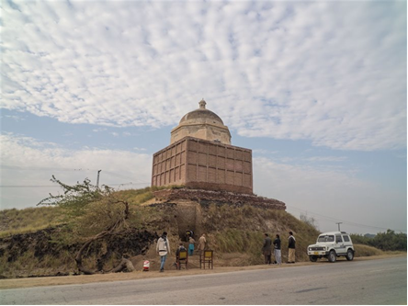

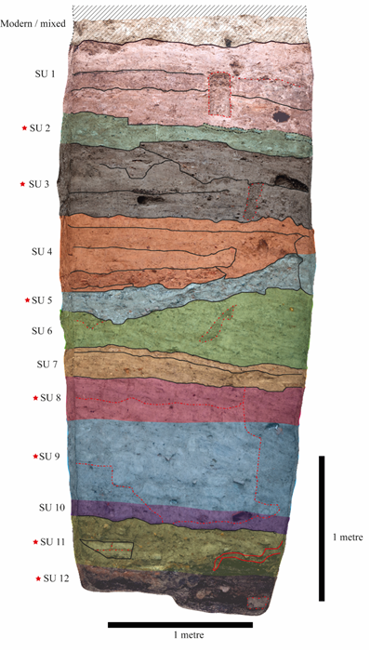

Supplementary 2 table 1. Description of the stratigraphic sequence of the ModAgrO excavations at Bhando Qubo (Feb 2019, Oct 2019).
STRATIGRAPHIC UNIT 1
3A = surface above the floor (rubified, pseudo-abandonment)
3B = floor with white spots
3C = preparation of floor 3B

STRATIGRAPHIC UNIT 2
3D = floor with white spots
3E = preparation of floor 3D
3A, 3B, 3C, 3E, 3D = sequence of floors, 3A-3B-3C on the one hand, and 3D -3E on the other hand

STRATIGRAPHIC UNIT 3
Sequence of floors with not much preparation
4A = floor with white spots
4A_1 = pit that cuts 4A, 4B and 4C and is covered by 3E. It is not a fireplace. It is an undifferentiated context that was firstly considered as 4A
4B = Whitish, it covers a few fire structures below 4A. In the interface with 4C there’s Baloochi pottery
4B_2 = ash accumulation, possibly a fireplace context inside 4B
4C = floor, identified by flat pottery
4D = Few white spots, plaster, last level of the floor sequences. Associated to a main fireplace (4D_1) surrounded by a cleaning area with grinding stones

STRATIGRAPHIC UNIT 4
5 = very compacted and clayish, with non-baked bricks spread and “fish scale” pottery (culturally associated with Kot Diji). No other materials like charcoal
6A = preparation for SU5, with very fragmented pottery

STRATIGRAPHIC UNIT 5
6B = covered by 6A, rubified and with charcoal. Composed of 2 phases, an uneven surface (preparation) and a floor, but all together has been considered as 6B.

STRATIGRAPHIC UNIT 6
7 = pure clay, possible wash-off from the lateral platform
8 = different from SU7 for being richer in material and very fragmented (including pottery) but connected to SU7. There is Baloochi pottery.

STRATIGRAPHIC UNIT 7
9A = floor
9B = mix of clay, a bit of pottery, another possible floor. The lowest part is considered already SU10, it is possible that some materials from SU10 have been labelled as SU9.
10 = floor with flat pottery
10_1 = big fireplace

STRATIGRAPHIC UNIT 8
11, 12 y 13 = artificial, filling with scarce material, quite pure clay, some big charcoal (it hasn’t been much re-worked/damaged)

STRATIGRAPHIC UNIT 9
14 = full of material, particularly pottery. Non-identified sequence of floors, at least two, because there are entire and flat pottery clusters at different levels. Two activity surfaces.
15 = almost no material, only a bead. Filling below SU14
16 = almost no material, only a pottery sherd and a charcoal, below SU15

STRATIGRAPHIC UNIT 10
17 = layer of mudbrick platform/pure clay patches, continuation of SU18 but regularized
18 = clay lumps

STRATIGRAPHIC UNIT 11
19 = rubified, on top of which the clay lumps lay, interdigitated with SU18, a fire event that creates an uneven surface. Full of charcoal. End of the SU22-SU21-SU20 sequence
20 = occupation floor, with fireplace and a lot of material. There could be two different episodes because there are two different uses of the fireplace
21 = occupation floor where the sunken pot appears. Clear clay patches at the same level of the sunken pot
22 = a lot of broken pottery, it could be the preparation for SU21. Together with SU21 it is a very intense frequentation pack

STRATIGRAPHIC UNIT 12
23 = rubble filling, connected to the kiln
24 = abandonment of kiln
25 = kiln

Supplementary 2 figure 2. Photograph of layer 4B
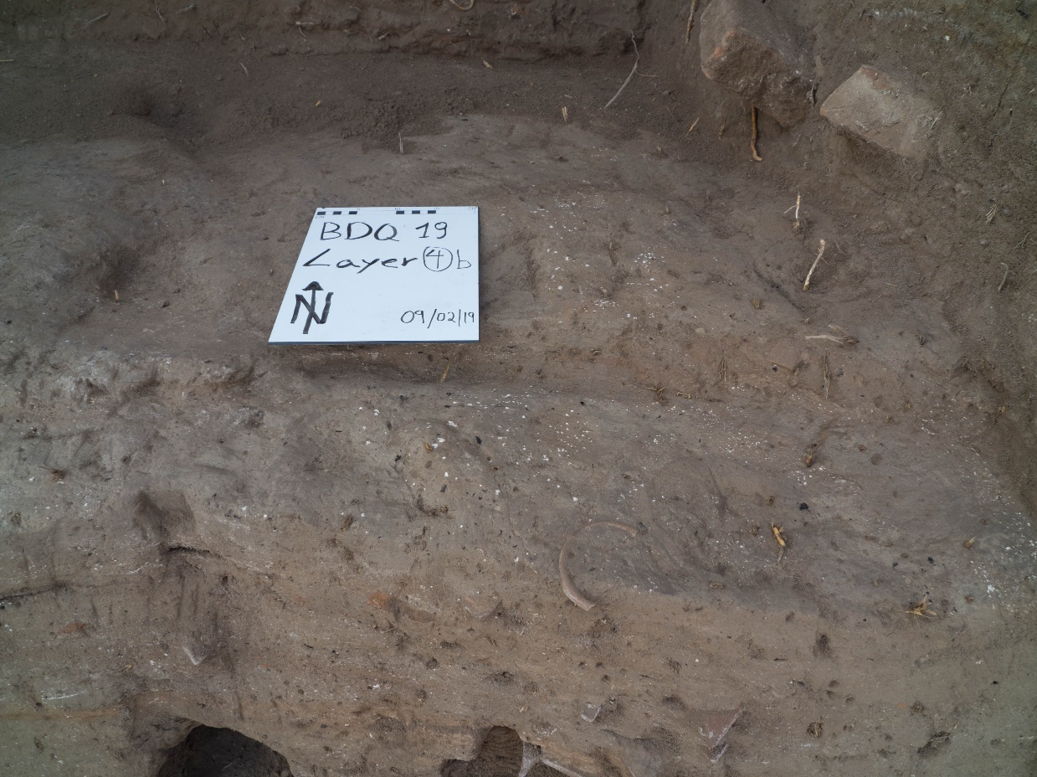
Supplementary 2 figure 3. Photograph of a micromorphology block showing layer 4B-2
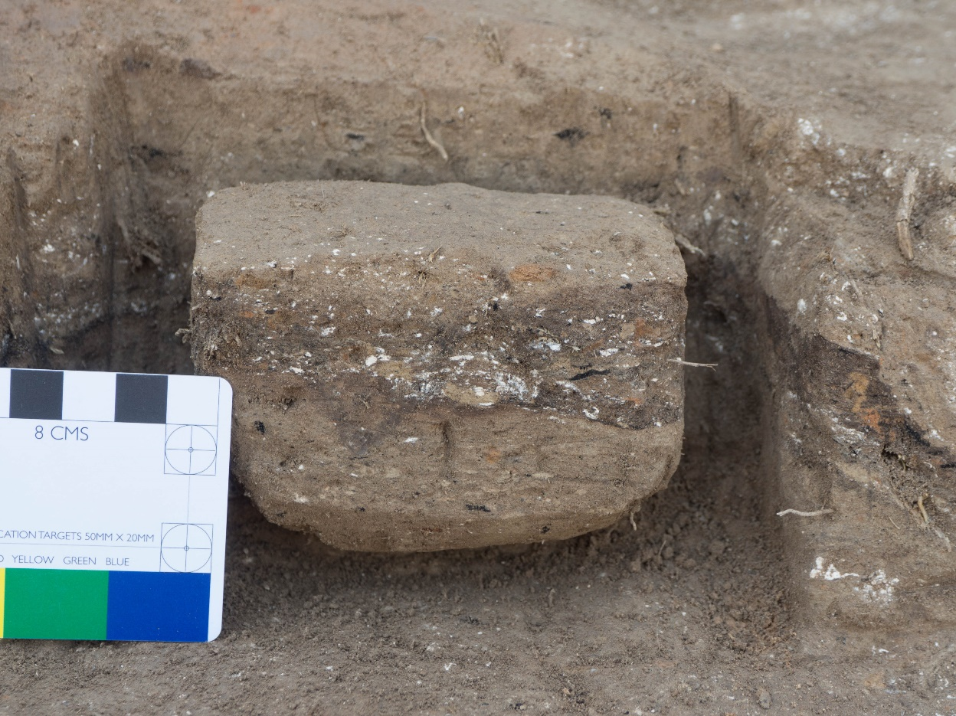
Supplementary 3
Morphological and anatomical identification criteria for the pearl millet caryopses
Domesticated grains are consistently larger than wild forms. In the 3rd millennium BC, the average grain breadth had increased by 38% compared to the wild type (Fuller 2021: 211). Two other qualitative features of domesticated pearl millet are the presence of multiple (usually paired) spikelets and the appearance of non-shattering stalked involucres (Fuller 2021: 211).
In this publication, the identification of domesticated pearl millet caryopses is therefore based on morphology, size, and size ratios, following the criteria outlined by Fuller (2003, 2006, 2020, 2021).
The grains typically show an ovate outline in plain view, with a wedge-shaped longitudinal section. The scutellum is long, wide, and deep, extending over two-thirds to three-quarters of the caryopsis length. The hilum and scutellum tip are projecting, while the grain base is narrowly acute. Most caryopses are elongate-conical, characteristic of two-grained spikelets, while a smaller proportion are more widely ovate, typical of single-grained spikelets (Fuller 2003: 248). This variation can be observed in Figure 2 of the manuscript.
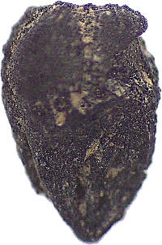
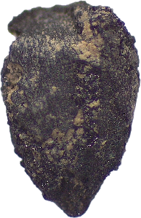
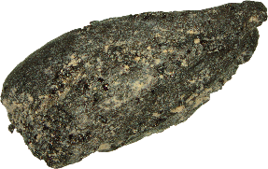

Scale: 1 mm

Supplementary 4

Supplementary 4 table 1. Measurements of the charred Pennisetum glaucum (L.) R. Br. grains from Bhando Qubo, layer 4B-2
 | L | B | H | eL | eL/L | L/B | L/H | B/H | B/Lx100
PM ARCH 1 | 1,12 | 0,69 | 0,52 | 0,67 | 0,60 | 1,62 | 2,15 | 1,33 | 61,61
PM ARCH 2 | 2,16 | 1,17 | 0,92 | 1,31 | 0,61 | 1,85 | 2,35 | 1,27 | 54,17
PM ARCH 3 | 1,03 | 0,62 | * | 0,66 | 0,64 | 1,66 | * | * | 60,19
Supplementary 4 table 2. Measurements of the charred Pennisetum sp. grains from Bhando Qubo, layer 4B-2
 | L | B | H | eL | eL/L | L/B | L/H | B/H | B/Lx100
CSP ARCH 4 | 1,83 | 0,93 | * | 1,3 | 0,71 | 1,97 | * | * | 50,82
CSP ARCH 5 | 1,8 | 1,02 | 0,7 | 1,13 | 0,63 | 1,76 | 2,57 | 1,46 | 56,67
Supplementary 4 table 3. Measurements of modern Pennisetum glaucum (L.) R. Br. caryopses from Pakistan, UPF Laboratory for Environmental Archaeology seeds reference collection - ref. BGP 1377
 | L | B | H | eL | eL/L | L/B | L/H | B/H | B/Lx100
PM REF 1 | 3,15 | 2,19 | 1,63 | 2,16 | 0,69 | 1,44 | 1,93 | 1,34 | 69,52
PM REF 2 | 3,17 | 1,68 | 1,39 | 1,93 | 0,61 | 1,89 | 2,28 | 1,21 | 53,00
PM REF 3 | 3,52 | 2,34 | 1,95 | 2,49 | 0,71 | 1,50 | 1,81 | 1,20 | 66,48
PM REF 4 | 2,83 | 1,54 | 1,15 | 1,83 | 0,65 | 1,84 | 2,46 | 1,34 | 54,42
Measurements taken after Fuller (2020) and Jacomet (2006)
* Measurements not taken due to the state of preservation

Supplementary 5

Protocol for macrobotanical sampling

- Fix a floatation mesh (<0.5 mm) to a plastic/metal bucket with clothes pegs.
- Place half duryu (ca 5 L) of sediment into another bucket and top up with water.
- Stir the sediment for ca 1 minute with a bare hand or a stick to make the charred remains float (careful not to break them).
- Recover the floating remains or “light fraction” (which includes charred remains but also modern leaves, roots, etc.) by carefully pouring the sediment with water into the bucket with the floatation mesh, so the mesh will trap the charred remains and the water will pass through. Pour out the remaining water and top up with water again the bucket with sediment to recover as much material as possible. Repeat steps 3 and 4.
- Wet-sieve the residue left on the bucket (i.e. the part that did not float or “heavy fraction”) to recover archaeological artefacts (e.g. small potsherds, bones, lithic material, etc.). The leftover water in the bucket with the floatation mesh can be used for water sieving to save water.
- Transfer the remaining heavy fraction into a textile bin bag placed on a flat surface so it can be spread to dry more quickly. Store it in textile bags in order to avoid water retention if not totally dry.
- Repeat all the process for the remaining soil sample. The same mesh is to be used to process the 20 L of one context.
- Once the whole 20 L sample has been floated, transfer the light fraction trapped in the mesh to a fine fabric, close it with rope or wire and label it with the corresponding information (site, stratigraphic unit, floated volume, date). Place it to dry in the shade.
- Once dry, transfer the light fraction to a zip-lock plastic bag (with the label) and store it.

