Supporting Figures
Figure S1.
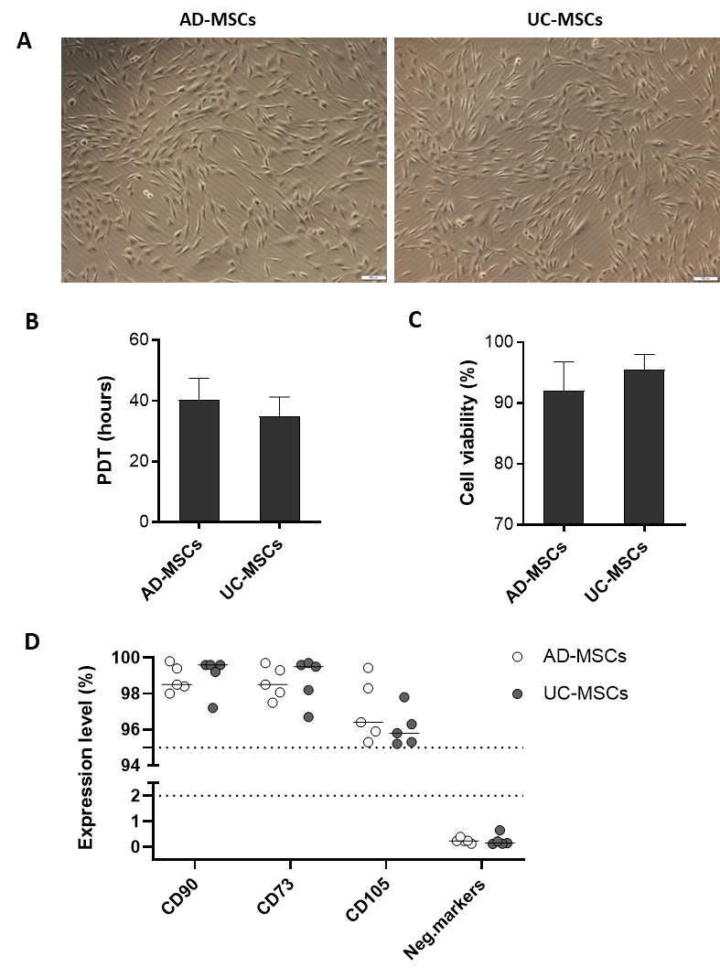
Figure S1. Characterization of UC-MSCs and AD-MSCs at Passage 6. (A) Morphology of the isolated cells. UC- and AD-MSCs adhered to the vessel surfaces and exhibited a spindle-shaped or elongated fibroblast-like shape. (B) The PTDs of AD- and UC-MSCs were 40.3 ± 4.6 hours and 35.0 ± 4.4 hours, respectively (n=5). (C) Cell viability was assessed by DAPI staining and measured via flow cytometry (n=5). (D) Cells were collected for flow cytometry analysis (n=5). More than 95% of the AD-MSCs and UC-MSCs were positive for CD90, CD105, and CD73, and both types of cells expressed very low levels of the negative MSC markers CD45, CD34, CD11b, CD19, and HLA-DR (<1%).
Figure S2.
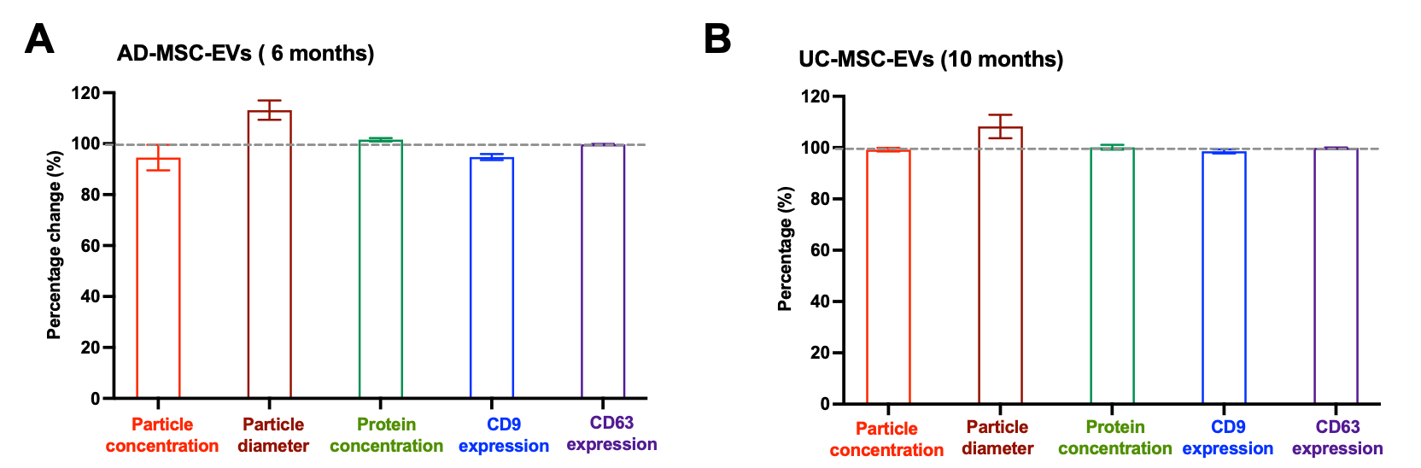

Figure S2. The preservation of particle concentration and diameter, protein concentration and CD9 and CD63 expression in UC-MSC-EVs and AD-MSC-EVs. (A) AD-MSC-EVs after 6 months of storage at -80ºC. (B) UC-MSC-EVs after 10 months of storage at -80ºC. Particle concentration and diameter of the EVs were dertermined by nanoparticle tracking analysis NTA. Protein concentration was measured by Bradford assay. Expression of CD9 and CD93 were analysed by flow cytometry.

