Supporting material 2

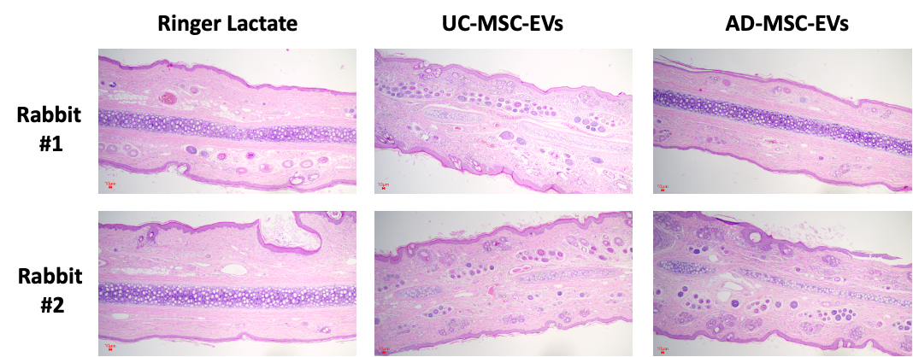
Figure S3.

Figure S3. Hematoxylin and eosin (HE) staining of injected ear tissues following vascular stimulation of representative animals (supporting data to Fig 2G). New Zealand rabbits received injections of either Ringer’s lactate (control), 50 µg UC-MSC-EVs, or 50 µg AD-MSC-EVs. Tissue samples were collected on day 4 post-injection for histological analysis.

Figure S4.

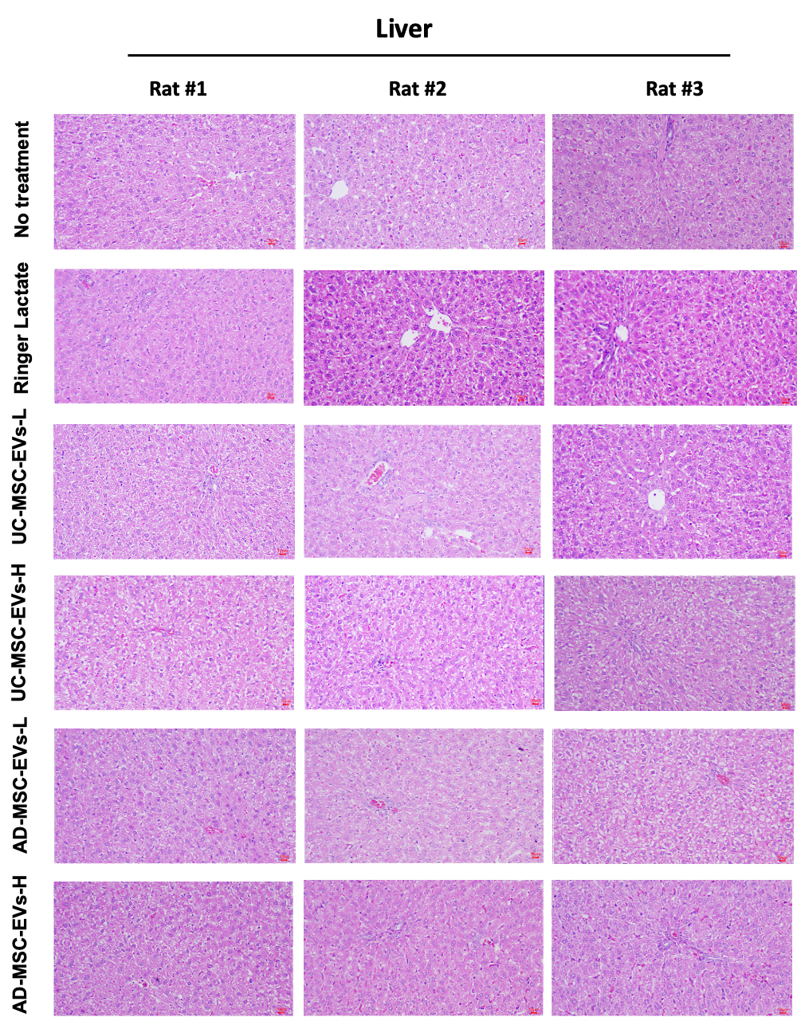
Figure S4. HE staining of liver tissues for macroscopic and microscopic evaluation of subchronic toxicity induced by UC-MSC-EVs and AD-MSC-EVs of representative animals (rat #1 images represent the original data presented in Figure 7C). Wistar rats received injections of either Ringer’s lactate, UC-MSC-EVs, or AD-MSC-EVs at low (50 µg; UC-MSC-EVs-L and AD-MSC-EVs-L) or high (150 µg; UC-MSC-EVs-H and AD-MSC-EVs-H) doses on days 0, 10, and 20. Liver samples were collected on day 30 post-injection for histological analysis.

Figure S5
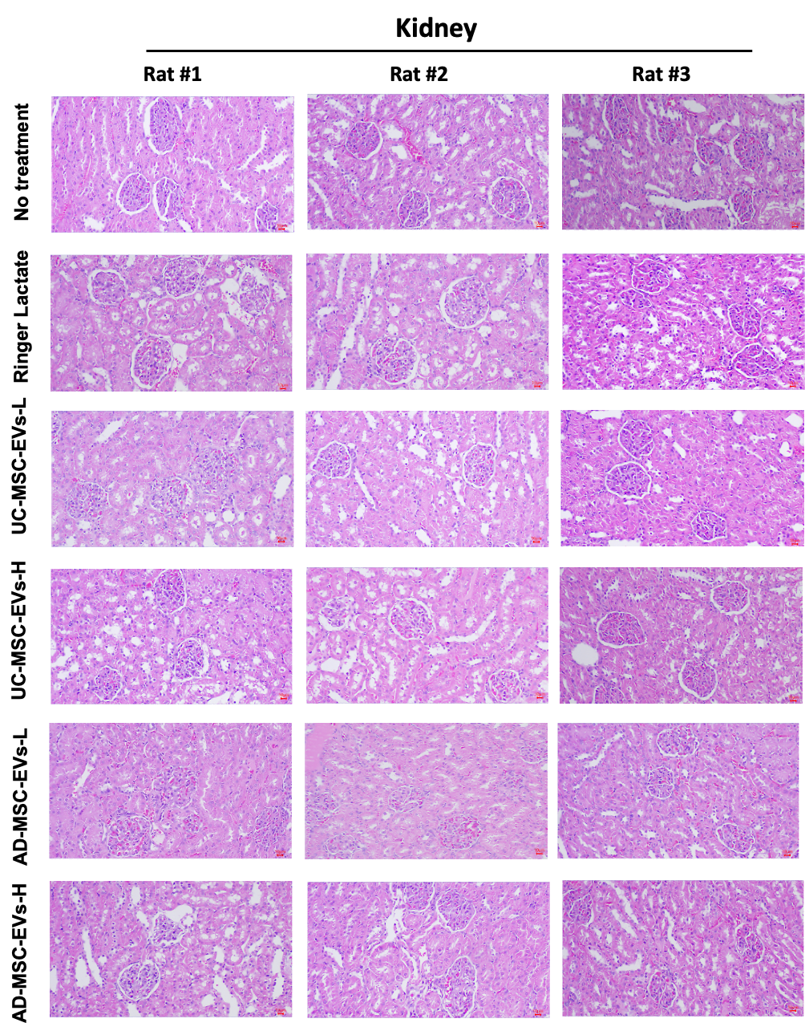
Figure S5. HE staining of kidney tissues for macroscopic and microscopic evaluation of subchronic toxicity induced by UC-MSC-EVs and AD-MSC-EVs of representative animals (rat #1 images represent the original data presented in Figure 7C). Wistar rats received injections of either Ringer’s lactate, UC-MSC-EVs, or AD-MSC-EVs at low (50 µg; UC-MSC-EVs-L and AD-MSC-EVs-L) or high (150 µg; UC-MSC-EVs-H and AD-MSC-EVs-H) doses on days 0, 10, and 20. Kidney samples were collected on day 30 post-injection for histological analysis.
Figure S6
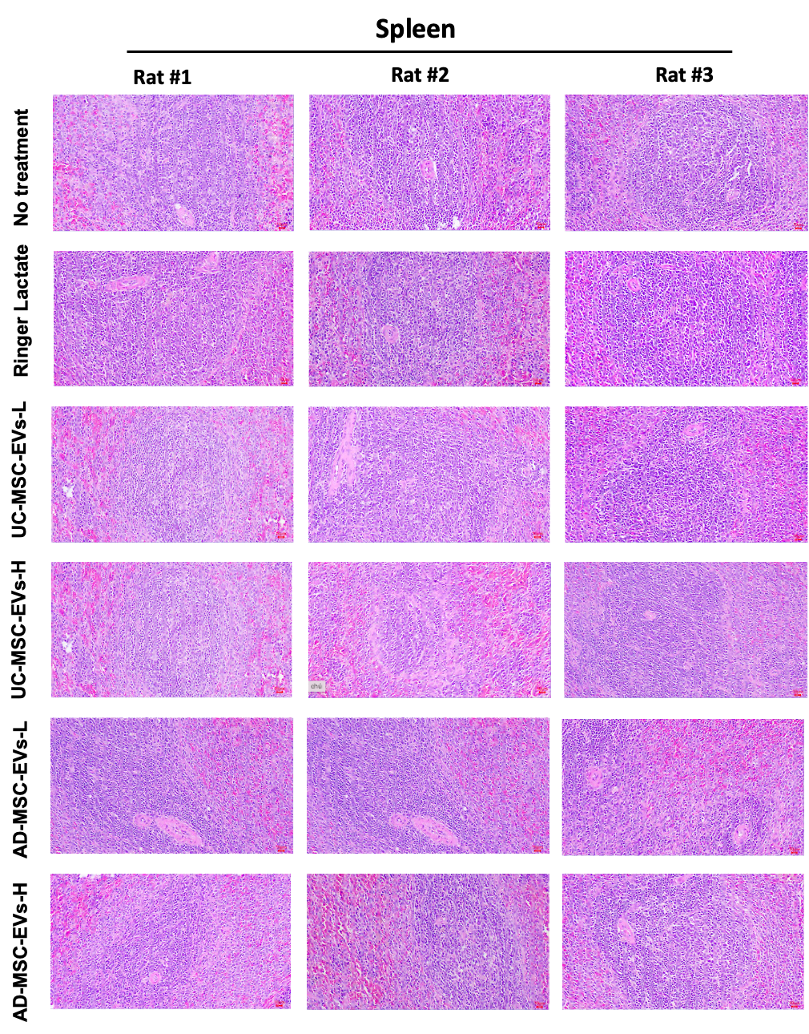
Figure S6. HE staining of spleen tissues for macroscopic and microscopic evaluation of subchronic toxicity induced by UC-MSC-EVs and AD-MSC-EVs of representative animals (rat #1 images represent the original data presented in Figure 7C). Wistar rats received injections of either Ringer’s lactate, UC-MSC-EVs, or AD-MSC-EVs at low (50 µg; UC-MSC-EVs-L and AD-MSC-EVs-L) or high (150 µg; UC-MSC-EVs-H and AD-MSC-EVs-H) doses on days 0, 10, and 20. Spleen samples were collected on day 30 post-injection for histological analysis.

