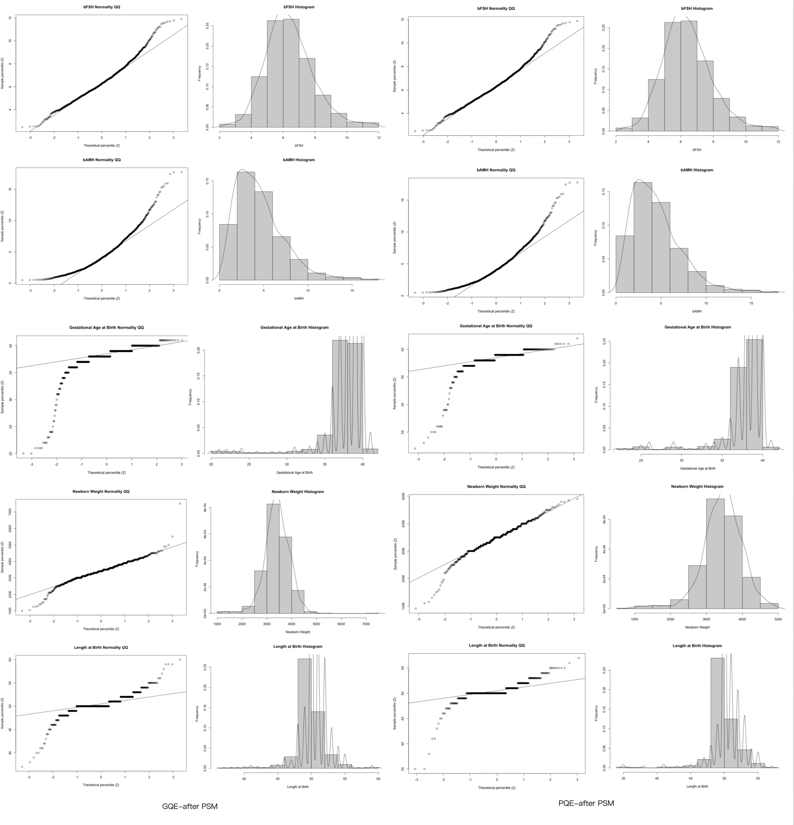
Supplementary Figure S1. Q–Q plots and histograms for continuous variables by group (GQE vs PQE) after PSM.

