Table S1 Univariable and Multivariable regression analysis of the TG/HDL ratio and TyG index with the MAP (original data)
Exposure | Unadjusted β  β (95% CI) P value | Model 1  β (95% CI) P value | Model 2  β (95% CI) P value
TG/HDL-C ratio | 0.90 (0.70, 1.10) <0.0001 | 0.83 (0.63, 1.03) <0.0001 | 0.48 (0.22, 0.74) 0.0003
TyG index | 0.29 (0.23, 0.35) <0.0001 | 0.28 (0.22, 0.34) <0.0001 | 0.15 (0.07, 0.24) 0.0004
TG/HDL-C quartile
Q1 | Reference | Reference | Reference
Q2 | 2.25 (1.31, 3.20) <0.0001 | 2.11 (1.16, 3.06) <0.0001 | 1.42 (0.16, 2.67) 0.0269
Q3 | 3.02 (2.07, 3.97) <0.0001 | 2.78 (1.83, 3.73) <0.0001 | 2.04 (0.78, 3.30) 0.0015
Q4 | 4.87 (3.93, 5.82) <0.0001 | 4.50 (3.54, 5.45) <0.0001 | 2.55 (1.26, 3.85) 0.0001
TyG index quartile
Q1 | Reference | Reference | Reference
Q2 | 0.56 (-0.39, 1.51) 0.2479 | 0.56 (-0.39, 1.50) 0.2507 | -0.92 (-2.23, 0.40) 0.1715
Q3 | 2.58 (1.62, 3.53) <0.0001 | 2.61 (1.66, 3.56) <0.0001 | 1.26 (-0.07, 2.60) 0.0632
Q4 | 4.36 (3.40, 5.31) <0.0001 | 4.33 (3.38, 5.28) <0.0001 | 1.99 (0.57, 3.42) 0.0061
Data were presented as β (95% CI) P value. β coefficients represent: (1) regression coefficients per unit increase for continuous analysis of TG/HDL-C ratio and TyG index; (2) mean differences compared to Q1 reference group for quartile analysis. CI confidence interval.
Model 1: adjusted for gender and age
Model 2: adjusted for gender, age, cholesterol, hs-cTnT, NT-proBNP, HbA1c, albumin, WBC, platelet and creatinine.
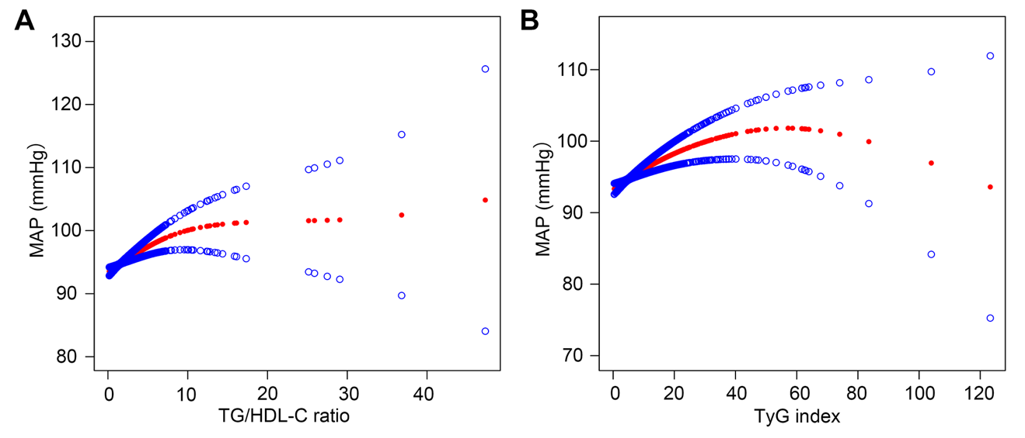
Figure S1 Dose-response relationships between insulin resistance markers and MAP using generalized additive models (original data)
(A) TG/HDL-C ratio and MAP. (B) TyG index and MAP. Red lines represent estimated values with 95% confidence intervals (blue lines). Adjusted for gender, age, cholesterol, hs-cTnT, NT-proBNP, HbA1c, albumin, WBC, platelet and creatinine.
Table S2 Subgroup analysis of insulin resistance markers with MAP (original data)
 | N | TG/HDL ratio  β（95%CI）P value | N | TyG index  β（95%CI）P value
Gender
Male | 4568 | 0.53 (0.22, 0.84) 0.0008 | 4537 | 0.20 (0.09, 0.31) 0.0003
Female | 2773 | 0.22 (-0.27, 0.70) 0.3814 | 2751 | 0.07 (-0.06, 0.20) 0.2984
P for interaction |  | 0.061 |  | 0.023
Age
<65 | 4159 | 0.45 (0.14, 0.76) 0.0042 | 4124 | 0.18 (0.07, 0.29) 0.0011
>=65 | 3182 | 0.62 (0.10, 1.14) 0.0194 | 3164 | 0.09 (-0.05, 0.24) 0.2120
P for interaction |  | 0.912 |  | 0.283
Adjusted for gender, age, cholesterol, hs-cTnT, NT-proBNP, HbA1c, albumin, WBC, platelet and creatinine.

