Influence of climatic and land use factors on post-monsoon distribution of Aedes mosquito vectors in Udupi taluk
Prathiksha Prakash Nayak¹, Jagadeesha Pai B^{2*}, Sreejith Govindan^{3*}, Naren Babu N⁴
¹ Research scholar, Department of Civil Engineering, Manipal Institute of Technology, Manipal Academy of Higher Education, Manipal, India. prathiksha.nayak@learner.manipal.edu
^{2*} Associate Professor, Department of Civil Engineering, Manipal Institute of Technology, Manipal Academy of Higher Education, Manipal, India. jaga.pai@manipal.edu
^{3*} Associate Professor, Division of Microbiology, Department of Basic Medical Sciences, Manipal Academy of Higher Education, Manipal, India. g.sreejith@manipal.edu
⁴ Lecturer, Manipal Institute of Virology, Manipal Academy of Higher Education, Manipal, India. naren.babu@manipal.edu
*Corresponding author Email: Jagadeesha Pai B, Sreejith Govindan

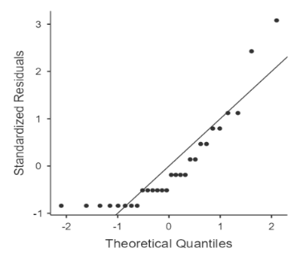 | 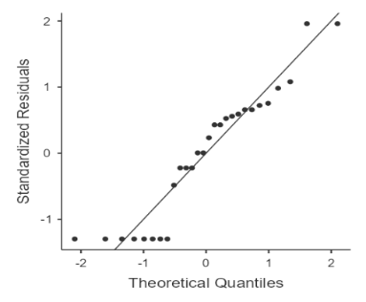 |  | 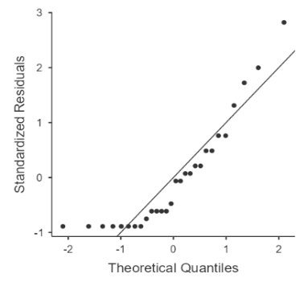
(a) | (b) |  | (c)
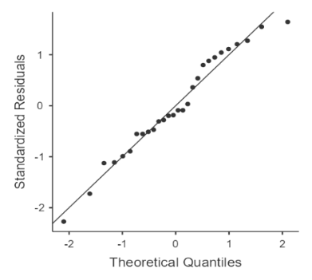 | 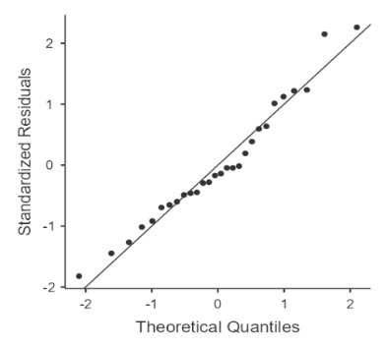 |  | 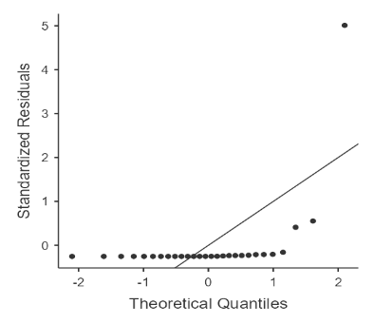
(d) | (e) |  | (f)
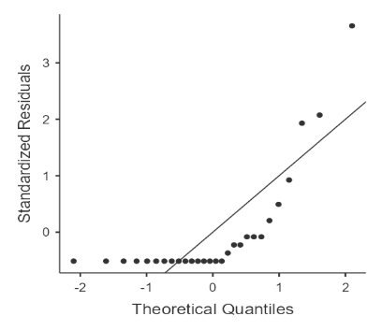 |  | 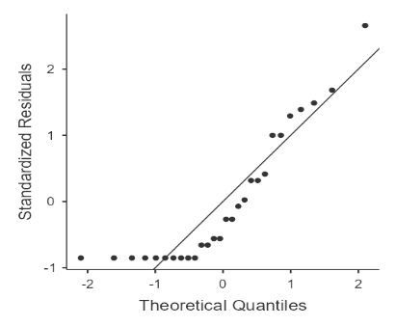
(g) |  | (h)

Supplementary Figure 1 (S1). Q-Q plots: (a) House index, (b) Container index, (c) Breteau index, (d) Temperature, (e) Humidity, (f) Rainfall, (g) Aedes aegypti, (h) Aedes albopictus

