Supporting Information for

In-cell NMR spectra of chemically unmodified RNA at physiological temperature with extended lifetime through RNase inhibitor cocktail in living human cells
Omar Eladl,^{1,2,3,#,†} Yudai Yamaoki,^{1,2,4,5,†} Takashi Nagata^{1,2,4,5} and Masato Katahira ^{1,2,4,5,}*
¹ Institute of Advanced Energy, Kyoto University, Kyoto 611-0011, Japan.
² Graduate School of Energy Science, Kyoto University, Kyoto 606-8501, Japan.
³ Faculty of Pharmacy, Zagazig University, Zagazig 44519, Egypt.
⁴ Integrated Research Center for Carbon Negative Science, Institute of Advanced Energy, Kyoto University, Uji 611-0011, Japan.
⁵ Biomass Product Tree Industry-Academia Collaborative Research Laboratory, Kyoto University, Uji, Kyoto 611-0011, Japan.
* Correspondence: katahira.masato.6u@kyoto-u.ac.jp
† These authors contributed equally to this work.
#Current address: Department of chemistry, New York University, NY 10012, USA

Number | Description |  | Page
1 | In vitro ¹H-NMR spectra of the aptamer^{free} at 10°C, 25°C, and 37°C | ……….. | 2
2 | In vitro ¹H-NMR spectra of the aptamer^{complex} at 10°C, 25°C, and 37°C | ……….. | 3

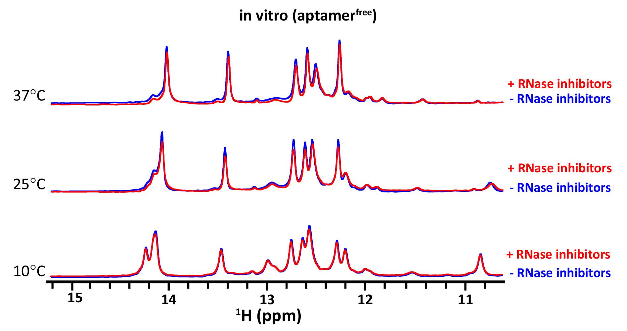Figure S1. In vitro ¹H-NMR spectra of the aptamer^{free}. The imino proton spectra of 150 µM aptamer^{free} in the absence (blue) and presence (red) of the RNase inhibitor cocktail acquired in transport buffer at 10°C, 25°C, and 37°C are shown.
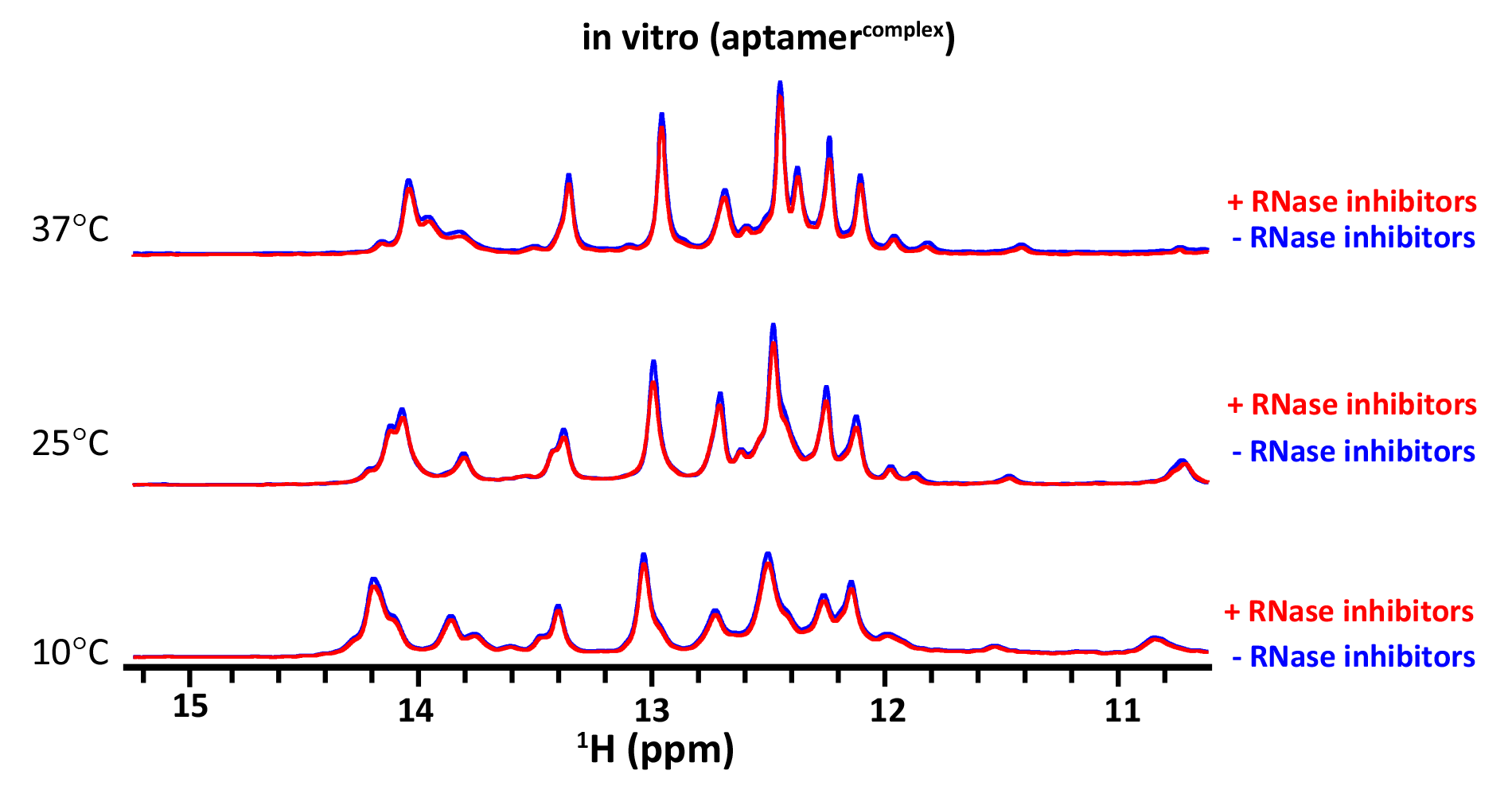
Figure S2. In vitro ¹H-NMR spectra of the aptamer^{complex}. The imino proton spectra of 150 µM aptamer^{complex} (with 150 µM Tat peptide) in the absence (blue) and presence (red) of the RNase inhibitor cocktail acquired in transport buffer at 10°C, 25°C, and 37°C are shown.

