Naturalistic fNIRS Assessment Reveals Decline in Executive Function and Altered Prefrontal Activation Following Social Media Use in College Students
Supplementary Materials
Table S1. Descriptive statistics for behavioral, emotional, and fNIRS outcome measures.
Measures | Group | Pre-mean (SD) | Post-mean (SD) | Change score mean (SD)
Go/No-Go accuracy
Correct Rejection rate | Social Media | 78.3 $±$ 3.55 | 72.2 $±$ 4.15 | -6.1$±$ 3.88
 | Control | 83.8 $±$ 3.3 | 85.6 $±$ 5.5 | 1.8 $±$ 2.66
Hit rate | Social Media | 90.8 $±$ 5.2 | 92.8.6 $± 7$.6 | 2.06 $±$ 2.4
 | Control | 94.7 $±$ 4.4 | 90.6 $±$ 6.9 | -4.1 $±$ 2.5
N-Back accuracy
0-back | Social Media | 96 $±$ 3.4 | 94 $±$ 3.8 | -2 $±$ 0.5
 | Control | 95 $±$ 4.3 | 96 $±$ 1.2 | 1 $±$ 2.3
2-back | Social Media | 88 $±$ 2.1 | 82 $±$ 4.6 | -6 $±$ 2.5*
 | Control | 88 $±$ 4.2 | 92 $±$ 1.6 | 4 $±$ 2.8
3-back | Social Media | 80.4 $±$ 5.5 | 72.8 $±$ 6.6 | -7.6 $±$ 1.3*
 | Control | 82.6 $±$ 3.9 | 90.4 $±$ 2.5 | 7.8 $±$ 1.4
DEQ Happiness | Social Media | 4.33 $±$ 0.26 | 4.37 $±$ 0.31 | 0.04 $±$ 0.1
 | Control | 4.82 $±$ 0.04 | 3.92 $±$ 0.35 | 0.8 $±$ 0.31
N-Back fNIRS activation
mPFC | Social Media | 0.55 $±$ 0.9 | 3.1 $±$ 0.82 | 2.55 $±$ 0.77*
 | Control | -2.7 $±$ 1.1 | -1.2 $±$ 0.4 | -0.5 $±$ 0.9
dlPFC | Social Media | -0.3 $±$ 1.2 | -2.7 $±$ 0.8 | -2.4 $±$ 1.1*
 | Control | 0.7 $±$ 0.7 | 1.6 $±$ 0.33 | 0.9 $±$ 0.44
vlPFC/IFG | Social Media | 2.3 $±$ 1.3 | 2.15 $±$ 0.91 | -0.15 $±$ 0.63
 | Control | 1.6 $±$ 0.72 | 1.92 $±$ 1.3 | 0.32 $±$ 0.58
Go/No-Go fNIRS activation
mPFC | Social Media | 2.22 $±$ 1.5 | 1.93 $±$ 1.7 | -0.29 $±$1.3
 | Control | 2.8 $±$ 0.82 | 1.4 $±$ 1.2 | 1.4 $±$ 0.88*
dlPFC | Social Media | 4.43 $±$ 1.9 | 4.04 $±$ 1.7 | -0.39 $±$ 1.5
 | Control | 3.01 $±$ 1.4 | 3.42 $±$ 2.1 | 0.41 $±$ 1.8
vlPFC/IFG | Social Media | -2.5 $±$ 1.6 | -3.02 $±$ 1.3 | -0.52 $±$ 1.1
 | Control | -2.02 $±$ 1.1 | -2.9 $±$ 1.8 | -0.88 $±$ 1.5
Note: Asterisks (*) indicate statistically significant differences in change score mean (p < 0.05).
Figure S1. Group by session interaction effect in Go/No-Go hit rate reaction time
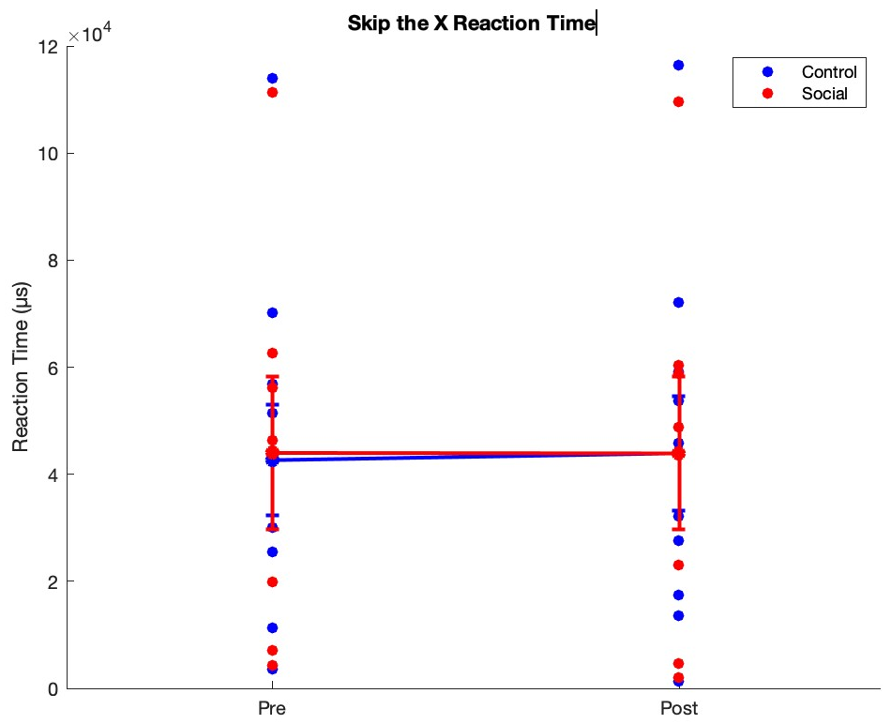

Figure S2. Interaction effect of group by session on behavioral accuracy for the average of 2-back + 3-back
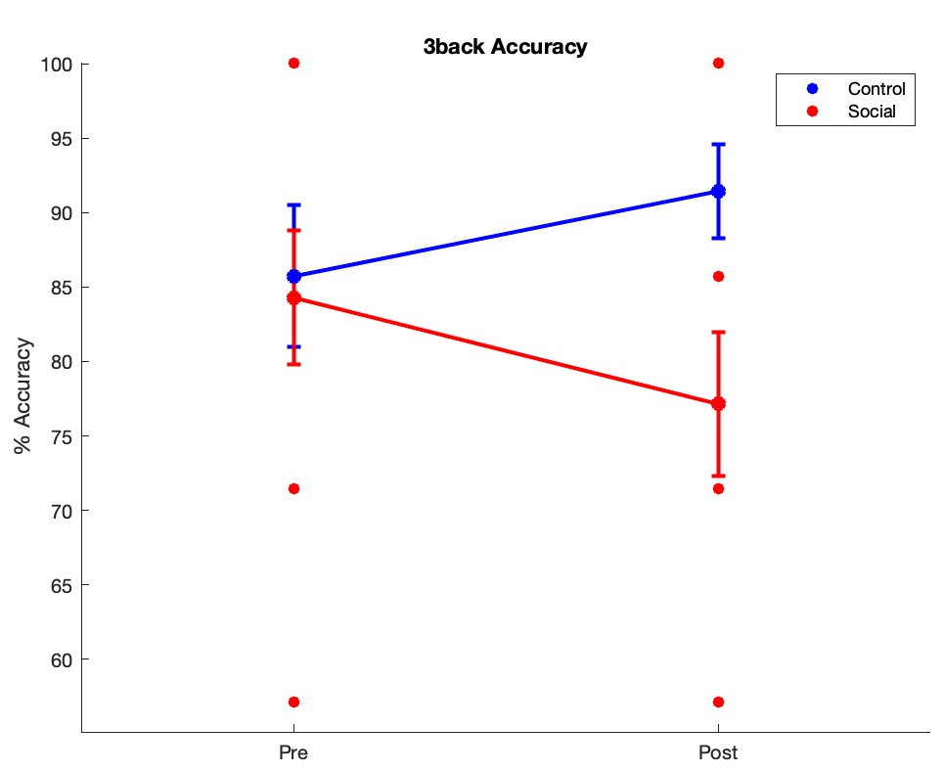
Figure S3. Group by session significant interaction effect in average DEQ Happiness item score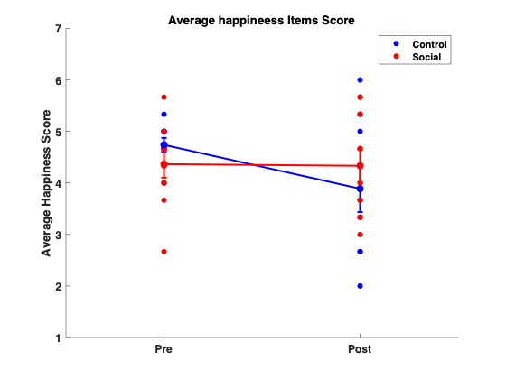
Figure S4. Channel maps of significant post–pre cortical activation for Oxy-Hb and deOxy-Hb in the prefrontal cortex during the n-back task conditions: (a) 0-back, (b) 2-back, and (c) 3-back. Contrast maps are also shown: (d) 2-back vs. 0-back, (e) 3-back vs. 0-back, and (f) 3-back vs. 2-back. The color bar represents the t-values at each channel location across all participants.

deOxy-Hb | Oxy-Hb
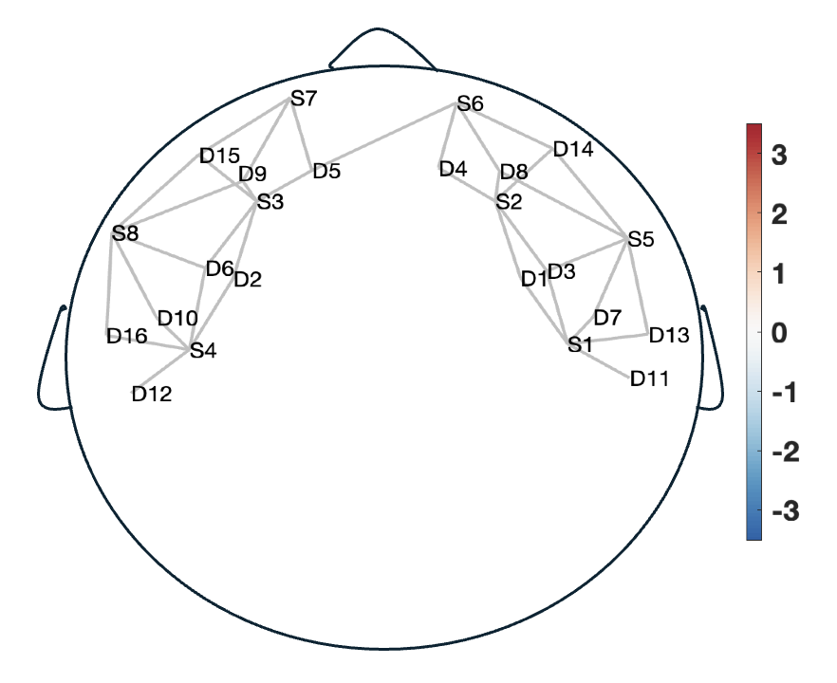  a  t-value  t-value | t-value
b  t-value | 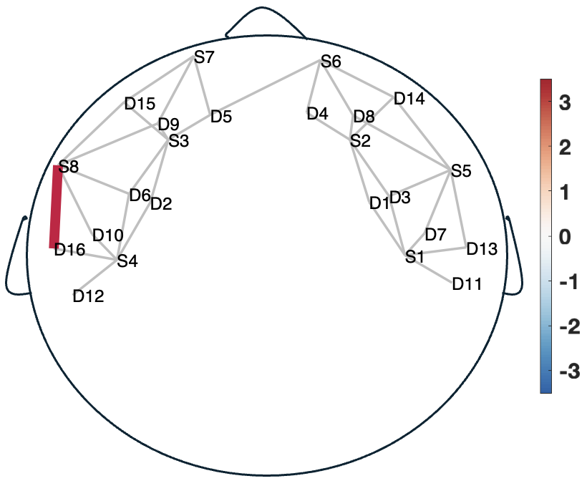  t-value
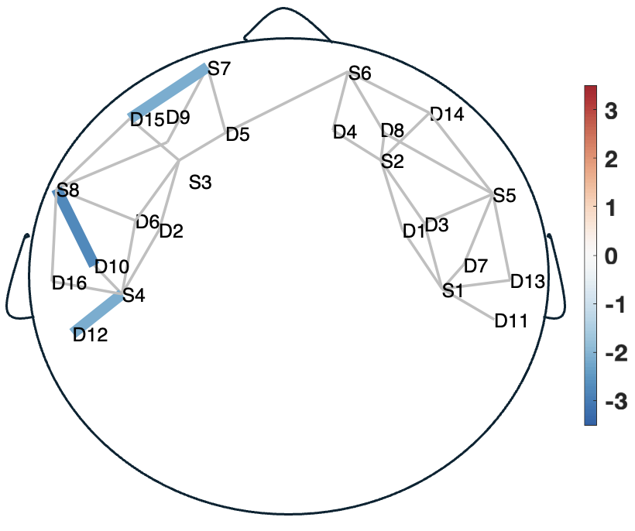  c  t-value | 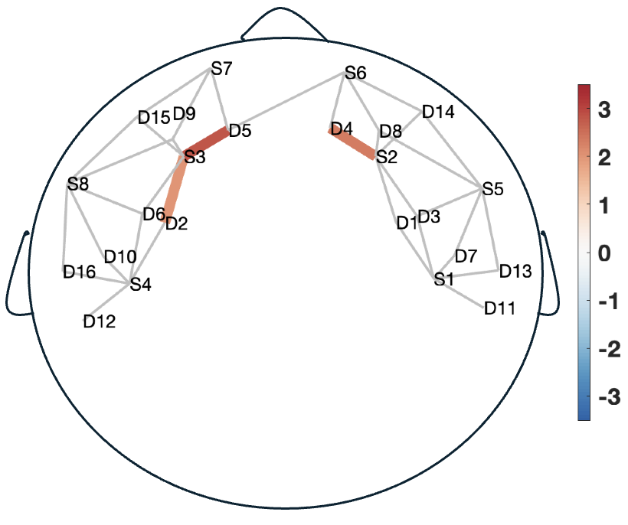  t-value
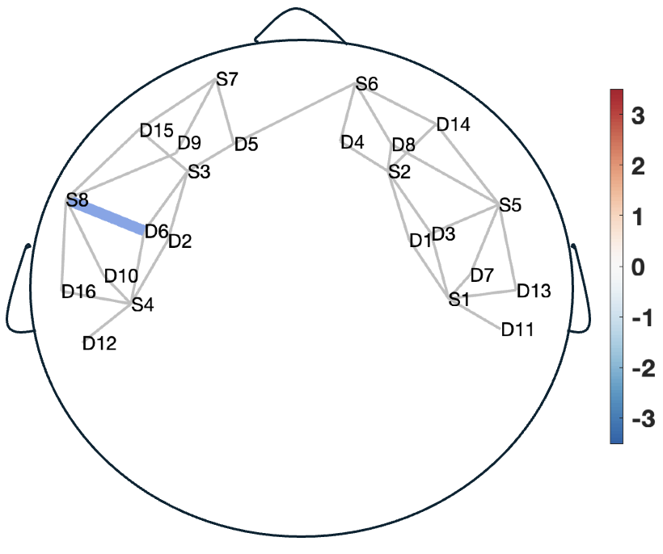  d | 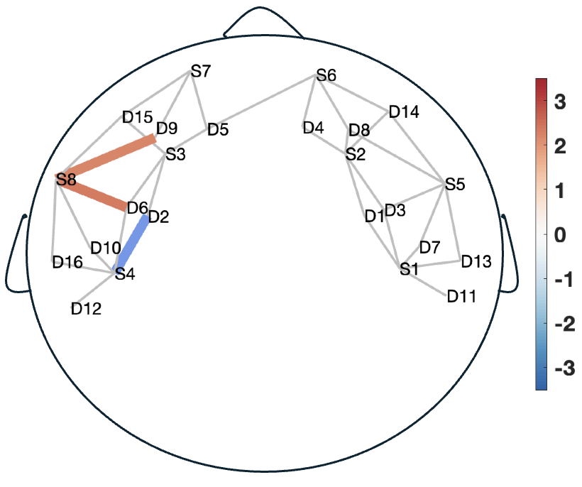  t-value  t-value
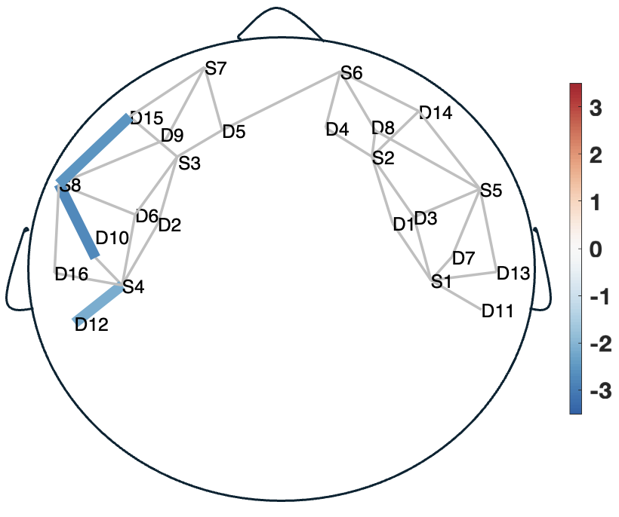  t-value | 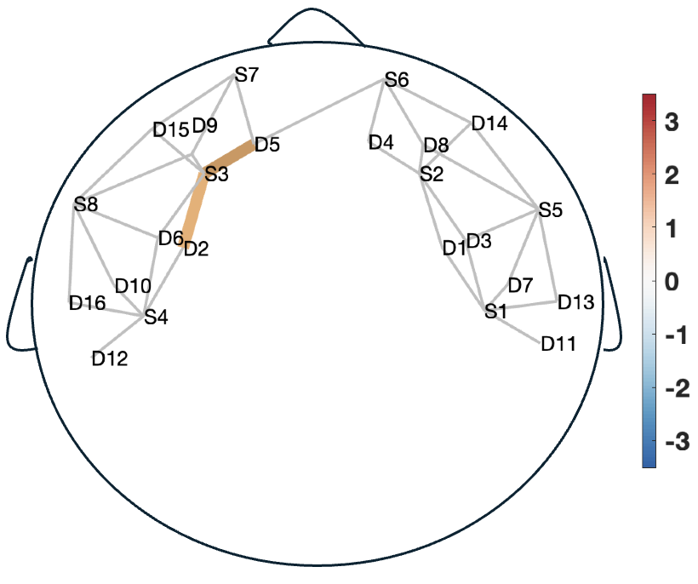  t-value
t-value | 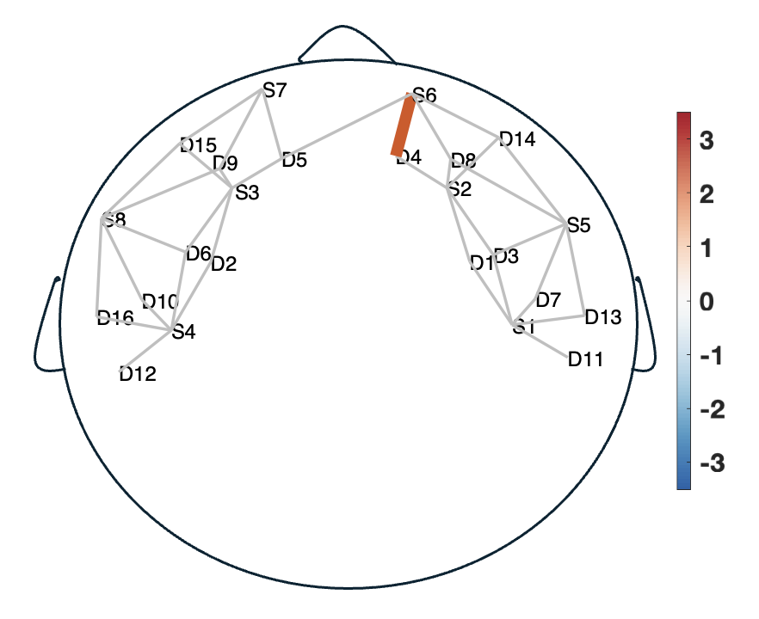
f
e
d
t-value

Figure S5. Channel maps of significant post–pre cortical activation (Oxy-Hb and deOxy-Hb) in the prefrontal cortex during the Go/No-go task conditions: (a) Go and (b) No-go. The color bar represents the t-values at each channel location across all participants.
b
a

deOxy-Hb | Oxy-Hb
 | t-value
t-value | t-value  t-value

Table S2. MNI coordinates by channel and source-detector pairs, with estimated brain regions based on the AAL atlas.
Channel# | Source# | Detector# | MNI X | MNI Y | MNI Z | AAL area (Est.)
1 | 1 | 1 | 80.4091 | 21.205 | 70.2417 | Dorsolateral PFC (R)
2 | 1 | 3 | 88.3619 | 3.3474 | 64.8035 | Dorsolateral PFC (R)
3 | 1 | 11 | 89.8454 | -13.5960 | 64.5663 | Dorsolateral PFC (R)
4 | 1 | 13 | 88.7812 | -9.4398 | 55.2180 | Inferior Frontal Gyrus (R)
5 | 2 | 1 | 63.9014 | 49.9305 | 49.2314 | Middle Frontal Gyrus (R)
6 | 2 | 3 | 66.6794 | 46.4813 | 43.2807 | Middle Frontal Gyrus (R)
7 | 2 | 4 | 41.9547 | 68.4834 | 25.6394 | Superior Frontal Gyrus (R)
8 | 2 | 14 | 57.8031 | 49.7126 | 12.5706 | Superior Frontal Gyrus (R)
9 | 3 | 2 | -52.9428 | 50.6653 | 57.5372 | Middle Frontal Gyrus (L)
10 | 3 | 5 | -34.4210 | 68.8709 | 30.9296 | Superior Frontal Gyrus (L)
11 | 3 | 6 | -56.7733 | 47.2818 | 50.9422 | Middle Frontal Gyrus (L)
12 | 3 | 15 | -52.3534 | 50.0577 | 20.6902 | Superior Frontal Gyrus (L)
13 | 4 | 2 | -66.8671 | 21.4644 | 82.6727 | Dorsolateral PFC (L)
14 | 4 | 6 | -70.6976 | 18.0809 | 76.0777 | Dorsolateral PFC (L)
15 | 4 | 12 | -77.7428 | -14.1437 | 79.5150 | Dorsolateral PFC (L)
16 | 4 | 16 | -77.9138 | -9.3651 | 69.3578 | Inferior Frontal Gyrus (L)
17 | 5 | 3 | 78.8554 | 18.3161 | 33.4819 | Inferior Frontal Gyrus (R)
18 | 5 | 7 | 84.0332 | 3.9074 | 33.9945 | Inferior Frontal Gyrus (R)
19 | 5 | 8 | 68.7417 | 30.0706 | 16.0520 | Middle Frontal Gyrus (R)
20 | 5 | 13 | 84.4525 | -8.8797 | 24.4090 | Ventrolateral PFC (R)
21 | 5 | 14 | 69.9821 | 21.5473 | 2.7718 | Orbitofrontal Cortex (R)
22 | 6 | 4 | 27.2478 | 67.4585 | 0.0858 | Medial Frontal Gyrus (R)
23 | 6 | 5 | 2.2562 | 67.5533 | 1.9412 | Medial Frontal Gyrus
24 | 6 | 8 | 41.8558 | 57.2110 | 0.2971 | Medial Frontal Gyrus (R)
25 | 6 | 14 | 43.0962 | 48.6877 | -12.9830 | Inferior Frontal Gyrus (Orbital, R)
26 | 7 | 5 | -22.3681 | 68.4019 | 4.3152 | Medial Frontal Gyrus (L)
27 | 7 | 9 | -36.3902 | 58.6583 | 5.9708 | Medial Frontal Gyrus (L)
28 | 7 | 15 | -40.3006 | 49.5886 | -5.9242 | Inferior Frontal Gyrus (Orbital, L)
29 | 8 | 6 | -70.5645 | 19.5719 | 43.1606 | Inferior Frontal Gyrus (L)
30 | 8 | 9 | -62.2342 | 31.4174 | 24.8036 | Middle Frontal Gyrus (L)
31 | 8 | 10 | -75.9978 | 4.0817 | 44.8844 | Inferior Frontal Gyrus (L)
32 | 8 | 15 | -66.1446 | 25.2374 | 12.9086 | Orbitofrontal Cortex (L)
33 | 8 | 16 | -77.7808 | -4.9845 | 36.4407 | Ventrolateral PFC (L)

Figure S6. Natural setting of wearable fNIRS headband
