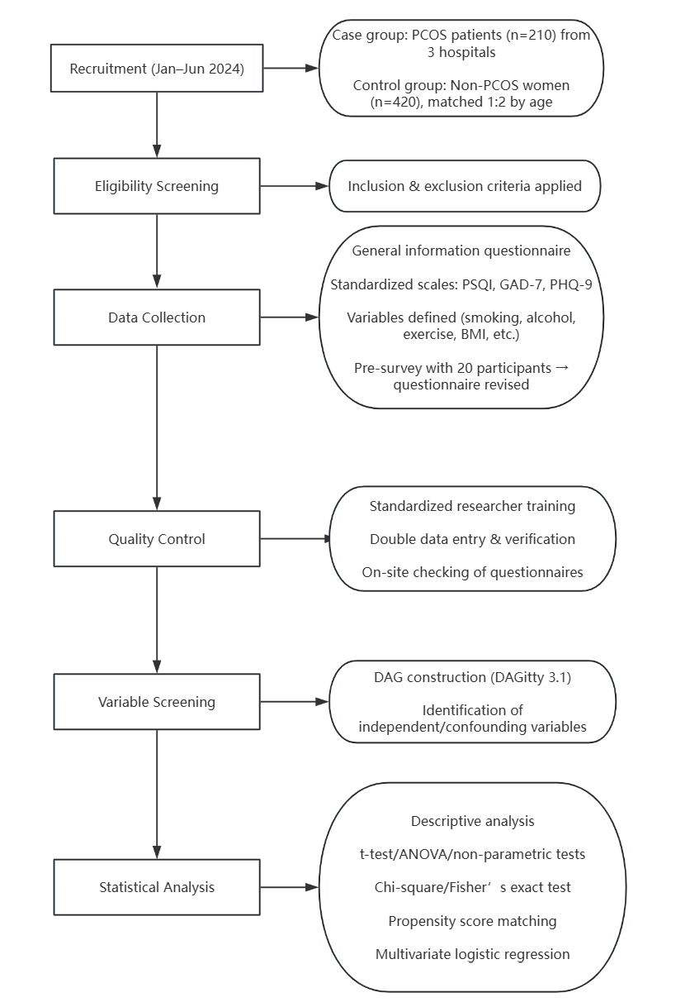

Figure 2. flow chart of the methodology

