PDB ID | Name of molecules | Binding energy | type of interaction | residue ID | Distance
3W2S | 5a | -10.746 | Hydrophobic Interactions | VAL726A | 3.31
 |  |  |  | ALA743A | 3.7
 |  |  |  | LYS745A | 3.94
 |  |  |  | LEU777A | 3.72
 |  |  |  | LEU777A | 3.97
 |  |  |  | LEU788A | 3.8
 |  |  |  | ASP837A | 3.84
 |  |  |  | LEU844A | 3.55
 |  |  |  | THR854A | 3.8
 |  |  |  | PHE856A | 3.44
3W2S | 5a | -10.746 | Hydrogen Bonds | LYS745A | 2.03
 |  |  |  | LYS745A | 2.74
 |  |  |  | ASP855A | 3.62
3W2S | 5a | -10.746 | p-Stacking | PHE723A | 4.14
3W2S | 5a | -10.746 | p-Cation Interactions | LYS745A | 4.5
3W2S | 5b | -10.205 | Hydrophobic Interactions | LEU718A | 3.6
 |  |  |  | VAL726A | 3.75
 |  |  |  | ALA743A | 3.89
 |  |  |  | THR790A | 3.98
 |  |  |  | LEU844A | 3.49
3W2S | 5b | -10.205 | Hydrogen Bonds | CYS797A | 3.49
 |  |  |  | THR854A | 2.39
3W2S | 5c | -9.914 | Hydrophobic Interactions | LEU718A | 3.48
 |  |  |  | LEU718A | 3.6
 |  |  |  | LEU777A | 3.66
 |  |  |  | LEU788A | 3.25
 |  |  |  | THR790A | 3.55
 |  |  |  | LEU792A | 3.34
 |  |  |  | LEU844A | 3.6
 |  |  |  | LEU1001A | 3.78
3W2S | 5c | -9.914 | Hydrogen Bonds | CYS797A | 2.47
3W2S | 5d | -10.539 | Hydrophobic Interactions | LEU718A | 3.61
 |  |  |  | VAL726A | 3.6
 |  |  |  | ALA743A | 3.72
 |  |  |  | LEU777A | 3.7
 |  |  |  | LEU777A | 3.58
 |  |  |  | LEU788A | 3.93
 |  |  |  | THR790A | 3.83
 |  |  |  | LEU792A | 3.98
 |  |  |  | LEU844A | 3.54
3W2S | 5d | -10.539 | Hydrogen Bonds | LYS745A | 3.14
 |  |  |  | THR854A | 3.17
 |  |  |  | THR854A | 2.16
3W2S | 5e | -10.197 | Hydrophobic Interactions | LEU718A | 3.62
 |  |  |  | VAL726A | 3.6
 |  |  |  | ALA743A | 3.74
 |  |  |  | LEU788A | 3.97
 |  |  |  | THR790A | 3.82
 |  |  |  | LEU792A | 3.99
 |  |  |  | LEU844A | 3.54
3W2S | 5e | -10.197 | Hydrogen Bonds | LYS745A | 3.15
 |  |  |  | THR854A | 3.14
 |  |  |  | THR854A | 2.13
3W2S | 5f | -10.696 | Hydrophobic Interactions | LEU718A | 3.53
 |  |  |  | VAL726A | 3.77
 |  |  |  | ALA743A | 3.89
 |  |  |  | MET766A | 3.89
 |  |  |  | LEU777A | 3.72
 |  |  |  | THR790A | 3.6
 |  |  |  | LEU792A | 3.85
 |  |  |  | LEU844A | 3.77
 |  |  |  | PHE856A | 3.65
3W2S | 5f | -10.696 | Hydrogen Bonds | LYS745A | 3.32
 |  |  |  | THR854A | 2.43
3W2S | 5g | -10.049 | Hydrophobic Interactions | LEU718A | 3.49
 |  |  |  | VAL726A | 3.63
 |  |  |  | ALA743A | 3.65
 |  |  |  | LEU777A | 3.55
 |  |  |  | LEU788A | 3.8
 |  |  |  | LEU792A | 3.75
 |  |  |  | LEU844A | 3.65
3W2S | 5g | -10.049 | Hydrogen Bonds | LYS745A | 3.24
 |  |  |  | THR790A | 3.09
 |  |  |  | THR854A | 3.25
 |  |  |  | THR854A | 2.19
3W2S | 5h | -10.179 | Hydrophobic Interactions | LEU718A | 3.6
 |  |  |  | VAL726A | 3.59
 |  |  |  | ALA743A | 3.74
 |  |  |  | LEU777A | 3.7
 |  |  |  | LEU792A | 3.97
 |  |  |  | LEU844A | 3.63
3W2S | 5h | -10.179 | Hydrogen Bonds | LYS745A | 3.22
 |  |  |  | THR854A | 3.09
 |  |  |  | THR854A | 2.02
3W2S | 5i | -10.493 | Hydrophobic Interactions | LEU718A | 3.57
 |  |  |  | ALA743A | 3.93
 |  |  |  | THR790A | 3.41
 |  |  |  | LEU792A | 3.82
 |  |  |  | LEU844A | 3.77
3W2S | 5i | -10.493 | Hydrogen Bonds | THR854A | 2.58
3W2S | 5i | -10.493 | Halogen Bonds | CYS775A | 3
 |  |  |  | PHE856A | 3.1
3W2S | 5j | -10.952 | Hydrophobic Interactions | VAL726A | 3.31
 |  |  |  | ALA743A | 3.72
 |  |  |  | LYS745A | 3.87
 |  |  |  | LEU777A | 3.82
 |  |  |  | LEU788A | 3.78
 |  |  |  | LEU844A | 3.58
 |  |  |  | THR854A | 3.82
 |  |  |  | PHE856A | 3.43
3W2S | 5j | -10.952 | Hydrogen Bonds | LYS745A | 1.91
 |  |  |  | LYS745A | 2.8
3W2S | 5j | -10.952 | p-Stacking | PHE723A | 3.97
3W2S | 5j | -10.952 | p-Cation Interactions | LYS745A | 4.46
3W2S | 5k | -9.954 | Hydrophobic Interactions | PHE723A | 3.74
 |  |  |  | VAL726A | 3.87
 |  |  |  | ALA743A | 3.69
 |  |  |  | LYS745A | 3.28
 |  |  |  | LEU788A | 3.75
 |  |  |  | THR790A | 3.27
 |  |  |  | LEU844A | 3.78
 |  |  |  | THR854A | 3.82
 |  |  |  | PHE856A | 3.53
3W2S | 5k | -9.954 | Hydrogen Bonds | SER720A | 2.59
 |  |  |  | LYS745A | 3.32
 |  |  |  | ASP855A | 3.07
 |  |  |  | ASP855A | 1.91
 |  |  |  | ASP855A | 2.34
3W2S | 5l | -10.864 | Hydrophobic Interactions | VAL726A | 3.31
 |  |  |  | ALA743A | 3.7
 |  |  |  | LYS745A | 3.86
 |  |  |  | LEU777A | 3.82
 |  |  |  | LEU788A | 3.75
 |  |  |  | ASP837A | 3.84
 |  |  |  | LEU844A | 3.46
 |  |  |  | THR854A | 3.86
 |  |  |  | PHE856A | 3.43
 |  |  |  | ALA859A | 3.81
3W2S | 5l | -10.864 | Hydrogen Bonds | LYS745A | 1.9
 |  |  |  | LYS745A | 2.77
 |  |  |  | ASP855A | 3.7
3W2S | 5l | -10.864 | p-Stacking | PHE723A | 4.16
3W2S | 5l | -10.864 | p-Cation Interactions | LYS745A | 4.55
3W2S | 5m | -11.21 | Hydrophobic Interactions | VAL726A | 3.68
 |  |  |  | ALA743A | 3.54
 |  |  |  | LEU777A | 3.85
 |  |  |  | LEU788A | 3.45
 |  |  |  | THR790A | 3.74
 |  |  |  | MET793A | 3.95
 |  |  |  | LEU844A | 3.69
 |  |  |  | LEU844A | 3.56
3W2S | 5m | -11.21 | Hydrogen Bonds | LYS745A | 2.61
3W2S | 5n | -10.977 | Hydrophobic Interactions | LEU718A | 3.77
 |  |  |  | VAL726A | 3.56
 |  |  |  | ALA743A | 3.49
 |  |  |  | LEU788A | 3.26
 |  |  |  | LEU788A | 3.86
 |  |  |  | THR790A | 3.79
 |  |  |  | LEU792A | 3.93
 |  |  |  | LEU844A | 3.78
3W2S | 5n | -10.977 | Hydrogen Bonds | LYS745A | 2.9
3W2S | 5o | -11.274 | Hydrophobic Interactions | VAL726A | 3.67
 |  |  |  | ALA743A | 3.5
 |  |  |  | LEU777A | 3.79
 |  |  |  | LEU788A | 3.61
 |  |  |  | LEU788A | 3.43
 |  |  |  | THR790A | 3.75
 |  |  |  | LEU844A | 3.81
 |  |  |  | LEU844A | 3.64
3W2S | 5o | -11.274 | Hydrogen Bonds | LYS745A | 2.59
3W2S | 5o | -11.274 | Halogen Bonds | CYS775A | 3.2
3W2S | 5p | -9.847 | Hydrophobic Interactions | LEU718A | 3.71
 |  |  |  | VAL726A | 3.96
 |  |  |  | VAL726A | 3.68
 |  |  |  | LEU844A | 3.46
 |  |  |  | LEU844A | 3.59
 |  |  |  | THR854A | 3.85
3W2S | 5p | -9.847 | Hydrogen Bonds | GLY721A | 3.12
 |  |  |  | PHE723A | 2.49
 |  |  |  | GLY724A | 2.22
 |  |  |  | GLY724A | 2.9
 |  |  |  | CYS797A | 2.83
3W2S | 5p | -9.847 | p-Stacking | PHE723A | 4.75
3W2S | 5q | -11.533 | Hydrophobic Interactions | VAL726A | 3.34
 |  |  |  | ALA743A | 3.88
 |  |  |  | LYS745A | 3.97
 |  |  |  | LEU788A | 3.51
 |  |  |  | ASP837A | 3.53
 |  |  |  | LEU844A | 3.54
 |  |  |  | THR854A | 3.69
 |  |  |  | PHE856A | 3.48
 |  |  |  | ALA859A | 3.79
3W2S | 5q | -11.533 | Hydrogen Bonds | LYS745A | 2.11
 |  |  |  | LYS745A | 2.67
3W2S | 5q | -11.533 | p-Stacking | PHE723A | 3.89
3W2S | 5q | -11.533 | p-Cation Interactions | LYS745A | 4.45
3W2S | 5r | -10.896 | Hydrophobic Interactions | LEU718A | 3.45
 |  |  |  | VAL726A | 3.56
 |  |  |  | ALA743A | 3.68
 |  |  |  | LEU788A | 4
 |  |  |  | THR790A | 3.97
 |  |  |  | LEU792A | 4
 |  |  |  | LEU844A | 3.51
 |  |  |  | PHE856A | 3.78
3W2S | 5r | -10.896 | Hydrogen Bonds | LYS745A | 3.18
 |  |  |  | THR854A | 3.06
3W2S | W2R | -11.006 | Hydrophobic Interactions | LEU718A | 3.78
 |  |  |  | PHE723A | 3.78
 |  |  |  | PHE723A | 3.89
 |  |  |  | VAL726A | 3.67
 |  |  |  | ALA743A | 3.68
 |  |  |  | LYS745A | 3.62
 |  |  |  | LEU788A | 3.87
 |  |  |  | THR790A | 3.4
 |  |  |  | THR854A | 3.96
 |  |  |  | LEU858A | 3.67
3W2S | W2R | -11.006 | Hydrogen Bonds | LYS745A | 1.85
 |  |  |  | MET793A | 2.07
 |  |  |  | ASP855A | 2.4
 |  |  |  | PHE856A | 2.93
 |  |  |  | PHE856A | 2.04
3W2S | W2R | -11.006 | p-Cation Interactions | LYS745A | 4.33

Table 1S. Docking Score and intermolecular interactions of ligands with PDB ID 3W2S from PLIP.
Graphs:
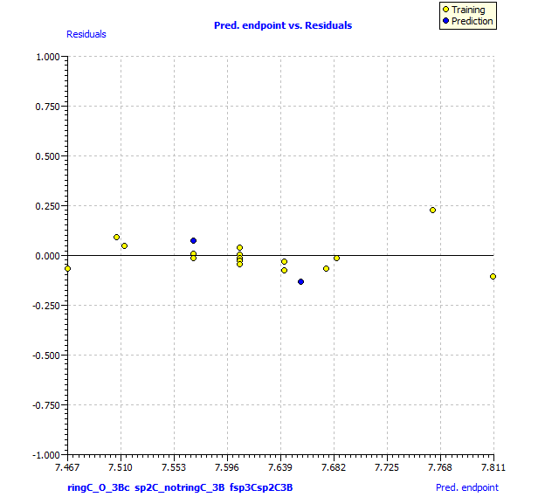
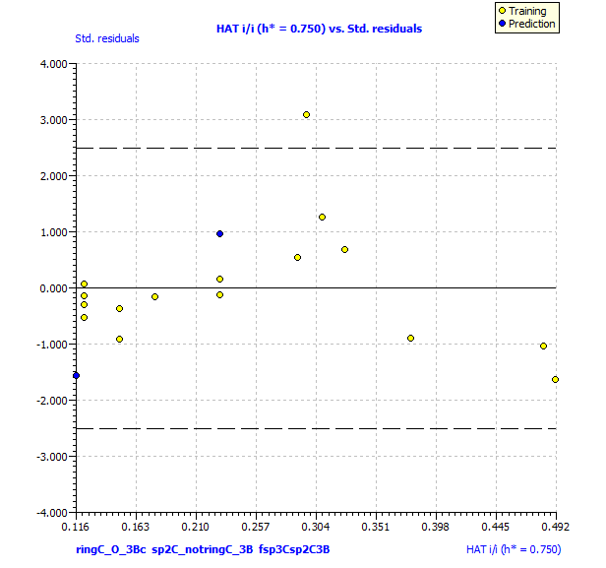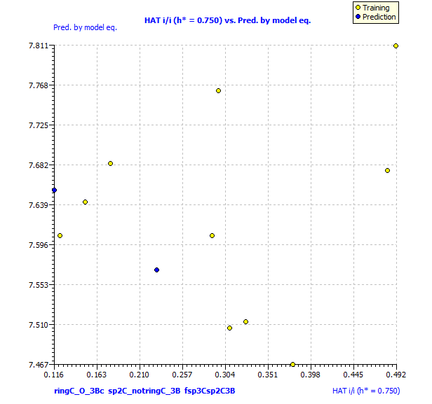

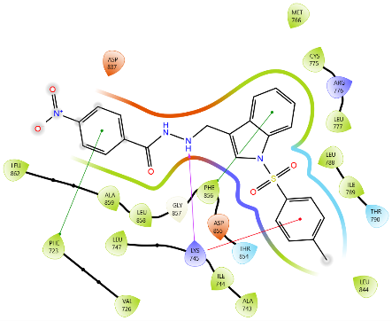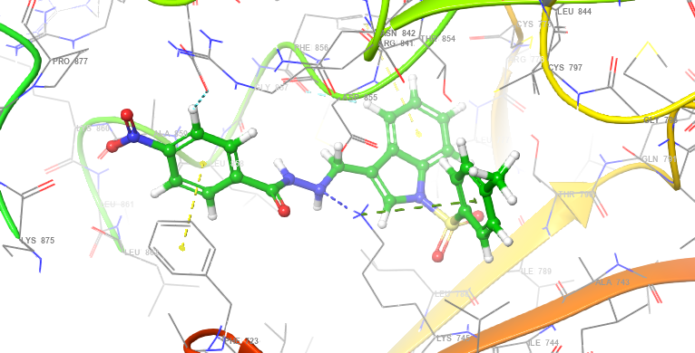

Fig S1: 2D and 3D images of the interaction of protein 3W2S with 5a.
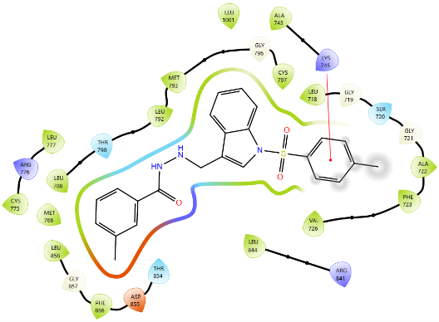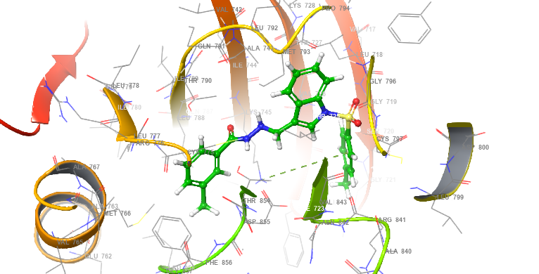

Fig S2: 2D and 3D images of the interaction of protein 3W2S with 5b.
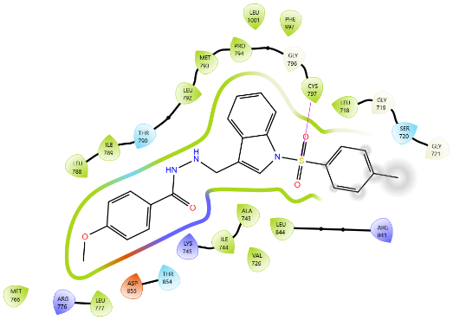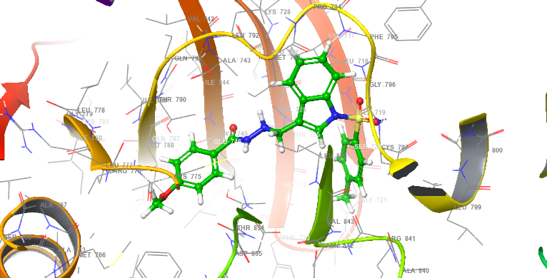

Fig S3: 2D and 3D images of the interaction of protein 3W2S with 5c.

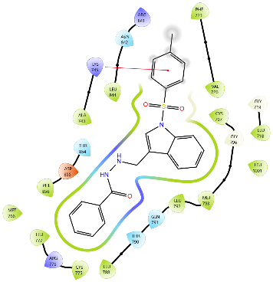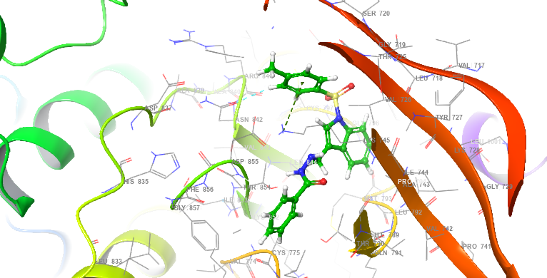

Fig S4: 2D and 3D images of the interaction of protein 3W2S with 5d.
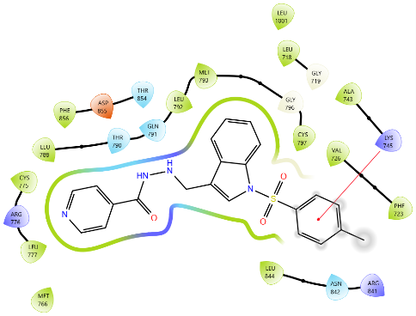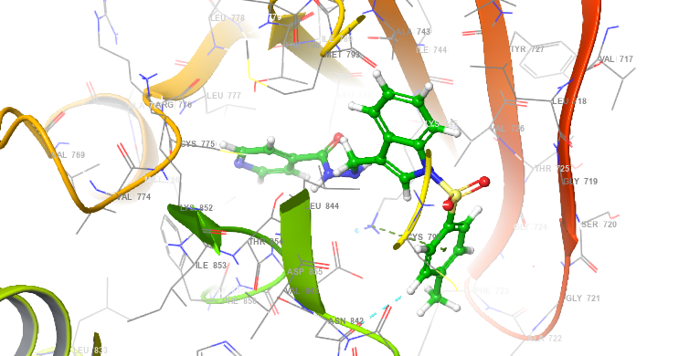

Fig S5: 2D and 3D images of the interaction of protein 3W2S with 5e
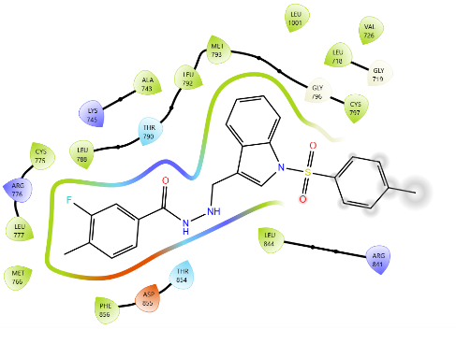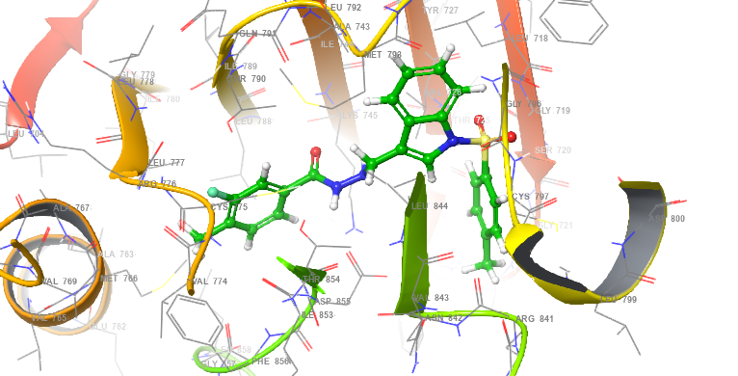

Fig S6: 2D and 3D images of the interaction of protein 3W2S with 5f
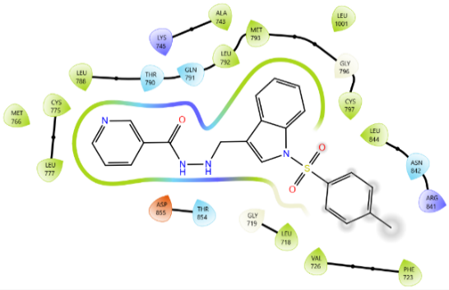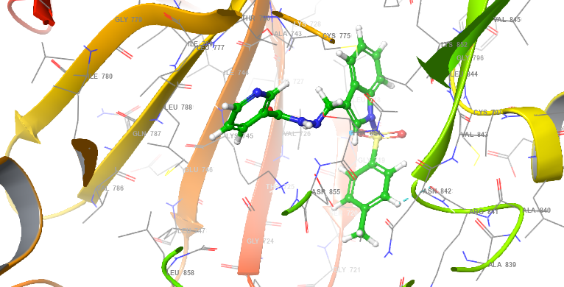

Fig S7: 2D and 3D images of the interaction of protein 3W2S with 5g
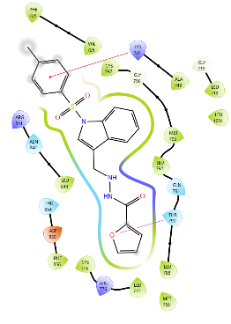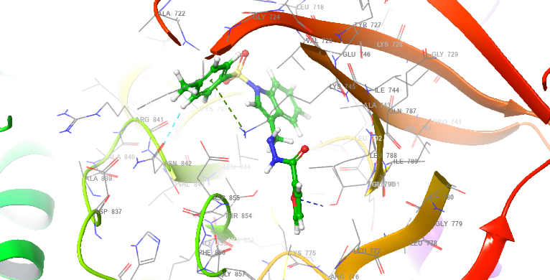

Fig S8: 2D and 3D images of the interaction of protein 3W2S with 5h
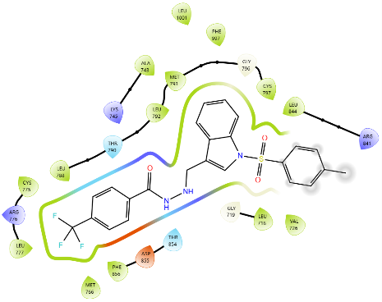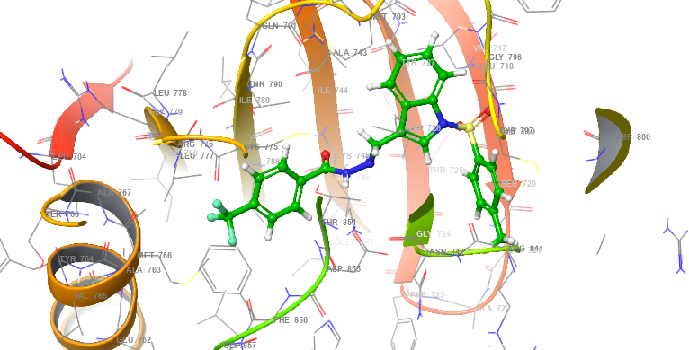

Fig S9: 2D and 3D images of the interaction of protein 3W2S with 5i
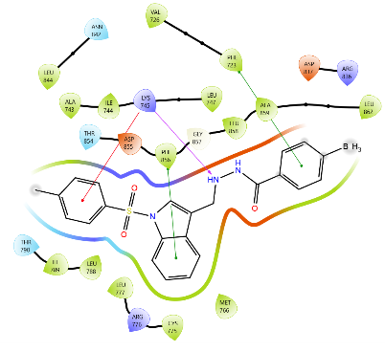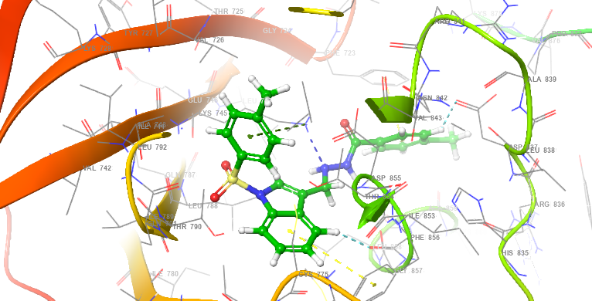

Fig S10: 2D and 3D images of the interaction of protein 3W2S with 5j
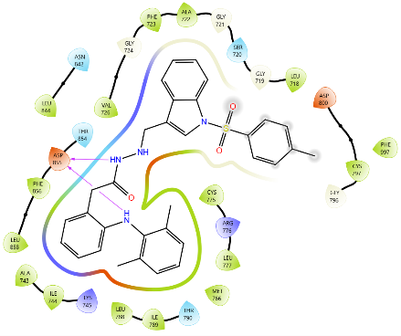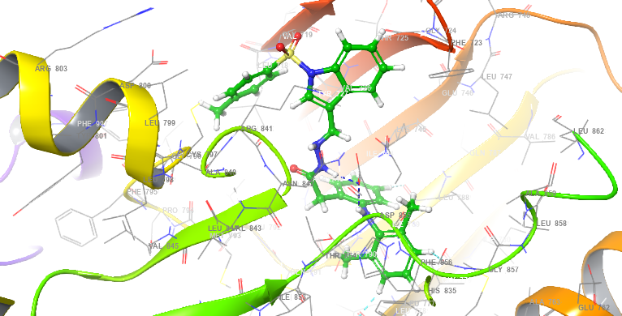

Fig S11: 2D and 3D images of the interaction of protein 3W2S with 5k
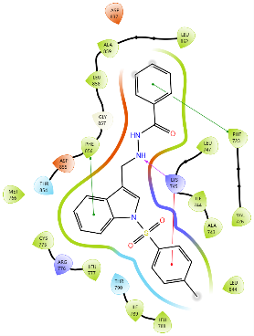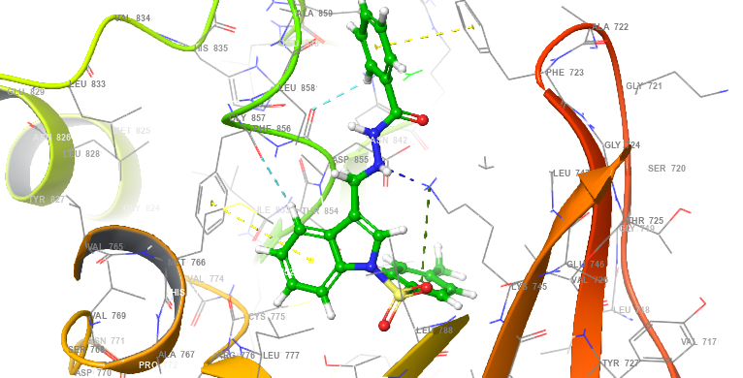

Fig S12: 2D and 3D images of the interaction of protein 3W2S with 5l
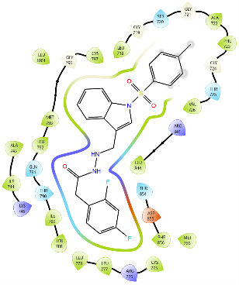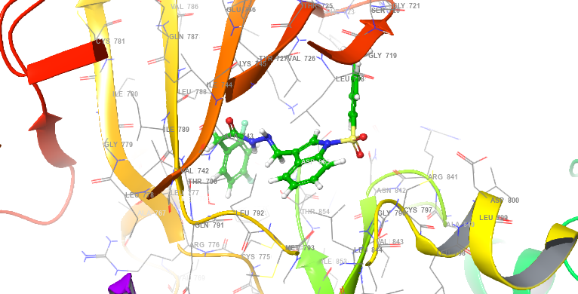

Fig S13: 2D and 3D images of the interaction of protein 3W2S with 5m
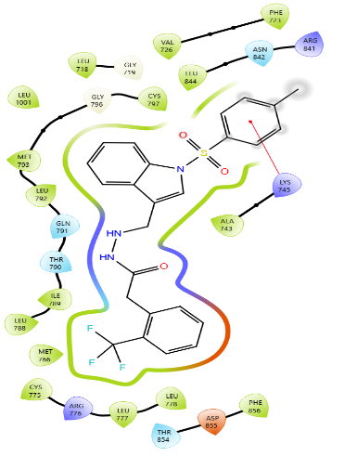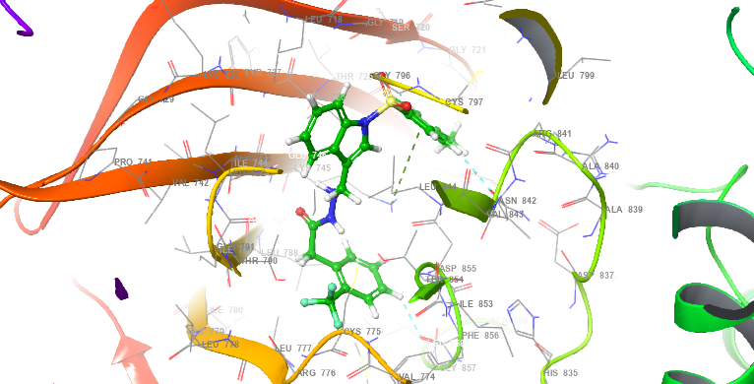

Fig S14: 2D and 3D images of the interaction of protein 3W2S with 5n
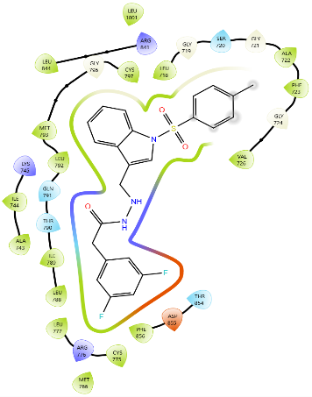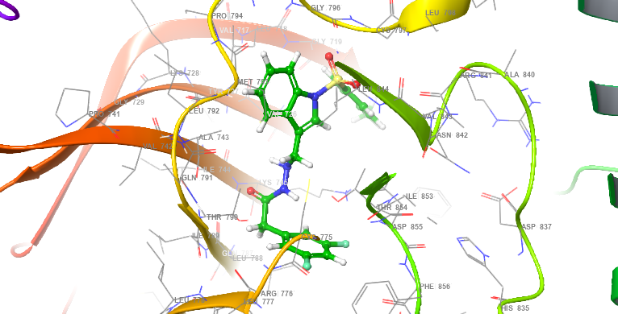

Fig S15: 2D and 3D images of the interaction of protein 3W2S with 5o
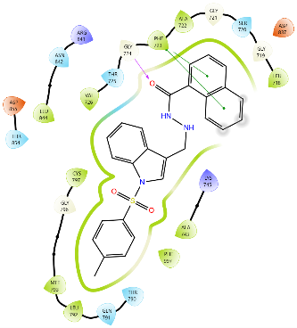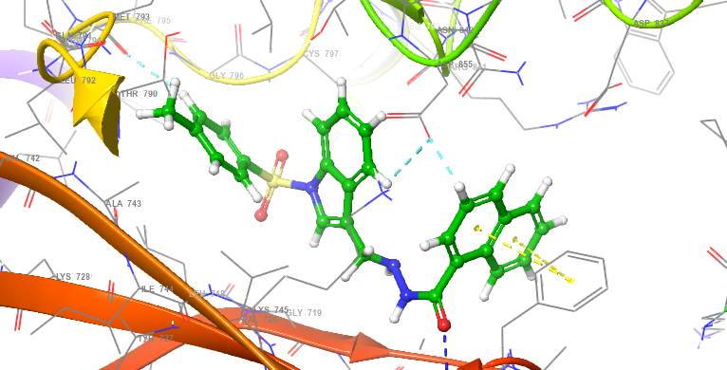

Fig S16: 2D and 3D images of the interaction of protein 3W2S with 5p
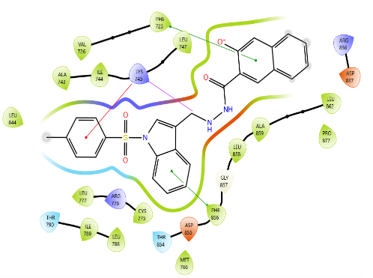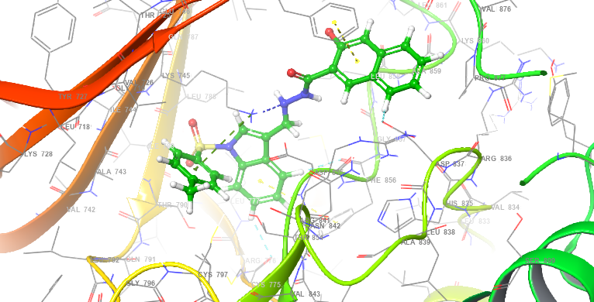

Fig S17: 2D and 3D images of the interaction of protein 3W2S with 5q
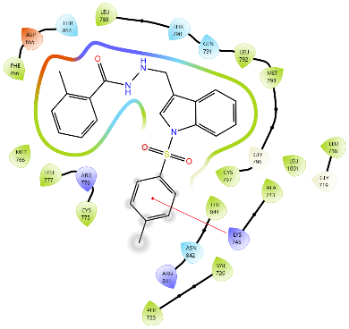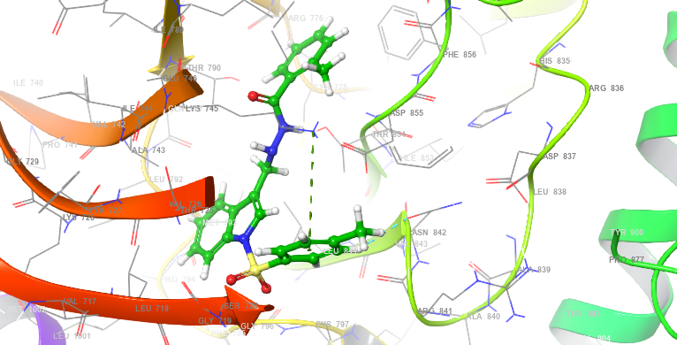

Fig S18: 2D and 3D images of the interaction of protein 3W2S with 5r
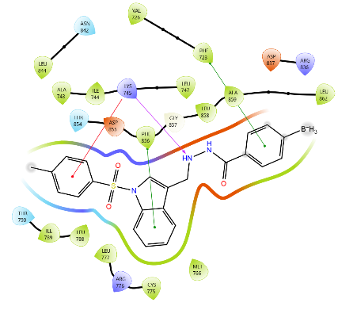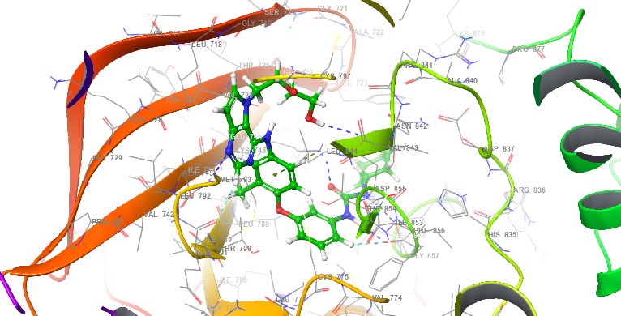

Fig S19: 2D and 3D images of the interaction of protein 3W2S with W2R

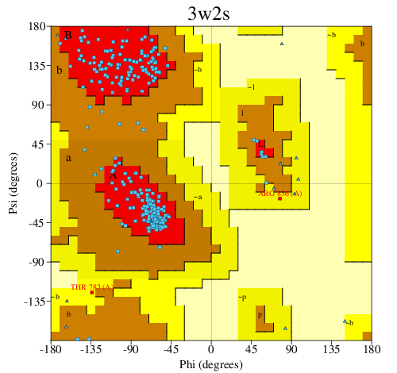
Figure S20: Ramachandran Plot 3W2S obtained from PROCHECK server

¹H NMR and ¹³C NMR Spectra of 5a
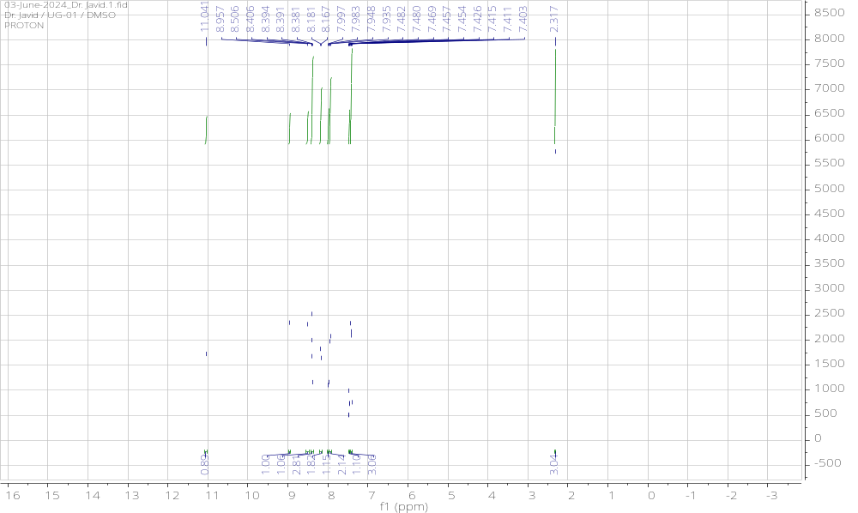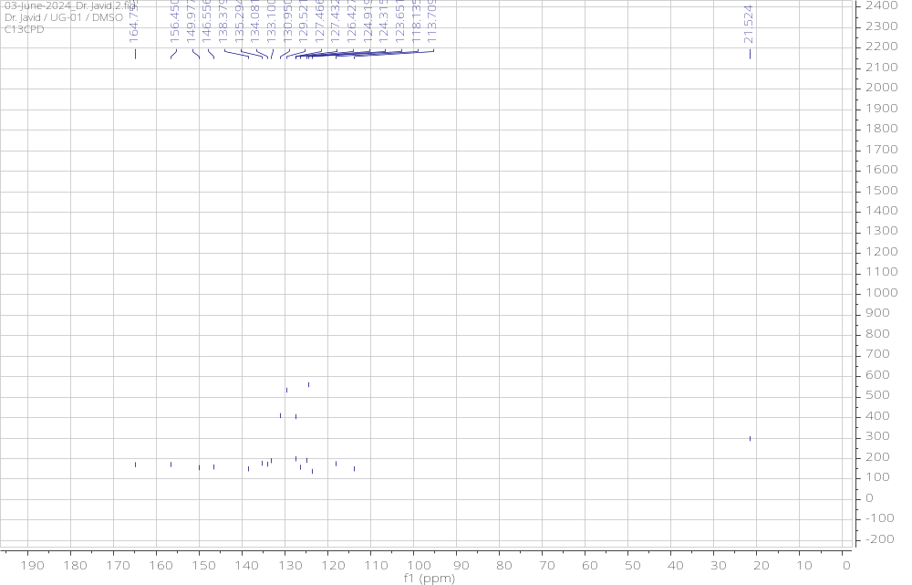

¹H NMR and ¹³C NMR Spectra of 5b
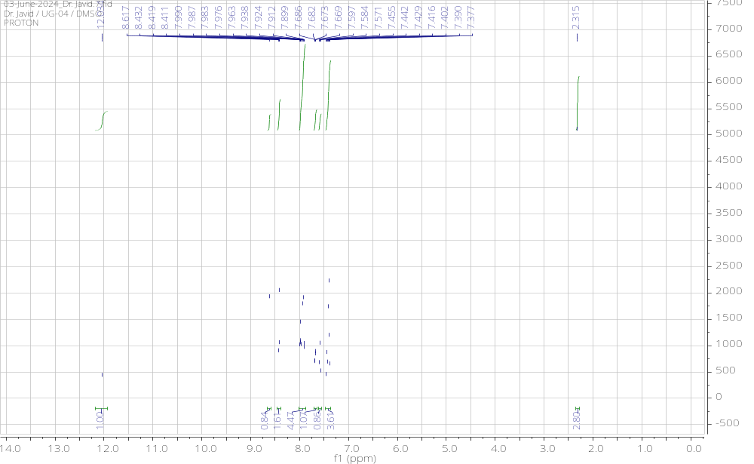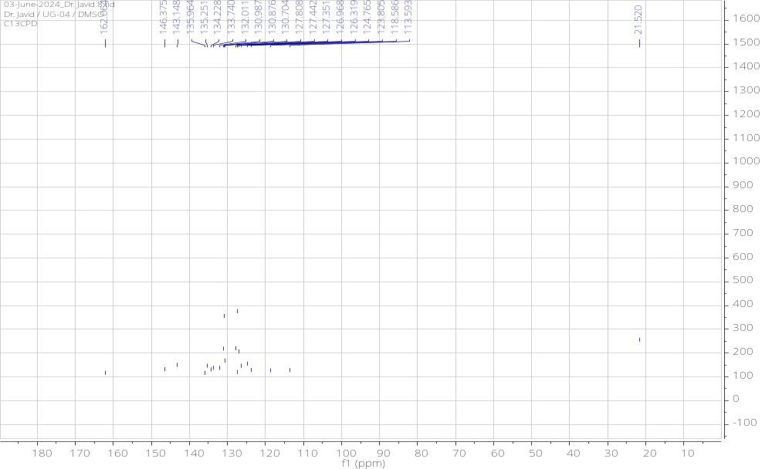

¹H NMR and ¹³C NMR Spectra of 5c
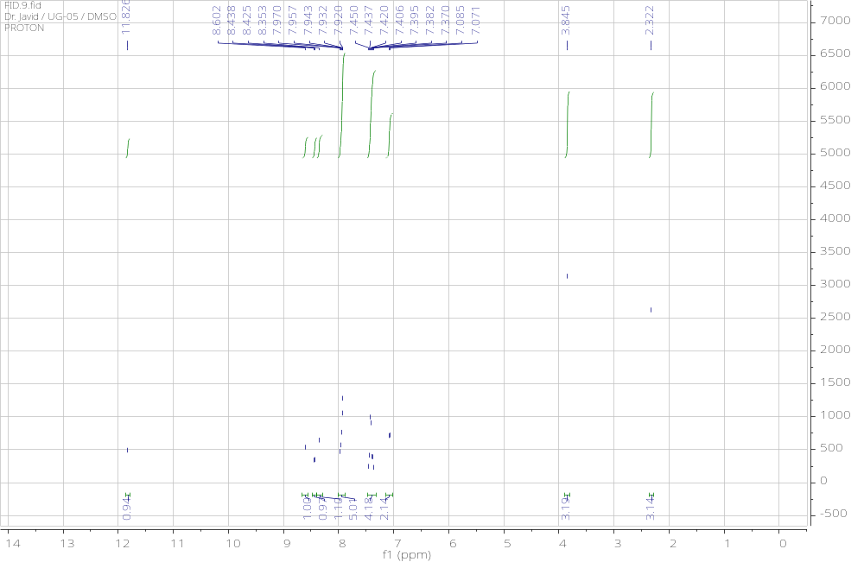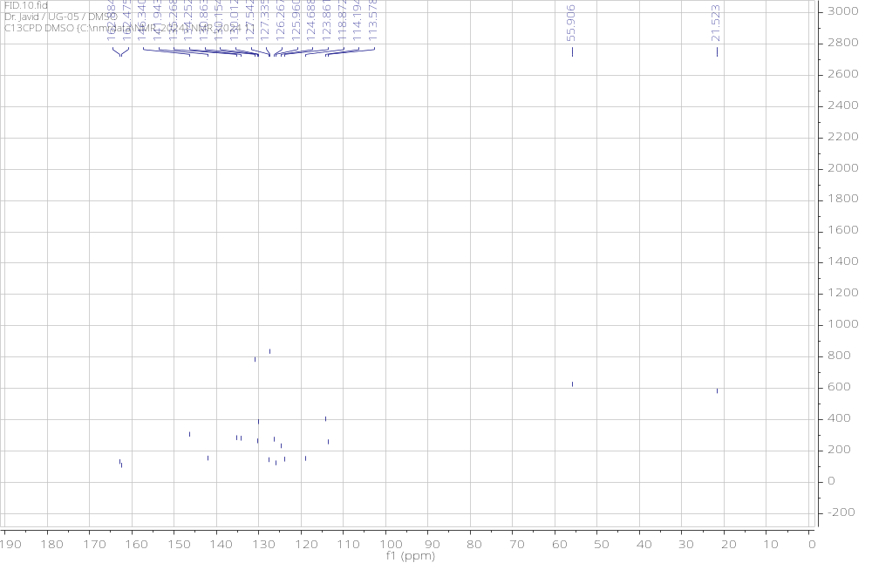

¹H NMR and ¹³C NMR Spectra of 5d
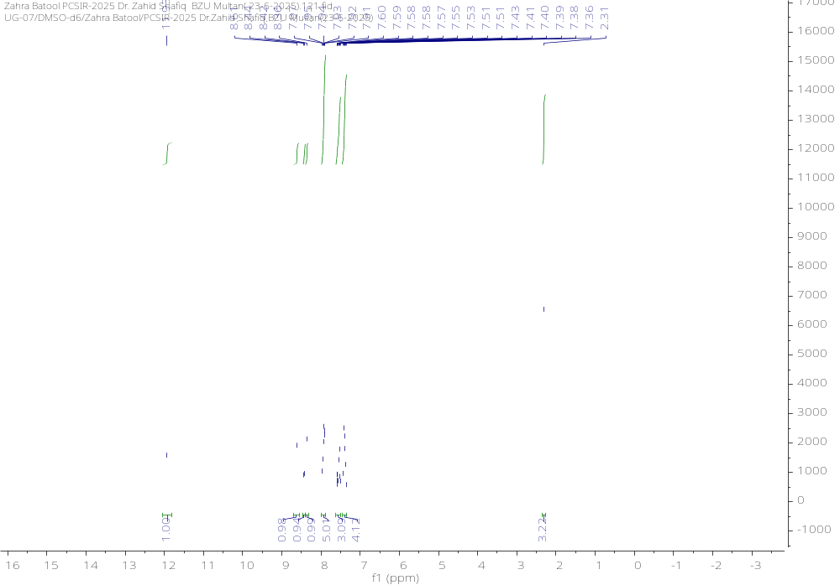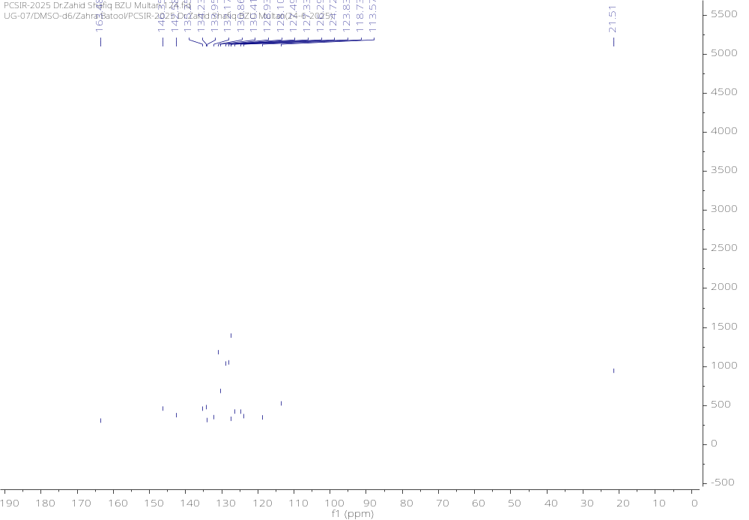

¹H NMR and ¹³C NMR Spectra of 5e
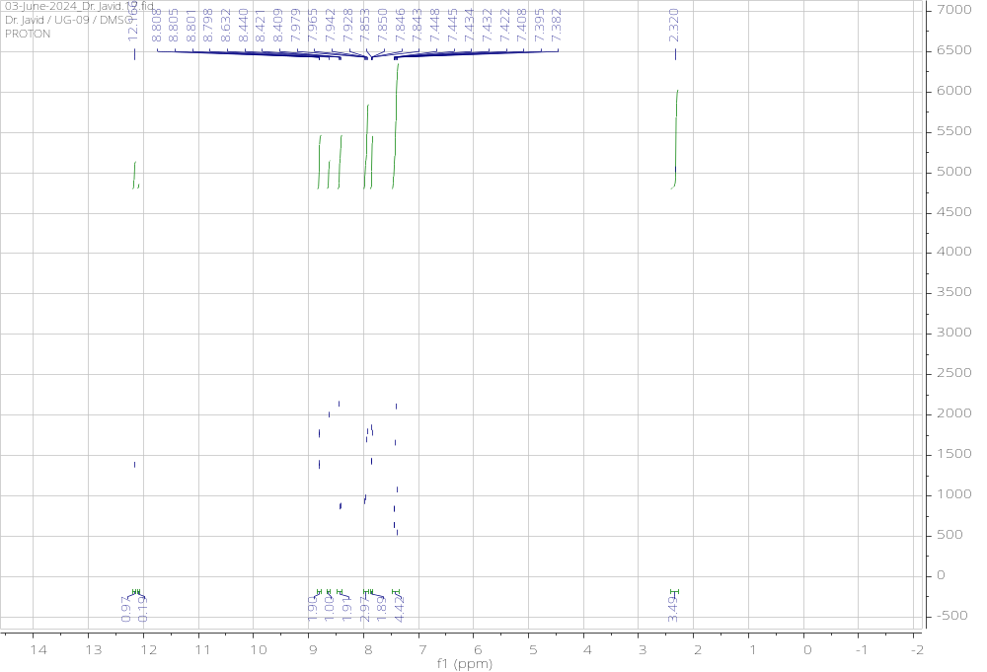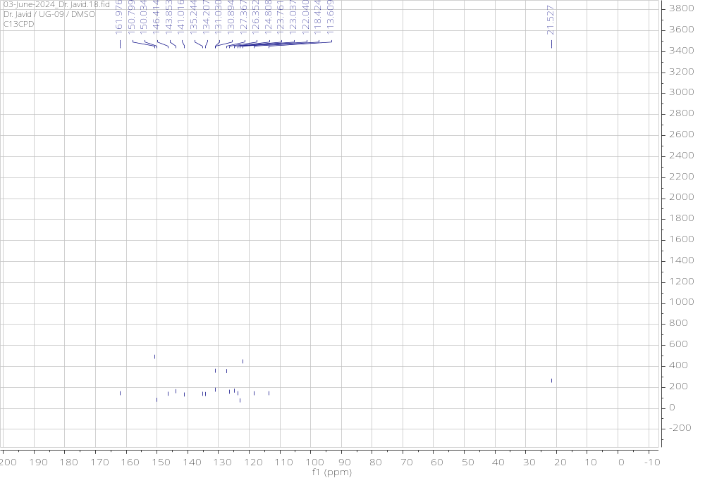

¹H NMR and ¹³C NMR Spectra of 5f
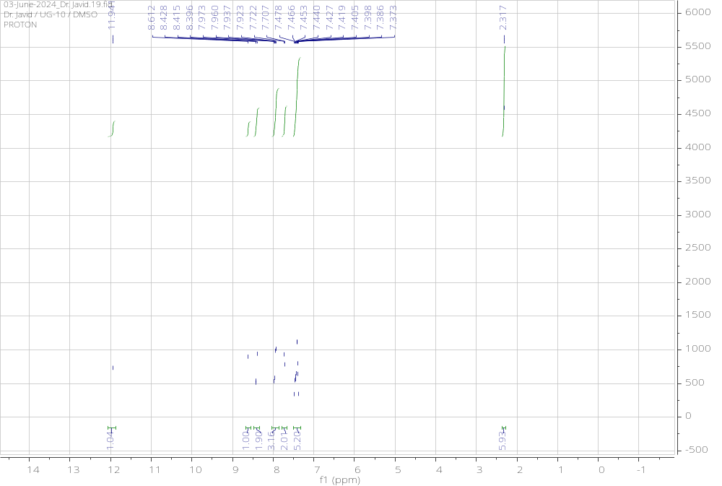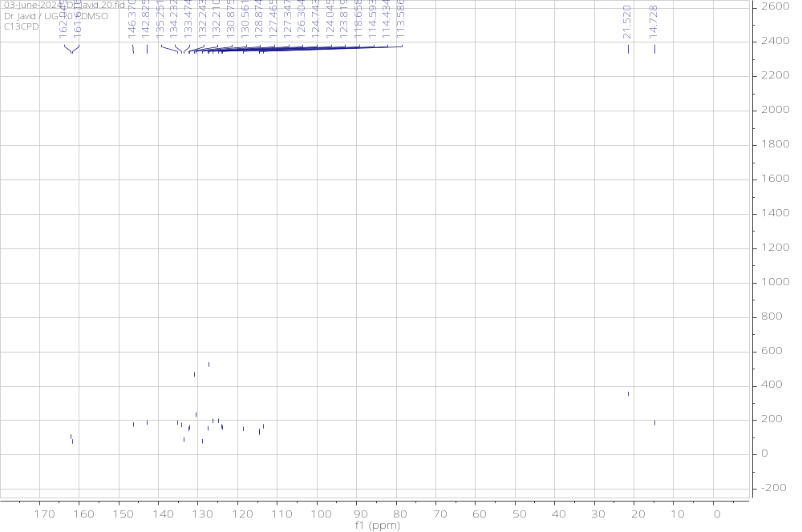

¹H NMR and ¹³C NMR Spectra of 5g
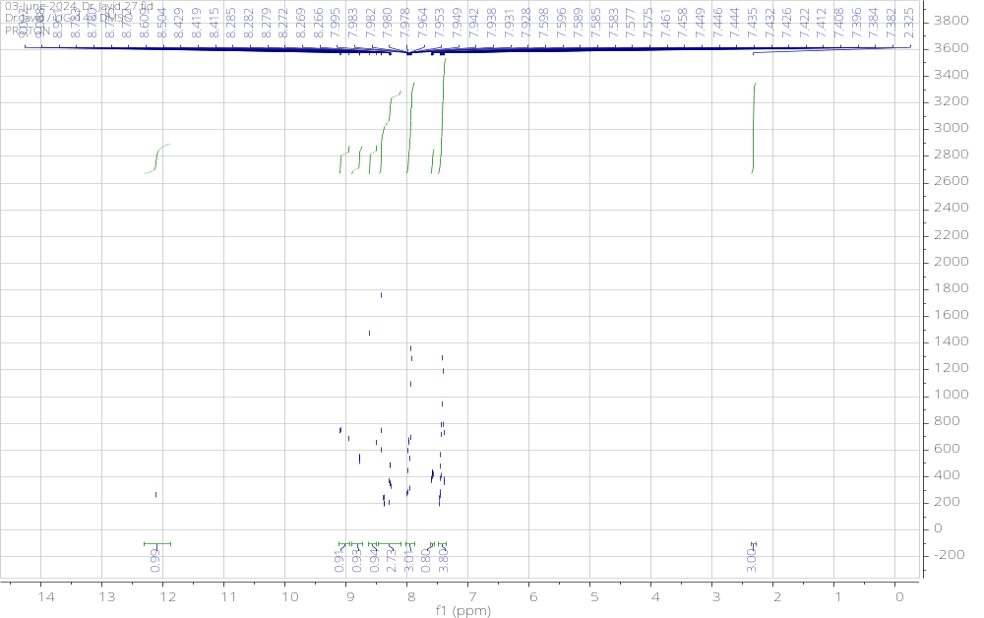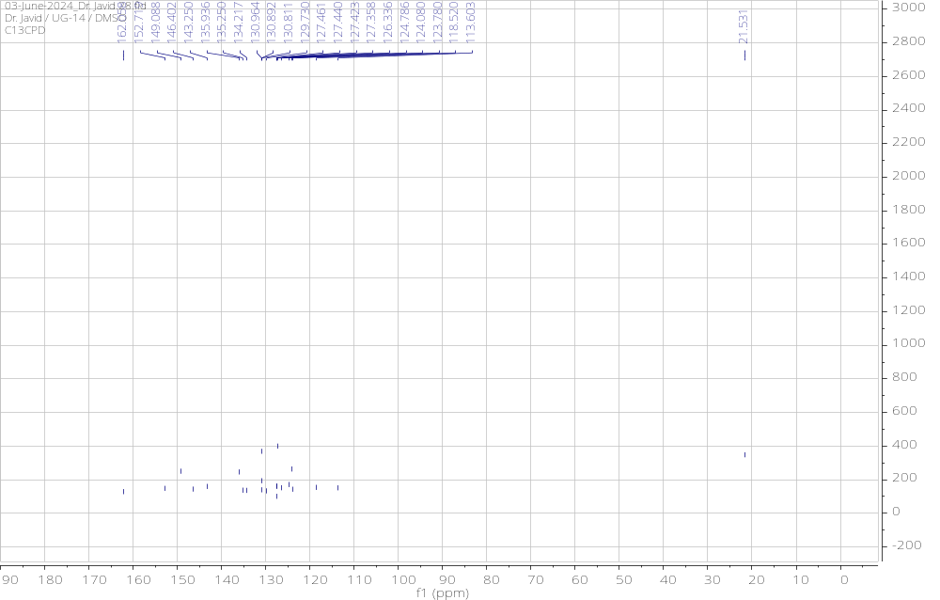

¹H NMR and ¹³C NMR Spectra of 5h
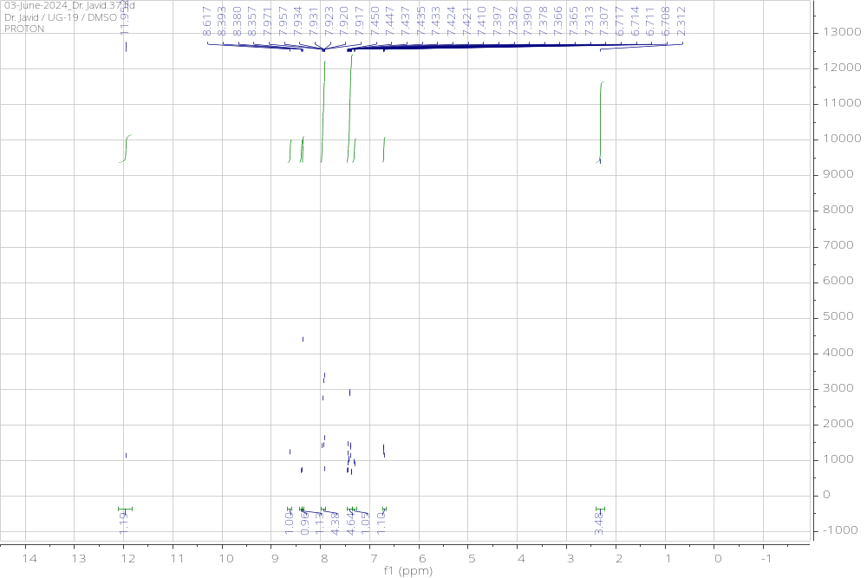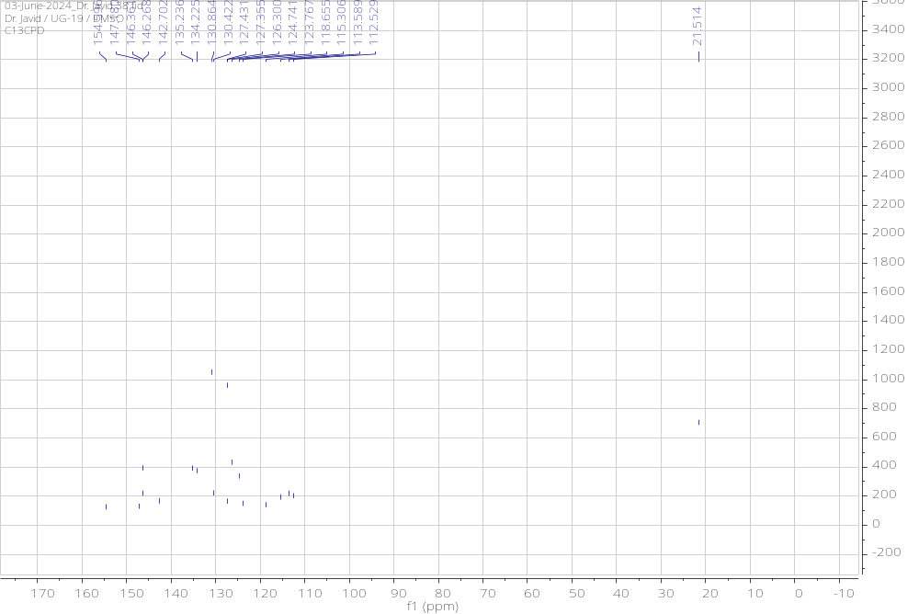

¹H NMR and ¹³C NMR Spectra of 5i
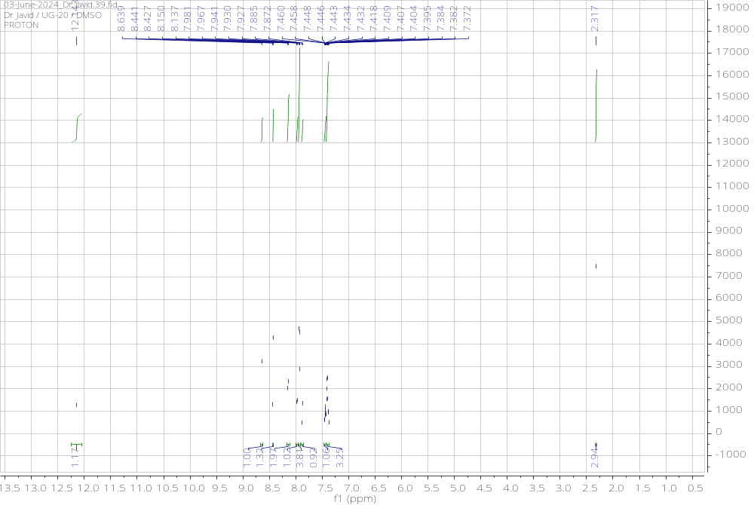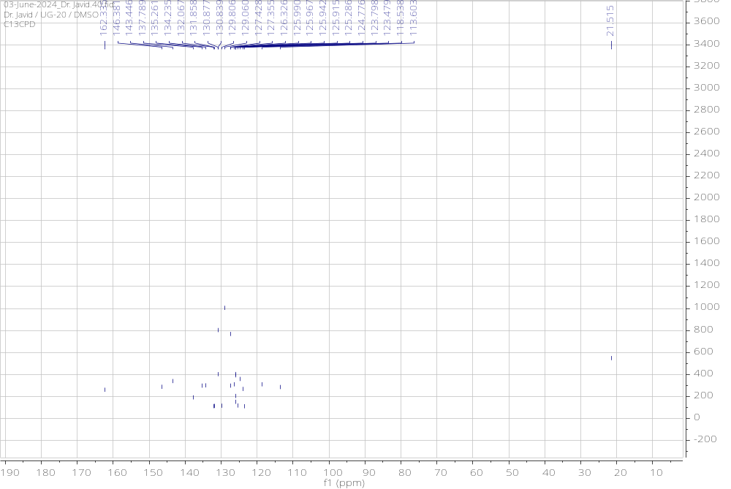

¹H NMR and ¹³C NMR Spectra of 5j
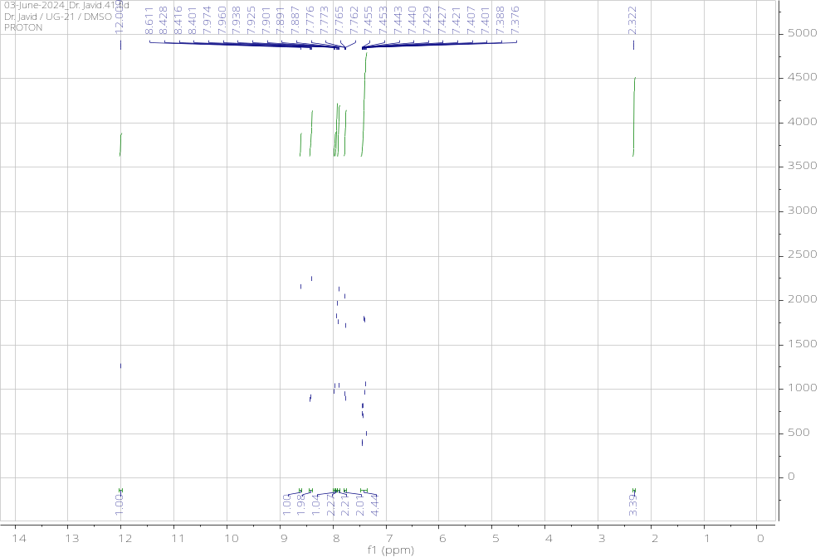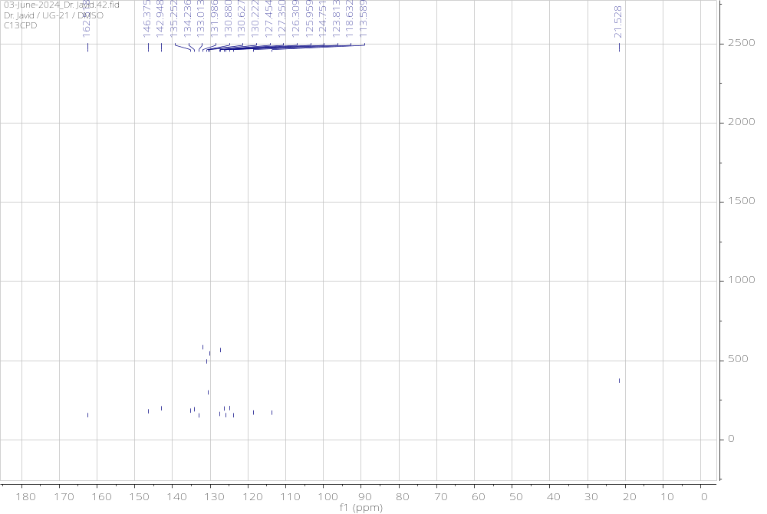

¹H NMR and ¹³C NMR Spectra of 5k
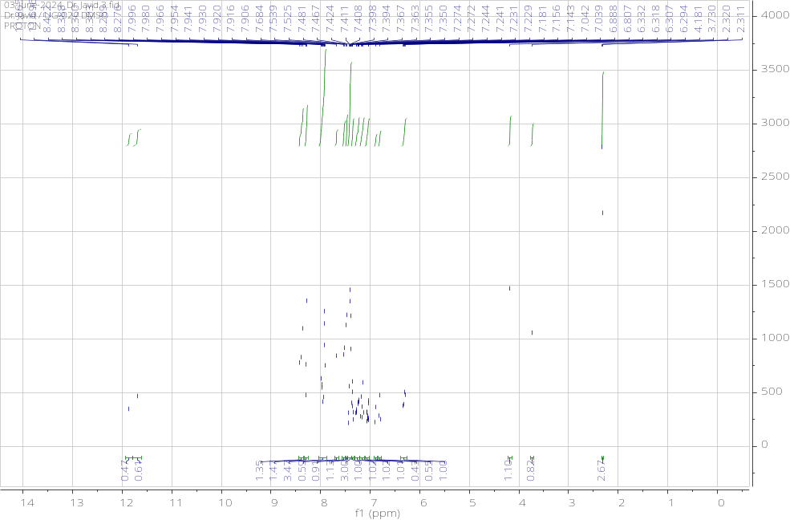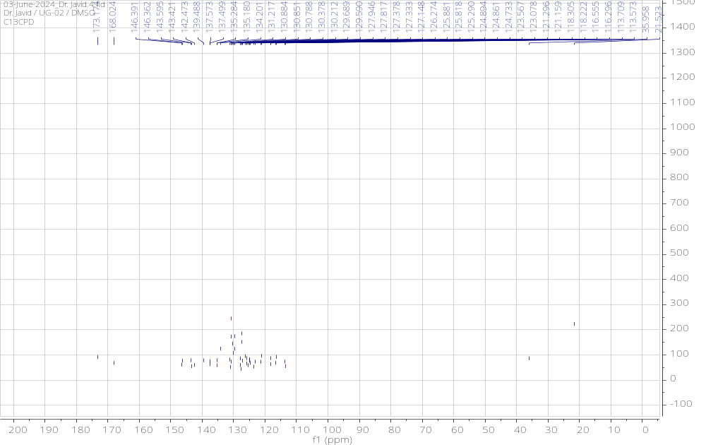

¹H NMR and ¹³C NMR Spectra of 5l
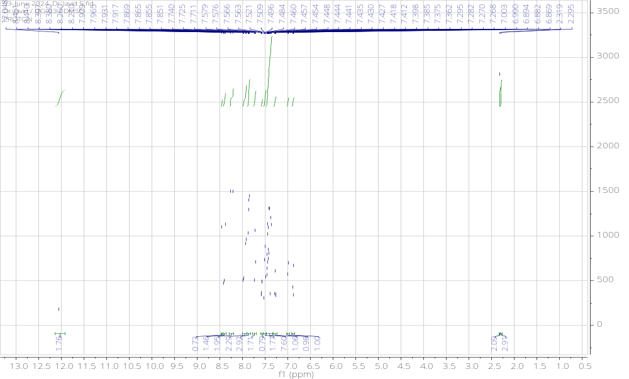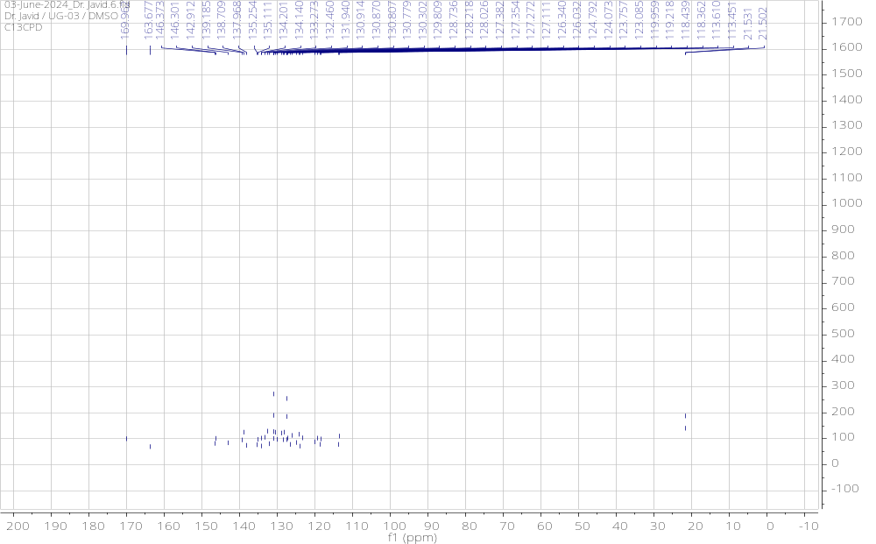

¹H NMR and ¹³C NMR Spectra of 5m
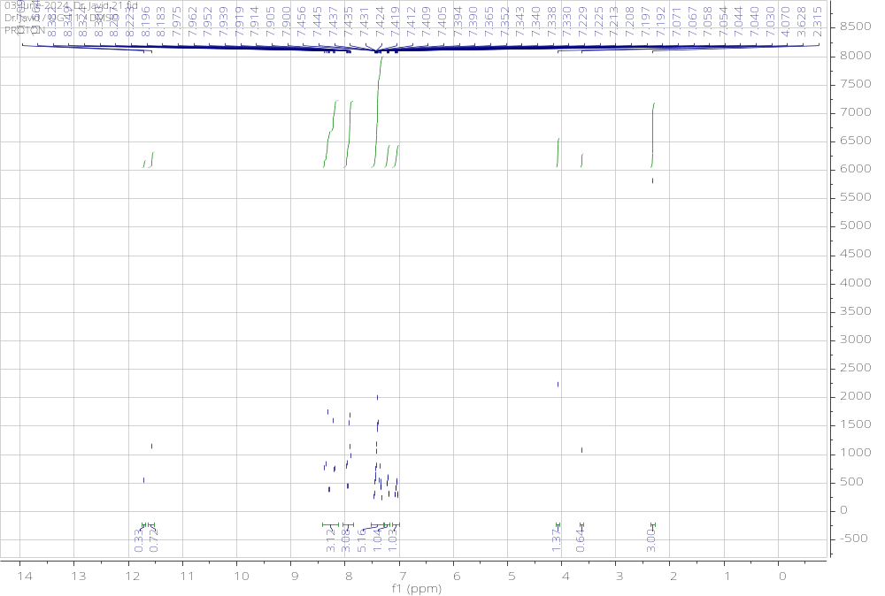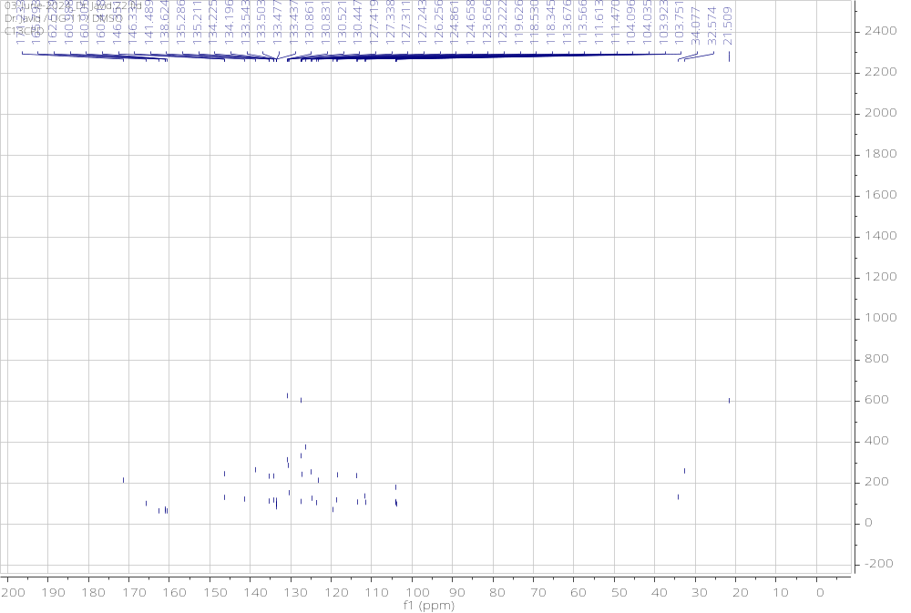

¹H NMR and ¹³C NMR Spectra of 5n
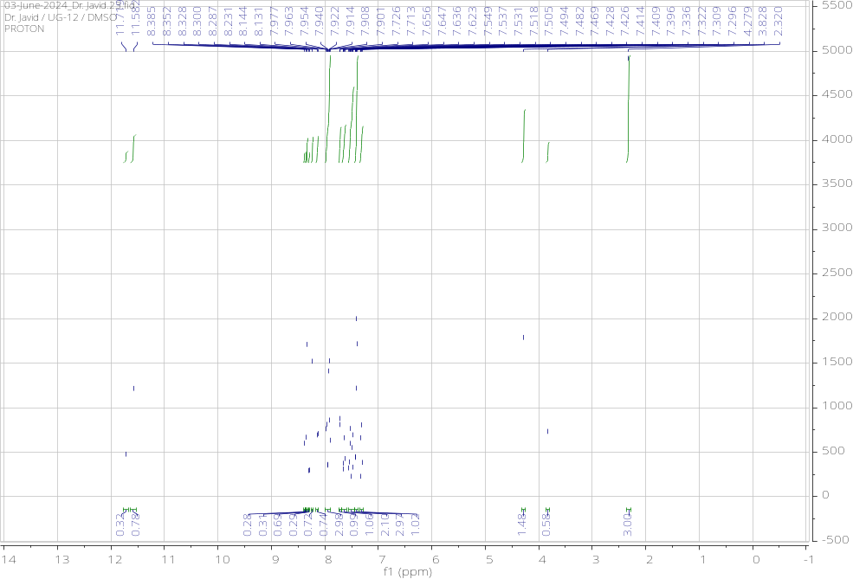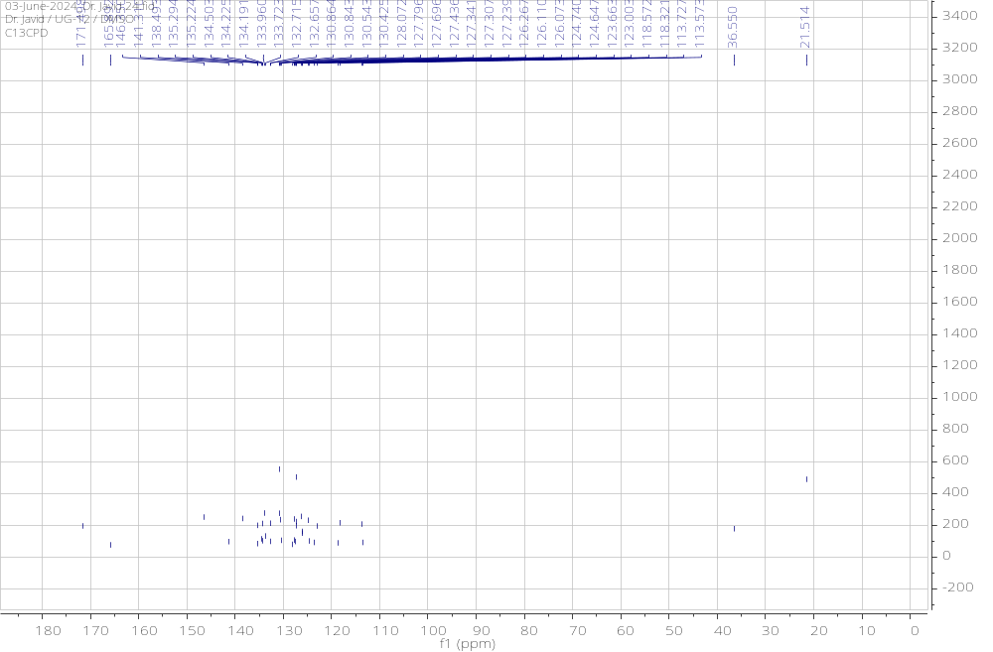

¹H NMR and ¹³C NMR Spectra of 5o
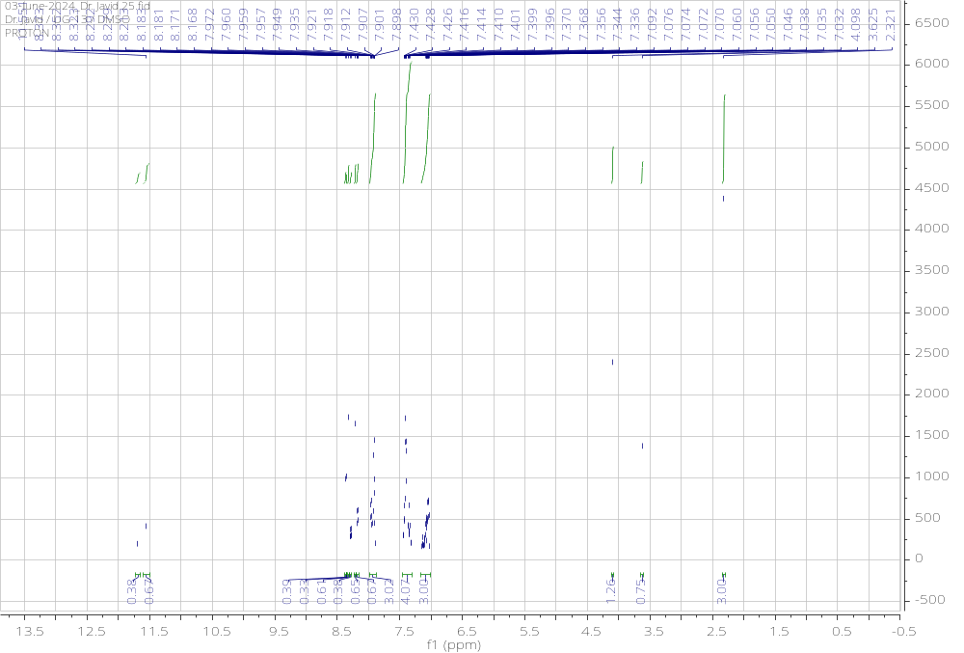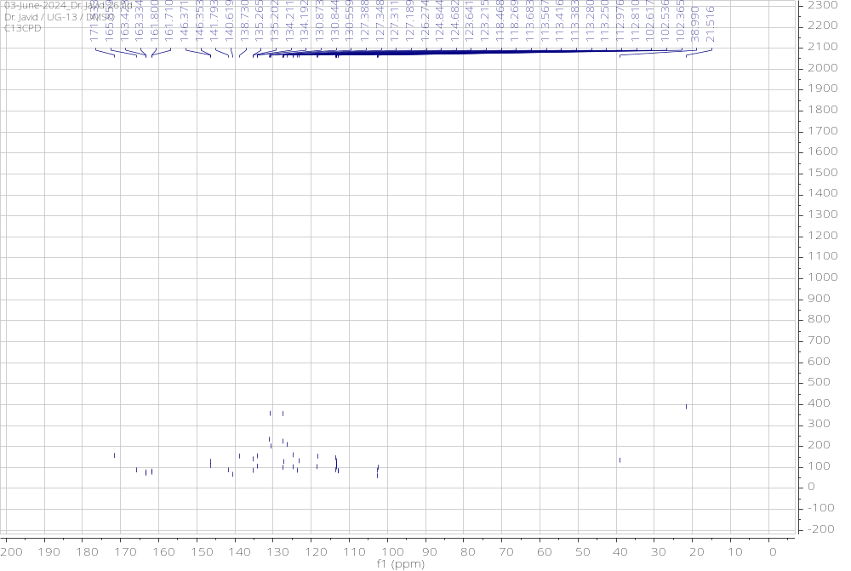

¹H NMR and ¹³C NMR Spectra of 5p
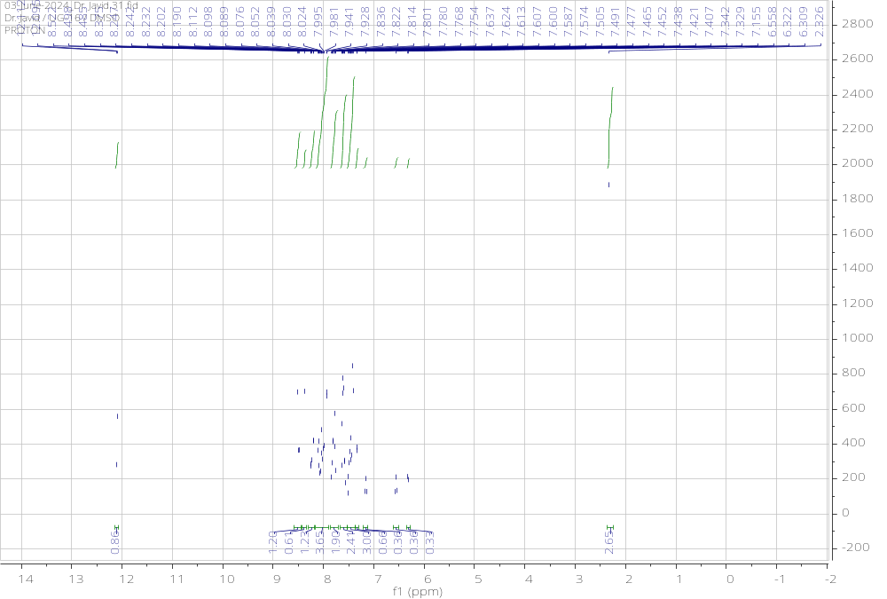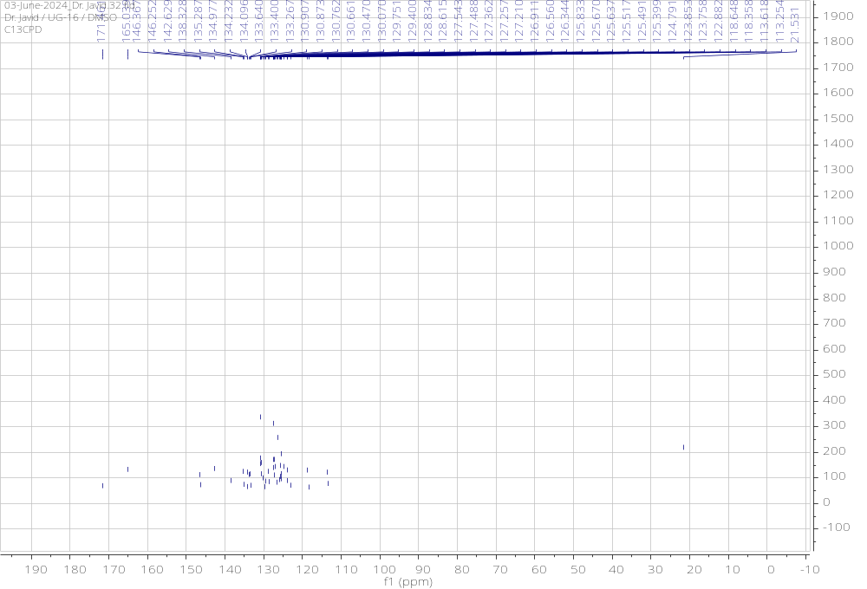

¹H NMR and ¹³C NMR Spectra of 5q
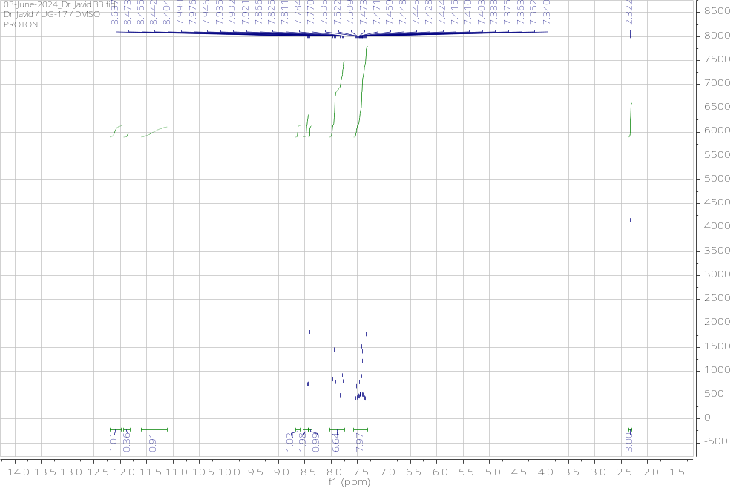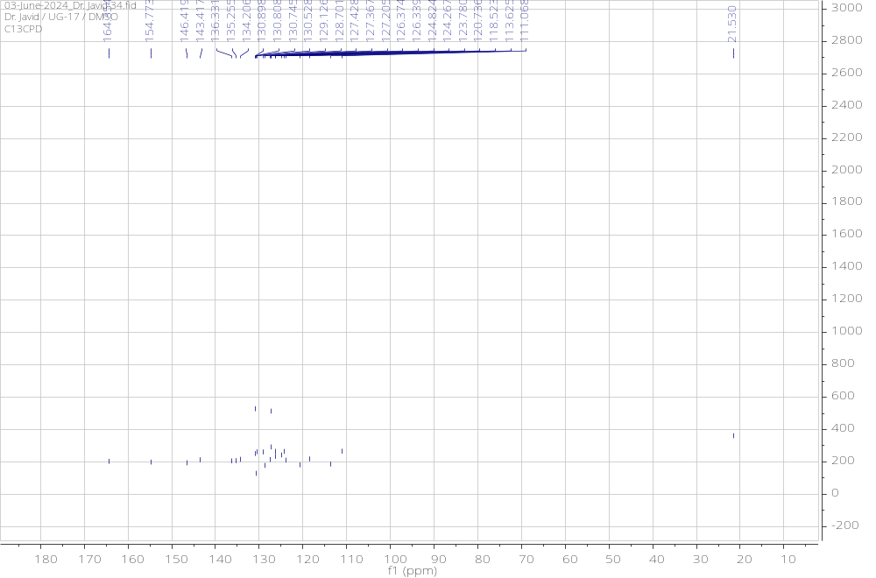

¹H NMR and ¹³C NMR Spectra of 5r
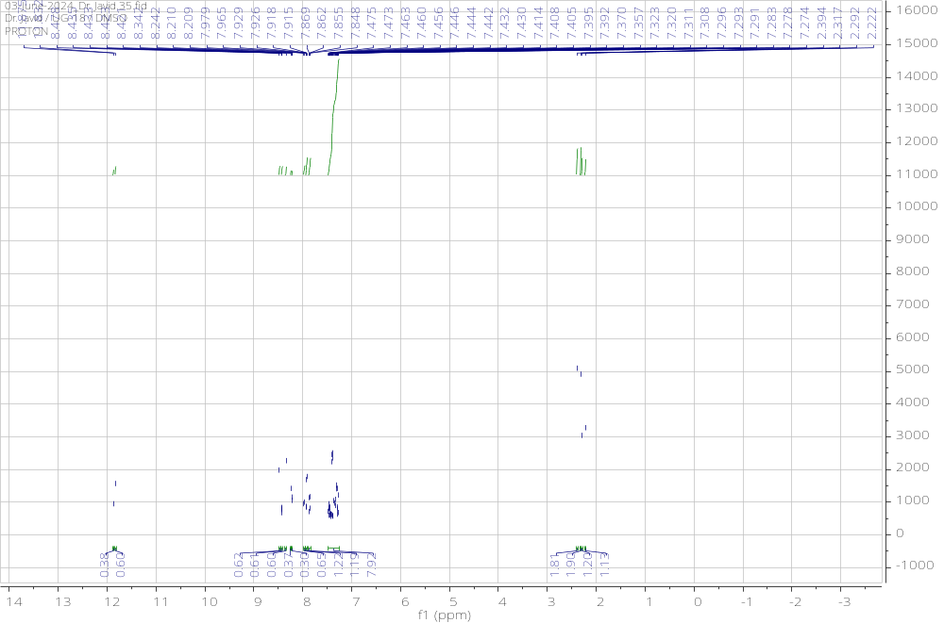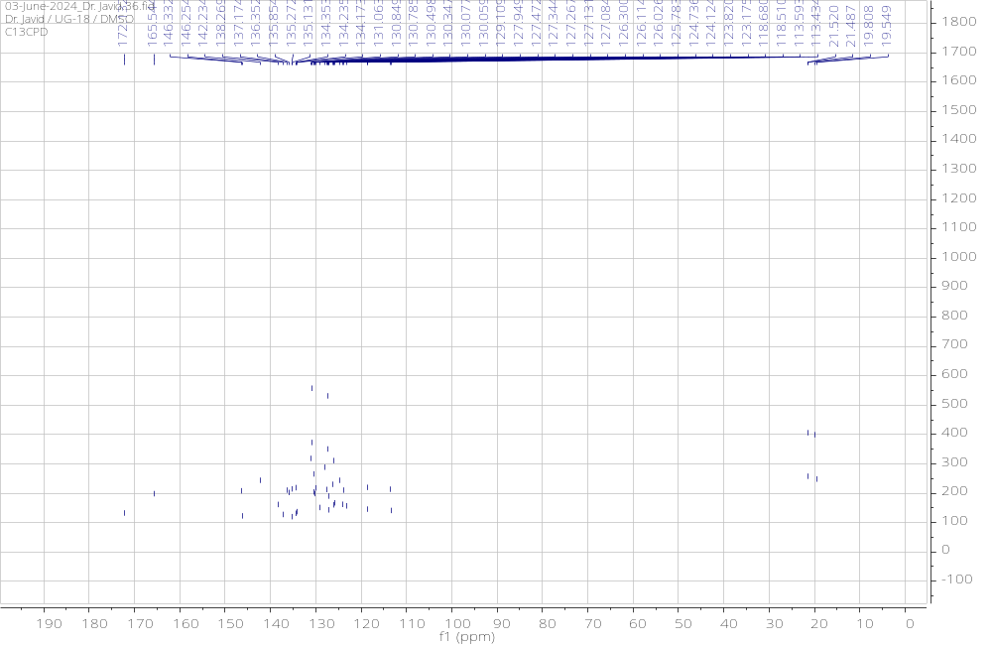

QTOF-HRMS of 5a
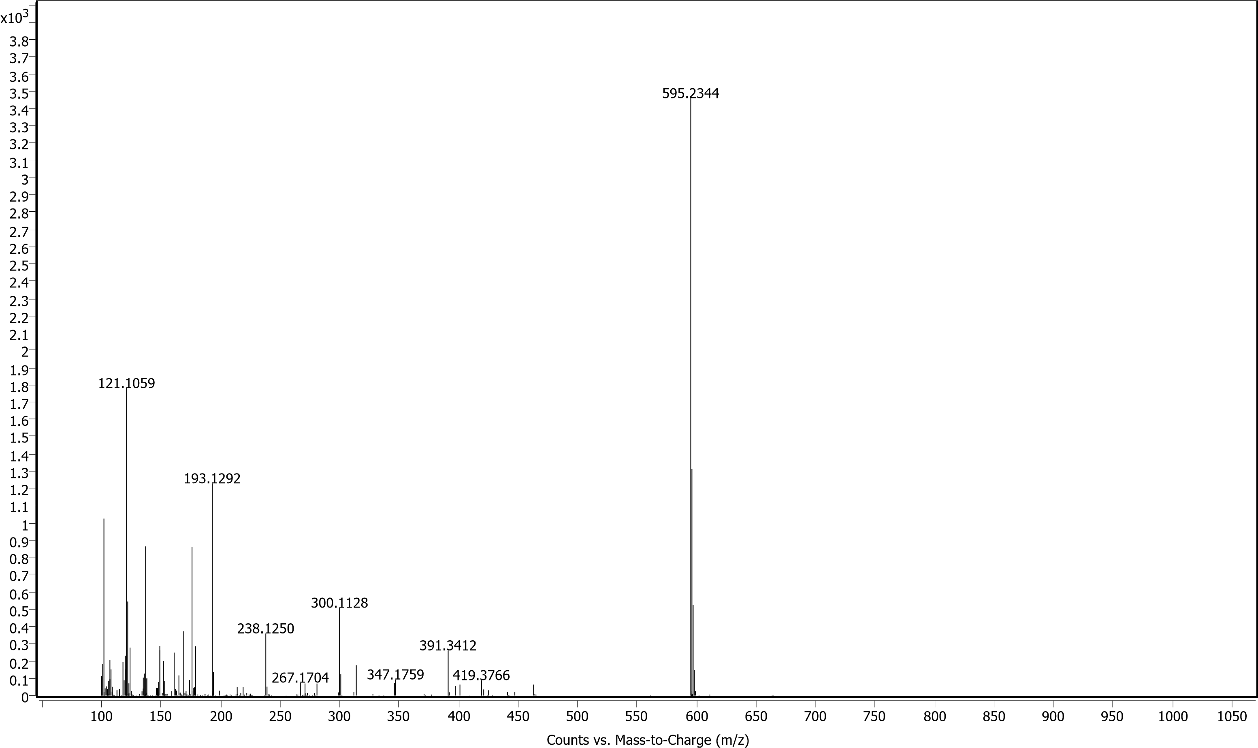
FT-IR of 5a
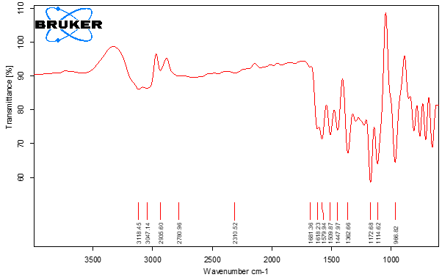
QTOF-HRMS of 5b
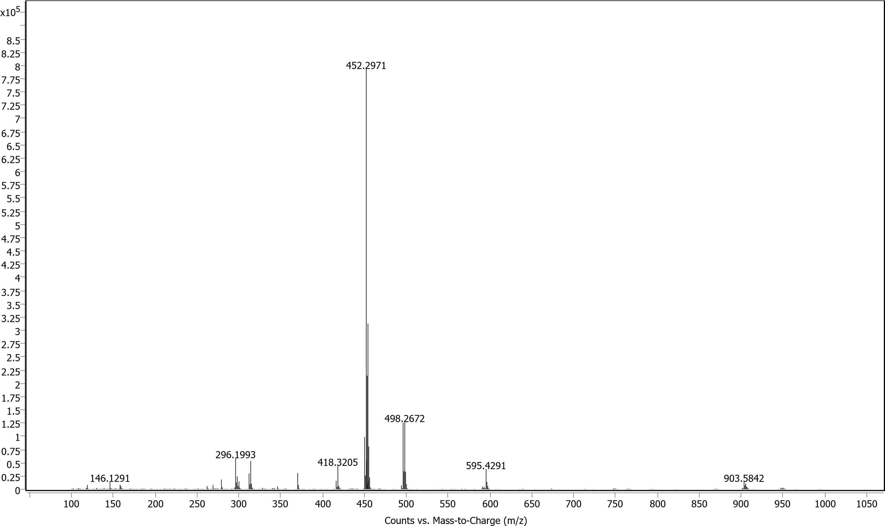
FT-IR of 5b
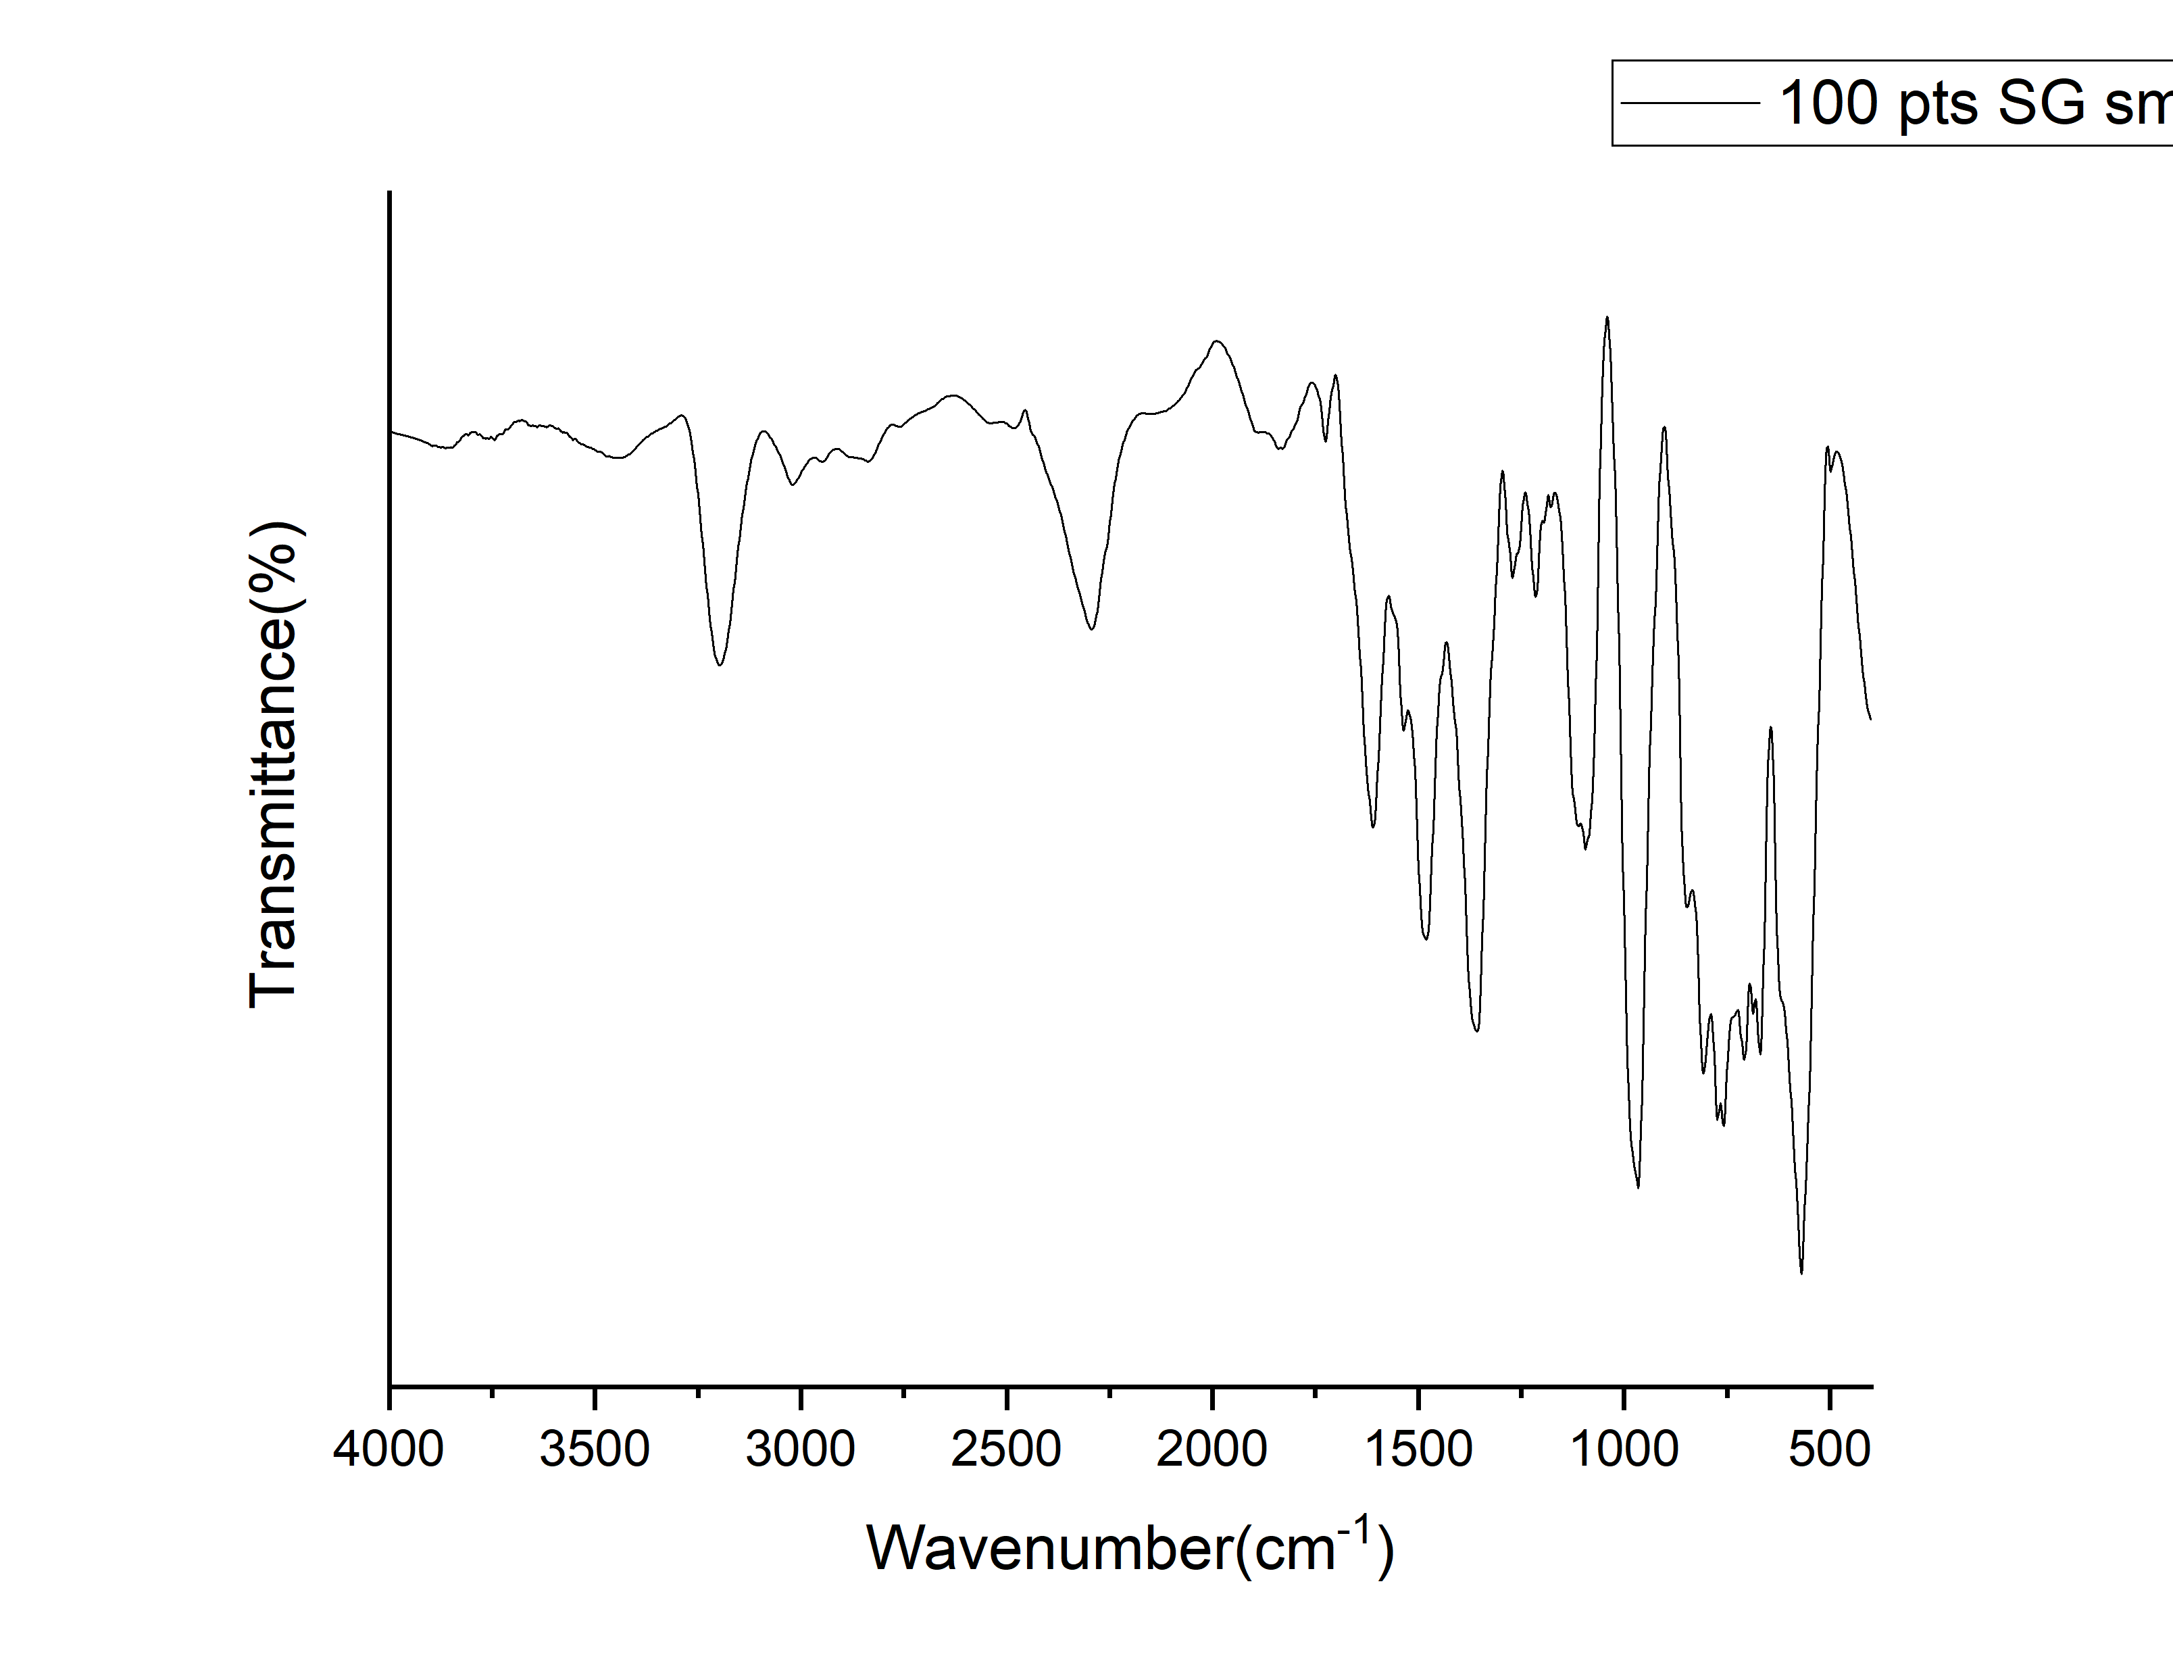
QTOF-HRMS of 5c
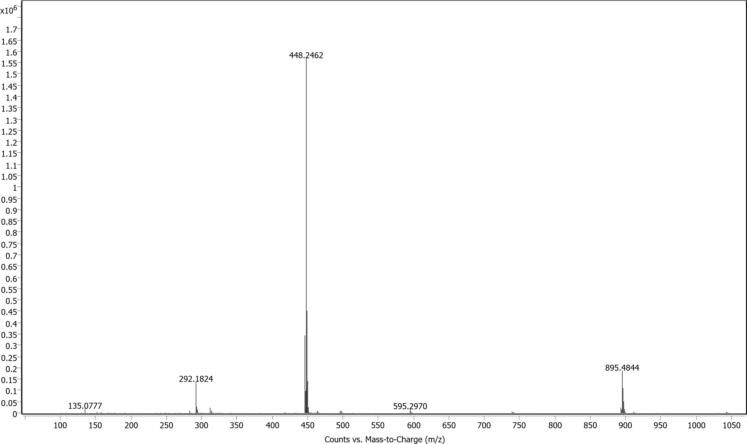
FT-IR of 5c
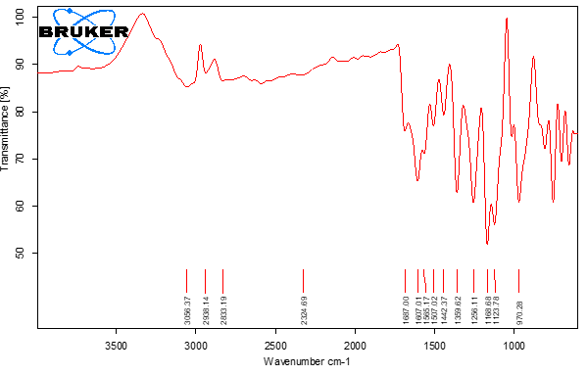
QTOF-HRMS of 5d
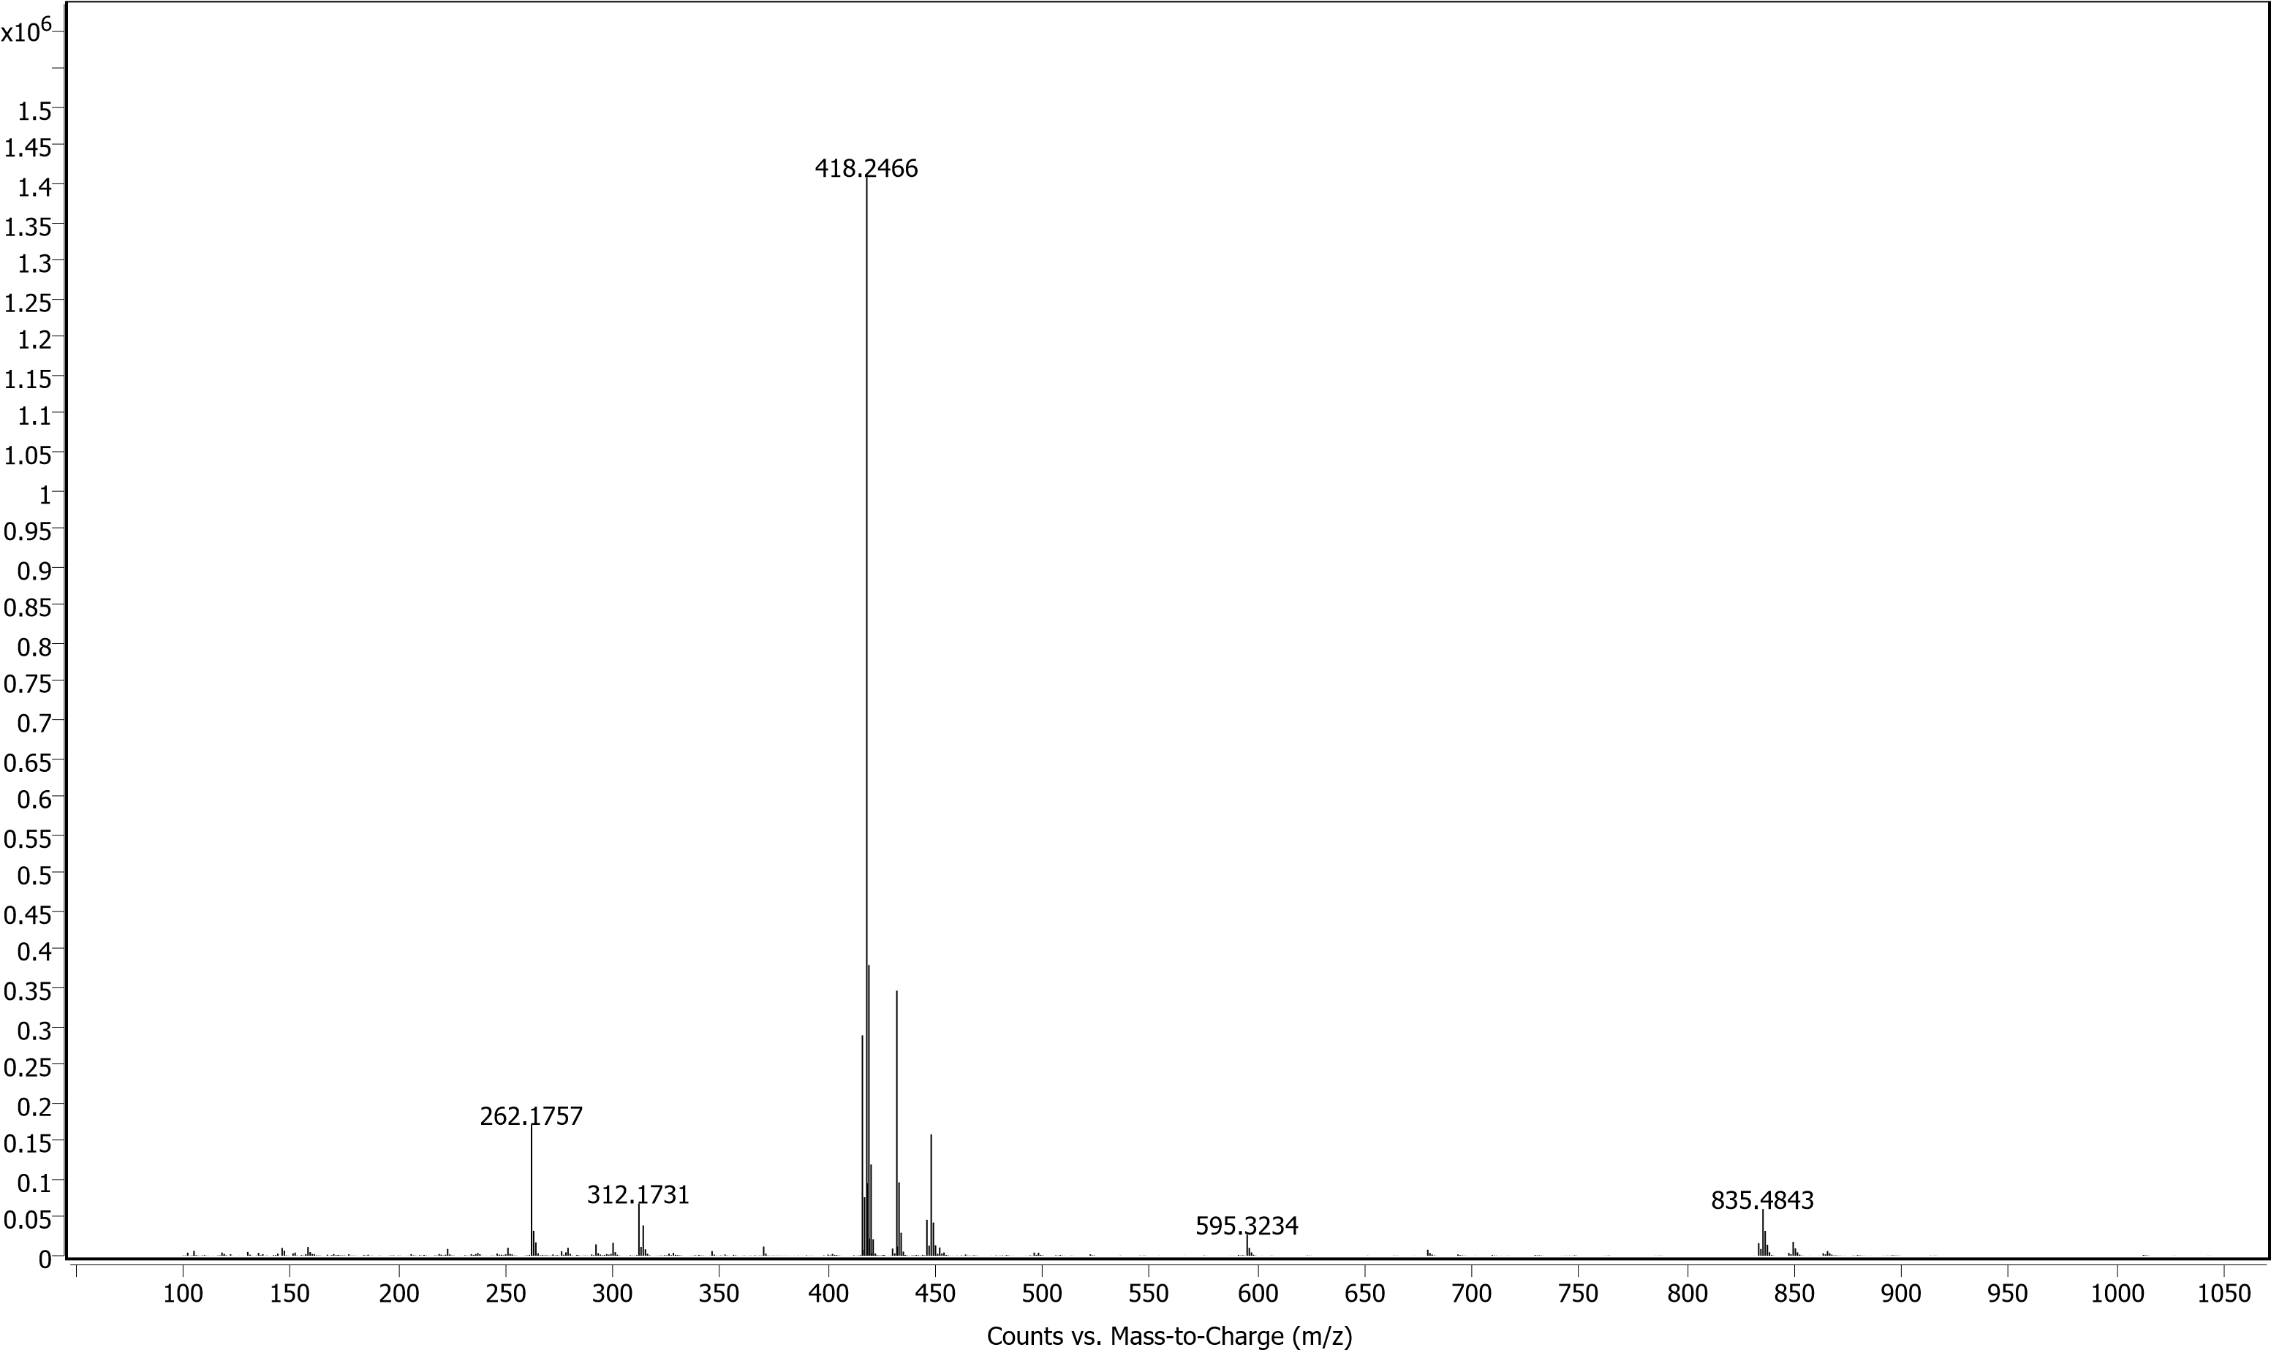
FT-IR of 5d
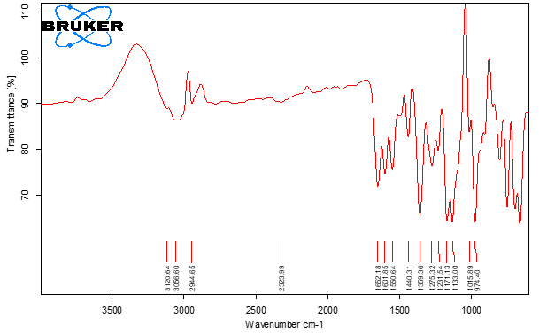
QTOF-HRMS of 5e
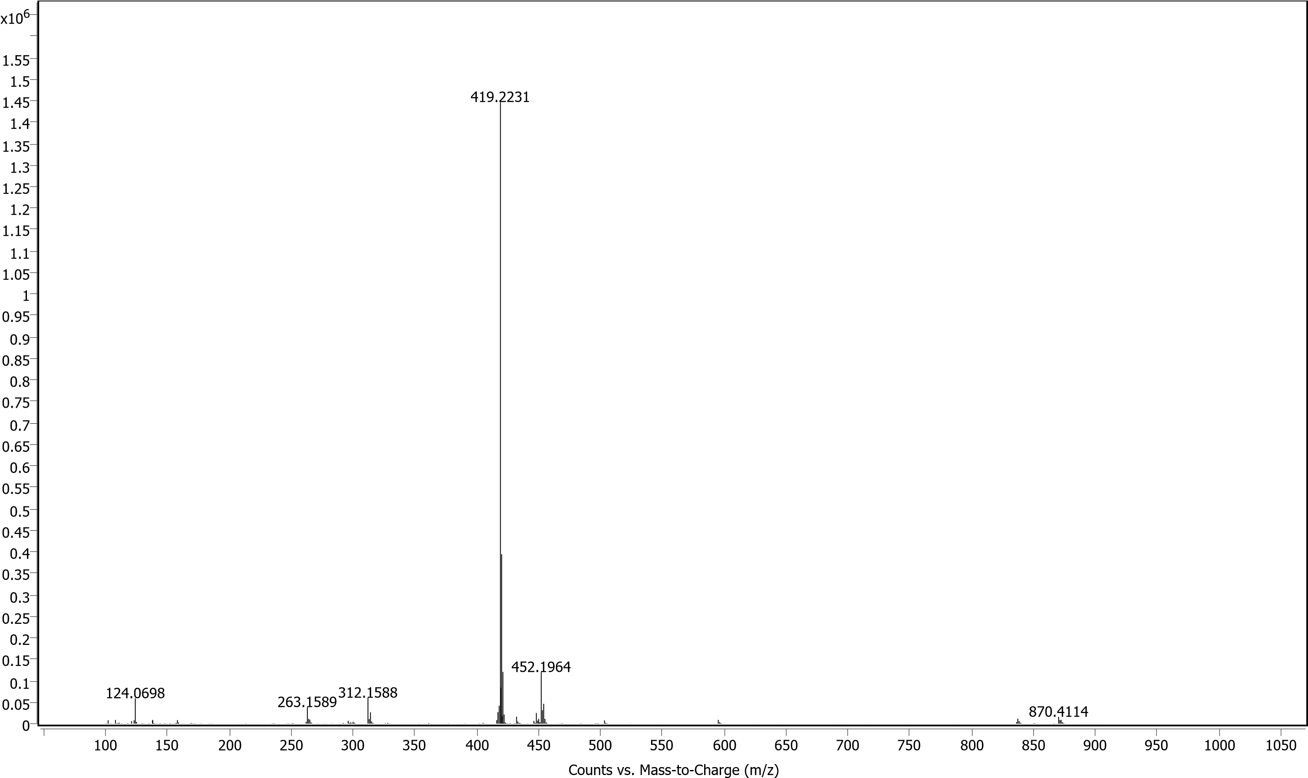
FT-IR of 5e
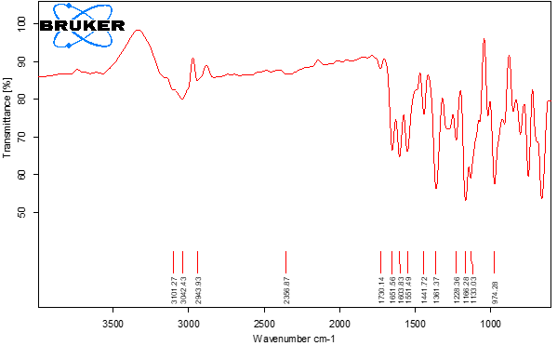
QTOF-HRMS of 5f
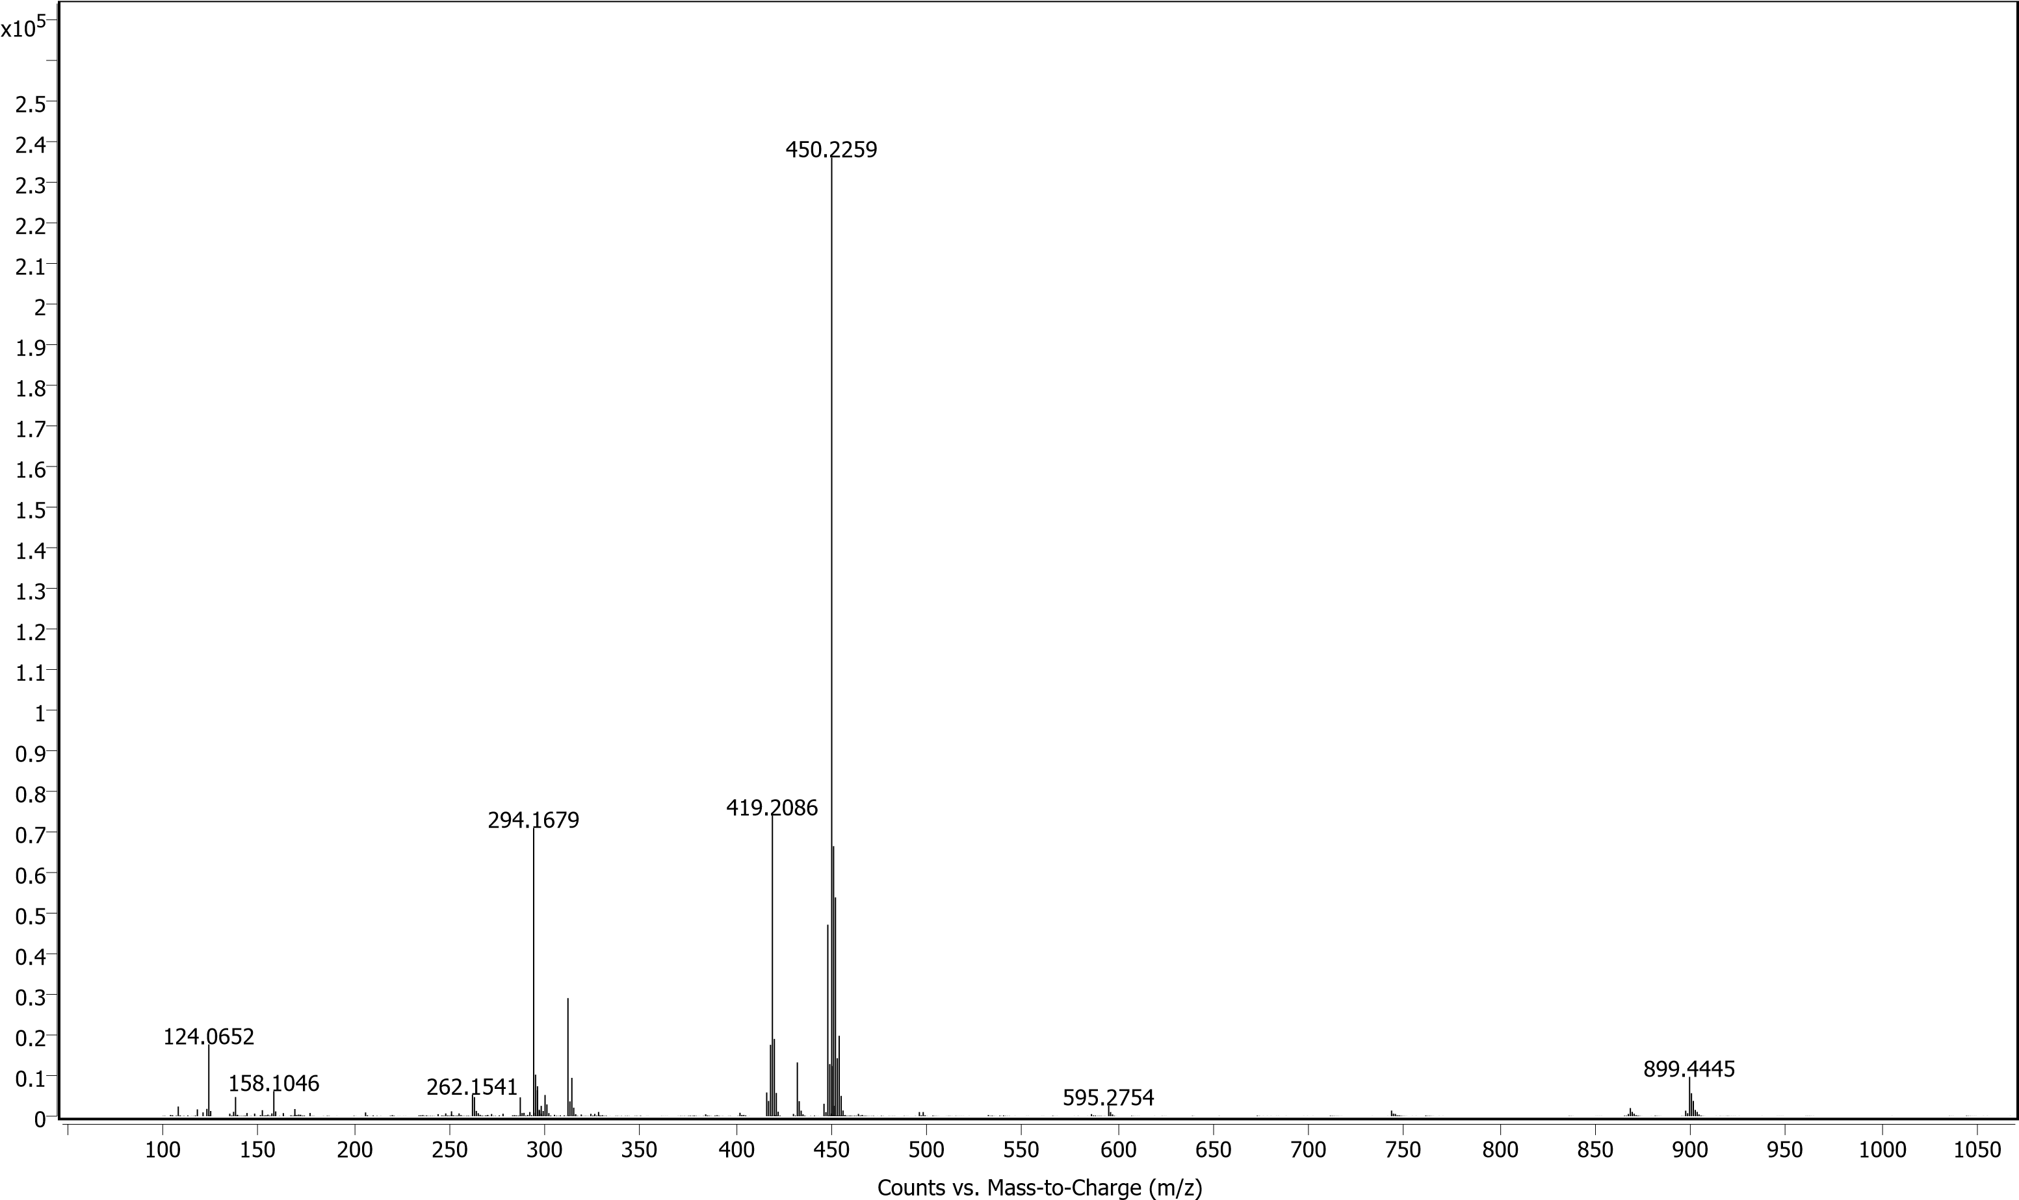
FT-IR of 5f
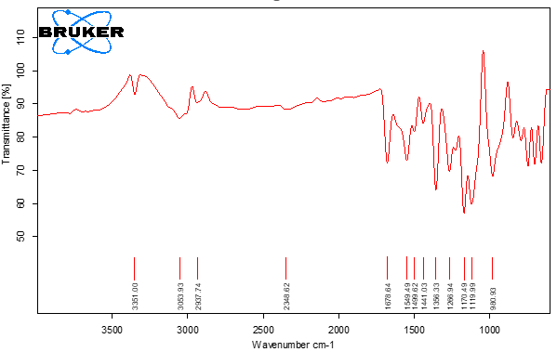
QTOF-HRMS of 5g
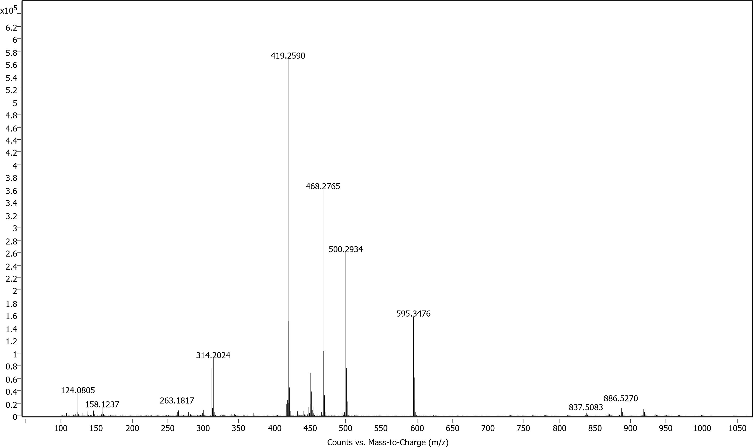
FT-IR of 5g
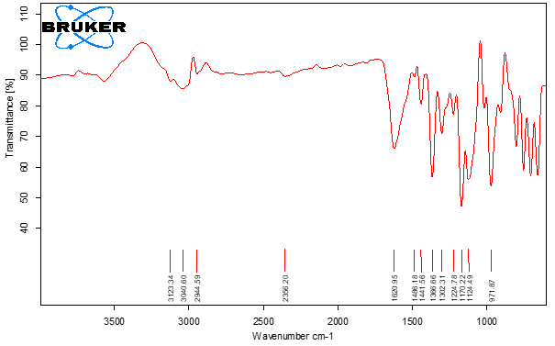
QTOF-HRMS of 5h
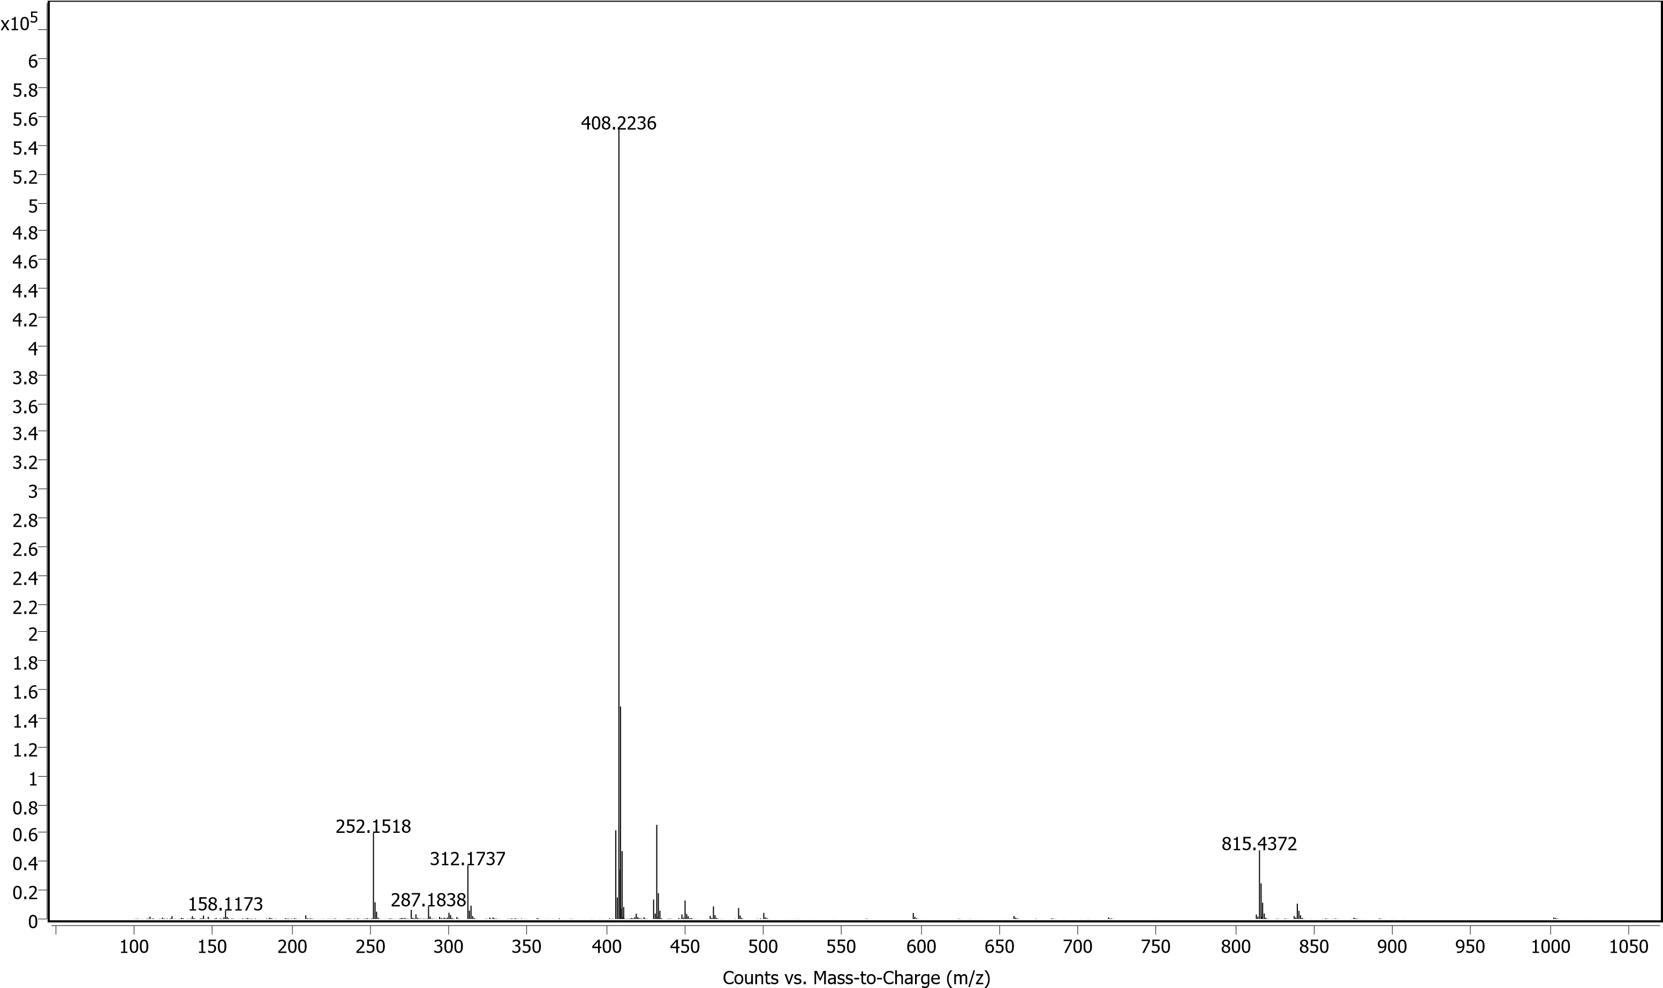
FT-IR of 5h
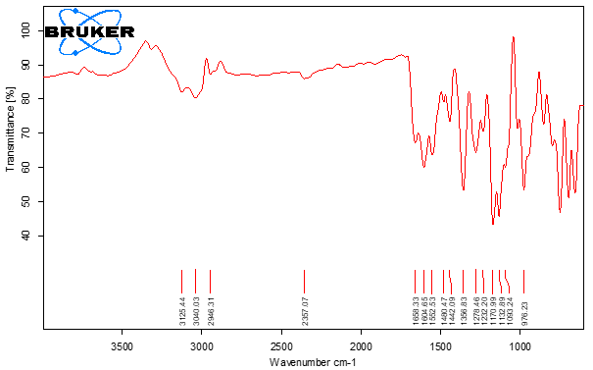
QTOF-HRMS of 5i
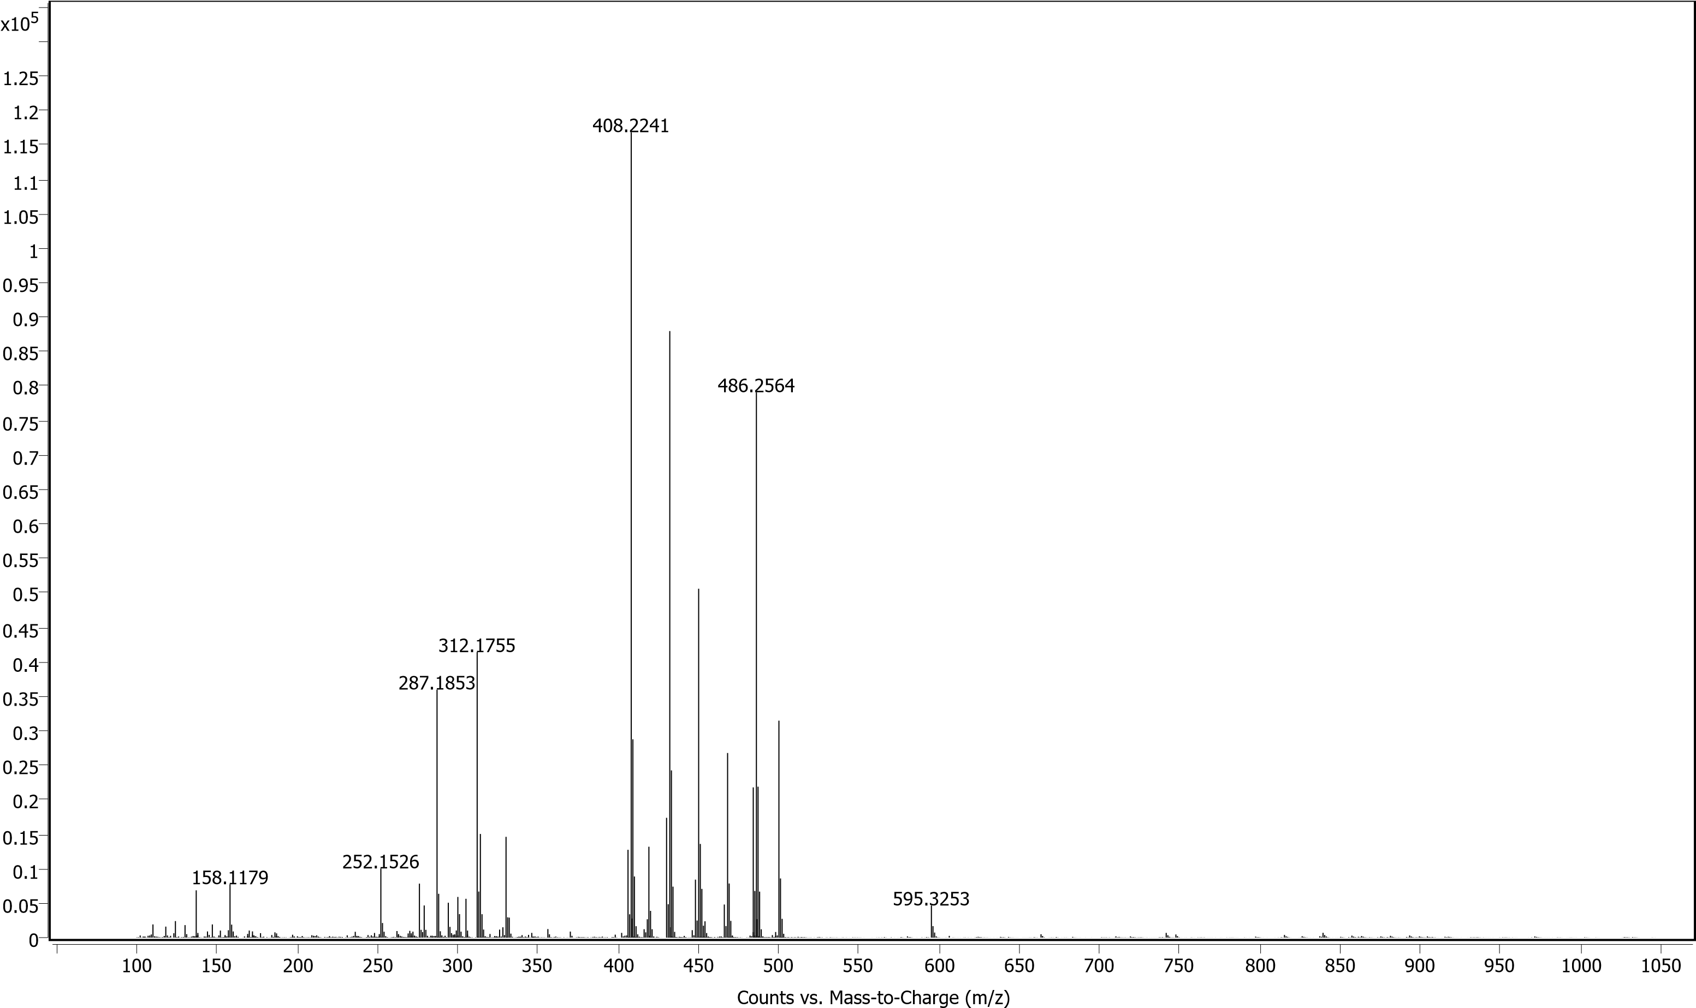
FT-IR of 5i
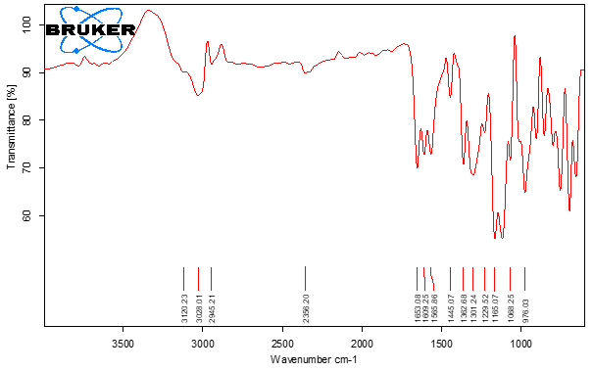
QTOF-HRMS of 5j
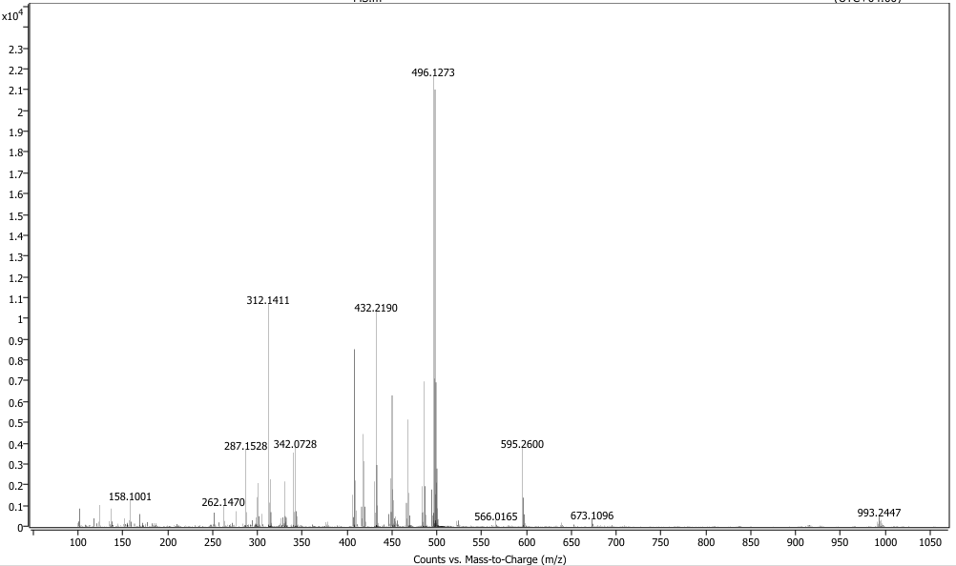
FT-IR of 5j
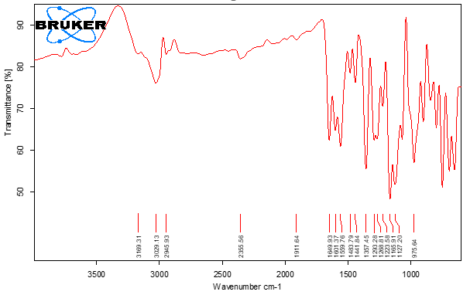
QTOF-HRMS of 5k
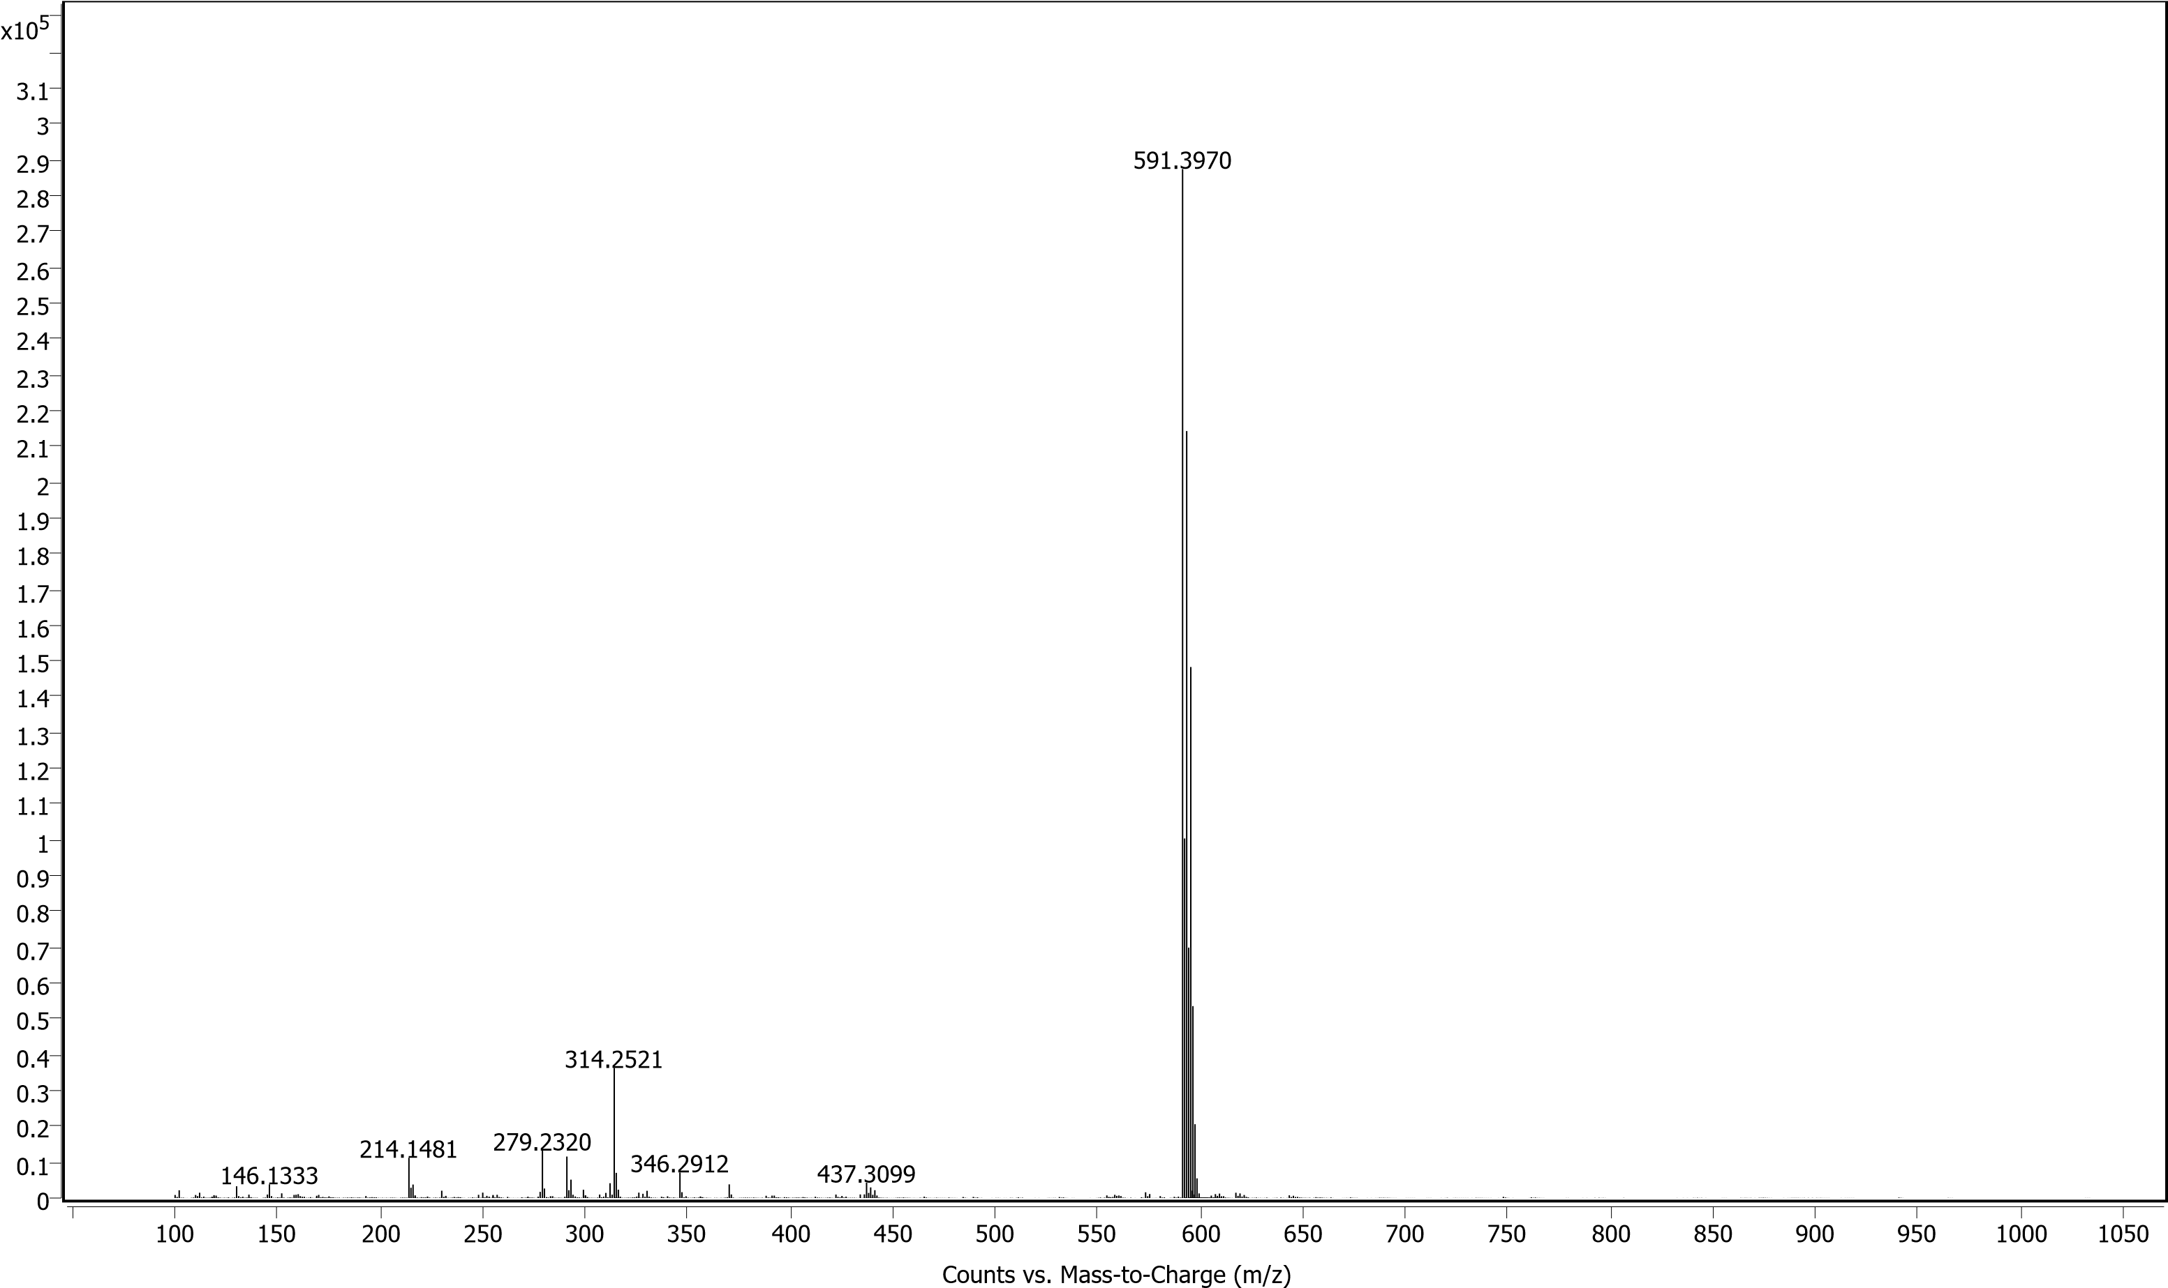
FT-IR of 5k
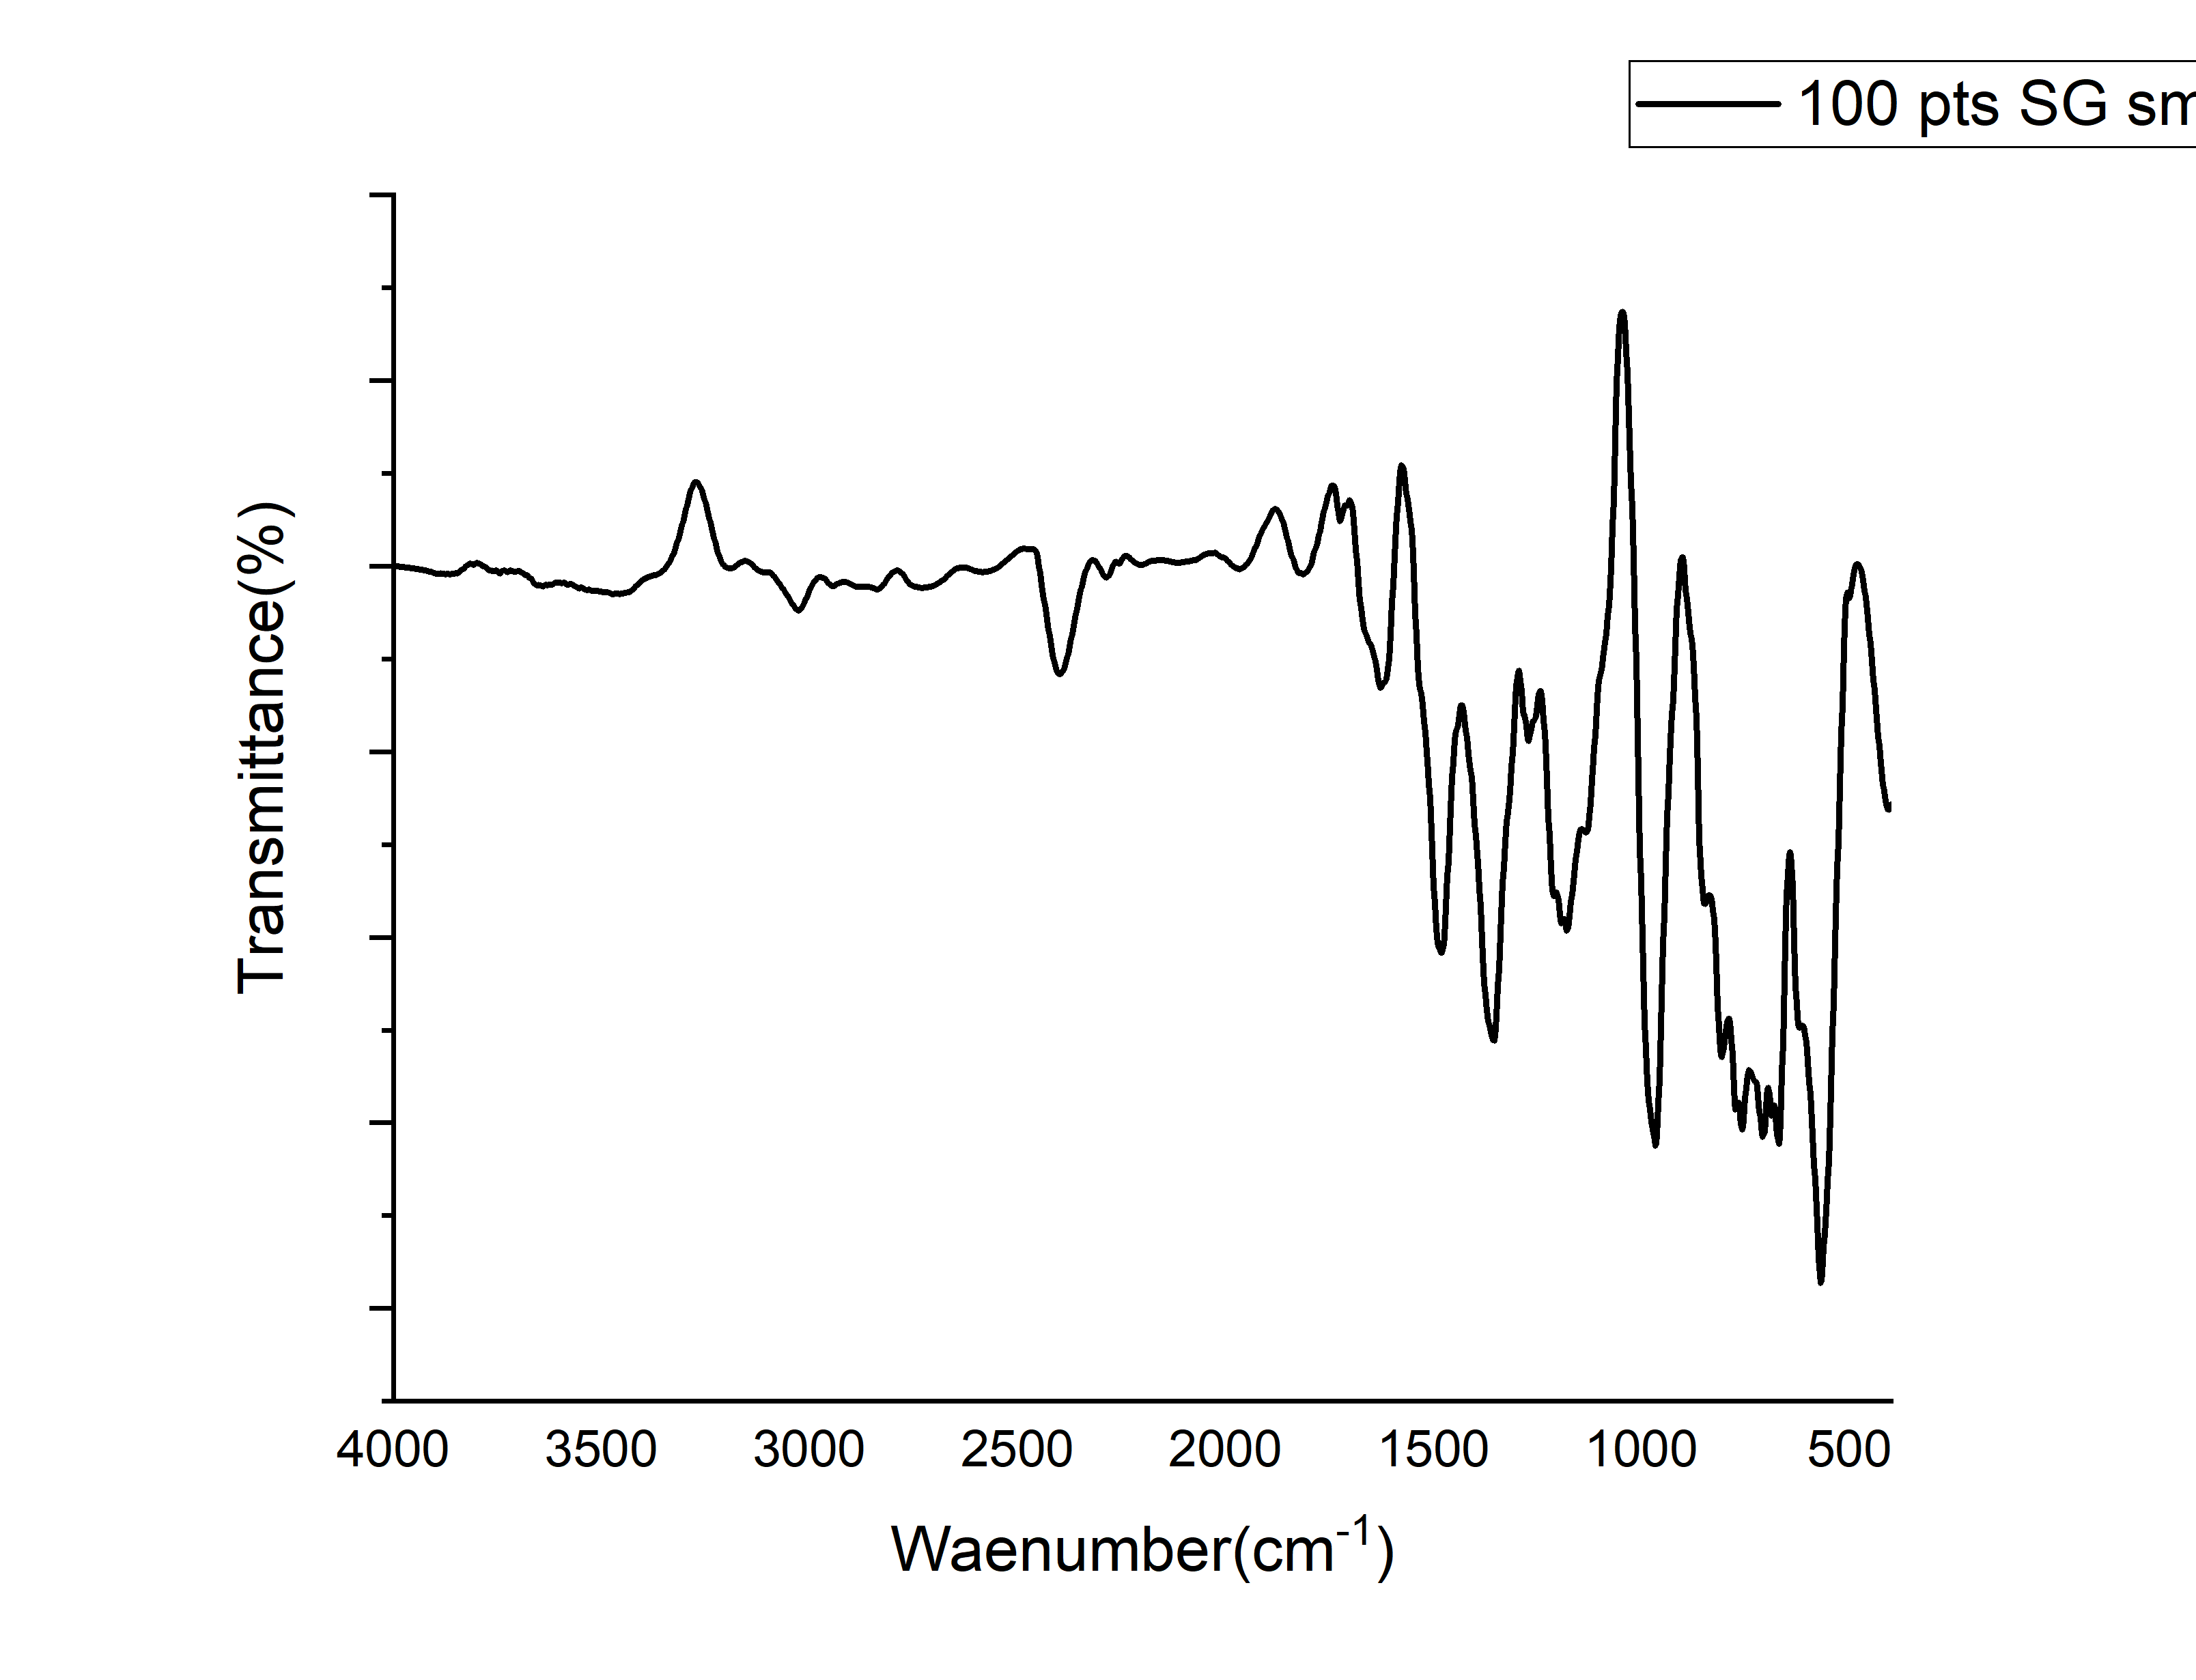
QTOF-HRMS of 5l
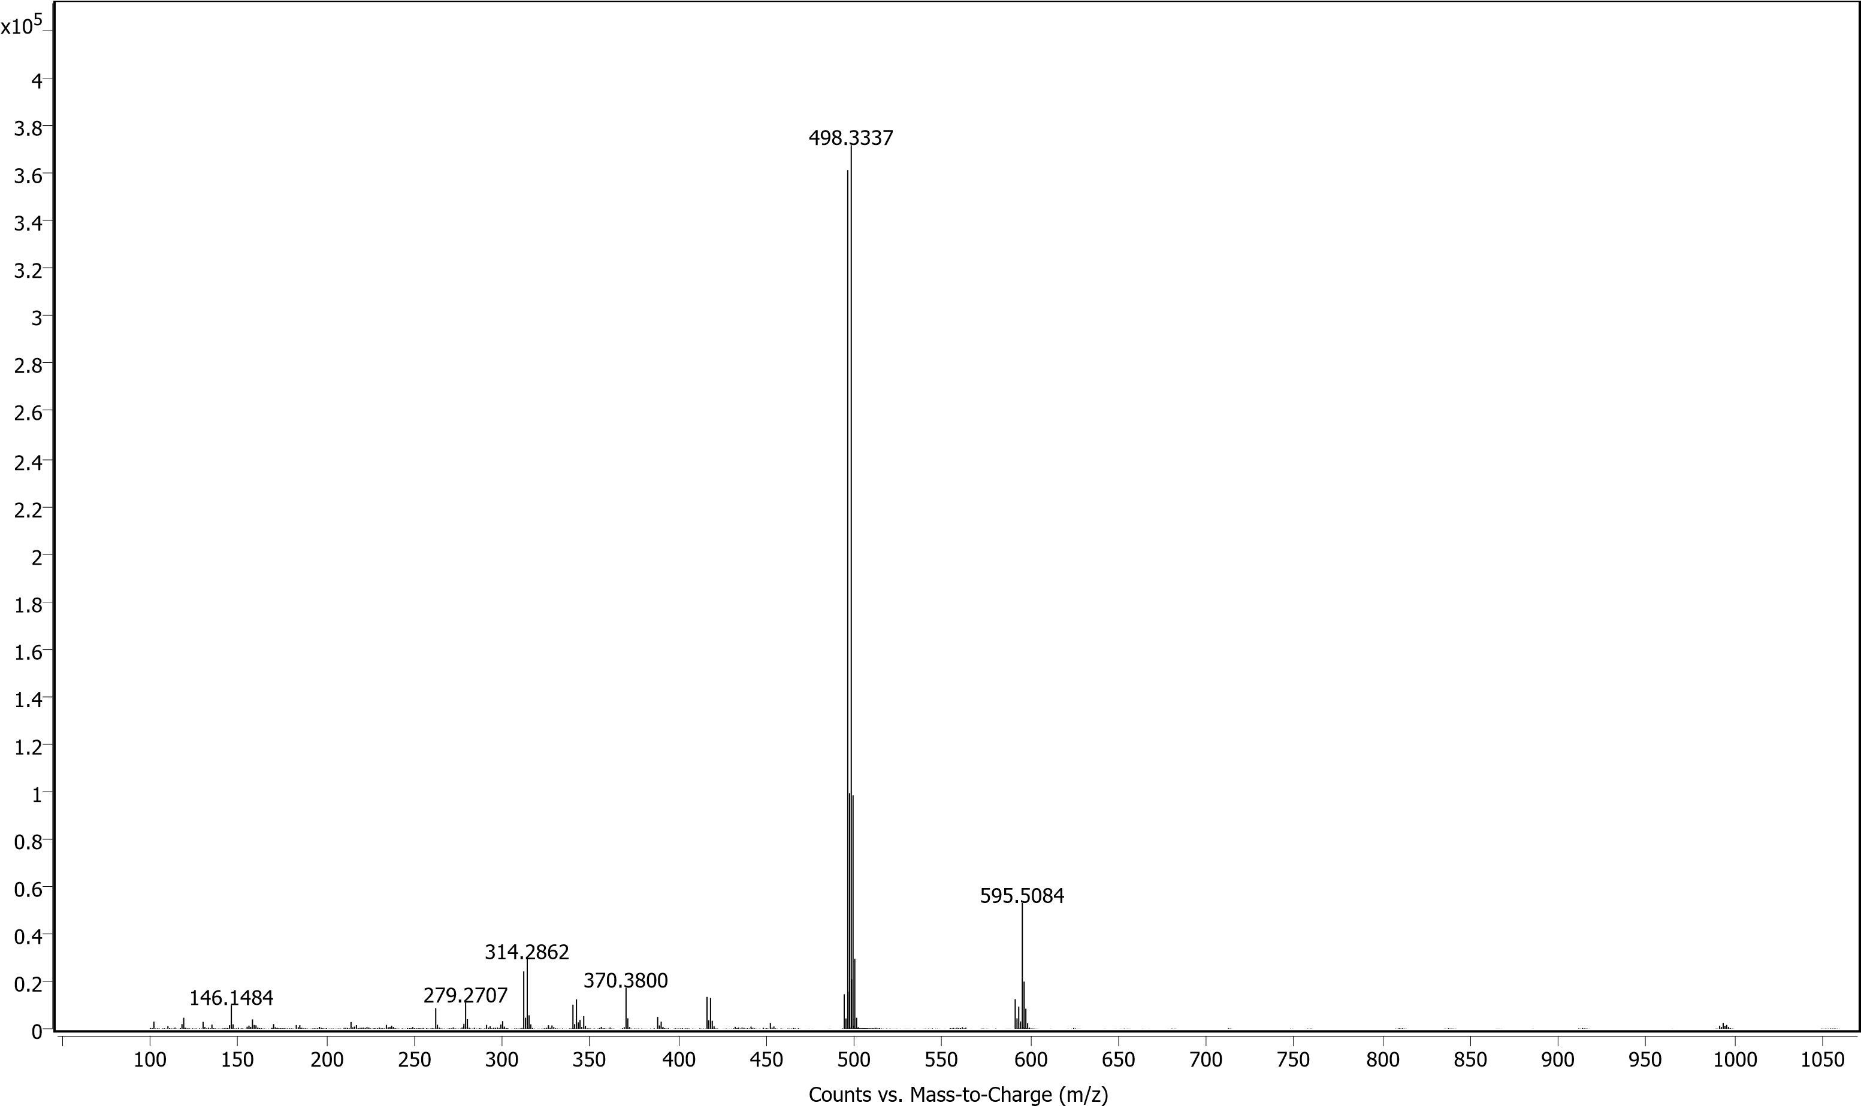
FT-IR of 5l
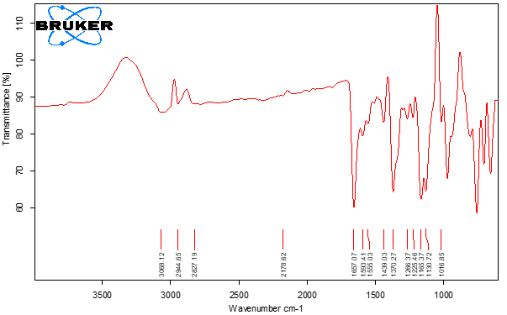
QTOF-HRMS of 5m
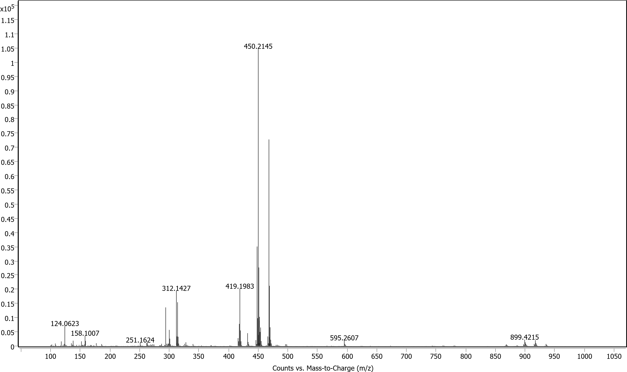
FT-IR of 5m
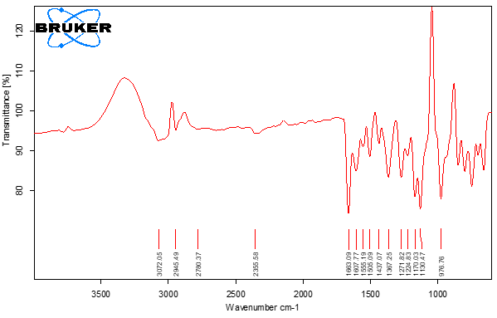
QTOF-HRMS of 5n
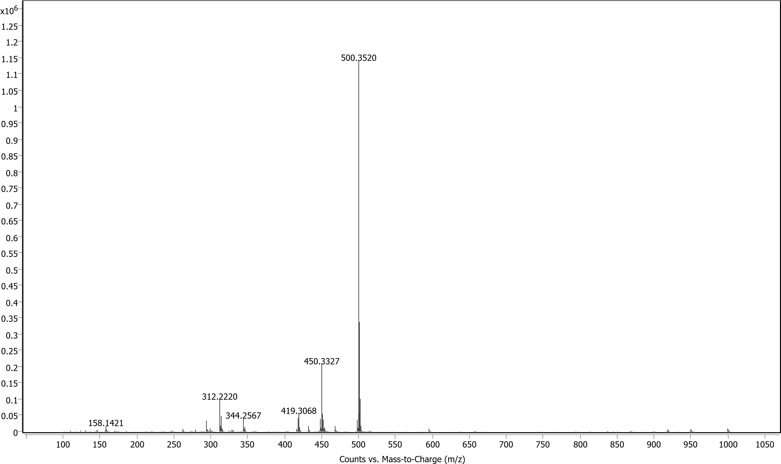
FT-IR of 5n
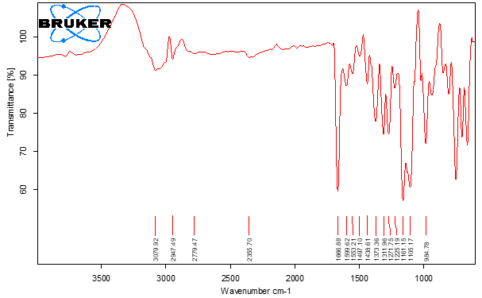
QTOF-HRMS of 5o
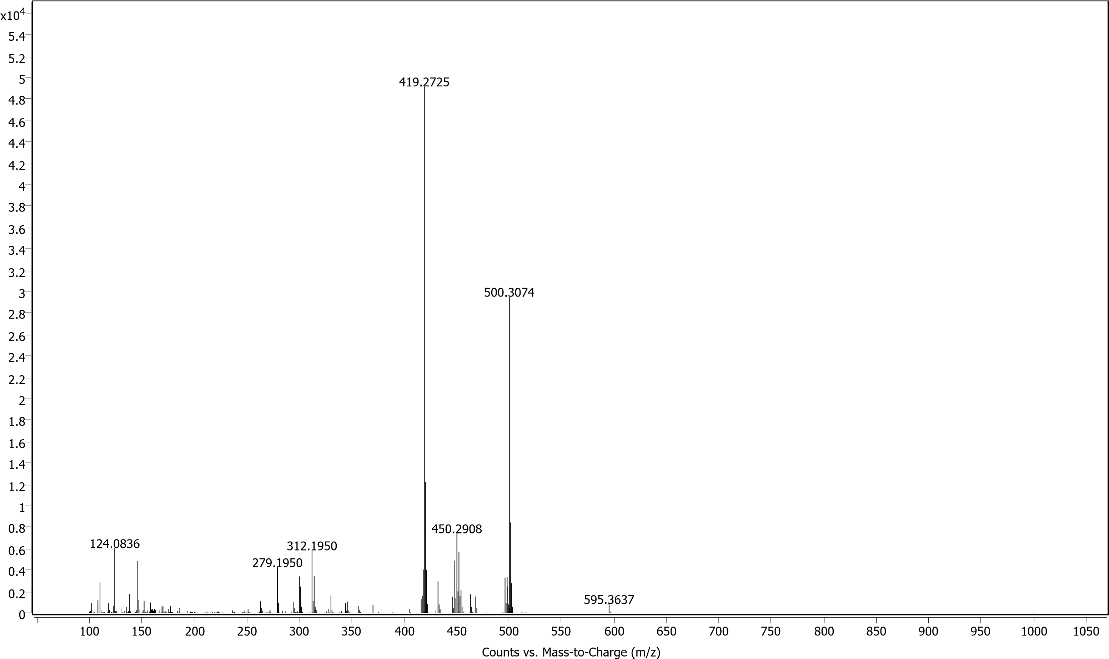
FT-IR of 5o
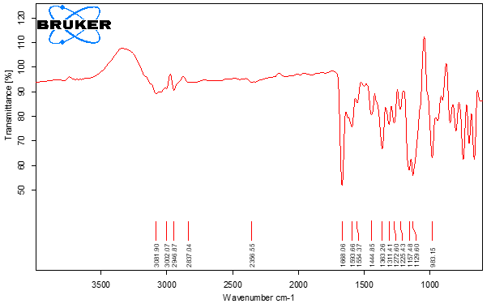
QTOF-HRMS of 5p
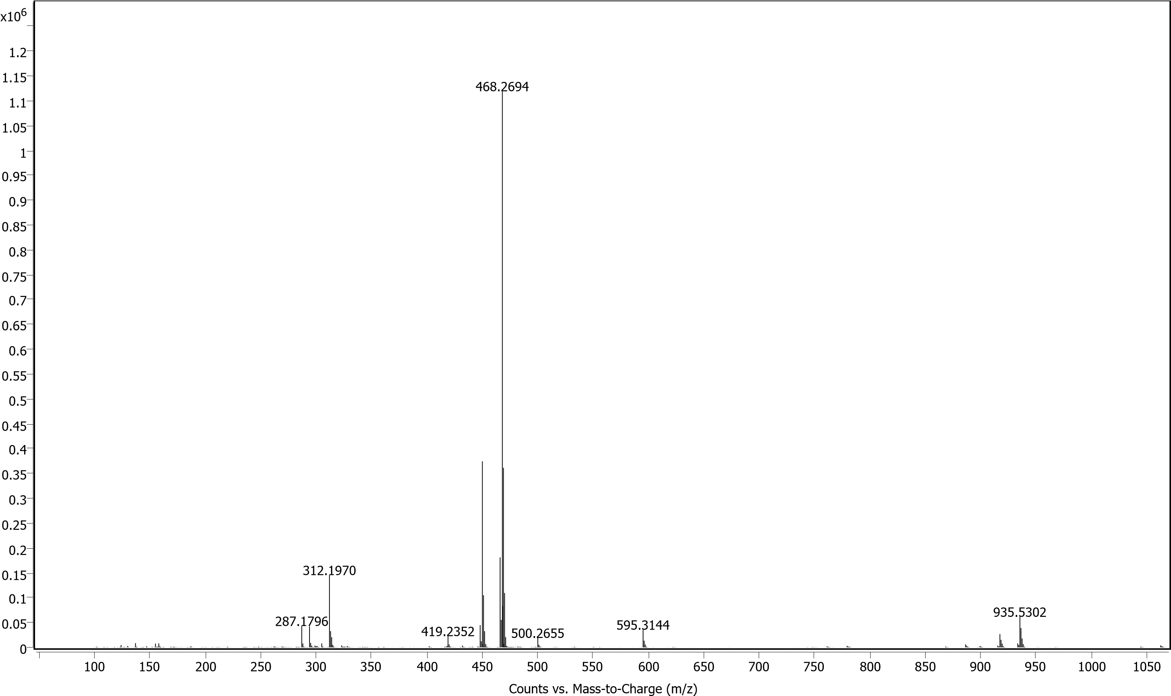
FT-IR of 5p
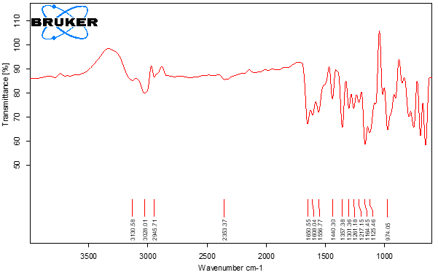
QTOF-HRMS of 5q

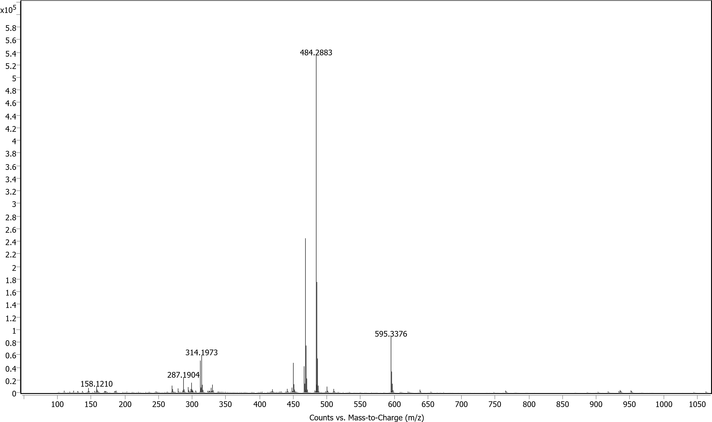
FT-IR of 5q
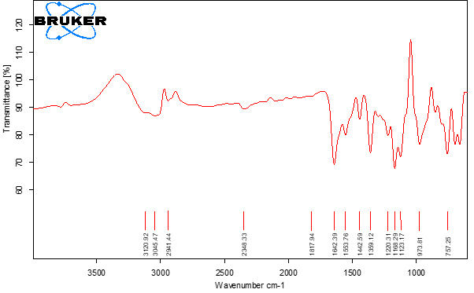
QTOF-HRMS of 5r
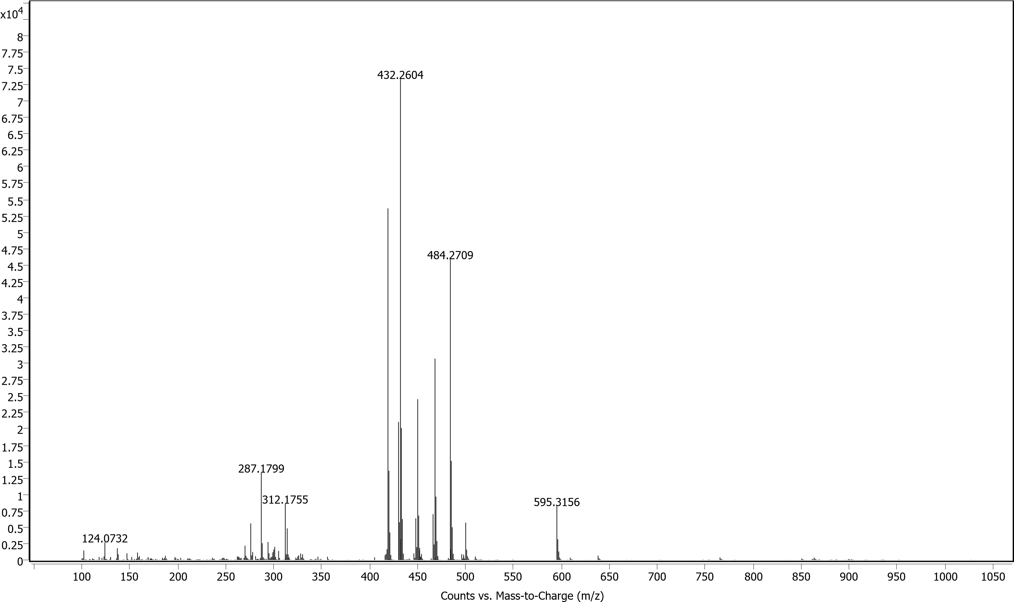
FT-IR of 5r
