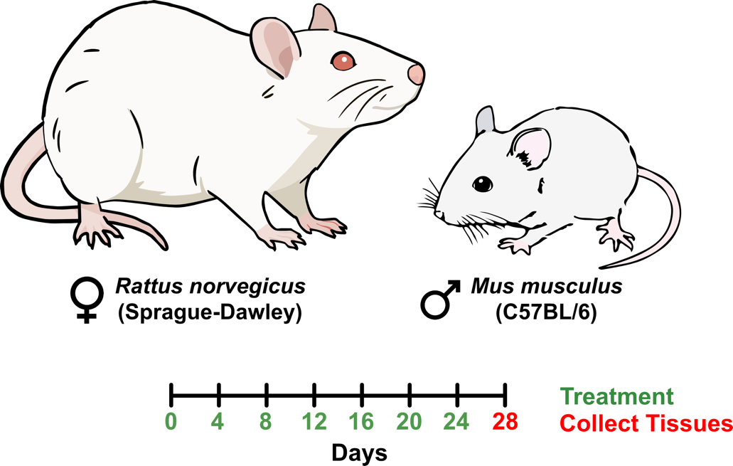
Figure S1. Study design and treatment regimen. Bulk RNAseq and snRNAseq datasets were used in this meta-analysis. Beginning on postnatal day (PND) 30, male C57BL/6Crl mice received oral gavage of either 0.1 mL sesame oil vehicle or TCDD at doses of 0.03, 0.1, 0.3, 1, 3, 10, or 30 μg/kg body weight. Female SD rats were treated starting on PND29 with either 0.1 mL sesame oil vehicle or 0.01, 0.03, 0.1, 0.3, 1, 3, or 10 μg/kg TCDD. All animals were dosed every four days over a 28-day period for a total of seven repeated exposures. Treatment days are marked in green, and liver tissue collection was performed on day 28, indicated in red. Bulk RNAseq data were obtained from GEO under accession numbers GSE110293 (rat) and GSE203302 (mouse), while snRNAseq data for mouse were retrieved from GSE148339.

