Title: Unveiling Potential Retinal and Choroidal Markers with SS-OCTA in Detecting Cerebral Small Vessel Disease

Short title: SS-OCTA for CSVD early screening.

Authors: Zeqi Shen¹†, Weitao Yu²†, Shouxuan Gao³, Sheng Zhang³*, Chaoyang Hong¹*

1. Center for Rehabilitation Medicine, Department of Ophthalmology, Zhejiang Provincial People’s Hospital (Affiliated People’s Hospital), Hangzhou Medical College, Hangzhou, Zhejiang, China. 310014
2. The Second School of Clinical Medicine, Hangzhou Normal University, Hangzhou, Zhejiang, China. 310006
3. Center for Rehabilitation Medicine, Department of Neurology, Zhejiang Provincial People’s Hospital (Affiliated People’s Hospital), Hangzhou Medical College, Hangzhou, Zhejiang, China. 310014

† These two authors contributed equally as co-first authors.

Zeqi Shen
Center for Rehabilitation Medicine, Department of Ophthalmology, Zhejiang Provincial People’s Hospital (Affiliated People’s Hospital), Hangzhou Medical College, Hangzhou, Zhejiang, China. 310014
Tel: +86 15827046027
Fax: +86 0571 85893001
Email: 15810027976@163.com

Weitao Yu
The Second School of Clinical Medicine, Hangzhou Normal University, Hangzhou, Zhejiang, China. 310006
Tel: +86 15827046027
Fax: +86 0571 85893473
Email: jiaxingwty@163.com

Shouxuan Gao
Center for Rehabilitation Medicine, Department of Neurology, Zhejiang Provincial People’s Hospital (Affiliated People’s Hospital), Hangzhou Medical College, Hangzhou, Zhejiang, China. 310014
Tel: +86 15827046027
Fax: +86 0571 85893473
Email: shouxuan_gao@163.com

Sheng Zhang
Center for Rehabilitation Medicine, Department of Neurology, Zhejiang Provincial People’s Hospital (Affiliated People’s Hospital), Hangzhou Medical College, Hangzhou, Zhejiang, China. 310014
Tel: +86 0571 85893472
Fax: +86 0571 85893473
Email: zhangsheng@hmc.edu.cn

Chaoyang Hong, PhD
Center for Rehabilitation Medicine, Department of Ophthalmology, Zhejiang Provincial People’s Hospital (Affiliated People’s Hospital), Hangzhou Medical College, Hangzhou, Zhejiang, China. 310014
Tel: +86 0571 85893001
Fax: +86 0571 85893001
Email: hcy1999@sina.com

*Corresponding Authors
Chaoyang Hong, PhD
Center for Rehabilitation Medicine, Department of Ophthalmology, Zhejiang Provincial People’s Hospital (Affiliated People’s Hospital), Hangzhou Medical College, Hangzhou, Zhejiang, China. 310014
Tel: +86 0571 85893001
Fax: +86 0571 85893001
Email: hcy1999@sina.com

Shen Zhang, PhD
Center for Rehabilitation Medicine, Department of Neurology, Zhejiang Provincial People’s Hospital (Affiliated People’s Hospital), Hangzhou Medical College, Hangzhou, Zhejiang, China. 310014
Tel: +86 0571 85893472
Fax: +86 0571 85893473
Email: zhangsheng@hmc.edu.cn

*These two authors contributed equally as co-corresponding authors.

Supplementary Methods

SS-OCTA examination
The SS-OCTA machine (VG200I; Intalight, Inc., vangogh v3.0.188) includes a scanning source laser with a central wavelength of approximately 1050 nm and a scanning rate of 200,000 A-scan scans per second. This SS-OCTA machine is equipped with automatically pupil focusing and tracking utility based on integrated confocal scanning laser ophthalmoscopy to eliminate eye motion artifacts. The axial resolution is 3.8 μm, and the lateral resolution is 10 μm. The scanning depth is 3 mm.

This study investigates the macular fovea and the center of the optic nerve head (ONH). A 6×6 mm area scanning mode was used to capture three-dimensional volume data using a grating scanning scheme with 512 consecutive horizontal B-scans. Each B-scan contains 512 A-scans, which are repeated four times and averaged. Additionally, vessel density (VD), perfusion area (PA), choroidal vascular index (CVI), choroidal vascular volume (CVV), and average thickness within the 6×6 mm scan mode of the Early Treatment of Diabetes Retinopathy Study (ETDRS) gird were measured. The radius of each ring in the 6×6mm scan mode is 1, 3 and 6 mm. These measurements were also obtained using the automatic measurement software equipped in the OCTA machine.

The locations of radial capillary network (RPC), superficial vascular complexes (SVC), deep vascular complexes (DVC), and choriocapillaris (CC) from superficial to deep are as follows: i) RPC is situated from 5 μm below the inner limiting membrane (ILM) to the junction of the RNFL and ganglion cell layer (GCL); ii) SVC is located from 5 μm below the ILM to the 1/3 of GCL+ inner plexiform layer (IPL) above the junction of IPL and inner nuclear layer (INL); iii) DVC is situated at the 1/3 of GCL+IPL above the junction of IPL and INL to 25 μm above the junction of INL and outer plexiform layer (OPL); iv) CC is located from 10 μm below the upper boundary of Bruch’s membrane (BM) to 25 μm above the lower boundary of BM.

We measured the following OCTA parameters. Firstly, thickness parameters. We measured macular and optic nerve head (ONH) thickness, including the macular RNFL thickness, ganglion cell layer (GCL) thickness, choroidal thickness, and peripapillary RNFL thickness. Secondly, blood flow parameters, including i) VD of the RPC, SVC, and DVC in the macular and ONH, respectively. VD refers to the percentage of vascular area per unit area of the total scanning area; ii) PA of RPC, SVC, DVC and CC refers to the total area of blood vessels per unit area; iii) choroidal vascular index (CVI) is a three-dimensional index representing the ratio of choroidal vascular volume to total choroidal volume, and it reflects the volume density of choroidal blood vessels; iv) choroidal vascular volume (CVV) is another three-dimensional index representing the volume of blood vessels in the choroid region.

Brain MRI imaging protocol
All participants underwent MRI scans for diagnosing CSVD using an eight-channel phased array head coil on a 3.0 Tesla whole-body MRI scanner (Discovery MR750 3.0T; GE Healthcare), including T1, T2, T2-weighted fluid-attenuated inversion recovery (FLAIR), diffusion-weighted imaging (DWI) and susceptibility weighted imaging (SWI) sequences.

T1-weighted images using the magnetization-prepared fast gradient echo (MPRAGE) sequence with repetition time (TR) of 6.7 ms, echo time (TE) of 2.9 ms, TI of 450 ms, flip angle of 12°, slice thickness of 1 mm, slice spacing of 0 mm, matrix of 256 × 256, field of view (FOV) of 256 × 256 mm2, and 192 vectorial sections with 1 × 1 × 1 mm3 voxels. T2-weighted images: TR of 9,823 ms, TE of 101 ms, FOV of 220 mm × 220 mm, slice thickness of 5 mm, and inter-slice gap of 1.5 mm. T2-weighted fluid-attenuated inversion recovery (FLAIR) images using a fast spin-echo sequence with TR of 7500 ms, TE of 152 ms, TI of 2,100 ms, flip angle of 90°, slice thickness of 4 mm, matrix size of 320 × 256, and FOV of 24 cm. DWI using an EPI sequence with TR of 4,000 ms, TE of 79 ms, flip angle of 90°, slice thickness of 4 mm, matrix of 256 × 256, FOV of 24 cm, and b-value of 1,000 s/mm2 along three orthogonal directions. SWI sequence was in an axial orientation parallel to the anterior commissure to posterior commissure line and covered the whole lateral ventricles, using a three-dimension multi-echo gradient-echo sequence with 11 equally spaced echoes: echo time = 4.5 ms [first echo], inter-echo spacing = 4.5 ms, re-petition time = 34 ms, FOV = 24 cm × 24 cm, matrix size = 416 × 384, flip angle = 20°, slice thickness = 2.0 mm with no gap between slices and in-plane spatial resolution of 0.4688 mm/pixel.
Supplementary Figures
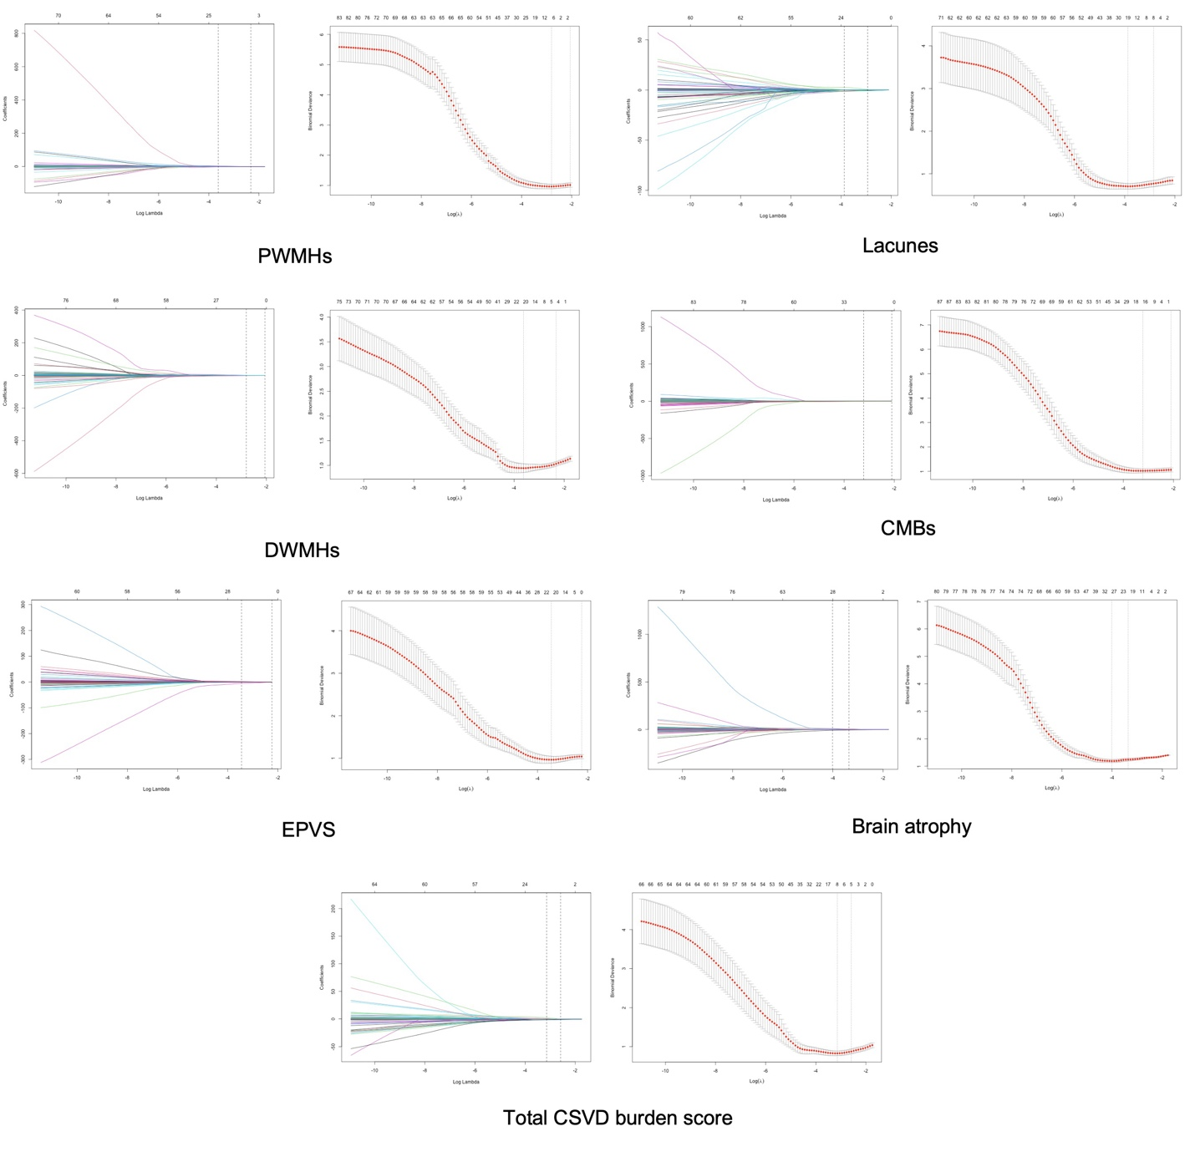
Supplementary Figure I. LASSO regression analysis of CSVD imaging features. LASSO, least absolute shrinkage and selection operator; PWMHs, periventricular white matter hyperintensities; DWMHs, deep white matter hyperintensities; EPVS, enlarged perivascular spaces; CMBs, cerebral microbleeds.

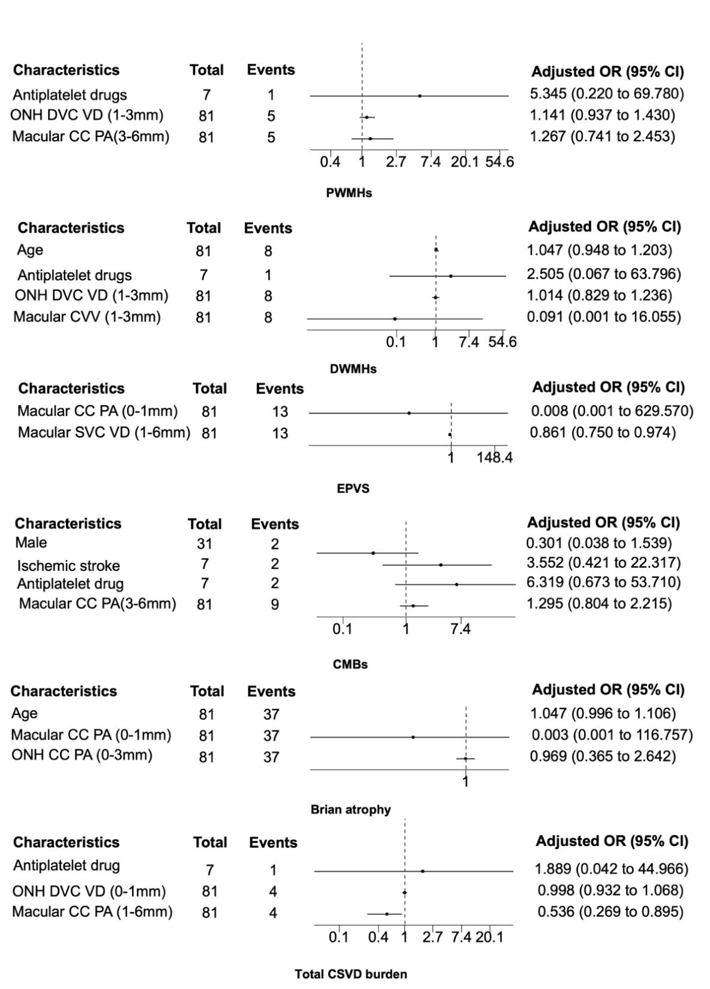
Supplementary Figure II. Binary logistic regression analysis of CSVD imaging features in non-hypertension group. CSVD, cerebral small vessel disease; PWMHs, periventricular white matter hyperintensities; DWMHs, deep white matter hyperintensities; EPVS, enlarged perivascular spaces; CMBs, cerebral microbleeds; ONH, optic nerve head; VD, vessel density; PA, perfusion area; SVC, superficial vascular complexes; DVC, deep vascular complexes; CC, choriocapillaris; CVV, choroidal vascular volume; OR, odds ratio; CI, confidence interval.
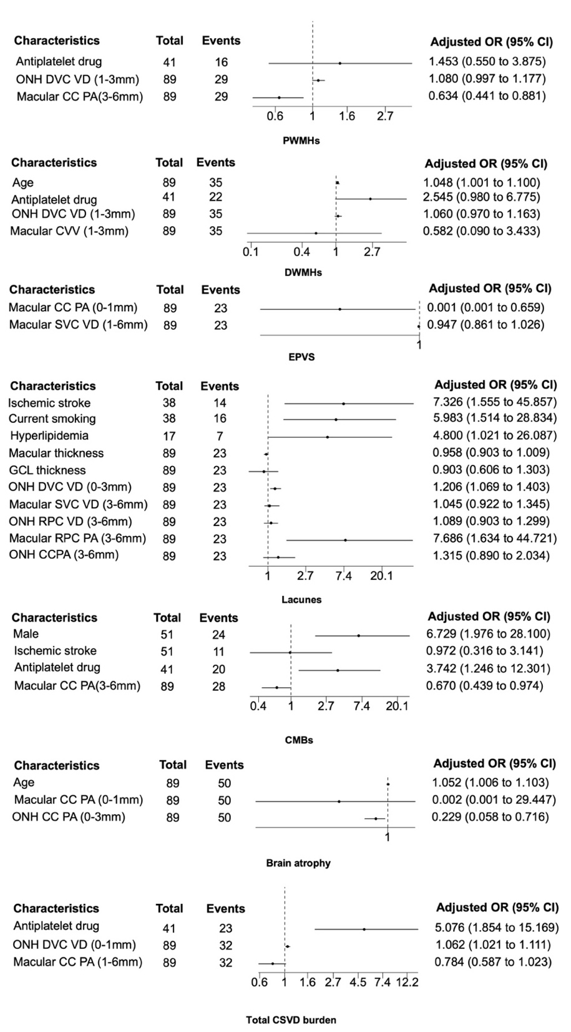
Supplementary Figure III. Binary logistic regression analysis of CSVD imaging features in hypertension group. CSVD, cerebral small vessel disease; PWMHs, periventricular white matter hyperintensities; DWMHs, deep white matter hyperintensities; EPVS, enlarged perivascular spaces; CMBs, cerebral microbleeds; ONH, optic nerve head; GCL, ganglion cell layer; VD, vessel density; PA, perfusion area; SVC, superficial vascular complexes; DVC, deep vascular complexes; RPC, radial capillary network; CC, choriocapillaris; CVV, choroidal vascular volume; OR, odds ratio; CI, confidence interval.
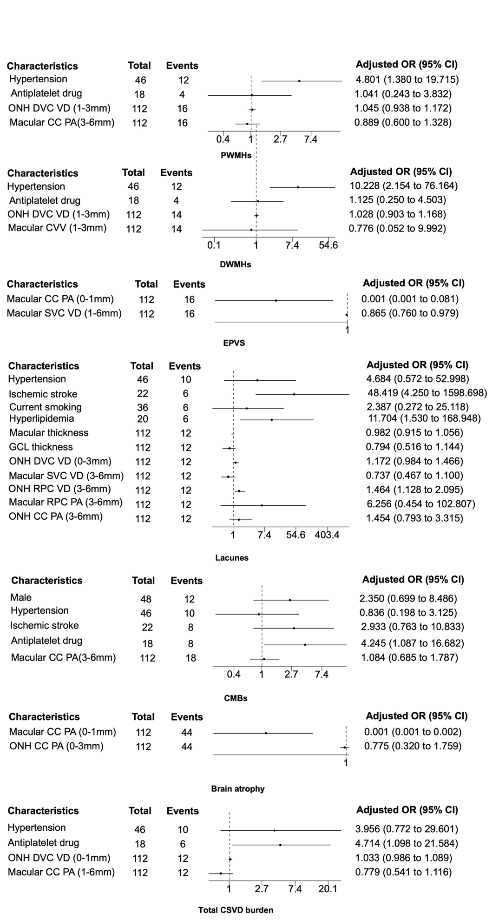
Supplementary Figure IV. Binary logistic regression analysis of CSVD imaging features in non-elderly group. CSVD, cerebral small vessel disease; PWMHs, periventricular white matter hyperintensities; DWMHs, deep white matter hyperintensities; EPVS, enlarged perivascular spaces; CMBs, cerebral microbleeds; ONH, optic nerve head; GCL, ganglion cell layer; VD, vessel density; PA, perfusion area; SVC, superficial vascular complexes; DVC, deep vascular complexes; RPC, radial capillary network; CC, choriocapillaris; CVV, choroidal vascular volume; OR, odds ratio; CI, confidence interval.

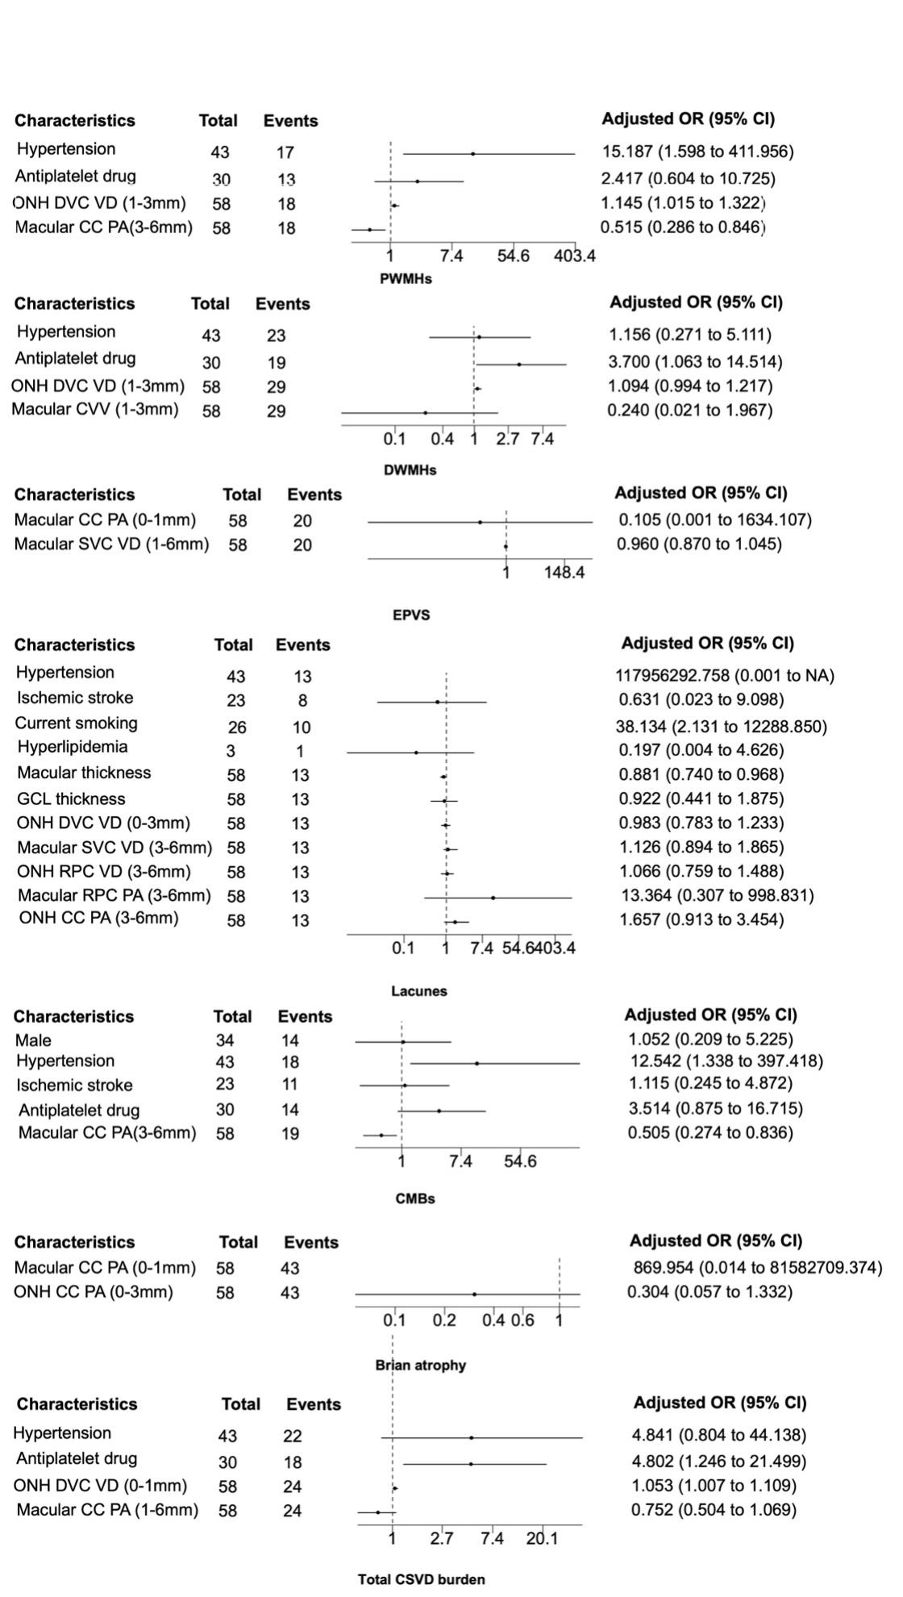
Supplementary Figure V. Binary logistic regression analysis of CSVD imaging features in elderly group. CSVD, cerebral small vessel disease; PWMHs, periventricular white matter hyperintensities; DWMHs, deep white matter hyperintensities; EPVS, enlarged perivascular spaces; CMBs, cerebral microbleeds; ONH, optic nerve head; GCL, ganglion cell layer; VD, vessel density; PA, perfusion area; SVC, superficial vascular complexes; DVC, deep vascular complexes; RPC, radial capillary network; CC, choriocapillaris; CVV, choroidal vascular volume; OR, odds ratio; CI, confidence interval.

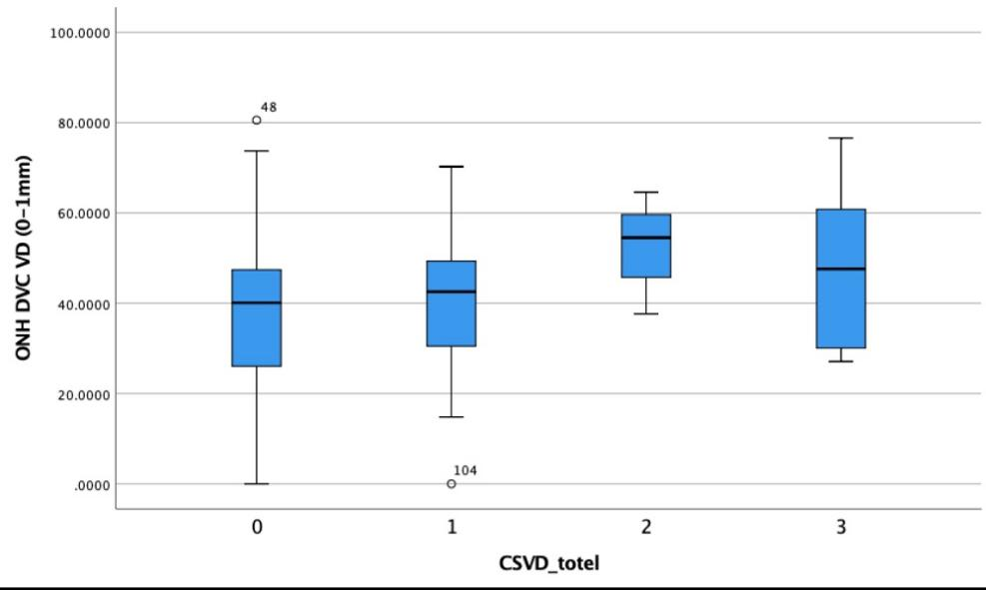

Supplementary Figure VI. Box plots of ONH DVC VD (0–1 mm) across different total CSVD burden scores (0–3). The plots show the distribution, density, and median values of ONH DVC VD in each group. ONH DVC VD increased with CSVD burden, peaked in patients with a burden score of 2, and subsequently declined in those with a score of 3. CSVD, cerebral small vessel disease; ONH, optic nerve head; DVC, deep vascular complexes; VD, vessel density

Supplementary Table I. All 101 parameters measured by OCTA machine.
Category | Parameter Type | Measurement Region | Layer | ETDRS Zones (mm) | Count
Thickness | Macular thickness | Macula | N/A | 0-1, 0-3, 0-6, 1-3, 1-6, 3-6 | 5
 | GCL thickness
 | Choroidal thickness
 | mRNFL
 | pRNFL
Blood Flow | Vascular Density (VD) | Macula | SVC, DVC, RPC | 0-1, 0-3, 0-6, 1-3, 1-6, 3-6 | 18
 |  | Optic nerve head (ONH) |  |  | 18
 | Perfusion Area (PA) | Macula | SVC, DVC, RPC, CC | 0-1, 0-3, 0-6, 1-3, 1-6, 3-6 | 24
 |  | Optic nerve head (ONH) | SVC, DVC, RPC, CC |  | 24
 | Choroidal Vascularity Index (CVI) | Macula | N/A | 0-1, 0-3, 0-6, 1-3, 1-6, 3-6 | 6
 | Choroidal Vessel Volume (CVV) | Macula | N/A |  | 6
Total |  |  |  |  | 101
OCTA, optical coherence tomography angiography; ONH, optic nerve head; GCL, ganglion cell layer; VD, vessel density; PA, perfusion area; SVC, superficial vascular complexes; DVC, deep vascular complexes; RPC, radial capillary network; CC, choriocapillaris; CVV, choroidal vascular volume; CVI, choroidal vascular index.

Supplementary Table II. ONH DVC VD (0–1 mm) across different total CSVD burden scores (0–3)
CSVD burden score |  | ONH DVC VD
 | N | Mean | 95% CI
0 | 77 | 38.96 | 35.03-42.89
1 | 57 | 39.64 | 35.87-43.41
2 | 20 | 53.02 | 49.22-56.83
3 | 16 | 47.31 | 38.32-56.29
CSVD, cerebral small vessel disease; ONH, optic nerve head; DVC, deep vascular complexes; VD, vessel density

