SUPPLEMENTARY FIGURE
CHEMICAL STRUCTURES
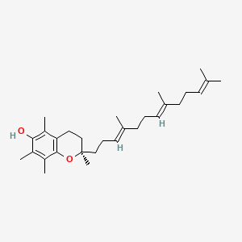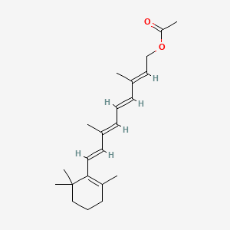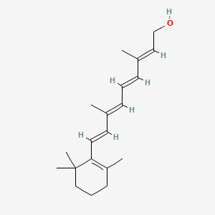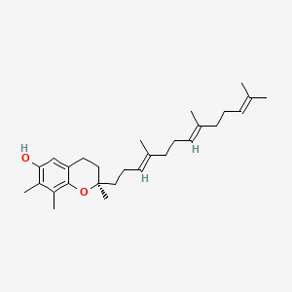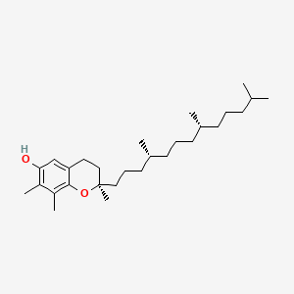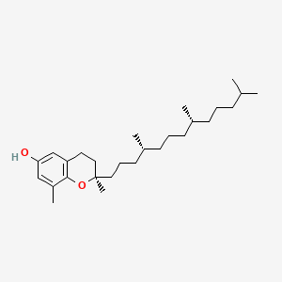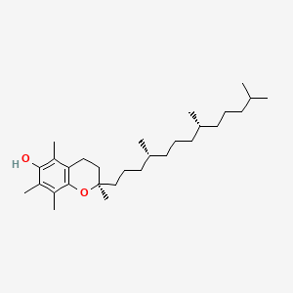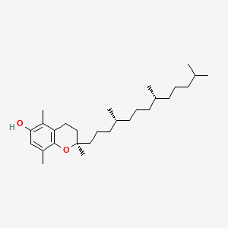
- Retinol (C₂₀H₃₀O)
- Retinyl Acetate (C₂₂H₃₂O₂)
- γ-Tocotrienol (C₂₈H₄₂O₂)
- β-Tocopherol (C₂₈H₄₈O₂)
- γ-Tocopherol (C₂₈H₄₈O₂)
- α-Tocopherol (C₂₉H₅₀O₂)
- δ-Tocopherol (C₂₇H₄₆O₂)
- α-Tocotrienol (C₂₉H₄₄O₂)
*Source : PubChem (https://pubchem.ncbi.nlm.nih.gov/compound/)

SUPPLEMENTARY TABLE

Vitamin Class | Standard (vitamer) | Concentration (mM)
A | Retinol | 0.1 mM
A | Retinyl Acetate | 0.1 mM
E | α-Tocopherol | 10 mM
E | β-Tocopherol | 10 mM
E | γ-Tocopherol | 10 mM
E | δ-Tocopherol | 10 mM
E | α-Tocotrienol | 10 mM
E | γ-Tocotrienol | 10 mM
Table S1. Concentration of stock standard solutions

Calibrator | Vitamin A  (RET, RET.ACE)  (µM) | Vitamin E  (BTF, GTF, DTF, ATT)  (µM) | Vitamin E  (GTT)  (µM) | Vitamin E  (ATF)  (µM) | ISTD (mM)
1 | 0.25 | 5.0 | 2.5 | 10.0 | 0.1
2 | 0.5 | 10.0 | 5.0 | 20.0 | 0.1
3 | 1.0 | 20.0 | 10.0 | 40.0 | 0.1
4 | 2.0 | 40.0 | 20.0 | 60.0 | 0.1
5 | 5.0 | 80.0 | 50.0 | 80.0 | 0.1
6 | 10.0 | 100.0 | 100.0 | 100.0 | 0.1
Table S2. Concentrations of standards in calibrator solutions

Standard | Standard concentrations in QC
Standard | Low QC (µM) | Medium QC (µM) | High QC (µM)
Retinol (RET) | 0.75 | 5.13 | 7.56
Retinyl Acetate  (RET. ACE) | 0.75 | 5.13 | 7.56
γ-Tocotrienol (GTT) | 7.50 | 51.25 | 75.63
α-Tocotrienol (ATT) | 15.00 | 52.50 | 76.25
δ-Tocopherol (DTF) | 15.00 | 52.50 | 76.25
β-Tocopherol (BTF) | 15.00 | 52.50 | 76.25
γ-Tocopherol (GTF) | 15.00 | 52.50 | 76.25
α-Tocopherol (ATF) | 30.00 | 55.00 | 77.50
Table S3. Concentration of standards in spiked quality control (QC) samples

Analytes | Elution Time (min) | Detection Wavelength (nm)
Retinol (RET) | ~4.3 | 325
Retinyl Acetate (RET.ACE) | ~5.6 | 325
γ-Tocotrienol (GTT) | ~11.0 | 298
α-Tocotrienol (ATT) | ~12.0 | 298
δ-Tocopherol (DTF) | ~18.0 | 298
β-Tocopherol (BTF) | ~22.0 | 298
γ-Tocopherol (GTF) | ~23.0 | 298
α-Tocopherol (ATF) | ~27.0 | 298
Internal Standard (ISTD) | ~4.6 | 255
Table S4. Retention time and detection wavelengths of analysed vitamers and internal standards using the developed UHPLC method. Retention time variability (~) accounts for minor differences due to experimental conditions.

