Supporting Information
In search for non precious metal oxide electrodes with the case of BaMoO₃ thin films for the hydrogen evolution reaction

Phu Tran Phong Le^{1,2*}, Vadim Ratovskii¹, Anja Bieberle-Hütter², Gertjan Koster¹, Christoph Baeumer^{1,3*}.
¹ MESA+ Institute for Nanotechnology, University of Twente, PO Box 217, 7522 NH Enschede, The Netherlands
² Dutch Institute for Fundamental Energy Research (DIFFER), P.O. Box 6336, 5600 HH Eindhoven The Netherlands
³ Peter Gruenberg Institute 7, Forschungszentrum Juelich GmbH, 52425 Juelich, Germany and JARA-FIT, RWTH Aachen University, 52056 Aachen, Germany

*Corresponding author emails: t.p.p.le@utwente.nl
c.baeumer@utwente.nl
Keywords: catalysts, electrolysis, perovskite oxides, hydrogen evolution reaction, degradation, thin films

- Sample configuration and electrical connections for rotating disk electrode (RDE) measurements
Figure S1 shows the sample configuration and electrical connections ¹ for HER measurements in rotating disk electrode (RDE) measurements.
Figure S1. The schematic of sample configuration and electrical connections for HER in RDE [1].
- Thickness analysis, reciprocal space mapping of BaMoO₃ thin film and a control experiment of BaMoO₃ during HER
The thickness of the as-deposited BaMoO₃ film was determined using a cross-section SEM image. The image was taken under the Pt contact at a location where the BaMoO₃ film was not exposed to the electrolyte during HER (Figure S2a). The film thickness at this location is well representative for the as-deposited BaMoO₃ thin film.
The reciprocal space mapping around (103) reflections of NdGaO₃(001)_{pc} substrate and 700 nm BaMoO₃(001) film is shown in Figure S2b. It indicates the film is not strained on the substrate and is fully relaxed to the BaMoO₃ bulk value of 4.04 Å for both out-of-plane and in-plane lattice constants.
Another 700 nm BaMoO₃ film on NdGaO₃(001)_{pc} substrate was cycled under HER conditions, and it was pulled out at 0 V vs RHE during anodic scan. A clear colour change of the electrolyte-exposed dark-red film is also observed. XRD patterns of this BaMoO₃ sample before and after such experiment show similar features as the BaMoO₃ sample described in the main text.
Figure S2. (a) The thickness of the BaMoO₃ film was determined using a cross-section SEM image. (b) The reciprocal space mapping around (103) reflections of NdGaO₃(001)_{pc} substrate and 700 nm BaMoO₃(001). A control experiment of BaMoO₃ where the sample was pulled out of the electrolyte at 0 V vs RHE during the anodic scan: (c) CV curve, (d) optical images and (e) XRD patterns of the sample before and after the experiment.

- Degradation of BaMoO₃ films on Ca₂Nb₃O₁₀ nanosheets on Si
Oxide nanosheets, which are 2-dimensional micro-sized single crystals with a large library of crystal structures, can serve a similar role as single crystalline substrates for the growth of locally epitaxial oxide thin films with single out–of–plane orientation.^{2–5} Oxide nanosheets are a cheap alternative to avoid the usage of expensive single crystalline substrates. They can be deposited on large surfaces, for example 8-inch Si wafers, as well as on amorphous transparent substrates, like glass, using Langmuir-Blodgett method.⁶ In this work, Ca₂Nb₃O₁₀ nanosheets were used for the growth of single out-of-plane oriented BaMoO₃(001) films, which are considered to have more defects compared to BaMoO₃(001) films on single crystalline NdGaO₃(001)_{pc} substrates due to the grain-boundary of oxide nanosheets. The detailed preparation and deposition of Ca₂Nb₃O₁₀ nanosheets on Si were described elsewhere.⁷ The growth conditions of BaMoO₃ on these nanosheets were the same as on single crystalline NdGaO₃(001)_{pc} substrates as described in the manuscript. Figure S3 shows the results from materials characterizations of BaMoO₃ before and after HER.
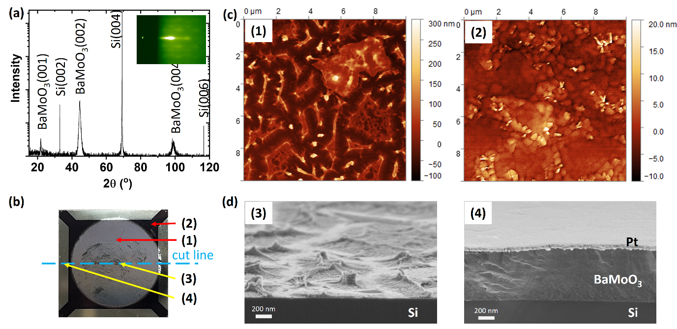
Figure S3. Degradation of 700 nm BaMoO₃ thin film on Ca₂Nb₃O₁₀ nanosheets on Si under HER conditions. (a) XRD shows single out-of-plane oriented perovskite BaMoO₃(001) due to the induced directional growth of Ca₂Nb₃O₁₀ nanosheets. The RHEED pattern in the inset shows a streaky pattern, resulting from the highly crystalline thin film. (b) Optical image of a 700 nm thick BaMoO₃(001) thin film sample after one CV cycle under HER conditions. The grey circular area was exposed to HER; numbers refer to the locations where AFM and cross-sectioned SEM were performed; the cut line indicates where the sample was cut for cross-sectional SEM imaging. (c) AFM and (d) high-resolution cross-sectional SEM images at different locations indicate the rapid degradation of BaMoO₃ forming a wave-like morphology of different stoichiometry. (1) AFM in the degraded center. (2) AFM in the pristine area (no electrolyte contact). (3) cross-sectional SEM image in degraded center. (4) cross-sectional SEM image in the Pt-contact area (no electrolyte contact).
The EDX results (Figure S4) show that the remaining film in the exposed BaMoO₃ film area (location 3, Figure S3b) had a composition of Ba:Mo:O ratio of 1:1.8:11.3, whereas the unreacted BaMoO₃ area (location 4, Figure S3b) had a composition of 1:0.9:2.9.
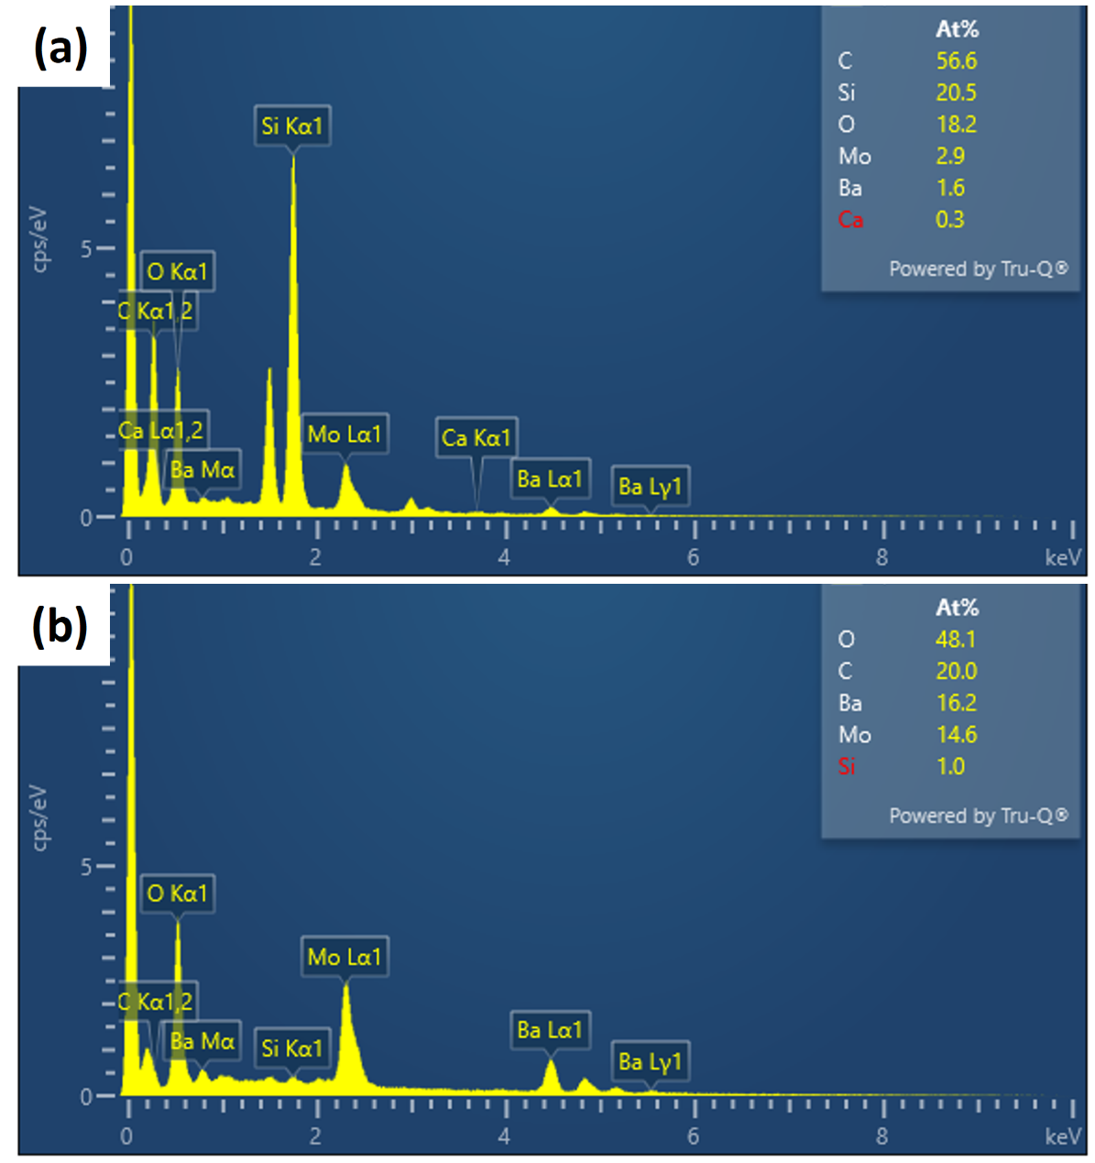
Figure S4. Comparison of the composition of 700 nm BaMoO₃ film before and after CV in HER conditions: (a) and (b) show EDX data of BaMoO₃ film in the exposed area (location 3, Figure 3b) and unreacted area (location 4, Figure 3b), respectively.

References
1. Baeumer, C. et al. Tuning electrochemically driven surface transformation in atomically flat LaNiO3 thin films for enhanced water electrolysis. Nat. Mater. 20, 674–682 (2021).
2. Shibata, T. et al. Versatile van der Waals epitaxy-like growth of crystal films using two-dimensional nanosheets as a seed layer: orientation tuning of SrTiO3 films along three important axes on glass substrates. J. Mater. Chem. C 2, 441–449 (2013).
3. Nguyen, M. D. et al. Highly Oriented Growth of Piezoelectric Thin Films on Silicon Using Two-Dimensional Nanosheets as Growth Template Layer. ACS Appl. Mater. Interfaces 8, 31120–31127 (2016).
4. Le, P. T. P. et al. Tailoring Vanadium Dioxide Film Orientation Using Nanosheets: a Combined Microscopy, Diffraction, Transport, and Soft X-Ray in Transmission Study. Advanced Functional Materials 30, 1900028 (2020).
5. Le, P. T. P., Huang, S., Nguyen, M. D., ten Elshof, J. E. & Koster, G. Tuning the metal insulator transition of vanadium dioxide on oxide nanosheets. Applied Physics Letters 119, 081601 (2021).
6. Le, P. T. P. et al. Correlated Metals Transparent Conductors with High UV to Visible Transparency on Amorphous Substrates. Advanced Materials Interfaces 10, 2201335 (2023).
7. Le, P. T. P., ten Elshof, J. E. & Koster, G. Shape Control of Ca2Nb3O10 Nanosheets: Paving the Way for Monolithic Integration of Functional Oxides with CMOS. ACS Appl. Nano Mater. 3, 9487–9493 (2020).

