- Supplementary Table S1.Proportional Hazards Assumption Tests for Air Pollutant Exposures in the Cox Models
- Supplementary Table S2. Subgroup and interaction analyses of air pollutant exposure and risk of cardiac events
- Supplementary Table S3. Multi-pollutant Cox regression models for incident heart disease risk
- SupplementaryTable S4. Hazard ratios for PM₂.₅ and O₃ across long-term exposure windows
- Supplementary Table S5. Variance inflation factors (VIFs) for PM₂.₅ with other pollutants.
- Supplementary Table S6. Sensitivity analyses for extreme values of PM₂.₅ exposure.
- Supplementary Table S7. Sensitivity analyses of PM₂.₅ associations using city-level clustering and frailty models
- Supplementary Table S8. Sensitivity analysis of PM₂.₅ effects
- Supplementary Table S9. Collinearity diagnostics (Correlation coefficients and VIF)
- Supplementary Table S10. Exploratory pollutant–pollutant interaction terms (Cox regression, fully adjusted)
- Supplementary Table S11. Hazard ratios (HRs) for single-pollutant models expressed per 1-SD and per 10 μg/m³ increases.

Supplementary Table S1.Proportional Hazards Assumption Tests for Air Pollutant Exposures in the Cox Models
Exposure | n / events | PH test for exposure (P) | Global PH test (P)
NO₂ | 7750 / 1412 | 0.585 | 0.0089
O₃ | 7750 / 1412 | 0.564 | 0.008
PM₁ | 7750 / 1412 | 0.981 | 0.0089
PM₁₀ | 7750 / 1412 | 0.133 | 0.0054
PM₂.₅ | 7750 / 1412 | 0.628 | 0.0084

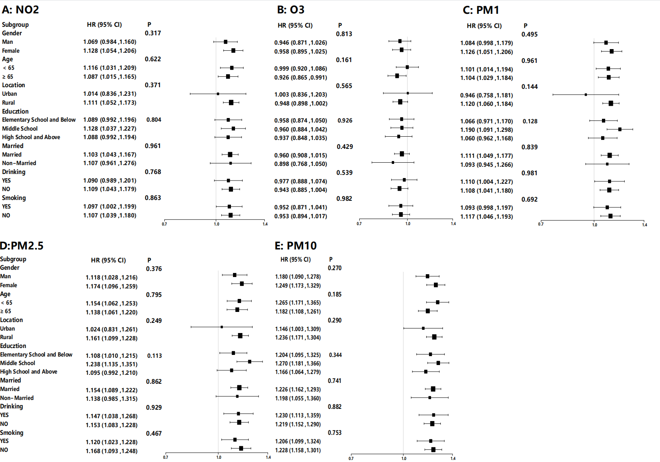
Figure S1. Subgroup-specific interaction analyses of the associations between air pollution exposure and mortality risk

Supplementary Table S2. Subgroup and interaction analyses of air pollutant exposure and risk of cardiac events
Subgroup | NO₂ HR (95% CI) | O₃ HR (95% CI) | PM₁ HR (95% CI) | PM₂.₅ HR (95% CI) | PM₁₀ HR (95% CI)
Gender
Male | 1.069 (0.984, 1.160) | 0.946 (0.871, 1.026) | 1.084 (0.998, 1.179) | 1.118 (1.028, 1.216) | 1.180 (1.090, 1.278)
Female | 1.128 (1.054, 1.206) | 0.958 (0.895, 1.025) | 1.126 (1.051, 1.206) | 1.174 (1.096, 1.258) | 1.249 (1.173, 1.329)
P for interaction | 0.317 | 0.813 | 0.495 | 0.376 | 0.27
Age
<65 | 1.116 (1.031, 1.209) | 0.999 (0.920, 1.086) | 1.101 (1.014, 1.194) | 1.154 (1.062, 1.253) | 1.265 (1.171, 1.365)
≥65 | 1.087 (1.015, 1.165) | 0.926 (0.865, 0.991) | 1.104 (1.029, 1.184) | 1.138 (1.061, 1.220) | 1.182 (1.108, 1.261)
P for interaction | 0.622 | 0.161 | 0.961 | 0.795 | 0.185
Location
Urban | 1.014 (0.836, 1.231) | 1.003 (0.836, 1.203) | 0.946 (0.758, 1.181) | 1.024 (0.831, 1.261) | 1.146 (1.003, 1.309)
Rural | 1.111 (1.052, 1.173) | 0.948 (0.898, 1.002) | 1.120 (1.060, 1.184) | 1.161 (1.099, 1.228) | 1.236 (1.171, 1.304)
P for interaction | 0.371 | 0.565 | 0.144 | 0.249 | 0.29
Education
Elementary or below | 1.089 (0.992, 1.196) | 0.958 (0.874, 1.050) | 1.066 (0.971, 1.170) | 1.108 (1.010, 1.215) | 1.204 (1.095, 1.325)
Middle school | 1.128 (1.037, 1.227) | 0.960 (0.884, 1.042) | 1.190 (1.091, 1.298) | 1.238 (1.135, 1.351) | 1.270 (1.181, 1.366)
High school or above | 1.088 (0.992, 1.194) | 0.937 (0.848, 1.035) | 1.060 (0.962, 1.168) | 1.095 (0.992, 1.210) | 1.166 (1.064, 1.279)
P for interaction | 0.961 | 0.926 | 0.128 | 0.113 | 0.344

Supplementary Table S3. Multi-pollutant Cox regression models for incident heart disease risk
Core Pollutant | Model | Pollutant | HR (95% CI) | P-value
PM₂.₅ | + NO₂ | PM₂.₅ | 1.110 (1.052-1.171) | <0.001
 |  | NO₂ | 0.964 (0.878-1.058) | 0.440
 | + O₃ | PM₂.₅ | 1.104 (1.068-1.141) | <0.001
 |  | O₃ | 0.865 (0.789-0.948) | 0.002
 | + O₃ + NO₂ | PM₂.₅ | 1.065 (1.004-1.130) | 0.036
 |  | O₃ | 0.820 (0.730-0.921) | <0.001
 |  | NO₂ | 1.093 (0.969-1.233) | 0.147
PM₁₀ | + NO₂ | PM₁₀ | 1.087 (1.066-1.109) | <0.001
 |  | NO₂ | 0.914 (0.851-0.981) | 0.014
 | + O₃ | PM₁₀ | 1.084 (1.066-1.102) | <0.001
 |  | O₃ | 0.802 (0.729-0.882) | <0.001
 | + O₃ + NO₂ | PM₁₀ | 1.088 (1.065-1.111) | <0.001
 |  | O₃ | 0.813 (0.732-0.903) | <0.001
 |  | NO₂ | 0.975 (0.899-1.057) | 0.552
O₃ | + NO₂ | O₃ | 0.779 (0.700-0.867) | <0.001
 |  | NO₂ | 1.216 (1.138-1.299) | <0.001
 | + PM₂.₅ | O₃ | 0.865 (0.789-0.948) | 0.002
 |  | PM₂.₅ | 1.104 (1.068-1.141) | <0.001
NO₂ | + O₃ | NO₂ | 1.216 (1.138-1.299) | <0.001
 |  | O₃ | 0.779 (0.700-0.867) | <0.001
 | + PM₂.₅ | NO₂ | 0.964 (0.878-1.058) | 0.440
 |  | PM₂.₅ | 1.110 (1.052-1.171) | <0.001
Multi-pollutant model (after VIF verification) | + O₃ + NO₂ | PM₂.₅ | 1.065 (1.004-1.130) | 0.036
 |  | O₃ | 0.820 (0.730-0.921) | <0.001
 | + O₃ + NO₂ | PM₁₀ | 1.088 (1.065-1.111) | <0.001
 |  | O₃ | 0.813 (0.732-0.903) | <0.001

SupplementaryTable S4. Hazard ratios for PM₂.₅ and O₃ across long-term exposure windows
Window | PM₂.₅ | P | O₃ | P
Window | HR (95% CI) | P | HR (95% CI) | P
Single Year
2008 | 1.082 (1.047–1.117) | <0.001 | 0.932 (0.852–1.019) | 0.121
2009 | 1.092 (1.059–1.126) | <0.001 | 0.859 (0.791–0.932) | <0.001
2010 | 1.098 (1.063–1.134) | <0.001 | 0.999 (0.914–1.093) | 0.99
Mean_2y
2008–2009 | 1.088 (1.054–1.123) | <0.001 | 0.889 (0.815–0.969) | 0.007
2009–2010 | 1.095 (1.061–1.130) | <0.001 | 0.916 (0.840–1.000) | 0.05
2008–2010 | 1.091 (1.057–1.127) | <0.001 | 0.920 (0.842–1.006) | 0.066
Leave-one-out
2008 | 1.095 (1.061–1.130) | <0.001 | 0.916 (0.840–1.000) | 0.05
2009 | 1.090 (1.055–1.126) | <0.001 | 0.964 (0.880–1.055) | 0.426
2010 | 1.088 (1.054–1.123) | <0.001 | 0.889 (0.815–0.969) | 0.007
Note: Exposure windows include single-year averages (2008, 2009, 2010), two-year averages (2008–2009, 2009–2010), the three-year average (2008–2010, main analysis), and a leave-one-out approach (recalculating the three-year mean after excluding one year).

Supplementary Table S5. Variance inflation factors (VIFs) for PM₂.₅ with other pollutants.
Predictor vs. PM₂.₅ | VIF | Flag
PM₁ | 6.35 | > threshold
NO₂ | 5.9 | > threshold
PM₁₀ | 3.48 | OK
O₃ | 1.72 | OK
Note: VIFs were calculated to assess multicollinearity, with a threshold set at 5. PM₁ and NO₂ demonstrated moderate collinearity with PM₂.₅, while PM₁₀ and O₃ showed relatively low collinearity.

Supplementary Table S6. Sensitivity analyses for extreme values of PM₂.₅ exposure.
Analysis | HR (95% CI) | P | N
Winsorized 1%/99% | 1.092 (1.057–1.127) | <0.001 | 7750
City trim top/bottom 1% | 1.091 (1.054–1.128) | <0.001 | 7496

Supplementary Table S7. Sensitivity analyses of PM₂.₅ associations using city-level clustering and frailty models
Model | HR (95% CI) | P
Cluster (city) | 1.091 (1.027–1.159) | 0.005
Frailty (city) | 1.055 (0.993–1.121) | 0.085

Supplementary Table S8. Sensitivity analysis of PM₂.₅ effects
Model specification | Method | HR (95% CI) | P-value
PM₂.₅ (single-pollutant) | Cox regression | 1.091 (1.057–1.127) | <0.001
PM₂.₅ + O₃ | Cox regression | 1.104 (1.068–1.141) | <0.001
PM₂.₅ + NO₂ | Cox regression | 1.110 (1.052–1.170) | <0.001
PM₂.₅ + O₃ + NO₂ | Cox regression | 1.065 (1.004–1.129) | 0.036
Core model (VIF < 5) | Cox regression | 1.091 (1.057–1.127) | <0.001
Ridge regression (simplified) | Ridge regression | 1.146 (–) | –

Supplementary Table S9. Collinearity diagnostics (Correlation coefficients and VIF)

A. Correlation matrix
Pollutant | PM₁ | PM₂.₅ | PM₁₀ | NO₂ | O₃
PM₁ | 1 | 0.97 | 0.84 | 0.86 | 0.29
PM₂.₅ | 0.97 | 1 | 0.91 | 0.81 | 0.25
PM₁₀ | 0.84 | 0.91 | 1 | 0.76 | 0.33
NO₂ | 0.86 | 0.81 | 0.76 | 1 | 0.55
O₃ | 0.29 | 0.25 | 0.33 | 0.55 | 1

B. Variance Inflation Factor (VIF)
Model | PM₁ | PM₂.₅ | PM₁₀ | NO₂ | O₃
Model 1 | 9 | 6.35 | 20.6 | 21.6 | 28.8
Model 2 | 6.42 | 3.48 | 15.9 | 39 | 39.5
Model 3 | 4.62 | 5.9 | 5.89 | 8.55 | 8.62
Model 4 | 1.78 | 1.72 | 1.71 | 1.28 | 4.44
Notes:
a) VIF thresholds: VIF > 10 indicates severe multicollinearity (highlighted in red), VIF < 5 suggests acceptable collinearity.
b) Model 4 represents the final optimized model after collinearity diagnostics.
c) Correlation coefficients >0.8 imply strong collinearity (e.g., PM₁-PM₂.₅: r=0.97).
d) VIF calculation: Variance Inflation Factors were computed using the car::vif() function in R.
e) All models adjusted for: age, gender, education, location, marital status, smoking, drinking, social activity, BMI, hypertension, and diabetes.

Supplementary Table S10. Exploratory pollutant–pollutant interaction terms (Cox regression, fully adjusted)
Interaction term | HR (95% CI) | P-value | FDR q-value
PM₂.₅ × NO₂ | 1.001 (1.001–1.001) | 2.64 × 10⁻⁸ | 2.64 × 10⁻⁸
PM₂.₅ × O₃ | 1.002 (1.002–1.003) | 1.61 × 10⁻¹¹ | 1.61 × 10⁻¹¹
NO₂ × O₃ | 1.001 (1.000–1.003) | 1.89 × 10⁻² | 1.89 × 10⁻²

Supplementary Table S11. Hazard ratios (HRs) for single-pollutant models expressed per 1-SD and per 10 μg/m³ increases.
Pollutant | HR (95% CI) per 1-SD | HR (95% CI) per 10 μg/m³
PM₁ | 1.114 (1.056,1.175) | 1.126 (1.061,1.195)
PM₂.₅ | 1.158 (1.097,1.223) | 1.091 (1.057,1.127)
PM₁₀ | 1.231 (1.172,1.294) | 1.070 (1.053,1.087)
NO₂ | 1.108 (1.051,1.167) | 1.115 (1.054,1.179)
O₃ | 0.952 (0.903,1.003) | 0.920 (0.842,1.006)
Notes: Hazard ratios per 10 μg/m³ were derived from the per-SD estimates using pollutant-specific standard deviations from the study population.

