Supporting information
Supplementary Figure 1. The distribution of the predictive score in the derivation and validation datasets.
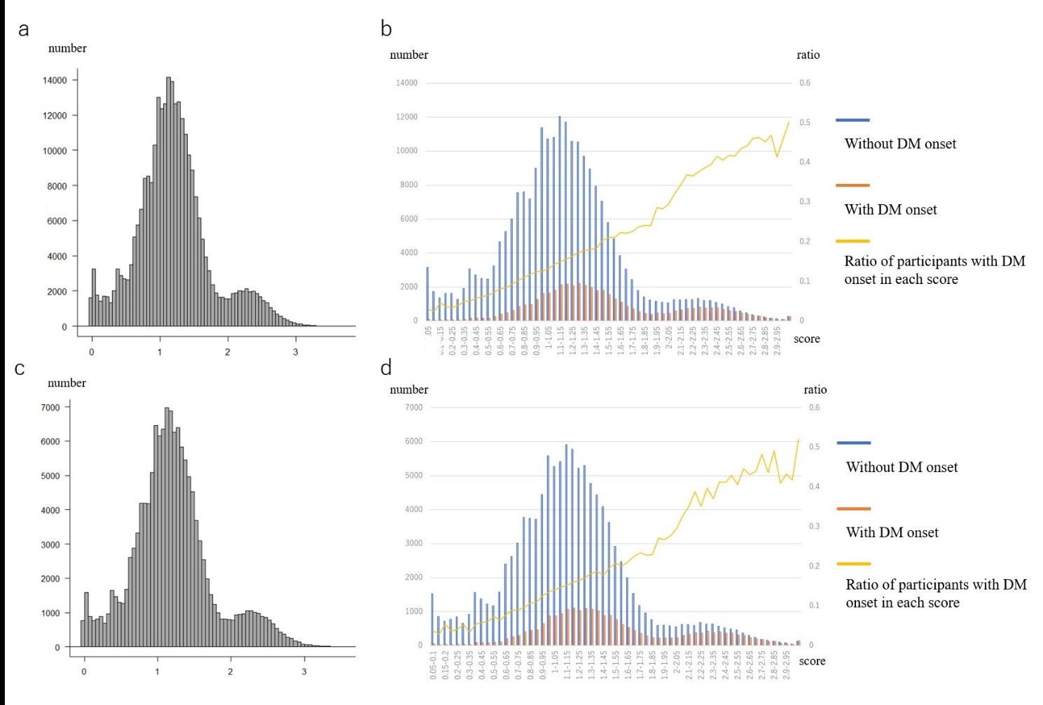
(a) Histogram of the predictive score for all patients in the derivation dataset.
(b) Distribution among individuals who developed diabetes and those who did not in the derivation dataset, along with the proportion of type 2 diabetes mellitus onset at each score level.
(c) Histogram of the predictive score for all patients in the validation dataset.
(d) Distribution among individuals who developed diabetes and those who did not in the validation dataset, along with the proportion of type 2 diabetes mellitus onset at each score level.

Supplementary Figure 2. The cumulative incidence curves for the onset of type 2 diabetes mellitus classified by score category from derivation data set.

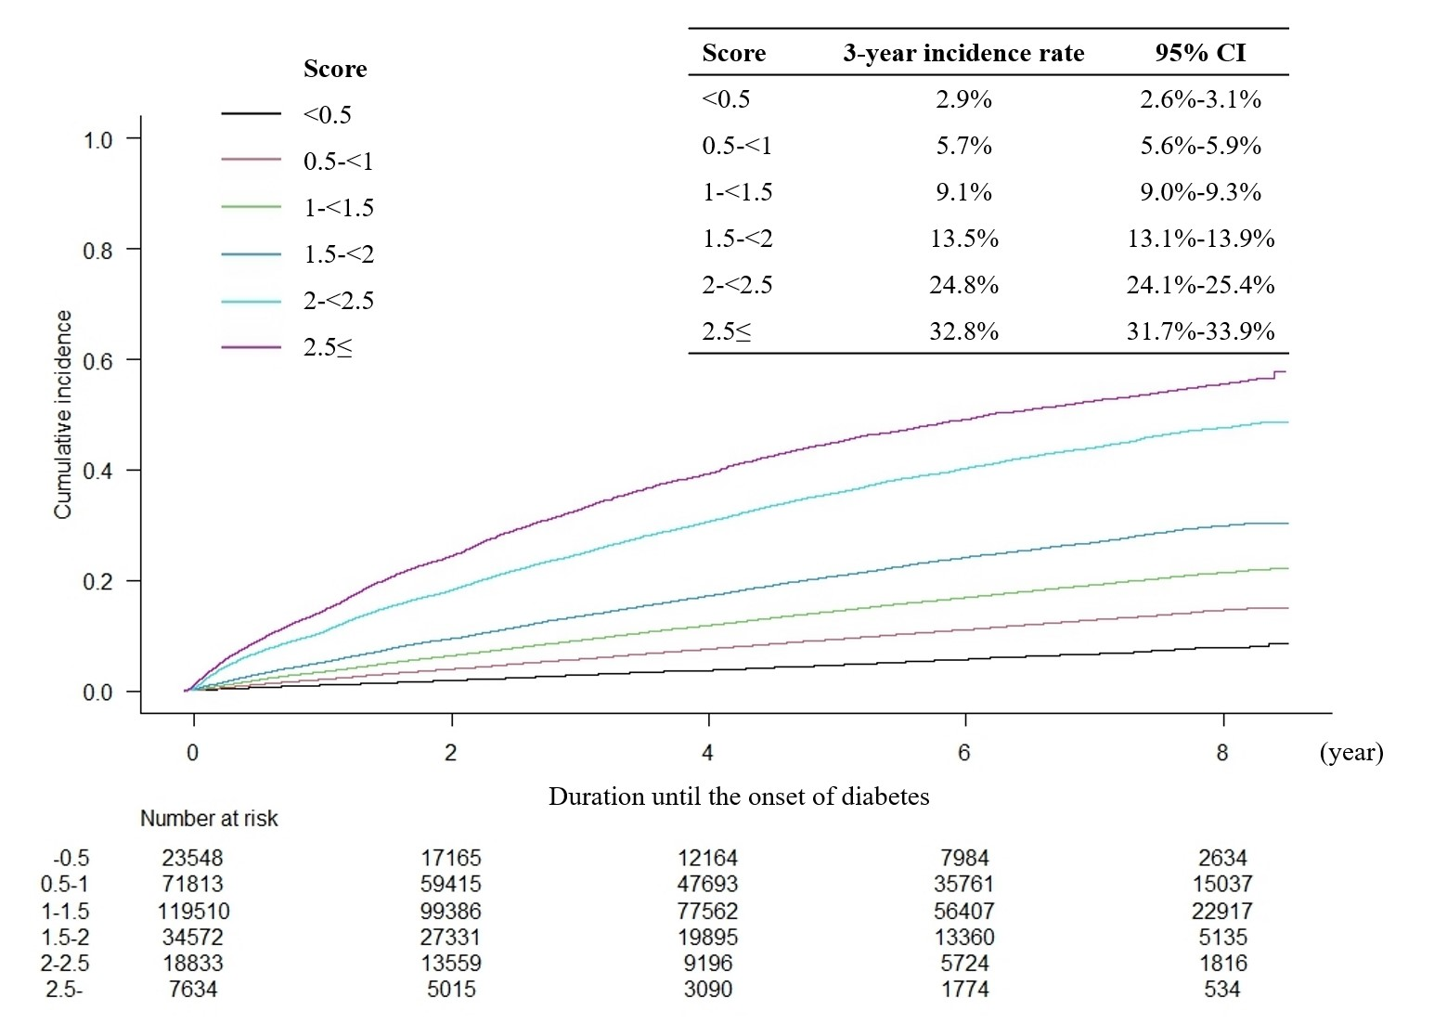
Patients were classified into the following score categories: less than 0.5, 0.5 to less than 1, 1 to less than 1.5, 1.5 to less than 2, 2 to less than 2.5, and 2.5 or higher.

Supplementary Table 1. Contents of Annual Health Examination.

Content | Major variable
Basic information | examination date, age, sex
Questionnaire responses | medication, lifestyle (current smoking, alcohol drinking, exercise, eating, sleep)
Anthropometric factors | height, weight, waist circumference (ages 40–74 years)
Blood pressure | systolic and diastolic
Hematological values | red blood cell count, hematocrit, hemoglobin
Biochemical values | aspartate aminotransferase, alanine aminotransferase, γ-glutamyl transpeptidase, triglyceride, high-density lipoprotein cholesterol, low-density lipoprotein cholesterol, fasting glucose and hemoglobin A1c, serum creatinine c
Urinalysis | glucose, protein
Physiological test | electrocardiography, fundoscopy
Physician consultation | disease history, medication history, subjective and objective symptoms

Supplementary Table 2. Definitions of diabetic rerated agents according to drug codes.

Drug classification | ATC name | Drug code | ATC code
Insulin | Insulin glargine (Genetical Recombination) | 3969501 | A10AE54
 | Lixisenatide | 3969501 | A10AE54
 | Insulin degludec (Genetical Recombination) | 3969500 | A10AE56
 | Liraglutide (Genetical Recombination) | 3969500 | A10AE56
 | Insulin human (Genetical Recombination) | 2492403 | A10AE56
 |  | 2492413 | A10AE56
 | Insulin lispro (Genetical Recombination) | 2492414 | A10AB04
 |  |  | A10AC04
 |  |  | A10AD04
 | Insulin aspart (Genetical Recombination) | 2492415 | A10AB05
 |  |  | A10AD05
 | Insulin glulisine | 2492418 | A10AB06
 | Insulin degludec (Genetical Recombination) | 2492500 | A10AD06
 | Insulin aspart (Genetical Recombination) | 2492500 | A10AD06
 | Insulin glargine (Genetical Recombination) | 2492416 | A10AE04
 | Insulin glargine (Genetical Recombination) [Insulin Glargine Biosimilar 1] | 2492420 | A10AE04
 | Insulin detemir (Genetical Recombination) | 2492417 | A10AE05
 | Insulin degludec (Genetical Recombination) | 2492419 | A10AE06
 | Insulin lispro (Genetical Recombination) | 2492422 | A10AB04
 | [Insulin lispro biosimilar 1] |  | A10AC04
 |  |  | A10AD04
Diabetes agent | Metformin hydrochloride | 3962002 | A10BA02
 | Buformin hydrochloride | 3962001 | A10BA03
 | Pioglitazone hydrochloride | 3969100 | A10BD05
 | Metformin hydrochloride | 3969100 | A10BD05
 | Glibenclamide hydrate | 3961003 | A10BB01
 | Glibenclamide | 3961003 | A10BB01
 | Chlorpropamide | 3961004 | A10BB02
 | Gliclazide | 3961007 | A10BB09
 | Glimepiride | 3961008 | A10BB12
 | Acetohexamide | 3961001 | A10BB31
 | Pioglitazone hydrochloride | 3969101 | A10BD06
 | Glimepiride | 3969101 | A10BD06
 | Vildagliptin | 3969104 | A10BD08
 | Metformin hydrochloride | 3969104 | A10BD08
 | Alogliptin benzoate | 3969103 | A10BD09
 | Pioglitazone hydrochloride | 3969103 | A10BD09
 | Alogliptin benzoate | 3969105 | A10BD13
 | Metformin hydrochloride | 3969105 | A10BD13
 | Empagliflozin | 3969108 | A10BD19
 | Linagliptin | 3969108 | A10BD19
 | Acarbose | 3969003 | A10BF01
 | Miglitol | 3969009 | A10BF02
 | Voglibose | 3969004 | A10BF03
 | Pioglitazone hydrochloride | 3969007 | A10BG03
 | Sitagliptin phosphate hydrate | 3969010 | A10BH01
 | Vildagliptin | 3969011 | A10BH02
 | Saxagliptin hydrate | 3969017 | A10BH03
 | Alogliptin benzoate | 3969012 | A10BH04
 | Linagliptin | 3969014 | A10BH05
 | Teneligliptin hydrobromide hydrate | 3969015 | A10BH08
 | Anagliptin | 3969016
 | Trelagliptin succinate | 3969024
 | Omarigliptin | 3969025
 | Dapagliflozin propylene glycolate hydrate | 3969019 | A10BK01
 | Canagliflozin hydrate | 3969022 | A10BK02
 | Empagliflozin | 3969023 | A10BK03
 | Ipragliflozin L-proline | 3969018 | A10BK05
 | Luseogliflozin hydrate | 3969020 | A10BK07
 | Tofogliflozin hydrate | 3969021
 | Repaglinide | 3969013 | A10BX02
 | Nateglinide | 3969006 | A10BX03
 | Mitiglinide calcium hydrate | 3969008 | A10BX08
 | Imeglimin hydrochloride | 3969026 | A10BX15
 | Mitiglinide calcium hydrate | 3969102
 | Voglibose | 3969102
 | Teneligliptin hydrobromide hydrate | 3969106
 | Canagliflozin hydrate | 3969106
 | Sitagliptin phosphate hydrate | 3969107
 | Ipragliflozin L-proline | 3969107
 | Anagliptin | 3969109
 | Metformin hydrochloride | 3969109
 | Exenatide | 2499411 | A10BJ01
 | Liraglutide (Genetical Recombination) | 2499410 | A10BJ02
 | Lixisenatide | 2499415 | A10BJ03
 | Dulaglutide (Genetical Recombination) | 2499416 | A10BJ05
 | Semaglutide (Genetical Recombination) | 2499418 | A10BJ06
 | Semaglutide (Genetical Recombination) | 2499014 | A10BJ06

ATC; Anatomical Therapeutic Chemical.

Supplementary Table 3. Japanese codes for diabetes milieus and comorbidities according to ICD-10.
Disease | ICD-10 codes
Diabetes | E10, E11, E14
Type 1 diabetes | E10
Type 2 diabetes | E11, 14
Any diabetic complication | E102, E103, E104, E105, E106, E107, E108, E112, E113, E114, E115, E116, E117, E118, E122, E123, E124, E125, E126, E127, E128, E132, E133, E134, E135, E136, E137, E138, E142, E143, E144, E145, E146, E147, E148
Any malignancy (except for nonmelanoma skin cancer) | C00-C53, C54, C55-C76, C81-C85, C88, C90-C97
Metastatic solid tumor | C77-C80
ICD-10; International Statistical Classification of Diseases and Related Health Problems 10th Revision

Supplementary Table 4. Comparison of patient profiles between derivation and validation datasets.

Variable | Category or unit | Derivation dataset | Validation dataset | p-value
Variable | Category or unit | n = 308,832 | n = 154,416 | p-value
Age | 1 year | 66.77 (11.45) | 66.81 (11.47) | 0.310
Age as categorical variable | <50 years | 31077 (10.1) | 15404 (10.0) | 0.575
 | 50-<60 years | 30432 (9.9) | 15193 (9.8)
 | 60-<70 years | 123898 (40.1) | 61754 (40.0)
 | 70-<80 years | 84337 (27.3) | 42493 (27.5)
 | ≥80 years | 39088 (12.7) | 19572 (12.7)
Sex | Female | 195210 (63.2) | 97542 (63.2) | 0.789
Health checkup
BMI (kg/m²) | <18.5 | 30858 (10.0) | 15438 (10.0) | 0.928
 | 18.5-<22 | 115181 (37.3) | 57616 (37.3)
 | 22-<25 | 100823 (32.7) | 50379 (32.6)
 | 25-<30 | 54711 (17.7) | 27300 (17.7)
 | ≥30 | 7077 (2.3) | 3603 (2.3)
Systolic blood pressure (mmHg) | <120 | 85362 (27.6) | 42495 (27.5) | 0.972
 | 120-<130 | 76380 (24.7) | 38284 (24.8)
 | 130-<140 | 70589 (22.9) | 35328 (22.9)
 | 140-<150 | 40383 (13.1) | 20182 (13.1)
 | 150-<160 | 19883 (6.4) | 9986 (6.5)
 | ≥160 | 16151 (5.2) | 8093 (5.2)
Diastolic blood pressure (mmHg) | <70 | 90130 (29.2) | 44858 (29.1) | 0.664
 | 70-<80 | 108210 (35.0) | 54339 (35.2)
 | 80-<90 | 79685 (25.8) | 39775 (25.8)
 | 90-<100 | 23800 (7.7) | 11987 (7.8)
 | ≥100 | 6910 (2.2) | 3400 (2.2)
Hematocrit (%) | ≥50 | 5003 (2.0) | 2613 (2.0) | 0.177
 | 40-50 | 165728 (64.9) | 82599 (64.8)
 | 30-<40 | 83429 (32.7) | 41584 (32.6)
 | <30 | 1277 (0.5) | 672 (0.5)
Hemoglobin (g/dL) | ≥15.5 | 25463 (10.0) | 12784 (10.0) | 0.268
 | 13.5-<15.5 | 109128 (42.7) | 54447 (42.7)
 | 11.5-<13.5 | 106287 (41.6) | 52800 (41.4)
 | <11.5 | 14621 (5.7) | 7475 (5.9)
Erythrocyte count (10⁴/µL) | ≥550 | 2961 (1.2) | 1572 (1.2) | 0.061
 | 450-<550 | 107796 (42.2) | 54105 (42.4)
 | 350-<450 | 140297 (54.9) | 69580 (54.5)
 | <350 | 4584 (1.8) | 2327 (1.8)
Triglyceride (mg/dL) | <100 | 168454 (54.6) | 84284 (54.6) | 0.509
 | 100-<150 | 82967 (26.9) | 41266 (26.7)
 | ≥150 | 57364 (18.6) | 28838 (18.7)
HDL cholesterol (mg/dL) | ≥40 | 294412 (95.3) | 147103 (95.3) | 0.330
 | <40 | 14369 (4.7) | 7284 (4.7)
LDL cholesterol (mg/dL) | <120 | 132848 (43.0) | 65936 (42.7) | 0.118
 | 120-<140 | 77711 (25.2) | 39126 (25.3)
 | ≥140 | 98182 (31.8) | 49307 (31.9)
AST (IU/L) | <30 | 266927 (86.4) | 133402 (86.4) | 0.899
 | 30-<50 | 36529 (11.8) | 18334 (11.9)
 | ≥50 | 5373 (1.7) | 2678 (1.7)
ALT (IU/L) | <30 | 274030 (88.7) | 137005 (88.7) | 0.952
 | 30-<50 | 26603 (8.6) | 13286 (8.6)
 | ≥50 | 8196 (2.7) | 4121 (2.7)
γ–GTP (IU/L) | <50 | 271357 (87.9) | 135612 (87.8) | 0.610
 | 50-<100 | 26694 (8.6) | 13456 (8.7)
 | ≥100 | 10734 (3.5) | 5312 (3.4)
HbA1c (%) | <5.5 | 118163 (38.6) | 58995 (38.5) | 0.753
 | 5.5-<6 | 155688 (50.8) | 77829 (50.8)
 | 6-<6.5 | 32485 (10.6) | 16351 (10.7)
eGFR (ml/min/1.73 m²) | ≥60 (G1-G2) | 238169 (77.1) | 119077 (77.1) | 0.962
 | 45-<60 (G3a) | 60446 (19.6) | 30207 (19.6)
 | 30-<45 (G3b) | 10217 (3.3) | 5132 (3.3)
 |  | 16954 (4.3) | 8618 (4.4)
Uric acid (mg/dL) | ≥9 | 1752 (0.6) | 951 (0.6) | 0.140
 | 7-<9 | 26346 (8.9) | 13132 (8.8)
 | 5-<7 | 128863 (43.3) | 64145 (43.1)
 | <5 | 140591 (47.2) | 70498 (47.4)
Urinary protein | – | 266324 (86.7) | 132997 (86.6) | 0.726
 | ± | 26494 (8.6) | 13343 (8.7)
 | ≥+ | 14465 (4.7) | 7256 (4.7)
Taken medication for common ailments
Medication for hypertension | Presence | 107354 (34.8) | 53712 (34.8) | 0.881
Medication for dyslipidemia | Presence | 76461 (24.8) | 37989 (24.6) | 0.246
Lifestyle habits
Habitual smoker† | Presence | 37600 (12.2) | 18923 (12.3) | 0.438
Exercise habits‡ | Presence | 139928 (50.1) | 69852 (50.0) | 0.624
≥10-kg weight gain since age 20 | Presence | 77031 (27.5) | 38247 (27.3) | 0.181
Heavy drinking§ | Presence | 14049 (4.5) | 6966 (4.5) | 0.564

BMI: body mass index, HDL: high-density lipoprotein, LDL: low-density lipoprotein, AST: aspartate aminotransferase, ALT: alanine aminotransferase, GTP: glutamyl transpeptidase.
†Habitual smoker was defined as a person who has smoked >100 cigarettes or has been a habitual smoker for ≥6 months and smoked for >1 month.
‡Exercise habit was defined a person who performed exercise that involved slight sweating for 30 minutes or more at least twice a week for over 1 year.
§Heavy drinking was defined as a person who consumes alcohol daily with a daily intake exceeding 360 mL.

Supplementary Table 5. Spearman’s correlation matrix
 | Age | Sex | BMI | SBP | DBP | Ht | Hb | RBC | TG | HDL | LDL | AST | ALT | γ-GTP | HbA1c | eGFR | UA | UP | HT | DL | Smoking | Exercise | Weight gain | Drinking
Age | 1.000
Sex | 0.104 | 1.000
BMI | -0.052 | -0.173 | 1.000
SBP | 0.262 | -0.033 | 0.163 | 1.000
DBP | -0.022 | -0.141 | 0.180 | 0.587 | 1.000
Ht | 0.173 | 0.363 | -0.204 | -0.062 | -0.191 | 1.000
Hb | 0.230 | 0.508 | -0.245 | -0.062 | -0.223 | 0.725 | 1.000
RBC | 0.253 | 0.361 | -0.232 | -0.042 | -0.190 | 0.577 | 0.679 | 1.000
TG | -0.013 | 0.138 | 0.284 | 0.107 | 0.112 | -0.169 | -0.204 | -0.188 | 1.000
HDL | 0.025 | -0.156 | 0.123 | 0.014 | 0.016 | -0.046 | -0.072 | -0.068 | 0.223 | 1.000
LDL | -0.080 | 0.081 | 0.078 | 0.028 | 0.064 | -0.108 | -0.106 | -0.134 | 0.151 | -0.042 | 1.000
AST | 0.027 | -0.099 | 0.065 | 0.068 | 0.066 | -0.068 | -0.101 | -0.046 | 0.071 | 0.041 | -0.049 | 1.000
ALT | -0.134 | -0.174 | 0.211 | 0.039 | 0.095 | -0.163 | -0.226 | -0.183 | 0.170 | 0.090 | 0.016 | 0.541 | 1.000
γ-GTP | -0.117 | -0.246 | 0.138 | 0.064 | 0.112 | -0.151 | -0.213 | -0.129 | 0.177 | 0.037 | -0.023 | 0.311 | 0.365 | 1.000
HbA1c | 0.105 | 0.033 | 0.136 | 0.058 | 0.014 | 0.000 | 0.011 | -0.059 | 0.111 | 0.039 | 0.084 | 0.017 | 0.058 | -0.003 | 1.000
eGFR | 0.322 | -0.005 | 0.052 | 0.082 | -0.002 | 0.084 | 0.102 | 0.098 | 0.060 | 0.055 | -0.033 | 0.019 | -0.036 | -0.035 | 0.039 | 1.000
UA | 0.010 | 0.448 | -0.260 | -0.091 | -0.131 | 0.222 | 0.301 | 0.221 | -0.219 | -0.119 | -0.004 | -0.121 | -0.176 | -0.210 | -0.060 | -0.216 | 1.000
UP | 0.086 | -0.066 | 0.040 | 0.070 | 0.035 | 0.000 | -0.003 | 0.000 | 0.031 | 0.040 | -0.032 | 0.047 | 0.030 | 0.040 | 0.006 | 0.100 | -0.060 | 1.000
HT | 0.333 | -0.009 | 0.160 | 0.226 | 0.074 | 0.050 | 0.063 | 0.074 | 0.072 | 0.042 | -0.156 | 0.054 | 0.020 | 0.035 | 0.070 | 0.207 | -0.114 | 0.092 | 1.000
DL | 0.210 | 0.129 | 0.087 | 0.061 | -0.023 | 0.043 | 0.076 | 0.060 | 0.067 | -0.006 | -0.184 | 0.031 | 0.011 | -0.028 | 0.127 | 0.120 | 0.022 | 0.020 | 0.301 | 1.000
Smoking | -0.198 | -0.269 | 0.020 | -0.044 | 0.027 | -0.154 | -0.215 | -0.127 | 0.106 | 0.087 | -0.033 | 0.027 | 0.070 | 0.140 | -0.044 | -0.081 | -0.128 | 0.032 | -0.074 | -0.099 | 1.000
Exercise | 0.106 | 0.147 | -0.556 | -0.086 | -0.126 | 0.169 | 0.210 | 0.200 | -0.230 | -0.105 | -0.057 | -0.072 | -0.208 | -0.138 | -0.105 | -0.013 | 0.206 | -0.040 | -0.095 | -0.050 | -0.054 | 1.000
Weight gain | -0.064 | 0.011 | 0.040 | -0.015 | 0.002 | 0.005 | -0.003 | -0.019 | 0.049 | 0.034 | 0.008 | -0.001 | 0.034 | 0.028 | -0.004 | -0.002 | -0.013 | 0.018 | -0.003 | -0.009 | 0.032 | -0.067 | 1.000
Drinking | -0.122 | -0.228 | 0.043 | 0.037 | 0.082 | -0.102 | -0.151 | -0.061 | 0.062 | -0.014 | -0.065 | 0.113 | 0.092 | 0.261 | -0.067 | -0.059 | -0.151 | 0.017 | -0.007 | -0.068 | 0.173 | -0.044 | 0.009 | 1.000
BMI: body mass index, SBP: systolic blood pressure, DBP: diastolic blood pressure, Ht: hematocrit, Hb: hemoglobin, RBC: Erythrocyte count, TG: triglyceride, HDL: high-density lipoprotein, LDL: low-density lipoprotein, AST: aspartate aminotransferase, ALT: alanine aminotransferase, GTP: glutamyl transpeptidase. UA: Uric acid, UP: urinary protein, HT: Medication for hypertension, DL: Medication for dyslipidemia, Smoking: Habitual smoker, Exercise: Exercise habits, Weight gain: weight change since age 20, Drinking: Heavy drinking
Supplementary Table 6. The predicted probability of the onset of type 2 diabetes mellitus at 1-year and 5-year.
Score | 1-year incidence rate (95% CI) | 5-year incident rate (95% CI)
<0.5 | 0.9% (0.8-1.1%) | 5.4% (4.9-5.9%)
0.5-<1 | 2.1% (2.0-2.3%) | 9.3% (9.0-9.7%)
1-<1.5 | 3.6% (3.4-3.7%) | 14.6% (14.3-14.9%)
1.5-<2 | 5.7% (5.4-6.1%) | 21.0% (20.4 -21.7%)
2-<2.5 | 10.5% (9.9-11.1%) | 36.4% (35.3-37.3%)
2.5≤ | 14.5% (13.4-15.6%) | 45.2% (43.5-46.9%)

CI: confidence interval

Supplementary Table 7. Post hoc statistical power by risk ratio and exposure prevalence (derivation -set baseline incidence 16.9%; α=0.05, two-sided)

Risk ratio | Exposure rate
Risk ratio | 0.002 | 0.005 | 0.01 | 0.02 | 0.05 | 0.1 | 0.2
1.10 | 0.196 | 0.411 | 0.686 | 0.930 | 1 | 1 | 1
1.15 | 0.372 | 0.731 | 0.953 | 0.999 | 1 | 1 | 1
1.20 | 0.579 | 0.926 | 0.998 | 1 | 1 | 1 | 1
1.25 | 0.763 | 0.988 | 1 | 1 | 1 | 1 | 1
1.30 | 0.890 | 0.999 | 1 | 1 | 1 | 1 | 1

Power was calculated for univariable comparisons across risk ratios 1.10–1.30 and exposure prevalences 0.2%–50%, using R 4.2.1 with the “TrialSize” framework (approximated via two-sample proportion tests; tabulation via statsmodels). Baseline incidence was 52,152/308,832.

