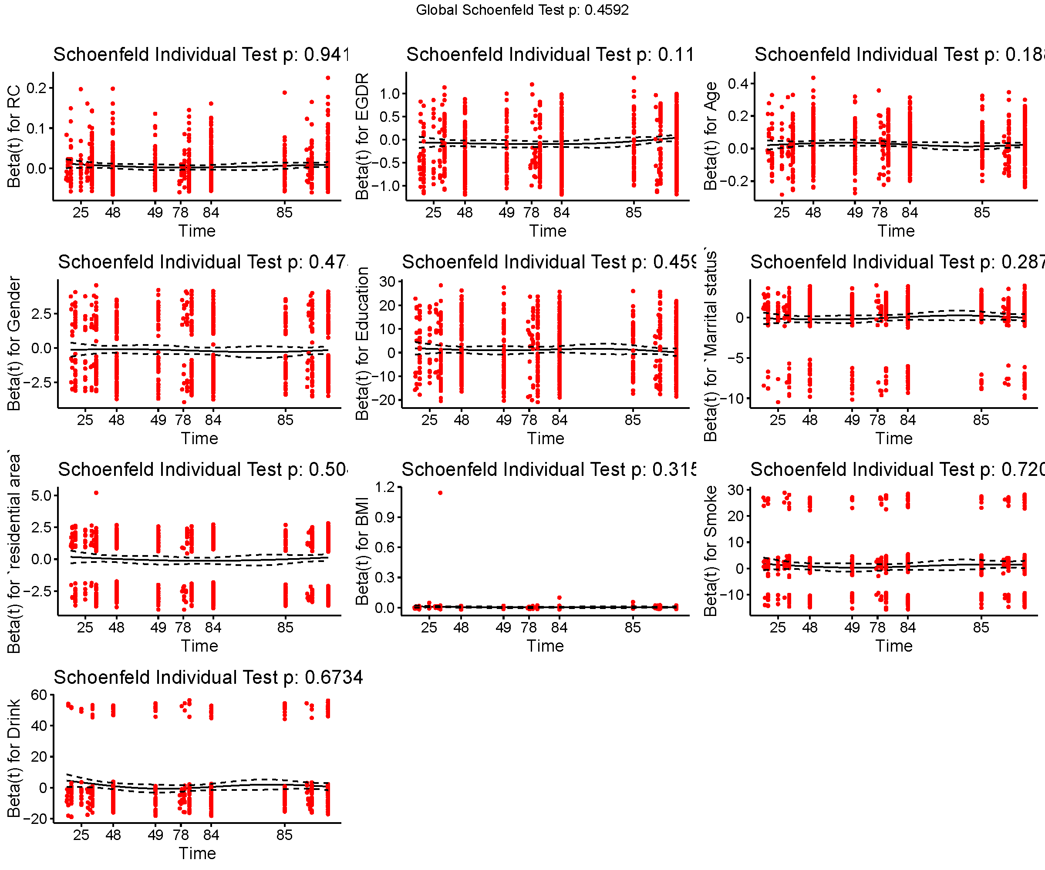
Fig. S1 Proportional hazard assumptions.

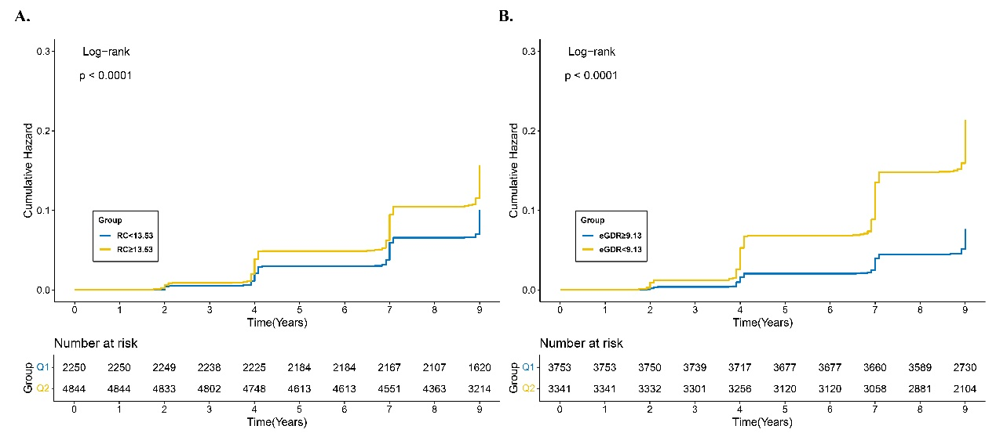
Fig. S2 Kaplan–Meier plot of CMM by RC (A) and eGDR (B) level. Abbreviation: CMM: cardiovascular metabolic multimorbidity, eGDR: estimated glucose disposal rate, RC: residual cholesterol.

Table S1 Variance Inflation Factor Analysis.
Characteristics | GVIF | Df | GVIF^(1/(2*Df))
Gender | 2.36 | 1 | 1.54
Education | 1.18 | 3 | 1.03
Marital status | 1.02 | 1 | 1.01
Residential area | 1.06 | 1 | 1.03
BMI | 1.01 | 1 | 1.00
Smoking | 2.03 | 2 | 1.19
Drink | 1.45 | 2 | 1.10

Table S2 Subgroup analysis for the association of the eGDR and RC on CMM risk
 | eGDR ≥ 9.13  & RC < 13.53 | eGDR ≥ 9.13  & RC ≥ 13.53 | eGDR < 9.13  & RC < 13.53 | eGDR < 9.13  & RC ≥ 13.53 | P for interaction
Age (years) |  |  |  |  | 0.585
< 60 | Reference | 1.42 (1.01–2.01) 0.046 | 2.44 (1.62–3.66) <0.001 | 3.79 (2.75–5.22) <0.001
≥ 60 | Reference | 1.40 (0.91–2.15) 0.121 | 2.60 (1.71–3.96) <0.001 | 3.16 (2.17–4.60) <0.001
Gender |  |  |  |  | 0.485
Female | Reference | 1.38 (0.97–1.95) 0.071 | 2.30 (1.57–3.36) <0.001 | 3.01 (2.19–4.14) <0.001
Male | Reference | 1.44 (0.94–2.20) 0.094 | 2.77 (1.79–4.30) <0.001 | 3.98 (2.72–5.83) <0.001
Smoking |  |  |  |  | 0.458
Never | Reference | 1.35 (0.98–1.87) 0.068 | 2.11 (1.48–3.00) <0.001 | 3.22 (2.40–4.32) <0.001
Ever | Reference | 0.88 (0.36–2.16) 0.777 | 2.76 (1.18–6.48) 0.019 | 3.03 (1.41–6.52) 0.005
Current | Reference | 1.86 (1.04–3.32) 0.035 | 3.74 (2.03–6.90) <0.001 | 4.13 (2.39–7.15) <0.001
Drinking |  |  |  |  | 0.807
Never | Reference | 1.52 (1.08–2.13) 0.015 | 2.72 (1.89–3.91) <0.001 | 3.42 (2.51–4.67) <0.001
Ever | Reference | 1.34 (0.51–3.50) 0.555 | 2.12 (0.78–5.78) 0.143 | 2.93 (1.24–6.92) 0.014
Current | Reference | 1.22 (0.73–2.02) 0.450 | 2.23 (1.31–3.78) 0.003 | 3.67 (2.35–5.75) <0.001
BMI |  |  |  |  | 0.052
Normal | Reference | 1.40 (1.02–1.93) 0.039 | 2.78 (1.97–3.91) <0.001 | 2.80 (2.07–3.79) <0.001
Overweight/obesity | Reference | 1.13 (0.68–1.86) 0.645 | 1.42 (0.83–2.43) 0.206 | 2.47 (1.56–3.90) 0.001
Residential area |  |  |  |  | 0.225
Urban | Reference | 1.47 (0.91–2.38) 0.115 | 3.02 (1.83–4.96) <0.001 | 3.14 (2.02–4.87) <0.001
Rural | Reference | 1.41 (1.02–1.95) 0.040 | 2.31 (1.62–3.28) <0.001 | 3.65 (2.72–4.90) <0.001
Hypertension |  |  |  |  | 0.208
Yes | Reference | 2.15 (0.46–10.14) 0.334 | 2.45 (0.60–9.93) 0.209 | 3.25 (0.81–13.07) 0.096
No | Reference | 1.39 (1.06–1.83) 0.018 | 3.42 (1.38–8.48) 0.008 | 5.33 (3.59–7.92) <0.001

Abbreviations: CMM, cardiometabolic multimorbidity; RC, residual cholesterol; eGDR, estimated glucose disposal rate; BMI, body mass index.

Table S3 Sensitivity analysis of the association between eGDR and RC in relation to CMM risk
 | Unadjusted models | Adjusted models
 | HR (95% CI), P-value | HR (95% CI), P-value
Excluding participants with missing covariate data
RC < 13.53 | Reference | Reference
RC ≥ 13.53 | 1.56 (1.33–1.83) <0.001 | 1.55 (1.32–1.82) <0.001
eGDR ≥ 9.13 | Reference | Reference
eGDR < 9.13 | 2.81 (2.43–3.25) <0.001 | 2.52 (2.17–2.93) <0.001
eGDR ≥ 9.13 & RC < 13.53 | Reference | Reference
eGDR ≥ 9.13 & RC ≥ 13.53 | 1.39 (1.06–1.82) 0.016 | 1.41 (1.08–1.85) 0.012
eGDR < 9.13 & RC < 13.53 | 2.73 (2.04–3.64) <0.001 | 2.49 (1.86–3.33) <0.001
eGDR <9.13 & RC ≥ 13.53 | 3.78 (2.96–4.82) <0.001 | 3.42 (2.68–4.38) <0.001
Excluding participants with follow duration less than two years
RC<13.53 | Reference | Reference
RC ≥ 13.53 | 1.55 (1.32–1.81) <0.001 | 1.52 (1.29–1.78) <0.001
eGDR ≥ 9.13 | Reference | Reference
eGDR <9.13 | 2.83 (2.45–3.29) <0.001 | 2.53 (2.18–2.94) <0.001
eGDR ≥ 9.13 & RC < 13.53 | Reference | Reference
eGDR ≥ 9.13 & RC ≥ 13.53 | 1.38 (1.06–1.81) 0.018 | 1.39 (1.06–1.82) 0.017
eGDR < 9.13 & RC < 13.53 | 2.77 (2.08–3.69) <0.0001 | 2.50 (1.88–3.34) <0.001
eGDR <9.13 & RC ≥ 13.53 | 3.78 (2.97–4.82) <0.0001 | 3.37 (2.64–4.31) <0.001
Including participants with non-fasting blood samples at baseline
RC<13.53 | Reference | Reference
RC>=13.53 | 1.63 (1.38–1.92) <0.001 | 1.60 (1.35–1.89) <0.001
eGDR ≥ 9.13 | Reference | Reference
eGDR<9.13 | 2.82 (2.42–3.29) <0.001 | 2.52 (2.15–2.95) <0.001
eGDR ≥ 9.13 & RC < 13.53 | Reference | Reference
eGDR ≥ 9.13 & RC ≥ 13.53 | 1.42 (1.07–1.88) 0.014 | 1.43 (1.08–1.89) 0.012
eGDR < 9.13 & RC < 13.53 | 2.68 (1.99–3.62) <0.001 | 2.43 (1.80–3.29) <0.001
eGDR <9.13 & RC ≥ 13.53 | 3.87 (3.01–4.97) <0.001 | 3.46 (2.69–4.46) <0.001
Adjusted models: adjusted for age, gender, education, marital status, body mass index, smoking, drinking, and residential area.
Abbreviations: CMM, cardiometabolic multimorbidity; RC, residual cholesterol; eGDR, estimated glucose disposal rate; BMI, body mass index.

