Supplementary Table 1. Clinical Characteristics of the Patient Population.
Perinatal characteristics | Normal (n=12) | Preeclampsia (n=12) | p-value
Maternal age (year) | 28.17±1.56 | 28.25±1.76 | 0.9043
Gestational age at birth (week) | 39.08±0.90 | 34.75±1.06 | <0.0001
Fetal weight (g) | 3531.167±201.97 | 2631.92±173.24 | <0.0001
Systolic blood pressure (mm/Hg) | 121.92±4.30 | 164.83±8.75 | <0.0001
Diastolic blood pressure (mm/Hg) | 79.25±5.07 | 119.42±3.87 | <0.0001
Proteinuria (mg/day) | 0.028±0.02 | 2682.92±411.93 | <0.0001
Body mass index | 27.08±1.83 | 26.08±2.35 | 0.2579

Supplementary Table 2. The 11 common genes identified in RNA-sequence data and CHIP-seq data.
Gene | log2FoldChange | CHIP-seq score
ODC1 | -1.900978515 | 1.932
RBBP9 | -1.705564595 | 1.601
CTDSPL | -1.24121707 | 1.82
MAP1LC3B | -1.189799009 | 1.561
SNX13 | -1.129401583 | 1.978
GALNT3 | -1.021934566 | 1.682
CHMP4A | 1.58651316493008 | 1.658
H2BC12 | 1.67546287785232 | 1.572
H4C4 | 2.05951042777114 | 1.926
H4C9 | 2.09805874526367 | 1.58
IL4I1 | 2.15664431372848 | 2.527

Supplementary Table 3. The primer sequences used in this study.
Primer | Secquence (5′-3′) |  | Gene ID | Description
hDNMT1 | F: AGTCCGATGGAGAGGCTAAG | R: TCCTGAGGTTTCCGTTTGGC | 1786 | For RT-qPCR of genes in human
hDNMT3A | F: CCCGAAGGTTTACCCACCTG | R: GCGATGTAGCGGTCCACTTG | 1788 | For RT-qPCR of genes in human
hDNMT3B | F: GAATGCGCTGGGTACAGTGG | R: GCCAGATTAAAGTGCTGGCTGA | 1789 | For RT-qPCR of genes in human
hTET1 | F: TTCGTCACTGCCAACCTTAG | R: ATGCCTCTTTCACTGGGTG | 80312 | For RT-qPCR of genes in human
hTET2 | F: CCCTTCTCCGATGCTTTCTG | R: TGGGTTATGCTTGAGGTGTTC | 54790 | For RT-qPCR of genes in human
hTET3 | F: AAGACACCTCGCAAGTTCC | R: GTTGGTCACCTGGTTCTGATAG | 200424 | For RT-qPCR of genes in human
hGAPDH | F: GTCTCCTCTGACTTCAACAGCG | R: ACCACCCTGTTGCTGTAGCCAA | 2597 | For RT-qPCR of genes in human
mTET1 | F: ACACAGTGGTGCTAATGCAG | R: AGCATGAACGGGAGAATCGG | 52463 | For RT-qPCR of genes in mouse
mODC1 | F: GACGAGTTTGACTGCCACATC | R: CGCAACATAGAACGCATCCTT | 18263 | For RT-qPCR of genes in mouse
mActin | F: GGCTGTATTCCCCTCCATCG | R: CCAGTTGGTAACAATGCCATGT | 11461 | For RT-qPCR of genes in mouse
1 | F: AGGCGGCTGCCAGCCCTGCCCGCA | R: CAAGGGACCTGGAAGTGATCC | 4953 | For the CUT&RUN assay
2 | F: AGAGCGGCACCGGGATCACTTCCA | R: CGGAAAAGGGAAATCGCGAGCG | 4953 | For the CUT&RUN assay
3 | F: AGCGGGCCACGACCTTGAGGCG | R: GTGGGTCTCCCCTAGGCCCCTCCA | 4953 | For the CUT&RUN assay
4 | F: TAGGGGAGACCCACCCGGAGAC | R: GGGCCCGCTCGTCTGTACCAAG | 4953 | For the CUT&RUN assay
5 | F: TTCCCTCCCGCGCCTCTGCT | R: GGACCCTGCTGCCGCCCATT | 4953 | For the CUT&RUN assay
6 | F: ATCCGGGCGCCTCGTTCTG | CGCCGAAGGGTTGGGAAAGAG | 4953 | For the CUT&RUN assay
TET1 | F: GACCCAAGCTGGCTAGCGTTTAAACTTAATGTCTCGATCCCGCCATGCAA | R: TCAGCGGGTTTAAACGGGCCCTCTAGACTCAGACCCAATGGTTATAGGGC | 80312 | For construction of plasmid pCDNA-TET1
P₄₅₁₂ | F: ATCGATAGGTACCGAGCTCTTACGAGCGGGCCACGACCTTGAGGCG | R: CTTTACCAACAGTACCGGAATGCCAGGGCCCGCTCGTCTGTACCAA | 4953 | For construction of plasmid pGL3-P₄₅₁₂
P₄₅₁₃ | F: ATCGATAGGTACCGAGCTCTTACGATACCTCGATGTTACAAAGACG | R: CTTTACCAACAGTACCGGAATGCCACGGAAAAGGGAAATCGCGAGCGG | 4953 | For construction of plasmid pGL3-P₄₅₁₃

Supplementary Table 4. P-values for statistical tests taken during analysis in this study.
Item | p-value | Item | p-value | Item | p-value | Item | p-value
Fig. 1A PE vs. Nor | <0.0001 | Fig. 2B siTET1 vs. siNC | 0.0139 | Fig. 4C siNC+H₂O₂ vs. siODC1+H₂O₂ | 0.0004 | Fig. 5E 5-mC OENC vs. OETET1 | 0.0002
Fig. 1B DNMT1 PE vs. Nor | 0.0913 | Fig. 2C siNC vs. siNC+H₂O₂ | 0.0120 | Fig. 4D siNC vs. siNC+H₂O₂ | <0.0001 | Fig. 5F ColumnB vs. ColumnD | 0.0006
Fig. 1B DNMT3A PE vs. Nor | 0.6137 | Fig. 2C siNC+H₂O₂ vs. si TET1+H₂O₂ | 0.0004 | Fig. 4D siNC+H₂O₂ vs. siTET1+H₂O₂ | 0.0007 | Fig. 5G ColumnB vs. ColumnD | <0.0001
Fig. 1B DNMT3B PE vs. Nor | 0.0026 | Fig. 2D 24 siNC vs. siNC+H₂O₂ | <0.0001 | Fig. 4E siNC vs. siNC+H₂O₂ | 0.0026 | Fig. 6B L-NAME vs. Nor | 0.0336
Fig. 1B TET1 PE vs. Nor | <0.0001 | Fig. 2D 24 siNC vs. siTET1+H2O2 | <0.0001 | Fig. 4E siNC+H₂O₂ vs. siTET1+H₂O₂ | 0.0359 | Fig. 6C Fetal L-NAME vs. Nor | <0.0001
Fig. 1B TET2 PE vs. Nor | 0.0002 | Fig. 2D 48 siNC vs. siNC+H₂O₂ | <0.0001 | Fig. 5D OENC IgG vs. 1 | 0.0701 | Fig. 6C Placental L-NAME vs. Nor | <0.0001
Fig. 1B TET3 PE vs. Nor | 0.0002 | Fig. 2D 48 siNC vs. siTET1+H₂O₂ | <0.0001 | Fig. 5D OENC IgG vs. 2 | 0.0380 | Fig. 6D L-NAME vs. Nor | 0.0005
Fig. 1C PE vs. Nor | 0.0091 | Fig. 2D 72 siNC vs. siNC+H₂O₂ | <0.0001 | Fig. 5D OENC IgG vs. 3 | 0.9988 | Fig. 6E Tet1 L-NAME vs. Nor | 0.0002
Fig. 1D H₂O₂ vs. Con | 0.0096 | Fig. 2D 72 siNC vs. siTET1+H₂O₂ | <0.0001 | Fig. 5D OENC IgG vs. 4 | 0.3081 | Fig. 6E Odc1 L-NAME vs. Nor | 0.0009
Fig. 1E DNMT1 PE vs. Nor | 0.0499 | Fig. 2E siNC₂ vs. siNC+H2O | <0.0001 | Fig. 5D OENC IgG vs. 5 | 0.9978 | Fig. 6F Tet1 L-NAME vs. Nor | 0.0002
Fig. 1E DNMT3A PE vs. Nor | 0.0231 | Fig. 2E siNC+H₂O₂ vs. siTET1+H₂O₂ | 0.0003 | Fig. 5D OENC IgG vs. 6 | 0.0212 | Fig. 6F Odc1 L-NAME vs. Nor | <0.0001
Fig. 1E DNMT3B PE vs. Nor | 0.4206 | Fig. 2F siNC vs. siNC+H₂O₂ | 0.0017 | Fig. 5D OETET1 IgG vs. 1 | <0.0001
Fig. 1E TET1 PE vs. Nor | <0.0001 | Fig. 2F siNC+H₂O₂ vs. siTET1+H₂O₂ | 0.018 | Fig. 5D OETET1 IgG vs. 2 | <0.0001
Fig. 1E TET2 PE vs. Nor | 0.0013 | Fig. 3E PE vs. Nor | 0.0016 | Fig. 5D OETET1 IgG vs. 3 | <0.0001
Fig. 1E TET3 PE vs. Nor | 0.7367 | Fig. 4A siTET1 vs. siNC | 0.0004 | Fig. 5D OETET1 IgG vs. 4 | <0.0001
Fig. 1F H₂O₂ vs. Con | 0.0057 | Fig. 4B H₂O₂ vs. Con | 0.0086 | Fig. 5D OETET1 IgG vs. 5 | 0.0025
Fig. 2A siTET1 vs. siNC | 0.0274 | Fig. 4C siNC vs. siNC+H₂O₂ | 0.0120 | Fig. 5D OETET1 IgG vs. 6 | <0.0001

Supplementary Figures. Uncropped images of the gels and blots used in this study.
Figure 1C Figure 1F
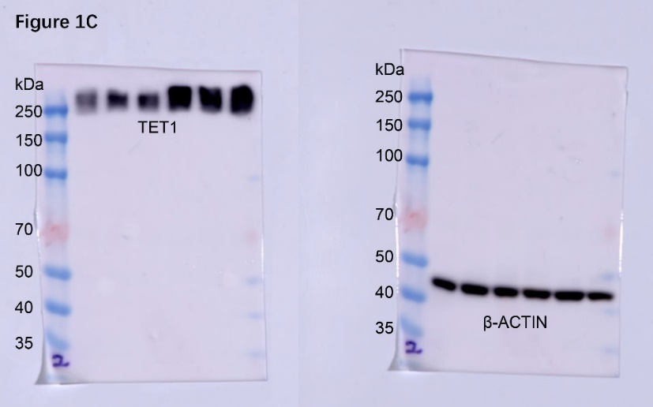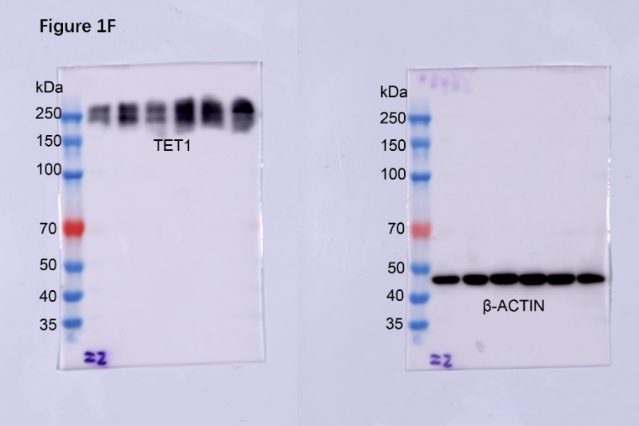
Figure 2A Figure 2C
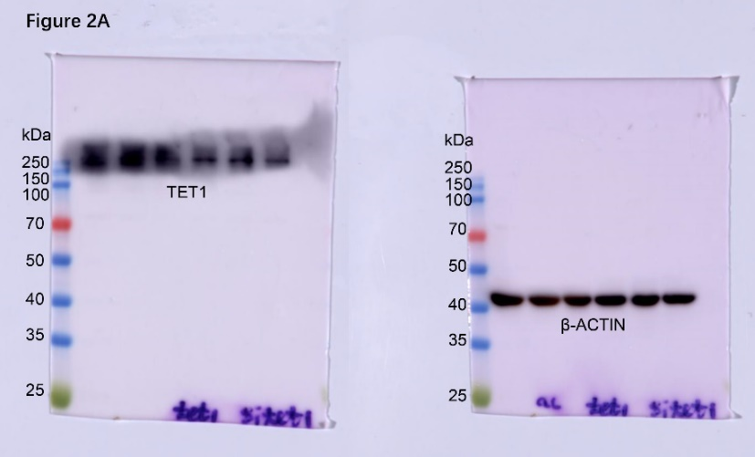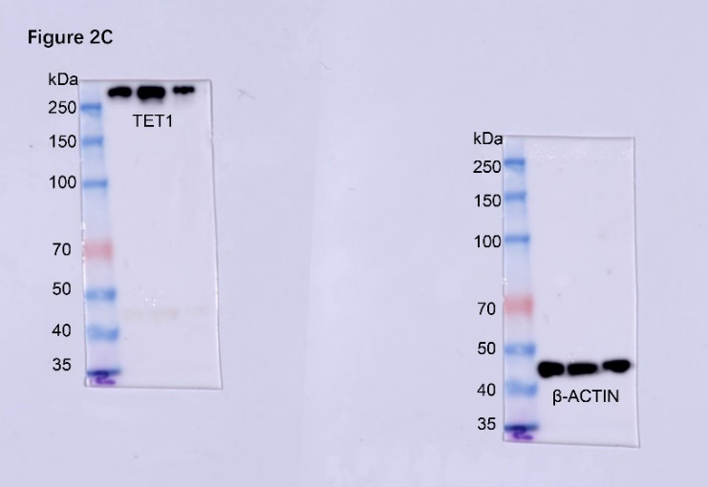

Figure 3E Figure 4A
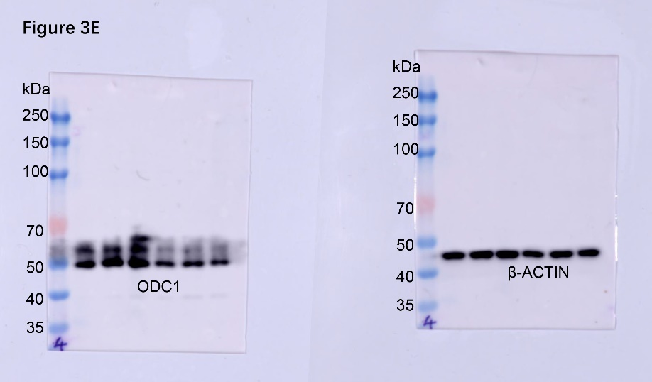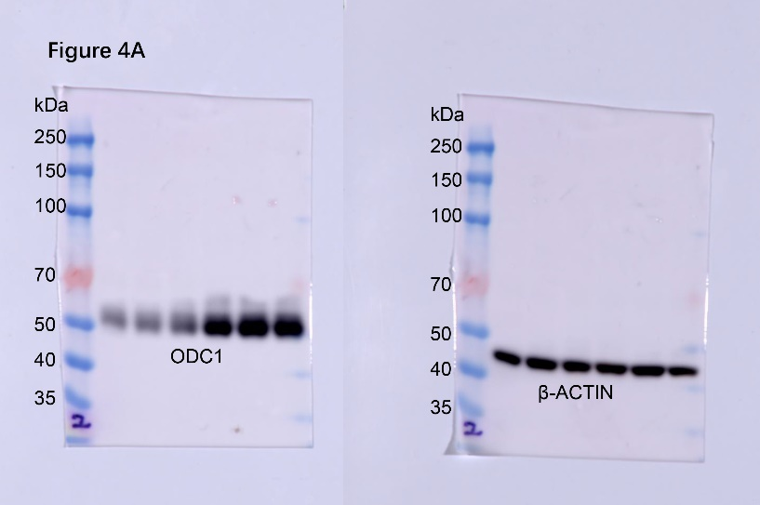
Figure 4B Figure 4C
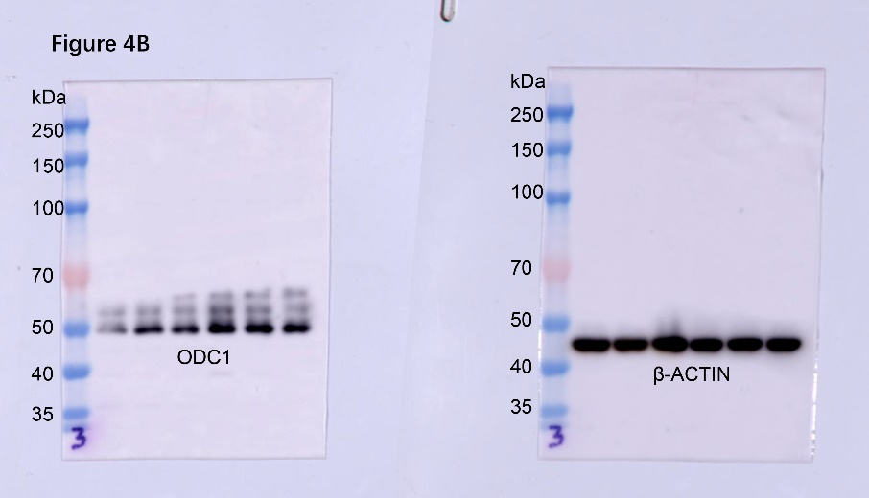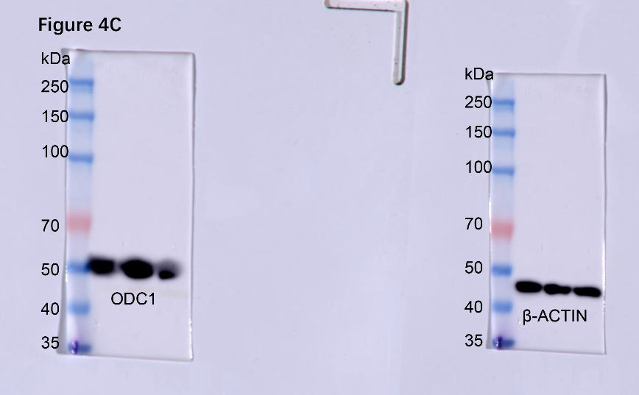
Figure 5F
