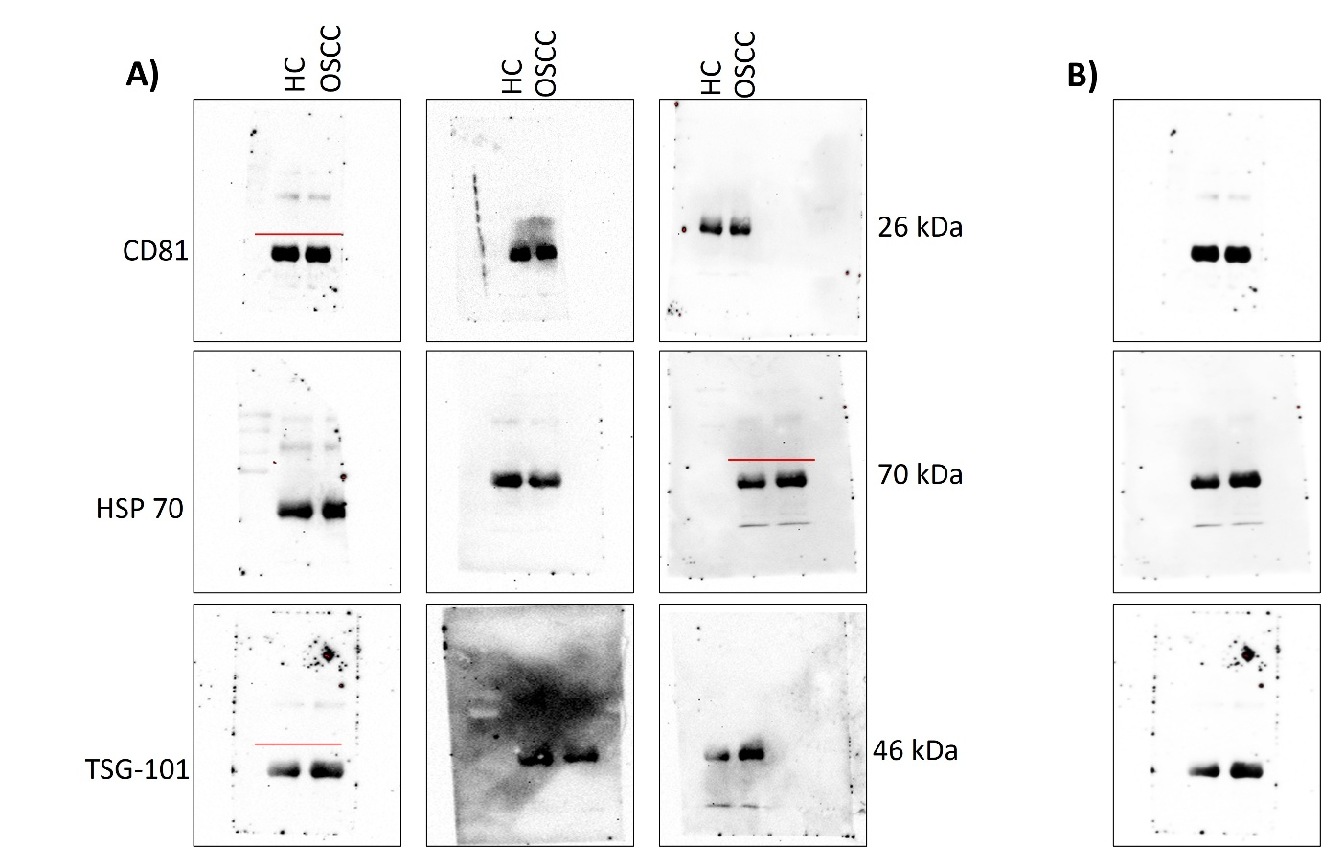
Supplementary Data:

Supplementary Figure 1: Full length and contrast-enhanced Western blot images for serum derived exosome characterization. (A) Full length Western blot images of exosomal markers CD81, HSP70, and TSG-101 in serum derived exosomes (n = 3). Red lines indicate where the blots were cropped to present in the main manuscript figures. (B) Contrast enhanced versions of the selected western blot images included in the main figures of the manuscript, shown here for clarity and transparency.

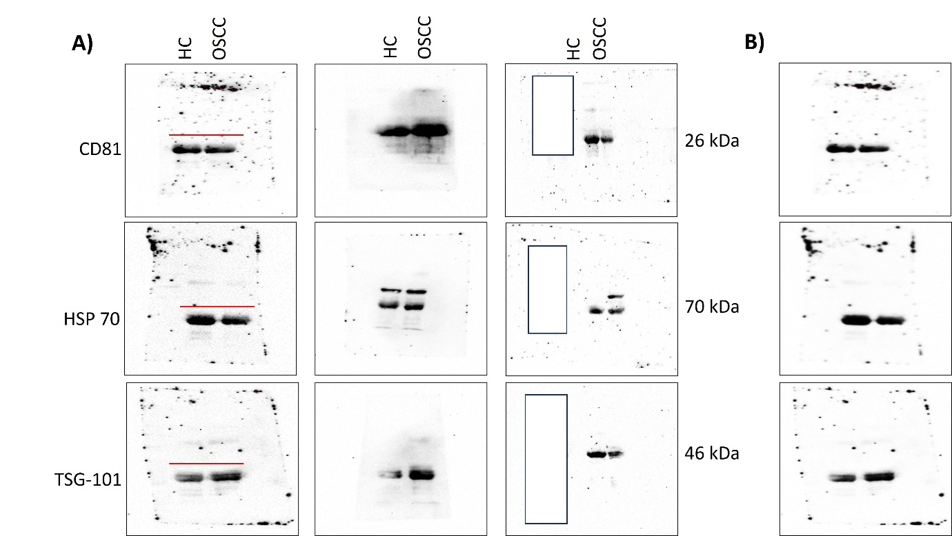
Supplementary Figure 2: Full length and contrast-enhanced Western blot images for saliva derived exosome characterization. (A) Full length Western blot images of exosomal markers CD81, HSP70, and TSG-101 in saliva derived exosomes (n = 3). Red lines indicate where the blots were cropped to present in the main manuscript figures. White masked regions represent lanes that are not related to the current study and were included for unrelated experimental purposes. (B) Contrast enhanced versions of the selected western blot images included in the main figures of the manuscript, shown here for clarity and transparency.
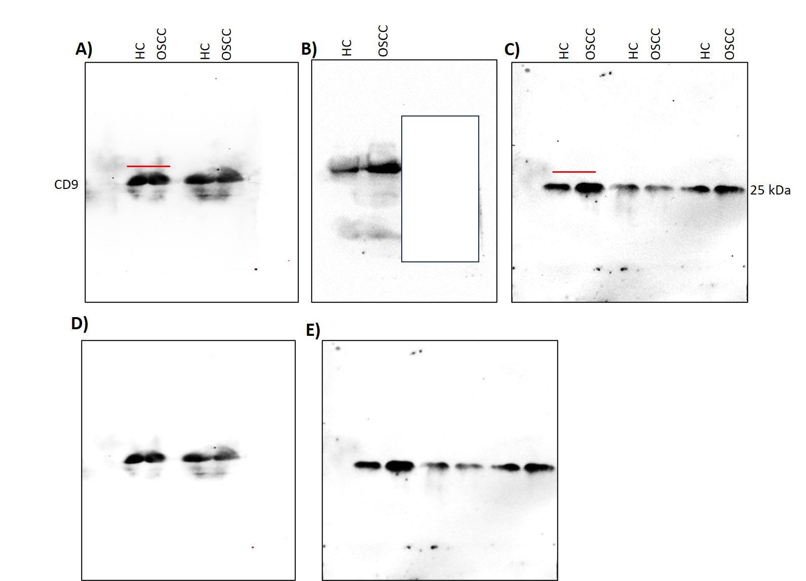
Supplementary Figure 3: Full length and contrast-enhanced Western blot images of CD9 from exosomes isolated from serum and saliva samples. (A, B) Full-length blots of CD9 from serum exosomes. (C) Full-length blots of CD9 from saliva exosomes. (D) Contrast-enhanced versions of the serum exosome blot included in the main figures. (E) Contrast-enhanced versions of the saliva exosome blot used in the main figure. White masked regions represent lanes that are not related to the current study and were included for unrelated experimental purposes. Red lines indicate cropped regions presented in the main manuscript.

Supplementary Table 1: List of Primer sequences and the PCR conditions for the targeted mRNA expression analysis in the present study
Gene | Forward Primer (5′–3′) | Reverse Primer (5′–3′) | Denaturation (10s) | Annealing/Extension (30s)
MMP9 | TTGACAGCGACAAGAAGTGG | GCCATTCACGTCGTCCTTAT | 95 °C | 60 °C
IL1 | ATGATGGCTTATTACAGTGGCAA | GTCGGAGATTCGTAGCTGGA | 95 °C | 60°C
IL6 | CCATCTTTGGAAGGTTCAGGTTG | ACTCACCTCTTCAGAACGAATTG | 95 °C | 62 °C
IL8 | ACTGAGAGTGATTGAGAGTGGAC | AACCCTCTGCACCCAGTTTTC | 95 °C | 62 °C
TNF-α | AGGACGAACATCCAACCTTCCCAA | TTTGAGCCAGAAGAGGTTGAGGGT | 95 °C | 62 °C
Chemerin | AGACAAGCTGCCGGAAGAGG | TGGAGAAGGCGAACTGTCCA | 95 °C | 62 °C
OAZ1 | AGAGAGAGTCTTCGGGAGAGG | AGATGAGCGAGTCTACGGTTC | 95 °C | 62 °C
SAT | CCAGTGAAGAGGGTTGGAGAC | TGGAGGTTGTCATCTACAGCAG | 95 °C | 62 °C
S100P | GAGTTCATCGTGTTCGTGGCTG | CTCCAGGGCATCATTTGAGTCC | 95 °C | 62 °C

Supplementary Table 2: Serum exosome biomarkers dose not shown correlation with tumour grade.
Tumour grade | Median | IQR (25%, 75%) | Comparison | P Value
IL1
I | 5.76 | 2.90, 13.82 | T1 Vs TII | 0.099
II | 15.31 | 6.40, 20.32 | TII Vs TIII | 0.587
III | 6.98 | 2.90, 22.73 | TI Vs TIII | 0.742
IL6
I | 1.82 | 0.31, 6.43 | T1 Vs TII | 0.888
II | 1.20 | 0.24, 5.33 | TII Vs TIII | 0.873
III | 0.72 | 0.43, 2.14 | TI Vs TIII | 0.659
IL8
I | 1.59 | 0.64, 6.77 | T1 Vs TII | 0.920
II | 2.13 | 0.80, 12.04 | TII Vs TIII | 0.645
III | 1.04 | 0.50, 7.67 | TI Vs TIII | 0.831
TNF-α
I | 6.08 | 1.93, 14.21 | T1 Vs TII | 0.348
II | 4.85 | 0.96, 28.91 | TII Vs TIII | 0.963
III | 3.09 | 1.19, 11.05 | TI Vs TIII | 0.347
S100 P
I | 3.06 | 1.72, 52.65 | T1 Vs TII | 0.919
II | 5.78 | 1.55, 27.43 | TII Vs TIII | 0.128
III | 2.21 | 0.34, 2.81 | TI Vs TIII | 0.245
SAT
I | 3.19 | 1.18, 18.05 | T1 Vs TII | 0.999
II | 2.39 | 0.94, 4.744 | TII Vs TIII | >0.999
III | 1.91 | 1.14, 3.37 | TI Vs TIII | 0.623
OAZ1
I | 6.80 | 2.32, 30.57 | T1 Vs TII | 0.989
II | 10.65 | 2.41, 29.37 | TII Vs TIII | 0.148
III | 1.92 | 0.27, 2.92 | TI Vs TIII | 0.140
MMP9
I | 3.23 | 1.40, 6.10 | TI Vs TII | >0.999
II | 5.06 | 1.27, 17.44 | TII Vs TIII | 0.456
III | 1.49 | 1.35, 2.64 | TI Vs TIII | >0.999
Chemerin
I | 2.28 | 1.02, 3.46 | T1 Vs TII | >0.999
II | 2.51 | 0.87, 4.66 | TII Vs TIII | >0.999
III | 2.02 | 0.78, 12.09 | TI Vs TIII | >0.999

Supplementary Table 3: Serum exosome biomarkers did not show significant changes in the lymph node metastasis in OSCC patients
Biomarker | LN− (Median) | IQR (25%, 75%) | LN+ (Median) | IQR (25%, 75%) | P value
MMP9 | 4.20 | 2.37, 7.62 | 1.55 | 1.58, 8.95 | 0.207
IL1 | 13.28 | 5.28, 16.0 | 5.98 | 3.60, 17.33 | 0.456
IL6 | 1.53 | 0.28, 2.43 | 0.84 | 0.42, 4.78 | 0.796
IL8 | 1.88 | 0.62, 4.96 | 1.16 | 0.69, 10.26 | 0.924
TNF-α | 7.21 | 1.61, 22.66 | 3.83 | 1.42, 15.48 | 0.635
Chimerin | 2.46 | 0.99, 3.56 | 1.56 | 0.90, 4.49 | 0.989
S100P | 3.02 | 1.30, 20.04 | 3.64 | 2.28, 30.49 | 0.524
SAT | 1.95 | 0.89, 4.81 | 3.21 | 1.15, 4.70 | 0.506
OAZ1 | 3.06 | 2.11, 24.56 | 6.76 | 1.76, 30.49 | 0.560

